Wireshark Mini-Project Report
ShieldGuard Inc. Technical Lab
Mini-Project: Wireshark Network Traffic Analysis

Objective
To capture and analyze live network traffic using Wireshark, identify communication patterns, and detect potential security concerns during common online activities.

Summary of Activity
Wireshark was installed and launched. A live capture was initiated while browsing a website and sending an email.

Key Findings
• DNS queries and HTTPS traffic were captured.
• Most traffic was encrypted via HTTPS.
• No unusual or suspicious traffic detected.
• Normal TCP handshakes and DNS requests observed.

Security Insights
• DNS queries visible in plain text.
• HTTPS encryption ensures confidentiality.
• No suspicious IP addresses or failed connection attempts.

Screenshot
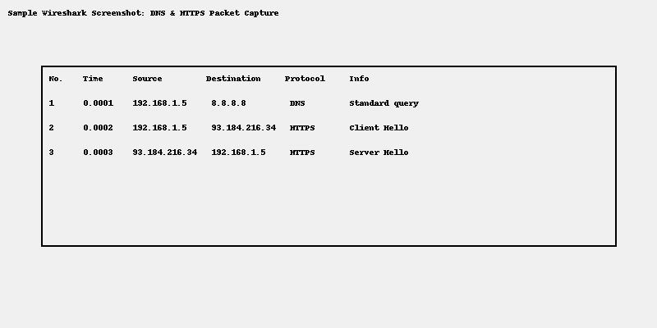
Figure 1: Sample Wireshark traffic showing DNS and HTTPS packets.

Recommendations
• Use DNS over HTTPS for additional privacy.
• Conduct extended capture sessions for thorough monitoring.
• Provide cybersecurity awareness training to end-users.

