Capstone Project: Securing the Access Grid - Cybershield Corp

Executive Summary
Cybershield Corp is overhauling its internal user and file access systems. This report details the design and implementation of a secure, scalable, and auditable Role-Based Access Control (RBAC) system. This RBAC solution supports department-specific access, secure inter-department collaboration, shared directory permissions, and centralized data segregation across Engineering, HR, Finance, Marketing, IT, and Executive departments.

Defined Departments and Responsibilities
- Engineering: Software development, DevOps, product maintenance
- HR: Employee records, payroll, performance analysis
- Finance: Budgeting, accounting, financial planning
- Marketing: Campaigns, branding, social media, budgeting
- IT Support: Network maintenance, helpdesk, infrastructure
- Executive: Strategic oversight and access to all departments' summaries

User Roles and Access Levels
- Junior Engineers: Read/write in /engineering/junior
- Senior Engineers: Full access to /engineering and read shared folders
- DevOps/Infra: Access to logs and shared engineering folders
- HR Staff: Full access to /hr and shared payroll documents
- Finance Staff: Access to finance and shared folders with HR/Marketing
- Marketing Team: Full access to /marketing and shared budgets
- Executives: Read-only access to all departments and full control over /executive
- Interns: Read-only access within their department

Directory and File Structure
/corp_data/
├── engineering/
│ ├── junior/
│ ├── senior/
│ └── shared/
├── hr/
│ └── payroll_shared/
├── finance/
│ └── marketing_budget/
├── marketing/
│ └── campaign_shared/
├── it/
│ └── logs/
├── executive/
└── shared/

Group and Permission Strategy
Linux Groups:
- eng_junior, eng_senior, eng_devops
- hr, finance, marketing, it_support
- executive, shared_hr_fin, marketing_finance
Windows AD Groups:
- G_ENG_JUNIOR, G_HR, G_SHARED_HR_FIN
- G_MARKETING_FINANCE, G_EXEC_READONLY
Permissions applied using `chown`, `chmod` on Linux or NTFS security settings on Windows.

Shared Directory Handling
- Shared folders have dedicated groups (e.g., shared_hr_fin)
- Only permitted departments are added to these groups
- Permissions are set to allow collaboration without overexposure

User-to-Permission Mapping (Sample)
Username | Department | Role | Groups | Access
alice_eng | Engineering | Junior Dev | eng_junior | /engineering/junior (rw)
jude_eng | Engineering | Senior Dev | eng_senior | /engineering (rw), /shared (ro)
dave_eng | Engineering | DevOps | eng_devops, it_support | /eng/shared (rw), /it/logs (ro)
bob_hr | HR | HR Assistant | hr | /hr (rw), /payroll_shared (rw)
chi_fin | Finance | Billing Clerk | finance | /finance (rw)
francis_mark | Marketing | Content Strategist | marketing, marketing_finance | /marketing (rw), /budget (rw)
jane_a | Executive | CEO | executive | /executive (full), /corp_data (ro)

Implementation Steps (Linux)
1. Create directories: mkdir -p /corp_data/...
2. Create groups: groupadd eng_junior, etc.
3. Set ownership: chown :group /path; chmod 770 /path
4. Add users: useradd username -G group
5. Apply sticky bits or NTFS as needed

Conclusion
This setup enforces least privilege, facilitates secure collaboration, and prepares Cybershield Corp for internal audits, red teaming, or penetration testing with a clean and scalable RBAC model.

Implementation Output & Simulated Screenshots
Below are simulated screenshots and expected command outputs to support auditability and testing.

Linux Filesystem Permissions
Command:
$ ls -l /corp_data/engineering
Output:
drwxrwx--- 2 root eng_junior 4096 Jul 22 10:00 junior
drwxrwx--- 2 root eng_senior 4096 Jul 22 10:00 senior
drwxrwx--- 2 root eng_devops 4096 Jul 22 10:00 shared

User Group Membership
Command:
$ id dave_eng
Output:
uid=1001(dave_eng) gid=1001(dave_eng) groups=1001(dave_eng),1002(eng_devops),1003(it_support)

Executive Directory Permissions
Command:
$ ls -ld /corp_data/executive
Output:
drwxr-x--- 2 root executive 4096 Jul 22 10:00 /corp_data/executive

Windows Server AD Steps
1. Create OUs for each department under your AD domain.
2. Use 'Active Directory Users and Computers' to define security groups:
- G_ENG_JUNIOR, G_HR, G_EXEC_READONLY, etc.
3. Assign users to groups according to their department and role.
4. Create folder structure on shared drive (e.g., D:\CorpData\).
5. Right-click folders → Properties → Security → Edit Permissions.
6. Add appropriate groups with Modify/Read/Full permissions.
7. Use Group Policy to enforce password, software, and account lockout policies.

Appendix: Setup Script
Below is a script that automates the Linux RBAC setup:
#!/bin/bash
mkdir -p /corp_data/{engineering/{junior,senior,shared},hr/payroll_shared,finance/marketing_budget,marketing/campaign_shared,it/logs,executive}
groupadd eng_junior && groupadd eng_senior && groupadd eng_devops
groupadd hr && groupadd finance && groupadd marketing && groupadd it_support
groupadd executive && groupadd shared_hr_fin && groupadd marketing_finance
chgrp eng_junior /corp_data/engineering/junior && chmod 770 /corp_data/engineering/junior
# ... (more chmod/chgrp commands here)
useradd alice_eng -G eng_junior

Implementation Screenshots

Engineering Directory Listing
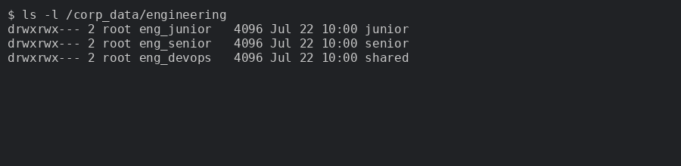

User Group Membership: dave_eng
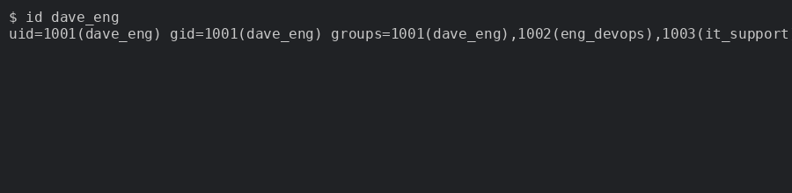

Executive Directory Permissions
