T.C.
ÇUKUROVA ÜNİVERSİTESİ
MÜHENDİSLİK FAKÜLTESİ

STAJ DEFTERİ

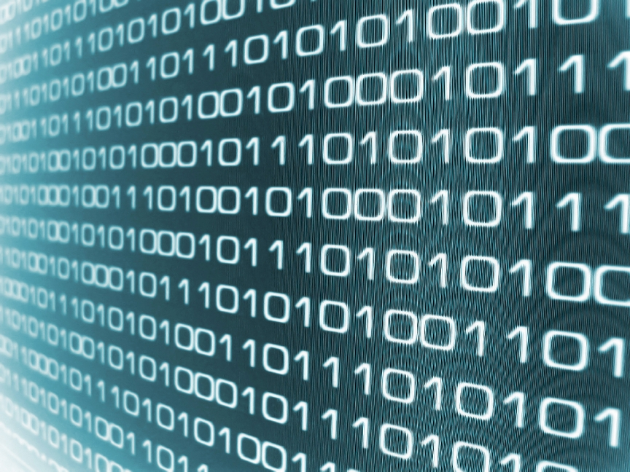

ADANA
PRATİK ÇALIŞMANIN GÜNLERE DAĞILMA ÇİZELGESİ

Öğrencinin Çalıştığı Günler | Günlük Çalışma Saati | İşyeri Amirinin İmzası | Öğrencinin Çalıştığı Konular
18/11/2024  19/11/2024  20/11/2024  21/11/2024  22/11/2024  23/11/2024 | 9  9  9  9  9  9 |  | General Information Meeting  Training on IoT Devices  Communication for IoT Devices  Decoding and Parsing IoT Signals  Decoding and Parsing IoT Signals  Visualizing IoT Signals

On the first day, there was an introductory meeting and I was informed about the company. We also discussed a roadmap about what I will do and contribute during my internship.
Also, on the first day, I signed a company-mandated NDA, so the code I wrote will have some parts changed or removed as it's added to these notes.
This roadmap includes processing, making usable, monitoring/tracking and analyzing the signals of IoT devices.

Overview
Ordinatrum Bilişim Teknolojileri was founded in 2011, with a mission to revolutionize healthcare through innovative technology solutions. Based in Istanbul, Turkey, Ordinatrum specializes in healthcare information systems, focusing on digital solutions that enhance hospital operations, patient care, and decision-making processes.
The company’s flagship product, ARC ICU, is an advanced software solution designed for intensive care units (ICUs). It enables real-time monitoring and analysis of patient data, assisting healthcare professionals with critical decisions. This product, which has received FDA approval, highlights Ordinatrum’s commitment to delivering high-quality, cutting-edge solutions to the global healthcare market.
Business Partners and Clients
Ordinatrum collaborates with various hospitals, medical institutions, and healthcare providers in Turkey and internationally. With a strong research and development focus, the company has partnered with leading organizations such as TÜBİTAKfor R&D initiatives. Its client base includes both public and private sector hospitals, aiming to improve patient care quality and operational efficiency.
Ordinatrum also seeks to expand its global footprint, with a goal to increase exports and form new partnerships in healthcare technology markets worldwide. The company is currently targeting an export value of $100 million over the next five years.
Vision and Mission
Ordinatrum’s mission is to combine the latest technology with innovation to improve the institutions it serves. The company's vision is to represent Turkey in global markets while maintaining customer satisfaction and contributing to sustainable growth in healthcare.

Sayfa No | Çalışmanın |  | KONTROL
1 | Konusu : General Information Meeting | Yapıldığı Tarih  18/11/2024

Today, I attended an in-depth training session on the fundamentals of IoT (Internet of Things) devices, which introduced the concept of interconnected physical objects embedded with sensors, software, and technologies that communicate over the internet. IoT devices have dramatically transformed industries such as healthcare, agriculture, smart homes, and cities, enabling real-time data collection and automation. The session focused on different types of IoT signals and formats, including sensor data (e.g., temperature, humidity, motion), actuator signals, and common communication protocols like MQTT, JSON, and XML, which help facilitate the exchange and processing of data.

We explored the essential components of an IoT system:
- Sensors and Actuators: These devices serve as the "eyes and ears" of IoT systems. Sensors gather data from the environment (e.g., temperature, pressure, or movement), while actuators respond by triggering physical actions (e.g., turning on a fan or adjusting a thermostat).
- Connectivity: Once data is gathered, it needs to be transmitted to a central hub or cloud platform. This is done via communication protocols such as Wi-Fi, Bluetooth, Zigbee, or cellular networks (e.g., 4G/5G). The choice of protocol depends on factors like range, bandwidth, power consumption, and the specific IoT application.
- Data Processing: Data collected by IoT devices is often processed locally on the device, but in complex systems, it is transmitted to cloud platforms where more intensive analysis and decision-making can take place. Edge computing, where data is processed closer to the source, has also become a key topic in modern IoT systems.
- User Interface: Finally, the processed data is presented to users via a dashboard or application, allowing them to monitor the system and take necessary actions, such as adjusting settings or receiving alerts.

We also explored real-world IoT applications, such as healthcare IoT systems for patient monitoring. In these systems, IoT devices monitor vital signs like heart rate and blood pressure and send the data to healthcare providers for real-time analysis. This can lead to timely interventions, improving patient outcomes. Additionally, we discussed the challenges and opportunities of scaling IoT systems and ensuring security in an increasingly connected world.

Sayfa No | Çalışmanın |  | KONTROL
2 | Konusu : Training on IoT Devices | Yapıldığı Tarih  19/11/2024

The focus of today’s session was on communication protocols in IoT systems. We learned about the various technologies and standards that enable devices to communicate with each other and with the cloud. This is a crucial aspect of IoT, as seamless communication ensures data flows reliably between devices, gateways, and cloud services. Here are the key takeaways from the training:
- Communication Models:
  - Device-to-Device (D2D): This involves direct communication between two or more IoT devices without involving a central server. It’s commonly used in Bluetooth or Zigbee networks.
  - Device-to-Cloud (D2C): In this model, IoT devices send data to a cloud server for processing and analysis. The cloud platform typically provides storage, analysis, and management tools. Protocols like MQTT and HTTP are used here.
  - Device-to-Gateway: In this model, IoT devices communicate with a local gateway, which aggregates data and sends it to the cloud. Gateways help reduce bandwidth usage and provide localized processing.
- Protocols:
  - MQTT (Message Queuing Telemetry Transport)
  - HTTP/HTTPS
  - CoAP (Constrained Application Protocol)
- Security: We discussed the importance of encryption, authentication, and other best practices for securing IoT communications.
The session also included hands-on training where we set up an MQTT broker and simulated device communication. Here’s a simple Python example using the paho-mqtt library to send and receive messages:
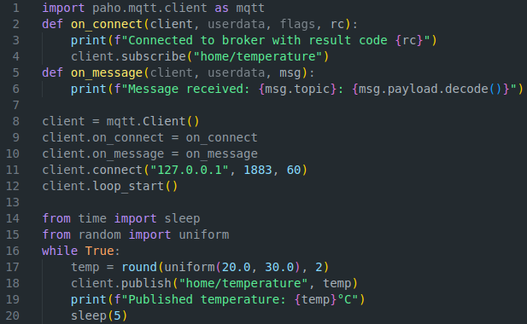

Sayfa No | Çalışmanın |  | KONTROL
3 | Konusu : Communication of IoT Devices | Yapıldığı Tarih  20/11/2024

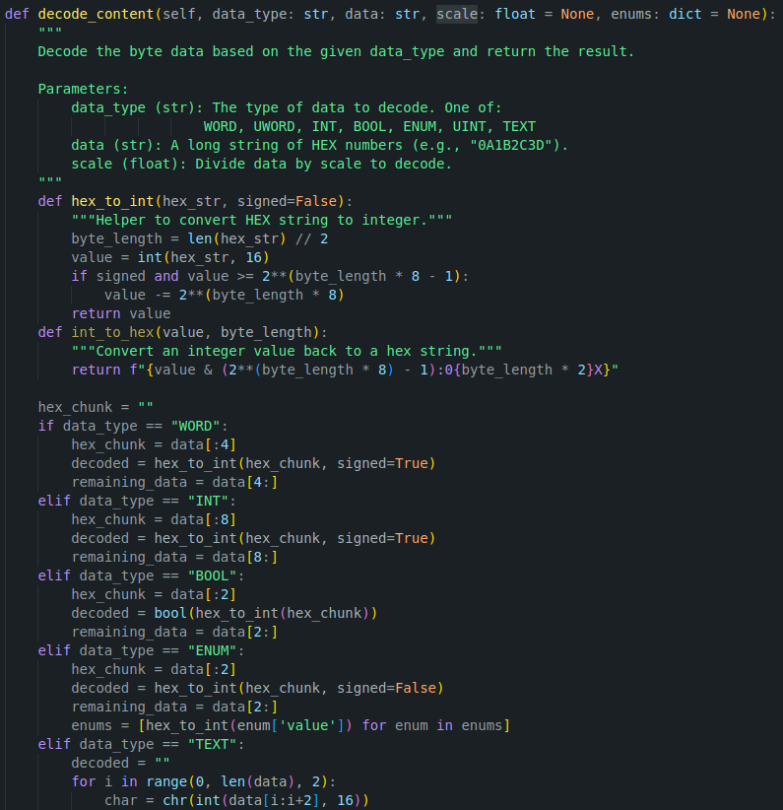
Today, I to complete some tasks to expand my understanding of the signal processing mechanisms for the IoT devices used by the company. In particular, I aimed to refine the process for parsing and decoding XML-based signals, which arrive in the form of byte data encoded as hex and some other string-formetted signals. Since I use the company's real device data in these tasks, I cannot include the full codes due to the privacy agreement I signed. The first step in handling these signals involved parsing the XML structure. Each signal comes as an XML document, with attributes such as message ID, class, and a cyclic redundancy check (CRC) value for integrity verification. Here's how I approached the parsing process:
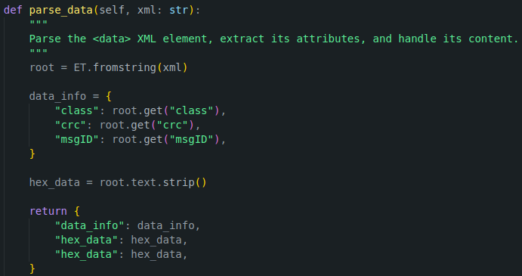
The next step was to decode the hexadecimal data. The IoT devices output different types of information: integers, unsigned integers, boolean values, enumerations, and even text. Each data type requires a different decoding method, and this is handled based on the given data_type.

For instance, when the data type is an integer (INT), I need to convert the hex string into a signed integer value. For text data, the hex string must be converted into ASCII characters. The decoding process also includes handling enums (where values correspond to specific statuses or states), and optionally applying a scale factor if the data needs to be normalized.

Sayfa No | Çalışmanın |  | KONTROL
4 | Konusu : Decoding and Parsing IoT Signals | Yapıldığı Tarih  21/11/2024

Today, I worked on processing encoded bit data, specifically focusing on decoding a section of a larger bit stream. The data was packed tightly in bits, making it necessary to use Python’s struct module to unpack and extract specific portions of the signal.
Decoding Encoded Bit Data
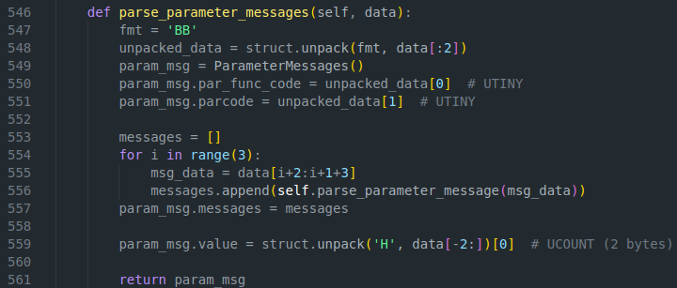
The first task was to decode a small portion of the signal, which contains different parameters packed as bytes. Using the struct.unpack() method, I was able to extract specific fields from the bit data stream. Here's an example of the code I used for this process:
In this function, I used struct format strings (e.g., '2B') to extract the required bytes from the bit data, which represent specific parameters like function codes and parameter codes. After extracting these values, I applied additional decoding logic to parse the entire message.
Automating Signal Processing with Rules
To further streamline the processing of the decoded data, I implemented a rule-based system. This system allows for automating changes to parsed signals based on predefined conditions. The rules make the parser more flexible by enabling dynamic updates or modifications based on specific criteria, such as function codes or parameter limits. The rules can be easily added, updated, or removed.
Here’s an example of how I added rules to the parser:
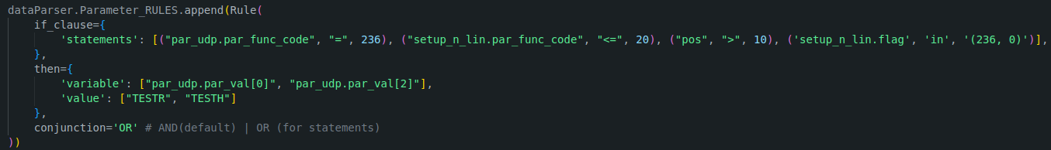
By the end of the day, I had successfully implemented a system that not only decodes bit signals but also applies custom rules to automate the processing of these signals. This was a valuable exercise in working with large datasets and creating a more dynamic and adaptable parser for IoT signals.
Sayfa No | Çalışmanın |  | KONTROL
5 | Konusu : Decoding and Parsing IoT Signals | Yapıldığı Tarih  22/11/2024

Today, I focused on creating a real-time data visualization tool using Matplotlib to continuously collect data, update a dictionary of parameters, and refresh graphs in real time as new signal data is received. This task was particularly exciting because it combined asynchronous programming with real-time data handling and visual representation.
Key Tasks:
- Data Collection: The primary goal was to continuously collect incoming data using an asynchronous data collector. Once data was received, it was processed, added to a dictionary, and prepared for plotting. Here's the data_collector function.
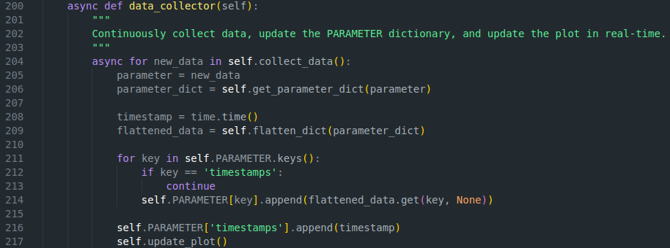
In this method, the system continuously collects new data. Each time data is collected, it is flattened, processed, and added to the PARAMETER dictionary, which holds the various parameters being tracked (like par_func_code, parcode, etc.). The timestamp for each data point is also recorded.
- Real-Time Plotting: To visualize the collected data, I integrated interactive plotting using Matplotlib's interactive mode (plt.ion()). This mode enables the graph to be updated dynamically each time new data is collected. Here's the code for the main function that keeps the system running and continuously updates the plots. Plots are repeats itself in the image below due to limited amount of data for testing:
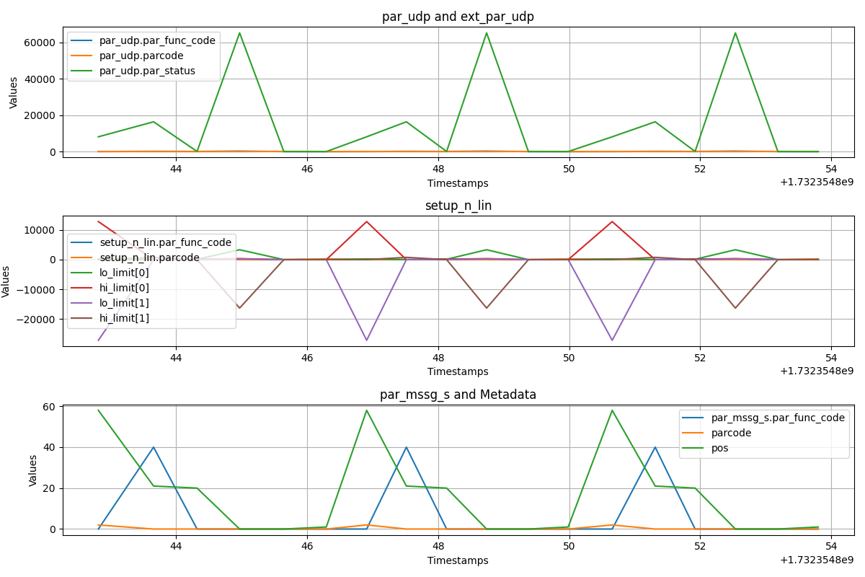
I learned real-time data visualization using Matplotlib and asynchronous programming. I handled nested data structures for accurate plots, tackling challenges like performance with large datasets and timestamp accuracy. The final tool updates interactive plots, making it useful for IoT device monitoring and live data analysis.

Sayfa No | Çalışmanın |  | KONTROL
6 | Konusu : Visualizing IoT Signals | Yapıldığı Tarih  23/11/2024

Sayfa No | Çalışmanın |  | KONTROL
 | Konusu : | Yapıldığı Tarih  /11/2024

Sayfa No | Çalışmanın |  | KONTROL
 | Konusu : | Yapıldığı Tarih  /11/2024

Sayfa No | Çalışmanın |  | KONTROL
 | Konusu : | Yapıldığı Tarih  /11/2024

Sayfa No | Çalışmanın |  | KONTROL
 | Konusu : | Yapıldığı Tarih  /11/2024

Sayfa No | Çalışmanın |  | KONTROL
 | Konusu : | Yapıldığı Tarih  /11/2024

Sayfa No | Çalışmanın |  | KONTROL
 | Konusu : | Yapıldığı Tarih  /11/2024

Sayfa No | Çalışmanın |  | KONTROL
 | Konusu : | Yapıldığı Tarih  /11/2024

Sayfa No | Çalışmanın |  | KONTROL
 | Konusu : | Yapıldığı Tarih  /11/2024

Sayfa No | Çalışmanın |  | KONTROL
 | Konusu : | Yapıldığı Tarih  /11/2024

Sayfa No | Çalışmanın |  | KONTROL
 | Konusu : | Yapıldığı Tarih  /11/2024

Sayfa No | Çalışmanın |  | KONTROL
 | Konusu : | Yapıldığı Tarih  /11/2024

Sayfa No | Çalışmanın |  | KONTROL
 | Konusu : | Yapıldığı Tarih  /11/2024

Sayfa No | Çalışmanın |  | KONTROL
 | Konusu : | Yapıldığı Tarih  /11/2024

Sayfa No | Çalışmanın |  | KONTROL
 | Konusu : | Yapıldığı Tarih  /11/2024

Sayfa No | Çalışmanın |  | KONTROL
 | Konusu : | Yapıldığı Tarih  /11/2024

Sayfa No | Çalışmanın |  | KONTROL
 | Konusu : | Yapıldığı Tarih  /11/2024

