Short Specification Scanner User Interface

The Web-UI shall show data that is provided by a scanner process (online), or loaded from a database or text file.
The software shall show the data of 2 scanners (to be prepared for more), and the merged scanner data/summary.
Scanner data contains a dataset of 1800 (to be specified) tuples for each scanner picture. Each tuple contains
- Distance (this is raw data from scanner)
- X-Coordinate in a Cartesian X/Y coordinate system, calculated by the scanner process
- Y-Coordinate in a Cartesian X/Y coordinate system, calculated by the scanner process
Data arrives from scanner every 100ms.
The data is stored in files in following form:
Date/time 1 | Tuple 1  X  Y  Distance | Tuple 2  X  Y  Distance | Tuple 3  X  Y  Distance | …. | Tuple 1800  X  Y  Distance
….

Date/time  n | Tuple 1  X  Y  Distance | Tuple 2  X  Y  Distance | Tuple 3  X  Y  Distance | …. | Tuple 1800  X  Y  Distance

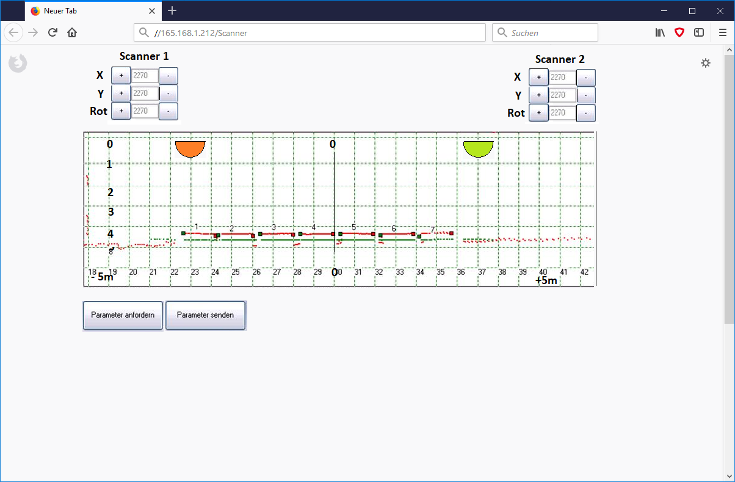

The software shall have following basic functions:
- show position of 2 laser scanners in the coordinate system
- input fields and +/- buttons for changing angle and X/Y coordinates of both scanners
- picture is updated in real time, thus allowing to align the pictures of both scanners
- show all calculated values under the scanner output field

The chart shall have following functionality:
- Zoom in/out
- Panning
- Set start/stop X/Y range manually (via input field)
- Data display as Single point, line, Spline/Trend
- X/Y-values like this:
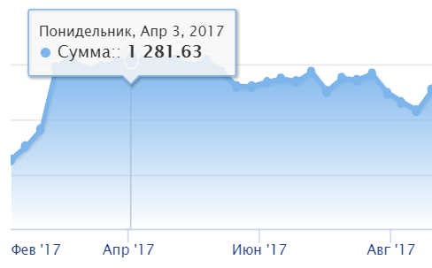
Optional functions:
- Output in Excel or csv-file (as in DevExpress)
- Output into PDF, print function

Examples for suitable Chart components:
Vector Image Rendering by DevExpress:
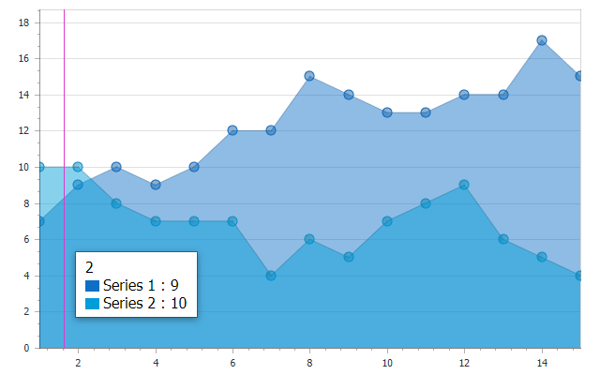
2D Charting control by DevExpress:
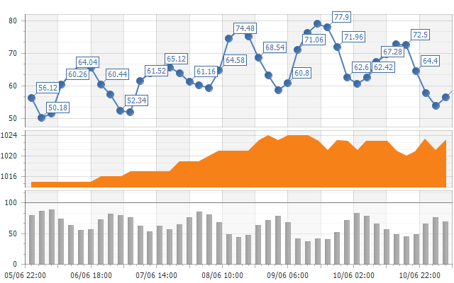

Development with C# / ASP.NET

