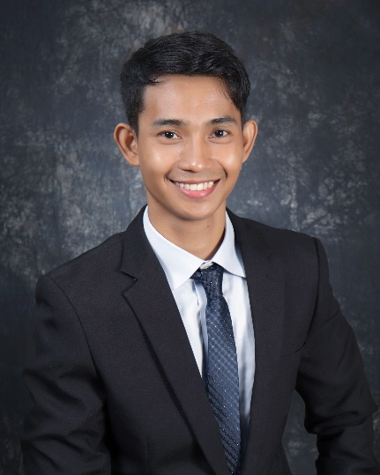

ELYRIC A. **MANATAD**Looc, Mandaue City, Cebu 6014, Philippines│Mobile: 09912046696│Email: [elyricmanatad@gmail.com](mailto:elyric_manatad@yahoo.com)│   
Date of Birth: May 15, 1996│Sex: Male │ Height: 5’4 │ Civil Status: Single │Religion: Christian│

**Objective:**  
Highly motivated **Junior Web Developer** with a passion for building interactive and user-friendly web applications. Skilled in front-end and back-end technologies, seeking an opportunity to contribute to a development team and further enhance my programming skills.

**Education**

October 2020 **CITE Technical Institute Incorporated** Talamban, Cebu City, Philippines

To

November2023 Course**:** Computer Engineering Technology

**Technical Skills:**

- **Front-end:** HTML, CSS, JavaScript, React JS, React Redux Toolkit, Next JS and Tailwind CSS

- **Back-end:** PHP, Laravel RESTful API, and (minor exposure to Django REST API)

- **Mobile Development:** Exposure to Flutter and FireStore

- **Database:** MySQL, SQLite

- **Others:** Git, Agile Methodology, Docker

**Experience/OJT**

**Internship:**

August 2022 **Sun Asterisk Philippines**  (Remote)

to **-** Junior Web Developer

July 2023

**Projects:**

**E-Learning System (ELS)**

Developed a fully functional e-learning system website using React JS, Tailwind and Laravel REST API. Implemented a user and admin feature, creating questions and answers, view total score, view learned categories, can follow another user and admin have the full access.

**Messenger clone APP**

Developed a Messenger clone app using Flutter and FireStore. Working with UI and Implemented a simple CRUD operation.

**Learning Management System (LMS)**

Developed and contributed to our simulation project for the new employee on my previous company using React JS, Tailwind, TypeScript, React Redux Toolkit, and Django RESTful API. We have a UI/UX designer and all we do is turn that design (Figma) into a working code. We implemented a user and admin feature with Google sign in, can create courses, learning path for the new employee if what they should learn and manage their learning path.

**Languages:**

- English: Basic proficiency

- Tagalog: Native proficiency

- Cebuano: Native proficiency

**Reference: Contact:**

**Mr. Ryan Dupay**

Sun Asterisk PH Branch Manager 09287413411 | ryan.dupay@sun-asterisk.com