# The Role and Importance of Computer Graphics in Modern Society

Computer graphics have revolutionized how we interact with technology, offering dynamic visual representations that span across various disciplines. This document outlines the pivotal role of computer graphics in modern society, exploring its types, applications, and transformative impact on fields ranging from scientific visualization to e-commerce.

 **by Elysée NIYIBIZI**

**[](https://gamma.app/?utm_source=made-with-gamma)**

# Types of Computer Graphics: Raster and Vector

Computer graphics primarily divide into two categories: raster graphics and vector graphics, each serving unique functions based on their composition and scalability.

**Raster Graphics:** These graphics are composed of pixels arranged in a grid. The resolution of a raster graphic determines its quality; when scaled beyond its original size, it can appear pixelated or blurry. Common examples include photographs and digital paintings. Raster graphics are widely used in applications such as photo editing, digital image displays, and are crucial for rendering realistic details and textures.

**Vector Graphics:** Vector graphics use mathematical formulas to represent images through geometric primitives like points, lines, curves, and polygons. This mathematical approach allows vector graphics to be scaled infinitely without any loss in quality. Vector graphics are typically used for logos, illustrations, CAD drawings, and any application where scalability and clean lines are essential. Software such as Adobe Illustrator relies heavily on vector graphics for its design capabilities.

[](https://gamma.app/?utm_source=made-with-gamma)Understanding the distinction between raster and vector graphics is crucial for choosing the appropriate medium in various design and digital applications, each offering its own advantages depending on the required use case.

# Scientific Visualization

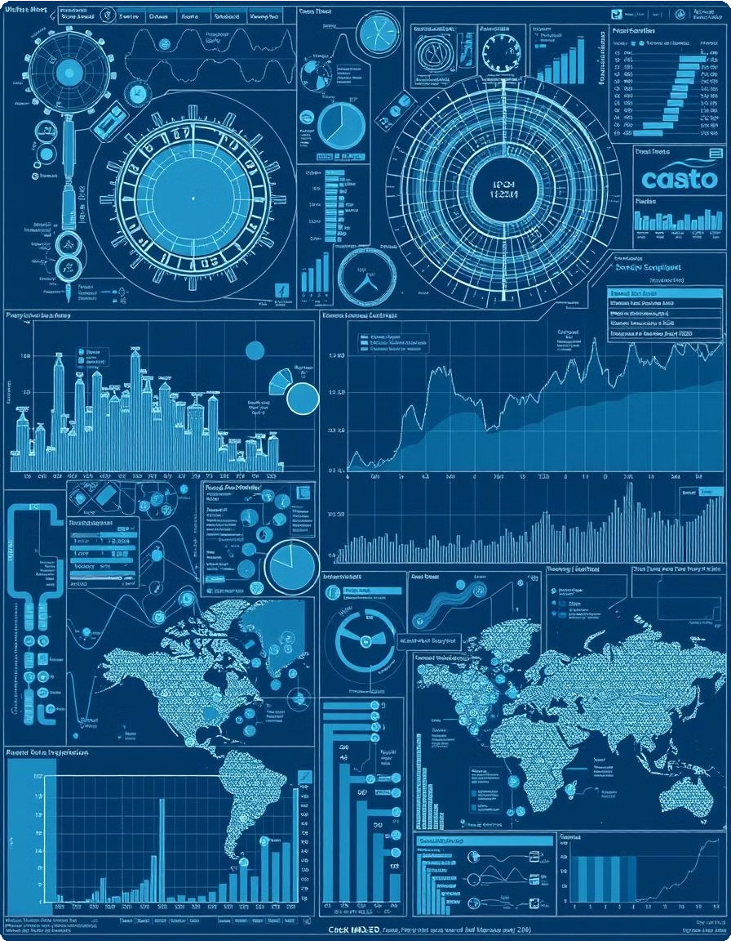

Scientific visualization is the process of transforming complex scientific data into graphical formats that allow researchers and analysts to gain insights and make discoveries. By converting abstract data into visual representations, it simplifies understanding and facilitates the identification of patterns, trends, and anomalies that would otherwise be difficult to discern.

Applications of scientific visualization include climate modeling, where massive datasets of temperature, pressure, and wind speed are converted into visual simulations to study climate change patterns. In astronomy, it helps to visualize cosmic phenomena, such as galaxy formations or black hole interactions. Furthermore, in physics, it enables simulations of particle behavior or fluid dynamics, aiding in research and education.

The role of computer graphics in scientific visualization is essential, enabling scientists to interpret their data more effectively and communicate their findings to broader audiences. High-quality visual renderings can uncover hidden relationships within data and promote more accurate modeling and predictions.

# Engineering and CAD

Computer-Aided Design (CAD) and Engineering significantly benefit from computer graphics by assisting in the creation and testing of complex designs digitally. This technology allows engineers and designers to visualize, simulate, and modify designs before physical prototypes are made, saving time and resources.

In architecture, CAD software uses computer graphics to create detailed 3D models of buildings, allowing architects to explore designs from multiple angles and ensure structural integrity. Mechanical engineers use CAD to design machinery and mechanical components, optimizing their functionality and performance through digital simulations. Civil engineers employ these tools for planning and designing infrastructure projects like roads, bridges, and tunnels, enhancing safety and efficiency.

[](https://gamma.app/?utm_source=made-with-gamma)The use of computer graphics in engineering and CAD not only streamlines the design process but also improves the overall quality and precision of the final products. It enables better collaboration among design teams and provides enhanced visualization capabilities for stakeholders.

# Medical Imaging



Medical imaging relies extensively on computer graphics to enhance the understanding of internal body structures and provide detailed views for diagnostic purposes. This technology enables medical professionals to visualize organs, tissues, and bones in a non-invasive manner, improving the accuracy and efficiency of medical diagnoses.

Magnetic Resonance Imaging (MRI) scans are used to produce detailed images of soft tissues, helping in the detection of abnormalities such as tumors or injuries. Three-dimensional anatomy models, created with computer graphics, allow medical students and professionals to study the human body in an interactive and realistic manner. Surgical planning also utilizes these techniques to prepare complex procedures, reducing risks and improving patient outcomes.

The integration of computer graphics in medical imaging provides enhanced visualization tools that improve diagnostic accuracy, support medical education, and aid in surgical preparation, ultimately leading to better patient care.

# Virtual Reality (VR) and Augmented Reality (AR)

Virtual Reality (VR) and Augmented Reality (AR) technologies offer immersive experiences that are transforming fields such as gaming, education, and training. VR creates completely artificial environments, while AR overlays digital content onto the real world.

VR gaming provides users with immersive, interactive gaming experiences, enhancing engagement and realism. AR learning apps overlay digital information onto physical objects, making learning more interactive and engaging. Virtual tours use VR to allow people to explore locations remotely, providing detailed and realistic simulations of real-world environments.

[](https://gamma.app/?utm_source=made-with-gamma)Computer graphics are the backbone of VR and AR, enabling the creation of realistic and interactive environments. These technologies are increasingly being adopted in training simulations, education, and entertainment, revolutionizing how people interact with digital content and the physical world.

# Web Design and Development

Computer graphics play a crucial role in web design and development by making websites visually appealing and user- friendly. The design elements created with computer graphics enhance the overall user experience and ensure that websites are both aesthetically pleasing and highly functional.

User Interface (UI) and User Experience (UX) design heavily rely on computer graphics to create intuitive layouts, engaging visuals, and interactive elements that guide users through a website effectively. Banner design uses graphics to create compelling advertisements that capture attention and drive traffic. Additionally, animations add dynamic elements to websites, enhancing their interactivity and engagement.

The use of computer graphics in web design and development enhances the visual appeal of websites, improves user engagement, and contributes to the overall success of online platforms. A well-designed website that integrates graphics effectively can significantly enhance the user experience and achieve specific business goals.

[](https://gamma.app/?utm_source=made-with-gamma)

# Art and Digital Creativity

Computer graphics provide artists with powerful tools to create and share digital artwork, revolutionizing traditional art forms and enabling new creative possibilities. These tools allow artists to create, manipulate, and distribute their work easily, reaching a global audience.

Digital painting software allows artists to create artwork with a wide range of brushes, textures, and effects, mimicking traditional painting techniques or exploring new styles. Three-dimensional modeling software enables the creation of virtual sculptures and objects, providing artists with a new medium for expressing their creativity. Concept art, essential in the gaming and film industries, uses computer graphics to visualize ideas and designs before production.

Computer graphics have democratized the art world, making it easier for artists to create and share their work, experiment with new techniques, and collaborate with others. Digital art has become an integral part of modern culture, influencing various creative industries and providing new opportunities for artistic expression.

[](https://gamma.app/?utm_source=made-with-gamma)

# Data Visualization and E-commerce

Data visualization is critical in converting raw data into insightful charts and graphs, aiding in effective decision-making. E-commerce leverages computer graphics to enhance product presentation and user engagement.

**Data Visualization:** Business dashboards utilize graphics to display key performance indicators (KPIs), enabling quick assessments of business performance. Analytics platforms convert complex data sets into interactive visualizations for data-driven decision-making. Research reports use graphics to present findings in a clear and compelling manner, aiding in the communication of research outcomes.

**E-commerce:** Online stores use 3D product views to provide customers with a more detailed and realistic representation of products, enhancing their confidence in purchasing decisions. Product configurators enable customers to customize products visually before making a purchase, improving user engagement and satisfaction.

The fusion of computer graphics in data visualization and e-commerce leads to better informed decisions and more engaging customer experiences. Visual aids in data analysis facilitate the identification of trends and patterns, while graphical enhancements in e-commerce drive sales and improve customer satisfaction.

[](https://gamma.app/?utm_source=made-with-gamma)