Names: Elysée NIYIBIZI Date: 27/02/2026
ReG No: 2305000921
Department: BCS (Computer Science)
Module: Internet of Things and Embedded System Practice

Smart Room Temperature Monitoring System - IoT Assignment

Step 1: IoT Topic
Smart environment monitoring for a classroom or room using temperature and humidity sensing.

Step 2: Identify Objects
General Object:
Classroom environment monitoring system.
Specific Objects:
- DHT11 temperature and humidity sensor
- ESP32 microcontroller
- WiFi network
- Cloud dashboard
- Power supply

Step 3: IoT Components
Sensors:
DHT11 temperature and humidity sensor.
Microcontroller:
ESP32.
Connectivity Module:
Built-in WiFi in ESP32.
Actuator:
LED for temperature alert.
Power Supply:
5V USB power.

Step 4: Power Consumption Calculation
DHT11 sensor:
Current = 0.3 mA at 5V
Power = V × I = 5 × 0.0003 = 0.0015 W
ESP32 with WiFi active:
Current = 240 mA at 5V
Power = 5 × 0.24 = 1.2 W
LED:
Current = 20 mA at 5V
Power = 5 × 0.02 = 0.1 W
Total Power Consumption:
0.0015 + 1.2 + 0.1 = 1.3015 W

Step 5: System Flowchart Description
Start → Initialize ESP32 → Connect to WiFi → Read temperature and humidity from DHT11 → Send data to cloud dashboard → Check temperature threshold → If temperature > 30°C turn ON LED → Else turn OFF LED → Wait 10 seconds → Repeat

Flowchart Diagram
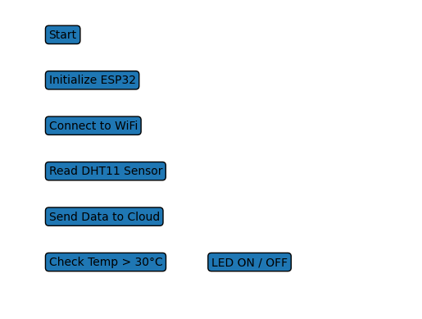

Block Diagram Description
DHT11 Sensor → ESP32 Microcontroller → WiFi → Cloud Dashboard
ESP32 → LED Alert

Block Diagram
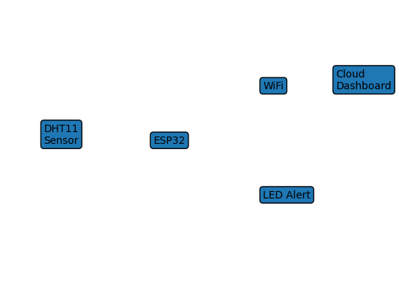

Sample ESP32 Code (for demonstration)
#include <WiFi.h>
#include "DHT.h"
#define DHTPIN 4
#define DHTTYPE DHT11
#define LEDPIN 2
DHT dht(DHTPIN, DHTTYPE);
void setup() {
Serial.begin(115200);
dht.begin();
pinMode(LEDPIN, OUTPUT);
}
void loop() {
float temp = dht.readTemperature();
if (temp > 30) {
digitalWrite(LEDPIN, HIGH);
} else {
digitalWrite(LEDPIN, LOW);
}
delay(10000);
}

Step 6: Conclusion
This system monitors room temperature and humidity in real time. Data is sent to a cloud dashboard for remote viewing. An LED provides a local alert when temperature exceeds the threshold.
Benefits:
- Low cost implementation
- Real time monitoring
- Improves classroom comfort
Challenges:
- Dependence on WiFi connectivity
- Limited accuracy of DHT11 sensor
- Power consumption during WiFi transmission
Future Improvements:
- Add LCD display
- Store historical data in a database
- Send mobile notifications
- Add automatic fan control

