[NailArt Studio] Site Plan

[Elysian Lin]

WDD 130

Overview

Purpose

The purpose of this website is to introduce and share creative nail art ideas, styles, and care tips.

It aims to show visitors how nail design can express personality and beauty, while also teaching simple nail care techniques that anyone can try at home.

The site also serves as a portfolio-style showcase for different nail art looks and inspiration.

Audience
- Individuals interested in nail design, fashion, or beauty
- People who want to learn simple nail care routines
- Visitors looking for inspiration or new nail ideas
- Potential clients or followers who enjoy stylish, aesthetic websites

Branding

Website Logo
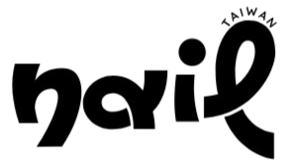

Style Guide

Color Palette
Primary | Secondary | Accent 1 | Accent 2
#ffffff | #000000 | # 19150f | # 93908b

Typography

Heading Font: [DM Serif Display]

Paragraph Font: [Raleway]

Navigation
Home Gallery Nail Talk

Content

Home
- Big title: NailArt Studio
- Short slogan
- About me
- Artworks

Gallery
- photo
Quiz
- How to care for your nails (e.g., daily maintenance steps)
- Nail polish application tips
- Pre- and post-manicure care advice

Wireframes

Home
