NailArt Studio

Elysian Lin

WDD 130

Overview

Purpose

The purpose of this website is to introduce and share creative nail art ideas, styles, and care tips.

It aims to show visitors how nail design can express personality and beauty, while also teaching simple nail care techniques that anyone can try at home.

The site also serves as a portfolio-style showcase for different nail art looks and inspiration.

Audience
- Individuals interested in nail design, fashion, or beauty
- People who want to learn simple nail care routines
- Visitors looking for inspiration or new nail ideas
- Potential clients or followers who enjoy stylish, aesthetic websites

Branding

Website Logo


Style Guide

Color Palette
Primary | Secondary | Accent 1 | Accent 2
#ffffff | #000000 | # 19150f | # 93908b
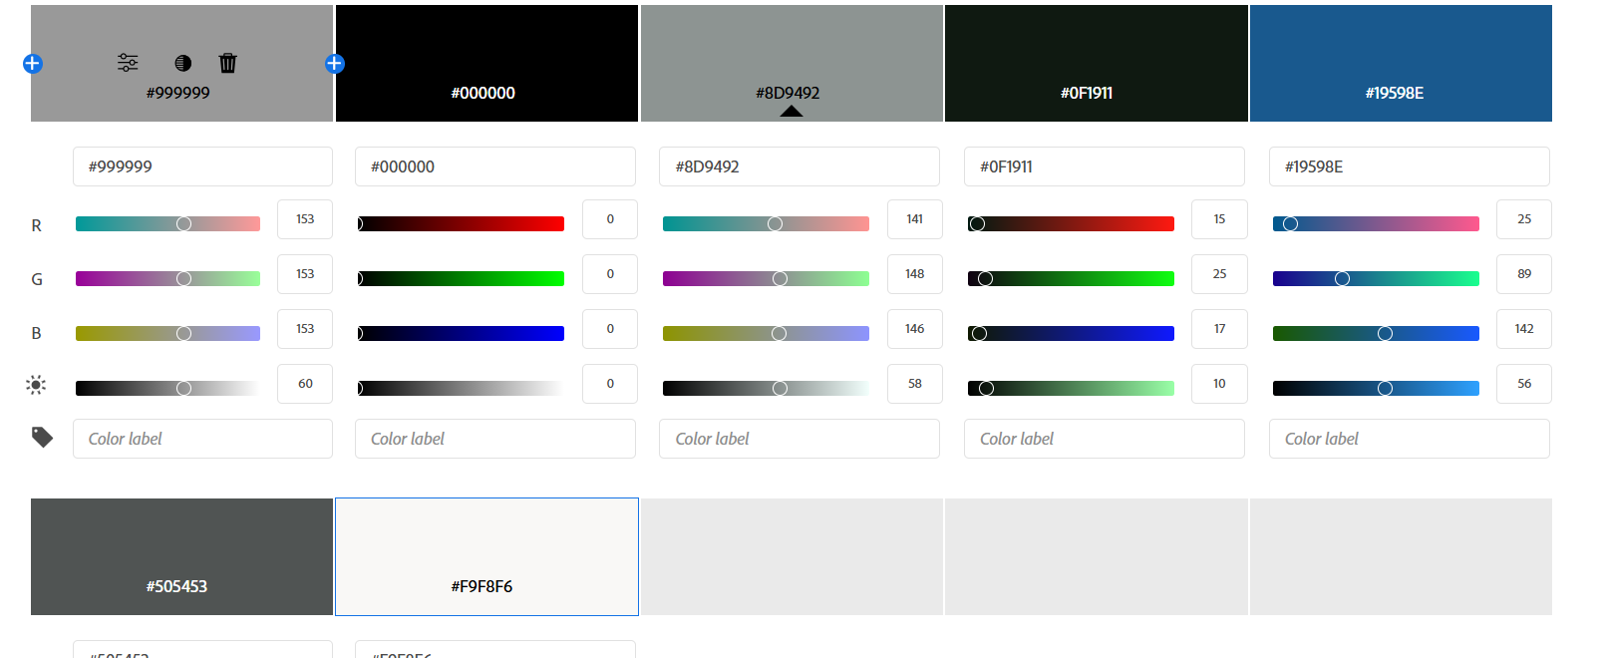

Typography

Heading Font: DM Serif Display

https://fonts.google.com/specimen/DM+Serif+Display?query=DM

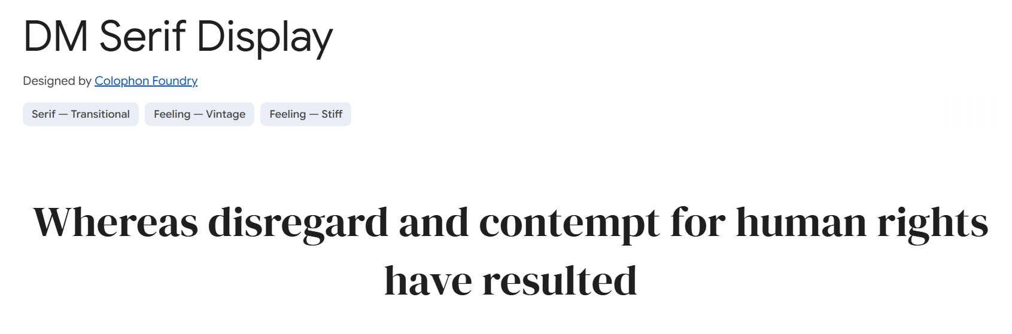

Paragraph Font: Raleway

https://fonts.google.com/specimen/Raleway?query=%22Raleway



Navigation
Home Gallery Nail Talk

Content

Home
- Big title: NailArt Studio
NailArt Studio
Turning fingertips into tiny masterpieces, one stroke at a time.
View All Artworks →
- About me
I'm from Taiwan.
Student at BYUI
Major: Biochemistry
Minor: Web Development
I love doing nail art. It’s my favorite way to relax and get creative. I enjoy designing nails for myself and my sisters, turning simple ideas into fun and colorful designs.
- Artworks
View All Artworks →
Three pictures
Gallery
- Photo (grid)
Nail Talk
- Big title: Basic Tools & Uses
- Nail Preparation Tools
- Electric Nail Drill Kit
- Purpose: Improves efficiency; suitable for nail removal, cuticle care, and surface preparation.
- Notes: Use proper speed control and correct angle to avoid burning yourself.
- Nail Clippers for Acrylic Nails
- Purpose: Trim acrylic or artificial nails to the desired length quickly and cleanly.
- Notes: Cut slowly and evenly to avoid cracking the nail.
- Buffer Block
- Purpose: Smooth the nail surface, improve polish adhesion, and remove small scratches.
- Notes: Avoid over-buffing; it can thin and weaken the natural nail.
- Steel Pusher
- Purpose: Push back dead skin and keratin around the nail edges and grooves.
- Notes: Beginners should use cuticle softener and push gently to avoid injuring the nail root.
- Cuticle Pusher & Nail Nipper
- Purpose: Remove dead skin around the nail for a cleaner surface and better gel adhesion.
- Notes: Disinfect tools before and after each use to prevent infection.
- Cuticle Oil
- Purpose: Moisturizes and nourishes the cuticles, keeping nails flexible and healthy.
- Notes: Apply after finishing your manicure for a natural shine and hydration boost.
- Functional Gel
- Base Coat
- Purpose: Protects the natural nail and improves adhesion of the color gel.
- Notes: Apply a thin, even layer. Avoid getting gel on the skin or cuticle area.
- Builder Gel
- Purpose: Strengthens the nail surface and helps extend nail length if needed.
- Notes: Control the thickness and avoid over-curing under the UV lamp.
- Top Coat
- Purpose: Seals the color, adds shine, and protects the nail surface from scratches.
- Notes: Avoid water or lotion for 30 minutes after curing for the best result.
- Nail Curing Lamps
- Handheld UV/LED Nail Lamp
- Purpose: Portable and convenient for curing small areas such as one finger or nail art details.7
- Notes: Hold about 1–2 inches away from the nail surface; ideal for quick touch-ups or travel use.
- Builder Gel
- Purpose: Designed for curing the whole hand or both hands at once with strong and even UV/LED light.
- Notes: Make sure all nails are evenly exposed to the light. Avoid looking directly at the LEDs during curing.

Wireframes

Home
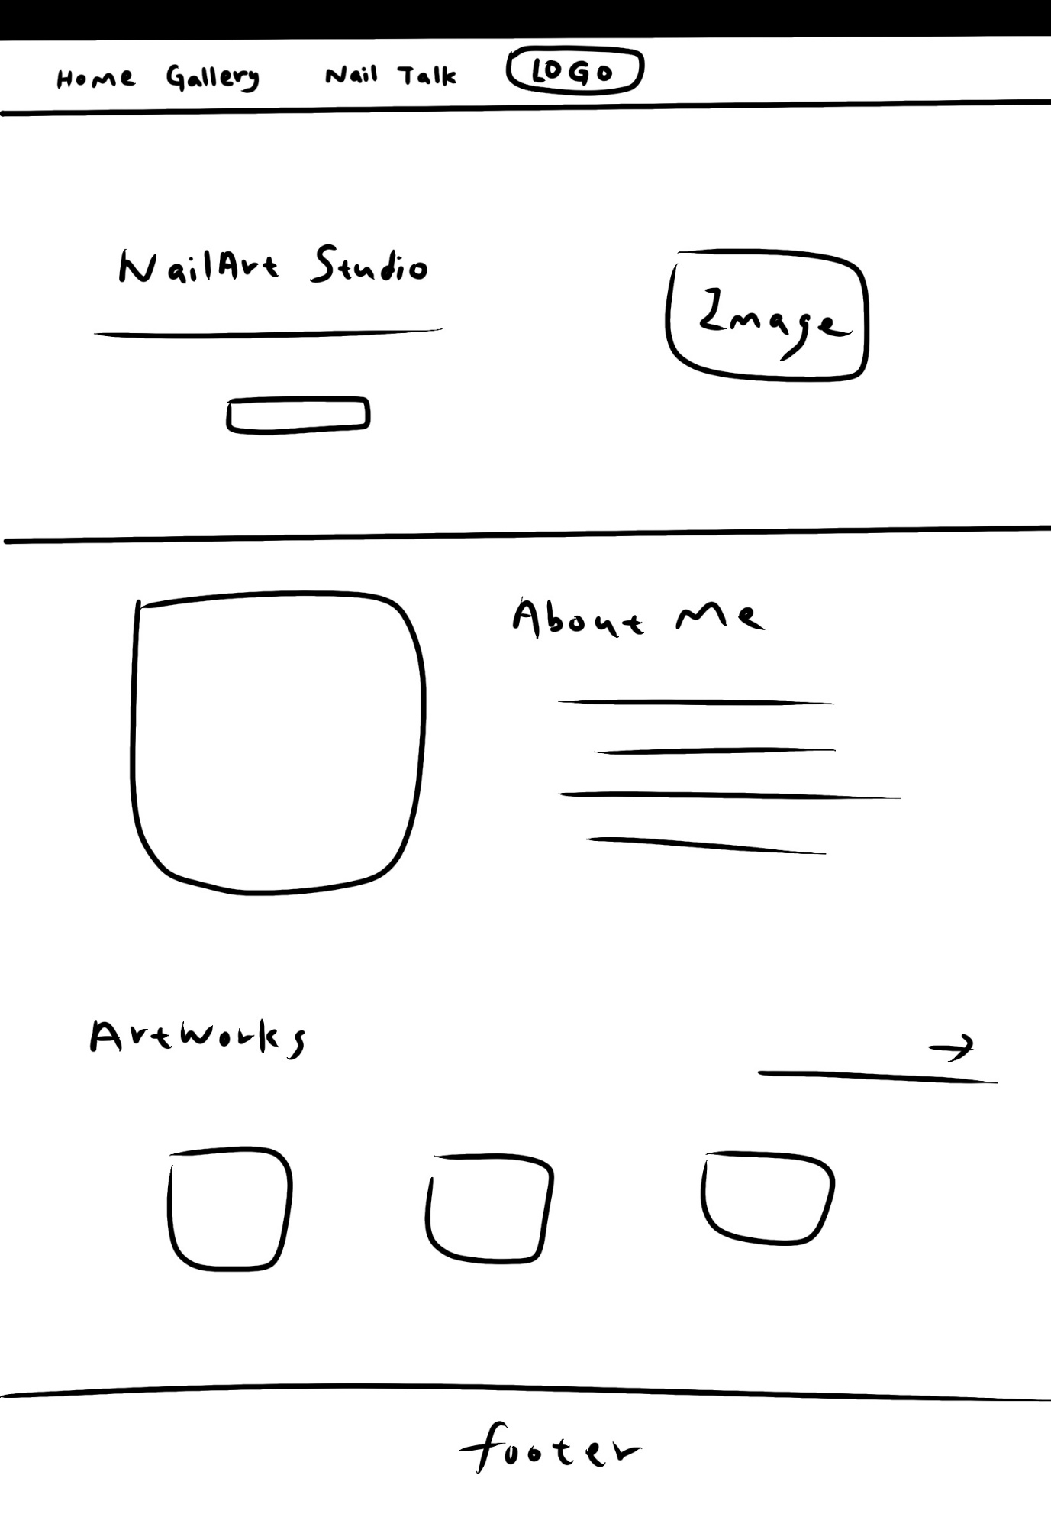
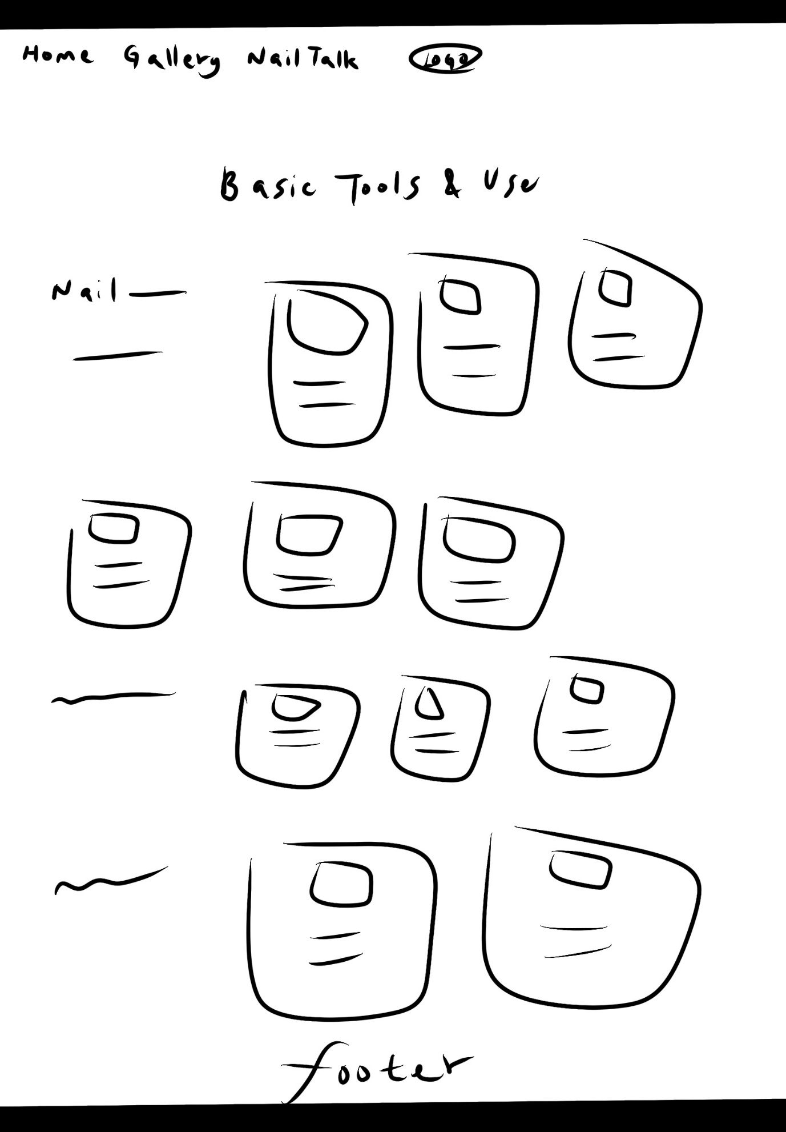
Footer
