**5006CEM**

**People and Computing**

**Legal / Ethical Issues Report**

List of Figures

Figure 1 Accuracy of Face Recognition Technologies​ 5

Table of Contents

List of Figures 2

1 Image Recognition 4

2 Face Recognition in Law Inforcement 5

3 Predictive Policing 6

4 References 7

1. Image Recognition

Image recognition software uses artificial intelligence to recognise what is in images or videos based on a large amount of training data – millions of images already identified by humans (Wachter-Boettcher, 2017, p. 118). Image recognition is used for various purposes, for example, to categorise images, to secure personal devices by face ID, to guide self-driving cars and so on.

Image recognition software is known to have issues with identifying dark-skinned people. In her book, Technically Wrong, Sara Wachter-Boettcher (2017, p. 116) tells the story of Jacky Alciné, whose images were labelled as 'gorillas' by Google Photos' auto-tagging feature. The same error repeats over time. In 2015, Flickr tagged an image of a black man as 'ape' (Wachter-Boettcher, 2017, p. 122). A video of black men posted in 2020 on Facebook was labelled as 'primates' (Mac, 2021).

AI systems are not infallible, and minor errors could be understandable. However, some errors can have fatal consequences, for example, if autonomous vehicles fail to recognize dark-skinned people or confuse a wheelchair user with a shopping trolley (Byrne-Haber, 2019). The reliability of image recognition strongly depends on the training data. Therefore, the training data needs to equally represent people of all human races and all skin colours as well as people with facial disorders and physical disabilities. The correct functionality of the software needs to be tested on people of all human races, skin colours, people with facial disorders and physical disabilities, and no software can launch without passing these tests.

1. Face Recognition in Law Inforcement

Face recognition is used to help to identify people who committed a crime. Face recognition has achieved high accuracy, however, this varies across different demographic groups, as shown in the graph below. The results of face recognition are almost 100 % accurate for men with light skin. For dark-skinned women, the accuracy decreases by about 30 %.

Figure 1

Accuracy of Face Recognition Technologies

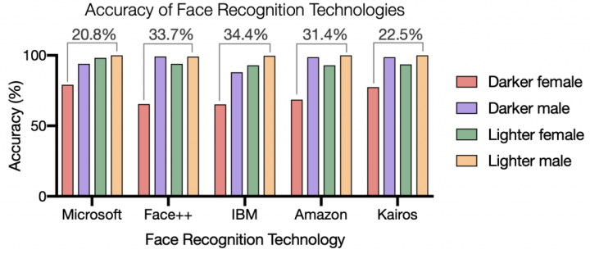

Note. From *Racial Discrimination in Face Recognition Technology*, by A. Najibi, 2020, SITN. (<https://sitn.hms.harvard.edu/flash/2020/racial-discrimination-in-face-recognition-technology/>).

In 2019, Nijeer Parks spent 11 days in jail based on a facial recognition match even though he was innocent (General & Sarlin, 2021). In 2020, Robert Julian-Borchak Williams was arrested and spent a night in jail because he was mistakenly identified as a shoplifter by a facial recognition algorithm (Hill, 2021). Both Parks and Williams are black.

Lower accuracy for dark-skinned people needs to be taken into consideration when face recognition is used to arrest suspects. Face recognition outputs must be carefully checked, especially if the quality of the images is low. A person cannot be arrested without knowing this is done based on facial recognition technology, like in Parks's case. Also, they must be shown the images according to which they were identified as offenders.

1. Predictive Policing

Predictive policing tools use artificial intelligence to predict a defendant's chances of re-offending. This is based on a person's criminal history, education, social environment and so on. (Northpointe, 2015, p. i). These are compared with historical data of other criminals, and a score indicating the risk of recidivism is given. Historical data may date back to times when police discriminated against certain communities, and algorithms trained upon them will be biased (Rolland, 2021).

Since the length of the convict's sentence can be affected by the outcome of predictive policing algorithms, they cannot rely on incomplete or biased data. Predictive policing tools need to be tested thoroughly, and they cannot be used if any indication of discrimination is shown.

The predictive policing tool COMPAS, Correctional Offender Management Profiling for Alternative Sanctions, is widely used by police departments in the USA even though it is known to be biased against black people (Angwin et al., 2016). Bernard Parker and Dylan Fugett were both arrested for drug possession, they both had very similar criminal profiles, but Parker, who is black, was flagged as high-risk by COMPAS and Fugett, who is white, was flagged as low-risk (Wachter-Boettcher, 2017, p. 108). Unlike Fugett, Parker has not been arrested ever since (Wachter-Boettcher, 2017, p. 109).

1. References

Angwin, J., Larson, J., Mattu, S., & Kirchner, L. (2016, May 23). *Machine Bias*. ProPublica. <https://www.propublica.org/article/machine-bias-risk-assessments-in-criminal-sentencing>

Byrne-Haber, S. (2019, July 11). *Disability and AI Bias*. Medium. <https://sheribyrnehaber.medium.com/disability-and-ai-bias-cced271bd533>

General, J., & Sarlin, J. (2021, April 29). A false facial recognition match sent this innocent Black man to jail. CNN. <https://edition.cnn.com/2021/04/29/tech/nijeer-parks-facial-recognition-police-arrest/index.html>

Hill, K. (2021, August 3). *Wrongfully Accused by an Algorithm*. The New York Times. <https://www.nytimes.com/2020/06/24/technology/facial-recognition-arrest.html>

Mac, R. (2021, October 4). *Facebook Apologizes After A.I. Puts ‘Primates’ Label on Video of Black Men*. The New York Times. <https://www.nytimes.com/2021/09/03/technology/facebook-ai-race-primates.html>

Najibi, A. (2020, October 24). *Racial Discrimination in Face Recognition Technology*. SITN. <https://sitn.hms.harvard.edu/flash/2020/racial-discrimination-in-face-recognition-technology/>

Northpointe. (2015, March 19). *Practitioner’s Guide to COMPAS Core*. <https://s3.documentcloud.org/documents/2840784/Practitioner-s-Guide-to-COMPAS-Core.pdf>

Rolland, A. (2021, July 23). *ETHICS, ARTIFICIAL INTELLIGENCE AND PREDICTIVE POLICING*. Security Distillery. <https://thesecuritydistillery.org/all-articles/ethics-artificial-intelligence-and-predictive-policing>

Wachter-Boettcher, S. (2017). *Technically Wrong: Sexist Apps, Biased Algorithms, and Other Threats of Toxic Tech*. W. W. Norton & Company.