|  |
| --- |
|  |
| Usability Lab Website for Department of Information Science of UNT |
|  |
|  |

**INFO 5745: Information Architecture**

March 1, 2020

Randall Crane, Jared Palmer, Addison Steelman, Mary Suttle

Contents

Project Plan 3

Communication Plan: 3

Meeting schedule: 3

Division of Labor: 3

Context and Background 4

Organization 4

Stakeholders 4

Technology Assessment 5

Research 6

Benchmarking and Lessons Learned 6

Usability Laboratory 6

Observations 7

Benchmarking Evaluation Results 7

What Works & Takeaways: 8

What Doesn’t Work & Takeaways: 8

Content Analysis and Metadata 9

Content Analysis 9

Format 9

Source 9

Subject 9

Existing Architecture: 9

Organization: 9

Labeling: 9

Metadata: 10

Understanding Users 11

Personas and Use Cases 11

Card Sorting 12

Blueprints 16

Wireframes 17

Content Mapping and Inventory 19

Controlled Vocabulary 22

# Project Plan

## Communication Plan:

Communication is accomplished via Canvas group site.  Online meetings are held using Big Blue Button and Microsoft Teams.

## Meeting schedule:

* Saturday, February 22,7:00 PM
* Monday, March 9, 7:00 PM
* Monday, March 23, 7:00 PM
* Monday, April 6, 7:00 PM
* Monday, April 20, 7:00 PM
* Monday, May 4, 7:00 PM

## Division of Labor:

|  |  |  |
| --- | --- | --- |
| Randall Crane | 1 | * Plan the term Your project plan * Wireframes |
| Jared Palmer | 2 | * Define the context and background * Blueprints |
| Addison Steelman | 3 | * Understand the content * Controlled vocabulary |
| Mary Suttle | 4 | * Understand the users of your project * Content mapping and inventory |

# Context and Background

## Organization

The University of North Texas is a public research university founded in 1890 that is located just north of the DFW metroplex in Denton, Texas. As one of the nation’s largest universities, the University of North Texas offers over 100 bachelor’s degree programs on top of the 80+ master’s and 30+ doctoral degree programs. The mission of the University of North Texas is the create a caring and creative community that will prepare students for careers in a rapidly changing world. Through this mission, the University of North Texas believes that their students will become the innovative leaders of tomorrow and the University will become globally known for collaborative and imaginative educative innovation and scholarly activity.

The University of North Texas has a main campus that is in Denton, Texas, which is about 36 miles north of the DFW metroplex. In addition to this main campus, the University of North Texas system also includes additional satellite campuses in Dallas, Fort Worth, and Frisco, Texas. The university is ranked among the United States’ top 131 tier one research universities according to the 2018 Carnegie Classification of Institutions of Higher Education. This designation as a tier one research university is earned through UNT’s strong dedication to research across multiple disciplines from arts to sciences and everything in between.

One of the main goals of the University of North Texas’ five-year strategic plan is to support, communicate, and celebrate a dedicated culture of scholarly activity to expand the universities innovative impact on the student population and community. The way that UNT plans on meeting this goal is through the expansion of resources to facilitate innovation at the university. With this strategy and goal in mind, the university is planning on creating a Usability Lab Website for the Department of Information Science that will serve the university as a hub for research in the field of Information Science and more specifically User Experience and Usability.

With the creation of the University of North Texas’ own Usability Lab Website, the tier one research university will further broaden its footprint through the expansion of its breadth of research. The new Usability Lab website will connect users to information and research pertaining to Human-Computer Interaction, Usability, and User Experience. This research will benefit a wide variety of other fields such as journalism, healthcare, education, business, and computer science. The creation of the Usability Lab Website is a natural progression in the University of North Texas’ mission to expand their research and maintain their ranking as one of the top research universities in the United States.

## Stakeholders

The University of North Texas is a public state university that is funded in part by governmental grants and through private donations. Since the university is not privately owned, the university is free to make decisions based on what is best for the future expansion and growth of the university instead of based on profit. The major stakeholders in the university, and in this project, include the State of Texas, UNT’s Board of Regents, and the current students and faculty within the Information Science department. Other stakeholders include private donors, current students, faculty, alumni, citizens of Denton, beneficiaries of the university’s research, and future UNT students.

## Technology Assessment

The website that will be created during this project will be designed using Drupal and hosted locally on the University of North Texas’ domain. The design of this website will be completed asynchronously between multiple students on their personal computers. The students will be meeting using Canvas’ Conference feature and communicating both synchronously and asynchronously throughout the length of the project.

# Research

## Benchmarking and Lessons Learned

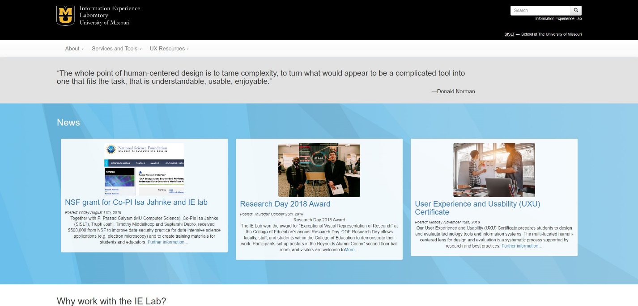<http://ielab.missouri.edu/>

The Information Experience Laboratory website focuses on providing users with information regarding their IE labs. In addition, it also provides users with relatively up-to-date news and client stories regarding their services. It seems to be a sub-section of the University of Michigan’s main website. The information on this website is organized through a hierarchical approach, and has the main topics listed at the top of the page. These can be tagged as “About,” “Services and Tools,” or “UX Resources.”

Observations:

* A good mixture of textual and iconic labeling should be used throughout the site.
* Labels and correct sizing of textual information for hyperlinks should be used for easy navigation.
* The navigation header is used concisely throughout the website, which is a plus for easy usability.
* The color scheme of the website is a bit bland, but considering this is a university website the colors do not need to be flashy either, as this would cause distraction.
* The news section is in ordered through chronological schemes, based upon the most recent date of posting.

## Usability Laboratory

<https://internal.simmons.edu/students/technology/cocis-tech>

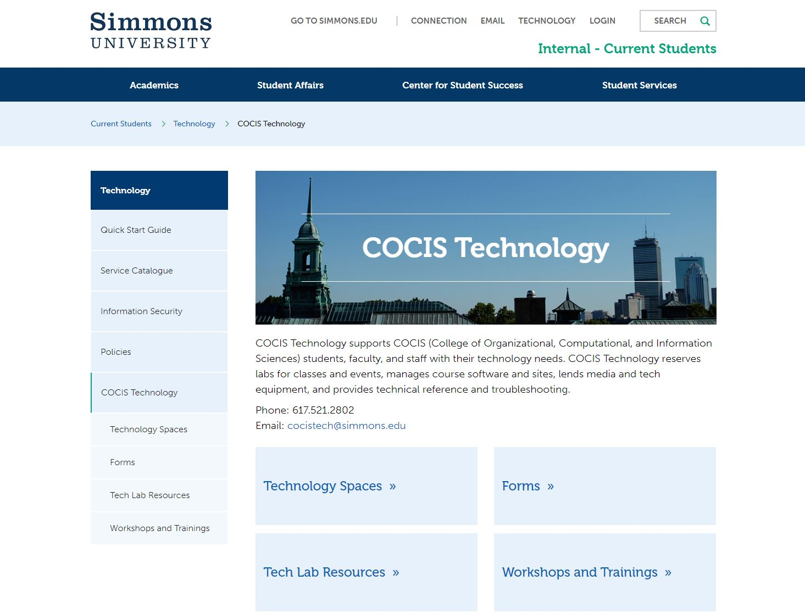

The Usability Laboratory website at Simmons University focuses on providing information regarding COCIS technology for things regarding technology lab spaces to workshops and trainings. The COCIS Technology site is embedded within the Technology tab, which is embedded in the Current students tab. The global navigations seems to split into two separate sections, one for the main topics such as “Academics” or “Student Affairs” and a smaller subsection that involves the current page a user is looking at. There is also local navigation on the side which gives users information regarding what’s nearby. The navigation positioning seems to be a strength of this website.

Observations

* Good use and a mix of global, local, and contextual navigation systems should be used.
* There is supplemental navigation at the top of the page, making it easy for users to search for specifics.
* The labeling systems are clear and logical, mixing a good use of textual and iconic labeling.

## Observations

* Good use and a mix of global, local, and contextual navigation systems should be used.
* There is supplemental navigation at the top of the page, making it easy for users to search for specifics.
* The labeling systems are clear and logical, mixing a good use of textual and iconic labeling.

## Benchmarking Evaluation Results

Based upon the strengths and weaknesses of both of these websites, the following conclusions are described below.

## What Works & Takeaways:

* The mix of iconic and textual labeling provides easy user viewing.
* A search bar provides for efficient and timely supplemental navigation throughout the site.
* The proper sizing of hyperlinks such as emails or other websites emphasizes the importance of certain sections and links on the site.
* Consistent navigation headers help for easy usability.
* Any graphics that should be used should be interesting and eye-catching.
* Design represents the companies values and overall theme.

## What Doesn’t Work & Takeaways:

* Providing too much textual information can overwhelm the user, thus they will not read any of it. There needs to be a good mix between both.
* Having too bland of a color scheme makes the website seem dull, outdated, and boring. Simmons University used a good mix of blues, while the University of Missouri used a mixture of greys that almost dated the website entirely.

# Content Analysis and Metadata

## Content Analysis

The Usability Lab Website for the Department of Information Science at UNT is designed to provide information regarding teaching, research activities and events involving UX courses and its curricula. The following section provides information regarding overall content analysis and metadata.

## Format

A lot of the information is provided through textual labeling that is clickable through either general hyperlinks or in the global and local navigation systems. Much of the information provided is in the form of text presented as a webpage.

## Source

The sources will be from anyone involved with information regarding Usability Labs and functions. Sources may also include third-party contents or vendors.

## Subject

Website: Home page; Quick Start Guide; About Us; Latest News; Services and Tools; Directory; Alumni; Technology Spaces; Resources & Forms

## Existing Architecture:

The Usability Lab Website for the Information Science department at UNT will be designed based on the existing architecture of information gathered from the University of Missouri’s website (<http://ielab.missouri.edu/>) and Simmons University website (<https://internal.simmons.edu/students/technology/cocis-tech>)

## Organization:

The analysis of the other University websites reveals that the use of organized global, local, and contextual navigation is appropriate for easy usability to find information. Having a hierarchical structure will help the users quickly learn the site, which ultimately avoids user frustration and a “click-out” of the site altogether. In terms of quick navigation, a search bar at the top of the page will help to also shorten the time it takes for a user to find specific information.

## Labeling:

Using a mixture of both textual and iconic labeling will help to provide a nice clean and modern look that reflects UNT’s core values. In addition, having clear and concise labeling will avoid user confusion. Keeping information free of textual jargon and using clear language will also help. Keeping the labels consistent with the rest of the color scheme of the site will be beneficial as well. It should also be noted not too use to many labels as this might overwhelm the user. The labels should ultimately be concise and straight to the point.

1). Home

2). Quick Start Guide

3). About Us

4). Latest News

5). Services and Tools

6). Directory

7). Alumni

8). Technology Spaces

9). Resources and Forms.

## Metadata:

The specific metadata associated with this webpage will be explored. Having a search bar that can predict relevant keywords would be beneficial for the user’s ease of search. Using controlled vocabulary will help to further organize the information regarding the usability website at UNT. The Dublin Core standard would helpful, as this is the standard used by many universities and libraries still to this day. Ultimately, the metadata needs to adequately describe the content, be concise, and be embedded within the HTML so that the index terms are invisible to the user.

The HTML codes of the two competitor sites were also examined. Both websites used “meta charsets of UTF-8”. The main webpages of both websites were examined and their respective HTML codes. The process was examined by using the function of “view page source” in the browser of Google Chrome.

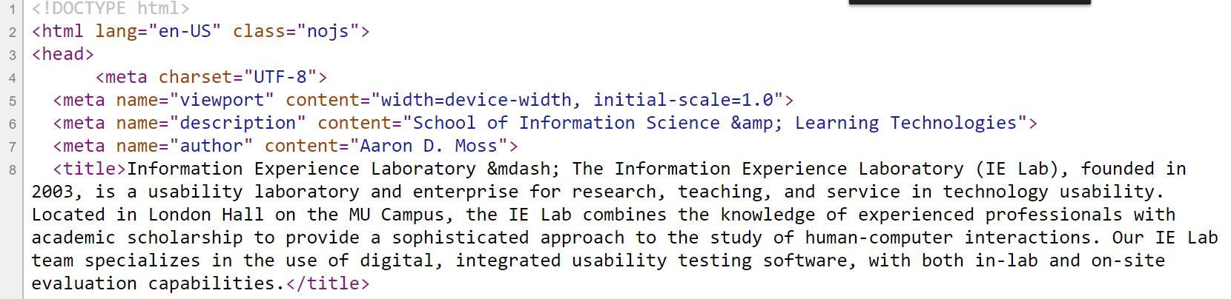**Screenshot of The Information Experience Laboratory HTML codes:**

**Screenshot of Usability Laboratory HTML codes:**

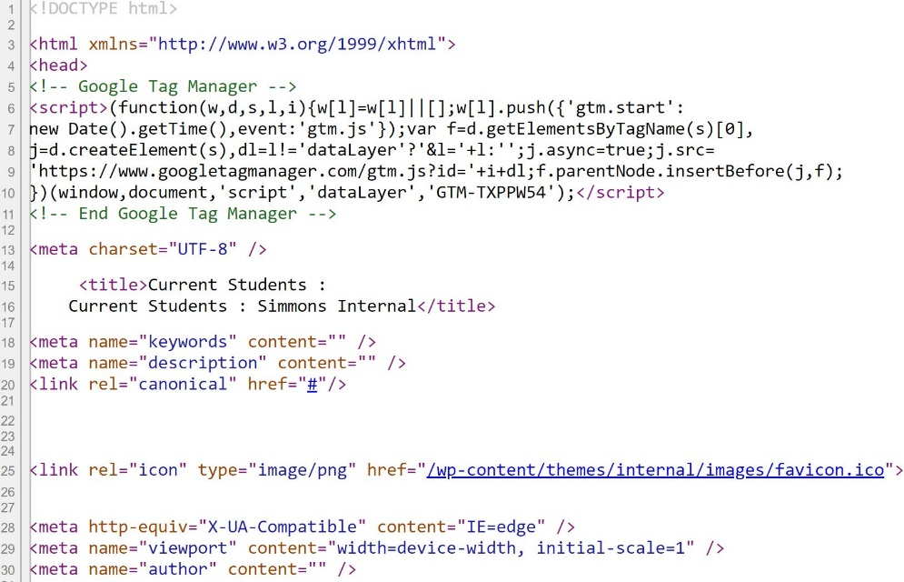

## Understanding Users

Understanding the users of our website is paramount to a successful information architecture. We will use personas, user cases and card sorting as research methods to better understand our user’s behavior as it relates to user centered design. A group of research participants were chosen that are heterogeneous to represent many different types of users that may access the system. Primary, Secondary and Supplementary personas were developed to aid in the design of the system. These participants will provide vital feedback for our study. This was done to ensure that a multitude of users would have input ensuring diversity of user experience and design. All users have information needs, will likely perform various tasks on the website and display a diverse set of information seeking behaviors. The research techniques used will yield quantitative results and data analysis will be conducted to inform decisions regarding the design of the website.

## Personas and Use Cases

Primary Persona: Ben Haynes is thirty-five years old and a full time student at The University of Texas at San Antonio, he is pursuing a B.S. in Data Analytics. He currently works at Chase Bank as a mortgage officer where his main job duties include working with customers to assist in getting funds for home buying, processing forms and providing information to prospective customers. He is considered an expert in the online system with which he currently works at the bank and the company intranet. Ben uses a laptop for most of his schoolwork and most of the time for his job. He also uses his smartphone often for work and school. He is tech savvy and knows various computer programs for work and has taken business computer classes.

Frustrations: Ben gets frustrated if he is unable to find something quickly and conveniently on a website. If he has difficulty locating information it sometimes causes him to fall behind in his work which causes a delay in meeting deadlines.

Goals: He prefers to access a website that is well organized, has labels and drop down menus that allows intuitive information access. Ben would like to move up within Chase Bank as a Data Analyst and become increasingly proficient in data analytics methodologies and practices.

Secondary Persona: Alisha Woods is forty-five years old and has a M.S. in Filmmaking from University of Washington. She works for a film production company in Hollywood, California as a film researcher. She spends most of her days performing research for the film company to assist directors and producers in making decisions regarding upcoming films. She has performed research for film companies for one year. She is new to her job and has technical experience but is working to increase her technological knowledge and expertise. Alisha uses her desktop at work, her laptop at home and her smartphone for work and personal use. She is moderately tech savvy and has taken one introduction to computer class as an undergraduate student. She hopes to learn more about databases and information retrieval in her role as a researcher.

Frustrations: The need to read through many pages just to find one correct piece of information frustrates Alisha. If she doesn’t find the information she needs on the homepage, through a navigation bar with drop down menus she is likely to look elsewhere for information.

Goals: Alisha prefers websites that are easy to navigate and have information that is searchable through a homepage with labels and drop-down menus. She likes information that is well organized and prefers to work with websites that displays information in a concise manner.

Supplementary Persona: Patrece Johnson is fifty-five years old, she is a special education teacher and works with children ages eight through ten. She has a M.S. in Special Education from Texas A&M University and she graduated thirty years ago. She works with children who are visually impaired to teach them life skills to assist them in reaching their educational goals. She uses her computer once a day at work to make case notes for each student and to submit attendance records. She does not use a computer at home but does user her smartphone often. Patrece does not consider herself tech savvy but does know how to use the computer for work and to shop online. She plans to attend college to take a business computer class in the summer.

Frustrations: Patrece gets frustrated when the information on a website is not well organized and the information she needs most is not displayed on the navigation bar.

Goals: She wants to be more efficient and expedient in finding information. She also wants to increase her internet usage so that she can increase her research skills for work.

Universal Information Collected

The three personas listed as well as the user surveys conducted illustrate a need to find information quickly and conveniently. Although the users access websites and information in different ways there were some similarities noted. All uses discussed the need to access information for their jobs and when they have difficulty finding information, they are likely to fall behind in their work. They all stated they prefer information that is displayed intuitively and is neatly organized. They also shared a desire to have drop down menus and labels that are on the navigation bar to increase the speed with which they find information.

## Card Sorting

Card sorting is used as a tool to delineate the site structure from the perspective of each participant. Eleven participants were selected to complete the card sorting activity and ten participants completed it. OptimalSort is the software used for the exercise and each participant received a card sorting activity to complete, which entails dropping and dragging the correct terms into appropriate groups according to the user. For this project open sort will be used initially to allow users to create a design schema. A total of thirty cards are used and a high level of granularity, with no cross listing allowed. The data collected is analyzed using quantitative research methods through information received through OptimalSort. The information is used to determine the global and local navigation for the website. Due to the diversity of users and the responses received from card sorting, this will give an aggregate representation of users preferred design of the website

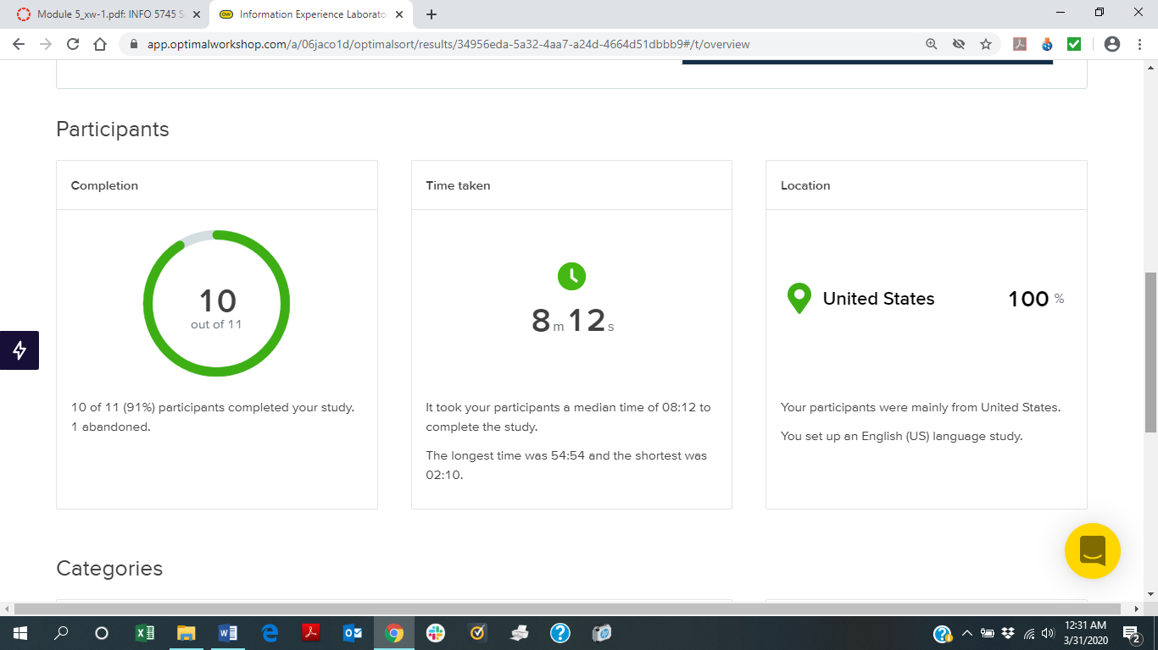

**OptimalSort Card’s with Description**

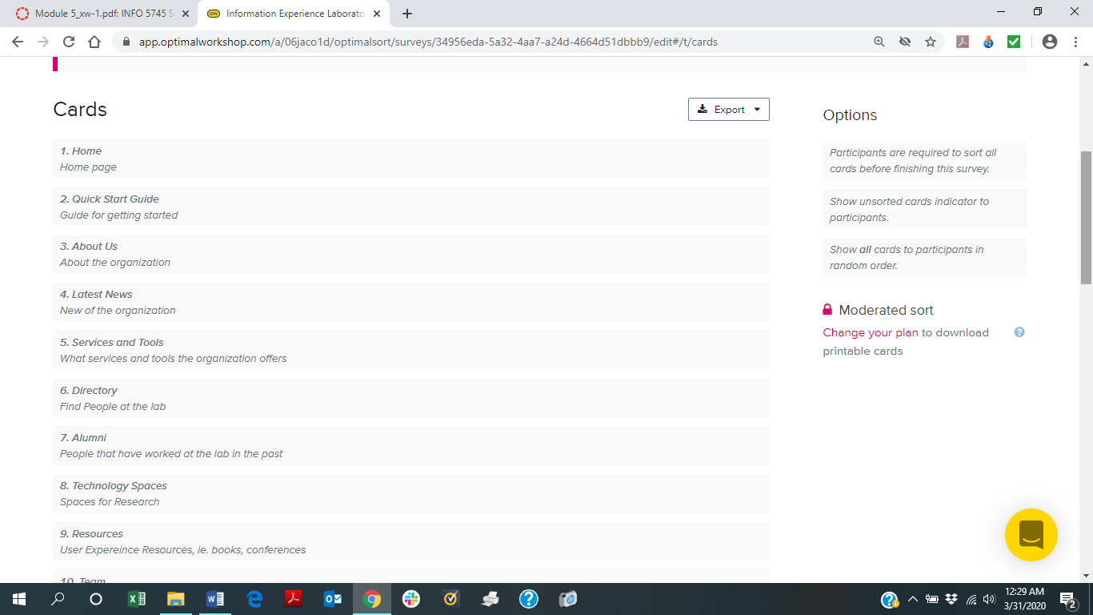

A description was included in the survey for clarification of its meaning.

**Card Sorting Open Type**

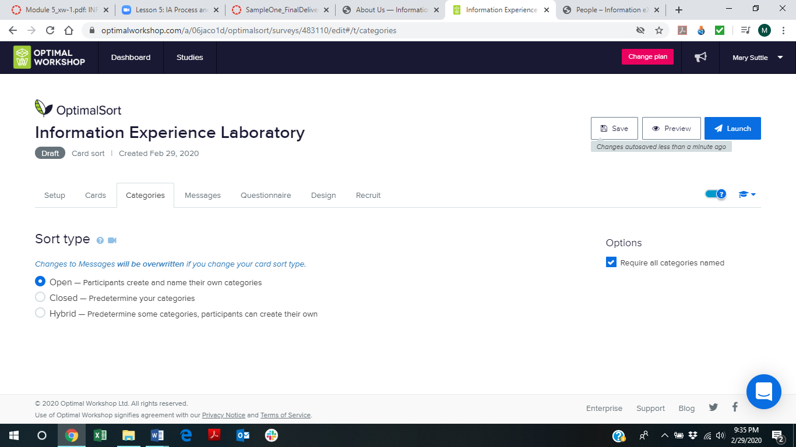

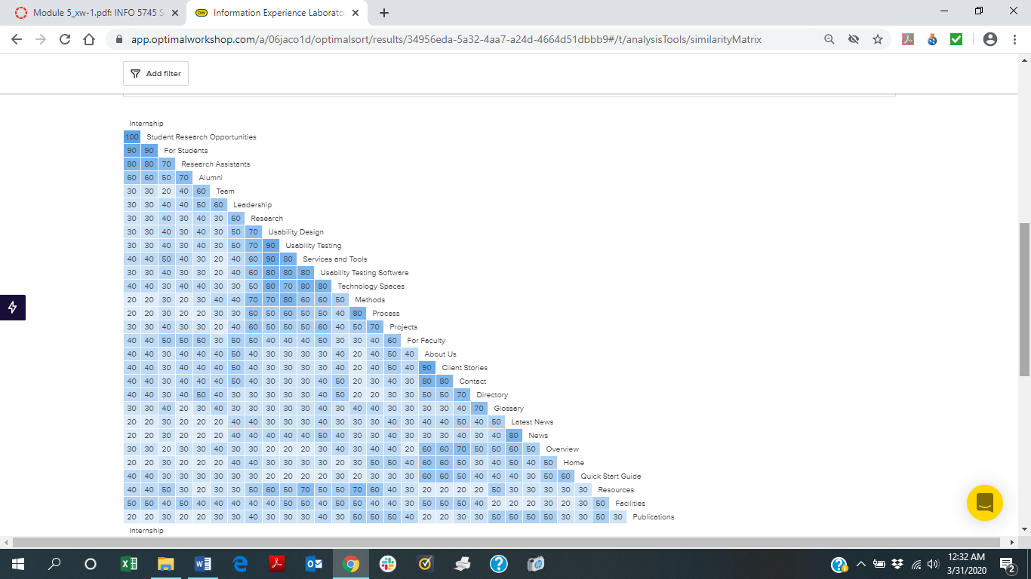

The similarity matrix shows the grouping of the categories and the percentage of agreement between card sorting participants. The similarity matrix was used to determining the grouping of labels from the perspective of the information student. It was a guide, as was all data, to determine the best labels and the following labels that were assigned to the global and secondary navigation.

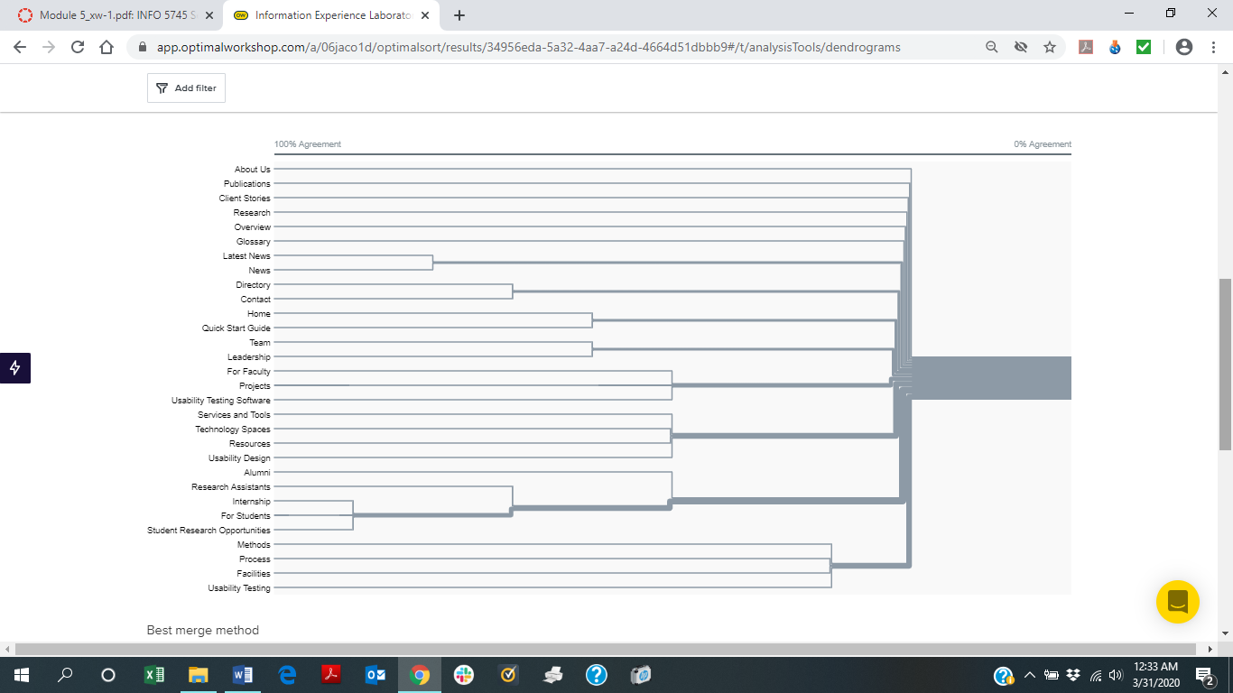

The dendogram shown above notes the level of agreement between users.

A low level of frequency was noted due to a few numbers of card being placed into the same categories by multiple users. There were five categories that were standardized and had agreements of greater than sixty percent. Two categories were created for Contact Us and were standardized with a sixty percent agreement rate. Two categories were created for faculty and were standardized with an agreement rate of sixty-three percent. Two categories were created for students and were standardized with an agreement rate of seventy-five percent. Two categories were created for publications and were standardized with an agreement rate of seventy-five percent. Three categories were created for news and were standardized with an agreement rate of eighty-three percent.

Based on the information submitted from participants and the discretion of the information student the following three tabs were chosen for the global navigation of the webpage. The similarity matrix, the dendogram and the categories that were a result of the participants card sorting results.

|  |
| --- |
| **About Us** |
| Home |
| Overview |
| Quickstart Guide |
| Directory |
| Contact |

|  |
| --- |
| **News** |
| Latest News |
| Client Stories |

|  |
| --- |
| **User Resources** |
| Technology Spaces |
| Services and Tools |
| Publications |
| Facilities |
| Glossary |

The following four labels with corresponding labels listed under the primary label were chosen based on the information submitted by the participants as well as the discretion of the information student for the secondary navigation.

|  |
| --- |
| **Research** |
| Usability Design |
| Usability Testing |
| Usability Testing Software |
| Methods |
| Process |

|  |
| --- |
| **For Students** |
| Student Research Opportunities |
| Internships |
| Research Assistants |

|  |
| --- |
| **Faculty** |
| For Faculty |
| Projects |

|  |
| --- |
| **Leadership** |
| Team |
| Alumni |

# Blueprints

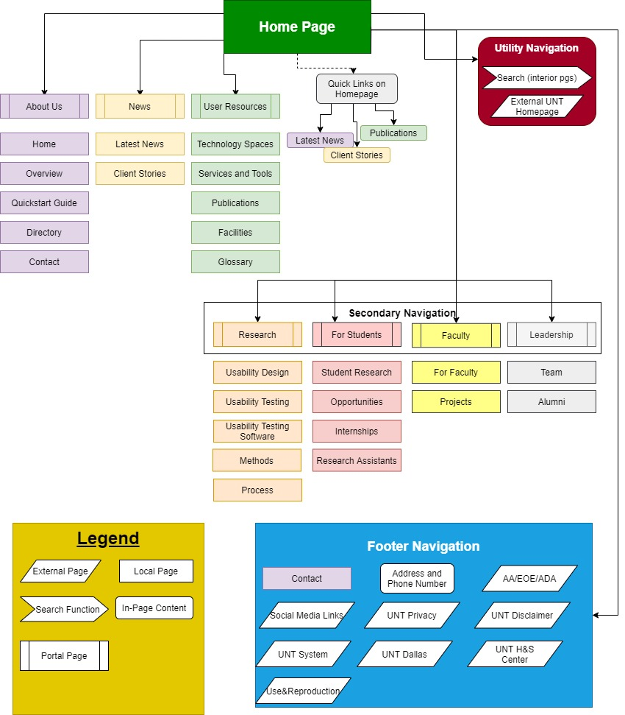

# Wireframes

Home Page

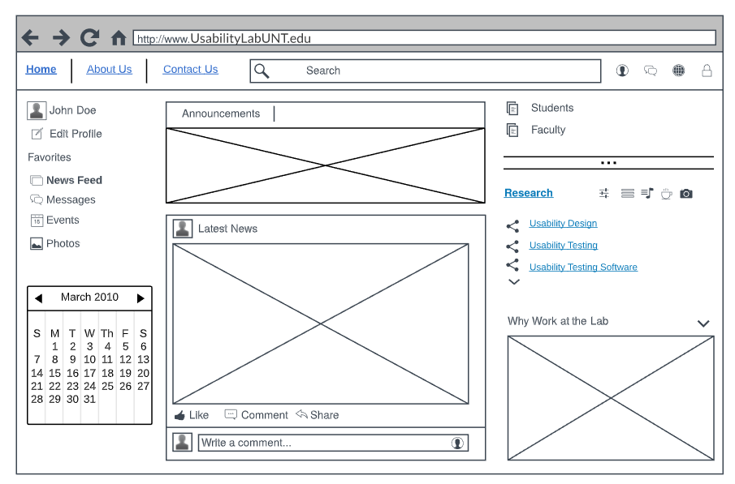

About Us Page

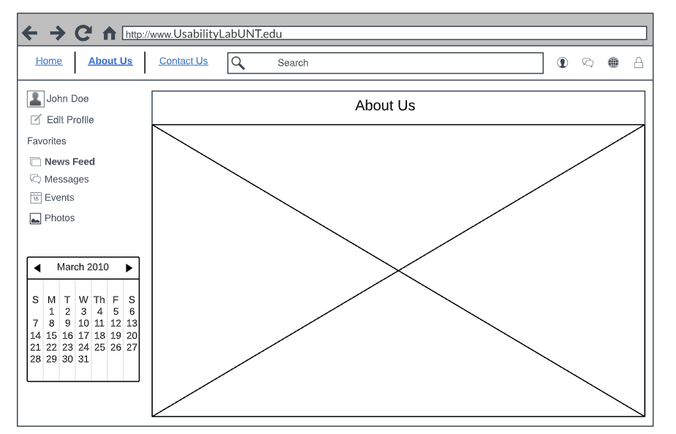

Contact Us Page

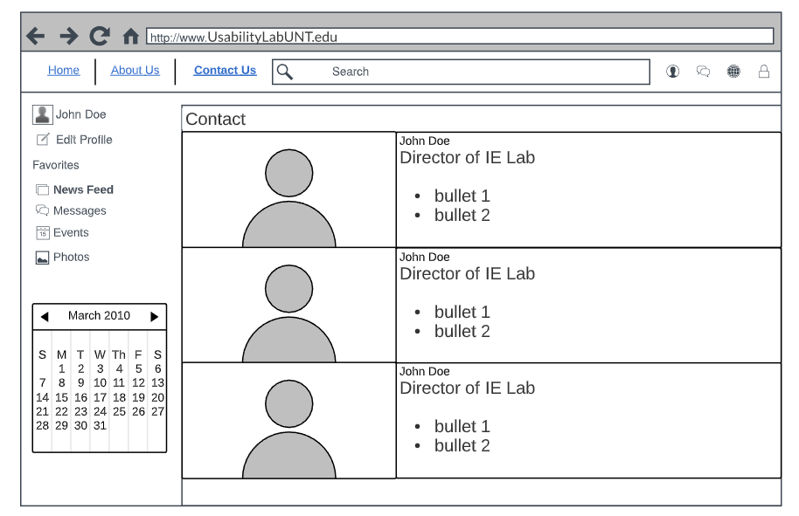

Mobile Device Home Screens

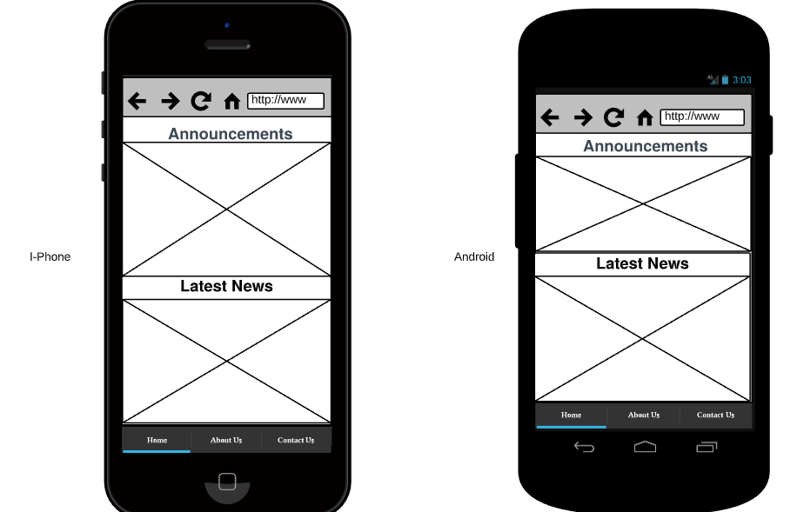

# Content Mapping and Inventory

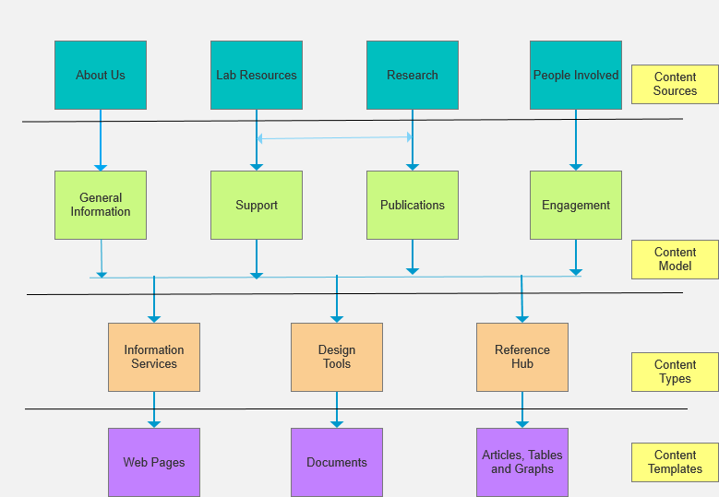

The content map is way to explore the high-level design of the website. It is necessary to consider the concepts covered to determine which groups of information are most crucial for the design and content of the site and to choose those that are related in terms of relationships.

The IE (Information Service) Laboratory’s purpose is to improve digital communication through research and development of websites. Through assessments and user data the lab provides information services to clients to improve user experience. Further, the lab provides research services conducted by the faculty, staff and students and produces publications and the latest news regarding information services and digital innovations.

The purpose of the Information Experience Website is to share information about the laboratory and its services. The site offers information regarding the research and opportunities available for those interested in participating for faculty, staff and students. There is also information regarding the technology spaces and types of software used. Further, there is information regarding usability testing and the research currently in progress and upcoming research opportunities. Additionally, information is included for past research and other resources.

I chose to focus on the relationships between categories and what each category represents for the user. Some concepts were combined and the functioning which is evidenced by the chart. The flow chat is designed with content sources, which leads to content models, then to content types and content templates.

The about us content source is a way for the user to learn about the IE Laboratory. Under about us the user can find an overview about the functions of the lab and ways in which services are offered. There is also a quick start guide, ways to contact the lab and a directory, which is all general information. The content type is information services which is a way of sharing information and this is done through web pages.

Two of the content sources are lab resources and research. There is a great deal of overlap between these two content sources which is why they relate to a line and arrows. The lab’s content model is support because that is what is offered at the lab and the research content model is publications because of the publications produced and information offered at the lab. The lab resources content types are design tools for creating research and serves as a reference hub for information and publications. Further, the research content type would be a design tool and reference hub. The content template for the lab resources are documents and articles, tables and graphs. The content templates for research are documents and articles, tables and graphs. These sources are from internally generated content, some are externally generated, and some are from other similar websites such as Google Scholar.

The people involved are a content source because of the importance of the faculty, staff and students involved with the lab. The content model would be engagement because the people working in the lab are responsible for getting others involved and for the functioning of the lab. The content type would be a reference hub because the people involved are available for reference information. The content template would be web pages because their information is listed on web pages they produce, and documents, articles, tables and graphs they have generated internally and externally.

**Content Inventory**

|  |  |  |
| --- | --- | --- |
| Page ID Number/Title | URL | Content |
| 1.0 About Us | http://site1-isvm2.unt.edu/aboutus | [Introduction Info; navigation](http://site1-isvm2.unt.edu/aboutus) |
| 1.1 Home |  |  |
| 1.2 Overview |  |  |
| 1.3 Quick Start Guide |  |  |
| 1.4 Directory |  |  |
| 1.5 Contact |  |  |
| 2.0 News | http://site1-isvm2.unt.edu/news | [Articles & Announcements](http://site1-isvm2.unt.edu/news) |
| 2.1 Latest News |  |  |
| 2.2 Client Stories |  |  |
| 3.0 User Resources |  |  |
| 3.1 Technology Spaces |  |  |
| 3.2 Services and Tools |  |  |
| 3.3 Publications |  |  |
| 3.4 Facilities |  |  |
| 3.5 Glossary |  |  |
| 4.0 Research |  |  |
| 4.1 Usability Design |  |  |
| 4.2 Usability Testing |  |  |
| 4.3 Usability Testing Software | |  |
| 4.4 Methods |  |  |
| 4.5 Process |  |  |
| [5.0 For Students](http://site1-isvm2.unt.edu/forstudents/studentresearch) | http://site1-isvm2.unt.edu/forstudents/ | [Search browse student info](http://site1-isvm2.unt.edu/forstudents/) |
| 5.1 Student Research | /studentresearch | [Testimonials about research](http://site1-isvm2.unt.edu/forstudents/) |
| 5.2 Opportunities |  |  |
| 5.3 Internships |  |  |
| 5.4 Research Assistants |  |  |
| 6.0 Faculty |  |  |
| 6.1 For Faculty |  |  |
| 6.2 Projects |  |  |
| 7.0 Leadership |  |  |
| 7.1 Team |  |  |
| 7.2 Alumni |  |  |
| 8.0 Legend |  |  |
| 8.1 External Page |  |  |
| 8.2 Local Page |  |  |
| 8.3 Search Function |  |  |
| 8.4 In-Page Content |  |  |
| 8.5 Portal Page |  |  |
| 9.0 Footer Navigation |  |  |
| 9.1 Contact |  |  |
| 9.2 Addy & Phone Num |  |  |
| 9.3 AA/EOE/ADA |  |  |
| 9.4 Social Media Links |  |  |
| 9.5 UNT Privacy |  |  |
| 9.6 UNT Disclaimer |  |  |
| 9.7 UNT System |  |  |
| 9.8 UNT Dallas |  |  |
| 9.9 UNT H&S Center |  |  |
| 9.10 Use & Reproduce. |  |  |

The content inventory is used to locate information within a website and to see what areas still need to be developed. We developed a page for About Us, this is a way to provide navigation to users and to provide introductory information about IE Lab. We chose to develop this page due to the need for users to have information about the lab and also because it is a great way to provide navigation for the website. We developed a page For Students to show the research experiences and information about student research. It is a way to get students engaged in the lab and it serves to search and browse student information. We also developed a News page and this information provides articles and announcements for upcoming events and information that is provided by the lab. It is a way to provide new developments for those interested in the lab.

# 

# Controlled Vocabulary

Results from the open card sort in the first deliverable show there are seven main categories including 1) About Us, 2) News, 3) User Resources, 4) Research, 5) For Students, 6) Faculty, and 7) Leadership. The purpose of the controlled vocabulary is to connect similar terms for clarity and consistency. A legend has been made below to show the relationships between narrow, broad, and related terms. The list of vocabulary terms shown will be used on the Usability Lab Website for the Department of Information Science at UNT. The ERIC thesaurus was referred to, as it includes educational resources that are closely similar to the UNT website. This was helpful in determining related and narrow terms for students and faculty, as this is a website designed to share information about the usability lab at UNT. Many students and faculty are involved with this website, which is why the educational resources were beneficial as they closely relate.

|  |
| --- |
| Legend: |
| USE = Use the preferred term |
| UF = Use For |
| NT = Narrow Term |
| BT = Broad Term |
| RT = Related Term |

Preferred terms are listed in **bold**

**Home**

RT About Us

NT Overview

RT QuickStart Guide

UF Contact

UF General Information

USE About

RT Homepage

**Directory**

UF Member Directory

NT Member Profiles

**News**

UF Latest News

UF Client Stories

RT Publications

RT Student Publications

**Information Science**

UF Usability Lab

UF UX Resources

RT Information Systems

NT Library Science

NT Computer Science

BT Sciences

USE Informatics

USE Information Industry

RT Information Management

**Technology Spaces**

RT Facilities

RT Facility Guidelines

NT Educational Facilities

NT Shared Facilities

NT Community Centers

NT Library Facilities

**User Resources**

RT Services and Tools

RT Technology Spaces

RT Publications

RT Facilities

RT Glossary

RT Student Records

RT Lab Resources

**Research**

UF Usability Design

UF Usability Testing

UF Usability Testing Software

NT Methods

NT Process

RT Research Tools

RT Evaluation Methods

RT Research Design

RT Research Skills

RT Student Research

RT Research and Development

RT Research Utilization

**For Students**

UF Student Research

BT Opportunities

UF Internships

UF Research Assistants

RT College Freshman

RT College Graduates

NT Two Year College Students

RT Undergraduate Study

RT Students

NT Part Time Students

NT Full Time Students

**Faculty**

USE Faculty and Staff

USE For Faculty

UF Projects

UF Staff Information

RT Our Faculty

RT Adjunct Faculty

NT College Presidents

NT Graduate School Faculty

NT Teaching Assistants

RT School Personnel

RT Teachers

RT Employees

USE Instructors

USE Educators

**Leadership**

UF Team

UF Alumni

RT Community Leaders

RT Leadership Training

NT Student Leadership

NT Teacher Leadership

RT Leaders Guides

**Legend**

RT External Page

RT Local Page

RT Search Function

RT In Page Content

RT Portal Page

**Footer Navigation**

BT Social Media

RT Social Networks

RT Web Sites

BT Privacy Policy

RT Educational Policy

BT Disclaimer

NT UNT Dallas

NT UNT H&S Center

RT Contac