Nama : Elyza Putri Rahayu
Kelas : TI – 1G
NIM : 254107020035
No Absen : 08

LAPORAN TUGAS PRAKTIKUM JOBSHEET 5
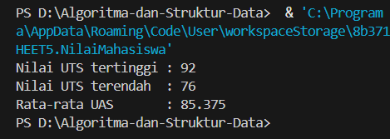
Kode Program :
package JOBSHEET5;

public class NilaiMahasiswa {

static int[] uts = {78, 85, 90, 76, 92, 88, 80, 82};
static int[] uas = {82, 88, 87, 79, 95, 85, 83, 84};

static int maxUTS(int[] arr, int left, int right) {
if (left == right) {
return arr[left];
}

int mid = (left + right) / 2;

int maxKiri = maxUTS(arr, left, mid);
int maxKanan = maxUTS(arr, mid + 1, right);

return Math.max(maxKiri, maxKanan);
}

static int minUTS(int[] arr, int left, int right) {
if (left == right) {
return arr[left];
}

int mid = (left + right) / 2;

int minKiri = minUTS(arr, left, mid);
int minKanan = minUTS(arr, mid + 1, right);

return Math.min(minKiri, minKanan);
}

static double rataUAS(int[] arr) {
int total = 0;

for (int i = 0; i < arr.length; i++) {
total += arr[i];
}

return (double) total / arr.length;
}

public static void main(String[] args) {

int max = maxUTS(uts, 0, uts.length - 1);
int min = minUTS(uts, 0, uts.length - 1);
double rata = rataUAS(uas);

System.out.println("Nilai UTS tertinggi : " + max);
System.out.println("Nilai UTS terendah : " + min);
System.out.println("Rata-rata UAS : " + rata);
}
}

