Nama : Elyza Putri Rahayu
Kelas : 1G
NIM : 254107020035
No Absen : 08

LAPORAN JOBSHEET 1 ( KONSEP DASAR PEMROGRAMAN )
2.1 Pemilihan
import java.util.Scanner;

public class PemilihanmenghitungnilaiakhirMHS {
public static void main(String[] args) {
Scanner sc = new Scanner(System.in);

double bobotNilaiTugas = 0.2;
double bobotNilaiKuis = 0.2;
double bobotNilaiUTS = 0.3;
double bobotNilaiUAS = 0.4;

System.out.println("Program menghitung Nilai Akhir");
System.out.println("================================");
System.out.print("Masukkan Nilai Tugas : ");
int NilaiTugas = sc.nextInt();
System.out.print("Masukkan Nilai Kuis : ");
int NilaiKuis = sc.nextInt();
System.out.print("Masukkan Nilai UTS : ");
int NilaiUTS = sc.nextInt();
System.out.print("Masukkan Nilai UAS : ");
int NilaiUAS = sc.nextInt();

System.out.println("=================================");
System.out.println("=================================");

if (NilaiTugas < 0 || NilaiTugas > 100 ||
NilaiKuis < 0 || NilaiKuis > 100 ||
NilaiUTS < 0 || NilaiUTS > 100 ||
NilaiUAS < 0 || NilaiUAS > 100) {

System.out.println("Nilai tidak valid");
} else {
double nilaiakhir = NilaiTugas*bobotNilaiTugas + NilaiKuis*bobotNilaiKuis + NilaiUTS*bobotNilaiUTS + NilaiUAS*bobotNilaiUAS;

String nilaiHuruf;
String keterangan;

if (nilaiakhir > 80 ) {
nilaiHuruf = "A";
} else if (nilaiakhir >= 73 ) {
nilaiHuruf = "B+";
} else if (nilaiakhir >= 65 ) {
nilaiHuruf = "B";
} else if (nilaiakhir >= 60 ) {
nilaiHuruf = "C+";
} else if (nilaiakhir >= 50 ) {
nilaiHuruf = "C";
} else if ( nilaiakhir >= 39 ) {
nilaiHuruf = "D";
} else {
nilaiHuruf = "E";
}

if (nilaiHuruf.equals("A") || nilaiHuruf.equals("B+") || nilaiHuruf.equals("B") || nilaiHuruf.equals("C+") || nilaiHuruf.equals("C")) { keterangan = "SELAMAT ANDA LULUS";
} else {
keterangan = "TIDAK LULUS";
}

System.out.println("nilai akhir : " + nilaiakhir);
System.out.println("nilai huruf : " + nilaiHuruf);

System.out.println("==================================");

System.out.println(keterangan);
}
}
}
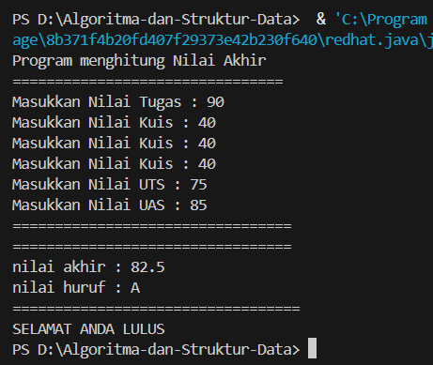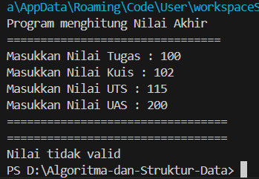
2.2 Perulangan
import java.util.Scanner;

public class Perulanganderetanbilangan {
public static void main(String[] args) {
Scanner sc = new Scanner(System.in);

System.out.print("Masukkan NIM : ");
String NIM = sc.nextLine();

int n = Integer.parseInt(NIM.substring(NIM.length() - 2));

if (n < 10) {
n += 10;
}

for (int i = 1; i <= n; i++) {

if (i == 10 || i == 15) {
continue;
}

if (i % 3 == 0) {
System.out.print("# ");
} else if (i % 2 == 0) {
System.out.print(i + " ");
} else {
System.out.print("* ");
}
}

sc.close();
}
}
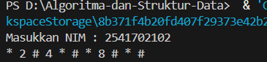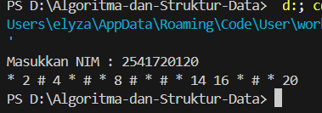

2.3 Array
import java.util.Scanner;

public class ArrayMenghitungIPSem {
public static void main(String[] args) {
Scanner sc = new Scanner(System.in);

System.out.println("==============================");
System.out.println("Program Menghitung IP Semester");
System.out.println("==============================");

System.out.print("Masukkan jumlah mata kuliah: ");
int n = sc.nextInt();
sc.nextLine();

String[] namaMK = new String[n];
int[] sks = new int[n];
String[] nilaiHuruf = new String[n];
double[] bobot = new double[n];

double totalNilai = 0;
int totalSKS = 0;

for (int i = 0; i < n; i++) {
System.out.println("\nMata Kuliah ke-" + (i + 1));

System.out.print("Nama Mata Kuliah : ");
namaMK[i] = sc.nextLine();

System.out.print("SKS : ");
sks[i] = sc.nextInt();
sc.nextLine();

System.out.print("Nilai Huruf : ");
nilaiHuruf[i] = sc.nextLine();

if (nilaiHuruf[i].equalsIgnoreCase("A")) {
bobot[i] = 4.0;
} else if (nilaiHuruf[i].equalsIgnoreCase("B+")) {
bobot[i] = 3.5;
} else if (nilaiHuruf[i].equalsIgnoreCase("B")) {
bobot[i] = 3.0;
} else if (nilaiHuruf[i].equalsIgnoreCase("C+")) {
bobot[i] = 2.5;
} else if (nilaiHuruf[i].equalsIgnoreCase("C")) {
bobot[i] = 2.0;
} else if (nilaiHuruf[i].equalsIgnoreCase("D")) {
bobot[i] = 1.0;
} else {
bobot[i] = 0.0;
}

totalNilai += bobot[i] * sks[i];
totalSKS += sks[i];
}

double ip = totalNilai / totalSKS;

System.out.println("\n==============================");
System.out.println("IP Semester : " + ip);

sc.close();
}
}
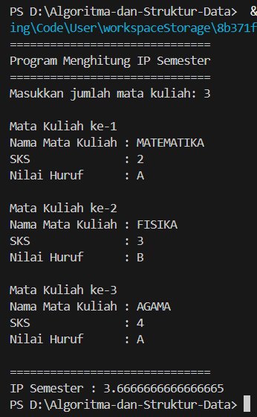
2.4 Fungsi
public class fungsiRoyalGarden {

static int[] harga = {75000, 50000, 60000, 10000};
// Urutan: Aglonema, Keladi, Alocasia, Mawar

public static int hitungPendapatan(int[] stokCabang) {
int totalPendapatan = 0;
for (int i = 0; i < stokCabang.length; i++) {
totalPendapatan += stokCabang[i] * harga[i];
}
return totalPendapatan;
}

public static String tentukanStatus(int pendapatan) {
if (pendapatan > 1500000) {
return "Sangat Baik";
} else {
return "Perlu Evaluasi";
}
}

public static void main(String[] args) {

int[][] stok = {
{10, 5, 15, 7},
{6, 11, 9, 12},
{2, 10, 10, 5},
{5, 7, 12, 9}
};

System.out.println("Pendapatan Setiap Cabang RoyalGarden");
System.out.println("===================================");

for (int i = 0; i < stok.length; i++) {
int pendapatan = hitungPendapatan(stok[i]);
String status = tentukanStatus(pendapatan);

System.out.println("RoyalGarden " + (i + 1));
System.out.println("Pendapatan : Rp " + pendapatan);
System.out.println("Status : " + status);
System.out.println("-----------------------------------");
}
}
}
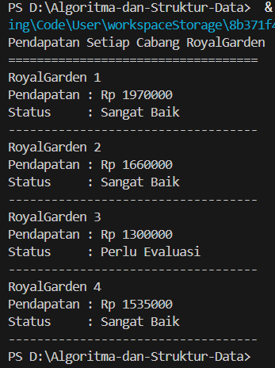
TUGAS
No 1
import java.util.Scanner;

public class Tugas1 {
public static void main(String[] args) {
Scanner sc = new Scanner(System.in);

char[] KODE = {'A','B','D','E','F','G','H','L','N','T'};

char[][] KOTA = {
{'B','A','N','D','U','N','G'},
{'J','A','K','A','R','T','A'},
{'B','A','N','D','U','N','G'},
{'C','I','R','E','B','O','N'},
{'B','O','G','O','R'},
{'P','E','K','A','L','O','N','G','A','N'},
{'S','E','M','A','R','A','N','G'},
{'S','U','R','A','B','A','Y','A'},
{'M','A','L','A','N','G'},
{'T','E','G','A','L'}
};

System.out.print("Masukkan kode plat nomor: ");
char inputKode = sc.next().charAt(0);

boolean ditemukan = false;

for (int i = 0; i < KODE.length; i++) {
if (inputKode == KODE[i]) {
System.out.print("Nama Kota: ");
for (int j = 0; j < KOTA[i].length; j++) {
System.out.print(KOTA[i][j]);
}
System.out.println();
ditemukan = true;
break;
}
}

if (!ditemukan) {
System.out.println("Kode plat tidak ditemukan");
}

sc.close();
}
}
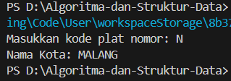

No 2
import java.util.Scanner;

public class Tugas2{
Scanner sc = new Scanner(System.in);

public static void inputJadwal(String[][] jadwal, int n, Scanner sc) {
for (int i = 0; i < n; i++) {
System.out.println("\nJadwal ke-" + (i + 1));

System.out.print("Nama Mata Kuliah : ");
jadwal[i][0] = sc.nextLine();

System.out.print("Ruang : ");
jadwal[i][1] = sc.nextLine();

System.out.print("Hari Kuliah : ");
jadwal[i][2] = sc.nextLine();

System.out.print("Jam Kuliah : ");
jadwal[i][3] = sc.nextLine();
}
}

public static void tampilkanSemuaJadwal(String[][] jadwal, int n) {
System.out.println("\nDAFTAR JADWAL KULIAH");
System.out.println("==============================================================");
System.out.printf("%-25s %-20s %-10s %-15s\n",
"Mata Kuliah", "Ruang", "Hari", "Jam");
System.out.println("==============================================================");

for (int i = 0; i < n; i++) {
System.out.printf("%-25s %-20s %-10s %-15s\n",
jadwal[i][0], jadwal[i][1], jadwal[i][2], jadwal[i][3]);
}
}

public static void tampilkanByHari(String[][] jadwal, int n, String hari) {
System.out.println("\nJadwal Hari " + hari);
boolean ditemukan = false;

for (int i = 0; i < n; i++) {
if (jadwal[i][2].equalsIgnoreCase(hari)) {
System.out.println(jadwal[i][0] + " | " +
jadwal[i][1] + " | " +
jadwal[i][3]);
ditemukan = true;
}
}

if (!ditemukan) {
System.out.println("Tidak ada jadwal pada hari tersebut.");
}
}

public static void tampilkanByMataKuliah(String[][] jadwal, int n, String mk) {
boolean ditemukan = false;

for (int i = 0; i < n; i++) {
if (jadwal[i][0].equalsIgnoreCase(mk)) {
System.out.println("\nDetail Jadwal Mata Kuliah");
System.out.println("Mata Kuliah : " + jadwal[i][0]);
System.out.println("Ruang : " + jadwal[i][1]);
System.out.println("Hari : " + jadwal[i][2]);
System.out.println("Jam : " + jadwal[i][3]);
ditemukan = true;
}
}

if (!ditemukan) {
System.out.println("Mata kuliah tidak ditemukan.");
}
}

public static void main(String[] args) {
Scanner sc = new Scanner(System.in);

System.out.print("Masukkan jumlah jadwal kuliah: ");
int n = sc.nextInt();
sc.nextLine();

String[][] jadwal = new String[n][4];

inputJadwal(jadwal, n, sc);

tampilkanSemuaJadwal(jadwal, n);

System.out.print("\nMasukkan hari yang ingin dicari: ");
String hari = sc.nextLine();
tampilkanByHari(jadwal, n, hari);

System.out.print("\nMasukkan nama mata kuliah yang ingin dicari: ");
String mk = sc.nextLine();
tampilkanByMataKuliah(jadwal, n, mk);

sc.close();
}
}

- Menginput data jadwal kuliah
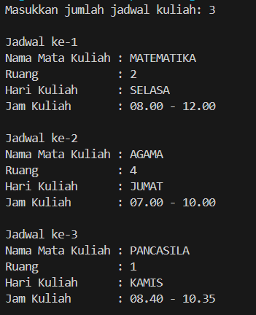
- Menampilkan seluruh jadwal kuliah dalam bentuk tabel
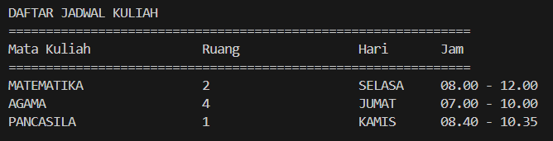
- Menampilkan jadwal dihari tertentu
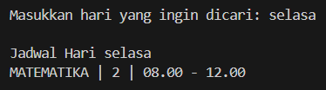

- Menampilkan jadwal berdasar mata kuliah tertentu
