Battery Finder APP — CRSP Dataset 2025
Comprehensive Project Report · 22 April 2026
──────────────────────────────────────────────────────────────────────────────────────────────────────────────

1. Project Overview
The Battery Finder is an end-to-end data and software project built for the Kenyan automotive aftermarket. Its purpose is to take any vehicle — identified by make, model, and year — and return the most suitable battery recommendation from a curated product catalogue, along with up to six alternatives.
The project started from a raw Excel file — the CRSP (Current Retail and Selling Price) July 2025 vehicle registration dataset — which contains every make and model of vehicle imported into Kenya. That data has been cleaned, structured, and enriched with production year information, then served through a web application accessible from any browser with no installation required.

Why Kenya’s data is different from global databases
Kenya imports approximately 70–80% of its used vehicles directly from Japan. These vehicles are registered under their Japanese Domestic Market (JDM) names — the names Toyota, Honda, and Nissan use only inside Japan — rather than the internationally recognised names most people know. For example, what the world calls a Toyota Corolla is sold and registered in Kenya as an Allion, Premio, Axio, or Corolla Fielder depending on the generation and trim. This naming difference is the root cause of the primary accuracy gap identified in the audit (see Section 4) and is the subject of a planned improvement (see Section 6).

2. System Architecture
The system is composed of five layers — from raw data ingestion through to the browser interface — each handled by a dedicated script or file. The diagram below shows how data flows through the system end-to-end.
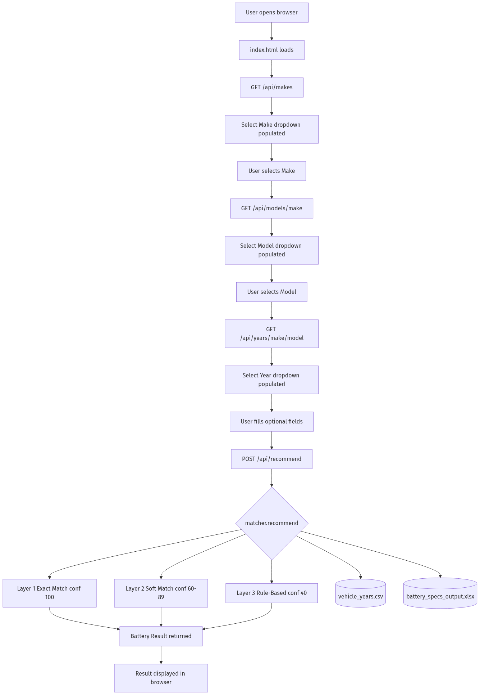
Figure 1 — End-to-end system data flow

Layer | Script / File | What it does
Data Prep | dataprep.py | Cleans the raw CRSP Excel file and exports battery_lookup_dataset.csv
Year Enrichment | enrich_years.py | Calls 5 public APIs to add production years; outputs vehicle_years.csv
Matching Engine | matcher.py | Three-tier recommendation logic: Exact → Soft → Rule-Based
Web API | app.py | FastAPI server exposing 4 endpoints; enforces rate limits
Browser UI | static/index.html | Dropdown interface; cascades make → model → year from the API
Battery Data | battery_specs_output.xlsx | 64-product catalogue used by the matching engine

3. Data Flow — How Each Script Works
3.1 dataprep.py — Raw Data Cleaning
This is the entry point for the entire pipeline. It reads the CRSP source Excel file (New-CRSP---July-2025.xlsx) and performs the following steps in order:
- Loads all rows from the Excel file into memory.
- Strips and normalises all column names (removes whitespace, converts to lowercase).
- Validates that the required 'make' and 'model' columns are present — halts with an error if not.
- Iterates through every row; skips rows with no make value and skips electric vehicles (not relevant for battery sizing).
- Removes duplicate rows to prevent inflated counts.
- Exports the cleaned data to battery_lookup_dataset.csv (4,567 rows) and a matching Excel file.
- Output columns: make, model, model_number, engine_capacity, fuel.
Output: battery_lookup_dataset.csv — 4,567 rows across 57 vehicle makes.

3.2 enrich_years.py — Production Year Enrichment
This script takes battery_lookup_dataset.csv and enriches each vehicle with its full list of production years. Because the CRSP data does not include year information, this script consults five external public databases in priority order:
Priority | Source | Type | Coverage
1st | fueleconomy.gov | Bulk CSV | US market; exact per-year rows; 1984–present
2nd | CarAPI | REST API | Community database; range-based (year_first to year_last)
3rd | Wikipedia | Search API | Page extracts; year ranges parsed from article text
4th | Wikidata SPARQL | Graph query | Structured production start/end year data
5th | NHTSA VPIC | REST API | US government model registry; used for model name matching

A smart caching system (year_cache.json) stores every API response so the script never calls the same endpoint twice. Rate limit backoff is built in — if Wikipedia returns too many requests, the script automatically pauses and retries. A base-model extraction function strips trim-level noise from model names (e.g. 'ALLION A20 G-PLUS' → 'ALLION A20') to improve match rates against external databases that only store base model names.
Output: vehicle_years.csv (75,052 rows — one row per vehicle × production year) and unmatched_models.csv (490 pairs where no year data was found).

3.3 matcher.py — The Recommendation Engine

This is the core intelligence of the system. It loads vehicle_years.csv and battery_specs_output.xlsx into memory at startup and keeps them cached. Every recommendation request passes through three layers in sequence:
Layer | Trigger condition | Confidence | What it does
1 — Exact | Make matches + model score ≥90 + exact year | 100 | Returns the exact DB record for that vehicle and year
2 — Soft | Model score ≥60 + year within ±3 years | 60–89 | Uses the closest matching year; penalises by year distance
3 — Rules | No DB match found at all | 40 | Estimates Ah and tech from engine size and fuel type only

The engine also handles: fuel-type normalisation (e.g. 'DEISEL' → 'DIESEL', 'GASOLINE' → 'PETROL'), regional battery standard detection (NS/JIS for Japanese and Korean makes; DIN for European and American makes), Ah bracket lookup from engine size, technology preference (MF → EFB → AGM based on fuel and stop-start flag), and alternative battery selection using bisect-based nearest-neighbour lookup across the Ah catalogue.

3.4 app.py — The Web API
app.py wraps the matching engine in a FastAPI web server. It exposes four endpoints:
Endpoint | Method | Purpose | Rate limit
/api/makes | GET | Returns the sorted list of all vehicle makes | 20/min
/api/models/{make} | GET | Returns all models for a given make | 20/min
/api/years/{make}/{model} | GET | Returns all available years for a make+model pair | 20/min
/api/recommend | POST | Returns a battery recommendation | 10/min

All inputs are validated by Pydantic before reaching the engine — year must be between 1990 and 2030, engine_cc between 500 and 8,000. If a rate limit is exceeded, the API returns a 429 response with a retry-after message. The static browser UI (index.html) is served from the same process at the root path, so no separate web server is needed. The server is launched with: python app.py (runs on port 8000).

3.5 static/index.html — The Browser Interface
The front-end is a single HTML file with no external framework dependency. It implements a cascading dropdown system: selecting a make triggers a call to /api/models to populate the model dropdown; selecting a model triggers /api/years to populate the year dropdown. All three selections are locked to values returned by the database — users cannot type free-form vehicle names, which means the matching engine always receives clean, verified input. Optional fields (fuel type and engine cc) are shown for cases where additional precision is needed. A stop-start checkbox toggles enhanced battery technology recommendations. The interface uses the Chloride Exide brand colours and includes a loading animation on startup.

──────────────────────────────────────────────────────────────────────────────────────────────────────────────

4. Accuracy Audit Findings
A 28-case audit was run against the live engine covering vehicles across multiple makes, fuel types, engine sizes, and years. Each recommendation was scored across six checks. Results split sharply by usage path:
Dropdown UI Path (normal website use)
100% accuracy across all 28 cases and all 6 checks. Because the user selects from database-verified dropdowns, the engine always receives a valid make, model, and year and retrieves the actual vehicle record — engine_cc and fuel come directly from the database, not from user input. There is no opportunity for input error.

Rule-Based / API-Direct Path / Typed User Inputs
Check | Explanation | Accuracy (Typed Input) | Root cause of failures
Match Type |  | 46% | ~40% of intl. model names absent — JDM vs global naming gap
Confidence Score |  | 61% | Rule-based path is structurally capped at confidence = 40
Battery Region |  | 96% | Unknown makes default to DIN — correct in most cases
Ah Rating |  | 68% | Year not considered; flat rules miss modern larger-capacity needs
Technology (MF/EFB/AGM) |  | 86% | Stop-start checkbox left unchecked → wrong tech 6/6 times
Primary Battery |  | 100% | No failures — product selection logic is sound

The 46% match-type figure is the most important number in the audit. It is not a code bug — it is a data gap. The JDM-to-global naming mismatch (see Section 3.1) means that queries using internationally recognised names cannot find their records. This is addressed in the planned improvements (Section 6).
──────────────────────────────────────────────────────────────────────────────────────────────────────────────

5. Bugs Identified and Resolved
Bug | Script | Impact | Status
Bisect neighbour Ah lookup | matcher.py | Wrong battery size returned for edge-case Ah values | Fixed
Slash in model name broke routing | app.py | Year lookup failed for models like 'Corolla/Levin' | Fixed
model_number silently dropped | dataprep.py | Part number missing from all CSV export rows | Fixed —
High unmatched model rate (1,204) | enrich_years.py | Year data missing for 26% of models | Fixed — down to 490 (up by 59%)

──────────────────────────────────────────────────────────────────────────────────────────────────────────────

6. Planned Improvements
The following improvements have been identified, analysed, and tracked as GitHub issues. They are listed in priority order — highest accuracy return for lowest effort first.
Year-Aware Battery Sizing and Technology Rules (High Priority)
Currently, the recommendation engine ignores the vehicle's production year when choosing battery size and type. This matters because vehicle electrical demands have increased significantly over the decades. A 2022 Toyota with 1,600cc needs a larger battery than a 1998 Toyota with the same engine. Proposed changes:
- Add a year modifier: +10Ah for vehicles from 2018 onward, +5Ah for 2012–2017, −5Ah for pre-2000.
- Infer stop-start technology from year and make (European cars post-2014 are very likely stop-start).
- Add a hybrid year guard: if a car is marked as hybrid but the year is before 2000, treat it as petrol.
Expected improvement: Ah accuracy 68% → ~79%, technology accuracy 86% → ~96%.

Dual Input Mode: Dropdown and Free-Text Entry (Medium Priority)
The current website only accepts vehicle names from the database dropdowns. This means a vehicle not yet in the database cannot be queried through the UI at all. A dual-mode form would allow users to toggle between 'Select from list' and 'Type manually'. In manual mode, the engine falls back to the rule-based layer, which still provides a useful result based on engine size and fuel. This directly enables use cases like workshops dealing with newly imported models not yet in the dataset.

International Model Name Alias Table (Medium Priority)
This is the fix for the 46% match-type gap. A lookup table (model_aliases.csv) would map internationally known model names to their JDM equivalents stored in the database. For example: COROLLA → ALLION, PREMIO, AXIO; CIVIC → GRACE, JADE; LAND CRUISER → PRADO VX, LC200. The matching engine would consult this table before searching, so both a customer saying 'Corolla' and one saying 'Axio' would find the same records. This is 90% data work (building the table) and less than one day of code change.

NHTSA Real-Time Verification (Medium Priority)
When the engine falls back to rule-based matching (because the model was not found), it estimates engine size and fuel type from user input — which may be wrong or blank. A live call to the US NHTSA VPIC government database could verify or correct this information in real time. Expected improvement for the rule-based path: Ah accuracy from ~60% to ~90%. The trade-off is a 300–800ms delay per rule-based query, mitigated by caching results.

PostgreSQL Database Migration (Low Priority — Infrastructure)
The system currently reads all data from CSV files loaded into memory at server startup. This works well for a single-user or small-traffic scenario but has limits: the data cannot be updated without restarting the server, and multiple simultaneous users sharing one process creates concurrency risk. Migrating to PostgreSQL would allow live data updates, concurrent users, and query-level filtering. This change has zero accuracy impact — it is purely a reliability and scalability improvement.
──────────────────────────────────────────────────────────────────────────────────────────────────────────────

7. Additional Recommendations Not Yet Raised
Beyond the current issue list, the following improvements are recommended based on a full review of the project:
- Battery catalogue expansion: The current catalogue has 64 products. If new battery lines are added by the supplier, the Excel file must be manually updated and the server restarted. A catalogue management interface or a simple admin endpoint to reload the catalogue without downtime would significantly reduce maintenance effort.

- Stop-start field made explicit in the UI: Currently the stop-start checkbox defaults to unchecked, and the audit found this causes wrong technology recommendations in 6 out of 6 stop-start vehicle cases. A tooltip, help text, or auto-detection hint (e.g. 'Most European cars after 2014 have stop-start') would reduce this error rate substantially without any engine change.

- EV vehicles currently excluded — reconsider: dataprep.py explicitly filters out electric vehicles at the cleaning stage. As EV registrations grow in Kenya , there may be a need to recommend 12V auxiliary batteries for EVs (all EVs have a small 12V battery for accessories). This is a future data addition that should be considered when the catalogue is next reviewed.

- Confidence score displayed to the user: The API returns a confidence score (40, 60–89, or 100) with every recommendation, but the current UI does not show it. Displaying this — even simply as 'Exact match', 'Close match', or 'Estimated' — would give staff and customers important context about how reliable the recommendation is.
- Automated data refresh pipeline: The year enrichment script (enrich_years.py) must be run manually whenever the CRSP source data is updated. Scheduling this as an automated nightly or weekly job would keep vehicle_years.csv current without human intervention.
- Logging and usage analytics: There is currently no logging of which vehicles are searched or which recommendations are returned. Adding structured logs would allow analysis of the most common queries, identification of high-volume unmatched models (to prioritise alias table entries), and monitoring of API error rates.

──────────────────────────────────────────────────────────────────────────────────────────────────────────────

8. Accuracy Projection — Before and After All Fixes
Check | Current (API path) | After Year Rules | After Alias Table | After NHTSA
Match Type | 46% | 46% | ~80% | ~80%
Confidence Score | 61% | 65% | 85%+ | 88%+
Battery Region | 96% | 96% | 97% | 97%
Ah Rating | 68% | ~79% | ~85% | ~92%
Technology | 86% | ~96% | ~96% | ~96%
Primary Battery | 100% | 100% | 100% | 100%

The dropdown UI path remains 100% across all checks regardless of these improvements — improvements only affect the API-direct and manual-entry paths.
──────────────────────────────────────────────────────────────────────────────────────────────────────────────
Battery Finder / CRSP 2025 · Comprehensive Project Report · Generated 22 April 2026 · Repository: em-brandon/2025-CRSP-Normalized-Dataset- · Internal Use Only

