Title: Consumer-mediated nutrient cycling in marine environments: a global meta-analysis
Short running title: Marine nutrient cycling across latitudes
Keywords (6-10): Bottom-up, coastal, consumer-mediated nutrient dynamics, egestion, excretion, global, meta-analysis, nitrogen, primary producers, synthesis

Abstract
Aim:
Animals release nutrients through their metabolic waste products, which can bolster primary productivity. For a given level of nutrient provisioning, we should expect the largest effect on primary producers to occur in more nutrient-limited waters, but empirical tests for global-scale patterns of animal-mediated provisioning effects on primary producers are lacking. Here, we quantify the magnitude and variability of the effect of provisioning across marine taxa and regions.
Location:
Global.
Time period:
1900–2024.
Major taxa studied:
Marine primary producers and invertebrates, fishes, and birds.
Methods:
Using a systematic review and meta-analysis, we collated 246 effect sizes drawn from 43 studies to quantify the growth benefit of nutrient provisioning by animals to various primary producers in experimental settings and along natural gradients. We compared the effect of provisioning on productivity for each major group of primary producers across latitudes, sea surface temperatures, levels of ambient nitrogen and phosphorus concentrations, levels of experimentally supplied nitrogen, and considered several additional biological and experimental covariates.
Results:
We found a variable but generally positive effect of provisioning on productivity. Macroalgae, corals, and phytoplankton responded consistently positively to provisioning, but the responses of seagrass and endosymbionts were more variable. The response of macroalgae to provisioning was stronger in higher-latitude, cool, nitrogen-rich waters, even when controlling for the level of experimental nitrogen provisioning by animals. In contrast, the response of seagrass was stronger in warmer waters, and to a lesser extent, low latitudes. We found no global trends in the response of phytoplankton, corals or endosymbionts, and the level of nitrogen provisioning only increased the response of macroalgae and phytoplankton. Not enough studies reported phosphorus concentrations to properly investigate this potential moderator.
Main conclusions:
Our results suggest animal-provisioned nutrients enhance primary productivity across a broad range of ecological contexts. Contrary to our predictions, we found limited evidence that nutrient provisioning by animals had an overall stronger effect on primary producers in nitrogen-poor waters than in nitrogen-rich waters, but the differences between regions varied strongly among primary producer groups.

Introduction
Nutrient enrichment is an important process in supporting primary productivity and thus ecosystem structure (Elser et al., 2007). Sufficient provisioning of nitrogen (N), phosphorus (P), and other limiting elements can dramatically alter communities not only by increasing net primary productivity but also by altering the structure and diversity of plant communities across ecosystems (Gough et al., 2016). As such, considerable effort has gone into predicting the contexts under which nutrient provisioning may produce sizeable impacts on ecosystems. Logically, we expect that nutrient provisioning should only be important relative to the nutrient demands of the primary producer, the availability of nutrients in the system, and the level of provisioning (Evans-White & Lamberti, 2006). For example, in P-poor soils, tropical tree species show variable responses to N enrichment but consistently positive responses to P (Fortier & Wright, 2021). Phosphorus enrichment also famously causes algal blooms in P-limited lakes, while N fails to produce a similar effect when added in isolation (Schindler, 1974). Finally, even the form and relative amounts of the supplied nutrients are important. Coral reef fish appear to supply N and P at an ideal ratio for corals, but deviations from this ratio (e.g., very high or very low N:P ratios) are associated with decreased or no growth (Stambler et al., 1991; Allgeier et al., 2014). As global biogeochemical cycles are altered through anthropogenic disturbances, understanding broad trends in responses to nutrient provisioning remains a key research goal.
Although consumers are often assumed to mediate primary productivity through “top-down” effects, e.g. herbivory (Paine, 1966; Poore et al., 2012), they can also mediate “bottom-up” processes through metabolic nutrient release (Allgeier et al., 2017). Top-down controls of higher trophic groups may be especially weak relative to bottom-up influences (Davis et al., 2017; Tebbett et al., 2024; Paul et al., 2025). Nutrient provisioning by consumers via excretion or egestion has been shown to substantially affect primary productivity and community functioning in freshwater (Vanni, 2002; Atkinson et al., 2017), terrestrial (McNaughton et al., 1988; Sitters et al., 2017), and marine (Meyer et al., 1983; Peterson & Heck, 2001; Bracken et al., 2007; Pfister et al., 2014) ecosystems. Consumer-mediated nutrient cycling (CNC) refers both to the storage and cycling of nutrients through animal tissues, processes that can be described by the metabolic theory of ecology (body size, temperature) and ecological stoichiometry (trophic guild, body N:P) (Allgeier et al., 2015; Vanni & McIntyre, 2016). Scaling up from the individual to the population or community level can be challenging, but CNC generally depends on the total biomass and diversity of animals in a system (Allgeier et al., 2017).
From first principles, we would assume that the effect of CNC should be largest in ecosystems with low nutrient availability and high internal nutrient recycling, such as tropical coral reefs (McIntyre et al., 2007; Miller & Wheeler, 2012; Allgeier et al., 2017; Brines et al., 2022). Indeed, many early papers on CNC focused on tropical marine ecosystems, where waters are often nutrient-poor (Meyer et al., 1983; Meyer & Schultz, 1985). Biogeochemical theory makes a similar prediction for P limitation in tropical forests; however, Turner et al., (2018) showed that tropical tree species responded similarly to P regardless of where they occurred along a P gradient, suggesting that species-level P limitation does not extend to the community level. In waters with high external nutrient input, such as those frequently found at temperate latitudes, the ecological relevance of CNC may be more context-dependent than in oligotrophic ecosystems (Allgeier et al., 2017). For example, despite high annual nutrient availability, primary producers in upwelling systems, in which seasonal offshore winds bring deep, nutrient-rich waters to the surface, may also experience periods of nutrient depletion. The delivery of nutrients may be mismatched with the timing of summer productivity (Jackson, 1977; Chang et al., 2003; McPhee-Shaw et al., 2007), increasing the importance of alternative nutrient sources in the summer (Hepburn & Hurd, 2005; Brzezinksi et al., 2013). In temperate tidepools that are isolated from the ocean for extended periods of time, nutrient provisioning by animals can prevent nutrient depletion and support continuous productivity (Bracken, 2004). Despite this potential context dependence, empirical tests for global-scale patterns of provisioning effects on primary producers are currently lacking.
Nutrient provisioning by animals in marine systems is particularly interesting with respect to nitrogen due to its role as a commonly limiting nutrient, and the varying ability of primary producers to uptake and assimilate its different forms. Although the addition of N and P in experimental combination produces the largest increase in primary productivity across systems (Elser et al., 2007), non-additive effects are common (Allgeier et al., 2011). Phosphorus can be limiting for some marine primary producers in some areas (Krom et al., 1991), but the growth of many species of macroalgae (Jackson, 1977), seagrasses (Hillman et al., 1989), and phytoplankton (Moore et al., 2013) is limited by the availability of inorganic N, both exogenous and endogenous to the system. However, exogenous sources supply N primarily in the form of nitrate, which requires active uptake and metabolic conversion to ammonium by plants and algae before use (Probyn & McQuaid, 1985; Smith et al., 1999). In contrast, many marine animals, such as fishes and invertebrates, contribute N (e.g., via excretion) in the form of ammonium, which can be passively taken up and immediately assimilated into amino acids by primary producers (Lobban & Harrison, 1994; Phillips & Hurd, 2004). Therefore, excretion by marine animals represents an important endogenous source of N in marine ecosystems (Allgeier et al., 2017).
In this study, we assessed the effects of animal-provisioned nutrients on primary productivity in different marine ecosystems and specifically tested several hypotheses about the contexts underpinning where these effects might be the most pronounced. We asked how the effects of CNC at a global scale vary in relation to background N and P levels, temperature, and latitude. If conventional wisdom holds, then nutrient provisioning by animals should be most impactful on primary producer growth when background nutrients are low, i.e. in warm-water areas often found at low latitudes. We considered additional biological (such as taxonomic groups of primary producers and nutrient suppliers) and experimental factors (such as the level of nitrogen provisioning by animals) to explain further sources of heterogeneity. Our systematic review and meta-analysis of published literature strengthen our understanding of consumers in mediating bottom-up processes on a global scale.

Materials and methods
Literature search and article screening
We conducted a systematic review and meta-analysis of existing literature to investigate the effect of animal-provisioned nutrients on marine primary producers. Our literature search targeted five key elements for articles to be considered: (1) marine habitat, (2) nutrients, (3) excretion or egestion (4) primary producers, and (5) a measured response. For each element we generated search terms of analogous words (see Supporting Information S1). Our search covered papers published from 1900 - August 27, 2024; the search was performed on the last day of the interval. We searched the Web of Science Core Collection (Web of Science) and Aquatic Sciences and Fisheries Abstracts (ProQuest) databases and added six papers from our personal files. In Web of Science, our search initially yielded 1,767 publications before we limited the list to reviewed articles in relevant categories, which excluded unreviewed papers and those outside our field, leaving us with 1,387 publications. For the Aquatic Sciences and Fisheries Abstracts database, we initially collected 1,518 publications using the same search string, which narrowed to 889 publications once we restricted article types and relevant subjects as above (see Supporting Information S1 for full list of restrictions). We merged these two searches and removed duplicates using the ‘revtools’ package (Westgate, 2019) in R (v4.4.1, R Core Team, 2024), resulting in 1,922 publications (Supporting Information Fig. S1.1).
Each record had to meet the following criteria to be included: (1) the study was conducted in the marine environment, (2) treatment levels were established using manipulated or observed variation in animal-provisioned nutrients, but not using chemical fertilizer additions, (3) the response of primary producers to nutrient provisioning was measured quantitatively, and (4) the study reported all necessary information required to calculate an effect size of animal-provisioned nutrients on primary productivity. We first scanned all titles and abstracts of publications using ‘revtools’ to determine if the articles met our criteria. Next, we combined the screening of the full texts with data extraction. We extracted meta-data and calculated effect sizes when the publication met all criteria.

Data extraction
We extracted the mean primary producer response, standard deviation, and sample size for both the unprovisioned control and the provisioned treatment to calculate effect sizes. We calculated effect sizes as log-transformed response ratio (LnRR) using the ‘escalc’ function from the ‘metafor’ package (Viechtbauer, 2010):
$$LnRR=ln⁡(\frac{{\underline{X}}_{e}}{{\underline{X}}_{c}})$$
where ${\underline{X}}_{e}$ and ${\underline{X}}_{c}$ are the means of the experimental (provisioned, i.e. more animals) and control (unprovisioned, i.e. fewer animals) treatments, respectively. Effect sizes could not be calculated for ratio values equal to zero (i.e. zero growth in the experimental or control mean), so these cases were excluded (n = 9). When studies included multiple experiments, response metrics, or species, we extracted an effect size for each. When studies included multiple treatment levels, we only compared control and maximum treatment levels. For time-series data we considered growth achieved between the first and last measurements, when possible, but still recorded the final measurement when the first measurement was unavailable. When instantaneous measurements (e.g., oxygen production via photosynthesis) were made at multiple time points, we included all time points. We recorded the type of measurement extracted (growth, final measurement, or instantaneous) to determine whether all three types of measurements could be included in the same model (Supporting Information Tables S1.1, S1.2). We used WebPlotDigitizer (https://automeris.io/WebPlotDigitizer/) to extract the mean and standard deviation when data were only available in graph form. When standard errors or confidence intervals were provided, we calculated standard deviations from these values. When mean and standard deviation were not reported, we used the provided raw data to compute these values ourselves. We also extracted information on the study location (latitude, longitude, water temperature, background N and P availability), experimental design, study duration, animal species or groups that provided the nutrients, level of N and P provisioning, primary producer species or groups and the types of responses measured, and when the study occurred.

Data analysis
We conducted our statistical analysis in R (v4.4.1, R Core Team, 2024) using RStudio (v4.2.764, Posit team, 2024). We constructed all models using the ‘rma.mv’ function from the ‘metafor’ package (Viechtbauer, 2010), and used ‘emmeans’ to make pairwise comparisons between subgroups and to calculate slope estimates for subgroups (Lenth, 2024). We used the restricted maximum likelihood estimator to estimate residual heterogeneity (Q_{E} test) and used the omnibus test of moderators to test the null hypothesis that all coefficients = 0. We set test = “t” to use a t-distribution similar to the Knapp-Hartung method. To align our interpretation of p-values with the language of evidence, we consider p < 0.01 as providing strong evidence, 0.01 < p < 0.05 as moderate evidence, 0.05 < p < 0.1 as weak evidence, and p > 0.1 as little evidence (Muff et al., 2022).
As some studies contributed multiple effect sizes, we used multilevel meta-analysis models with “study” as a random effect to account for non-independence among effect sizes (Noble et al., 2017). We first fit a null multilevel model with effect size as the response variable and no explanatory variables (moderators) to estimate the overall effect of CNC on primary productivity. The heterogeneity of the null model was high (I² = 98.97, (Nakagawa & Santos, 2012), so we used meta-regression models (three-level mixed-effects models) to explain this heterogeneity and test our hypotheses.

Moderator analysis
To examine the taxonomic specificity of responses to nutrient provisioning, we grouped primary producers into (1) benthic macroalgae (i.e., any algae attached to the substrate), (2) symbiotic cnidarian hosts (hereafter corals), (3) endosymbionts, (4) phytoplankton, (5) seagrass, or (6) plants. We found only three studies of plants (two mangrove studies, one cordgrass study) so this group was excluded from final analyses. We constructed a model with primary producer taxa as the only moderator to calculate mean effect sizes for each producer group.
To drill into potential drivers of geographic patterns and provide direct tests of our hypothesis, we considered five potential moderators: absolute latitude, annual sea surface temperature (SST), background nitrogen (N) concentration, background phosphorus (P) concentration, and level of N provisioning. We extracted coordinates provided by the authors for each study location to obtain absolute latitude. We extracted annual mean SST from the NOAA optimally interpolated sea surface temperature (OISST) dataset for each study location, averaged across the year(s) in which the experiment was conducted. We downloaded subsets of the data through the ‘rerddap’ package (Chamberlain, 2025). We used satellite-derived SST because in situ temperature data were not reported in all studies, but we provide the analysis of the restricted in situ mean temperature dataset in Supporting Information 1 (Table S1.3). We recorded the concentration of N (in any combination of nitrate, nitrite and ammonium) and P present in the ambient or control treatment when provided by the authors. We estimated the level of N provisioning by animals as the difference between the concentration of N in the experimental versus control treatments as a proxy for the supply rate. Very few studies (see Results) reported background P concentrations, most of which focused on phytoplankton, which severely restricted our sample size and prevented us from conducting meaningful statistics on this nutrient. For completeness, we provide our full rationale and the results of the models in Supporting Information 2 (Fig. S2.1–2; Tables S2.1–2). We also compared effect sizes between Large Marine Ecosystems (results in Supporting Information 1; Fig. S1.2–3).
Due to intercorrelations (Fig. 1a), we were unable to include latitude, SST and background N in a single model and instead built separate “main” models to examine the effect of each individually. We scaled and centered each variable to facilitate slope comparisons. For each of the three moderators, we fit a model with the target moderator, primary producer group, and an interaction between the two. We include categorical versions of these three main models (e.g., latitude as tropical vs temperate) in Supporting Information 1 (Fig. S1.4; Tables S1.4–9).
The level of N provisioning was not correlated with the other main moderators. We log-transformed the level of N provisioning before fitting a model with the level of N provisioning, primary producer group, and an interaction between the two. We also reran the three main models above with level of provisioning (scaled and centered) as an additional moderator. Unfortunately, N provisioning levels were only available for half of the experiments included in the meta-analysis, which restricted the sample sizes of these analyses.
We considered several additional study-level covariates that we a priori thought might be potential effect size moderators: experimental design, measurement type, measured response, consumer taxon, and study duration. We scored each experiment’s design on a 3-point scale of ‘naturalness’: (1) Field: provisioning animals unstocked (i.e., experiments where animal abundance was not manipulated, e.g. natural differences in abundance between sites or gradients), (2) Field: provisioning animals stocked (i.e., experiments where animals were transplanted or caged to increase provisioning), and (3) Mesocosm: lab experiments. We classified measurements of productivity as either (1) growth (i.e., change over time), (2) final measurement (i.e., measurement at the end of a period), or (3) instantaneous (i.e., rates such as oxygen production). We categorized measurements based on the type of response measured (e.g., length, biomass, percent cover). We classified the taxonomic division or phylum of each provisioning consumer or group of consumers. We considered the duration of a study as the number of days between the application of the experimental treatment and the final measurement, or the duration of the growth period. In cases where instantaneous measurements (e.g., shoot length) were taken in observational (unmanipulated) studies, we considered the duration as spanning 0 days. We log(x+1)-transformed study duration. For each of these study-level covariates, we ran separate models to investigate sub-group differences. Then, we ran additional models with each study-level covariate, primary producer group, and the interaction between the two. In addition, individual inclusion of most of these additional moderators in the “main models” did not improve fit based on comparison by AIC (Supporting Information Table S1.10). Since not all studies provided information on all of moderators, sample sizes are variable.
Finally, we ran generalized linear mixed-effects models (GLMMs) to confirm that study duration and the level of N provisioning did not vary across latitudes or experimental design types, and that the level of N provisioning did not vary among consumer taxa (Tables S1.11– 15).

Testing for biases and non-independence
Meta-analyses can be vulnerable to publication bias (Yang et al., 2023), so we calculated Rosenthal’s failsafe number (i.e., the number of non-significant studies we would have to include to overturn our significant results); the large failsafe N (99,557) relative to our sample size (N = 246) suggests that our results are robust to publication bias. We also visually inspected funnel plots for evidence of small-study bias. The pattern was unusual with many studies with high precision but variable effect sizes and few studies with low precision and near-average effect sizes (Fig. S1.5). As the pattern was relatively symmetric about the mean, we interpret it cautiously as reflecting limited publication bias but high heterogeneity. Finally, we calculated Cook’s Distance and examined whether papers with D_{k} > 1 (n = 11 papers) had a substantial effect on the results. We reran each model, removing these potentially influential studies, and found no major differences in effect sizes or p-values. We therefore retained all studies in the final analysis.

Results
Description of dataset
After screening, our systematic review narrowed from 1,922 to 43 studies, which contributed 246 individual effect sizes (Table S1.16, a list of data sources is given in Appendix 1). The studies spanned a range of latitudes, background N concentrations, and sea surface temperatures (Fig. 1a), but very few studies reported P concentrations (n = 13 studies). There was a bias towards studies conducted in the northern hemisphere (Fig. 1b), but effect sizes were evenly distributed between tropical and temperate latitudes, with the number of studies increasing steadily over time for both regions (Fig. 1c). Most effect sizes were drawn from phytoplankton (n = 72), which included both diatoms and dinoflagellates, and seagrasses, which comprised Zostera marina, Cymodocea nodosa, and Thalassia testudinum (n = 50). Macroalgae (n = 42) were represented by green, red, and brown fleshy and turf algae, as well as calcified algae. Symbiotic cnidarians were split into hosts (n = 39), which included corals and an anemone, and endosymbionts (n = 33; Table S1.17). The responses of primary producers to changes in nutrient levels were reported as measurements pertaining to individuals (i.e., length, width, area, biomass), populations (i.e., percent cover, abundance, biomass) or as performances (photosynthesis, chlorophyll a) (Table S1.18). These measurements were evenly distributed across climate regions. Unstocked field experiments (i.e., the most natural design) constituted the majority of experimental designs (n = 107), followed by mesocosm experiments (n = 84) and field experiments where animals were stocked (n = 55). Animals used in provisioning experiments were primarily sessile invertebrates (n = 135) comprising bivalves, sponges, and a single hydroid species. Vertebrates (n = 81) were represented by fishes and birds, while mobile invertebrates (n = 30) were sea cucumbers, jellies and gastropods (Table S1.19). Seagrass provisioned by bivalves (n = 49), followed by phytoplankton provisioned by bivalves (n = 33) and corals provisioned by fishes (n = 27), were the most common combinations of primary producers and consumers (Fig. 2).

Primary producer responses to nutrient provisioning: Global trends
Overall, we found strong evidence of a positive effect of nutrient provisioning by animals on primary productivity (null model; log-transformed response ratio ± SE: 0.33 ± 0.06, p < 0.001, Fig. 3), with producers growing 1.4 times more, on average, under provisioned than unprovisioned conditions. This overall positive effect reflects the consistently positive effects of provisioning by animals on macroalgae, coral, and phytoplankton (i.e., no overlap of confidence intervals with 0, Fig. 3), but effects on endosymbionts and seagrass were less consistent (Fig. 3, Table S1.20).
The effect of nutrient provisioning on primary producers varied across latitudes, annual sea surface temperature (SST), background N levels, and primary producer groups. More specifically, we found strong evidence that the response of macroalgae to provisioning decreased with SST (p = 0.01), and moderate evidence that their response increased with latitude and background N (p = 0.03 and 0.047, respectively, Fig. 4, Tables S1.21–26). Seagrass demonstrated different relationships: there was moderate evidence that their response to nutrient provisioning increased with SST (p = 0.03), weak evidence that their response decreased with latitude (p = 0.098), and no evidence that their response varied in response to background N (p = 0.95, Fig. 4, Tables S1.21–26). There was no evidence of an effect of latitude, SST or background N on the responses of phytoplankton, endosymbionts, or corals to nutrient provisioning (p > 0.15, Fig. 4, Tables S1.21–26).
As mentioned previously, only half of the studies provided information on the level of N provisioning, which restricted our dataset (n = 126). There was a weakly positive correlation between effect size and the level of N provisioning for macroalgae (p = 0.049, Fig. 4dh, Tables S1.27, S1.28), but there was no trend for the response of other primary producers. When we included the level of N provisioning as an additional moderator in the three main models, we found strong evidence that the response of macroalgae to provisioning increased with latitude and decreased with SST (p < 0.005), but the moderate effect of background N disappeared (p = 0.30) and there was no evidence of an effect of the level of N provisioning in any of the models (all p > 0.26). There was no evidence of relationships between effect sizes and latitude, SST, or background N for the other producer groups in the models that included the level of N provisioning as a covariate (full results in Supporting Information 1; Fig. S1.6, Tables S1.29–31). Finally, the level of N provisioning did not vary with latitude (p = 0.63, Table S1.11) or experimental design (p > 0.86, Table S1.12). The level of N provisioning also did not vary among birds, fishes, sea cucumbers, or molluscs, but jellies supplied less N than all other groups (Fig. S1.7, Table S1.13).
The moderators, in combination with primary producer group, explained more variation than a null model for the latitude, SST, background N, and the level of N provisioning models (all p < 0.012). However, for all models, there was still a significant amount of unexplained heterogeneity (p < 0.001).

Primary producer responses to nutrient provisioning: Study-level covariates
When considering our categorical study-level covariates, we found consistently positive responses of producers to nutrient provisioning in all three experimental design types (mesocosm, unstocked and stocked field experiments), and with all types of measurements (instantaneous, growth rate, and end point, Fig. 5). We found less consistently positive responses among the types of responses measured (e.g., photosynthesis vs percent cover) and the taxon of the provisioning animal (e.g., fishes vs sea cucumbers, Fig. 5). However, we found no evidence that the response of producers varied significantly among experimental designs, measurement types or responses, or the taxon of the provisioning animal (all pairwise comparisons p > 0.18). When we considered subgroup differences within each primary producer group, we found moderate evidence that the effect of nutrient provisioning on macroalgae was stronger in mesocosm experiments than in unstocked experiments (p = 0.02, Fig. 5, Tables S1.32, S1.33). Studies that recorded growth rates over time documented stronger effects of nutrient provisioning on macroalgae than experiments that measured producers at the end of the experiment (p = 0.01), but growth rate experiments had weakly smaller effect sizes than end-point experiments for corals (p = 0.047, Fig. 5, Tables S1.34, S1.35). For corals, measurements of percent cover revealed larger effects of provisioning than measurements of biomass (p = 0.01, Fig. 5, Tables S1.36, S1.37), and sponge- and bird-provisioned nutrients elicited weakly larger responses than fish-provisioned nutrients (p < 0.04 for both pairwise comparisons, Fig. 5, Tables S1.38, S1.39). There was no evidence for other pairwise subgroup differences (p > 0.15, Fig. 5, Tables S1.32–39).
There was a positive relationship between experimental duration and the response of macroalgae and phytoplankton to nutrient provisioning (i.e., no overlap of confidence intervals with 0, Fig. 6), but no significant relationship emerged for the other producer groups (Table S1.40). Experimental duration did not vary with latitude (GLMM: p = 0.11, Table S1.14), but we found strong evidence that coral studies lasted longer than experiments involving other producers (p < 0.001 for all pairwise comparisons). For macroalgae, field experiments with stocked animals were longer than unstocked field experiments (p < 0.01, Table S1.15). Experiments on endosymbionts in mesocosms were longer than unstocked field experiments (p = 0.003).

Discussion
Overall, we found a positive effect of nutrient provisioning by animals, amounting to a 1.4 times increase in the growth and performance of primary producers across studies. Animals were generally able to bolster primary productivity through metabolic nutrient addition across varying marine ecosystems and experimental designs, thus supporting their role in bottom-up processes. However, the overall positive effect size masks substantial variation: some primary producers, such as macroalgae, corals and phytoplankton, responded strongly and consistently positively to animal-mediated nutrient additions while other groups – endosymbionts and seagrass – did not. We found moderate to strong evidence that macroalgae respond more to animal provisioning in cooler, higher-latitude, more N-replete environments and when the level of N provisioning was higher. Conversely, we found moderate to weak evidence that seagrass responded more strongly in warmer, lower-latitude waters. Not enough studies reported P concentrations to properly investigate this potential moderator. We therefore find little support for the general expectation that the effect of consumer-mediated nutrient cycling on primary producers should be more marked in nitrogen-poor environments, but large amounts of heterogeneity remained unexplained by our models, suggesting the effects of natural variability or processes unaccounted for.
Of all primary producers examined, the group that showed the strongest and most consistent trends was macroalgae. This is perhaps not surprising since many species, especially ephemeral ones, have a great capacity for rapid uptake and growth rates (Bracken & Stachowicz, 2006; Liu et al., 2007). The responses of macroalgae to animal provisioning increased with latitude and background N availability, and decreased with sea surface temperature, all of which point strongly to larger responses by macroalgae in colder, more N-replete environments. As such, our results mirror findings that temperate macroalgae respond more strongly to fertilization in high-productivity regions compared to low-productivity regions (Burkepile & Hay, 2006), as these macroalgae may be better adapted to readily accepting and assimilating nutrients. Conversely, tropical and subtropical macroalgae appear not respond to artificially elevated N and or P in low-latitude seagrass ecosystems (Shayka & Allgeier, 2025). Herbivory may also mediate the response to fertilization in tropical macroalgae (Burkepile & Hay, 2006). Macroalgae were also the only primary producers in our dataset to respond (positively) to the level of N provisioning. Past exposure to nutrients can influence future uptake rates, which are limited by supply rates, and some plants grown in high-N conditions have a greater ability to uptake ammonium (Zalamea et al., 2016). In fertilization experiments, plots are sometimes taken over by producers with larger potential for uptake and assimilation of nutrients (Gough et al., 2016), so it follows that producer communities exposed to high nutrient availability may be composed of species that are able to uptake and use nutrients well. For example, temperate seaweeds, such as giant kelp (Macrocystis pyrifera), from nutrient-rich waters have a high surge uptake capacity, being able to quickly take up and store large amounts of N (Cedeno et al., 2021).
We found that seagrass responses to provisioning, although positive on average, were less consistent than those of macroalgae. This may be because nutrient additions tend to promote fast-growing epiphytes, macroalgae, and or water-clouding phytoplankton, which can negatively impact the growth of relatively slower growing seagrass species (Cardoso et al., 2004; Shayka & Allgeier, 2025). Indeed, when we considered only studies that measured simultaneously the responses of seagrass and epiphytes, we found that the two groups showed opposite relationships with latitude, background N availability, and SST (full results in Fig. S1.8, S1.9, Tables S1.41–46). Seagrass may also exhibit a negative physiological response to high levels of N in the water column and excessive organic matter in the sediment (Burkholder et al., 1992; Marbà et al., 2006). Excessive organic matter (i.e. feces) can elevate levels of toxic sulfide produced by sulfate-reducing bacteria (Marbà et al., 2006), resulting in reduced photosynthesis, growth, and survival of seagrass (Borum et al., 2014). Only one study compared the effects of ammonium excretion, which resulted in epiphyte blooms, to biodeposits, which also stunted seagrass growth due to sulfide stress (Vinther & Holmer, 2008). Interestingly, chemosynthetic lucinid bivalves can alleviate this stress, due to the endosymbiotic sulfide-consuming bacteria present in their gills (van der Geest et al., 2020; Cardini et al., 2022).
In our study, seagrass responses to provisioning were unaffected by background N and supplied N but varied more strongly in relation to SST. Sea surface temperature may directly influence responses of seagrass to provisioning as temperature drives many of the processes that govern CNC, both for consumers (e.g., excretion; (Devine & Vanni, 2002; Vanni & McIntyre, 2016), producers (e.g., nutrient uptake, growth; (Lobban & Harrison, 1994), and seagrass-associated N-fixing bacteria (Cardini et al., 2018). The observed effect of SST may also reflect taxonomic differences: most high-SST studies focused on Thalassia spp., while most low-SST studies considered Zostera spp. (although one warm-SST study also used Zostera spp.). It would be revealing to examine the responses of these genera in areas where they co-occur, such as the Mediterranean Sea and the southern Sea of Cortez (Short et al., 2007). Although increased nutrients reduced temperate seagrass growth at high nutrient levels (Griffin, 2024) and increased growth at low nutrient availability (Meysick et al., 2020), we did not find evidence that seagrass responses to nutrient additions were mediated by water column N. Many seagrass species are associated with N-fixing microbes (Welsh, 2000), which may reduce N-limitation. Indeed, tropical and subtropical seagrass may be more P than N limited (Shayka & Allgeier, 2025). N limitation may also be more common on sandy substrate, while P limitation is more common on carbonate substrates (Touchette & Burkholder, 2000), although N-limitation was documented on a carbonate mud bank when nutrients were provisioned by bird guano (Powell et al., 1989). The response of seagrass to CNC is likely controlled by a complex suite of interactions between sediment conditions, water column and porewater nutrients, above- and below-ground microbes, and epiphytes.
Phytoplankton, which tend to respond quickly to eutrophication to the detriment of ecosystems (D’Angelo & Wiedenmann, 2014), demonstrated consistently positive responses to nutrient provisioning by animals. However, their responses were unmodulated by latitude, SST, background nutrients or nutrient supply. Instead, the effect of nutrient provisioning on phytoplankton increased strongly with experimental duration, despite the latter ranging only from 0 – 14 days. This result is consistent with the finding that phytoplankton growth is more affected by study duration than by the volume of the vessel (Domingues et al., 2023). However, even when we controlled for experiment duration, the responses of phytoplankton to nutrient provisioning did not vary across our four main variables of interest. As phytoplankton are found across a wide range of latitudes and nutrient levels and can be grown in relatively simple laboratory experiments, future studies could use this group to further test the hypotheses explored here.
We found the response of corals to nutrient provisioning was more consistently positive than the response of endosymbionts, even when we restricted our dataset to studies that measured both taxa (see full results in Table S1.47). Corals are not primary producers but they can convert increased symbiont abundance in their tissues into biomass by digesting excess symbiont cells (Wiedenmann et al., 2023), hence many studies examine ‘coral productivity’. It is possible that this process of digesting surplus symbiotic cells partly masks endosymbiont responses to animal-mediated provisioning, which is why measurements of coral responses to CNC were more consistently positive than direct measurements of the endosymbionts. Nevertheless, our results support qualitative conclusions that fish-derived nutrients benefit corals (Allgeier et al., 2017; Stier et al., 2025), although a tipping point may exist beyond which fish excretions facilitate macroalgae and suppress coral (Burkepile et al., 2013). Studies on corals and endosymbionts were limited geographically, so it is perhaps unsurprising that broad-scale patterns failed to emerge across the narrow ranges of latitudes, N levels and temperatures at which these taxa are found. However, when considering coral growth in general, a negative relationship between growth rates and latitude appears (Logan & Tomascik, 1991; Dullo, 2005). It is particularly interesting that there was no evidence that the level of N provisioning, on its own or in combination with the other main moderators, influenced the responses of corals and endosymbionts to CNC.
We found mixed evidence that study characteristics impacted the measured effect of nutrient provisioning by animals on primary productivity. Experiments generally manipulated the abundance of the consumers that contributed the most biomass or nutrient cycling in an ecosystem, but unprovisioned controls were not completely devoid of all animal biomass, especially in field experiments. Experiments may therefore provide information on the impact of additional provisioning relative to minimal provisioning, but not always relative to a complete absence of provisioning. Nevertheless, we did not find consistent differences in effect size, or in the level of N provisioning, recorded between types of experiments across a broad variety of experimental designs. Animals across a range of phyla supplied comparable levels of N provisioning, with the exception of jellies, which supplied less N than other groups. For example, bivalves, which have been shown to increase N concentrations under natural conditions (Bracken & Nielsen, 2004; Aquilino et al., 2009; Pfister et al., 2014) did not have lower supply rates than fishes. The type of measurement or response used to characterize primary productivity also did not consistently moderate reported effect sizes, perhaps because log-transformation of the response ratios normalized effect sizes and minimized the effect of wide variation in units. Experimental durations were longest in studies of corals, likely due to their slow growth compared to other producers. Experiments on single coral species usually focused on fast-growing families (e.g., Acroporidae and Pocilloporidae; Dullo, 2005), but experiments still lasted 290 days on average. We trust that researchers chose experimental durations and consumer densities suited to their study systems, and found that neither variable was correlated with latitude or our other main variables of interest.
Although we assessed several study-level covariates, additional variables likely impacted the measured effect of nutrient provisioning on productivity. We were careful to exclude studies where the effect of grazing was confounded with nutrient provisioning, but other biotic variables such as competition may have been harder to control for. The strength of biotic interactions may also be mediated by nutrient availability: the strength of herbivore-algae interactions in the southeast Pacific declined when upwelled nutrients were high (Nielsen & Navarrete, 2004). Most studies that considered fish as the provisioning animal used omnivorous species or mixed assemblages, but fishes at different trophic levels may supply nutrients at varying rates and ratios (Paul et al., 2025). Limited reporting of P concentrations forced us to focus our analyses on N as the primary limiting nutrient, but animal excretion and excrement also contain P, which can be a limiting nutrient as well (Elser et al., 2007). In addition, abiotic variables such as depth, water flow, light, and turbidity can also moderate the impact of nutrient provisioning on primary productivity (Chase et al., 2014; Detmer et al., 2022; Tebbett et al., 2024). The inclusion of such factors could have helped explain more of the heterogeneity in our dataset.
Although nutrient provisioning by animals did not generally have a larger effect in warmer, N-poor waters than in temperate marine ecosystems, our meta-analysis was unsuited to answer whether it is more important in the tropics. Vitousek et al., (2010) distinguished between limiting nutrients, which can increase growth, and ultimate nutrients, which can transform entire environments. Across tundras, streams and lakes in the Arctic, for example, the addition of N and P not only increases net primary production but also alters food webs, geophysical processes, and habitat structures, making these two elements ultimate nutrients in these environments (Gough et al., 2016). Nitrogen may similarly be an ultimate nutrient in oligotrophic marine ecosystems. Excretion by coral reef fishes onto new artificial reefs starts positive feedback loops, which can create novel ecosystems in sparse seagrass seascapes (Layman et al., 2013, 2016). In contrast, nutrient provisioning may not transform temperate marine ecosystems as dramatically. Nitrogen provisioning may increase diversity of producer communities (Bracken & Nielsen, 2004) and may support kelp growth once spring upwelling ceases, but it is often thought of and considered as a supplement to upwelling, not as the primary source of nutrients (Brzezinksi et al., 2013). Therefore, nutrient provisioning may be a more important process in the tropics, even though it may not produce larger effects (at least on macroalgae) than in temperate ecosystems.
We were surprised to discover how few studies provided data on the environmental conditions under which experiments were run. We suggest that future research on nutrient provisioning reports ambient nitrate, ammonium, and phosphate concentrations and quantify nutrient supply rates in µM or other standardized units to facilitate comparisons across studies. Measuring the nutrient content of producers is another method of quantifying background nutrient availability, as water column nutrients are not always a good proxy (Fourqurean & Zieman, 2002). In general, temperature was rarely considered in the studies captured by our systematic review, with the exception of experiments on the impact of provisioning on coral resilience to heatwaves (Chase et al., 2018) and seagrass response to nutrients and temperature (Griffin, 2024). Future research into nutrient provisioning by animals should consider more explicitly the effects of temperature, as it has the potential to alter individual metabolic rates, community composition, and thus the effects of provisioning (Peters et al., 2019).
In conclusion, we found an overall positive effect of consumer-mediated nutrient provisioning on marine primary productivity across a broad range of consumer–producer pairings in experiments ranging from simple mesocosms to observations of large, in situ gradients, providing further evidence that nutrient provisioning by animals is an important contributor to bottom-up processes. However, we found mixed evidence to support the existence of trends across latitude, temperature, background N availability or levels of N provisioning. Moreover, for the producer group that demonstrated the clearest trends, i.e. macroalgae, the associations with latitude, temperature and background N were opposite those expected, with stronger responses in lower latitude, cooler, N-rich waters. As humans continue to reduce and redistribute animal biomass worldwide, alter nutrient cycles through eutrophication, and threaten oceanographic processes through climate change, it becomes increasingly important to understand the role of animals in supporting primary productivity.

Data and Code Availability Statement: All data and code used to conduct analyses and visualize data are available from the OSF repository: https://osf.io/g5bq6 and Github: https://github.com/em-lim13/Ch1-Meta-analysis

References
Allgeier, J.E., Burkepile, D.E. & Layman, C.A. (2017) Animal pee in the sea: consumer-mediated nutrient dynamics in the world’s changing oceans. Global Change Biology, 23, 2166–2178.
Allgeier, J.E., Layman, C.A., Mumby, P.J. & Rosemond, A.D. (2014) Consistent nutrient storage and supply mediated by diverse fish communities in coral reef ecosystems. Global Change Biology, 20, 2459–2472.
Allgeier, J.E., Rosemond, A.D. & Layman, C.A. (2011) The frequency and magnitude of non-additive responses to multiple nutrient enrichment. Journal of Applied Ecology, 48, 96–101.
Allgeier, J.E., Wenger, S.J., Rosemond, A.D., Schindler, D.E. & Layman, C.A. (2015) Metabolic theory and taxonomic identity predict nutrient recycling in a diverse food web. Proceedings of the National Academy of Sciences, 112, E2640–E2647.
Aquilino, K.M., Bracken, M.E.S., Faubel, M.N. & Stachowicz, J.J. (2009) Local-scale nutrient regeneration facilitates seaweed growth on wave-exposed rocky shores in an upwelling system. Limnology and Oceanography, 54, 309–317.
Atkinson, C.L., Capps, K.A., Rugenski, A.T. & Vanni, M.J. (2017) Consumer-driven nutrient dynamics in freshwater ecosystems: from individuals to ecosystems. Biological Reviews, 92, 2003–2023.
Borum, J., Raun, A.L., Hasler-Sheetal, H., Pedersen, M.Ø., Pedersen, O. & Holmer, M. (2014) Eelgrass fairy rings: sulfide as inhibiting agent. Marine Biology, 161, 351–358.
Bracken, M.E.S. (2004) Invertebrate-mediated nutrient loading increases growth of an intertidal macroalga. Journal of Phycology, 40, 1032–1041.
Bracken, M.E.S., Gonzalez-Dorantes, C.A. & Stachowicz, J.J. (2007) Whole-community mutualism: Associated invertebrates facilitate a dominant habitat-forming seaweed. Ecology, 88, 2211–2219.
Bracken, M.E.S. & Nielsen, K.J. (2004) Diversity of intertidal macroalgae increases with nitrogen loading by invertebrates. Ecology, 85, 2828–2836.
Bracken, M.E.S. & Stachowicz, J.J. (2006) Seaweed diversity enhances nitrogen uptake via complementary use of nitrate and ammonium. Ecology, 87, 2397–2403.
Brines, E.M., Andskog, M.A., Munsterman, K.S., Layman, C.A., McCoy, M. & Allgeier, J.E. (2022) Anthropogenic nutrients mitigate importance of fish-mediated nutrient supply for seagrass beds in Haiti. Marine Biology, 169, 38.
Brzezinksi, M., Reed, D., Harrer, S., Rassweiler, A., Melack, J., Goodridge, B. & Dugan, J. (2013) Multiple sources and forms of nitrogen sustain year-round kelp growth on the inner continental shelf of the Santa Barbara Channel. Oceanography, 26, 114–123.
Burkepile, D.E., Allgeier, J.E., Shantz, A.A., Pritchard, C.E., Lemoine, N.P., Bhatti, L.H. & Layman, C.A. (2013) Nutrient supply from fishes facilitates macroalgae and suppresses corals in a Caribbean coral reef ecosystem. Scientific Reports, 3, 1493.
Burkepile, D.E. & Hay, M.E. (2006) Herbivore vs. nutrient control of marine primary producers: context-dependent effects. Ecology, 87, 3128–3139.
Burkholder, J.M., Mason, K.M. & Glasgow, H.B. (1992) Water-column nitrate enrichment promotes decline of eelgrass Zostera marina: evidence from seasonal mesocosm experiments. Marine Ecology Progress Series, 81, 163–178.
Cardini, U., van Hoytema, N., Bednarz, V.N., Al-Rshaidat, M.M.D. & Wild, C. (2018) N2 fixation and primary productivity in a red sea Halophila stipulacea meadow exposed to seasonality. Limnology and Oceanography, 63, 786–798.
Cardini, U., Marín-Guirao, L., Montilla, L.M., Marzocchi, U., Chiavarini, S., Rimauro, J., Quero, G.M., Petersen, J.M. & Procaccini, G. (2022) Nested interactions between chemosynthetic lucinid bivalves and seagrass promote ecosystem functioning in contaminated sediments. Frontiers in Plant Science, 13.
Cardoso, P.G., Pardal, M.A., Lillebø, A.I., Ferreira, S.M., Raffaelli, D. & Marques, J.C. (2004) Dynamic changes in seagrass assemblages under eutrophication and implications for recovery. Journal of Experimental Marine Biology and Ecology, 302, 233–248.
Cedeno, T.H., Brzezinski, M.A., Miller, R.J. & Reed, D.C. (2021) An evaluation of surge uptake capability in the giant kelp (Macrocystis pyrifera) in response to pulses of three different forms of nitrogen. Marine Biology, 168, 166.
Chamberlain, S. (2025) rerddap: General purpose client for “ERDDAPTM” servers. R package version 1.2.1.
Chang, F.H., Zeldis, J., Gall, M. & Hall, J. (2003) Seasonal and spatial variation of phytoplankton assemblages, biomass and cell size from spring to summer across the north-eastern New Zealand continental shelf. Journal of Plankton Research, 25, 737–758.
Chase, T.J., Pratchett, M.S., Frank, G.E. & Hoogenboom, M.O. (2018) Coral-dwelling fish moderate bleaching susceptibility of coral hosts. PLOS ONE, 13, e0208545.
Chase, T.J., Pratchett, M.S., Walker, S.P.W. & Hoogenboom, M.O. (2014) Small-scale environmental variation influences whether coral-dwelling fish promote or impede coral growth. Oecologia, 176, 1009–1022.
D’Angelo, C. & Wiedenmann, J. (2014) Impacts of nutrient enrichment on coral reefs: new perspectives and implications for coastal management and reef survival. Current Opinion in Environmental Sustainability, 7, 82–93.
Davis, K., Carlson, P.M., Bradley, D., Warner, R.R. & Caselle, J.E. (2017) Predation risk influences feeding rates but competition structures space use for a common Pacific parrotfish. Oecologia, 184, 139–149.
Detmer, A.R., Cunning, R., Pfab, F., Brown, A.L., Stier, A.C., Nisbet, R.M. & Moeller, H.V. (2022) Fertilization by coral-dwelling fish promotes coral growth but can exacerbate bleaching response. Journal of Theoretical Biology, 541, 111087.
Devine, J.A. & Vanni, M.J. (2002) Spatial and seasonal variation in nutrient excretion by benthic invertebrates in a eutrophic reservoir. Freshwater Biology, 47, 1107–1121.
Domingues, R.B., Mosley, B.A., Nogueira, P., Maia, I.B., Barbosa, A.B., Domingues, R.B., Mosley, B.A., Nogueira, P., Maia, I.B. & Barbosa, A.B. (2023) Duration, but not bottle volume, affects phytoplankton community structure and growth rates in microcosm experiments. Water, 15.
Dullo, W.-C. (2005) Coral growth and reef growth: a brief review. Facies, 51, 33–48.
Elser, J.J., Bracken, M.E.S., Cleland, E.E., Gruner, D.S., Harpole, W.S., Hillebrand, H., Ngai, J.T., Seabloom, E.W., Shurin, J.B. & Smith, J.E. (2007) Global analysis of nitrogen and phosphorus limitation of primary producers in freshwater, marine and terrestrial ecosystems. Ecology Letters, 10, 1135–1142.
Evans-White, M.A. & Lamberti, G.A. (2006) Stoichiometry of consumer-driven nutrient recycling across nutrient regimes in streams. Ecology Letters, 9, 1186–1197.
Fortier, R. & Wright, S.J. (2021) Nutrient limitation of plant reproduction in a tropical moist forest. Ecology, 102, e03469.
Fourqurean, J.W. & Zieman, J.C. (2002) Nutrient content of the seagrass Thalassia testudinum reveals regional patterns of relative availability of nitrogen and phosphorus in the Florida Keys USA. Biogeochemistry, 61, 229–245.
van der Geest, M., van der Heide, T., Holmer, M. & de Wit, R. (2020) First field-based evidence that the seagrass-lucinid mutualism can mitigate sulfide stress in seagrasses. Frontiers in Marine Science, 7.
Gough, L., Bettez, N.D., Slavik, K.A., Bowden, W.B., Giblin, A.E., Kling, G.W., Laundre, J.A. & Shaver, G.R. (2016) Effects of long-term nutrient additions on Arctic tundra, stream, and lake ecosystems: beyond NPP. Oecologia, 182, 653–665.
Griffin, J.E. (2024) Eelgrass-bivalve interactions in a changing ocean.
Hepburn, C.D. & Hurd, C.L. (2005) Conditional mutualism between the giant kelp Macrocystis pyrifera and colonial epifauna. Marine Ecology Progress Series, 302, 37–48.
Hillman, K., Walker, D.I., Larkum, A.W.D. & McComb, A.J. (1989) Productivity and nutrient limitation. Biology of seagrasses: a treatise on the biology of seagrasses with special reference to the Australian region (ed. by A.W.D. Larkum), A.J. McComb), and S.A. Shephard), pp. 635–685. Elsevier Science Pub., Amsterdam, The Netherlands.
Jackson, G.A. (1977) Nutrients and production of giant kelp, Macrocystis pyrifera, off southern California. Limnology and Oceanography, 22, 979–995.
Krom, M.D., Kress, N., Brenner, S. & Gordon, L.I. (1991) Phosphorus limitation of primary productivity in the eastern Mediterranean Sea. Limnology and Oceanography, 36, 424–432.
Layman, C.A., Allgeier, J.E. & Montaña, C.G. (2016) Mechanistic evidence of enhanced production on artificial reefs: A case study in a Bahamian seagrass ecosystem. Ecological Engineering, 95, 574–579.
Layman, C.A., Allgeier, J.E., Yeager, L.A. & Stoner, E.W. (2013) Thresholds of ecosystem response to nutrient enrichment from fish aggregations. Ecology, 94, 530–536.
Lenth, R. (2024) emmeans: Estimated marginal means, aka least-squares means. R package version 1.10.5.
Liu, D., Bai, J., Song, S., Zhang, J., Sun, P., Li, Y. & Han, G. (2007) The Impact of Sewage Discharge on the Macroalgae Community in the Yellow Sea Coastal Area Around Qingdao, China. Water, Air, & Soil Pollution: Focus, 7, 683–692.
Lobban, C.S. & Harrison, P.J. (1994) Seaweed ecology and physiology, Cambridge University Press.
Logan, A. & Tomascik, T. (1991) Extension growth rates in two coral species from high-latitude reefs of Bermuda. Coral Reefs, 10, 155–160.
Marbà, N., Holmer, M., Gacia, E. & Barron, C. (2006) Seagrass Beds and Coastal Biogeochemistry. Seagrasses: Biology, Ecology and Conservation (ed. by A.W.D. LARKUM), R.J. ORTH), and C.M. DUARTE), pp. 135–157. Springer Netherlands, Dordrecht.
McIntyre, P.B., Jones, L.E., Flecker, A.S. & Vanni, M.J. (2007) Fish extinctions alter nutrient recycling in tropical freshwaters. Proceedings of the National Academy of Sciences, 104, 4461–4466.
McNaughton, S.J., Ruess, R.W. & Seagle, S.W. (1988) Large mammals and process dynamics in African ecosystems. BioScience, 38, 794–800.
McPhee-Shaw, E.E., Siegel, D.A., Washburn, L., Brzezinski, M.A., Jones, J.L., Leydecker, A. & Melack, J. (2007) Mechanisms for nutrient delivery to the inner shelf: Observations from the Santa Barbara Channel. Limnology and Oceanography, 52, 1748–1766.
Meyer, J.L. & Schultz, E.T. (1985) Tissue condition and growth rate of corals associated with schooling fish. Limnology and Oceanography, 30, 157–166.
Meyer, J.L., Schultz, E.T. & Helfman, G.S. (1983) Fish schools: An asset to corals. Science, 220, 1047–1049.
Miller, C.B. & Wheeler, P.A. (2012) Biological Oceanography, John Wiley & Sons.
Moore, C.M., Mills, M.M., Arrigo, K.R., Berman-Frank, I., Bopp, L., Boyd, P.W., Galbraith, E.D., Geider, R.J., Guieu, C., Jaccard, S.L., Jickells, T.D., La Roche, J., Lenton, T.M., Mahowald, N.M., Marañón, E., Marinov, I., Moore, J.K., Nakatsuka, T., Oschlies, A., Saito, M.A., Thingstad, T.F., Tsuda, A. & Ulloa, O. (2013) Processes and patterns of oceanic nutrient limitation. Nature Geoscience, 6, 701–710.
Muff, S., Nilsen, E.B., O’Hara, R.B. & Nater, C.R. (2022) Rewriting results sections in the language of evidence. Trends in Ecology & Evolution, 37, 203–210.
Nakagawa, S. & Santos, E.S.A. (2012) Methodological issues and advances in biological meta-analysis. Evolutionary Ecology, 26, 1253–1274.
Nielsen, K.J. & Navarrete, S.A. (2004) Mesoscale regulation comes from the bottom-up: intertidal interactions between consumers and upwelling. Ecology Letters, 7, 31–41.
Noble, D.W.A., Lagisz, M., O’dea, R.E. & Nakagawa, S. (2017) Nonindependence and sensitivity analyses in ecological and evolutionary meta-analyses. Molecular Ecology, 26, 2410–2425.
Paine, R.T. (1966) Food web complexity and species diversity. The American Naturalist, 100, 65–75.
Paul, A., Thareja, H., Arthur, R., Alcoverro, T., Pulla, S. & Karkarey, R. (2025) Predators can facilitate herbivory in nutrient-limited marine ecosystems. Scientific Reports, 16, 3978.
Peters, J.R., Reed, D.C. & Burkepile, D.E. (2019) Climate and fishing drive regime shifts in consumer-mediated nutrient cycling in kelp forests. Global Change Biology, 25, 3179–3192.
Peterson, B. & Heck, K. (2001) Positive interactions between suspension-feeding bivalves and seagrass-a facultative mutualism. Marine Ecology Progress Series, 213, 143–155.
Pfister, C.A., Altabet, M.A. & Post, D. (2014) Animal regeneration and microbial retention of nitrogen along coastal rocky shores. Ecology, 95, 2803–2814.
Phillips, J.C. & Hurd, C.L. (2004) Kinetics of nitrate, ammonium, and urea uptake by four intertidal seaweeds from New Zealand. Journal of Phycology, 40, 534–545.
Poore, A.G.B., Campbell, A.H., Coleman, R.A., Edgar, G.J., Jormalainen, V., Reynolds, P.L., Sotka, E.E., Stachowicz, J.J., Taylor, R.B., Vanderklift, M.A. & Duffy, J.E. (2012) Global patterns in the impact of marine herbivores on benthic primary producers. Ecology Letters, 15, 912–922.
Posit team (2024) RStudio: Integrated Development Environment for R.
Powell, G.V.N., Kenworthy, J.W. & Fourqurean, J.W. (1989) Experimental evidence for nutrient limitation of seagrass growth in a tropical estuary with restricted circulation. Bulletin of Marine Science, 44, 324–340.
Probyn, T.A. & McQuaid, C.D. (1985) In-situ measurements of nitrogenous nutrient uptake by kelp (Ecklonia maxima) and phytoplankton in a nitrate-rich upwelling environment. Marine Biology, 88, 149–154.
R Core Team (2024) R: A language and environment for statistical computing.
Schindler, D.W. (1974) Eutrophication and recovery in experimental lakes: Implications for lake management. Science, 184, 897–899.
Shayka, B.F. & Allgeier, J.E. (2025) A New Conceptual Model of Tropical Seagrass Eutrophication: Evidence for Single Nutrient Management. Conservation Letters, 18, e13133.
Short, F., Carruthers, T., Dennison, W. & Waycott, M. (2007) Global seagrass distribution and diversity: A bioregional model. Journal of Experimental Marine Biology and Ecology, 350, 3–20.
Sitters, J., Bakker, E.S., Veldhuis, M.P., Veen, G.F., Olde Venterink, H. & Vanni, M.J. (2017) The stoichiometry of nutrient release by terrestrial herbivores and its ecosystem consequences. Frontiers in Earth Science, 5.
Smith, V.H., Tilman, G.D. & Nekola, J.C. (1999) Eutrophication: impacts of excess nutrient inputs on freshwater, marine, and terrestrial ecosystems. Environmental Pollution, 100, 179–196.
Stambler, N., Popper, N., Dubinsky, Z. & Stimson, J. (1991) Effects of nutrient enrichment and water motion on the coral Pocillopora damicornis. Pacific Science, 45, 299–307.
Stier, A.C., Chase, T.J. & Osenberg, C.W. (2025) Fish services to corals: a review of how coral-associated fishes benefit corals. Coral Reefs, 44, 825–834.
Tebbett, S.B., Bellwood, D.R., Bassett, T., Cuttler, M.V.W., Moustaka, M., Wilson, S.K., Yan, H.F. & Evans, R.D. (2024) The limited role of herbivorous fishes and turf-based trophic pathways in the functioning of turbid coral reefs. Reviews in Fish Biology and Fisheries, 34, 439–460.
Touchette, B.W. & Burkholder, J.M. (2000) Review of nitrogen and phosphorus metabolism in seagrasses. Journal of Experimental Marine Biology and Ecology, 250, 133–167.
Turner, B.L., Brenes-Arguedas, T. & Condit, R. (2018) Pervasive phosphorus limitation of tree species but not communities in tropical forests. Nature, 555, 367–370.
Vanni, M.J. (2002) Nutrient cycling by animals in freshwater ecosystems. Annual Review of Ecology and Systematics, 33, 341–370.
Vanni, M.J. & McIntyre, P.B. (2016) Predicting nutrient excretion of aquatic animals with metabolic ecology and ecological stoichiometry: a global synthesis. Ecology, 97, 3460–3471.
Viechtbauer, W. (2010) Conducting meta-analyses in R with the metafor package. Journal of Statistical Software, 36.
Vinther, H.F. & Holmer, M. (2008) Experimental test of biodeposition and ammonium excretion from blue mussels (Mytilus edulis) on eelgrass (Zostera marina) performance. Journal of Experimental Marine Biology and Ecology, 364, 72–79.
Vitousek, P.M., Porder, S., Houlton, B.Z. & Chadwick, O.A. (2010) Terrestrial phosphorus limitation: mechanisms, implications, and nitrogen–phosphorus interactions. Ecological Applications, 20, 5–15.
Welsh, D. t. (2000) Nitrogen fixation in seagrass meadows: Regulation, plant–bacteria interactions and significance to primary productivity. Ecology Letters, 3, 58–71.
Westgate, M.J. (2019) revtools: An R package to support article screening for evidence synthesis. Research Synthesis Methods, 10, 606–614.
Wiedenmann, J., D’Angelo, C., Mardones, M.L., Moore, S., Benkwitt, C.E., Graham, N.A.J., Hambach, B., Wilson, P.A., Vanstone, J., Eyal, G., Ben-Zvi, O., Loya, Y. & Genin, A. (2023) Reef-building corals farm and feed on their photosynthetic symbionts. Nature, 620, 1018–1024.
Yang, Y., Sánchez-Tójar, A., O’Dea, R.E., Noble, D.W.A., Koricheva, J., Jennions, M.D., Parker, T.H., Lagisz, M. & Nakagawa, S. (2023) Publication bias impacts on effect size, statistical power, and magnitude (Type M) and sign (Type S) errors in ecology and evolutionary biology. BMC Biology, 21, 71.
Zalamea, P.-C., Turner, B.L., Winter, K., Jones, F.A., Sarmiento, C. & Dalling, J.W. (2016) Seedling growth responses to phosphorus reflect adult distribution patterns of tropical trees. New Phytologist, 212, 400–408.

Figures
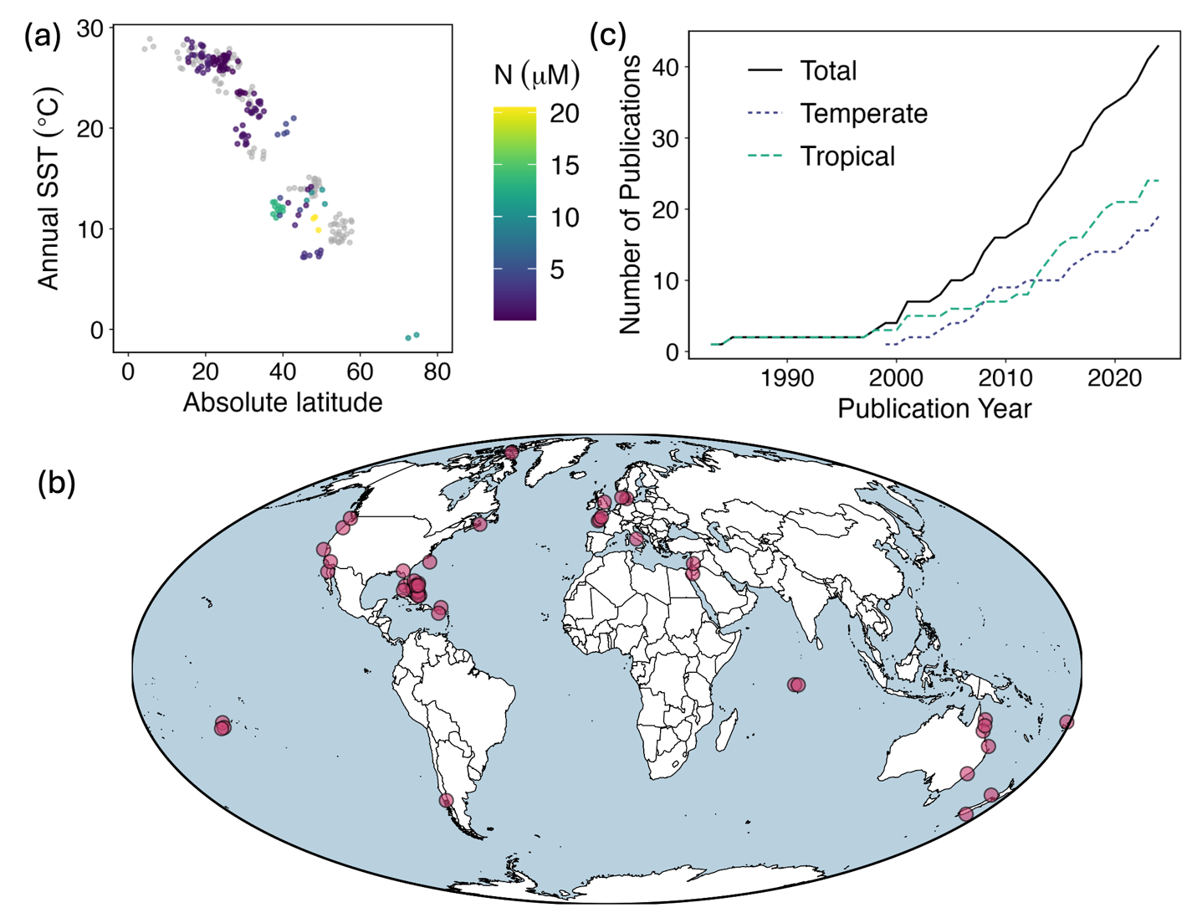
Figure 1. Description of studies included in the meta-analysis on the effect of nutrient provisioning by animals on marine primary producers. a) Relationships between absolute latitude, annual sea surface temperature (SST), and background nitrogen concentrations (N) for the published effect sizes included in our meta-analysis (n = 246). Studies that did not report background N are shown as grey points. b) Geographical locations of studies. c) Rate of accumulation of tropical and temperate studies included in our meta-analysis (n = 43 total).
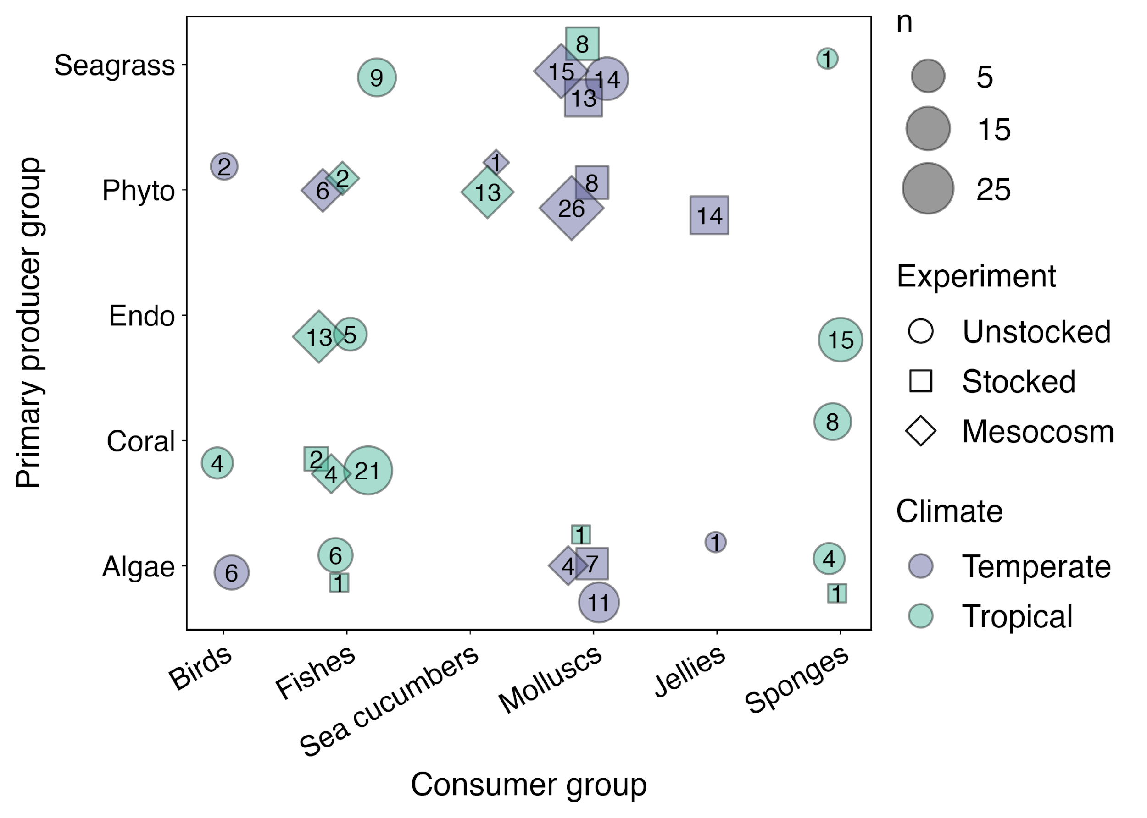
Figure 2. Combinations of primary producer groups, consumer groups, climate regions and experiment types in studies included in the meta-analysis on the effect of nutrient provisioning by animals on marine primary producers. The number of effect sizes in each combination are shown for each point.
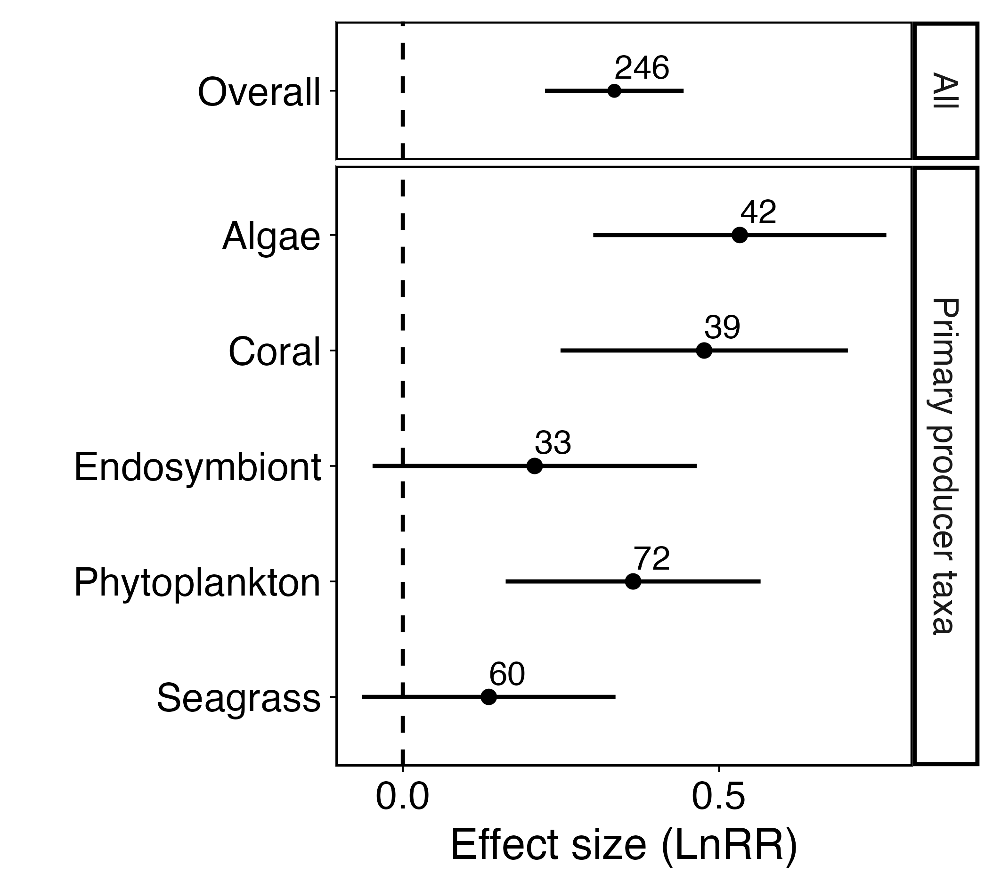
Figure 3. Results of the meta-regression models of the effect of nutrient provisioning by animals on all primary producers (top panel), and each individual taxonomic group (bottom panel). Estimated marginal means are shown as solid points surrounded by 95% confidence intervals with the number of effect sizes in each group shown above each point.
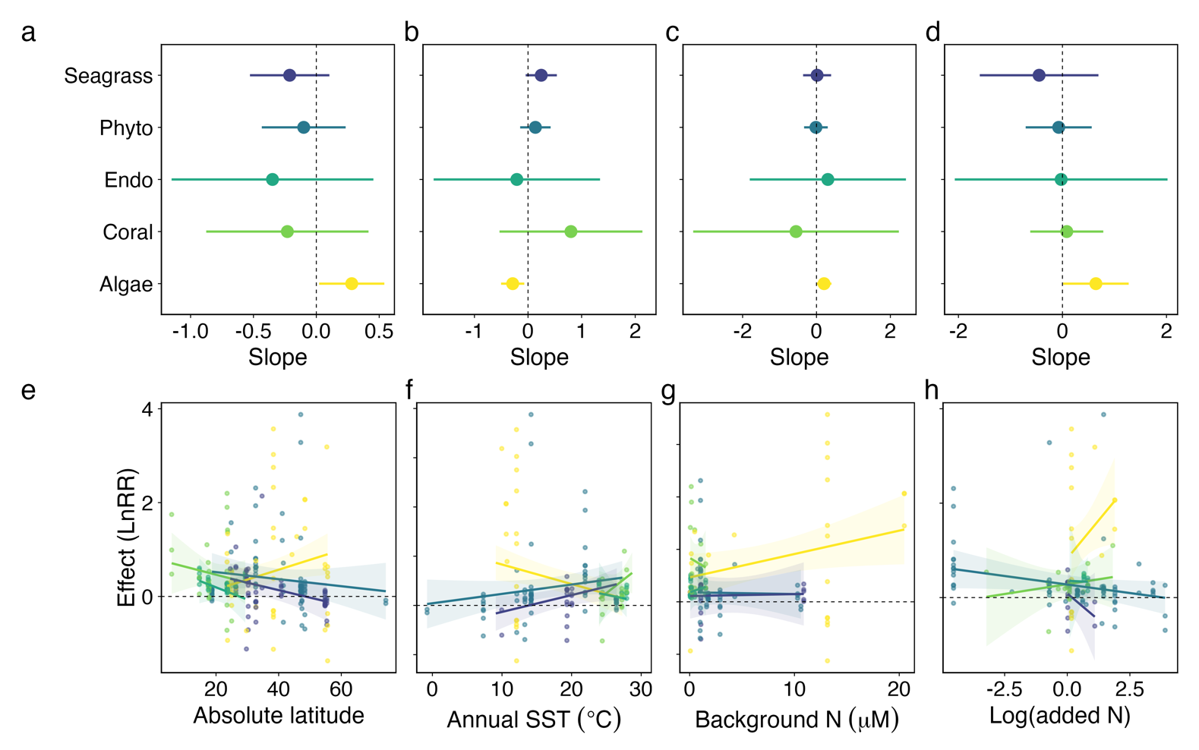
Figure 4. Results of the meta-regression models including (a, e) absolute latitude, (b, f) annual sea surface temperature, (c, g) background N, and (d, h) level of N provisioning (experimental – control N concentration) as continuous moderators. Effect of each moderator on the response of seagrass (purple), phytoplankton (blue), endosymbionts (teal), coral (green), and macroalgae (yellow) to nutrient provisioning by animals shown as (a – d) estimated slopes (filled dots) with 95% confidence intervals (surrounding lines) and (e – h) model-generated predictions across moderator ranges for each producer group, with raw effect sizes plotted as filled dots. An effect size of 0 on the log-transformed ratios of means (LnRR) scale means that the primary producer grew the same with and without nutrient addition. Positive effect sizes indicate larger responses (e.g., more growth) by provisioned than unprovisioned producers.
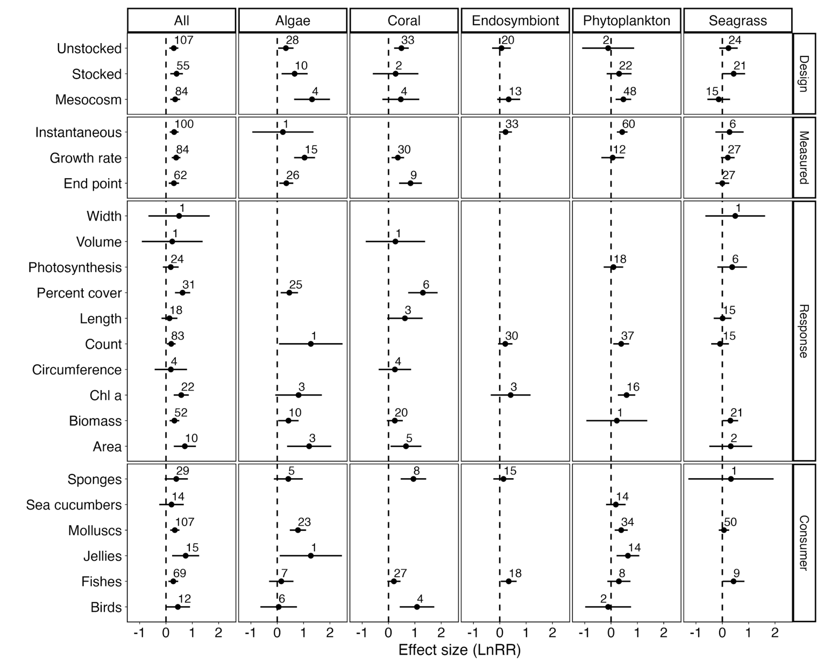
Figure 5. Results of the meta-regression models of the effect of nutrient provisioning by animals on all primary producers (1st column), or each individual taxa (columns 2–6). Models including experimental design (1st row), primary productivity measurement type (2nd row), primary producer response type (3rd row), or consumer taxa (4th row) as moderators. Estimated marginal means are shown as solid points surrounded by 95% confidence intervals with the number of effect sizes in each grouping shown above each point.
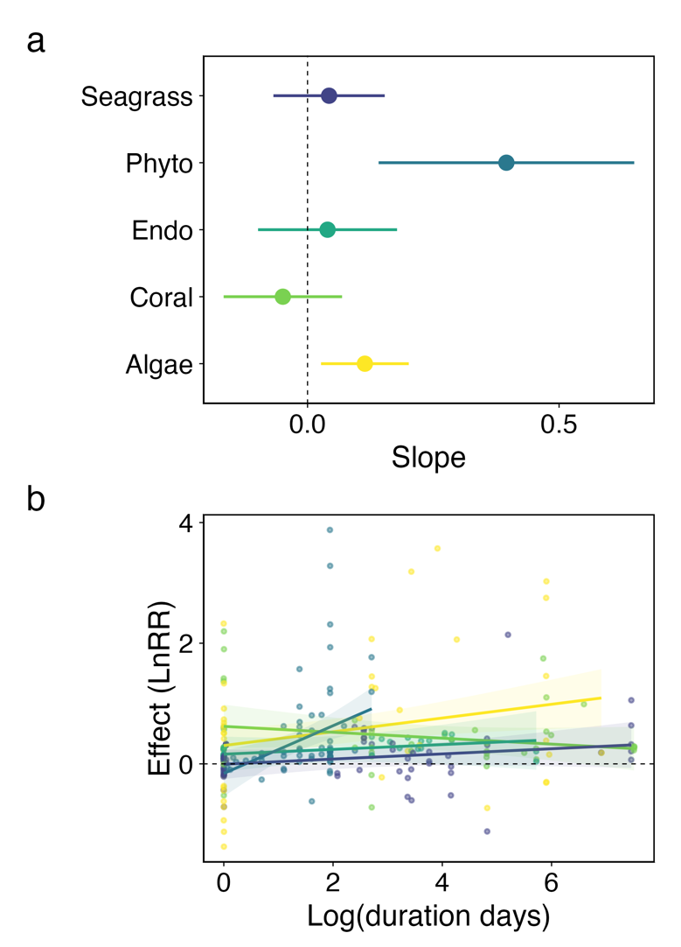
Figure 6. Results of the meta-regression models of the effect of nutrient provisioning by animals on primary producers including experimental duration as a continuous moderator. Effect of duration on the response of seagrass (purple), phytoplankton (blue), endosymbionts (teal), coral (green), and macroalgae (yellow) to nutrient provisioning by animals shown as (a) estimated slopes (filled dots) with 95% confidence intervals (surrounding lines) and (b) model-generated predictions across moderator ranges for each producer group, with raw effect sizes plotted as filled dots.

