Supporting information 2

Article title:
Consumer-mediated nutrient cycling in marine environments: a global meta-analysis

Journal:
Global Ecology and Biogeography

Authors:
Em G Lim^{1§} and Isabelle M Côté¹

Affiliations
¹Biological Sciences, Simon Fraser University, Vancouver, British Columbia, CAN

§Corresponding author
Em G. Lim: em_lim@sfu.ca; em.lim.phd@gmail.com
Department of Biological Sciences
Simon Fraser University
8888 University Drive
Burnaby, BC Canada V5A 1S6

Background phosphorus results
13 out of 43 studies reported background phosphorus (P) concentrations, which contributed 77 effect sizes (~30% of studies and effect sizes). These were not distributed evenly between primary producer groups. Endosymbionts (effect sizes = 5, number of studies = 1), corals (effect sizes = 3, studies = 2), and algae (effect sizes = 5, studies = 3) were poorly represented. Seagrass (effect sizes = 16, studies = 4) were slightly better represented, but the majority of studies that reported P concentration focused on phytoplankton (effect sizes = 48, studies = 6). Due to the very limited replication within most primary producer groups, the leverage (Cook’s distance) for the majority of studies was very high (C_{k} > 5). Therefore, we only report these results for transparency, but urge readers to interpret these results with extreme caution.

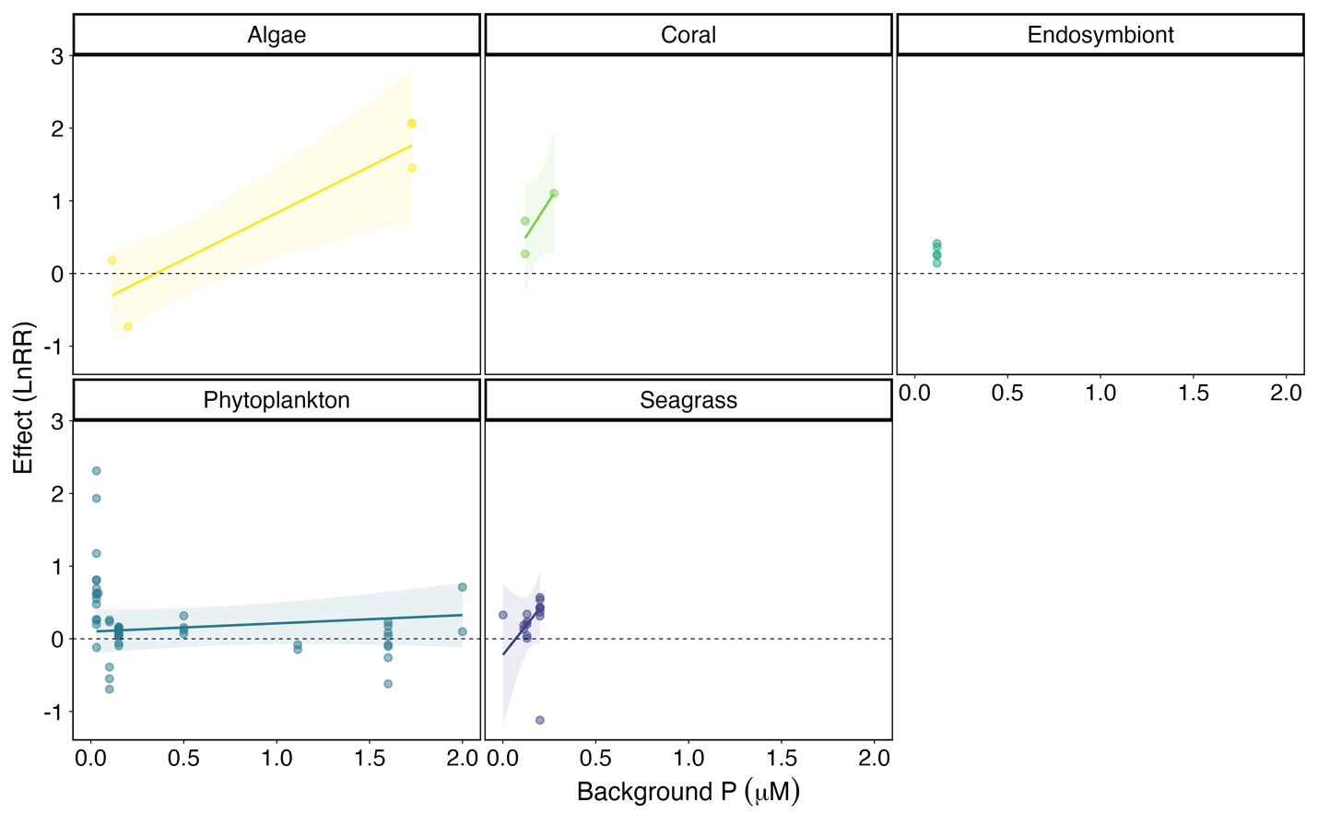
Figure S2.1. Results of the meta-regression model including background phosphorus and primary producer group as moderators. Effect of phosphorus on the response of seagrass (purple), phytoplankton (blue), endosymbionts (teal), coral (green), and algae (yellow) to nutrient provisioning by animals shown as model-generated predictions across reported phosphorus ranges for each producer group, with raw effect sizes plotted as filled dots.

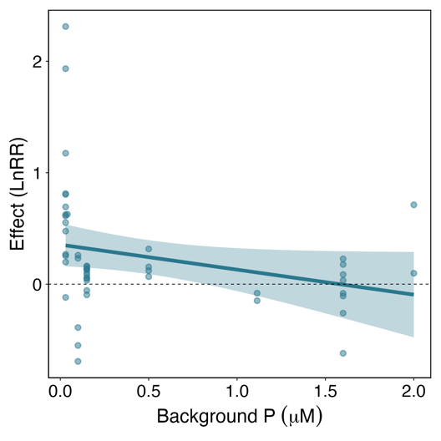
Figure S2.2. Results of the meta-regression model including background phosphorus as a continuous moderator, restricted only to phytoplankton studies. Effect of phosphorus on the response of phytoplankton to nutrient provisioning by animals shown as model-generated predictions, with raw effect sizes plotted as filled dots.

Table S2.1. Results of the three-level mixed-effects meta-regression model of primary producer responses to consumer-mediated nutrient provisioning with background phosphorus (scaled and centered) as a continuous moderator. For the primary producer groups, the estimate and p-value represent a comparison to the “control” level, i.e. algae. All effect sizes for endosymbionts came from one study and therefore had identical background phosphate concentrations, so the model is unable to generate an interaction term, because no slope can be estimated across a single predictor value.
 | estimate | SE | t-value | df | p-value
Intercept | 0.10 | 0.25 | 0.42 | 68 | 0.68
Phosphorus | 0.77 | 0.23 | 3.37 | 68 | 0.001
Coral | 1.6 | 0.95 | 1.69 | 68 | 0.10
Endo | 0.57 | 0.44 | 1.30 | 68 | 0.20
Phyto | 0.04 | 0.29 | 0.14 | 68 | 0.89
Seagrass | 1.15 | 0.86 | 1.33 | 68 | 0.19
Phosphorus: Coral | 1.64 | 2.25 | 0.73 | 68 | 0.47
Phosphorus: Phyto | -0.69 | 0.24 | -2.87 | 68 | 0.01
Phosphorus: Seagrass | 1.39 | 1.92 | 0.73 | 68 | 0.47

Table S2.2. Results of the three-level mixed-effects meta-regression model of primary producer responses to consumer-mediated nutrient provisioning with background phosphorus (scaled and centered) as the only moderator.
 | estimate | SE | t-value | df | p-value
Intercept | 0.31 | 0.12 | 2.5 | 75 | 0.01
Phosphorus | 0.14 | 0.08 | 1.83 | 75 | 0.07

