**Spatial dynamics of animal-mediated nutrients** **in temperate waters**

Em G Lim1, Claire M Attridge1, Jasmin M Schuster2,3, Kieran D Cox1, Kiara R Kattler1, Emily J Leedham1, Bridget Maher2, Andrew L Bickell2, Francis Juanes2, Isabelle M Côté1

1Department of Biological Sciences, Simon Fraser University, Burnaby, British Columbia, Canada

2Department of Biology, University of Victoria, Victoria, British Columbia, Canada

3Hakai Institute, Campbell River, British Columbia, Canada

**Abstract**

Consumer-mediated nutrient dynamics (CND), through which animals’ metabolic waste products fertilize primary producers, is known to drive variability in nutrient availability and thus primary productivity and community functioning in tropical waters. Yet, examinations of CND as a driver of variation in nutrient availability in temperate systems are limited. Therefore, we aimed to quantify and explain spatial variation in CND by surveying fish and macroinvertebrates via Reef Life Survey methods and measuring their ammonium excretions at 27 rocky reefs (3 years) and 17 kelp forests of varying density (1 year) in Barkley Sound, British Columbia. Ammonium concentrations varied from 0.009 to 2.5 uM across rocky reefs, and the relationship between animal biomass and ammonium varied with tidal exchange–weakly positive at slack and ebb tides, but weakly negative at flood tide. Ammonium was significantly higher within than near kelp forests, a difference that increased with tide exchange, kelp and animal biomass. We found fine-scale ammonium variability and nutrient enrichment on a scale of meters was only possible under low flow conditions. Our results suggest CND-driven variability acts on scales ranging from a few meters to over 20 km, contributing to finer-scale variation in nutrient availability than allochthonous nutrient sources such as upwelling. Therefore, CND may play a previously unrecognized role in structuring temperate marine ecosystems from the bottom up.

**Introduction**

Variability in resource availability can drive substantial variation in the growth, biomass and composition of primary producers (Dayton et al., 1999; Leibold, 1991; Tilman, 1984). There is evidence in many marine ecosystems that community structure depends on factors producing variation in the resources available to lower trophic levels, termed bottom-up control (Gruner et al., 2008). Although marine ecologists historically focused on external, abiotic sources of nutrients such as upwelling as drivers of variability in nutrient availability, there is now substantial evidence that consumers contribute to bottom-up effects as well (Allgeier et al., 2017). Animals’ metabolic waste products (i.e., excretion and egestion) fertilize primary producers via a process termed consumer-mediated nutrient dynamics (CND) (Vanni, 2002). However, the relative importance of consumer-regenerated nutrients in contributing to meaningful variation across spatial and temporal scales remains unclear. Therefore, identifying the scale on which biologically relevant variation in nutrient availability contributes meaningfully to community structure remains an active area of research.

Heterogeneity in consumer habitat use contributes substantially to spatial and temporal variation in nutrients supplied by animal waste (Benkwitt et al., 2019; Roman and McCarthy, 2010; Uthicke, 2001). For example, tropical coral reefs provide habitat, shelter, and food sources which attract dense aggregations of vertebrate and invertebrate consumers, and thus regenerated nutrients (Archer et al., 2015; Meyer et al., 1983; Shantz et al., 2015). On a broad scale, productivity increases with proximity to reefs with high densities of fishes (Layman et al., 2016), while on a fine scale, sheltering schools of fish increase nitrogen concentrations around individual heads of corals relative to neighboring uninhabited corals (Holbrook et al., 2008). Diurnal migrations are a source of temporal variation as some fishes travel from their nighttime feeding grounds to daytime hiding spots, transporting substantial quantities of nitrogen with them (Francis and Côté, 2018; Meyer and Schultz, 1985). Larger-scale temporal and spatial variation can arise from the migration of megafauna; whales transport nutrients across thousands of kilometers as they travel from their feeding to breeding grounds (Doughty et al., 2016). However, the current understanding of animal-driven spatio-temporal variability of nitrogen is drawn substantially from tropical ecosystems, often disregarding productive temperate marine ecosystems.

In temperate waters, external sources of nutrients, such as upwelling and freshwater runoff, are generally thought to be dominant drivers of nitrogen variability (Dayton et al., 1999; Mann, 1973). Due to the open nature of nearshore environments, high water flow due to currents, tides, and wave action are theorized to limit small-scale nutrient variation (Probyn and Chapman, 1983). Therefore, research on intertidal and shallow subtidal ecosystems has traditionally focused on top-down, trophic interactions as drivers of community composition at small scales, and considered resource limitation mainly at large, regional or continental scales (Menge, 1992; Paine, 1986). However, evidence suggests meso-scale variation in allochthonous nitrogen via upwelling may contribute to bottom-up control of benthic marine communities (Nielsen and Navarrete, 2004) and even weaken top-down control (Sellers et al., 2020). For example, intertidal mussel beds contributed to meso-scale (10 to 100 km) variation in nitrogen via regenerative processes along a coastline with varying mussel cover (Pfister et al., 2014). In a nearby wave-exposed shoreline, mussels also contributed to small, local-scale (1 – 100 m2) variation by increasing the concentration of nitrogen in the water column directly over the mussel beds (Aquilino et al., 2009). Vertical gradients in ammonium concentration in the water column arise from microbial remineralization in sandy sediment around kelp forests (Lowman et al., 2023). Therefore, regenerated nitrogen may contribute substantially to large-, meso-, and small-scale variation in nutrient availability, even in high-flow, upwelling nearshore coastal ecosystems.

Contrary to experiments that focused on intertidal animals as sources of nitrogen, here we consider animal-mediated variation in nutrient availability in shallow subtidal rocky reef and kelp forest communities. Both of these habitats attract dense aggregations of fishes and invertebrates, many of which are economically, ecologically, and culturally important (Steneck et al., 2002). These animals excrete metabolic waste in the form of ammonium (NH₄⁺), which is preferentially taken up by primary producers over other forms of nitrogen like nitrate and nitrite (Lobban and Harrison, 1994; Phillips and Hurd, 2004). These biomass and biodiversity hot spots may also contribute to nutrient hotspots on small to meso scales. Fast-growing canopy kelps, which form expansive underwater forests, may benefit from these excretions directly as a source of nitrogen, especially during low upwelling periods (Brzezinksi et al., 2013). These kelps, which comprise giant kelp (*Macrocystis pyrifera*) and bull kelp (*Nereocystis leutkeana*) in the northeast Pacific region, also affect seawater hydrodynamics and physical composition, both slowing flow within forests and creating gradients of carbon content, pH, alkalinity, and oxygen (Gaylord et al., 2007; Pfister et al., 2019). These modifications to the physical environment could affect the productivity and community composition of other primary producers, also contributing to small-scale spatial heterogeneity.

We aimed to quantify the contribution of regenerated nutrients to spatial variability in a temperate, wave-swept upwelling region: Barkley Sound in British Columbia (BC), Canada. This region is located on the traditional territories of the Huu-ay-aht First Nations and comprises an archipelago of islands, which are dotted with rocky reefs and kelp forests. Specifically, we measured variation in ammonium (NH₄⁺) concentrations among rocky reef sites, within kelp forest sites, and at an even smaller scale of a few metres. We quantified the abundance and diversity of fish and invertebrate communities at each rocky reef and kelp forest site, measured kelp forest metrics, and other abiotic variables to explore drivers of potential variation in NH₄⁺ concentrations. Due to this region’s external nutrient sources and high flow, CND would not be expected to contribute substantially to small-scale nutrient variability, but we hypothesize that meso-scale, among-site variation may be possible under normal mixing conditions. By characterizing the meaningful scale of animal-driven nutrient variability in this temperate region, we hope to better explain the role of consumers in structuring not only top-down, but also bottom-up control.

**Methods**

*Site description*

Barkley Sound is located in an upwelling region on the west coast of Vancouver Island, Canada. Upwelling supplies nitrates in the spring and early summer, while storm flush riverine inputs into the nearshore in the winter and spring (Pawlowicz, 2017). Due to the proximity of the Bamfield Marine Sciences Centre (BMSC), this region has been a long-term focal area for studies seeking to unravel ecosystem dynamics, document large-scale patterns of kelp response to heatwaves and establish ecological baselines (cite some BMSC papers here?). Subtidal fish communities include gobies, surfperches, rockfishes, greenlings, and sculpins. Invertebrate assemblages are dominated by urchins, turban snails, sea stars, abalone, and sea cucumbers.

*Among-site (meso-scale) variation*

We considered meso-scale variation as the differences in ammonium (NH₄⁺) concentrations among rocky reef sites, which ranged from 0.06 – 24 km apart (Fig. 1). We collected subtidal NH4+ samples paired with fish and invertebrate surveys using a globally standardized method (i.e., Reef Life Survey, RLS) at 27 subtidal sites near the BMSC from the end of April / early May to early May/mid-May each of three years (2021 – 2023) (Table 1). A full explanation of the Reef Life Survey method is available online (http://www.reeflifesurvey.com/methods) and provided by Edgar and Stuart-Smith (2009) and Edgar et al. (2020). At each rocky reef site, a pair of trained SCUBA divers assessed fish and invertebrate abundance and diversity along each side of a 50 m transect line (Fig. 2). First, fishes in the water column were counted and sized (total length, in various size class categories) within 5 m on either side of the transect line, and then cryptic fishes (also sized) and large mobile invertebrates (> 2.5 cm) were counted within 2.5 m on either side of the transect line.

Immediately following the RLS survey, we collected three 60 mL subtidal seawater samples along the transect (at 0, 25, and 50 m) at consistent depths and stored the syringes in sealed plastic bags upon collection to prevent contamination. Seawater samples were filtered into amber bottles in the field and frozen for a maximum of two weeks before NH4+ analysis. We confirmed that freezing samples for this duration did not affect NH4+ concentration (Lim, unpublished data). In 2021 and 2022, we followed the fluorometric method using 40 mL seawater samples (Holmes et al., 1999), and in 2023 we followed the fluorometric standard-additions protocol II (Taylor et al., 2007). For each survey, we took the average of the three NH4+ samples as the mean NH4+ concentration. Detailed NH₄⁺ analysis methodology is available in the supplement (S1?).

*Within-site (small-scale) variation*

To explore within-site variability, we measured NH4+ concentrations in and around kelp forests of varying density and composition at 16 sites in Barkley Sound from July to September 2022 (Table 2). Our sites comprised forests of varying densities dominated by giant kelp or bull kelp, as well as a sandy, no-kelp control site. First, to quantify the abundance and biodiversity of animal communities associated with each kelp forest, trained SCUBA divers counted and identified fish and invertebrate along 50 m transect lines placed immediately adjacent to the kelp forest following the RLS protocol as above. Next, we ran four 5 m-long transects, 5 m apart, into the kelp forest to assess kelp density, canopy height, and biomass (Fig. 2). We counted the number of canopy kelp individuals (bull or giant kelp) within 0.5 m on either side of the kelp transect to measure kelp density. To estimate canopy height, we measured the length of five randomly chosen kelp individuals per kelp transect; for bull kelp we measured the total length from holdfast to pneumatocyst *in situ*, but for giant kelp we collected five random individuals to measure from holdfast to apical meristem on dry land. To quantify bull kelp biomass, we measured the sub-bulb circumference (15 cm below the bottom of the bulb) of the same five bull kelps per transect *in situ* and calculated individual biomass using a quadratic diameter to biomass formula (Attridge, unpublished data). For giant kelp biomass, we weighed using X brand scale the same five individuals per transect that were collected for total length measurements. We multiplied the mean biomass estimate for each kelp species by the species density to calculate a biomass/m2 estimate for each kelp transect, which we then averaged over the four transects per forest to estimate overall mean forest biomass/m2. We estimated total forest area by swimming around the perimeter of the forest on the surface with a Garmin GPS(?).

Finally, to compare NH₄⁺ concentrations inside vs outside each kelp forest, we collected paired 60 mL syringes of seawater immediately outside the kelp forest within 0 – 2 m from the substrate, and 5 m into the kelp forest at the same depth (n = 3 pairs per forest). These paired seawater samples were matched to the first three kelp density, biomass, and canopy height transects. Outside each kelp forest, we also filled a Whirl-PakTM sample bag with seawater, to use in creating standards. Upon surfacing, we filtered 40 mL of each sample into amber bottles and also filled 8 amber bottles each with 40 mL of filtered seawater from the Whirl-Pak. We stored all samples on ice for transportation back to the laboratory, at which point we measured NH4+ concentration in each sample bottle following the fluorometric standard-additions protocol II (Taylor et al., 2007). For each paired inside vs outside NH₄⁺ sample, we calculated ∆ NH₄⁺ = inside NH₄⁺ - outside NH₄⁺.

*Within-meters (very small-scale) variation*

To assess the potential for animals to contribute to very small-scale nutrient variability, we conducted two caging experiments *in situ* to measure the effect of animals on the NH4+ concentration in their immediate surroundings. Both experiments were conducted near Bamfield; the first caging experiment took place at Scott’s Bay (48°50'05.2"N 125°08'49.3"W) on May 27, 2021. We constructed 18 wire cages X x X x X, which we covered in X mm plastic mesh. These cages were spaced 3 m apart along two weighted lines and deployed at 3 to 5.8 m depth (9 cages per line). We collected California sea cucumbers (*Apostichopus californicus*) from the site via SCUBA, measured contracted sea cucumber length and girth, and immediately placed them into the cages in randomly assigned densities of 0, 1, or 2 sea cucumbers (n = 6 replicates per density). After 24 h, we returned to collect water samples from each cage *in situ*. While underwater, we minimized water movement by reducing our fin and hand movements while opening the mesh lids, which were secured with wire, just wide enough to collect a 60 mL syringe of seawater. We Once at the surface, we filtered 40 mL of each sample into amber bottles and transported them on ice to the lab, where we measured NH4+ using the fluorometry (Holmes et al., 1999).

The second caging experiment took place in Bamfield Inlet (48°49'53"N 125°08'11"W) from June 10 – 19, 2023, and we replicated it from June 19 – 28, 2023 following the same methodology. For these experiments, we used red rock crabs (*Cancer productus*). We collected crabs from the site using crab traps and kept them at BMSC in flow-through sea tables for 2 – 10 days. Crabs were fed salmon every 2 – 4 days, and all crabs were fed the night before each experiment started. We constructed 12 cages from clear plastic X x X x X cm, with two X x X cm windows covered in a dual layer of X mm plastic mesh and X mm mesh to allow for water flow. The cages were randomly distributed every 2 m along a lead line anchored with cement buckets 0.8 m below chart datum. Each cage contained either one large crab (carapace 15.0 – 15.9 cm), one medium size crab (11.6 – 14.4 cm), or a control (i.e., a small rock, scraped clean, to weight the cages similarly to the crabs) (n = 4 replicates per experiment). During both experiments, we replaced the crabs after 4 days with freshly fed, similar-sized crabs, at which point we re-randomized the order of the cages along the line. We measured seawater NH₄⁺ concentration via snorkel at low tide at the beginning, middle, and end of each nine-day experiment by drawing water samples using a 60 mL syringe and a narrow tube attached to the centre of the cage. We filtered 40 mL of each sample into amber bottles, which were stored on ice before NH₄⁺ analysis via fluorometric standard-additions protocol II (Taylor et al., 2007).

*Statistical analyses*

All statistical analysis were conducted in R (v4.1.2, R Core Team, 2019) using RStudio (v1.3.1093, RStudio Team, 2016). We used tidyverse packages for data manipulation and visualization (Wickham et al., 2019), ‘glmmTMB’ for all modelling (Brooks et al., 2017), and DHARMa to check model fit (Hartig, 2022). All data and code are available at https://github.com/em-lim13/Ch2_Spatial_pee.

For each Reef Life Survey conducted, we calculated fish biomass from fish length following the formula (W = exp(log(a) + b*log(L))) where W is fish weight, L is the fish length, a and b are species-specific constants from FishBase (Froese et al., 2014). For invertebrates, only sunflower sea stars and economically important species (abalone and scallops) were sized, so we were only able to calculate weights for those species. For all others, we used published weight estimates from this region to estimate rough average weights for each taxon (Table 3). Animal abundance was calculated as the total number of fishes and invertebrates counted on each survey, and we used the ‘vegan’ package to calculate Shannon and Simpson diversity indices (Oksanen et al., 2022). We calculated the tide exchange by computing the rate of change of the tide height every minute, starting from the time each survey started and ending one hour later, and taking the average of those values. We downloaded tide height data from the website: <http://tbone.biol.sc.edu/tide/tideshow.cgi?site=Bamfield%2C+British+Columbia>.

Among-site (meso-scale) variation

To determine whether there was significant variation in NH₄⁺ among sites, we constructed generalized linear mixed-effect models with NH₄⁺ concentration as the response variable, and animal abundance, tide exchange, an interaction between abundance and tide, Shannon diversity, and survey depth as predictors, and a random effect of both site (1|site) and year (1|year). All predictors were scaled and centered around the mean using the scale function. We used a gamma distribution (link = ‘log’). We constructed additional models with animal biomass as a predictor instead of abundance, and Simpson’s diversity or species richness instead of Shannon diversity, but we determined that abundance and Shannon diversity were the best metrics by comparing alternative models using AIC (Table 3). We checked for collinearity of variables using car::vif, and all values were below 1.75. We visually inspected model residuals by plotting the output from DHARMa::simulateResiduals, and the model met all assumptions.

Within-site (small-scale) variation

To determine whether NH₄⁺ concentration differed inside and outside of kelp forests, we used a linear mixed-effects model with ∆ NH₄⁺ as the response variable (n = 3 estimates per site), and kelp species, mean forest kelp biomass/m2, tide exchange, animal biomass, survey depth, Shannon diversity, and interactions between kelp biomass and tide exchange, kelp biomass and animal biomass, and animal biomass and tide exchange as fixed effects. All continuous predictors were scaled and centered around the mean as above. We included site as a random effect (1|site) to account for the fact that each site contributed three estimates to the analysis and used a Gaussian distribution. We inspected residuals and checked for collinearity as above, and the model met all assumptions. Should I mention models with alternate variables?

Within-meters (very small-scale) variation

To quantify the ability of caged animals to affect the NH₄⁺ concentration in their immediate vicinity, we constructed separate linear models for each caging experiment. For the sea cucumber experiment, we regressed cage NH₄⁺ concentration against the treatment (i.e., sea cucumber density: 0, 1, or 2 sea cucumbers) and cage depth (centered) using a Gaussian distribution. Inspection of the residuals revealed no significant problems. For the red rock crab experiment, we constructed a generalized linear mixed-effects model with cage NH₄⁺ concentration as the response variable, treatment (no crab, medium crab, or large crab) as the predictor variable, and a random effect of sampling day. We used a gamma distribution (link = ‘log’) to ensure model residuals met all assumptions.

**Results**

We found evidence of meso-scale variation in ammonium (NH₄⁺) concentrations, which ranged from 0.01 μM – 2.54 μM among rocky reefs in Barkley Sound (Fig. 1). Overall, we found no evidence that NH₄⁺ concentration was correlated with animal abundance (estimate ± SE; - 0.61 ± 0.26, p = 0.90), tide exchange (0.02 ± 0.08, p = 0.82), Shannon diversity (- 0.04 ± 0.11, p = 0.071), or survey depth (0.04 ± 0.09, p = 0.65, Fig. 3a). However, we did find a significantly negative interaction between animal abundance and tide exchange (- 0.24 ± 0.10, p = 0.02, Fig. 3b), revealing a weakly positive effect of animal abundance on NH₄⁺ concentration, but only at ebb tide.

We also found evidence of small-scale variation; NH₄⁺ concentrations were significantly higher inside than outside giant kelp forests (mean increase ± SE; 0.15 ± 0.04 μM, p < 0.001) and bull kelp forests (0.33 ± 0.06, p < 0.001). The ‘excess’ NH₄⁺ concentration inside kelp forests increased with kelp forest biomass (coefficient ± SE; 0.42 ± 0.06, p < 0.001), tide exchange (0.12 ± 0.03, p < 0.001), and animal biomass (0.15 ± 0.06, p = 0.02, Fig. 4a, b). Ammonium concentrations did not vary between samples taken 5 m apart at the no-kelp control site (0.08 ± 0.11, p = 0.48, Fig. 4a). The difference in NH₄⁺ concentration in vs out of kelp forests decreased with Shannon diversity (- 0.18 ± 0.04, p < 0.001) and there was no effect of survey depth (0.01 ± 0.03, p = 0.82) on ∆ NH₄⁺ (Fig. 4a). We found evidence of a positive interaction between kelp forest biomass and tide exchange (0.29 ± 0.09, p < 0.001, Fig. 4b), whereby (describe the pattern here), but the other two interactions (kelp:animal biomass and tide:animal biomass) were not significant (p > 0.60, Fig. 4a).

We found mixed evidence for variability at very small scales. For sea cucumbers, we found no effect of sea cucumber density on cage NH₄⁺ concentration (p > 0.75 for both treatments, Fig. 5a). However, we did find a positive effect of cage depth (coefficient ± SE; 0.38 ± 0.05, p < 0.001). For red rock crabs, both medium and large crabs significantly increased the cage NH₄⁺ concentration relative to control cages (coefficient ± SE; medium crabs: 2.17 ± 0.22, p < 0.001, large crabs: 2.60 ± 0.26, p < 0.001, Fig. 5b).

**Figures**

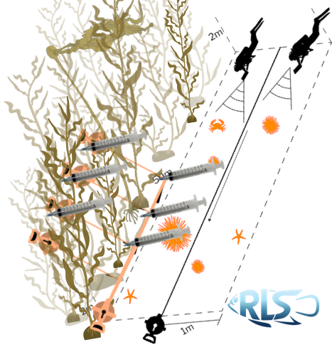

**Figure 1.** Placeholder schematic for the kelp pee samples. I will remake this!!!!!

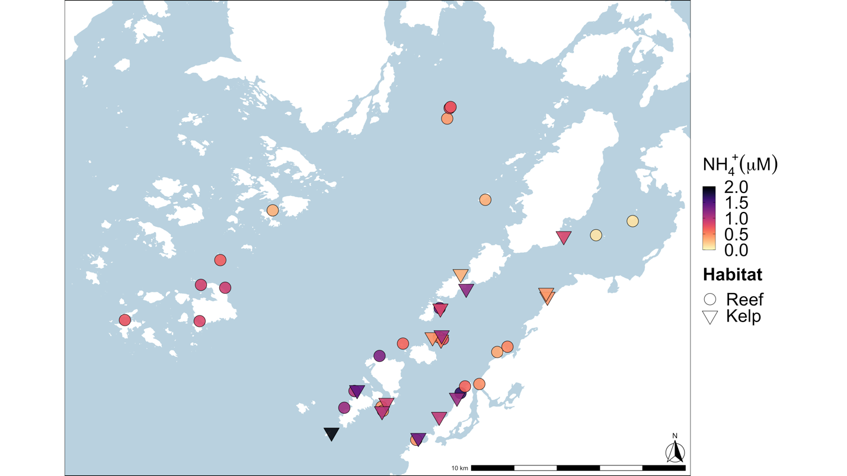

**Figure 2.** Study site map

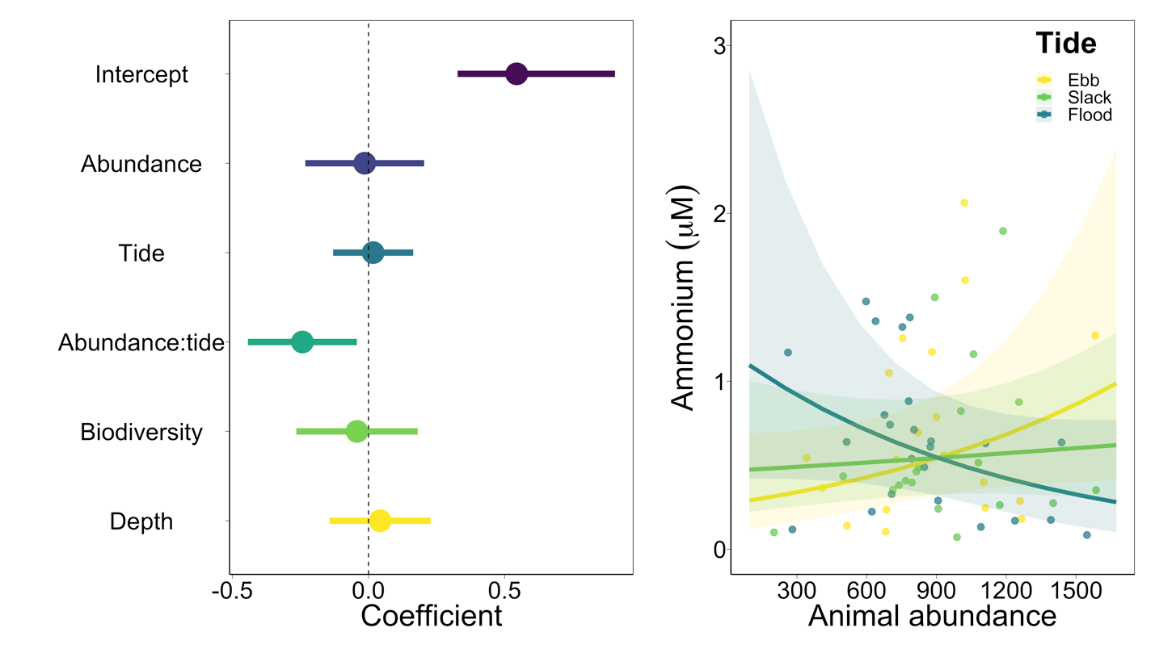

**Figure 3.** Among site model outputs.

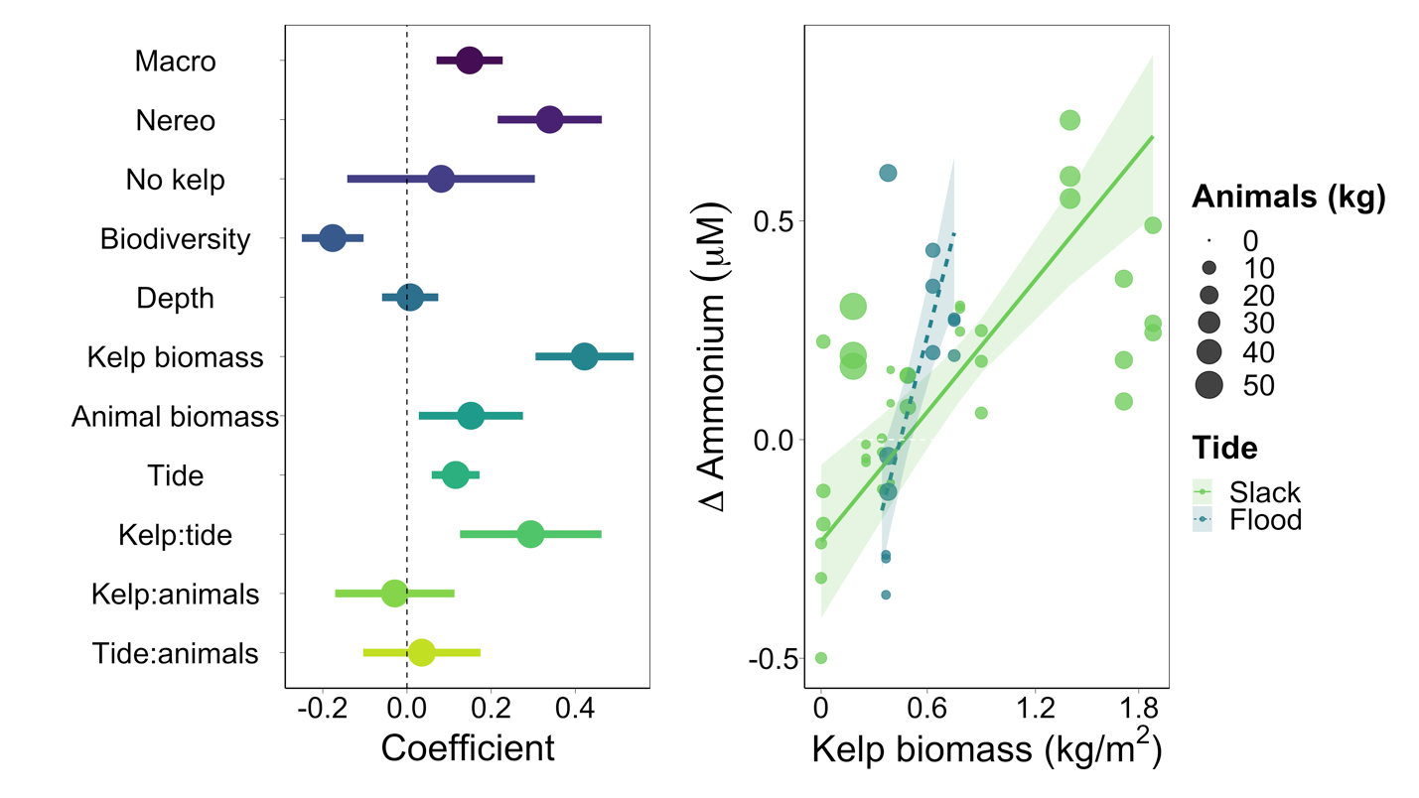

**Figure 4.** Within site model output

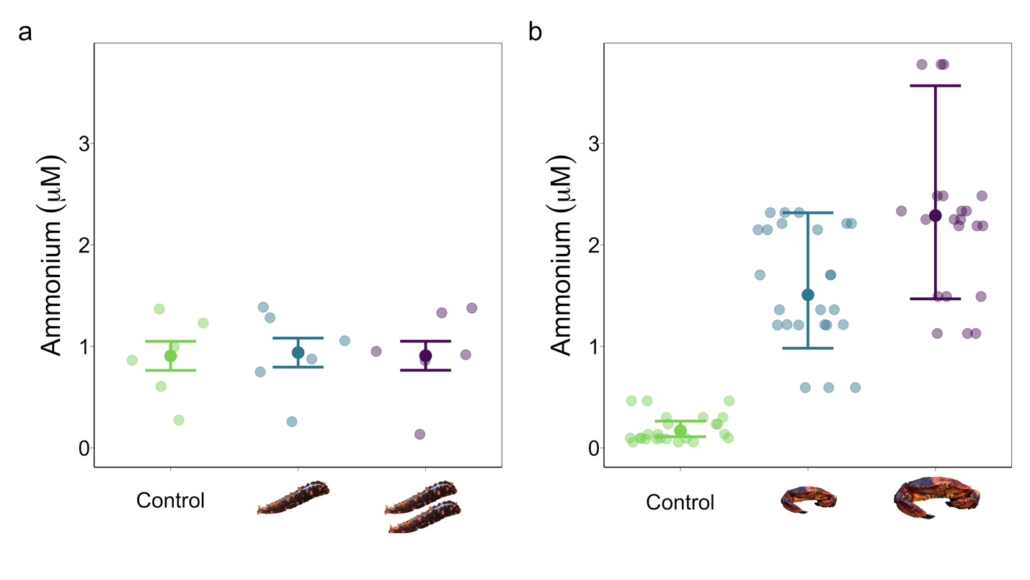**Figure 5.** Within meters crab and cuke cage experiments

**Table 1.** List of rocky reef sites sampled using Reef Life Survey methods, and the years each site was surveyed.

|  |  |  |  |
| --- | --- | --- | --- |
| **Site code** | **Site name** | **Coordinates** | **Years sampled** |
| BMSC1 | Dodger Channel | 48.82894897, -125.1975708 | 2021, 2022, 2023 |
| BMSC2 | Kirby | 48.85039902, -125.1987686 | 2021, 2023 |
| BMSC3 | Ohiat | 48.85558319, -125.1837997 | 2021, 2022, 2023 |
| BMSC4 | Kii xin | 48.81511688, -125.1753311 | 2021, 2023 |
| BMSC5 | Taylor Rock | 48.82733154, -125.1966019 | 2021, 2022, 2023 |
| BMSC6 | Baeria Rocks South Island | 48.95023346, -125.1555481 | 2021, 2022, 2023 |
| BMSC7 | Baeria Rocks North Island Southside | 48.95464325, -125.1539917 | 2021 |
| BMSC8 | Baeria Rocks North Island Northside | 48.95508194, -125.1533737 | 2021, 2022, 2023 |
| BMSC9 | Eagle Bay | 48.83478928, -125.1470261 | 2021, 2022, 2023 |
| BMSC10 | Ross Islets Slug Island | 48.87051773, -125.160347 | 2021, 2022, 2023 |
| BMSC11 | Wizard Island South | 48.85746765, -125.1582336 | 2021, 2022, 2023 |
| BMSC12 | Wizard Island North | 48.858284, -125.1609192 | 2021, 2022, 2023 |
| BMSC13 | Effingham West | 48.8650322, -125.3137207 | 2021, 2022 |
| BMSC14 | Effingham Archipelago | 48.87908173, -125.2974014 | 2021, 2022 |
| BMSC15 | Raymond Kelp Rock | 48.88028336, -125.3128815 | 2021, 2022 |
| BMSC16 | Faber Islets | 48.89070129, -125.300499 | 2021, 2022 |
| BMSC17 | Wouwer Channel | 48.86548233, -125.3614807 | 2021, 2022 |
| BMSC18 | Eussen Rock | 48.91161728, -125.2670364 | 2021, 2022 |
| BMSC19 | Ed King SW Pyramid | 48.82860184, -125.2212982 | 2021, 2022, 2023 |
| BMSC20 | Ed King East | 48.83566666, -125.214798 | 2021, 2022, 2023 |
| BMSC21 | Dixon SW | 48.85205078, -125.1235657 | 2021, 2022, 2023 |
| BMSC22 | Dixon Inside | 48.85426712, -125.1170349 | 2021, 2022, 2023 |
| BMSC23 | Aguilar Point | 48.837589, -125.144145 | 2022, 2023 |
| BMSC24 | Swiss Boy | 48.916073, -125.131174 | 2023 |
| BMSC25 | Goby Town | 48.838595, -125.135015 | 2023 |
| BMSC26 | Hosie South | 48.9071, -125.037017 | 2023 |
| BMSC27 | San Jose North Island | 48.901183, -125.060433 | 2023 |

Table 2. Sites used in kelp forest small-scale experiment -add dates?-

|  |  |  |
| --- | --- | --- |
| **Site code** | **Site name** | **Coordinates** |
| KCCA1 | Ross Islet Slug Island | 48.87039, -125.1599 |
| KCCA2 | Between Scotts and Bradys | 48.83287, -125.1493 |
| KCCA3 | Dodger Channel 1 | 48.83072, -125.19439 |
| KCCA4 | Flemming 112 | 48.87868, -125.1434 |
| KCCA6 | Less Dangerous Bay | 48.87535, -125.0915 |
| KCCA7 | Ed King East Inside | 48.83608, -125.2131 |
| KCCA9 | Wizard Islet South | 48.85728, -125.1595 |
| KCCA12 | North Helby Rock | 48.85831, -125.1649 |
| KCCA14 | Danvers Danger Rock | 48.877, -125.0923 |
| KCCA15 | Cable Beach (Blow Hole) | 48.82484, -125.16067 |
| KCCA16 | Tzartus 116 | 48.90084, -125.0811 |
| KCCA17 | Turf Island 2 | 48.884864, -125.146937 |
| KCCA18 | Second Beach | 48.815969, -125.174 |
| KCCA19 | Wizard Islet North | 48.85916, -125.15908 |
| KCCA21 | Bordelais Island | 48.81822, -125.2294516 |
| KCCA22 | Taylor Rock | 48.82721, -125.19717 |

**References**

Allgeier, J.E., Burkepile, D.E., Layman, C.A., 2017. Animal pee in the sea: consumer-mediated nutrient dynamics in the world’s changing oceans. Glob Change Biol 23, 2166–2178. https://doi.org/10.1111/gcb.13625

Aquilino, K.M., Bracken, M.E.S., Faubel, M.N., Stachowicz, J.J., 2009. Local-scale nutrient regeneration facilitates seaweed growth on wave-exposed rocky shores in an upwelling system. Limnol Oceanogr 54, 309–317. https://doi.org/10.4319/lo.2009.54.1.0309

Archer, S.K., Allgeier, J.E., Semmens, B.X., Heppell, S.A., Pattengill-Semmens, C.V., Rosemond, A.D., Bush, P.G., McCoy, C.M., Johnson, B.C., Layman, C.A., 2015. Hot moments in spawning aggregations: implications for ecosystem-scale nutrient cycling. Coral Reefs 34, 19–23. https://doi.org/10.1007/s00338-014-1208-4

Benkwitt, C.E., Wilson, S.K., Graham, N.A.J., 2019. Seabird nutrient subsidies alter patterns of algal abundance and fish biomass on coral reefs following a bleaching event. Glob Change Biol 25, 2619–2632. https://doi.org/10.1111/gcb.14643

Brooks, M.E., Kristensen, K., van Benthem, K.J., Magnusson, A., Berg, C.W., Nielsen, A., Skaug, H.J., Mächler, M., Bolker, B.M., 2017. glmmTMB balances speed and flexibility among packages for zero-inflated generalized linear mixed modeling. The R Journal 9, 378. https://doi.org/10.32614/RJ-2017-066

Brzezinksi, M., Reed, D., Harrer, S., Rassweiler, A., Melack, J., Goodridge, B., Dugan, J., 2013. Multiple sources and forms of nitrogen sustain year-round kelp growth on the inner continental shelf of the Santa Barbara Channel. Oceanog 26, 114–123. https://doi.org/10.5670/oceanog.2013.53

Dayton, P.K., Tegner, M.J., Edwards, P.B., Riser, K.L., 1999. Temporal and Spatial Scales of Kelp Demography: The Role of Oceanographic Climate. Ecological Monographs 69, 219–250. https://doi.org/10.1890/0012-9615(1999)069[0219:TASSOK]2.0.CO;2

Doughty, C.E., Roman, J., Faurby, S., Wolf, A., Haque, A., Bakker, E.S., Malhi, Y., Dunning, J.B., Svenning, J.-C., 2016. Global nutrient transport in a world of giants. Proceedings of the National Academy of Sciences 113, 868–873. https://doi.org/10.1073/pnas.1502549112

Edgar, G., Stuart-Smith, R., 2009. Ecological effects of marine protected areas on rocky reef communities—a continental-scale analysis. Mar. Ecol. Prog. Ser. 388, 51–62. https://doi.org/10.3354/meps08149

Edgar, G.J., Cooper, A., Baker, S.C., Barker, W., Barrett, N.S., Becerro, M.A., Bates, A.E., Brock, D., Ceccarelli, D.M., Clausius, E., Davey, M., Davis, T.R., Day, P.B., Green, A., Griffiths, S.R., Hicks, J., Hinojosa, I.A., Jones, B.K., Kininmonth, S., Larkin, M.F., Lazzari, N., Lefcheck, J.S., Ling, S.D., Mooney, P., Oh, E., Pérez-Matus, A., Pocklington, J.B., Riera, R., Sanabria-Fernandez, J.A., Seroussi, Y., Shaw, I., Shields, D., Shields, J., Smith, M., Soler, G.A., Stuart-Smith, J., Turnbull, J., Stuart-Smith, R.D., 2020. Establishing the ecological basis for conservation of shallow marine life using Reef Life Survey. Biological Conservation 252, 108855. https://doi.org/10.1016/j.biocon.2020.108855

Francis, F.T., Côté, I.M., 2018. Fish movement drives spatial and temporal patterns of nutrient provisioning on coral reef patches. Ecosphere 9, e02225. https://doi.org/10.1002/ecs2.2225

Froese, R., Thorson, J.T., Reyes Jr, R.B., 2014. A Bayesian approach for estimating length-weight relationships in fishes. Journal of Applied Ichthyology 30, 78–85. https://doi.org/10.1111/jai.12299

Gaylord, B., Rosman, J.H., Reed, D.C., Koseff, J.R., Fram, J., MacIntyre, S., Arkema, K., McDonald, C., Brzezinski, M.A., Largier, J.L., Monismith, S.G., Raimondi, P.T., Mardian, B., 2007. Spatial patterns of flow and their modification within and around a giant kelp forest. Limnology and Oceanography 52, 1838–1852. https://doi.org/10.4319/lo.2007.52.5.1838

Gruner, D.S., Smith, J.E., Seabloom, E.W., Sandin, S.A., Ngai, J.T., Hillebrand, H., Harpole, W.S., Elser, J.J., Cleland, E.E., Bracken, M.E.S., Borer, E.T., Bolker, B.M., 2008. A cross-system synthesis of consumer and nutrient resource control on producer biomass. Ecol Lett 11, 740–755. https://doi.org/10.1111/j.1461-0248.2008.01192.x

Hartig, F., 2022. DHARMa: Residual Diagnostics for Hierarchical (Multi-Level / Mixed) Regression Models. R package version 0.4.6.

Holbrook, S.J., Brooks, A.J., Schmitt, R.J., Stewart, H.L., 2008. Effects of sheltering fish on growth of their host corals. Mar Biol 155, 521–530. https://doi.org/10.1007/s00227-008-1051-7

Holmes, R.M., Aminot, A., Kerouel, R., Hooker, B.A., Peterson, B.J., 1999. A simple and precise method for measuring ammonium in marine and freshwater ecosystems. Canadian Journal of Fisheries and Aquatic Sciences 56, 1801–1808. https://doi.org/10.1139/f99-128

Layman, C.A., Allgeier, J.E., Montaña, C.G., 2016. Mechanistic evidence of enhanced production on artificial reefs: A case study in a Bahamian seagrass ecosystem. Ecol Eng 95, 574–579. https://doi.org/10.1016/j.ecoleng.2016.06.109

Leibold, M.A., 1991. Biodiversity and nutrient enrichment in pond plankton communities. Evol. Ecol. Res 1, 73–95.

Lobban, C.S., Harrison, P.J., 1994. Seaweed Ecology and Physiology. Cambridge University Press.

Lowman, H.E., Hirsch, M.E., Brzezinski, M.A., Melack, J.M., 2023. Examining the Potential of Sandy Marine Sediments Surrounding Giant Kelp Forests to Provide Recycled Nutrients for Growth. Journal of Coastal Research 39, 442–454. https://doi.org/10.2112/JCOASTRES-D-22-00035.1

Mann, K.H., 1973. Seaweeds: Their Productivity and Strategy for Growth. Science 182, 975–981. https://doi.org/10.1126/science.182.4116.975

Menge, B.A., 1992. Community Regulation: Under What Conditions Are Bottom-Up Factors Important on Rocky Shores? Ecology 73, 755–765. https://doi.org/10.2307/1940155

Meyer, J.L., Schultz, E.T., 1985. Migrating haemulid fishes as a source of nutrients and organic matter on coral reefs. Limnol Oceanogr 30, 146–156.

Meyer, J.L., Schultz, E.T., Helfman, G.S., 1983. Fish schools: An asset to corals. Science 220, 1047–1049. https://doi.org/10.1126/science.220.4601.1047

Nielsen, K.J., Navarrete, S.A., 2004. Mesoscale regulation comes from the bottom-up: intertidal interactions between consumers and upwelling. Ecology Letters 7, 31–41. https://doi.org/10.1046/j.1461-0248.2003.00542.x

Oksanen, J., Simpson, G.L., Blanchet, F.G., Kindt, R., Legendre, P., Minchin, P.R., O’Hara, R.B., Solymos, P., Stevens, M.H.H., Szoecs, E., Wagner, H., Barbour, M., Bedward, M., Bolker, B., Borcard, D., Carvalho, G., Chirico, M., Caceres, M.D., Durand, S., Evangelista, H.B.A., FitzJohn, R., Friendly, M., Furneaux, B., Hannigan, G., Hill, M.O., Lahti, L., McGlinn, D., Ouellette, M.-H., Cunha, E.R., Smith, T., Stier, A., Braak, C.J.F.T., Weedon, J., 2022. vegan: Community Ecology Package. R package version 2.6-4.

Paine, R.T., 1986. Benthic community—water column coupling during the 1982-1983 El Niño. Are community changes at high latitudes attributable to cause or coincidence?1. Limnology and Oceanography 31, 351–360. https://doi.org/10.4319/lo.1986.31.2.0351

Pawlowicz, R., 2017. Seasonal cycles, hypoxia, and renewal in a coastal fjord (Barkley Sound, British Columbia). Atmosphere-Ocean 55, 264–283. https://doi.org/10.1080/07055900.2017.1374240

Pfister, C.A., Altabet, M.A., Post, D., 2014. Animal regeneration and microbial retention of nitrogen along coastal rocky shores. Ecology 95, 2803–2814. https://doi.org/10.1890/13-1825.1

Pfister, C.A., Altabet, M.A., Weigel, B.L., 2019. Kelp beds and their local effects on seawater chemistry, productivity, and microbial communities. Ecology 100, e02798. https://doi.org/10.1002/ecy.2798

Phillips, J.C., Hurd, C.L., 2004. Kinetics of nitrate, ammonium, and urea uptake by four intertidal seaweeds from New Zealand. J Phycol 40, 534–545. https://doi.org/10.1111/j.1529-8817.2004.03157.x

Probyn, T.A., Chapman, A.R.O., 1983. Summer growth of Chordaria flagelliformis (O.F. Muell.) C. Ag.: Physiological strategies in a nutrient stressed environment. Journal of Experimental Marine Biology and Ecology 73, 243–271. https://doi.org/10.1016/0022-0981(83)90050-3

R Core Team, 2019. R: A language and environment for statistical computing.

Roman, J., McCarthy, J.J., 2010. The Whale Pump: Marine Mammals Enhance Primary Productivity in a Coastal Basin. PLoS ONE 5, e13255. https://doi.org/10.1371/journal.pone.0013255

RStudio Team, 2016. RStudio: Integrated development for R.

Sellers, A.J., Leung, B., Torchin, M.E., 2020. Global meta-analysis of how marine upwelling affects herbivory. Global Ecology and Biogeography 29, 370–383. https://doi.org/10.1111/geb.13023

Shantz, A.A., Ladd, M.C., Schrack, E., Burkepile, D.E., 2015. Fish-derived nutrient hotspots shape coral reef benthic communities. Ecological Applications 25, 2142–2152. https://doi.org/10.1890/14-2209.1

Steneck, R.S., Graham, M.H., Bourque, B.J., Corbett, D., Erlandson, J.M., Estes, J.A., Tegner, M.J., 2002. Kelp forest ecosystems: biodiversity, stability, resilience and future. Environmental Conservation 29, 436–459. https://doi.org/10.1017/S0376892902000322

Taylor, B.W., Keep, C.F., Hall, R.O., Koch, B.J., Tronstad, L.M., Flecker, A.S., Ulseth, A.J., 2007. Improving the fluorometric ammonium method: matrix effects, background fluorescence, and standard additions. Journal of the North American Benthological Society 26, 167–177. https://doi.org/10.1899/0887-3593(2007)26[167:ITFAMM]2.0.CO;2

Tilman, G.D., 1984. Plant Dominance Along an Experimental Nutrient Gradient. Ecology 65, 1445–1453. https://doi.org/10.2307/1939125

Uthicke, S., 2001. Nutrient regeneration by abundant coral reef holothurians. J. Exp. Mar. Biol. Ecol. 265, 153–170. https://doi.org/10.1016/S0022-0981(01)00329-X

Vanni, M.J., 2002. Nutrient cycling by animals in freshwater ecosystems. Annu Rev Ecol Syst 33, 341–370. https://doi.org/10.1146/annurev.ecolsys.33.010802.150519

Wickham, H., Averick, M., Bryan, J., Chang, W., McGowan, L.D., François, R., Grolemund, G., Hayes, A., Henry, L., Hester, J., Kuhn, M., Pedersen, T.L., Miller, E., Bache, S.M., Müller, K., Ooms, J., Robinson, D., Seidel, D.P., Spinu, V., Takahashi, K., Vaughan, D., Wilke, C., Woo, K., Yutani, H., 2019. Welcome to the Tidyverse. Journal of Open Source Software 4, 1686. https://doi.org/10.21105/joss.01686

Discussion notes

* Talk about Cedeno et al., 2021 paper!!! They suggest nitrates = temporal variation in nutrients, but ammonium/regeneration = spatial variation in where animals are! Show surge uptake in Macro, so they just need to be exposed to a burst of strong fish pee = take up and store tons of nitrogen.
* Pfister, Altabet and Weigel 2019 also did pee inside vs out, but only 3 forests and inside vs offshore
* Stewart et al 2009 also did inside vs out
* Make sure to compare magnitudes of variation! 0 – 20 umol nitrite, what increases did Pfister or Aquilio find?