**Spatial dynamics of animal-mediated nutrients** **in temperate waters**

Em G Lim1, Claire M Attridge1, Jasmin M Schuster2,3, Kieran D Cox1, Kiara R Kattler1, Emily J Leedham1, Bridget Maher2, Andrew L Bickell2, Francis Juanes2, Isabelle M Côté1

1Department of Biological Sciences, Simon Fraser University, Burnaby, British Columbia, Canada

2Department of Biology, University of Victoria, Victoria, British Columbia, Canada

3Hakai Institute, Campbell River, British Columbia, Canada

**Abstract**

Consumer-mediated nutrient dynamics (CND), through which animals’ metabolic waste products fertilize primary producers, drives variability in nutrient availability and thus primary productivity and community functioning in tropical waters. Yet, examinations of CND as a driver of variation in nutrient availability in temperate marine ecosystems are limited. Therefore, we aimed to quantify and explain spatial variation in CND by surveying the occurrences of X fish and X macroinvertebrates and measuring their ammonium excretions at 27 rocky reefs (3 years) and 17 kelp forests of varying density (1 year) in Barkley Sound, British Columbia. Ammonium concentrations ranged from 0.009 to 2.5 uM across rocky reefs, and the relationship between animal biomass and ammonium varied with tidal exchange–weakly positive at slack and ebb tides, but weakly negative at flood tide. Ammonium was significantly higher within than near kelp forests, a difference that increased with tide exchange, kelp biomass, and animal biomass. We observed fine-scale ammonium variability and nutrient enrichment on a scale of meters was only possible under low flow conditions. Our results suggest CND-driven variability acts on scales ranging from a few meters to over 20 km, contributing to finer-scale variation in nutrient availability than allochthonous nutrient sources such as upwelling. Therefore, CND may play a previously unrecognized role in structuring temperate marine ecosystems from the bottom up.

**Introduction**

Variability in resource availability can drive substantial variation in the growth, biomass and composition of primary producers (Dayton et al., 1999; Leibold, 1991; Tilman, 1984). There is evidence in many marine ecosystems that community structure depends on factors producing variation in the resources available to lower trophic levels, termed bottom-up control (Gruner et al., 2008). Although marine ecologists historically focused on external, abiotic sources of nutrients such as upwelling as drivers of variability in nutrient availability, there is now substantial evidence that consumers also contribute to bottom-up effects (Allgeier et al., 2017). Animals’ metabolic waste products (i.e., excretion and egestion) fertilize primary producers via a process termed consumer-mediated nutrient dynamics (CND) (Vanni, 2002). However, the relative importance of consumer-regenerated nutrients in contributing to meaningful variation across spatial and temporal scales remains unclear. Therefore, identifying the scale on which biologically relevant variation in nutrient availability contributes meaningfully to community structure remains an active area of research.

Heterogeneity in consumer habitat use contributes substantially to spatial and temporal variation in nutrients supplied by animal waste (Benkwitt et al., 2019; Roman and McCarthy, 2010; Uthicke, 2001). For example, tropical coral reefs provide habitat, shelter, and food sources that attract dense aggregations of vertebrate and invertebrate consumers, which create regenerated nutrients (Archer et al., 2015; Meyer et al., 1983; Shantz et al., 2015). On a broad scale, productivity increases with proximity to reefs with high densities of fishes (Layman et al., 2016), while on a fine scale, sheltering schools of fish increase nitrogen concentrations around individual heads of corals relative to neighboring uninhabited corals (Holbrook et al., 2008). Diurnal migrations are a source of temporal variation as some fishes travel from their nighttime feeding grounds to daytime hiding spots, transporting substantial quantities of nitrogen in their tissues with them (Francis and Côté, 2018; Meyer and Schultz, 1985). Larger-scale temporal and spatial variation can arise from the migration of megafauna; whales transport nutrients across thousands of kilometers as they travel from their feeding to breeding grounds (Doughty et al., 2016). However, the current understanding of animal-driven spatio-temporal variability of nitrogen is drawn substantially from tropical ecosystems, often disregarding productive temperate marine ecosystems.

In temperate waters, external sources of nutrients, such as upwelling and freshwater runoff, are generally thought to be dominant drivers of nitrogen variability (Dayton et al., 1999; Mann, 1973). Due to the open nature of nearshore environments, high water flow due to currents, tides, and wave action are theorized to limit small-scale nutrient variation (Probyn and Chapman, 1983). Therefore, research on intertidal and shallow subtidal ecosystems has traditionally focused on top-down, trophic interactions as drivers of community composition at small scales, and considered resource limitation mainly at large, regional or continental scales (Menge, 1992; Paine, 1986). However, evidence suggests meso-scale variation in allochthonous nitrogen via upwelling may contribute to bottom-up control of benthic marine communities (Nielsen and Navarrete, 2004) and even weaken top-down control (Sellers et al., 2020). For example, intertidal mussel beds contributed to meso-scale (10 to 100 km) variation in nitrogen via regenerative processes along a coastline with varying mussel cover (Pfister et al., 2014). In a nearby wave-exposed shoreline, mussels also contributed to small, local-scale (1 – 100 m2) variation by increasing the concentration of nitrogen in the water column directly over the mussel beds (Aquilino et al., 2009). Vertical gradients in ammonium concentration in the water column can arise from microbial remineralization in sandy sediment around kelp forests (Lowman et al., 2023). Therefore, regenerated nitrogen may contribute substantially to large-, meso-, and small-scale variation in nutrient availability, even in high-flow, upwelling nearshore coastal ecosystems.

Contrary to experiments that focused on intertidal animals as sources of nitrogen, here we consider animal-mediated variation in nutrient availability in shallow subtidal rocky reef and kelp forest communities. Both of these habitats attract dense aggregations of fishes and invertebrates, many of which are economically, ecologically, and culturally important (Steneck et al., 2002). These animals excrete metabolic waste in the form of ammonium (NH₄⁺), which is preferentially taken up by primary producers over other forms of nitrogen like nitrate and nitrite (Lobban and Harrison, 1994; Phillips and Hurd, 2004). These biomass and biodiversity hot spots may also contribute to nutrient hotspots on small to meso scales. Fast-growing canopy kelps, which form expansive underwater forests, may benefit from these excretions directly as a source of nitrogen, especially during low upwelling periods (Brzezinksi et al., 2013). These kelps, which comprise giant kelp (*Macrocystis pyrifera*) and bull kelp (*Nereocystis leutkeana*) in the northeast Pacific region, also affect seawater hydrodynamics and physical composition, both slowing water flow within forests and creating gradients of carbon content, pH, alkalinity, and oxygen (Gaylord et al., 2007; Pfister et al., 2019). These modifications to the physical environment could affect the productivity and community composition of other primary producers, also contributing to small-scale spatial heterogeneity.

We aimed to quantify the contribution of regenerated nutrients to spatial variability in a temperate, wave-swept upwelling region: Barkley Sound in British Columbia (BC), Canada. This region is located on the traditional territories of the Huu-ay-aht First Nations and comprises an archipelago of islands, which are dotted with rocky reefs and kelp forests. Specifically, we measured variation in ammonium (NH₄⁺) concentrations among rocky reef sites, within kelp forest sites, and at an even smaller scale of a few meters. We quantified the abundance and diversity of fish and invertebrate communities at each rocky reef and kelp forest site, measured kelp forest metrics, and other abiotic variables to explore drivers of potential variation in NH₄⁺ concentrations. Due to this region’s external nutrient sources and high flow, CND would not be expected to contribute substantially to small-scale nutrient variability, but we hypothesize that meso-scale, among-site variation may be possible under normal mixing conditions. By characterizing the meaningful scale of animal-driven nutrient variability in this temperate region, we hope to better explain the role of consumers in structuring not only top-down, but also bottom-up control.

**Methods**

*Site description*

Barkley Sound is located in an upwelling region on the west coast of Vancouver Island, Canada. Upwelling supplies nitrates in the spring and early summer, while storms flush riverine inputs into the nearshore in the winter and spring (Pawlowicz, 2017). Due to the proximity of the Bamfield Marine Sciences Centre (BMSC), this region has been a long-term focal area for studies seeking to unravel ecosystem dynamics, document large-scale patterns of kelp response to heatwaves and establish ecological baselines (Attridge et al., 2024; Howard et al., 2019; Starko et al., 2024, 2022; Tanasichuk, 1998). Subtidal fish communities include gobies, surfperches, rockfishes, greenlings, and sculpins. Invertebrate assemblages are dominated by urchins, turban snails, sea stars, abalone, and sea cucumbers.

*Among-site (meso-scale) surveys*

We considered meso-scale variation as the differences in ammonium (NH₄⁺) concentrations among rocky reef sites, which ranged from 0.06 – 24 km apart (Fig. 1). We collected subtidal NH4+ samples paired with fish and invertebrate surveys using a globally standardized method (i.e., Reef Life Survey, RLS) at 27 subtidal sites near the BMSC. Each site was surveyed between the end of April and middle of May for three years (2021-2023), with all annual surveys occurring within 2 weeks of each other (Supplemental Table 1). A full explanation of the Reef Life Survey method is available online (http://www.reeflifesurvey.com/methods) and provided by Edgar and Stuart-Smith (2009) and Edgar et al. (2020). Briefly, at each rocky reef site, a pair of trained SCUBA divers assessed fish and invertebrate abundance and diversity along each side of a 50 m transect line (Fig. 2). First, fishes in the water column were counted and sized (total length, in various size class categories) within 5 m on either side of the transect line, and then benthic cryptic fishes (also sized) and large mobile invertebrates (> 2.5 cm) were counted within 2.5 m on either side of the transect line.

Immediately following the RLS survey, we collected three 60 mL subtidal seawater samples at 0, 25, and 50 m along the transect at consistent depths and stored the syringes in sealed plastic bags upon collection to prevent contamination. Seawater samples were filtered into amber bottles in the field and frozen for a maximum of two weeks before NH4+ analysis. We confirmed that freezing samples for this duration did not affect NH4+ concentration (Lim, unpublished data). In 2021 and 2022, we followed the fluorometric method using 40 mL seawater samples (Holmes et al., 1999), and in 2023, we followed the fluorometric standard-additions protocol II (Taylor et al., 2007). The three NH₄⁺ samples collected during each survey were averaged to determine the mean NH₄⁺ concentration for each site.

*Within-site (small-scale) surveys*

To explore within-site variability, we measured NH4+ concentrations in and around kelp forests of varying density and composition at 16 sites in Barkley Sound from July to September 2022 (Supplemental Table 2). Our sites comprised forests of varying densities dominated by giant kelp (*Macrocystis pyrifera*) or bull kelp (*Nereocystis luetkeana*), as well as two no-kelp control sites. First, to quantify the abundance and biodiversity of animal communities associated with each kelp forest, divers used the RLS protocol to survey fish and invertebrate communities along 50 m transect lines placed immediately adjacent to the kelp forest following the RLS protocol as above. Next, we ran four 5 m-long transects, 5 m apart, into the kelp forest to assess kelp density, canopy height, and biomass (Fig. 2). Divers then counted the number of canopy kelp individuals (bull or giant kelp) within 0.5 m on either side of the kelp transect to measure kelp density. To estimate canopy height, we measured the length of five randomly chosen kelp individuals per kelp transect; for bull kelp we measured the total length from holdfast to pneumatocyst *in situ*, but for giant kelp we collected five random individuals to measure from holdfast to apical meristem on dry land. To quantify bull kelp biomass, we measured the sub-bulb circumference (15 cm below the bottom of the bulb) of the same five bull kelps per transect *in situ* and calculated individual biomass using a quadratic diameter to biomass formula (Attridge, unpublished data). For giant kelp biomass, we weighed using X brand scale the same five individuals per transect that were collected for total length measurements. We multiplied the mean biomass estimate for each kelp species by the species density to calculate a biomass/m2 estimate for each kelp transect, which we then averaged over the four transects per forest to estimate overall mean forest biomass/m2.

Finally, to compare NH₄⁺ concentrations inside vs outside each kelp forest, we collected paired 60 mL syringes of seawater immediately outside the kelp forest within 0 – 2 m from the substrate, and 5 m into the kelp forest at the same depth. We collected three paired NH₄⁺ samples from each site, which were spaced 5 m apart by matching them with the first three kelp transects. Outside each kelp forest, we also filled a Whirl-PakTM sample bag with seawater for creating standards. Upon surfacing, we filtered 40 mL of each sample into amber bottles and also filled 8 amber bottles each with 40 mL of filtered seawater from the Whirl-Pak. We stored all samples on ice for transportation back to the laboratory, at which point we measured NH4+ concentration in each sample bottle following the fluorometric standard-additions protocol II (Taylor et al., 2007). For each paired inside the kelp vs outside the kelp NH₄⁺ sample, we calculated ∆ NH₄⁺ = inside NH₄⁺ - outside NH₄⁺.

*Within-meters (very small-scale) variation*

To assess the potential for animals to contribute to very small-scale nutrient variability, we conducted two caging experiments *in situ* to measure the effect of animals on the NH4+ concentration in their immediate surroundings. Both experiments were conducted near Bamfield; the first caging experiment took place at Scott’s Bay (48°50'05.2"N, 125°08'49.3"W) on May 27, 2021. We constructed 18 wire cages X x X x X, which we covered in X mm plastic mesh. These cages were spaced 3 m apart along two weighted lines and deployed at 3 to 5.8 m depth (9 cages per line). We collected California sea cucumbers (*Apostichopus californicus*) from the site via SCUBA, measured contracted sea cucumber length and girth, and immediately placed them into the cages in randomly assigned densities of 0, 1, or 2 sea cucumbers (n = 6 replicates per density). After 24 h, we returned to collect water samples from each cage *in situ*. While underwater, we minimized water movement by reducing our fin and hand movements while opening the mesh lids, which were secured with wire, just wide enough to collect a 60 mL syringe of seawater. Once at the surface, we filtered 40 mL of each sample into amber bottles and transported them on ice to the lab, where we measured NH4+ using the fluorometric method (Holmes et al., 1999).

The second caging experiment took place in Bamfield Inlet (48°49'53"N 125°08'11"W) from June 10 – 19, 2023, and we replicated it from June 19 – 28, 2023 following the same methodology. For these experiments, we used red rock crabs (*Cancer productus*). We collected crabs from the site using crab traps and kept them at BMSC in flow-through sea tables for 2 – 10 days. Crabs were fed salmon every 2 – 4 days, and all crabs were fed the night before each experiment started. We constructed 12 cages from clear plastic X x X x X cm, with two X x X cm windows covered in a dual layer of X mm plastic mesh and X mm mesh to allow for water flow. The cages were randomly distributed every 2 m along a lead line anchored with cement buckets 0.8 m below chart datum. Each cage contained either one large crab (carapace 15.0 – 15.9 cm), one medium size crab (11.6 – 14.4 cm), or a control (i.e., a small rock, scraped clean, to weight the cages similarly to the crabs) (n = 4 replicates per experiment). During both experiments, we replaced the crabs after 4 days with freshly fed, similar-sized crabs, at which point we re-randomized the order of the cages along the line. We measured seawater NH₄⁺ concentration via snorkel at low tide at the beginning, middle, and end of each nine-day experiment by drawing water samples using a 60 mL syringe and a narrow tube attached to the centre of the cage. We filtered 40 mL of each sample into amber bottles, which were stored on ice before NH₄⁺ analysis via fluorometric standard-additions protocol II (Taylor et al., 2007).

*Statistical analyses*

All statistical analysis were conducted in R (v4.1.2, R Core Team, 2019) using RStudio (v1.3.1093, RStudio Team, 2016). We used tidyverse packages for data manipulation and visualization (Wickham et al., 2019), ‘glmmTMB’ for all modelling (Brooks et al., 2017), and DHARMa to check model fit (Hartig, 2022). All data and code are available at https://github.com/em-lim13/Ch2_Spatial_pee.

For each Reef Life Survey conducted, we calculated fish biomass from fish length following the formula (W = a*Lb) where W is fish weight, L is the fish length, a and b are species-specific constants from FishBase (Froese et al., 2014). For invertebrates, sunflower sea stars and economically important species (abalone and scallops) were measured, so we used published length-weight relationships to calculate wet weight from size. For all other invertebrates, we used published wet weight estimates from this region to estimate rough average biomass for each taxon. We used shell-free wet weight for species with large shells such as hermit crabs and snails. When biomass information was unavailable for a species, we used estimates from the closest relative or most similarly sized species available (Supplemental Table 1). Animal abundance was calculated as the total number of fishes and invertebrates counted on each survey, and we used the ‘vegan’ package to calculate Shannon and Simpson diversity indices (Oksanen et al., 2022). We calculated the tide exchange by computing the rate of change of the tide height every minute, starting from the time each survey started and ending one hour later, and taking the average of those values. We downloaded tide height data from the website: <http://tbone.biol.sc.edu/tide/tideshow.cgi?site=Bamfield%2C+British+Columbia>.

Among-site (meso-scale) variation

To determine whether there was significant variation in NH₄⁺ among sites, we constructed generalized linear mixed-effect models (GLMMs) with NH₄⁺ concentration as the response variable, and animal abundance, tide exchange, an interaction between abundance and tide, Shannon diversity, and survey depth as predictors, and a random effect of both site (1|site) and year (1|year). All predictors were scaled and centered around the mean using the scale function. We used a gamma distribution (link = ‘log’). We constructed additional models with animal biomass as a predictor instead of abundance, and Simpson’s diversity instead of Shannon diversity, but we determined that abundance and Shannon diversity were the best metrics by comparing alternative models using AIC (Supplemental Table 2). We checked for collinearity of variables using car::vif, and all values were below 1.9. We visually inspected model residuals by plotting the output from DHARMa::simulateResiduals, and the model met all assumptions.

We further investigated the relationship between the abundance of individual families and ammonium concentration

Within-site (small-scale) variation

To determine whether NH₄⁺ concentration differed inside and outside of kelp forests, we used a linear mixed-effects model (LMM) with ∆ NH₄⁺ as the response variable (n = 3 estimates per site), and kelp species, mean forest kelp biomass/m2, tide exchange, animal biomass, survey depth, Shannon diversity, and interactions between kelp biomass and tide exchange, kelp biomass and animal biomass, and animal biomass and tide exchange as fixed effects. All continuous predictors were scaled and centered around the mean as above. We included site as a random effect (1|site) to account for the fact that each site contributed three estimates to the analysis and used a Gaussian distribution. As above, we constructed additional models with animal abundance instead of biomass, and Simpson’s diversity instead of Shannon diversity, and chose our final set of predictors upon comparing model AIC values (Supplemental Table 3). We inspected residuals as above, and the model met all assumptions. We also ran our final model with centred continuous variables instead of scaled variables to facilitate interpretation of coefficients in the results.

Within-meters (very small-scale) variation

To quantify the ability of caged animals to affect the NH₄⁺ concentration in their immediate vicinity, we constructed separate linear models for each caging experiment. For the sea cucumber experiment, we regressed cage NH₄⁺ concentration against the treatment (i.e., sea cucumber density: 0, 1, or 2 sea cucumbers) and cage depth (centered) using a Gaussian distribution. The model met all assumptions upon inspection of the residuals. For the red rock crab experiment, we constructed a generalized linear mixed-effects model with cage NH₄⁺ concentration as the response variable and treatment (no crab, medium crab, or large crab) as the predictor variable. We included a random effect of sampling day, because we measured NH₄⁺ three times per experiment, and a random effect of experimental week, because we replicated the whole experiment twice. We used a gamma distribution (link = ‘log’) to ensure model residuals met all assumptions.

**Results**

We found evidence of meso-scale variation in ammonium (NH₄⁺) concentrations, which ranged from 0.01 μM – 2.54 μM among rocky reefs in Barkley Sound (Fig. 1). Overall, we found no evidence that NH₄⁺ concentration was correlated with animal abundance (GLMM, p = 0.90), tide exchange (p = 0.82), Shannon diversity (p = 0.71), or survey depth (p = 0.65, Fig. 3a). However, we did find a significantly negative interaction between animal abundance and tide exchange (p = 0.02, Fig. 3b), revealing a weakly positive effect of animal abundance on NH₄⁺ concentration, but only at ebb tide.

We also found evidence of small-scale variation; NH₄⁺ concentrations were significantly higher inside than outside giant kelp forests (LMM, mean increase ± SE; 0.15 ± 0.03 μM, p < 0.001) and bull kelp forests (0.42 ± 0.06 μM, p < 0.001). The ‘excess’ NH₄⁺ concentration inside kelp forests increased with kelp forest biomass by 0.67 ± 0.09 μM/kg/m2 kelp biomass (p < 0.001), tide exchange (0.42 ± 0.12 μM/m/s, p < 0.001), and animal biomass (0.005 ± 0.002 μM/kg animal biomass, p = 0.004, Fig. 4a, b). Ammonium concentrations did not vary between samples taken 5 m apart at the no-kelp control sites (- 0.10 ± 0.07 μM, p = 0.17, Fig. 4a). The difference in NH₄⁺ concentration in vs out of kelp forests decreased with Shannon diversity (- 0.39 ± 0.10 μM/diversity index unit, p < 0.001) and there was a weakly positive effect of survey depth (0.05 ± 0.02 μM/m, p = 0.03) on ∆ NH₄⁺ (Fig. 4a). We found evidence of a positive interaction between kelp forest biomass and tide exchange, whereby the positive effect of kelp biomass on ∆ NH₄⁺ increased with tide exchange (2.63 ± 0.59 μM/kg/m, p < 0.001, Fig. 4b). We also found a weakly negative interaction between kelp biomass and animal biomass (- 0.005 ± 0.002, p = 0.02), but the interaction between tide exchange and animal biomass was not significant (p = 0.41, Fig. 4a).

We found mixed evidence for variability at very small scales. For sea cucumbers, we found no effect of sea cucumber density on cage NH₄⁺ concentration, which was 0.92 ± 0.04 μM across all cages (LM, p > 0.75 for both treatments, Fig. 5a). However, we did find a positive effect of cage depth, whereby NH₄⁺ increased 0.38 ± 0.05 μM/m (p < 0.001). For red rock crabs, both medium and large crabs significantly increased the cage NH₄⁺ concentration relative to control cages by 804 % and 1266 % respectively (GLMM, p < 0.001 for all, Fig. 5b).

**Figures**

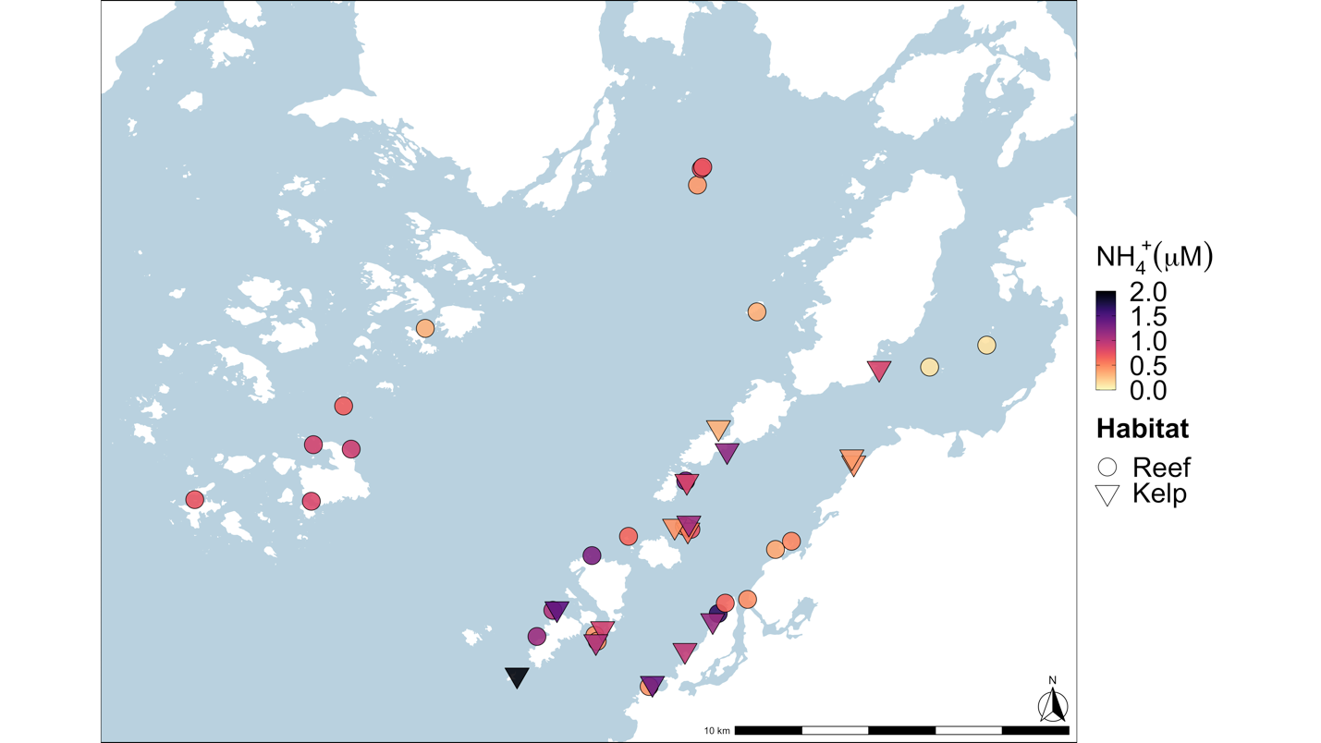**Figure 1.** Rocky reefs (circles) surveyed for among-site, meso-scale ammonium variation, and kelp forests surveyed (triangles) for within-site, small-scale ammonium variation in Barkley Sound, BC. Site colour indicates mean ammonium concentration found at each site, with darker points having higher concentrations of ammonium.

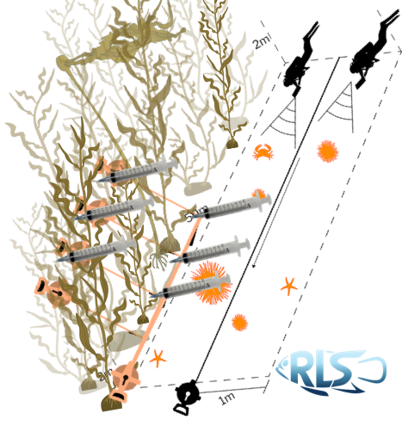

**Figure 1.** Placeholder schematic for the kelp pee samples. I will remake this!!!!!

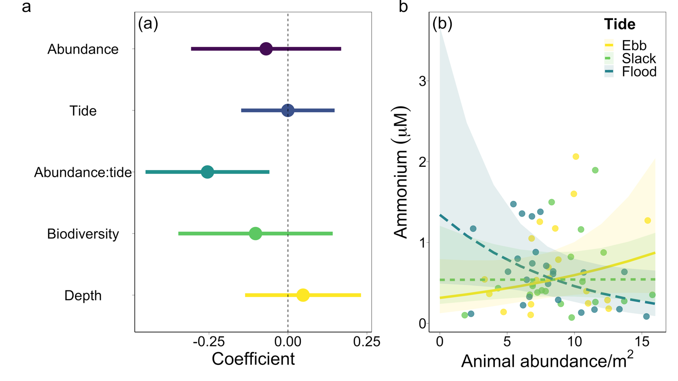

**Figure 3.** (a)Model coefficients surrounded by 95% confidence intervals and (b) model generated predictions for the investigation of among-site, meso-scale variation in ammonium concentration. The coefficients were generated from the generalized linear mixed-effects model, which used a gamma distribution (link = ‘log’) so coefficients are presented in log space. Continuous predictors were centred and scaled for comparison of effect size between varying units.

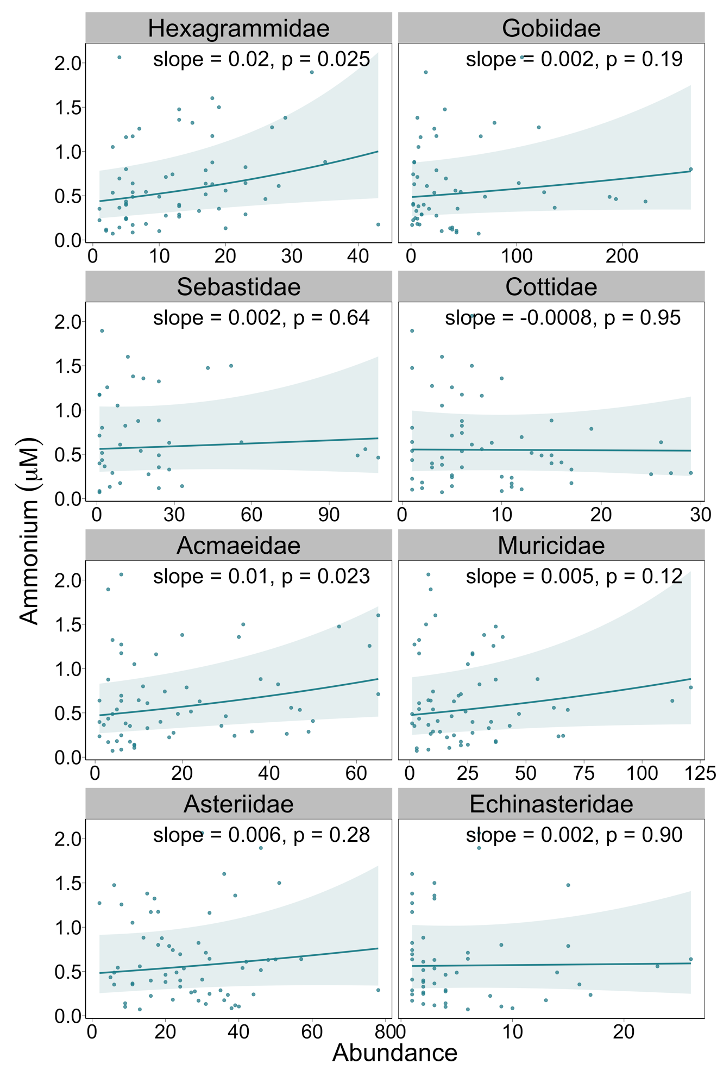

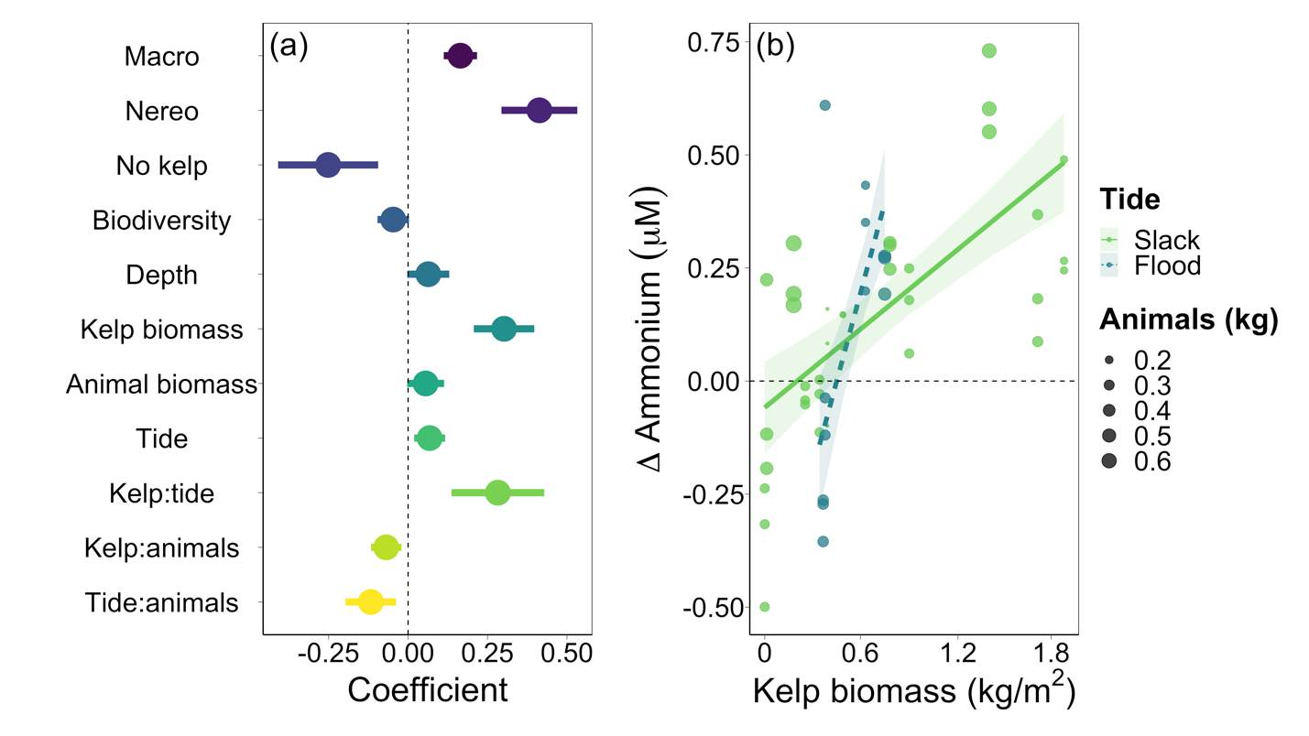

**Figure 4.** (a) Model coefficients surrounded by 95% confidence intervals and (b) model generated predictions for the investigation of within-site, small-scale variation in ammonium concentration. Continuous variables were scaled and centered in order to facilitate comparisons between variables measured in different units.

K so, Marco, Nereo, biodiversity, depth, kelp biomass, animal biomass, tide, kelp: tide, kelp:animals are all popping out.

-You’ve done an awesome job showing animal biomass, tide, and kelp biomass, so this is more or less leaves: Marco, Nereo, biodiversity, animal biomass (optional as species level cause it’s interesting), depth.

-Optional plots to consider would be (and this list is going to be far from perfect given my limited understanding of the data, so tweak it as needed, the point is to show the trends that can be further unpacked and not leave biodiversity is an unresolved place). Plots could either go in the main figure or the supplemental.

-1) Ammoniumconcentrations within macro, nereo, and no kelp sites, either as a box plot (but this will somewhat recreate the trend seen in a), so perhaps include depth in this (although a bit redundant, I think concentrations will be kind of stat that folks cite a lot). This could def be a supplemental plot.

-2) correlation between biodiversity and ammonium concentrations, likely with site type shown. I think it’s important not to leave the biodiversity finding in an unclear place and sort out what specifically is going on, especially as this could be a function of co-linearity, i.e., if the marco sites are more biologically diverse, then the nereo sites, this would contribute to this negative correlation. The same could be true for the no kelp sites given the ‘flaws’ of species richness as a term, i.e., 9 species at a no kelp site that occur at low abundances verse 6 species at a kelp site that occur at high abundances, would create a very understandable negative correlation between richness and ammonium. If you make this plot, rerun it with biomass included to see how it changes).

-3) several plots, each looking at the abundance of a species relative to ammonium concentrations, with the option to scale the size of the points by biomass. Biomass and abundance will be correlated for the inverts because the weights are fixed for each individual, but this isn’t the case for fish, so I’d check the implications of biomass on these plots for fish to determine if biomass needs to be included. This data isn’t really in the model, so there would be the option to make them a standalone plot, but they could also be a bottom panel row. You could make a panel figure for M1 and one for M2, then show the top ~4-5 r2 value species for each. I sent it to you, but just in case it any of this isn’t clear, I’m talking about a plot like this https://www.nature.com/articles/s41598-021-97862-8/figures/3

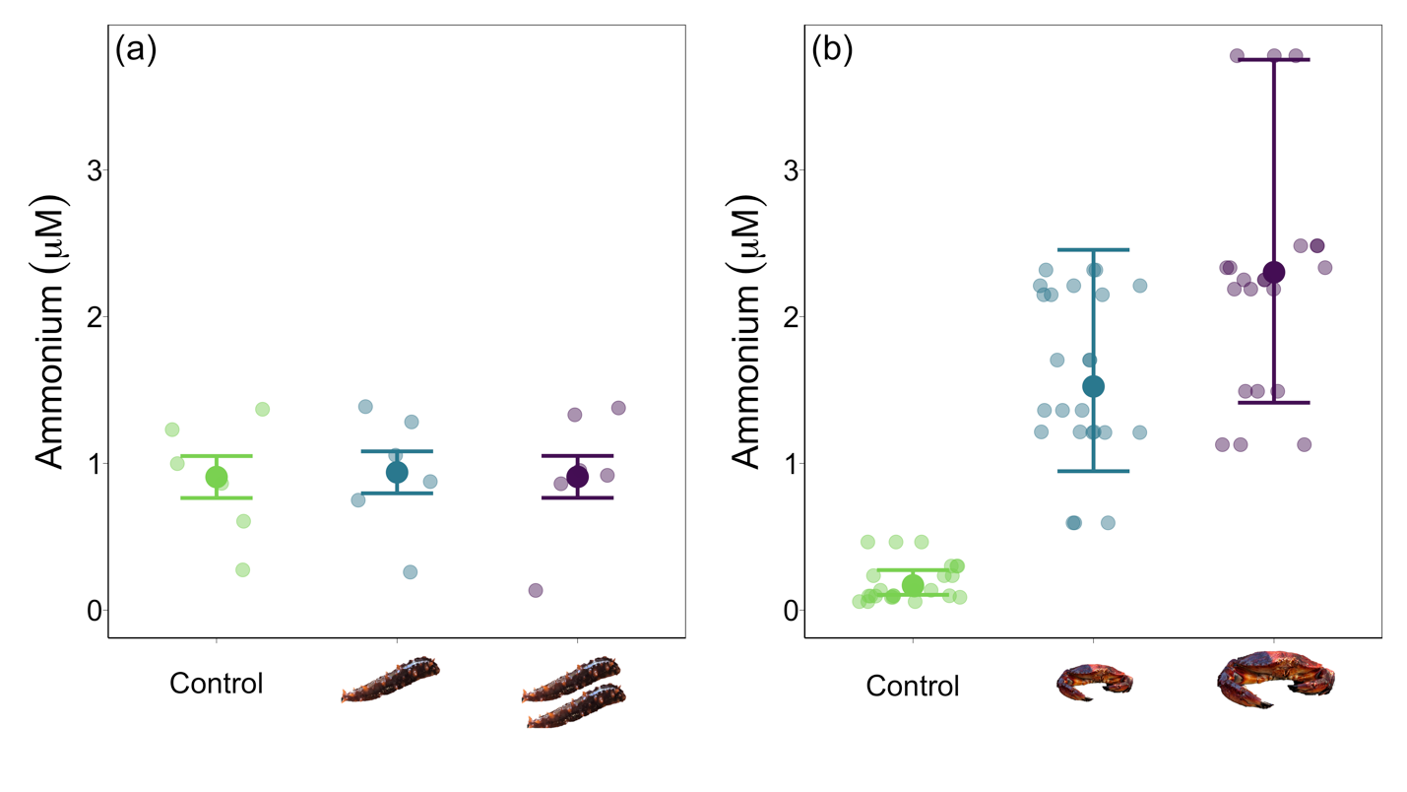

**Figure 5.** Mean ammonium concentration in experimental cages containing (a) zero, one, or two California sea cucumbers, and (b) control, medium size, or large size red rock crab. Error bars indicate 95% confidence intervals.

**Table 1.** List of rocky reef sites sampled using Reef Life Survey methods, and the years each site was surveyed.

|  |  |  |  |
| --- | --- | --- | --- |
| **Site code** | **Site name** | **Coordinates** | **Years sampled** |
| BMSC1 | Dodger Channel | 48.82894897, -125.1975708 | 2021, 2022, 2023 |
| BMSC2 | Kirby | 48.85039902, -125.1987686 | 2021, 2023 |
| BMSC3 | Ohiat | 48.85558319, -125.1837997 | 2021, 2022, 2023 |
| BMSC4 | Kii xin | 48.81511688, -125.1753311 | 2021, 2023 |
| BMSC5 | Taylor Rock | 48.82733154, -125.1966019 | 2021, 2022, 2023 |
| BMSC6 | Baeria Rocks South Island | 48.95023346, -125.1555481 | 2021, 2022, 2023 |
| BMSC7 | Baeria Rocks N Island Southside | 48.95464325, -125.1539917 | 2021 |
| BMSC8 | Baeria Rocks N Island Northside | 48.95508194, -125.1533737 | 2021, 2022, 2023 |
| BMSC9 | Eagle Bay | 48.83478928, -125.1470261 | 2021, 2022, 2023 |
| BMSC10 | Ross Islets Slug Island | 48.87051773, -125.160347 | 2021, 2022, 2023 |
| BMSC11 | Wizard Island South | 48.85746765, -125.1582336 | 2021, 2022, 2023 |
| BMSC12 | Wizard Island North | 48.858284, -125.1609192 | 2021, 2022, 2023 |
| BMSC13 | Effingham West | 48.8650322, -125.3137207 | 2021, 2022 |
| BMSC14 | Effingham Archipelago | 48.87908173, -125.2974014 | 2021, 2022 |
| BMSC15 | Raymond Kelp Rock | 48.88028336, -125.3128815 | 2021, 2022 |
| BMSC16 | Faber Islets | 48.89070129, -125.300499 | 2021, 2022 |
| BMSC17 | Wouwer Channel | 48.86548233, -125.3614807 | 2021, 2022 |
| BMSC18 | Eussen Rock | 48.91161728, -125.2670364 | 2021, 2022 |
| BMSC19 | Ed King SW Pyramid | 48.82860184, -125.2212982 | 2021, 2022, 2023 |
| BMSC20 | Ed King East | 48.83566666, -125.214798 | 2021, 2022, 2023 |
| BMSC21 | Dixon SW | 48.85205078, -125.1235657 | 2021, 2022, 2023 |
| BMSC22 | Dixon Inside | 48.85426712, -125.1170349 | 2021, 2022, 2023 |
| BMSC23 | Aguilar Point | 48.837589, -125.144145 | 2022, 2023 |
| BMSC24 | Swiss Boy | 48.916073, -125.131174 | 2023 |
| BMSC25 | Goby Town | 48.838595, -125.135015 | 2023 |
| BMSC26 | Hosie South | 48.9071, -125.037017 | 2023 |
| BMSC27 | San Jose North Island | 48.901183, -125.060433 | 2023 |

**Table 2.** List of sites used in kelp forest small-scale experiment, and the date of each survey.

|  |  |  |  |
| --- | --- | --- | --- |
| **Site code** | **Site name** | **Coordinates** | **Date** |
| KCCA1 | Ross Islet Slug Island | 48.87039, -125.1599 | 2022-07-04 |
| KCCA2 | Between Scott’s and Brady’s | 48.83287, -125.1493 | 2022-07-05 |
| KCCA3 | Dodger Channel 1 | 48.83072, -125.19439 | 2022-07-06 |
| KCCA4 | Flemming 112 | 48.87868, -125.1434 | 2022-07-07 |
| KCCA6 | Less Dangerous Bay | 48.87535, -125.0915 | 2022-07-24 |
| KCCA7 | Ed King East Inside | 48.83608, -125.2131 | 2022-07-25 |
| KCCA9 | Wizard Islet South | 48.85728, -125.1595 | 2022-07-27 |
| KCCA12 | North Helby Rock | 48.85831, -125.1649 | 2022-08-03 |
| KCCA14 | Danvers Danger Rock | 48.877, -125.0923 | 2022-08-06 |
| KCCA15 | Cable Beach (Blow Hole) | 48.82484, -125.16067 | 2022-08-07 |
| KCCA16 | Tzartus 116 | 48.90084, -125.0811 | 2022-08-18 |
| KCCA17 | Turf Island 2 | 48.884864, -125.146937 | 2022-08-20 |
| KCCA18 | Second Beach | 48.815969, -125.174 | 2022-08-21 |
| KCCA19 | Wizard Islet North | 48.85916, -125.15908 | 2022-08-22 |
| KCCA21 | Bordelais Island | 48.81822, -125.2294516 | 2022-09-01 |
| KCCA22 | Taylor Rock | 48.82721, -125.19717 | 2022-09-05 |

**Supplemental Table 1**. Wet weight estimates for each invertebrate species used to calculate total biomass for Reef Life Survey data. We used shell-free wet weight for species with large shells (eg. hermit crabs, snails). When weight information was unavailable for a species, we used estimates from the closest relative or most similarly sized species available. For the three species we measured *in situ*; *Pycnopodia helianthoides*, *Crassadoma gigantea*, and *Haliotis kamtschatkana*, we used published length-weight relationships to calculate wet weight from size.

|  |  |  |
| --- | --- | --- |
| Species | Weight (g) | Source, proxy species if applicable |
| *Cancer productus* | 200 | Lim, unpublished data |
| *Glebocarcinus oregonensis* | 3 | Hines 1982, small crabs |
| *Romaleon antennarium* | 3 | Hines 1982, small crabs |
| *Chorilia longipes* | 1.235 | Hines 1982, *Pugettia richii* |
| *Pugettia foliata* | 1.235 | Hines 1982, *Pugettia richii* |
| *Pugettia gracilis* | 1.235 | Hines 1982, *Pugettia richii* |
| *Pugettia producta* | 46 | Hines 1982 |
| *Pugettia richii* | 1.235 | Hines 1982 |
| *Scyra acutifrons* | 2 | Hines 1982 |
| *Scyra spp.* | 1.235 | Hines 1982 |
| *Cryptolithodes sitchensis* | 3 | Hines 1982, small crabs |
| *Cryptolithodes typicus* | 3 | Hines 1982, small crabs |
| *Hapalogaster mertensii* | 65 | Stewart et al 2015, *Phyllolithodes papillosus* |
| *Lopholithodes mandtii* | 65 | Stewart et al 2015, *Phyllolithodes papillosus* |
| *Phyllolithodes papillosus* | 65 | Stewart et al 2015 |
| *Oregonia gracilis* | 3 | Hines 1982, small crabs |
| *Paguroidea spp.* | 0.43 | McKinney et al 2004, Paguroidea |
| *Pagurus beringanus* | 0.43 | McKinney et al 2004, Paguroidea |
| *Pagurus hemphilli* | 0.43 | McKinney et al 2004, Paguroidea |
| *Pandalus danae* | 0.11 | McKinney et al 2004, *Palaemonetes pugio* |
| *Pandalus gurneyi* | 0.11 | McKinney et al 2004, *Palaemonetes pugio* |
| *Pandalus spp.* | 0.11 | McKinney et al 2004, *Palaemonetes pugio* |
| *Pandulus spp.* | 0.11 | McKinney et al 2004, *Palaemonetes pugio* |
| *Lophopanopeus bellus* | 3 | Hines 1982, small crabs |
| *Pachycheles pubescens* | 4.25 | Stillman and Somero 1996, *Petrolisthes spp.* |
| *Petrolisthes eriomerus* | 4.25 | Stillman and Somero 1996, *Petrolisthes spp.* |
| *Heptacarpus stylus* | 0.11 | McKinney et al 2004, *Palaemonetes pugio* |
| Brachyura spp. | 3 | Hines 1982, small crabs |
| Unidentified shrimp | 0.11 | McKinney et al 2004, *Palaemonetes pugio* |
| *Polyorchis penicillatus* | 0.01 | Båmstedt 2015, *Bolinopsis infundibulum* |
| *Mitrocoma cellularia* | 0.01 | Båmstedt 2015, *Bolinopsis infundibulum* |
| *Pleurobrachia bachei* | 0.01 | Båmstedt 2015, *Bolinopsis infundibulum* |
| *Bolinopsis infundibulum* | 0.01 | Båmstedt 2015 |
| *Evasterias troschelii* | 66.5 | O'Clair 1985 |
| *Leptasterias hexactis* | 5.5 | Menge 1975, *Leptasterias spp.* |
| *Leptasterias spp.* | 5.5 | Menge 1975, *Leptasterias spp.* |
| *Orthasterias koehleri* | 66.5 | O'Clair 1985, *Evasterias troschelii* |
| *Pisaster brevispinus* | 146.18 | Peters et al 2019, Pisaster giganteus |
| *Pisaster ochraceus* | 128 | Sanford 2002 |
| *Pycnopodia helianthoides* | 0.018*size^3.13 | Lee 2016 |
| *Stylasterias forreri* | 66.5 | O'Clair 1985, *Evasterias troschelii* |
| *Patiria miniata* | 26.97 | Peters et al 2019 |
| *Henricia pumila* | 10 | Menge 1975, *Henricia spp*. |
| *Henricia spp.* | 10 | Menge 1975 |
| *Dermasterias imbricata* | 92 | Montgomery 2014 |
| *Mediaster aequalis* | 10 | Menge 1975, *Henricia spp*. |
| *Solaster dawsoni* | 486 | Montgomery 2014, *Solaster stimpsoni* |
| *Solaster stimpsoni* | 486 | Montgomery 2014 |
| *Pteraster tesselatus* | 10 | Menge 1975, *Henricia spp.* |
| *Mesocentrotus franciscanus* | 29.51 | Schuster and Bates 2023 |
| *Strongylocentrotus droebachiensis* | 20 | Stewart et al 2015, *Strongylocentrotus polyacanthus* |
| *Strongylocentrotus purpuratus* | 20 | Stewart et al 2015, *Strongylocentrotus polyacanthus* |
| *Apostichopus californicus* | 319.31 | Peters et al 2019, *Apostichopus parvimensis* |
| *Chlamys hastata* | 2.5 | MacDonald 1991, *Chlamys spp.* |
| *Crassadoma gigantea* | 0.038*size^2.39 | MacDonald 1991 |
| *Enteroctopus dofleini* | 137.5 | Osborn 1995, *Octopus rubescens* |
| *Octopus rubescens* | 80 | Osborn 1995 |
| *Opalia wroblewskyi* | 0.91 | Palmer 1982, *Nucella spp.* |
| *Diodora aspera* | 0.91 | Palmer 1982, *Nucella spp.* |
| *Megathura crenulata* | 0.91 | Palmer 1982, *Nucella spp.* |
| *Haliotis kamtschatkana* | 0.00058*size^3.2 | Zhang 2007 |
| *Neverita lewisii* | 0.91 | Palmer 1982, *Nucella spp.* |
| *Ceratostoma foliatum* | 0.91 | Palmer 1982, *Nucella spp.* |
| *Nucella lamellosa* | 0.91 | Palmer 1982, *Nucella spp.* |
| *Armina californica* | 0.54 | McKinney et al 2004, gastropods |
| *Cadlina luteomarginata* | 0.54 | McKinney et al 2004, gastropods |
| *Cadlina modesta* | 0.54 | McKinney et al 2004, gastropods |
| *Cadlina sylviaearleae* | 0.54 | McKinney et al 2004, gastropods |
| *Coryphella verrucosa* | 0.54 | McKinney et al 2004, gastropods |
| *Dendronotus iris* | 0.54 | McKinney et al 2004, gastropods |
| *Dirona albolineata* | 0.54 | McKinney et al 2004, gastropods |
| *Dirona pellucida* | 0.54 | McKinney et al 2004, gastropods |
| *Diaulula odonoghuei* | 0.54 | McKinney et al 2004, gastropods |
| *Diaulula sandiegensis* | 0.54 | McKinney et al 2004, gastropods |
| *Peltodoris nobilis* | 0.54 | McKinney et al 2004, gastropods |
| *Doris montereyensis* | 0.54 | McKinney et al 2004, gastropods |
| *Doris odhneri* | 0.54 | McKinney et al 2004, gastropods |
| *Antiopella fusca* | 0.54 | McKinney et al 2004, gastropods |
| *Hermissenda crassicornis* | 0.54 | McKinney et al 2004, gastropods |
| *Acanthodoris hudsoni* | 0.54 | McKinney et al 2004, gastropods |
| *Acanthodoris nanaimoensis* | 0.54 | McKinney et al 2004, gastropods |
| *Onchidoris bilamellata* | 0.54 | McKinney et al 2004, gastropods |
| *Limacia cockerelli* | 0.54 | McKinney et al 2004, gastropods |
| *Polycera tricolor* | 0.54 | McKinney et al 2004, gastropods |
| *Triopha catalinae* | 0.54 | McKinney et al 2004, gastropods |
| *Triopha modesta* | 0.54 | McKinney et al 2004, gastropods |
| *Triopha spp.* | 0.54 | McKinney et al 2004, gastropods |
| *Melibe leonina* | 0.54 | McKinney et al 2004, gastropods |
| *Tritonia festiva* | 0.54 | McKinney et al 2004, gastropods |
| *Acmaea mitra* | 0.91 | Palmer 1982, *Nucella spp.* |
| *Lottia scutum* | 0.91 | Palmer 1982, *Nucella spp.* |
| *Berthella chacei* | 0.91 | Palmer 1982, *Nucella spp.* |
| *Calliostoma ligatum* | 0.91 | Palmer 1982, *Nucella spp.* |
| *Tegula funebralis* | 0.91 | Palmer 1982, *Nucella spp.* |
| *Pomaulax gibberosus* | 31 | Schuster and Bates 2023 |
| *Eurylepta leoparda* | 0.54 | McKinney et al 2004, gastropods |

**Supp Table 2**. Akaike’s Information Criterion (AIC) values calculated for each model of ammonium concentration in relation to animal abundance (AA) or animal biomass (AB), Shannon diversity (SHD) or Simpson diversity (SID), tide exchange rate (T), depth (D), and an interaction term. RE = random effect of both site and year. df is the degrees of freedom in the model. The model with the lowest AIC score is the “best” model; ΔAIC is the difference in AIC score between a given model and the “best” model; AIC weight represents the probability that a model is the best model, given the data and the set of candidate models.

|  |  |  |  |  |
| --- | --- | --- | --- | --- |
| **Predictors** | **df** | **AIC** | **ΔAIC** | **AIC weight** |
| AA + SHD + T + D + AA:T + RE | 9 | 45.60 | 0.00 | 0.49 |
| AA + SID + T + D + AA:T + RE | 9 | 46.09 | 0.50 | 0.39 |
| AB + SHD + T + D + AB:T + RE | 9 | 49.70 | 4.10 | 0.06 |
| AB + SID + T + D + AB:T + RE | 9 | 49.98 | 4.38 | 0.06 |

**Supp Table 3**. Akaike’s Information Criterion (AIC) values calculated for each model of delta ammonium concentration in vs outside kelp forests in relation to animal abundance (AA) or animal biomass (AB), Shannon diversity (SHD) or Simpson diversity (SID), kelp species (KS), kelp biomass (KB), tide exchange rate (T), depth (D), and three interaction terms. RE = random effect site. df is the degrees of freedom in the model. The model with the lowest AIC score is the “best” model; ΔAIC is the difference in AIC score between a given model and the “best” model; AIC weight represents the probability that a model is the best model, given the data and the set of candidate models.

|  |  |  |  |  |
| --- | --- | --- | --- | --- |
| **Predictors** | **df** | **AIC** | **ΔAIC** | **AIC weight** |
| AB + SHD + KS + KB + T + D + AB:T + AB:KB + KB:T + RE | 13 | -42.08 | 0.00 | 0.68 |
| AB + SID + KS + KB + T + D + AB:T + AB:KB + KB:T + RE | 13 | -40.42 | 1.66 | 0.30 |
| AA + SHD + KS + KB + T + D + AA:T + AA:KB + KB:T + RE | 13 | -34.54 | 7.55 | 0.02 |
| AS + SID + KS + KB + T + D + AA:T + AA:KB + KB:T + RE | 13 | -32.10 | 9.98 | 0.005 |

**References**

Allgeier, J.E., Burkepile, D.E., Layman, C.A., 2017. Animal pee in the sea: consumer-mediated nutrient dynamics in the world’s changing oceans. Glob Change Biol 23, 2166–2178. https://doi.org/10.1111/gcb.13625

Aquilino, K.M., Bracken, M.E.S., Faubel, M.N., Stachowicz, J.J., 2009. Local-scale nutrient regeneration facilitates seaweed growth on wave-exposed rocky shores in an upwelling system. Limnol Oceanogr 54, 309–317. https://doi.org/10.4319/lo.2009.54.1.0309

Archer, S.K., Allgeier, J.E., Semmens, B.X., Heppell, S.A., Pattengill-Semmens, C.V., Rosemond, A.D., Bush, P.G., McCoy, C.M., Johnson, B.C., Layman, C.A., 2015. Hot moments in spawning aggregations: implications for ecosystem-scale nutrient cycling. Coral Reefs 34, 19–23. https://doi.org/10.1007/s00338-014-1208-4

Attridge, C.M., Cox, K.D., Maher, B., Gross, S., Lim, E.G., Kattler, K.R., Côté, I.M., 2024. Studying Kelp Forests of Today to Forecast Ecosystems of the Future. Fisheries 49, 181–187. https://doi.org/10.1002/fsh.11065

Benkwitt, C.E., Wilson, S.K., Graham, N.A.J., 2019. Seabird nutrient subsidies alter patterns of algal abundance and fish biomass on coral reefs following a bleaching event. Glob Change Biol 25, 2619–2632. https://doi.org/10.1111/gcb.14643

Brooks, M.E., Kristensen, K., van Benthem, K.J., Magnusson, A., Berg, C.W., Nielsen, A., Skaug, H.J., Mächler, M., Bolker, B.M., 2017. glmmTMB balances speed and flexibility among packages for zero-inflated generalized linear mixed modeling. The R Journal 9, 378. https://doi.org/10.32614/RJ-2017-066

Brzezinksi, M., Reed, D., Harrer, S., Rassweiler, A., Melack, J., Goodridge, B., Dugan, J., 2013. Multiple sources and forms of nitrogen sustain year-round kelp growth on the inner continental shelf of the Santa Barbara Channel. Oceanog 26, 114–123. https://doi.org/10.5670/oceanog.2013.53

Dayton, P.K., Tegner, M.J., Edwards, P.B., Riser, K.L., 1999. Temporal and Spatial Scales of Kelp Demography: The Role of Oceanographic Climate. Ecological Monographs 69, 219–250. https://doi.org/10.1890/0012-9615(1999)069[0219:TASSOK]2.0.CO;2

Doughty, C.E., Roman, J., Faurby, S., Wolf, A., Haque, A., Bakker, E.S., Malhi, Y., Dunning, J.B., Svenning, J.-C., 2016. Global nutrient transport in a world of giants. Proceedings of the National Academy of Sciences 113, 868–873. https://doi.org/10.1073/pnas.1502549112

Edgar, G., Stuart-Smith, R., 2009. Ecological effects of marine protected areas on rocky reef communities—a continental-scale analysis. Mar. Ecol. Prog. Ser. 388, 51–62. https://doi.org/10.3354/meps08149

Edgar, G.J., Cooper, A., Baker, S.C., Barker, W., Barrett, N.S., Becerro, M.A., Bates, A.E., Brock, D., Ceccarelli, D.M., Clausius, E., Davey, M., Davis, T.R., Day, P.B., Green, A., Griffiths, S.R., Hicks, J., Hinojosa, I.A., Jones, B.K., Kininmonth, S., Larkin, M.F., Lazzari, N., Lefcheck, J.S., Ling, S.D., Mooney, P., Oh, E., Pérez-Matus, A., Pocklington, J.B., Riera, R., Sanabria-Fernandez, J.A., Seroussi, Y., Shaw, I., Shields, D., Shields, J., Smith, M., Soler, G.A., Stuart-Smith, J., Turnbull, J., Stuart-Smith, R.D., 2020. Establishing the ecological basis for conservation of shallow marine life using Reef Life Survey. Biological Conservation 252, 108855. https://doi.org/10.1016/j.biocon.2020.108855

Francis, F.T., Côté, I.M., 2018. Fish movement drives spatial and temporal patterns of nutrient provisioning on coral reef patches. Ecosphere 9, e02225. https://doi.org/10.1002/ecs2.2225

Froese, R., Thorson, J.T., Reyes Jr, R.B., 2014. A Bayesian approach for estimating length-weight relationships in fishes. Journal of Applied Ichthyology 30, 78–85. https://doi.org/10.1111/jai.12299

Gaylord, B., Rosman, J.H., Reed, D.C., Koseff, J.R., Fram, J., MacIntyre, S., Arkema, K., McDonald, C., Brzezinski, M.A., Largier, J.L., Monismith, S.G., Raimondi, P.T., Mardian, B., 2007. Spatial patterns of flow and their modification within and around a giant kelp forest. Limnology and Oceanography 52, 1838–1852. https://doi.org/10.4319/lo.2007.52.5.1838

Gruner, D.S., Smith, J.E., Seabloom, E.W., Sandin, S.A., Ngai, J.T., Hillebrand, H., Harpole, W.S., Elser, J.J., Cleland, E.E., Bracken, M.E.S., Borer, E.T., Bolker, B.M., 2008. A cross-system synthesis of consumer and nutrient resource control on producer biomass. Ecol Lett 11, 740–755. https://doi.org/10.1111/j.1461-0248.2008.01192.x

Hartig, F., 2022. DHARMa: Residual Diagnostics for Hierarchical (Multi-Level / Mixed) Regression Models. R package version 0.4.6.

Holbrook, S.J., Brooks, A.J., Schmitt, R.J., Stewart, H.L., 2008. Effects of sheltering fish on growth of their host corals. Mar Biol 155, 521–530. https://doi.org/10.1007/s00227-008-1051-7

Holmes, R.M., Aminot, A., Kerouel, R., Hooker, B.A., Peterson, B.J., 1999. A simple and precise method for measuring ammonium in marine and freshwater ecosystems. Canadian Journal of Fisheries and Aquatic Sciences 56, 1801–1808. https://doi.org/10.1139/f99-128

Howard, B.R., Francis, F.T., Côté, I.M., Therriault, T.W., 2019. Habitat alteration by invasive European green crab (Carcinus maenas) causes eelgrass loss in British Columbia, Canada. Biol Invasions 21, 3607–3618. https://doi.org/10.1007/s10530-019-02072-z

Layman, C.A., Allgeier, J.E., Montaña, C.G., 2016. Mechanistic evidence of enhanced production on artificial reefs: A case study in a Bahamian seagrass ecosystem. Ecol Eng 95, 574–579. https://doi.org/10.1016/j.ecoleng.2016.06.109

Leibold, M.A., 1991. Biodiversity and nutrient enrichment in pond plankton communities. Evol. Ecol. Res 1, 73–95.

Lobban, C.S., Harrison, P.J., 1994. Seaweed Ecology and Physiology. Cambridge University Press.

Lowman, H.E., Hirsch, M.E., Brzezinski, M.A., Melack, J.M., 2023. Examining the Potential of Sandy Marine Sediments Surrounding Giant Kelp Forests to Provide Recycled Nutrients for Growth. Journal of Coastal Research 39, 442–454. https://doi.org/10.2112/JCOASTRES-D-22-00035.1

Mann, K.H., 1973. Seaweeds: Their Productivity and Strategy for Growth. Science 182, 975–981. https://doi.org/10.1126/science.182.4116.975

Menge, B.A., 1992. Community Regulation: Under What Conditions Are Bottom-Up Factors Important on Rocky Shores? Ecology 73, 755–765. https://doi.org/10.2307/1940155

Meyer, J.L., Schultz, E.T., 1985. Migrating haemulid fishes as a source of nutrients and organic matter on coral reefs. Limnol Oceanogr 30, 146–156.

Meyer, J.L., Schultz, E.T., Helfman, G.S., 1983. Fish schools: An asset to corals. Science 220, 1047–1049. https://doi.org/10.1126/science.220.4601.1047

Nielsen, K.J., Navarrete, S.A., 2004. Mesoscale regulation comes from the bottom-up: intertidal interactions between consumers and upwelling. Ecology Letters 7, 31–41. https://doi.org/10.1046/j.1461-0248.2003.00542.x

Oksanen, J., Simpson, G.L., Blanchet, F.G., Kindt, R., Legendre, P., Minchin, P.R., O’Hara, R.B., Solymos, P., Stevens, M.H.H., Szoecs, E., Wagner, H., Barbour, M., Bedward, M., Bolker, B., Borcard, D., Carvalho, G., Chirico, M., Caceres, M.D., Durand, S., Evangelista, H.B.A., FitzJohn, R., Friendly, M., Furneaux, B., Hannigan, G., Hill, M.O., Lahti, L., McGlinn, D., Ouellette, M.-H., Cunha, E.R., Smith, T., Stier, A., Braak, C.J.F.T., Weedon, J., 2022. vegan: Community Ecology Package. R package version 2.6-4.

Paine, R.T., 1986. Benthic community—water column coupling during the 1982-1983 El Niño. Are community changes at high latitudes attributable to cause or coincidence?1. Limnology and Oceanography 31, 351–360. https://doi.org/10.4319/lo.1986.31.2.0351

Pawlowicz, R., 2017. Seasonal cycles, hypoxia, and renewal in a coastal fjord (Barkley Sound, British Columbia). Atmosphere-Ocean 55, 264–283. https://doi.org/10.1080/07055900.2017.1374240

Pfister, C.A., Altabet, M.A., Post, D., 2014. Animal regeneration and microbial retention of nitrogen along coastal rocky shores. Ecology 95, 2803–2814. https://doi.org/10.1890/13-1825.1

Pfister, C.A., Altabet, M.A., Weigel, B.L., 2019. Kelp beds and their local effects on seawater chemistry, productivity, and microbial communities. Ecology 100, e02798. https://doi.org/10.1002/ecy.2798

Phillips, J.C., Hurd, C.L., 2004. Kinetics of nitrate, ammonium, and urea uptake by four intertidal seaweeds from New Zealand. J Phycol 40, 534–545. https://doi.org/10.1111/j.1529-8817.2004.03157.x

Probyn, T.A., Chapman, A.R.O., 1983. Summer growth of Chordaria flagelliformis (O.F. Muell.) C. Ag.: Physiological strategies in a nutrient stressed environment. Journal of Experimental Marine Biology and Ecology 73, 243–271. https://doi.org/10.1016/0022-0981(83)90050-3

R Core Team, 2019. R: A language and environment for statistical computing.

Roman, J., McCarthy, J.J., 2010. The Whale Pump: Marine Mammals Enhance Primary Productivity in a Coastal Basin. PLoS ONE 5, e13255. https://doi.org/10.1371/journal.pone.0013255

RStudio Team, 2016. RStudio: Integrated development for R.

Sellers, A.J., Leung, B., Torchin, M.E., 2020. Global meta-analysis of how marine upwelling affects herbivory. Global Ecology and Biogeography 29, 370–383. https://doi.org/10.1111/geb.13023

Shantz, A.A., Ladd, M.C., Schrack, E., Burkepile, D.E., 2015. Fish-derived nutrient hotspots shape coral reef benthic communities. Ecological Applications 25, 2142–2152. https://doi.org/10.1890/14-2209.1

Starko, S., Neufeld, C.J., Gendall, L., Timmer, B., Campbell, L., Yakimishyn, J., Druehl, L., Baum, J.K., 2022. Microclimate predicts kelp forest extinction in the face of direct and indirect marine heatwave effects. Ecological Applications 32, e2673. https://doi.org/10.1002/eap.2673

Starko, S., Timmer, B., Reshitnyk, L., Csordas, M., McHenry, J., Schroeder, S., Hessing-Lewis, M., Costa, M., Zielinksi, A., Zielinksi, R., Cook, S., Underhill, R., Boyer, L., Fretwell, C., Yakimishyn, J., Heath, W., Gruman, C., Hingmire, D., Baum, J., Neufeld, C., 2024. Local and regional variation in kelp loss and stability across coastal British Columbia. Mar. Ecol. Prog. Ser. 733, 1–26. https://doi.org/10.3354/meps14548

Steneck, R.S., Graham, M.H., Bourque, B.J., Corbett, D., Erlandson, J.M., Estes, J.A., Tegner, M.J., 2002. Kelp forest ecosystems: biodiversity, stability, resilience and future. Environmental Conservation 29, 436–459. https://doi.org/10.1017/S0376892902000322

Tanasichuk, R., 1998. Interannual variations in the population biology and productivity of Euphausia pacifica in Barkley Sound, Canada, with special reference to the 1992 and 1993 warm ocean years. Mar. Ecol. Prog. Ser. 173, 163–180. https://doi.org/10.3354/meps173163

Taylor, B.W., Keep, C.F., Hall, R.O., Koch, B.J., Tronstad, L.M., Flecker, A.S., Ulseth, A.J., 2007. Improving the fluorometric ammonium method: matrix effects, background fluorescence, and standard additions. Journal of the North American Benthological Society 26, 167–177. https://doi.org/10.1899/0887-3593(2007)26[167:ITFAMM]2.0.CO;2

Tilman, G.D., 1984. Plant Dominance Along an Experimental Nutrient Gradient. Ecology 65, 1445–1453. https://doi.org/10.2307/1939125

Uthicke, S., 2001. Nutrient regeneration by abundant coral reef holothurians. J. Exp. Mar. Biol. Ecol. 265, 153–170. https://doi.org/10.1016/S0022-0981(01)00329-X

Vanni, M.J., 2002. Nutrient cycling by animals in freshwater ecosystems. Annu Rev Ecol Syst 33, 341–370. https://doi.org/10.1146/annurev.ecolsys.33.010802.150519

Wickham, H., Averick, M., Bryan, J., Chang, W., McGowan, L.D., François, R., Grolemund, G., Hayes, A., Henry, L., Hester, J., Kuhn, M., Pedersen, T.L., Miller, E., Bache, S.M., Müller, K., Ooms, J., Robinson, D., Seidel, D.P., Spinu, V., Takahashi, K., Vaughan, D., Wilke, C., Woo, K., Yutani, H., 2019. Welcome to the Tidyverse. Journal of Open Source Software 4, 1686. https://doi.org/10.21105/joss.01686

Discussion notes

* Talk about Cedeno et al., 2021 paper!!! They suggest nitrates = temporal variation in nutrients, but ammonium/regeneration = spatial variation in where animals are! Show surge uptake in Macro, so they just need to be exposed to a burst of strong fish pee = take up and store tons of nitrogen.
* Pfister, Altabet and Weigel 2019 also did pee inside vs out, but only 3 forests and inside vs offshore
* Stewart et al 2009 also did inside vs out
* Make sure to compare magnitudes of variation! 0 – 20 umol nitrite, what increases did Pfister or Aquilio find?