Description of the simulator
The simulator takes four inputs, the total number of peers in the network M, the total number of peers with files N, the total number of peers with corrupted data n (bad peers) and the probability for a peer to control its data p. A peer who isn't bad is called good.
The simulator works in steps in where each steps simulates a download/upload for each of the peers. There cannot be any unfinished downloads during the simulation. A peer without data (downloader) randomly selects an uploader from the peers with data.
The data is only tested in two situations. Either when a good peer, who didn't start with corrupt data, is about to upload the data or when a peer just received a new copy of the data. If the probability is set to 1, i.e 100 %, data will only be tested upon upload.
The simulation will terminate when all peers have received data, no matter if it is a good or corrupted copy. This is because of the restriction on when the data is tested for corruption.
It is implemented in python and consists of the files, main.py, simulator.py and plotter.py. By typing --help as the argument to main.py, you get the usage for the script.
The simulator plots a graph using gnuplot and outputs it as a .gif. It can be set to make multiple runs with the same parameters an take an average out of them. It is possible to plot the number of good peers, number of bad peers or the number of empty peers.

The result
The parameter of interest in this simulator is the probability p which determines how likely peers are to test their data and it will be the main focus of the test runs, but the other parameters will also be tested and explained.
The different values of p can be categorized into three different classes. Except for p = 1, one value from each class will be selected

p = 1
This type of simulation will give a very deterministic behavior, but it also shows us some good characteristics which all simulations will follow.
The simulation can be roughly split into two phases, the major phase when the number of downloaders exceeds the number of uploaders and a short phase when the number of uploader exceeds the number of downloaders.
In the first phase each uploader will always be picked for uploading. This will make the number of good peers grow exponentially, a behaviour independent of p. However, the number of corrupted peers will remain constants at double the start amount after the first step since each time, the good peers will drop the corrupted data and the bad peers will upload a new copy.
In the second phase, depending on what peers get selected for uploading, the number of bad peers can either increase or decrease from the previous constant amount.
Variations in the other parameters yields the following results:
M - Total number of steps for simulation to complete.
N - Higher N achieves the same result as a higher N
n - Higher number of either good or bad peers determines how quickly the first increases compared to the other.

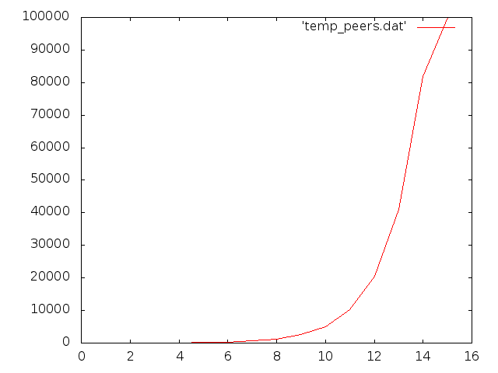Illustration 1: Number of good files averaged over 100 runs for M = 100000, N = 10, n = 5, p = 1
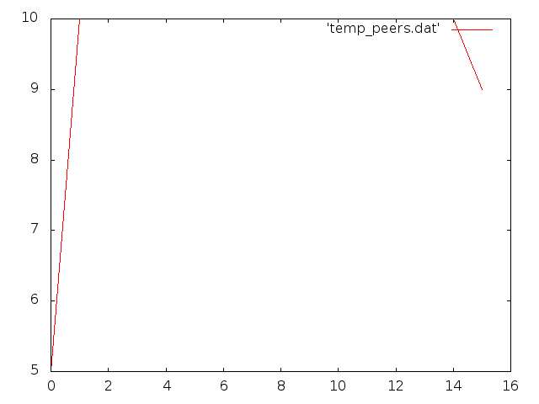Illustration 2: Number of bad files averaged over 100 runs for M = 100000, N = 10, n = 5, p = 1

p = 0.6
The differences compared to p = 1 lies in the corrupted peers. Instead of doubling straight away, the number of corrupted peers will increase asymptotically throughout the simulation.
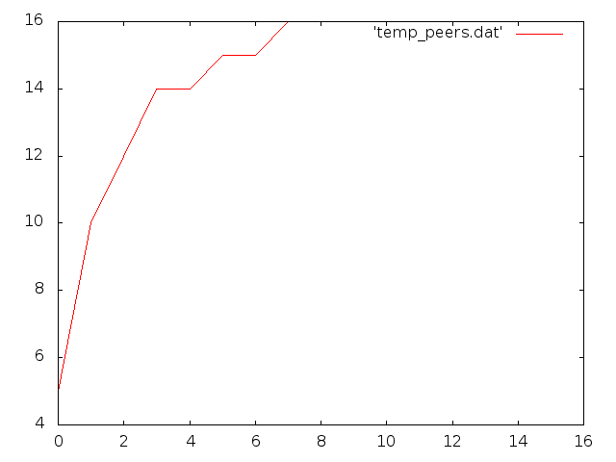Illustration 3: Number of bad files averaged over 100 runs for M = 100000, N = 10, n = 5, p = 0.6

p = 0.4
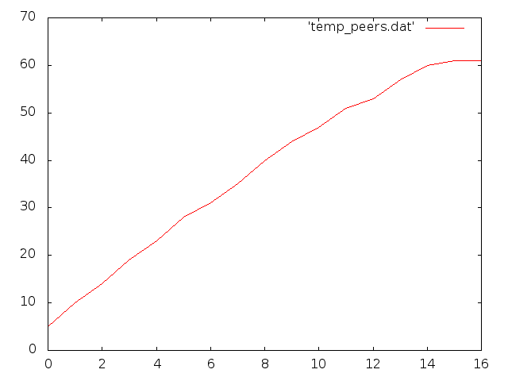Illustration 4: Number of bad files averaged over 100 runs for M = 100000, N = 10, n = 5, p = 0.4

Using this value for p will generate an approximately linear growth of the bad peers. It settles only when the simulation reaches the second phase.

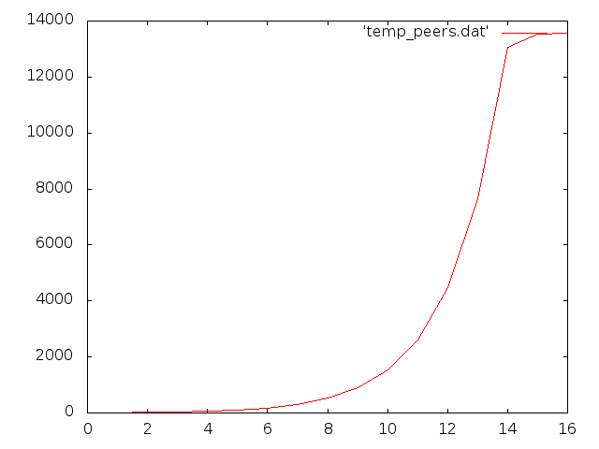Illustration 5: Number of bad files averaged over 100 runs for M = 100000, N = 10, n = 5, p = 0.1

p = 0.1
For values lower than 0.4 the growth of the bad peers will become exponential, approaching a square growth when the value for p approaches zero.

