Report lab 5 – Tools

Totalview
We used totalview as a normal debugger, i.e. we didn't use any advanced features such as the array visualization. However we found that it was pleasant to use and it was easy to control the execution and study the values of the different variables. For example it was very easy to track the values of an array over the different processes as we continued to step through the iterations.
At first we launched it without reading the manual, and the confusion set in pretty quickly as totalview dumped us in a precompiled library without debugging information, so we didn't really know how to make sense of what we were presented. However when we found out that we just had missed to select our main.cpp from the stack view it cleared right out. Later we were a bit confused about the different colors of the processes when a breakpoint was reached. This was solved by a quick read of the manual.

ITAC
We ran the trace analyzer with only two processes during only 10 iterations for these tests using 1000 particles in each process in a box of size 10,000 x 10,000. This was due to the massive amounts of trace data that was generated, easily exceeding our maximum allowed amount to store. However we believe that it shows the important aspects of the application.
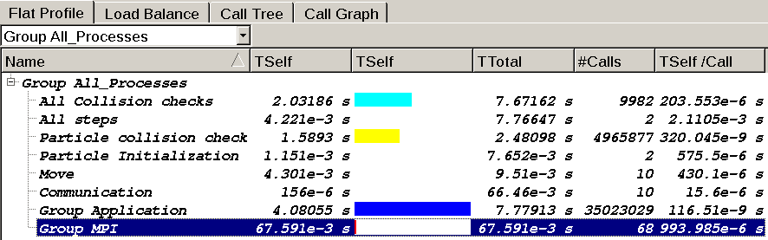Illustration 1: Screen grab of the flat profile view.
In illustration 1 we see three parts that take up the majority of the time. All collision checks is the outer loop for the collision checks, particle collision check is the loop which checks for collision between one particle versus all the other particles and finally Group Application is mostly made up of calls to functions dealing with the class std::list.
This profile is what we would expect, especially when we only run it in two processes, since the communication is minimal compared to the amount of collision checks we have to do due to the quadratic number of possible collisions between the particles in one process. With 1000 particles we get about 1,000,000 possible collision pairs compared to the number of crossing particles which is less than 10 per iteration on average.
If we were to focus on optimizing the application, the first step we would take would be to use a more effective storage type since the majority of all time is spent on storage operations. We could also use another method to keep track of collided particles than moving the particles between different lists.
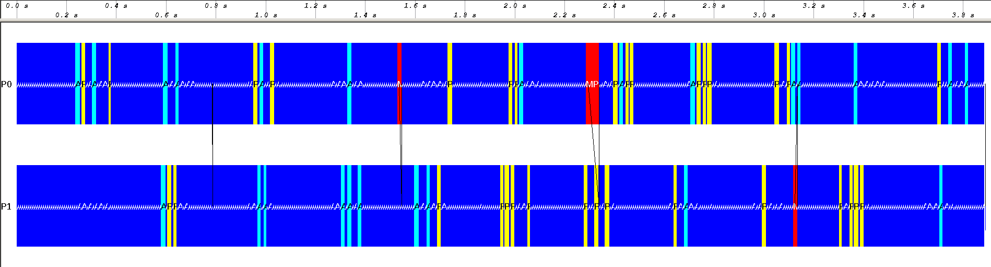Illustration 2: Screen grab of the event timeline covering all five iterations. Color coding from illustration 1.
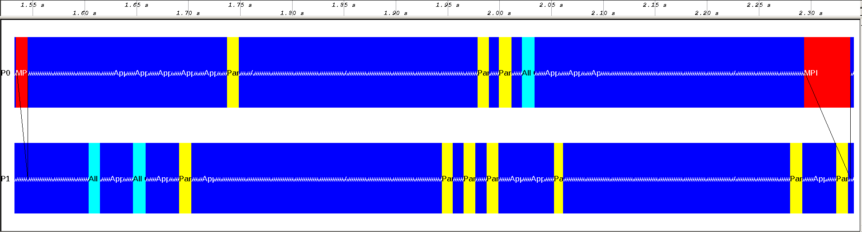Illustration 3: Screen grab of the event timeline zoomed in on one iteration. Color coding from illustration 1.
Illustration 2 and 3 reinforces what we saw from illustration 1. Here we can also see some parts that look red. Those are the cases where one process finishes its particle checks before the other process and have to wait for the other to eventually send data to it.

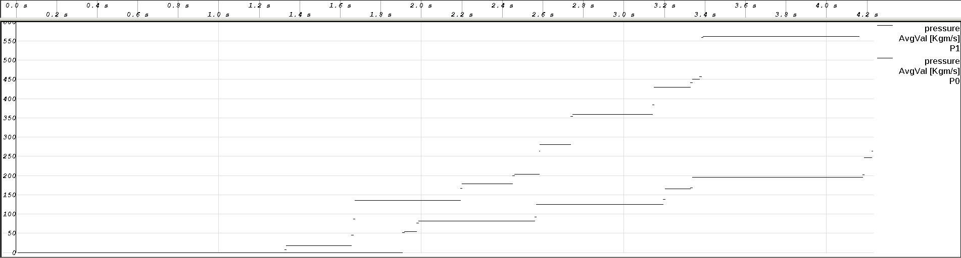Illustration 4: Screen grab of the pressure counter.
In illustration 4 we see the development of the total absorbed momentum in each process. We called the variables pressure in the source code. We didn't get any color coding of the different processes, but it is pretty clear which lines belong together at least. The development looks as expected when we have such a large box with so few particles. We both have parts with some wall collisions close together and long periods without any wall collisions. We can tell from the graph that the collisions on average amounts to about 50 kgm/s.

