User Manual About Event Tracker, Event Report, Event Visualizer

1.Event Capture:

1.1 Overview:

1.2 How to use:

1.2.1 First step:

1.2.2 Second step:

1.2.3 Third step:

1.2.4 Fourth step:

1.2.5 Fifth step:

1.2.6 Sixth step:

1.2.7 Seventh step:

2. Event Reports:

2.1 Overview:

2.2 How to use:

2.2.1 First step:

2.2.2 Second step:

2.2.3Third step:

2.2.4 Fourth step:

2.2.5 Fifth step:

2.2.6 Sixth step:

2.2.7 Seventh step:

2.2.8 Eighth step:

2.2.9 Ninths step:

2.2.10Tenth step:

2.2.11 Eleventh step:

2.2.12 Twelfth step:

2.2.13 Thirteenth step:

3. Event Visualizer:

3.1 Overview:

3.2 How to use:

3.2.1 First step:

3.2.2 Second step:

3.2.3 Third step:

3.2.4 Fourth step:

3.2.5 Fifth step:

3.2.6 Sixth step:

3.2.7 Seventh step:

3.2.8 Eighth step:

3.2.9 Ninths step:

3.2.10 Tenth step:

3.2.11 Eleventh step:

# Event Capture:

## Overview:

The event capture app allows users to register events that occurred at a particular time and place. An event can happen at any given point in time. This stands in contrast to routine data, which can be captured for predefined, regular intervals. Events in DHIS 2 are linked to program. Hence, the event capture app lets you select the organization unit, program and point in time when an event (also known as case or record) happened, before entering information for that event.

## How to use:

### First step:

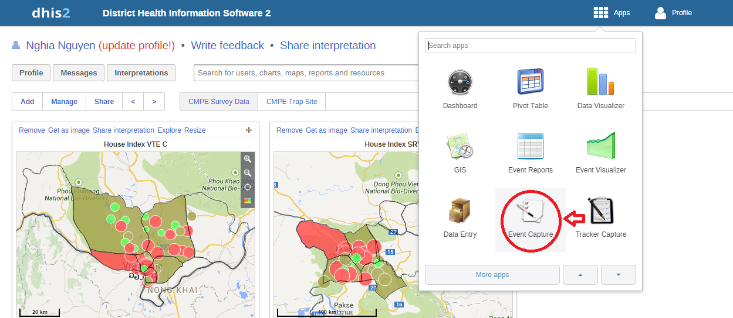

We find the icon in the red circle in the picture and click it to open the event capture interface.

### Second step:

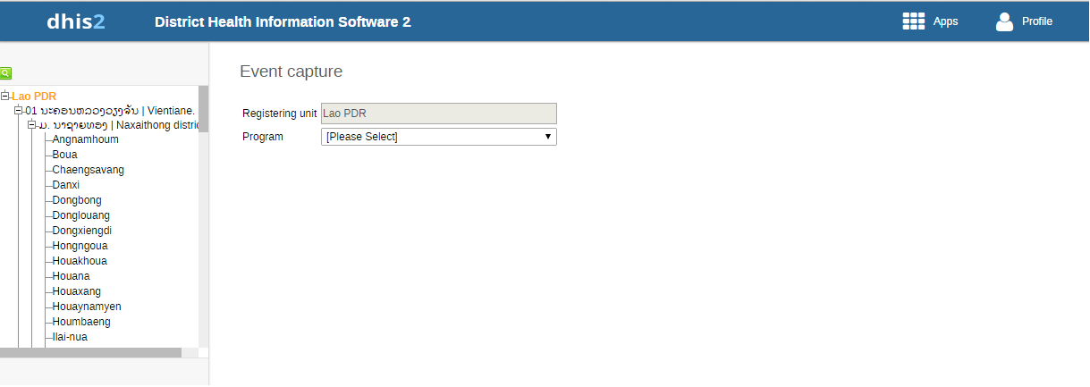

This is the event capture interface. We will have Organization Unit on the left and the combo-box to choose the program on the right.

### Third step:

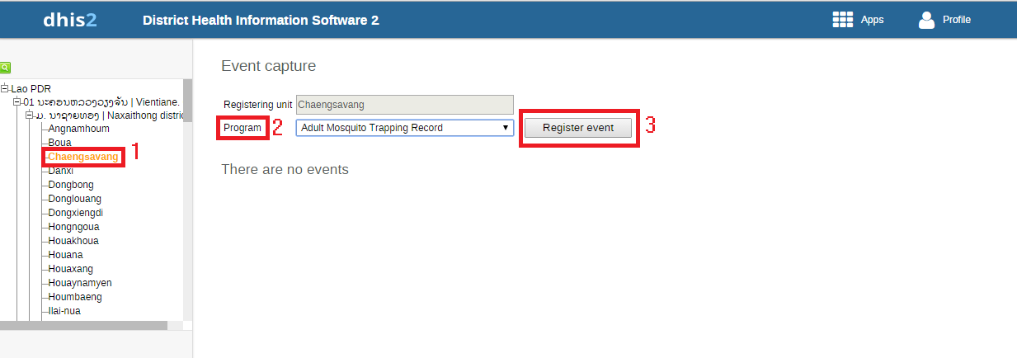

Now we will start to use the Event capture. We need to choose the Organization Unit on the left (the red square with number one in the picture). After that, we select the program (the combo-box on the right side). In this example, we will select the Adult Mosquito Trapping Record Program. Finally, press the Register Event.

### Fourth step:

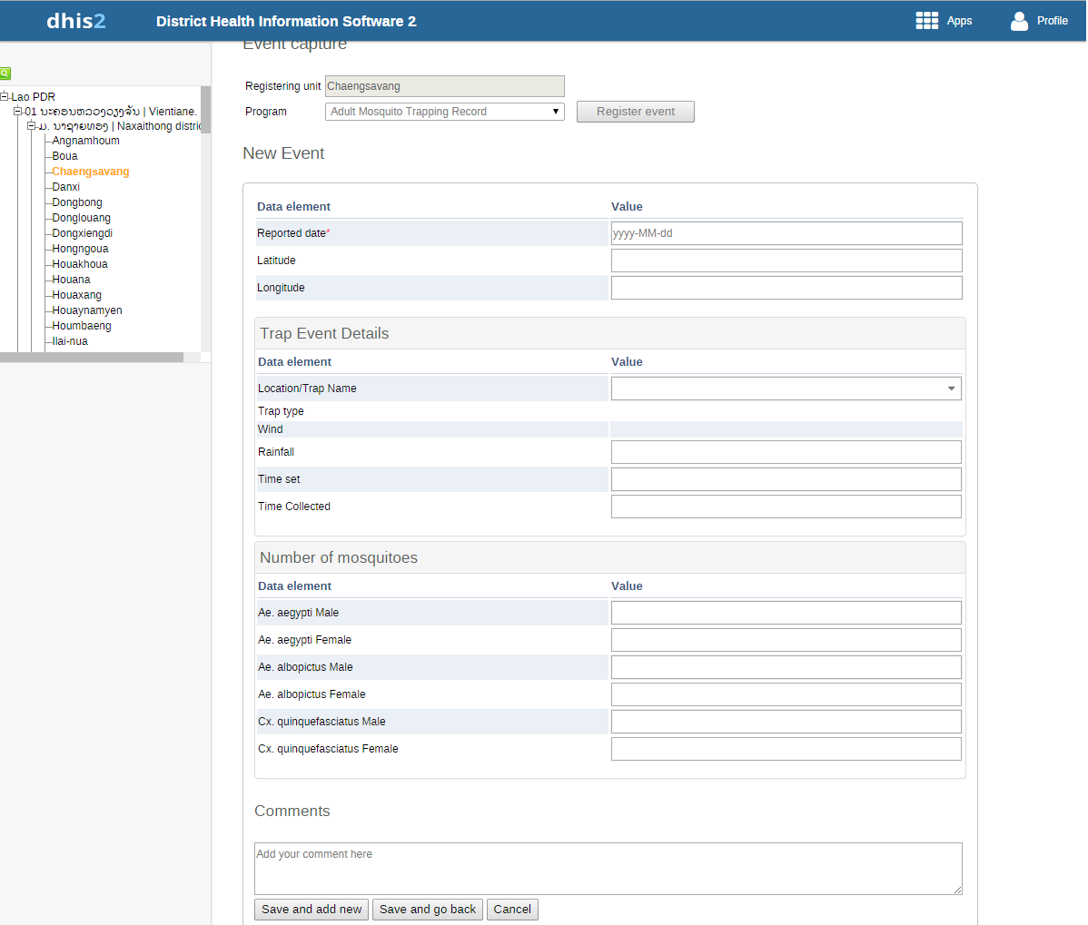

This is the register event interface. In this step, we need to fill all the blank field for the event. After that, press the Save and add new if we want to add more records. Or we can press the save and go back to the Capture Event interface. Finally the cancel button will escape to the capture event interface and save nothing.

### Fifth step:

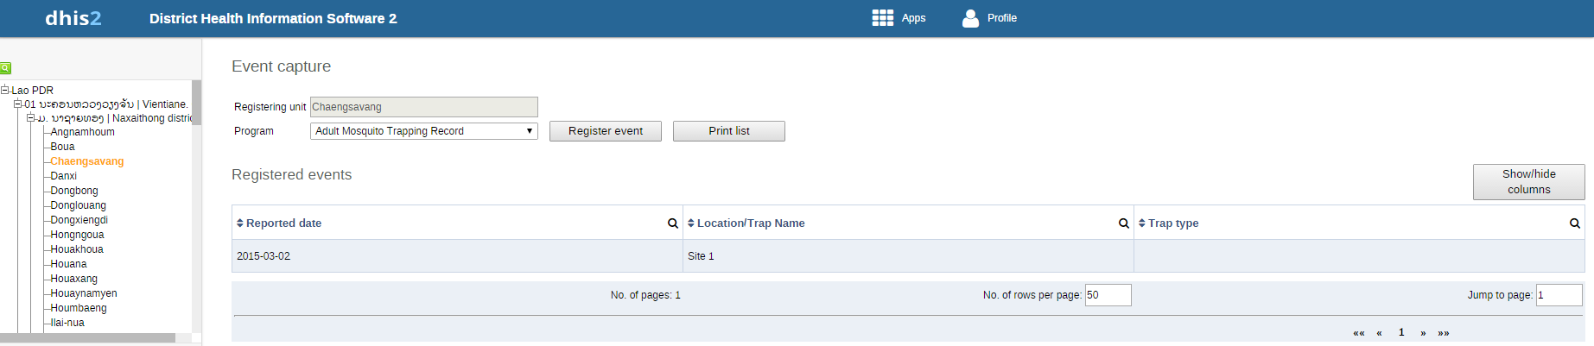

After we register one event. It will appear in the list like in the picture.

### Sixth step:

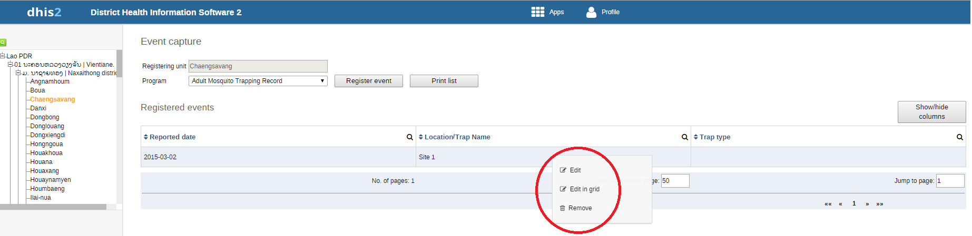

We can click to the record and it will appears the small box with three choice: Edit, Edit in grid and Remove. We can edit the record if we want.

### Seventh step:

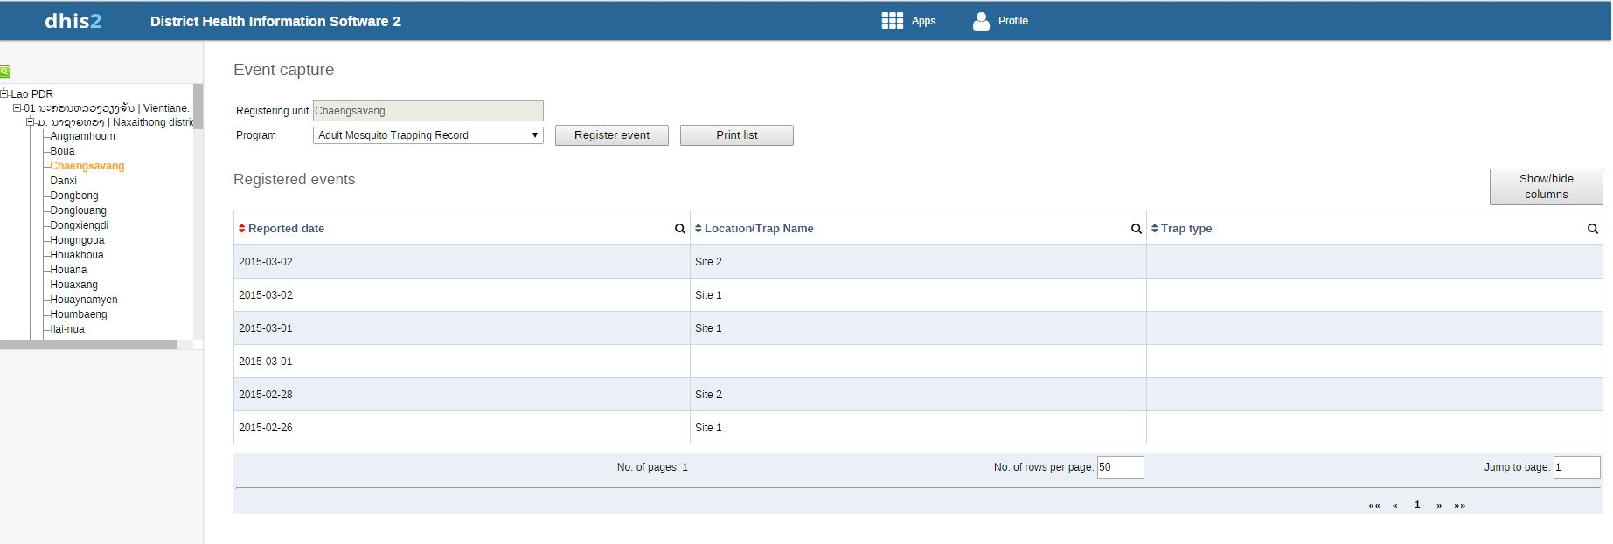

This is the interface after registered a few events.

# Event Reports:

## Overview:

The event reports app enables analysis of events in two fashions.

* Pivot table-style analysis with aggregated values of events
* Lists of events based on queries / filters

## How to use:

### First step:

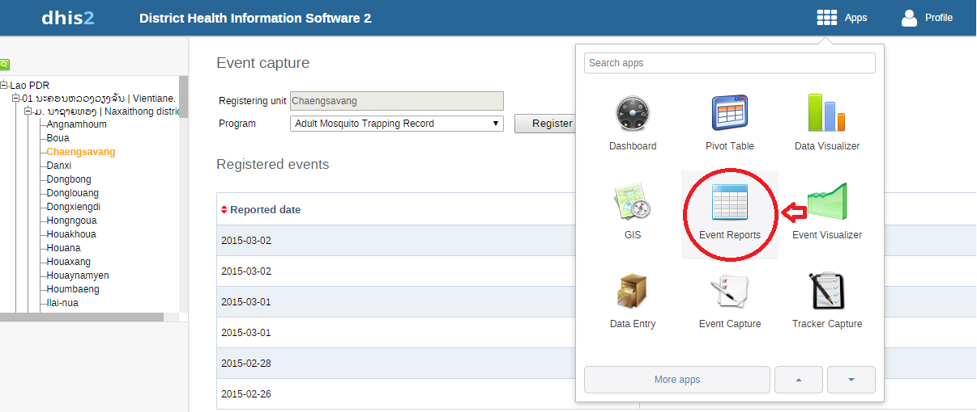

We find the icon in the red circle in the picture and click it to open the event report interface.

### Second step:

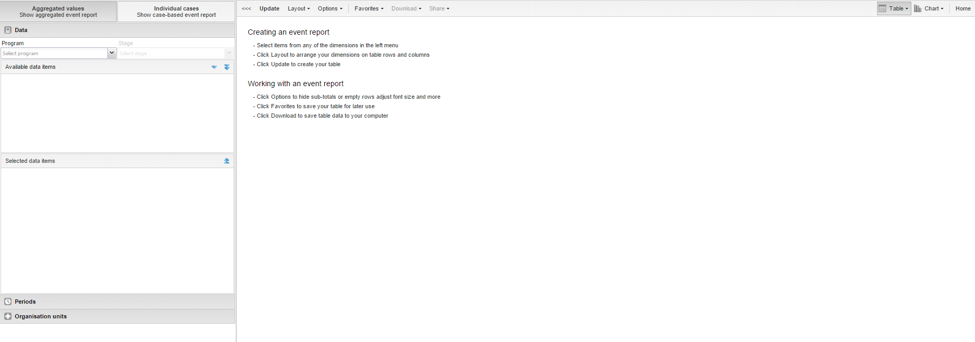

This is the interface of the Event report.

### Third step:

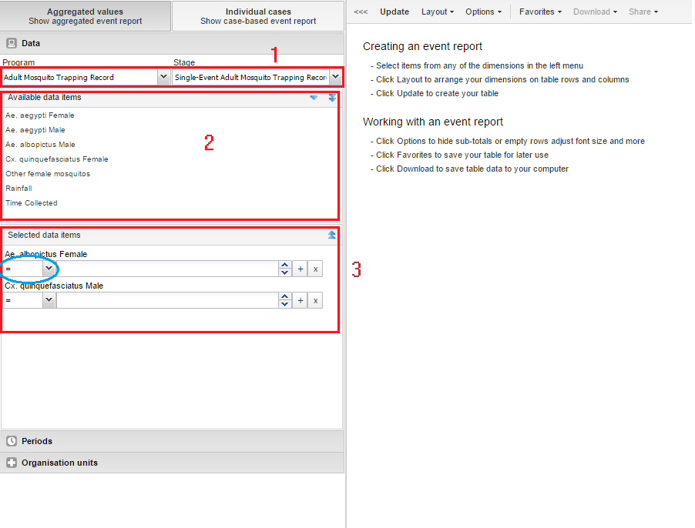

Start by selecting the program and program stage for the event report. The data elements associated with the selected program will be listed under available items. Each data element acts as a dimension, and can be selected by double-clicking on it. After selecting a data element, it will be visible under "selected data items". Here you can specify a filter for each data element, with operators such as "greater than", "in" or "equal" together with a filter value.

### Fourth step:

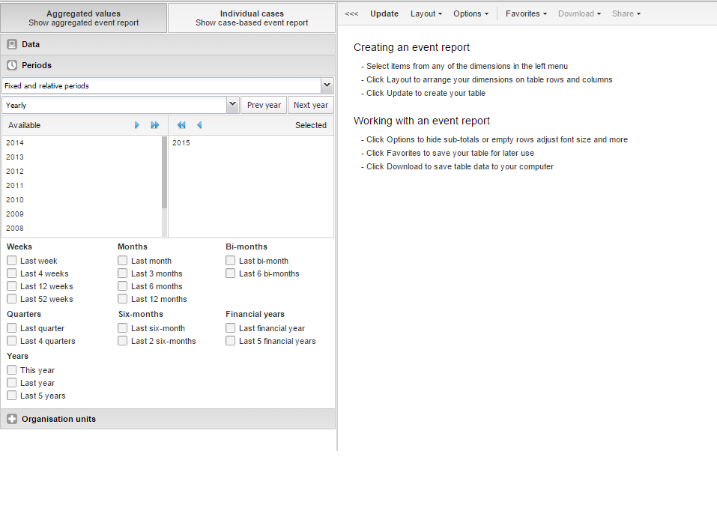

For the period dimension you have three options: relative periods, fixed periods and start/end dates. Relative periods can e.g. be "last 12 months", and has the advantage that it keeps the data in the report up to date as time goes. Fixed periods can e.g. be "2015". You can switch to start/end dates by selecting from the drop-down menu under the periods tab, which lets you specify flexible dates for the time span in the report.

### Fifth step:

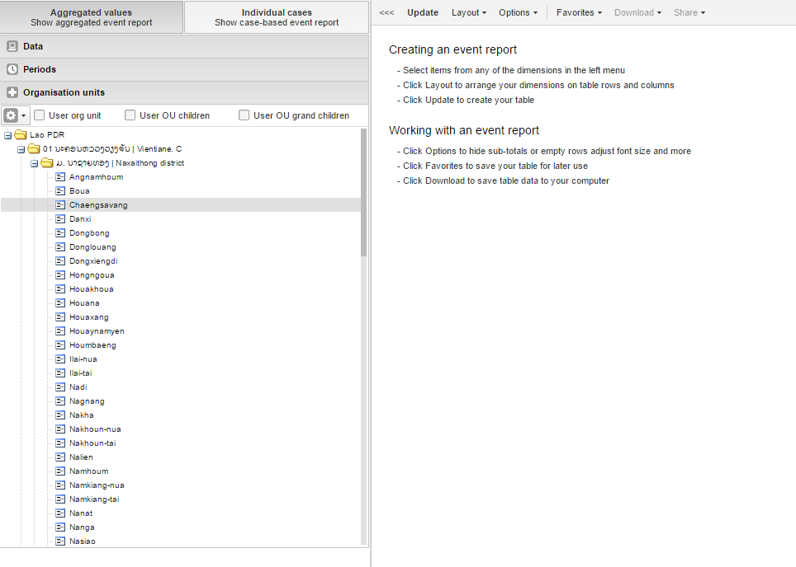

After select the period, we will come to choose the Organization Unit. The organisation unit dimension lets you select any org unit from the hierarchy. You can use the org unit mode selector to select org units explicitly, by org unit hierarchy levels and by org unit groups.

### Sixth step:

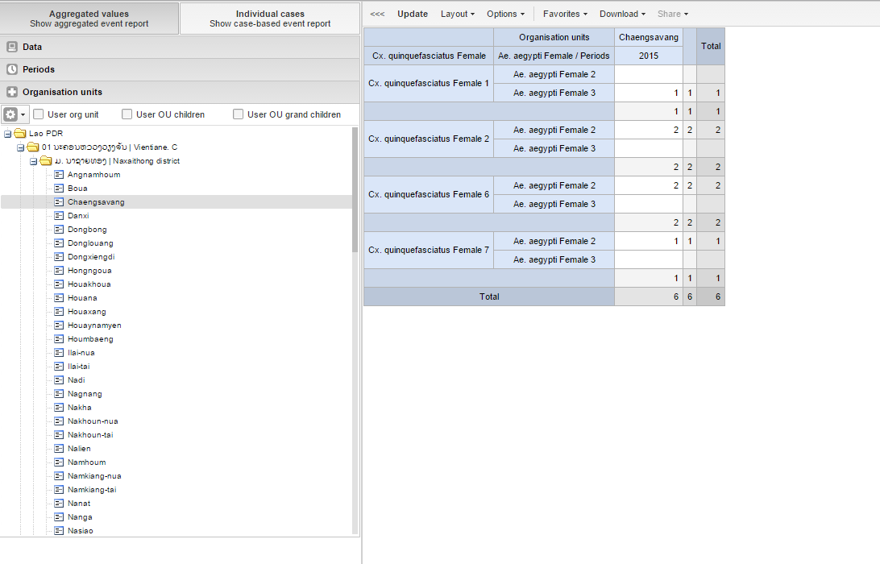

Finally we will press the update button and the report will appear. That is the basic way to create the report.

### Seventh step:

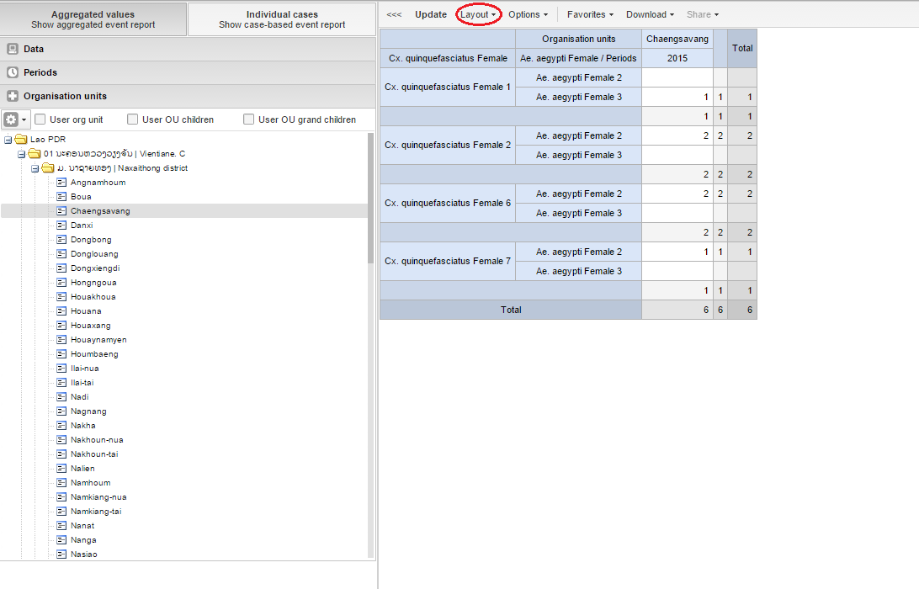

After create the report, we can configure the report suitable with us. First press the Layout button.

### Eighth step:

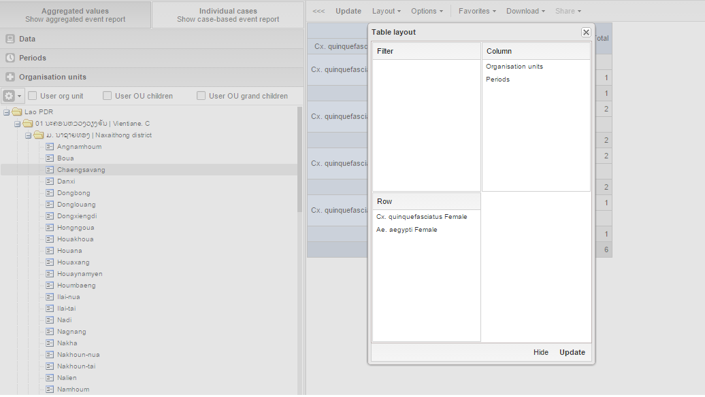

We can change the way of value show on the report. By dragging the data to Row or Column.

### Ninths step:

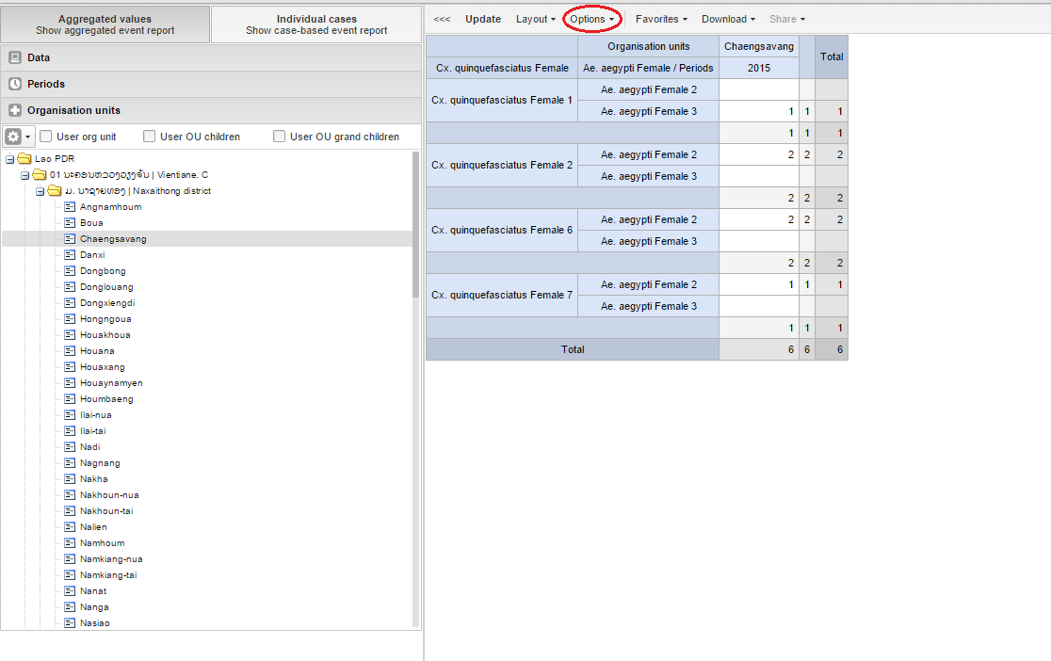

Next is the options, we click to the option button.

### Tenth step:

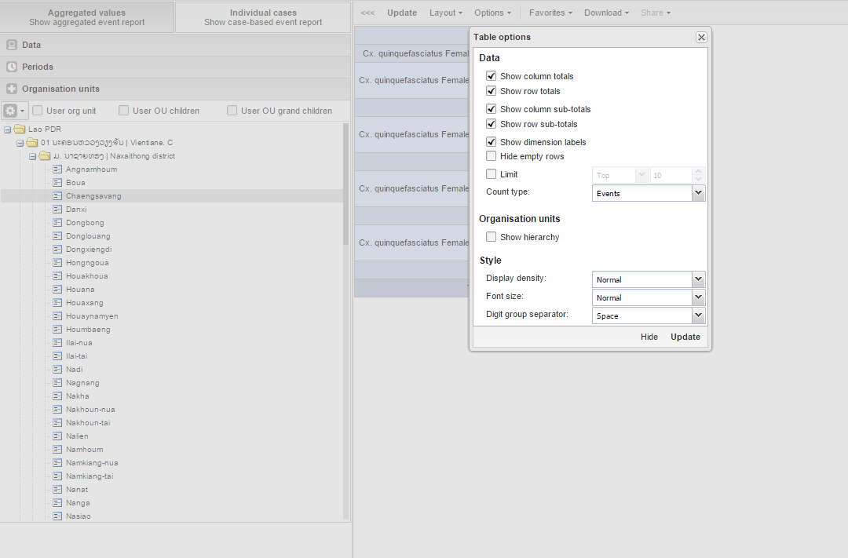

The following options apply to aggregated values-type reports only:

* Show totals: Show totals at the end of each column and row in the pivot table.
* Show sub-totals: Show sub-totals for each column and row in the pivot table.
* Hide empty rows: Hide empty rows in the pivot table.
* Limit: Set a limit on the max number of rows to display in the table, combined with a setting for showing top or bottom values.
* Show hierarchy: Include the names of all parents of each organization unit in labels.

These style-related options apply to both types of reports:

* Display density: Control padding around values inside cells.
* Font size: Control font size of values.
* Digit group separator: Control character to use for splitting digit groups.

### Eleventh step:

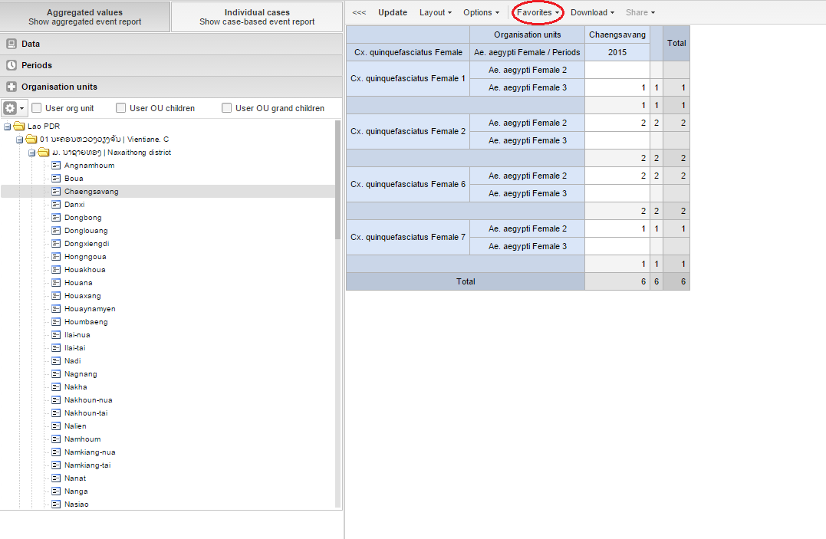

We can save and open the report by the favorite. Press the favorite button.

### Twelfth step:

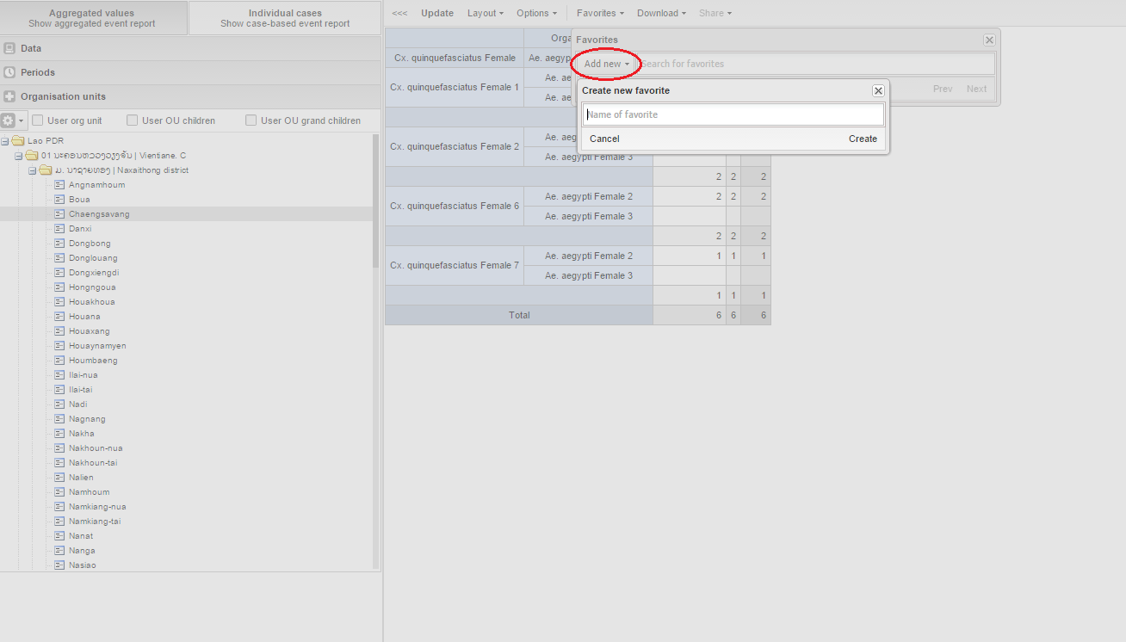

After that press the add new button and fill the name of the report and click create.

### Thirteenth step:

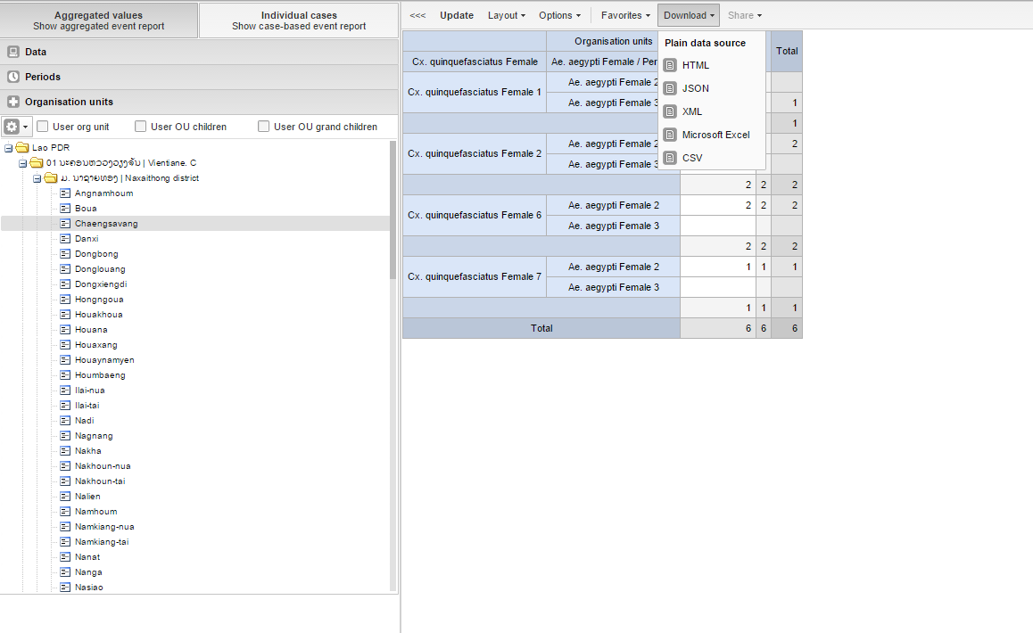

Finally we can download the report by pressing the button download and choose the save file type we want.

# Event Visualizer:

## Overview:

The event visualizer app enables chart analysis of events.

## How to use:

### First step:

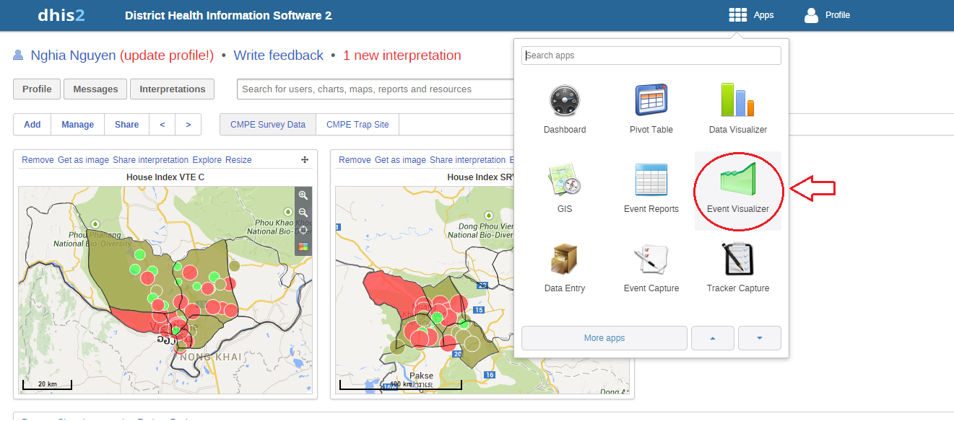

We find the icon in the red circle in the picture and click it to open the event visualizer interface.

### Second step:

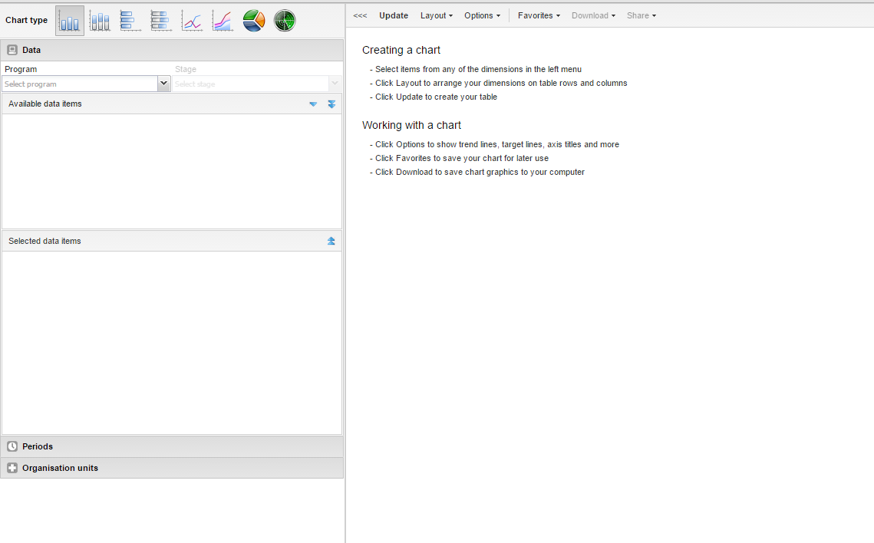

This is the interface of event visualizer. It mostly the same with the event report

### Third step:

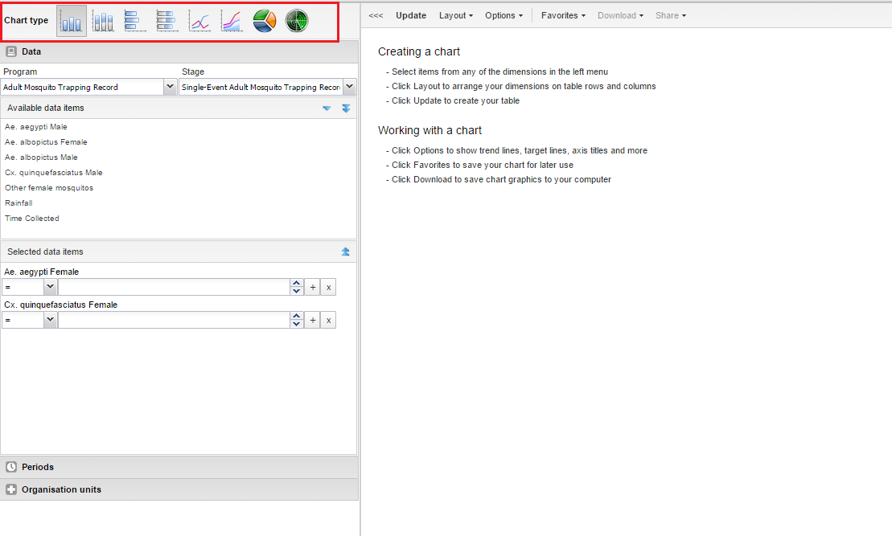

Now we start to create the event visualizer. First we need to choose the type of the chart. In DHIS2 we have total eight chart in the event visualizer.

### Fourth step:

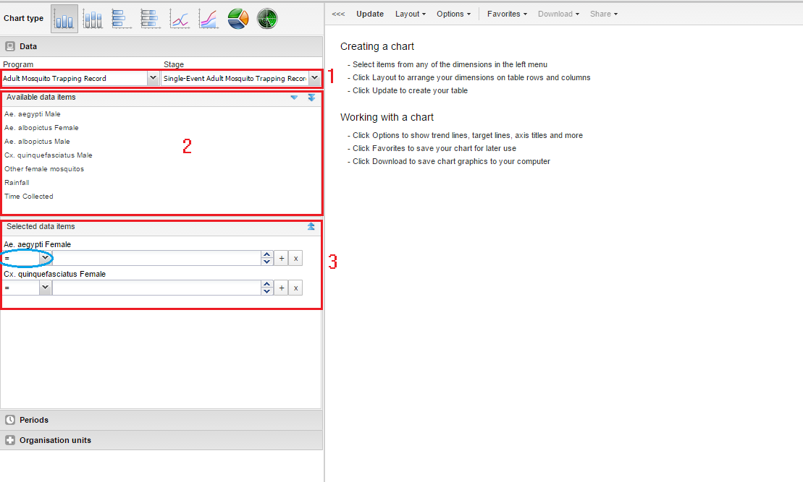

Start by selecting the program and program stage for the event report. The data elements associated with the selected program will be listed under available items. Each data element acts as a dimension, and can be selected by double-clicking on it. After selecting a data element, it will be visible under "selected data items". Here you can specify a filter for each data element, with operators such as "greater than", "in" or "equal" together with a filter value.

### Fifth step:

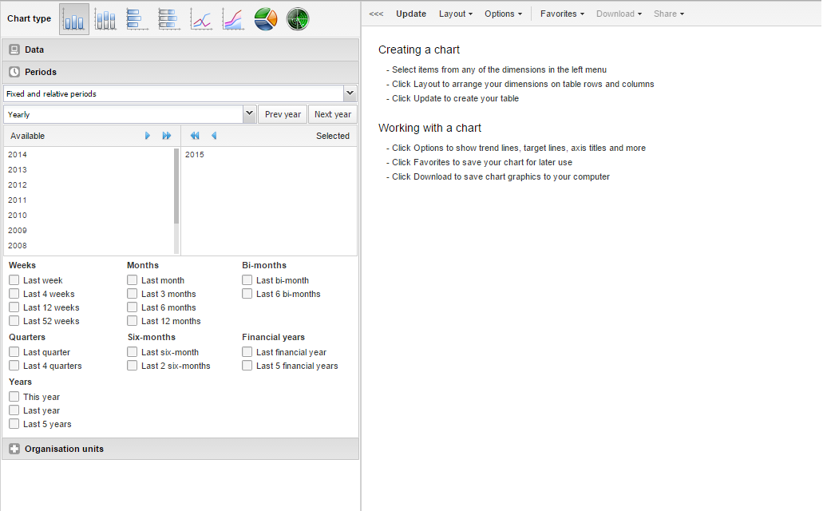

For the period dimension you have three options: relative periods, fixed periods and start/end dates. Relative periods can e.g. be "last 12 months", and has the advantage that it keeps the data in the report up to date as time goes. Fixed periods can e.g. be "January 2014". You can switch to start/end dates by selecting from the drop-down menu under the periods tab, which lets you specify flexible dates for the time span in the report.

### Sixth step:

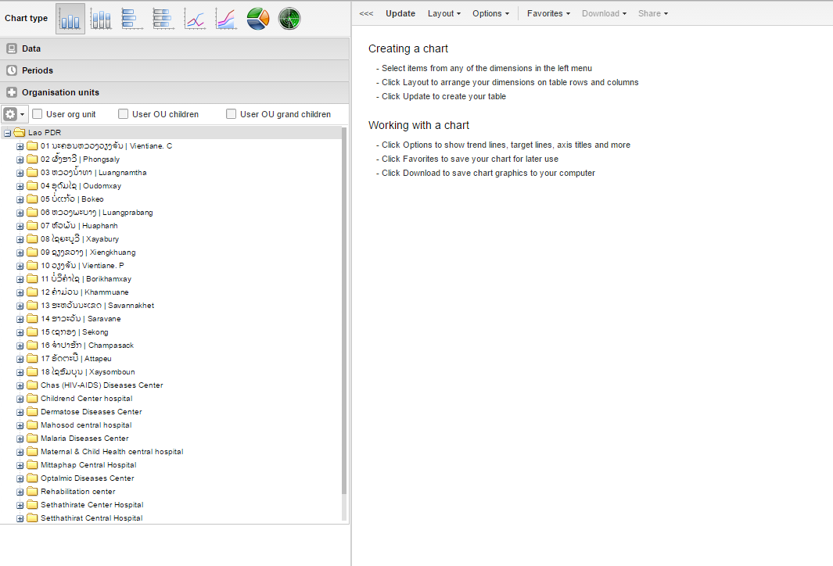

After select the period, we will come to choose the Organization Unit.The organisation unit dimension lets you select any org unit from the hierarchy. You can use the org unit mode selector to select org units explicitly, by org unit hierarchy levels and by org unit groups.

### Seventh step:

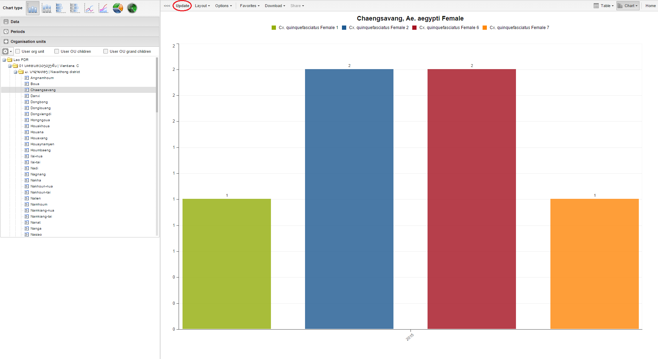

Finally we will press the update button and the chart will appear. That is the basic way to create the chart.

### Eighth step:

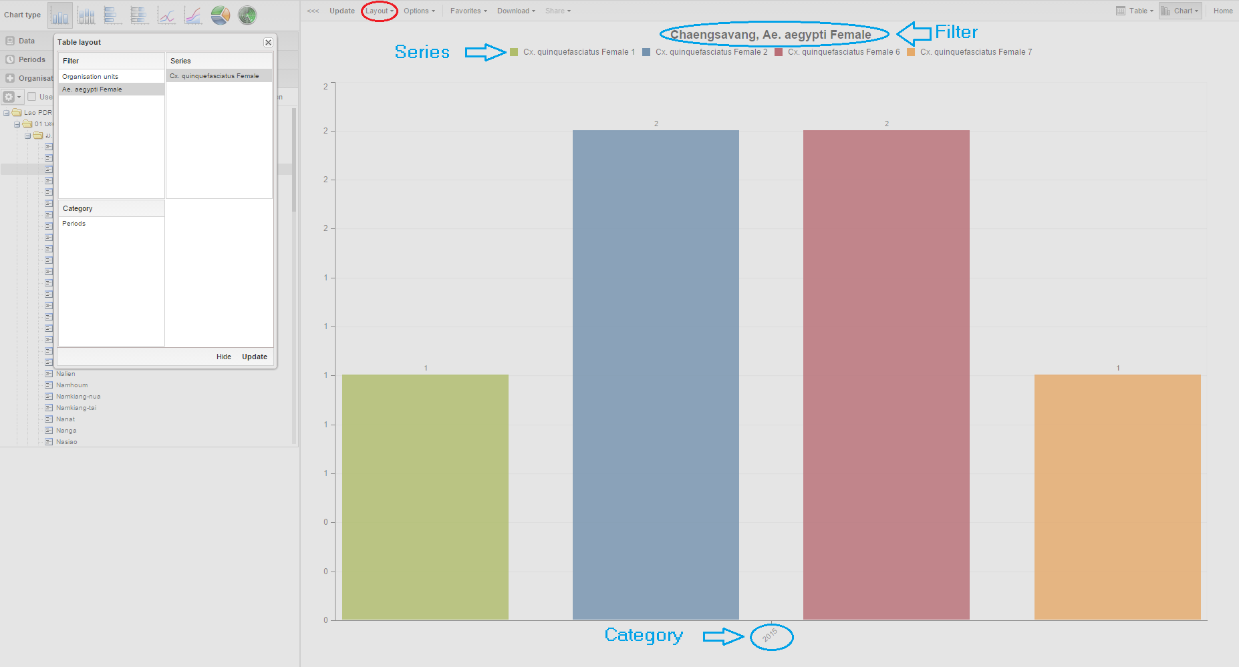

After create the chart, we can configure the chart suitable with us. By clicking **Layout** from the top menu you can control which dimensions should appear as columns, rows and filters in the chart. Each data element appears as individual dimensions and can be placed on any of the axes. Note that the series and category panels can only have one dimension at the time.

### Ninths step:

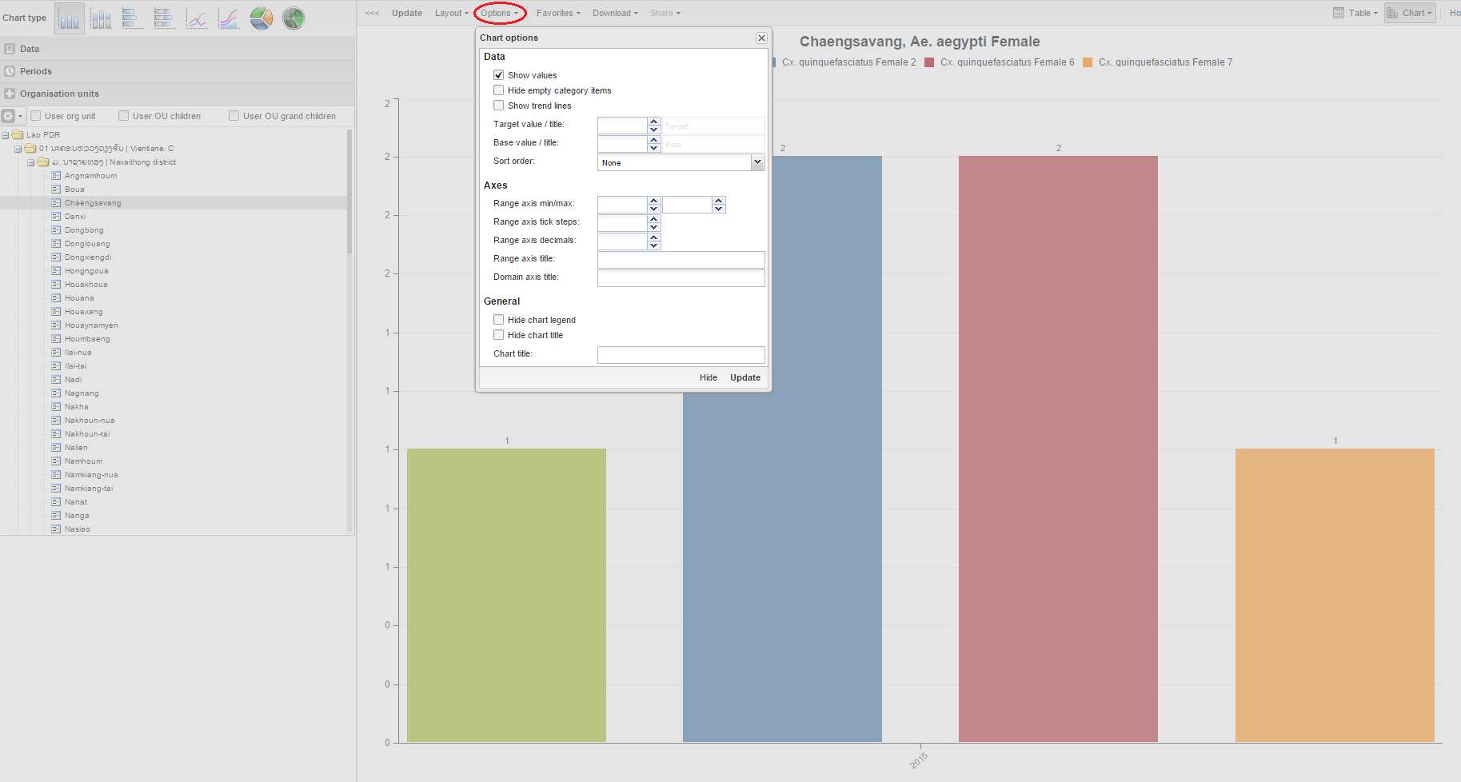

An event report can be customized using a range of options, which can be accessed by clicking on "Options" in the top menu. The following options apply to aggregated values-type reports only:

* Show values: Show values as numbers on top of each series.
* Hide empty category items: Hides category items with no data from the chart.
* Show trend lines: The trend line will visualize how your data evolves over time - e.g. is performance improving or deteriorating. Makes sense when periods are selected as category.
* Target line value/title: Displays a horizontal line at the given domain value. Useful e.g. when you want to compare your performance to the current target.
* Base line value/title: Displays a horizontal line at the given domain value. Useful e.g. when you want to visualize how your performance has evolved since the beginning of a process.
* Range axis max/min: Defines the maximum and minimum value which will be visible on the range axis.
* Range axis tick steps: Defines the number of ticks which will be visible on the range axis.
* Range axis decimals: Defines the number of decimals which will be used for range axis values.
* Range axis title: Displays a label next to the range axis (also referred to as the Y axis). Can give context information to the chart, e.g. the unit of measure being used.
* Domain axis title: Displays a label below the domain axis (also referred to as the X axis). Can give context information to the chart, e.g. the type of periods being listed.
* Hide chart legend: Hides the legend and leaves more room for the chart itself.
* Hide chart title: Hides the title of your chart.
* Chart title: Type any title you like and it will appear above the chart.

### Tenth step:

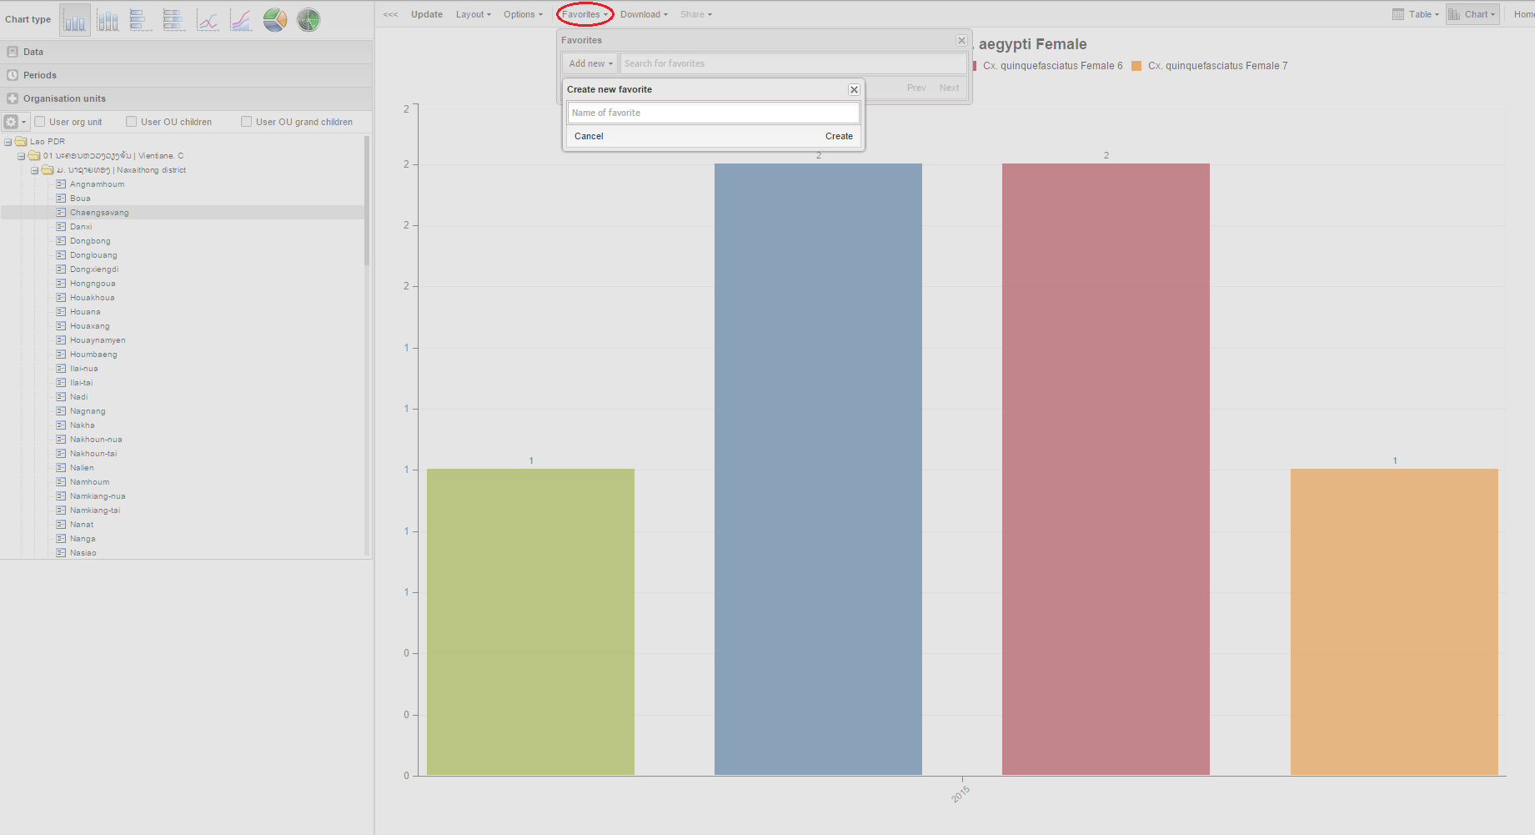

We can save and open the report by the favorite. Press the favorite button. After that press the add new button and fill the name of the report and click create.

### Eleventh step:

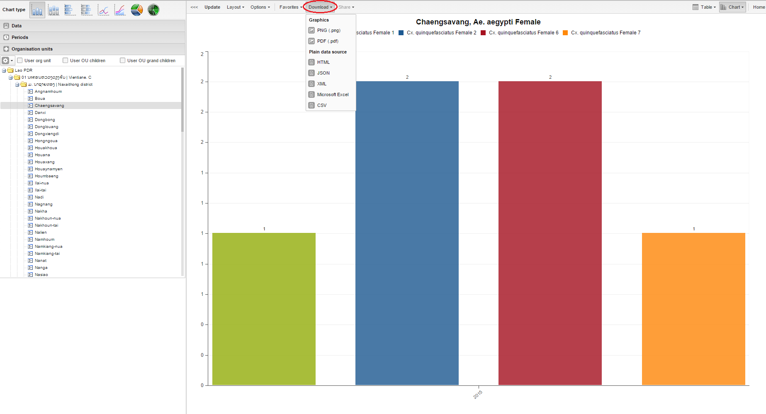

Finally we can download the report by pressing the button download and choose the save file type we want.