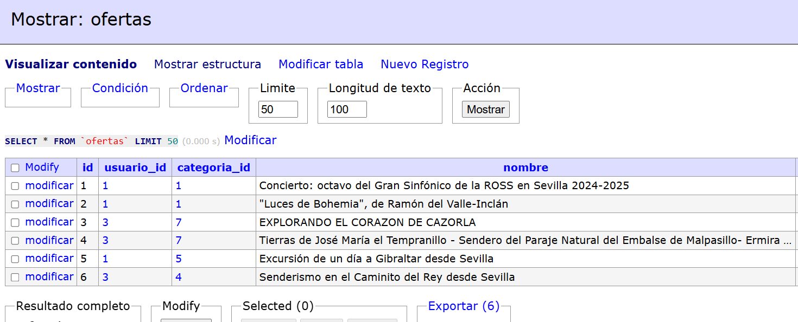

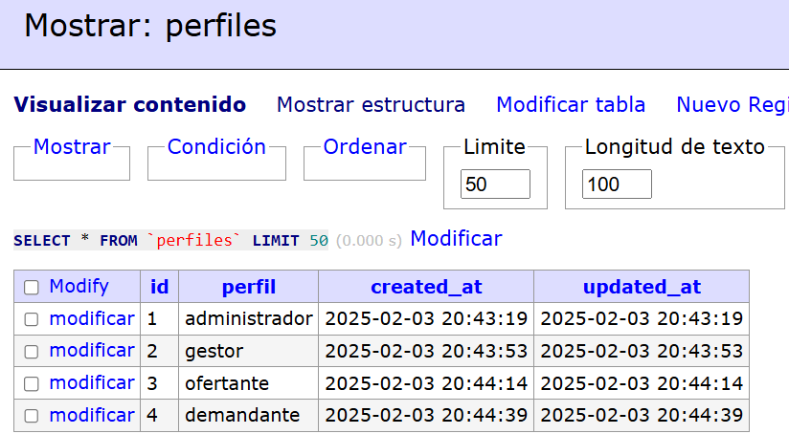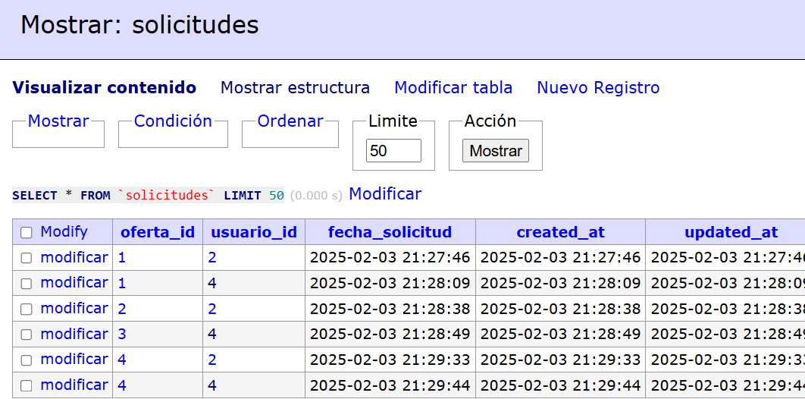

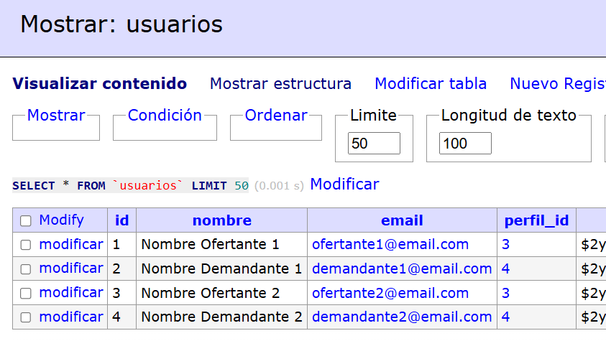

SELECT

o.id AS oferta_id,

o.nombre AS oferta_nombre,

COUNT(DISTINCT u.id) AS cantidad_demandantes

FROM solicitudes s

JOIN usuarios u ON s.usuario_id = u.id

JOIN perfiles p ON u.perfil_id = p.id

JOIN ofertas o ON s.oferta_id = o.id

WHERE p.perfil = 'demandante'

GROUP BY o.id, o.nombre

ORDER BY cantidad_demandantes DESC;