FilmPhile - Movie Recommendation

PROJECT REPORT SUBMITTED TO MAHATMA GANDHI UNIVERSITY, IN PARTIAL FULFILLMENT OF THE REQUIREMENTS FOR THE AWARD OF THE DEGREE OF BACHELOR OF SCIENCE IN COMPUTER APPLICATIONS

BY

ALEN THOMAS
Register Number:230021078065



DEPT. OF COMPUTER APPLICATIONS
BISHOP VAYALIL MEMORIAL
HOLY CROSS COLLEGE

CHERPUNKAL, KOTTAYAM 686584
October 2025
Department of Computer Applications
BISHOP VAYALIL MEMORIAL
HOLY CROSS COLLEGE

CERTIFICATE

Certified that the report entitled “FilmPhile - Movie Recommendation” is the bona fide record of the project work done by Mr. Alen Thomas (Reg.No.230021078065) under our guidance and supervision and is submitted in partial fulfillment of the Bachelor degree in Computer Applications, awarded by Mahatma Gandhi University, Kerala.

Ms. Jaise Jose | Ms. Seena S Nair
Project Guide | Head of the Department
Dr. Baby Sebastian
Principal

Submitted for Project Evaluation on ------/-----/-----

Internal Examiner External Examiner
DECLARATION

I hereby declare that the project work entitled “FilmPhile - Movie Recommendation” submitted in partial fulfillment of the requirements for the award of the Bachelor of degree in Computer Applications from BVM Holy Cross College, Cherpunkal, is record of bona fide work done under the guidance of Ms. Jaise Jose (Assistant Professor, Dept. of Computer Applications)

Date: | Name: Alen Thomas
Place: Cherpunkal | Reg No. 230021078065

ACKNOWLEDGEMENT

First and foremost, I thank God almighty for his eternal love and protection throughout the project. I take this opportunity to express my gratitude to all who helped me in completing this project successfully. It has been said that gratitude is the memory of the heart. I wish to express my sincere gratitude to our Principal Rev. Dr. Baby Sebastian Thonikuzhy for providing good faculty for guidance.

I owe a great depth of gratitude and respect for guidance towards Head of the Department Ms. Seena S Nair for helping us . I extend my whole hearted thanks to the Project Coordinator Ms. Jaise Jose for her valuable suggestions and for overwhelming concern and guidance from the beginning to the end of the project.

I thank our beloved teachers for their cooperation and suggestions that helped me throughout the project. I express my thanks to all my friends and classmates for their interest, dedication, and encouragement shown towards the project. I convey my hearty thanks to my family for the moral support, suggestions, and encouragement to make this venture a success.

ALEN THOMAS

ABSTRACT

The purpose of my project titled, “FILMPHILE - MOVIE RECOMMENDATION”, is a web application project, which includes HTML, CSS, JavaScript as Front-End and PHP, MySQL as Back-End. Many movie recommendation systems today suggest films only on the basis of popularity or ratings, which often fail to capture the unique preferences of individual viewers. The project entitled “FILMPHILE - MOVIE RECOMMENDATION” is a website that provides a high-quality online service and acts as a platform where users can easily discover movies tailored to their interests and moods. It helps ordinary users find the right movie based on parameters such as mood, language preference, and pacing style, thereby enhancing the viewing experience. The important modules in the project are Admin and User. The admin manages the overall system, verifies and maintains the movie database, while users register and interact with the system to get personalized recommendations. The system incorporates Machine Learning to improve accuracy and relevance of suggestions.

CONTENT

Contents Page No
- Introduction 1
  - Project Overview 2
1.2 Organization profile 2
- System Configuration 4
2.1 Hardware specification 5
2.2 Software specification 5
- System analysis 7
  - Preliminary Investigation 8
  - Existing System 8
3.2.1 Disadvantages of Existing System 9
  - Proposed System 9
    - Advantages of Proposed System 9
  - Feasibility Study 10
  - Requirement Specification 11
- System Design 13
  - Introduction 14
  - System Flowchart 14
  - Database Design 16
  - Dataflow Diagram 19
  - Input Design 23
  - Output Design 23
- System Development 25
  - Introduction 26
  - Menu level description 26
  - Process Specification 27
- System Testing 29
  - Testing Methods 30
  - Test Plan Activities 31
- System Implementation 34
- Conclusion and Future Scope 37
- Screen Layouts 39
- Bibliography 46

- INTRODUCTION

1.1 PROJECT OVERVIEW

The FilmPhile is a web-based movie recommendation system developed to help users discover films that best match their preferences and current mood. The project integrates both content-based filtering and collaborative filtering, along with mood-based categorization, to provide accurate and context-aware suggestions. Users can browse movies, explore details such as language, genre, and year of release, and receive recommendations tailored to their emotional state. The platform also allows users to maintain watchlater, view trailers, and share reviews, creating an engaging and interactive community experience. By combining recommendation algorithms with mood recognition, FilmPhile aims to enhance the movie discovery process, ensuring that users not only find films they are likely to enjoy but also those that align with their present feelings.

1.2 ORGANIZATION PROFILE

Organization Name : BVM Holy Cross College
Location : Cherpunkal , Kottayam, Kerala, India Year of Establishment: 1995
Type of Institution : Self-Financing College
Affiliation : Mahatma Gandhi University
Management : Holy Cross Forane Church, Cherpunkal

Vision: To be a leading institution of higher education that empowers students to become responsible citizens and ethical professionals.

Mission: To provide quality education that promotes academic excellence, holistic development, and social commitment.
Core Values :
- Academic Integrity
- Student-Centric Approach
- Social Responsibility
- Inclusiveness
- Excellence in all Endeavors

Contact Information:

BVM Holy Cross College
Cherpunkal, Kottayam,
Kerala-686529

Connect with BVM

Phone: 04822-267520
9446640157
Email:bvmhcc@gmail.com
Website: https://bvmcollege.com/

2. SYSTEM CONFIGURATION

2.1 HARDWARE SPECIFICATION

Processor - Intel core i3 and above
RAM - 8 GB
Hard disk - 256 GB

2 .2 SOFTWARE SPECIFICATION

Operating System - Windows 11
Web Browser - Google Chrome
Front-End - HTML, CSS, JavaScript
Back-End - PHP
Database - MySQL
Web Server - XAMPP

PHP:
PHP is a well-known server-side scripting language that is mostly used for web development, but it can also be used for simple programming tasks. In 1995, Rasmus Lerdorf created PHP; It powers more than 244 million websites and 2.1 million web servers and is currently maintained by the PHP group. PHP is now the recursive acronym for PHP: Hypertext Preprocessor. PHP used to stand for Personal Home Page. Web servers make use of a PHP processor module to comprehend PHP code and produce the page's output. A HTML source code can straightforwardly contain PHP commands, getting rid of the need for an external file to handle data. It can likewise run in independent mode and has a command-line interface capability.

The most important advantage of PHP is that it’s open-source and free from cost. It can be downloaded anywhere and is readily available to use for events or web applications. It is platform-independent. PHP-based applications can run on any OS like UNIX, Linux, Windows, etc.

MySQL:
MySQL, a popular SQL system for managing databases is utilized extensively, is created, distributed, and maintained by the organization called Oracle Corporation, the software development company.

MySQL, a popular SQL database management system that is utilized extensively, is created, distributed, and maintained by Oracle Corporation, the software development company. These systems are critical to computing as they enable efficient processing of large quantities of information, either as standalone applications or integrated into other software.

The most important advantage of MySQL is that it is open-source, implying that it is freely available to everyone and can be altered by any individual. Its use is free for everyone and comes with the right to make necessary changes to the source code. However, the GPL imposes certain restrictions on what can and cannot be done with the application. If the GPL license is not appropriate for a particular use case or if a commercial application requires integration with MySQL code, developers can obtain a licensed version by purchasing it from the MySQL team.

3. SYSTEM ANALYSIS

3.1 PRELIMINARY INVESTIGATION
Background - With the rapid growth of streaming services and digital media, users are overwhelmed by the sheer volume of movie options available online. Traditional recommendation systems often focus solely on popularity, ratings, or limited user history, which may not reflect an individual’s true preferences. FilmPhile is designed to address this gap by incorporating user moods, language preferences, and pacing styles into its recommendation engine, providing more personalized and emotionally engaging suggestions.

Objectives - The FilmPhile Movie Recommendation System aims to enhance user experience in content discovery by delivering highly relevant and mood-oriented movie suggestions. Its primary objectives include:
- Offering personalized recommendations based on mood, language, and pacing style.
- Improving user satisfaction by reducing the time spent searching for suitable movies.
By achieving these objectives, FilmPhile seeks to revolutionize the way users discover movies, making the experience more engaging, efficient, and enjoyable.

Significance -
The proposed system aims to:
- Simplify the movie selection process for users by reducing decision fatigue.
- Minimize irrelevant recommendations and improve viewing satisfaction.

3.2 EXISTING SYSTEM
One notable existing website that offers mood-based movie recommendations is PickAMovieForMe.com. It allows users to answer few general questions and recommend a single movie that best matches the inputs. But it has limitations.
- No filter based on language preferences users may get results in languages they don’t understand.
- Lacks control over movie pace doesn’t consider whether the user prefers slow-paced or fast-paced stories.
- Recommends only one movie at a time, even if multiple options match the user’s mood.
- Users can’t see other close matches or alternatives.
- Limited personalisation features-no watchlater and no review system.

3.2.1 DISADVANTAGES OF EXISTING SYSTEM
The existing movie recommendation approach faces several limitations that restrict its ability to provide a fully personalized and engaging user experience. These shortcomings reduce accessibility, variety, and interactivity, making the system less effective for diverse user needs. The key limitations are as follows:
- No Language Preference Support - Users may receive recommendations in languages they cannot understand, which reduces accessibility and usefulness.
- No Control Over Movie Pace - The system does not consider whether a user prefers slow-paced, normal, or fast-paced movies, limiting personalization.
- Single Recommendation Limitation - Only one movie is suggested at a time, even if multiple options match the user’s mood, reducing variety and choice.
- Lack of Alternative Suggestions - Users cannot explore other close matches, which restricts their ability to select from different options.
- No Personal Engagement Features - The system lacks watchlater functionality and a review section, preventing users from tracking their favourites or sharing experiences.
- Limited Personalization - The recommendation process is based on very general inputs and does not adapt deeply to individual user preferences.

3.3 PROPOSED SYSTEM
The proposed system, FilmPhile is a mood-based movie recommendation website that addresses limitations of existing solutions. Our website FilmPhile offers a smarter, more comprehensive recommendation engine that considers multiple user specific preferences.
- Users can choose their preferred language to ensure they get movies they can understand and enjoy.
- Users can decide whether they want a slow, normal or fast-paced movie.
- Instead of showing one result, suggest a list of movies.
- Include features like watchlater and review section to keep users engaged and help them track what they like.

3.3.1 ADVANTAGES OF PROPOSED SYSTEM
The proposed FilmPhile Movie Recommendation system offers several advantages over existing platforms, providing users with a more personalized, engaging, and efficient way to discover movies. The key advantages are as follows:

- Personalized Recommendations - Considers multiple user-specific preferences such as
language, mood, and pacing style to deliver highly relevant movie suggestions.
- Mood-Based Discovery - Recommends movies based on the user’s emotional state rather than just popularity or ratings, enhancing the overall viewing experience.
- Flexible Search Options - Allows users to filter results by language and pacing (slow, normal, fast), giving them greater control and convenience.
- Comprehensive Suggestions - Provides a curated list of movies instead of a single option, enabling users to explore a variety of recommendations.
- Engagement Features - Includes watchlater and review functionality, helping users save favourites and share feedback for a more interactive experience.
- Time-Saving - Narrows down options quickly, ensuring users don’t waste time browsing through irrelevant titles.
- Cross-Platform Discovery - Offers recommendations across different streaming platforms, giving users access to a wider range of films.
- User-Friendly Interface - Designed with simplicity and clarity, ensuring ease of use for all age groups and making movie discovery enjoyable.

3.4 FEASIBILITY STUDY
1. Technical Feasibility
- The system can be developed using widely available and proven technologies such as PHP, MySQL, HTML, CSS, and JavaScript.
- Mood-based recommendation logic can be implemented using PHP/MySQL queries.
Conclusion: Technically feasible, as tools and expertise required are easily available.

2. Operational Feasibility
- The system directly addresses user pain points by offering mood-based, language-specific, and pacing-based recommendations.
- Features like watchlater and reviews increase user engagement and satisfaction.
Conclusion: Operationally feasible, as the system enhances user experience and aligns with user needs.

3. Economic Feasibility
- Development costs are low because open-source technologies (PHP, MySQL, Apache) are used.
- Hosting and deployment can be done on affordable.

Conclusion: Economically feasible, as it requires minimal investment while providing high
value.

The feasibility study shows that the proposed FilmPhile Movie Recommendation System is technically, operationally, economically, feasible. It can be developed with available resources, will effectively address current limitations of existing systems, and can be delivered within the academic timeline.

3.5 REQUIREMENT SPECIFICATION
1. Functional Requirements
- User Registration & Login
- Users must be able to sign up, log in, and manage their profiles.
- Movie Recommendation
- Mood (happy, sad, angry, etc.)
- Language preference (Malayalam, Hindi, etc.)
- Pacing preference (slow, normal, fast)
Then Display a list of suggested movies instead of a single result.
- Watchlater Feature
- Users should be able to add movies to a personal watchlater.
- Users can remove movies from the watchlater anytime.
- Review System
  - Users can write reviews for movies they have watched.
  - Reviews should be editable only by the review owner.
- Trailer Preview
  - Provide links for selected movies.
- User Session Management
  - The system should maintain user sessions for preferences and watchlater
tracking.

2. Non-Functional Requirements
- Performance
  - The system should provide recommendations within 5-6 seconds.
- Scalability
    - Should be able to handle multiple concurrent users (e.g., 100+ in initial deployment).

- Security
  - User passwords must be stored securely (hashed).
  - Sessions must be protected against unauthorized access.
- Usability
  - Simple, intuitive, and responsive user interface.
  - Accessible on desktops, tablets, and smartphones.
- Reliability
- System should be available with minimal downtime.
- Maintainability
- Code should be modular and well-documented for easy updates.

4. SYSTEM DESIGN

4.1 INTRODUCTION

The FilmPhile Movie Recommendation System is a web-based application designed to enhance the process of discovering and selecting movies. The system aims to provide a personalized, efficient, and user-friendly platform for users by leveraging mood, language, and pacing preferences to generate accurate recommendations. It allows users to explore films beyond traditional rating-based suggestions, ensuring a more engaging and tailored viewing experience. This system design document outlines the architecture, components, and interfaces of the FilmPhile Movie Recommendation System.

4.2 SYSTEM FLOWCHART

The classical system flowchart approach to describing and documenting a system will be presented. These System Flowchart are also used in the structured approach that is form the general to detailed, of the system development life cycle. Because they have been used to describe system for many years, they are still common in many businesses. System flow chart is of two types: Process Oriented flowchart and information Oriented flow chart Basic flow chart symbols.

Used Flowchart Symbols:

Process
P

Terminal

Decision

Data Flow

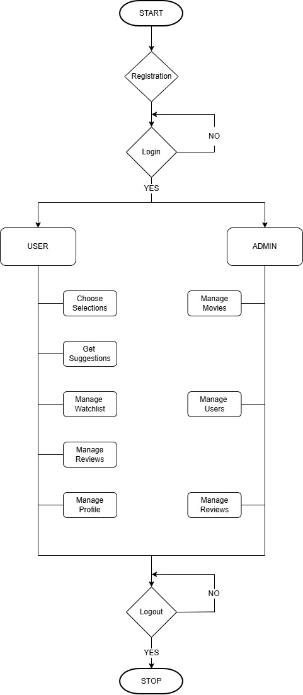
FLOWCHART

4.3 DATABASE DESIGN

It is a process of designing the database file, which is the key source of the information in the system. The objective of the database is to provide storage and it contributes to the overall efficiency of the system. The file should be properly designed and planned for collection, accumulation, editing, and retrieving the required information. The primary objectives of a database design are fast response time to enquiries, more information at low cost, clarity and ease of use, accuracy and integrity of the system, fast recovery and availability of powerful end-user languages. The theme behind a database is to handle information as an integrated whole. The main objective is to make information access easy, quick, inexpensive and flexible for the users.

PRIMARY KEY
The key which is to identify records. Also uniquely notify the not null constraints.

FOREIGN KEY
The key which references the primary key, is the data inserted in the primary key column of the table.

NORMALIZATION
After the conceptual level, the next level of process of database design to organize to base structure into a good shape called normalization. The normalization simplifies the entries, removing redundancies from the system data and finally builds a data structure, which is both flexible and adaptable to the system.

First normal form (1NF) sets the very basic rules for an organized database:
- Eliminate duplicate columns from the same table.
- Create separate tables for each group of related data and identify each row with a unique column or set of columns (the primary key).

Second normal form (2NF) further addresses the concept of removing duplicate data:
- Meet all the requirements of the first normal form.
- Remove subsets of data that apply to multiple rows of a table and place them in the separate tables

Database Name: filmphile_db
1. users
Primary Key : user_id

No: | Fieldname | Datatype(Size) | Key Constraints | Description of the field
1. | user_id | int(11) | Primary Key | Users Id
2. | first_name | varchar(100) | NOT NULL | First Name
3. | last_name | varchar(100) | NOT NULL | Last Name
4. | phone | varchar(20) | NOT NULL | Phone No
5. | email | varchar(100) | NOT NULL | Email
6. | password | varchar(255) | NOT NULL | Password
7. | avatar | varchar(255) | NOT NULL | Avatar
8. | status | varchar(10) | NOT NULL | Status of User

2. movies
Primary Key : movie_id

No: | Fieldname | Datatype(Size) | Key Constraints | Description of the field
1. | movie_id | int(11) | Primary key | Movie Id
2. | title | varchar(255) | NOT NULL | Title
3. | language | varchar(100) | NOT NULL | Language
4. | genre | varchar(150) | NOT NULL | Genre
5. | pace | varchar(50) | NOT NULL | Pace
6. | best_mood | varchar(100) | NOT NULL | Best Mood
7. | audience_type | varchar(100) | NOT NULL | Audience Type
8. | age-group | varchar(50) | NOT NULL | Age Group
9. | release_year | int(11) | NOT NULL | Release Year
10. | rating | decimal(3.1) | NOT NULL | Rating
11. | duration | varchar(20) | NOT NULL | Duration
12. | platform | varchar(100) | NOT NULL | Platform

13. | platform_logo | varchar(255) | NOT NULL | Platform Logo
14. | platform_link | varchar(255) | NOT NULL | Platform Link
15. | poster | varchar(255) | NOT NULL | Poster
16. | Trailer_link | varchar(255) | NOT NULL | Trailer Link
17. | Is_disabled | tinyint(1) | NOT NULL | Disable
18. | description | varchar(500) | NOT NULL | Description
19. | director | varchar(255) | NOT NULL | Director
20. | starring | varchar(255) | NOT NULL | Starring

3. watch_later
Primary Key : w_id
Foreign Key : user_id references table users,
movie_id references table movies

No: | Fieldname | Datatype(Size) | Key Constraints | Description of the field
1. | w_id | int(11) | Primary Key | Watch later Id
2. | user_id | int(11) | Foreign Key | Users Id
3. | movie_id | int(11) | Foreign Key | Movie Id
4. | added_at | timestamp | NOT NULL | Added Time

4. reviews
Primary Key : review_id
Foreign Key : user_id references table users,
movie_id references table movies

No: | Fieldname | Datatype(Size) | Key Constraints | Description of the field
1. | review_id | int(11) | Primary Key | Review Id
2. | movie_id | int(11) | Foreign Key | Movie id
3. | user_id | int(11) | Foreign Key | User id
4. | review_text | varchar(500) | NOT NULL | Reviews
5. | rating | int(11) | NOT NULL | Rating
6. | created_at | timestamp | NOT NULL | Created time

5. review_likes
Primary Key : r_id
Foreign Key : user_id references table users,
review_id references table reviews
No: | Fieldname | Datatype(Size) | Key Constraints | Description of the field
1. | r_id | int(11) | Primary Key | Review likes Id
2. | review_id | int(11) | Foreign Key | Review id
3. | user_id | int(11) | Foreign Key | User id
4. | created_at | timestamp | NOT NULL | Created time

4.4 DATA FLOW DIAGRAM

A data flow diagram (DFD) is a graphical representation of the flow of data through an information system, modelling its process aspects. A DFD is often used as a preliminary step to create an overview of the system, which can later be elaborated. DFD's can also be used for the visualization of data processing. A DFD shows what kind of information will be input to and output from the system, where the data will come from and go to, and where the data will be stored.

In the normal convention a DFD has four major symbols:
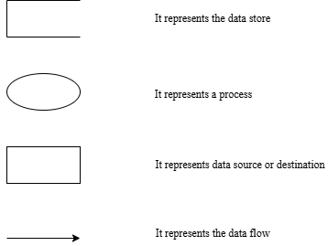

LEVEL 0

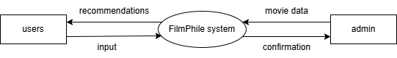

LEVEL 1 FOR ADMIN

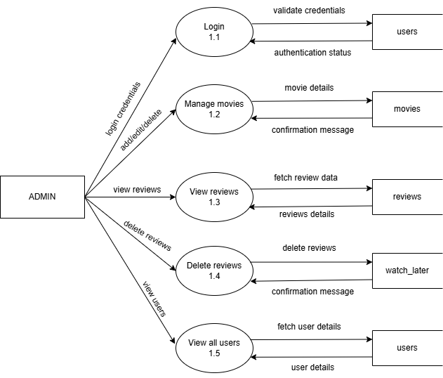

LEVEL 1 FOR USER

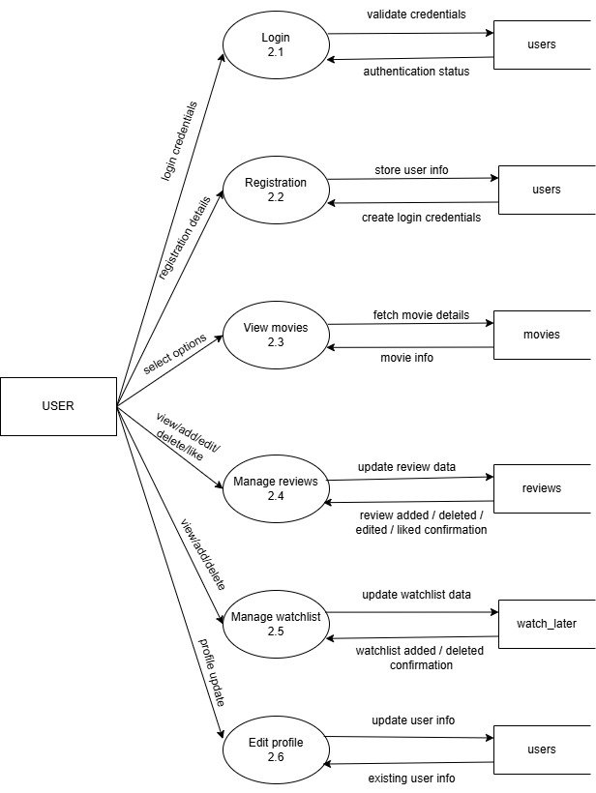

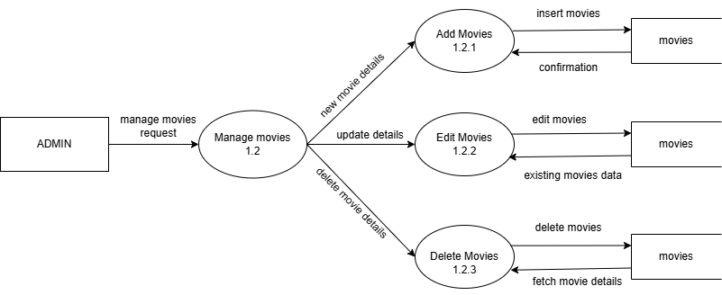
LEVEL 2 FOR ADMIN

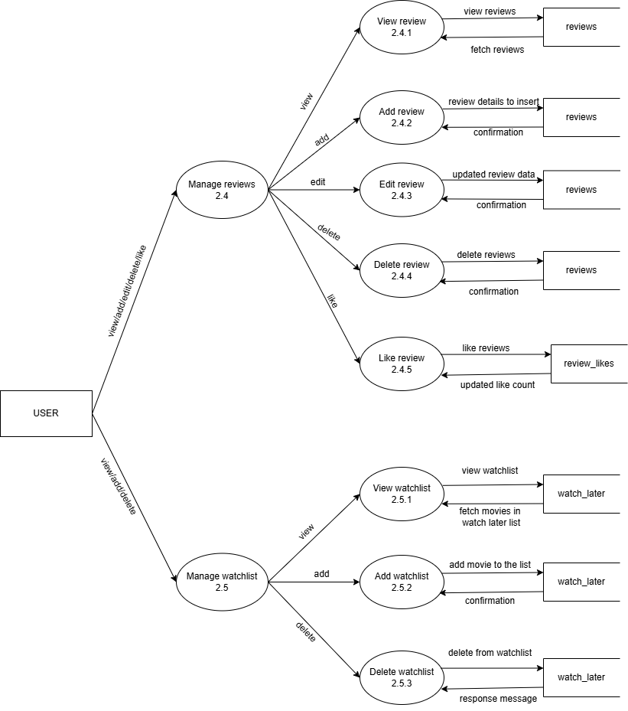
LEVEL 2 FOR USER

4.5 INPUT DESIGN

USER
First, we entering Register details (username, email, password).Then automatically Login after successful registration. After login, go to the Questions page. On that page, User can filter movies by Language, Genre, Mood, Pacing Style. User can add movies to watchlater. User can write review for a movie.
Finally, user can Confirm submission of review or watchlater addition.

ADMIN
First, we entering Login ID and Password. Then clicking on Login button to go to the Admin.
From the dashboard, admin can:
      - Add new movies to the database
      - Edit movie details (title, genre, language, etc.).
      - Remove movies if required.
      - Manage users (view, disable, or deactivate user accounts).
      - Monitor reviews and delete inappropriate reviews.
Finally, admin can Confirm submission of any changes made.

4.6 OUTPUT DESIGN

USER
The output design for the user in FilmPhile allows them to view personalized movie recommendations based on their selected mood, language, and pacing preferences. Once logged in, the user can see detailed information about each recommended movie such as title, genre, language, release year, and duration. The system also displays the user’s watchlater, showing all the movies they have saved for later viewing. In addition, the user can view the reviews they have submitted earlier, along with feedback given by other users, which helps them make better decisions. The output also enables the user to edit or update their own reviews, improving the accuracy of the recommendations they receive.

ADMIN
The output design for the admin in FilmPhile begins with access to the admin dashboard after a successful login. From the dashboard, the admin can see complete details about movies, users, reviews. The output provides the admin with the ability to monitor user activity, including the number of users registered, their reviews, and the movies added to their watchlater list. The admin can also view movie details. The system displays user reviews and feedback, allowing the admin to check for inappropriate content and take necessary actions. Furthermore, the admin can view and manage user accounts, including deleting inactive or old users, and can keep track of changes made to the movie database. The output also supports the admin in monitoring the performance of recommendations, ensuring that the system remains accurate, updated, and beneficial for users.

5. SYSTEM DEVELOPMENT

5.1 INTRODUCTION
The system was developed using XAMPP as the local server environment, providing a reliable platform for running the web application. PHP was used for server-side scripting, handling user requests and data processing, while JavaScript enhanced interactivity on the front-end. The development process focused on creating a seamless and efficient user experience by integrating the backend and frontend technologies to meet the system's functional requirements.

    - Planning: Define project scope, goals, and timelines.
    - Analysis: Gather and analyze requirements from stakeholders.
    - Design: Create a detailed design of the system architecture and components.
    - Implementation: Build the system using selected tools and technologies.
    - Testing: Verify that the system meets the requirements and works as expected.
    - Deployment: Release the system to production and make it available to users.
    - Maintenance: Provide ongoing support and updates to ensure the system remains functional and efficient.

5.2 MENU LEVEL DESRIPTION
1. Admin Dashboard
- Overview of movie recommendation system activity
- Access to all admin features
2. Movie Management
- Add and manage movies in the database
- Edit movie details such as title, genre, language, release year, and duration
- Remove movies that are outdated or irrelevant
3. User Management
- Manage user accounts (create, edit, or delete users)
- Monitor user activity and feedback
4. Reviews and Feedback Management
- View all user reviews.
- Remove inappropriate or spam reviews
- Monitor user feedback for system improvements
5. System Settings
- Configure system preferences and options
- Manage security and access controls

Movie Management Menu
- Add Movie - Add a new movie with all details (title, genre, language, release year, duration).
- Edit Movie - Edit details of an existing movie.
- Remove Movie - Delete a movie from the system.

User Management Menu
- Create User - Create a new user or admin account.
- Edit User - Edit an existing user’s account details.
- Delete User - Remove inactive or problematic user accounts.

Reviews and Feedback Menu
- View Reviews - See all reviews submitted by users.
- Moderate Reviews - Remove or edit inappropriate reviews.

5.3 PROCESS SPECIFICATION
User Registration Process
- User Registration: The user clicks on the "Register" button and creates a new account.
- User Information: The user enters their personal details (name, email, password).
- OTP Verification: The system verifies the email address and sends an OTP.

Admin Process
- Login: The admin logs in to the system using their username and password.
- Movie Management: The admin adds new movies by entering details such as title, genre, language, release year, and duration.
- Edit/Remove Movies: The admin edits or deletes existing movie details as required
- User Management: The admin manages user accounts, including creating, editing, or deleting users, and assigning roles.
- Review Moderation: The admin monitors user reviews and removes inappropriate or spam reviews.

User Process
- Login: The user logs in to the system using their email and password.

- Recommendation Page: The user views the list of recommended movies generated based on preferences and mood.
- Search/Filter Movies: The user can search for movies or filter by language, genre, or pacing style.
- Watchlater Management: The user adds movies to their watchlater for later viewing.
- Movie Review : The user writes reviews for movies they have watched.

Recommendation Process
- Preference Matching: The system matches user preferences (language, genre, mood, pacing) with available movies.
- Result Display: The system displays the recommended movies on the user’s page.

6. SYSTEM TESTING

6.1 TESTING METHODS
The purpose of system testing in FilmPhile Movie Recommendation is to identify and correct errors in the developed system. Testing is a vital element of software quality assurance and represents the final review of specifications, design, and coding. Since FilmPhile deals with personalized recommendations and user-generated content such as reviews, proper testing ensures reliability, accuracy, and smooth user experience. The increasing reliance on recommendation systems and the high cost of failure motivates well-planned and thorough testing. Different levels of testing were employed to make the system error-free, fault-free, and reliable.

Unit Testing
Unit testing in FilmPhile focuses on verifying the smallest modules of the system. Each module, such as user registration, login, movie search, recommendation generation, watchlater management, and review submission, was tested individually with different sets of inputs to ensure they provide the expected output. Validations such as email format, password strength, empty space, duplicate watchlater entries were tested. All control paths were checked to ensure smooth flow of data within each module, and error handling conditions were verified. In conclusion, each module was tested thoroughly to confirm that it works correctly before integration.

Integration Testing
After unit testing, all modules such as registration, login, movie management, recommendation engine, watchlater, and review system were integrated, and the testing process was repeated. The main goal of integration testing in FilmPhile was to ensure proper interfacing between modules. For example, the recommendation engine should work correctly with the review module, while the watchlater should properly fetch movies from the database. Incremental integration strategies were used to minimize complexity while combining modules. Each component was tested systematically to uncover interface-related errors and ensure the evolving system was functioning as intended.

System Testing
System testing is one of the most important phases of FilmPhile Movie Recommendation. After integrating all modules, the entire system was tested to verify that it meets the requirements of users and administrators. This included checking whether users can successfully register, log in, search movies, receive accurate recommendations, add to watchlater, and post reviews. On

admin side, system testing ensured that admins could manage movies, moderate reviews, handle users. Various scenarios and possible variations were considered to confirm that the system performs reliably under all conditions before moving to user acceptance testing.

Testing Environment and Tools

Debugging
Debugging in FilmPhile helped identify and fix errors during development. It ensured that the recommendation system produced expected results, such as displaying relevant movies for a given mood, and handled exceptional cases, such as when no movies matched the criteria. Debugging strategies like Black Box and White Box testing were applied for effective error detection.

      - Black Box Testing
Black Box Testing was applied to FilmPhile by testing its functionality without focusing on the internal code structure. For example, testers checked whether users could register, log in, receive recommendations, add movies to watchlater, and submit reviews as per the requirements. Similarly, admins were tested for managing movies, users, and reviews. This ensured that the system met functional requirements and provided accurate outputs.

      - White Box Testing
White Box Testing was used in FilmPhile to check the internal logic of the recommendation engine, database queries, and program flow. Developers verified whether algorithms processed user preferences correctly, whether reviews influenced recommendations, and whether data was securely fetched and updated in the database. This type of testing ensured structural correctness, optimized performance, and secure implementation.

6.2 TEST PLAN ACTIVITIES
Testing for the FilmPhile system commences with the formulation of the test plan and terminates with acceptance testing. The test plan is a general document that defines the scope, approach, schedule, and resources for testing. It also identifies the items to be tested and the responsibilities of personnel involved. Test planning can proceed in parallel with system design and coding activities.

The inputs required for preparing the test plan are:
- Project plan – defines the overall timeline and milestones.
- Requirements document – specifies functional and non-functional requirements such as recommendation accuracy, mood-based filtering, and user management.
- System design document – outlines the architecture, modules, and data flow that will guide test unit identification.
A test plan for FilmPhile will contain :
- Test Unit Specification
    - User Management (registration, login, profile management)
    - Movie Database Management
    - Recommendation Engine ( mood-based, and pace/language filters)
    - Watchlater & Reviews Management
Each test unit will be tested individually and later integrated into the complete system.
- Features to be Tested
- Core Features: Personalized recommendations, mood-based movie suggestions.
- Functional Features: Watchlater creation, review submission.
- Non-Functional Features: Response time of recommendations, security of user data.
- Integration Features: Interaction between recommendation engine and database, cross-module functionality.
- Approach for Testing
- Unit Testing – to test individual modules (user registration, recommendation).
- Integration Testing – to validate interactions between modules (e.g., recommendation engine using movie database and user preferences).
- System Testing – to test the entire FilmPhile application as a whole.
- Acceptance Testing – to verify system meets all user requirements and provides correct recommendations.
- Test Deliverables
  - Test plan document
  - Test cases and test scripts
  - Test data (movie datasets, user profiles, reviews)
  - Test results and defect reports
  - Final test summary report

- Personnel Allocation
- Test Manager – Oversees overall testing strategy.
- Test Engineers – Responsible for preparing test cases, executing unit and integration testing.
- Developers – Support debugging and defect fixing.
- End Users/Stakeholders – Involved in acceptance testing for feedback on recommendations and usability.

- SYSTEM IMPLEMENTATION

One of the important parts of implementation is user training. A normal user can be trained within a week to understand all aspects of the FilmPhile system, such as browsing movies, using filters, adding movies to watchlater, and providing reviews. Administrators and developers may require additional training on managing the movie database and monitoring the recommendation engine. Another important concern is the site preparation, which includes preparing the hosting server, ensuring proper internet connectivity, and securing the application environment, since the system runs entirely online.

IMPLEMENTATION STEPS

- Setup Development Environment
  - Install and configure the necessary tools, frameworks, and libraries (e.g., PHP, MySQL, HTML, CSS, JavaScript).
  - Prepare the movie dataset for the initial recommendation engine.
- Develop System Components
  - Build the User Management Module (registration, login, profile management).
  - Develop the Movie Database Module for adding, updating, and retrieving movies.
  - Implement the Recommendation Engine ( mood-based, and pace/language filters).
  - Design the Watchlater and Reviews Module.
  - Create the Search and Filtering Module for flexible movie discovery.
- Integrate System Components
  - Ensure seamless interaction between the database, recommendation engine, and user interface.
  - Test integration between watchlater/reviews and user profiles.
- Test System
  - Perform unit testing for individual modules.
  - Conduct integration testing to ensure proper communication between components.
  - Carry out system testing to validate functionality, performance, and security.
- Deploy System
  - Deploy the FilmPhile system to the production server.
  - Configure the database, recommendation engine, and hosting environment for live use.
- Provide Training
  - Train end users (movie viewers) to search, filter, and get recommendations.
  - Train administrators to manage the movie database and monitor recommendations.

  - Provide documentation for easy onboarding.
- Monitor and Maintain System
  - Continuously monitor the recommendation accuracy and system performance.
  - Fix bugs, update movie datasets, and improve filtering options.
  - Provide technical support and system upgrades for better scalability.

The implementation of the FilmPhile Movie Recommendation System requires a comprehensive approach that considers technical, organizational, and user-centric factors. By carefully analysing the needs of users, designing and developing a powerful recommendation engine, and implementing the system in a managed manner, FilmPhile can ensure a successful and engaging movie discovery platform that meets user expectations.

- CONCLUSION AND FUTURE SCOPE

CONCLUSION
The FilmPhile Movie Recommendation System provides a personalized, efficient, and user-friendly platform for discovering movies. It overcomes the limitations of traditional recommendation systems by considering multiple factors such as user preferences, mood, language, and pacing style, ensuring highly relevant and engaging suggestions. By offering features like search filters, watchlater management, and user reviews, the system enhances the overall movie-watching experience.

This system is particularly beneficial for movie enthusiasts, streaming platforms, and content providers, as it helps users easily discover content that matches their tastes while improving user engagement and satisfaction. With advancements in AI-driven recommendation engines, data analytics, and scalable architecture, FilmPhile has the potential to redefine how users explore movies, making the process more interactive, enjoyable, and personalized.

FUTURE SCOPE

- Mobile App Development : Develop dedicated mobile applications for Android and iOS to allow users to access recommendations, manage watchlater, and review movies on-the-go.
- Social Features : Introduce community-driven features such as friend-based recommendations, movie discussion forums, and sharing watchlater.

- SCREEN LAYOUTS

HOME PAGE

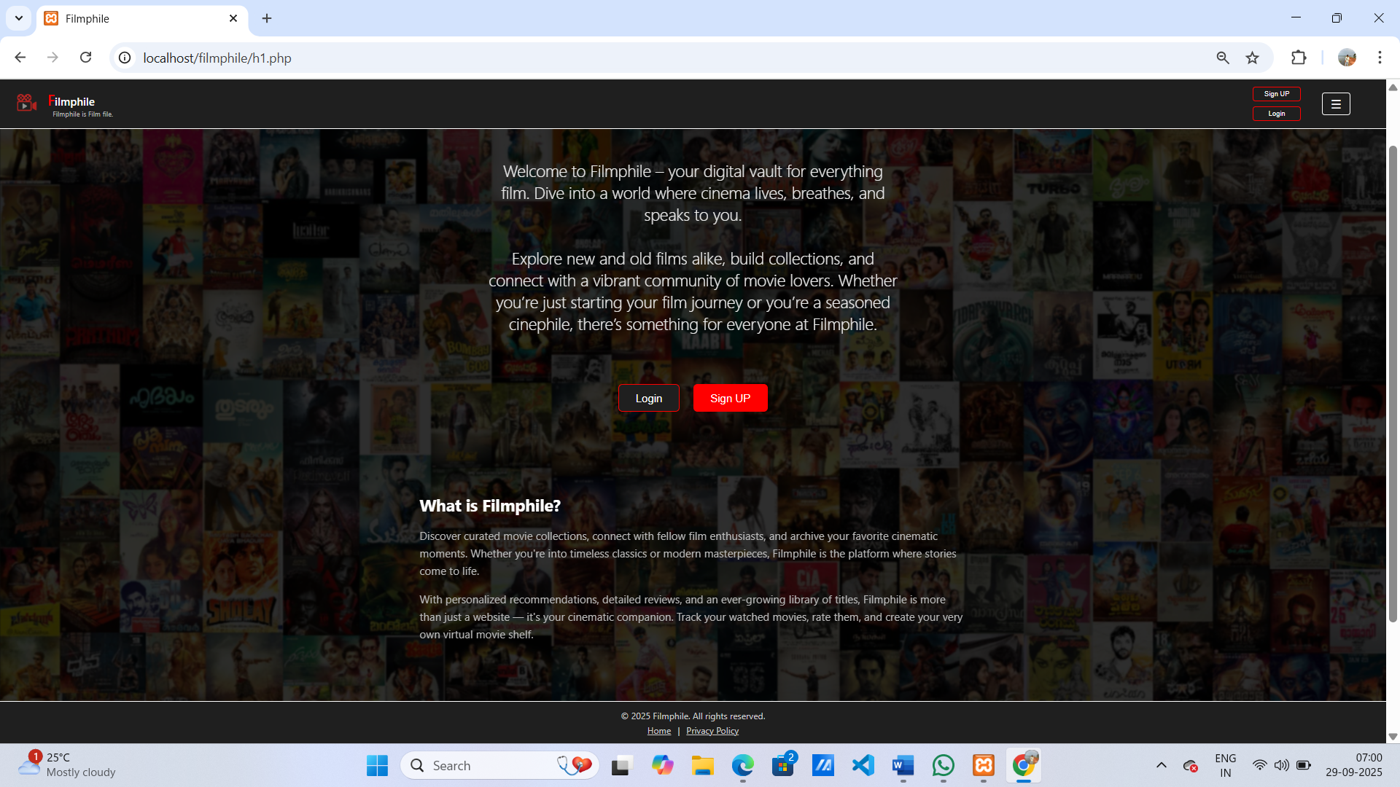

LOGIN PAGE

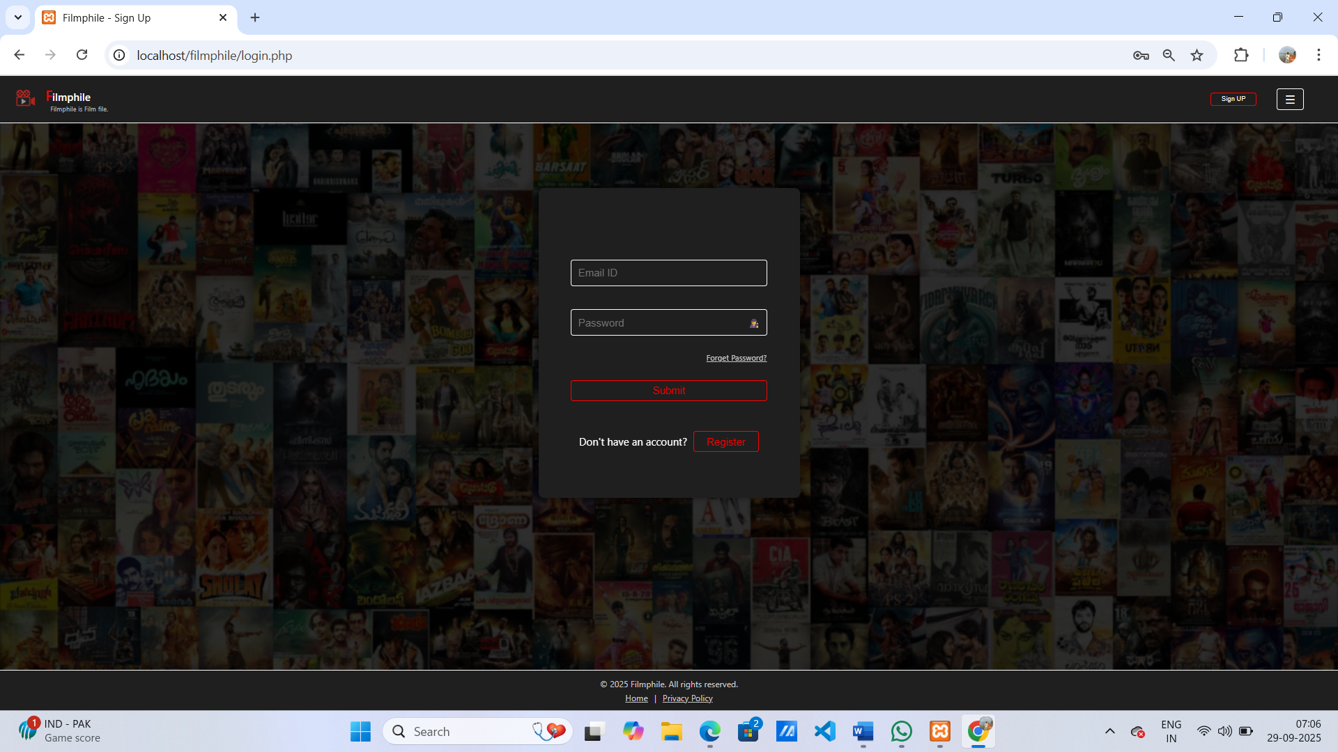

REGISTRATION PAGE

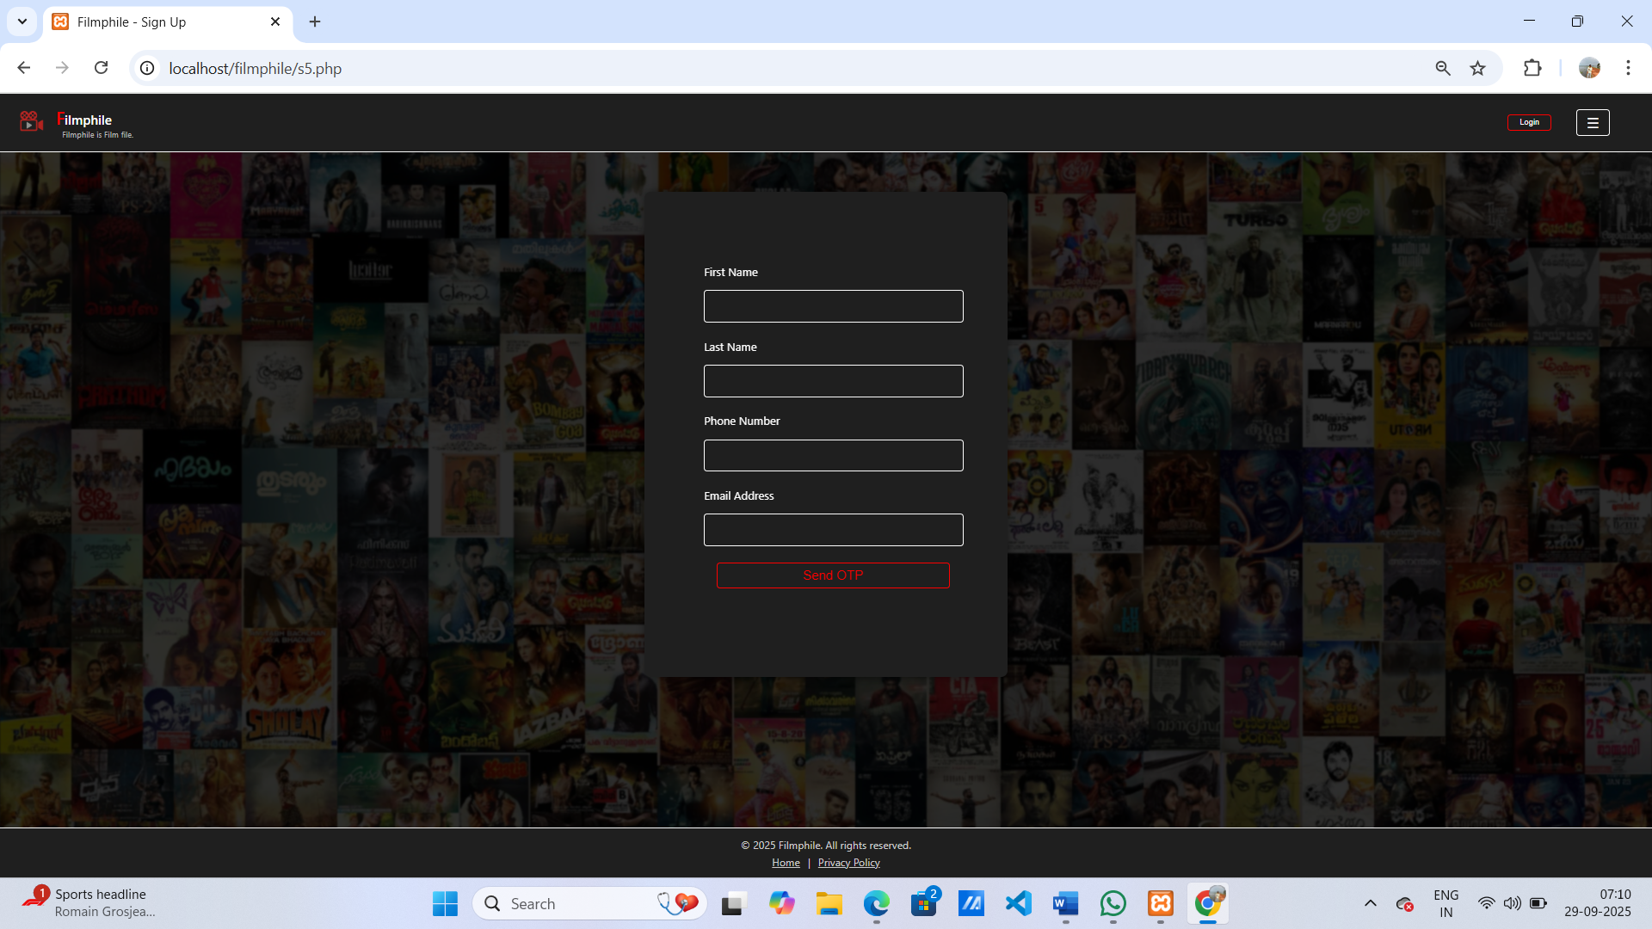

FORGOT PASSWORD PAGE

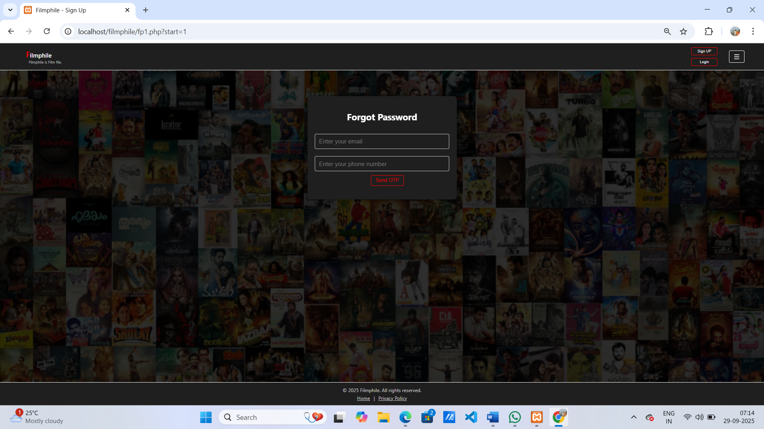

QUESTIONS PAGE

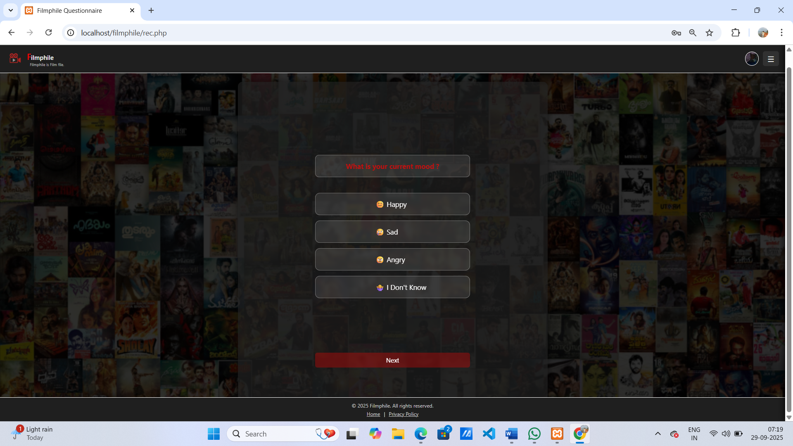

RECOMMENDATION PAGE

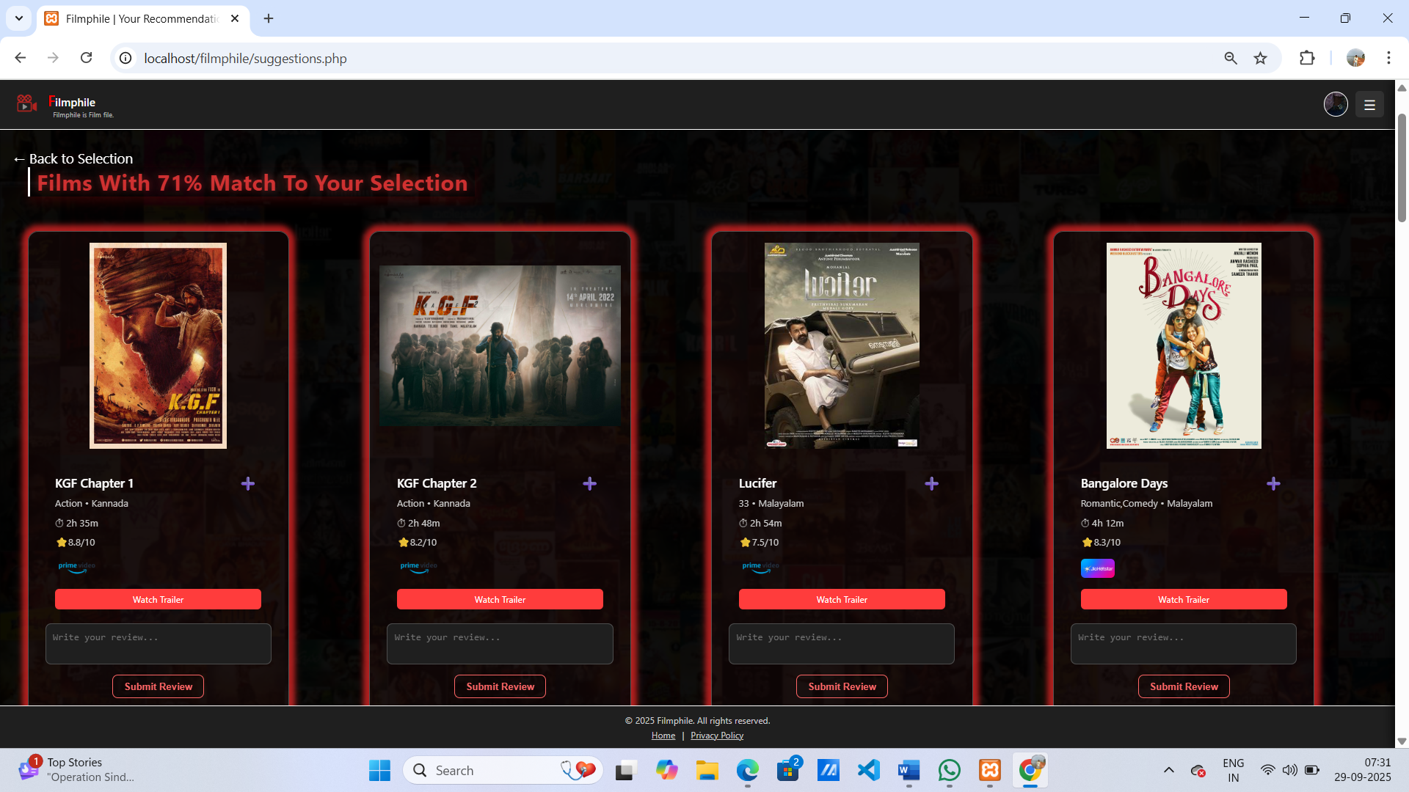

REVIEWS PAGE
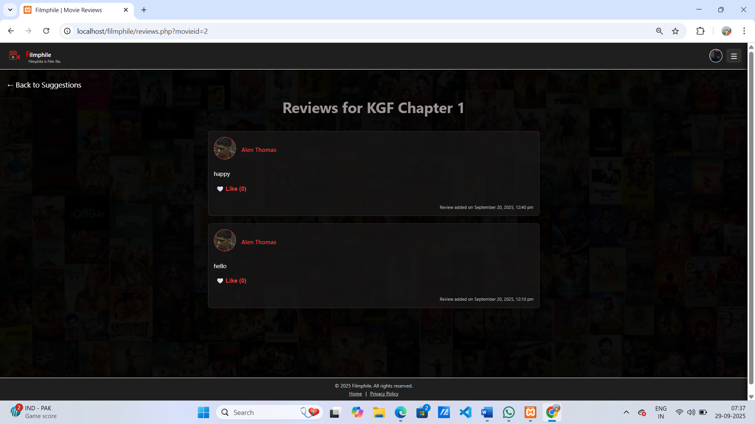

WATCHLATER PAGE

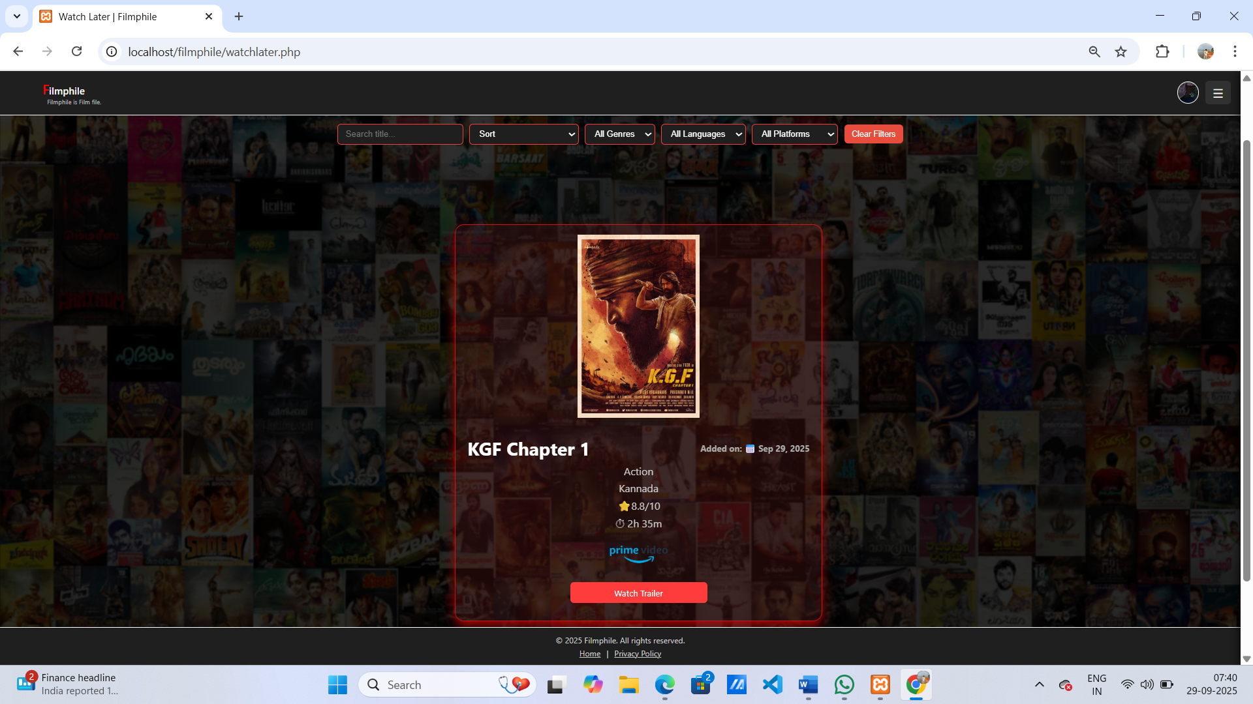

PROFILE PAGE

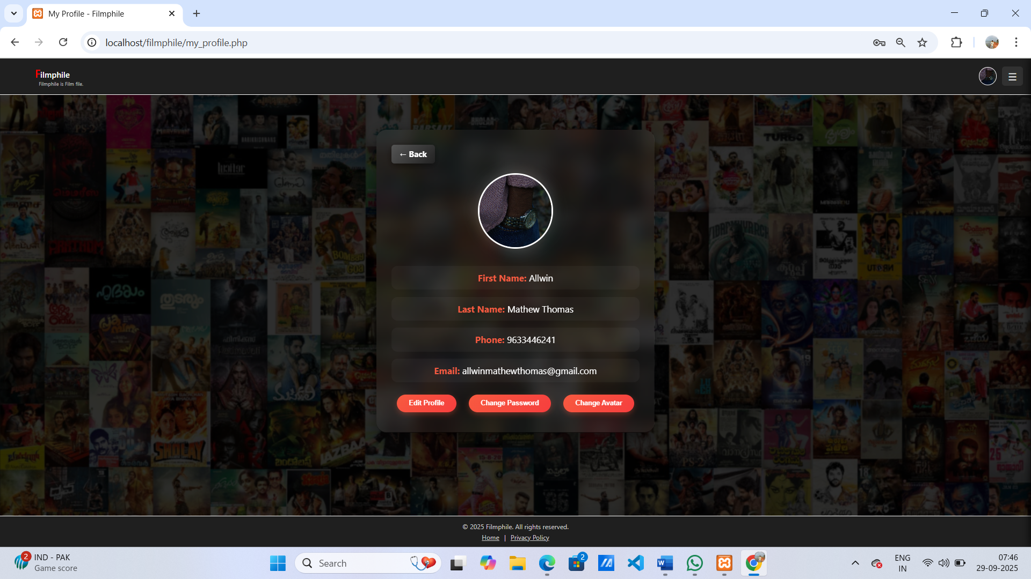

ADMIN DASHBOARD PAGE

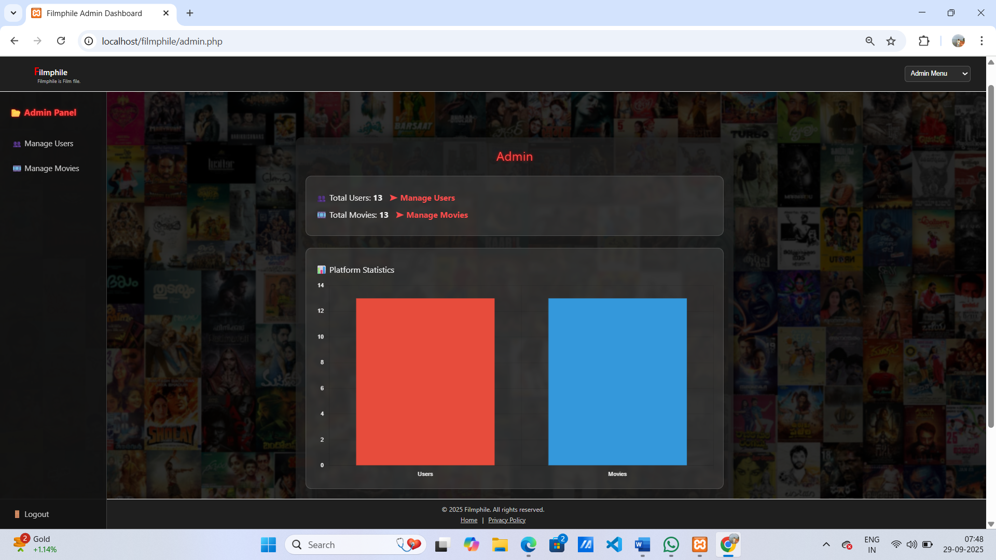

ADMIN MANAGE USERS PAGE

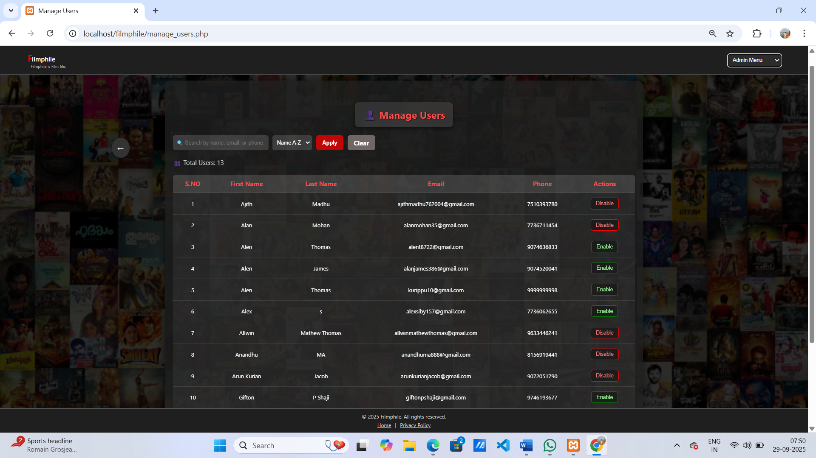

ADMIN MANAGE MOVIES PAGE

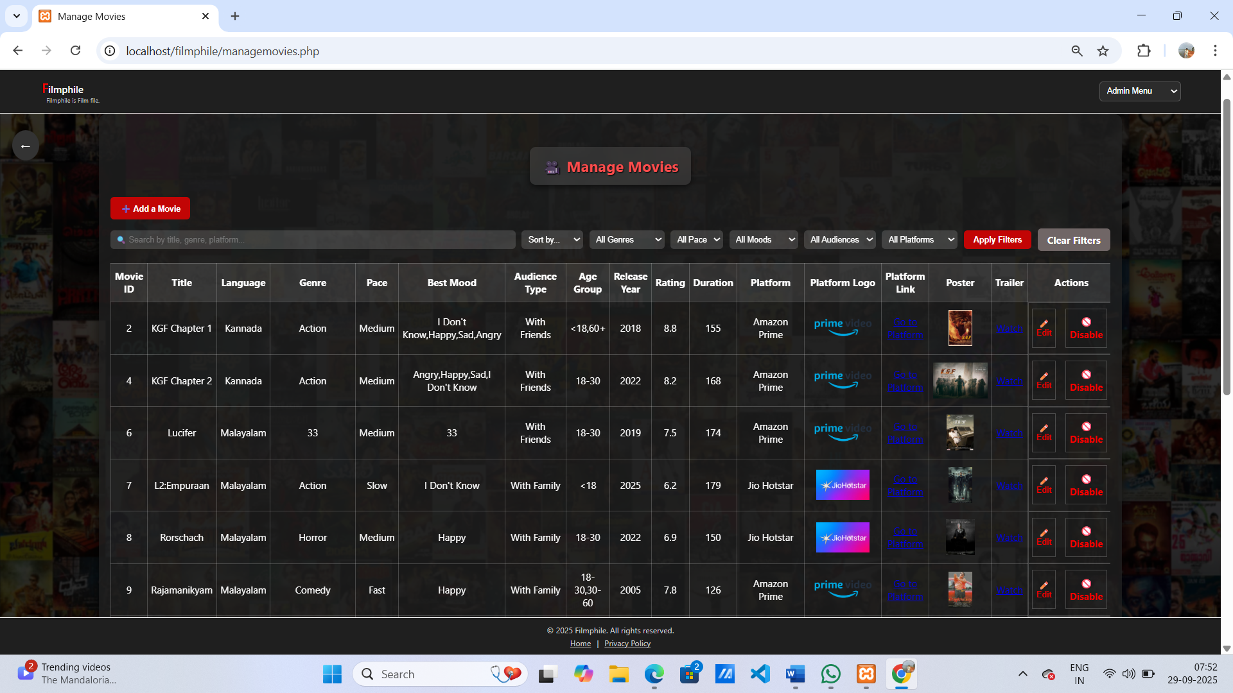

- BIBILOGRAPHY

Text Reference:
- Software Engineering: A practitioner's approach by Roger. S .Pressman 7.
- Programming PHP: Rasmus Lerdorf and Kevin Tatore, Shroff Publishers & Distributors Pvt. Ltd
- Binu M.B and Amaladevi V.C Web Programming using PHP, Prakash Publications,Changanacherry,2019.
- Learning PHP, MySQL & JavaScript: With JQuery, CSS & HTML5 by RobinNixon.

Web Reference:
- W3Schools: https: //www.w3schools.com/php/
- GeeksforGeeks:"Computer Science Portal." https://www.geeksforgeeks.org
- OpenAI: "GPT-3: Language Models for Text Generation." https://www.openai.com
- https://www.w3schools.com/django/django_templates.php
- https://dev.mysql.com/doc/refman/8.0/en/tutorial.html

