**Parareal implementation**

Consider the following ODE:

$$\left\{\begin{aligned}\frac{du}{dt}=f\left(t,u\right) , t∈[t_{0},t_{N}] \\ u\left(t_{0}\right)=u_{0}\end{aligned}\right.$$

Introduce the following propagation operator:

* **Coarse propagator $G$** (e.g. Forward Euler with $h \sim dT$)
* **Fine propagator $F$** (e.g. Forward Euler with $dt=dT/500$)

Notation: $U_{n}^{k}≈u\left(t_{n}\right)$ at the step $k$, with $t_{n}=t_{0}+n*dT$

**My parareal**

$$\left\{\begin{aligned}u^{'}=u*sin\left(t\right)+t , t∈[t_{0},t_{N}] \\ u\left(t_{0}\right)=0\end{aligned}\right.$$

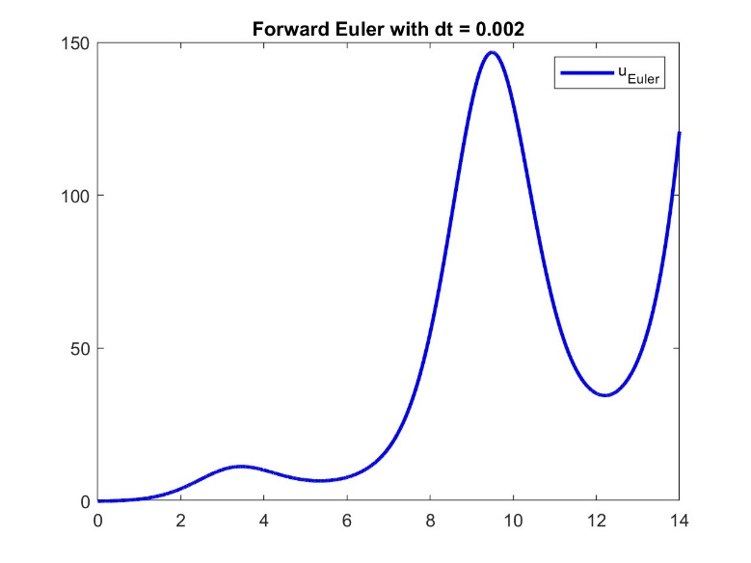

**Step ~ 0**

f = @(t,y) sin(t).*y + t;

t0 = 0; tN = 14;

y0 = 0;

dt = 0.002;

[t,y_fine] = fwd_Euler(t0,tN,y0,dt,f);

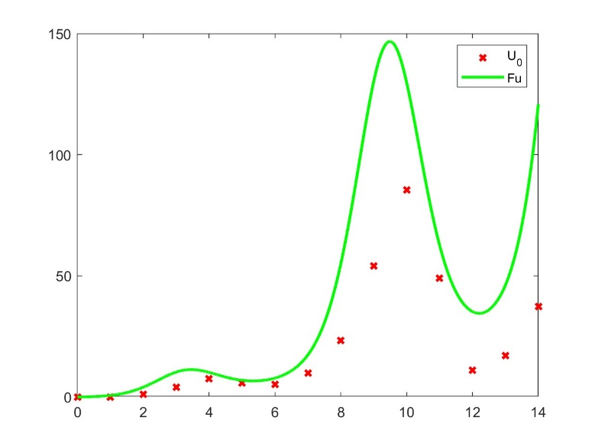

**Step 1**

Initial guess, first iteration of $G$

dT = 1;

[t_coarse,U_0] = fwd_Euler(t0,tN,u0,dT,f);

**Definitions of u_fine and t_fine**

for m = 1 : (tN - t0) / dT % from 1 to number of coarse subintervals

t_fine(m,:) = [t0 + (m-1) * dT : dt : t0 + m * dT]; % fine approx. of each subint.

end

% Notice: t_fine(m,end) = t_fine(m+1,1)

% L_coarse = n of coarse subintervals, L_fine = n of fine subinterval

u_fine = zeros(L_coarse, L_fine);

U = U_0;

**Iterative Step**

for k = 1 : k_max

$$F$$

Between two successive coarse time steps

% Evaluation of $F\left(t_{n+1},t_{n},U_{n}^{k}\right)$

% Parallel step: computation of the fine solution on each subinterval

parfor n = 1 : L_coarse - 1

[t_fine(n,:),u_fine(n,:)] = fwd_Euler(t_coarse(n),t_coarse(n+1),U_0(n),dt,f);

end

% Evaluation of $G\left(t_{n+1},t_{n},U_{n}^{k}\right)$

% Update of the coarse solution

for h = 1 : L_coarse - 1

du = sin(t_coarse(h))*U(h) + t_coarse(h);

U_k(h+1) = U(h) + dT*du;

end

% Evaluation of $G\left(t_{n+1},t_{n},U_{n}^{k+1}\right)$

for n = 1 : L_coarse - 1

du = sin(t_coarse(n))*U(n) + t_coarse(n);

U(n+1) = U(n) + dT*du;

% Correction step $U_{n+1}^{k+1}=G\left(t_{n+1},t_{n},U_{n}^{k+1}\right)+F\left(t_{n+1},t_{n},U_{n}^{k}\right)-G\left(t_{n+1},t_{n},U_{n}^{k}\right)$

U(n+1) = U(n+1) + u_fine(n, end) - U_k(n+1);

end

U_0 = U

End

**..Some plots now..**

