Parareal
The parareal algorithm is a parallel numerical method used to compute the numerical solution of an ODE like this:
$$\left\{\begin{aligned}u^{'}\left(t\right)=f\left(u,t\right) , t∈\left[0,T\right] \\ u\left(0\right)=u_{0}\end{aligned}\right.$$
For the purpose of the method, let introduce a couple of operators, quite identical yet defined on two different “grids”:
- Coarse operator: $G\left(t_{2},t_{1},u_{1}\right)=u_{h}\left(t_{2}\right)≈u(t_{2})$ s.t. $u_{h}\left(t_{1}\right)=u_{1}$ , it gives us a “coarse” approximation of the solution, defined on a grid of size $∆t_{G}$:
${\left\{t_{n}\right\}}_{n=0}^{N_{G}} : t_{0}=0$ and $t_{N_{G}}=T$

- Fine operator: $F\left(t_{2},t_{1},u_{1}\right)=u_{h}\left(t_{2}\right)≈u(t_{2})$ s.t. $u_{h}\left(t_{1}\right)=u_{1}$ , which provides us a more accurate approximation of the solution, defined on a “fine” grid of size $∆t_{F}$
${\left\{t_{n_{k}}\right\}}_{k=0}^{N_{F}} : t_{n_{0}}=t_{n}$ and $t_{n_{N_{F}}}=t_{n+1}$ for $n=0,1,…,N_{G}-1$
From now on let us adopt the following notation: $u_{h}\left(t_{n_{k}}\right)=U_{n+1}^{k+1}$
Parareal is an iterative method which reads as:
Given ${\left\{U_{n+1}^{0}\right\}}_{n=0}^{N_{G}}={\left\{G\left(t_{n+1},t_{n},U_{n}^{0}\right)\right\}}_{n=0}^{N_{G}}$ with $U_{0}^{0}=u_{h}\left(0\right)=u_{0}$, find ${\left\{U_{n+1}^{k+1}\right\}}_{k=0}^{N_{F}}$ s.t.
$$U_{n+1}^{k+1}=G\left(t_{n+1},t_{n},U_{n}^{k+1}\right)+F\left(t_{n+1},t_{n},U_{n}^{k}\right)-G\left(t_{n+1},t_{n},U_{n}^{k}\right)$$
It is clear that the solution of parareal for $k→+∞$ converges to a series of values $\left\{U_{n}\right\}$ s.t. $U_{n+1}=F(t_{n+1},t_{n},U_{n})$ so it reaches the accuracy approximation of the fine operator.

Example of application:
Suppose to have the following ODE:
$$\left\{\begin{aligned}y^{'}\left(t\right)=\sin\left(t\right)y\left(t\right)+t , t∈\left[0,5\right] \\ y\left(0\right)=0\end{aligned}\right.$$
Furthermore, suppose this is the choice of the operators:
Operator G: forward Euler with step $∆t_{G}=1$
Operator F: forward Euler with step $∆t_{F}=∆t_{G}/500$

To make us understand how the algorithm works we compare each step of it with a reference solution (the green one) that is obtained when F is applied solely. As explained before, it represent what our solution going towards.
Next page contains some plots of the different solutions in such a way we can follow the evolution of the approximations that are being done:
Plots of the initial guess + 5 iterations of Parareal:
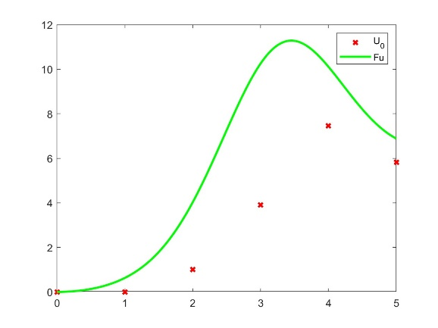
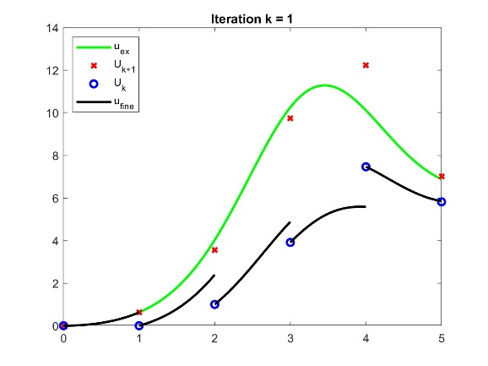
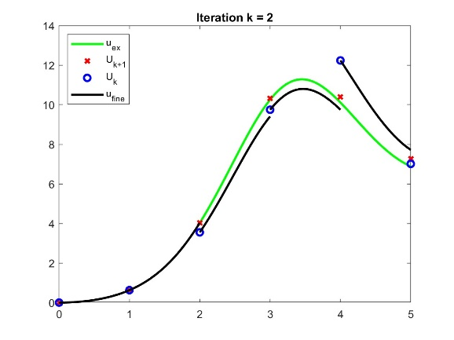

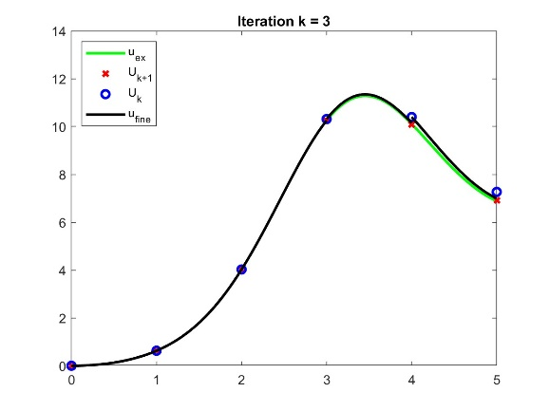
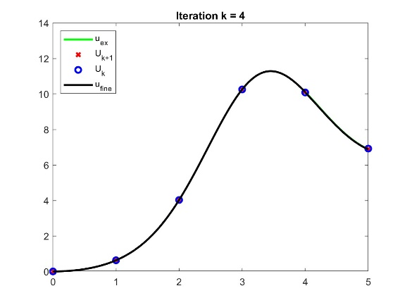
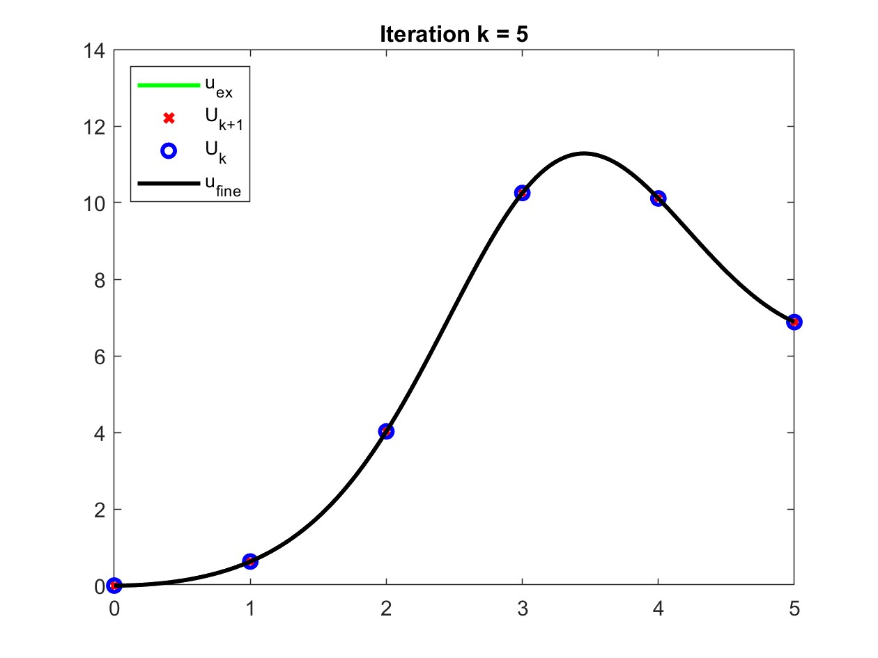

Pseudo-code
$U_{0}^{0}←{\tilde{U}}_{0}^{0}←y_{0}$ // Initialization
$$for n=1:N_{G}$$
$${\tilde{U}}_{n}^{0}←G({\tilde{U}}_{n-1}^{0})$$
$$U_{n}^{0}←{\tilde{U}}_{n}^{0}$$
$$end for$$
$for k=1:k_{max}$ //
$$U_{1}^{0}←y_{0}$$
$$parfor n=1:N_{G}$$
${\hat{U}}_{n}^{k-1}←F({\tilde{U}}_{n-1}^{k-1})$ // Parallel step, accomplished by the fine step operator
$$end parfor$$
$$for n=1:N_{G}$$
${\tilde{U}}_{n}^{k}←G\left(U_{n-1}^{k}\right)$ // Prediction of the solution at the next step
$U_{n}^{k}←{\tilde{U}}_{n}^{k}+{\hat{U}}_{n}^{k-1}-{\tilde{U}}_{n}^{k-1}$ // Correction step
$$end for$$
$$end for$$
Parareal in a system of ODEs
If we rearrange a bit our code, we can make it work for systems of ODEs. Quite fast we show the results of it when applied to the following Lotka-Volterra system, of which a reference solution is well known:
$$\left\{\begin{aligned}y_{1}^{'}=a-by_{2} \\ y_{2}^{'}=dy_{1}-g \\ \vec{y}\left(0\right)=\vec{y_{0}}\end{aligned}\right.$$
With $a=0.1$ ; $b=0.02$ ; $d=0.02$ ; $g=0.4$ ; $y_{0}=\left[15,15\right]$
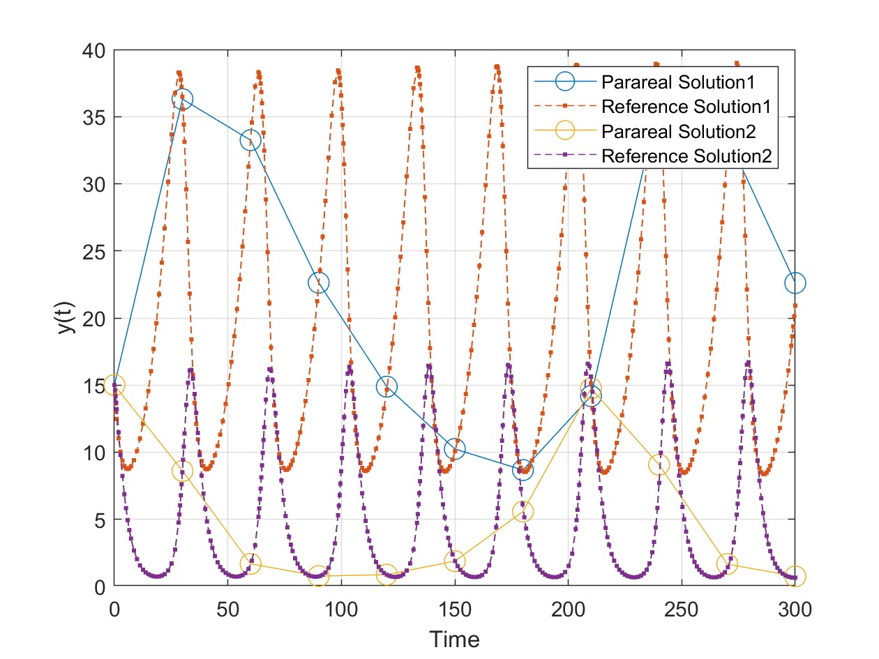

We are about to use Parareal for Systems.

