Parareal implementation
Consider the following ODE:
$$\left\{\begin{aligned}\frac{du}{dt}=f\left(t,u\right) , t∈[t_{0},t_{N}] \\ u\left(t_{0}\right)=u_{0}\end{aligned}\right.$$
Introduce the following propagation operator:
- Coarse propagator $G$ (e.g. Forward Euler with $h \sim dT$)
- Fine propagator $F$ (e.g. Forward Euler with $dt=dT/500$)
Notation: $U_{n}^{k}≈u\left(t_{n}\right)$ at the step $k$, with $t_{n}=t_{0}+n*dT$
My parareal
$$\left\{\begin{aligned}u^{'}=u*sin\left(t\right)+t , t∈[t_{0},t_{N}] \\ u\left(t_{0}\right)=0\end{aligned}\right.$$
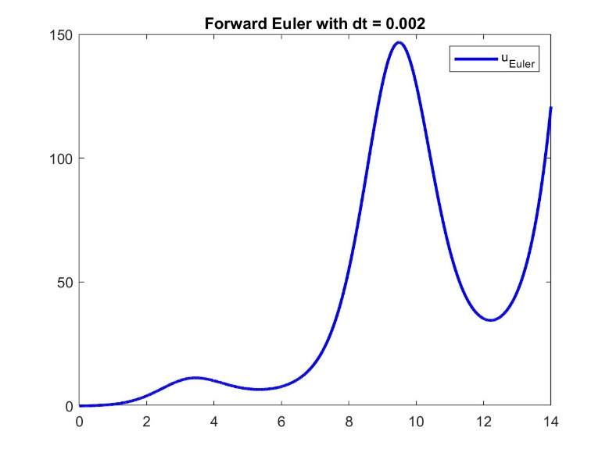

Step ~ 0
f = @(t,y) sin(t).*y + t;
t0 = 0; tN = 14;
y0 = 0;
dt = 0.002;

[t,y_fine] = fwd_Euler(t0,tN,y0,dt,f);

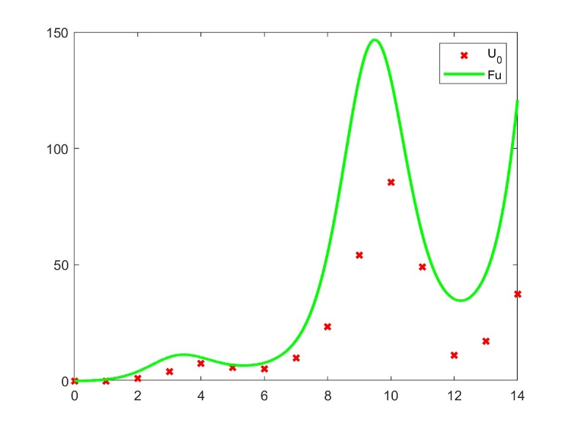
Step 1
Initial guess, first iteration of $G$
dT = 1;
[t_coarse,U_0] = fwd_Euler(t0,tN,u0,dT,f);

Definitions of u_fine and t_fine
for m = 1 : (tN - t0) / dT % from 1 to number of coarse subintervals
t_fine(m,:) = [t0 + (m-1) * dT : dt : t0 + m * dT]; % fine approx. of each subint.
end
% Notice: t_fine(m,end) = t_fine(m+1,1)

% L_coarse = n of coarse subintervals, L_fine = n of fine subinterval
u_fine = zeros(L_coarse, L_fine);

U = U_0;

Iterative Step
for k = 1 : k_max
$$F$$
Between two successive coarse time steps

% Evaluation of $F\left(t_{n+1},t_{n},U_{n}^{k}\right)$
% Parallel step: computation of the fine solution on each subinterval
parfor n = 1 : L_coarse - 1
[t_fine(n,:),u_fine(n,:)] = fwd_Euler(t_coarse(n),t_coarse(n+1),U_0(n),dt,f);
end

% Evaluation of $G\left(t_{n+1},t_{n},U_{n}^{k}\right)$
% Update of the coarse solution
for h = 1 : L_coarse - 1
du = sin(t_coarse(h))*U(h) + t_coarse(h);
U_k(h+1) = U(h) + dT*du;
end

% Evaluation of $G\left(t_{n+1},t_{n},U_{n}^{k+1}\right)$
for n = 1 : L_coarse - 1
du = sin(t_coarse(n))*U(n) + t_coarse(n);
U(n+1) = U(n) + dT*du;

% Correction step $U_{n+1}^{k+1}=G\left(t_{n+1},t_{n},U_{n}^{k+1}\right)+F\left(t_{n+1},t_{n},U_{n}^{k}\right)-G\left(t_{n+1},t_{n},U_{n}^{k}\right)$

U(n+1) = U(n+1) + u_fine(n, end) - U_k(n+1);
end

U_0 = U

End

..Some plots now..

