SBT-DF204:Computer Forensics Case Studies
Case Study1: Individual forensic investigation:
Investigating Harassment Email Traffic With Wireshark
By:
Okunlola Emmanuel Oluwasegun
2025/FSWD/11420
5th October, 2026.

CASE OVERVIEW
This case study simulates a realistic network forensic investigation focused on investigating a reported case of harassment emails using packet capture analysis in Wireshark. The investigation is based on a simulated university scenario involving repeated harassing emails sent to a Chemistry Department teacher, with the objective of determining whether the available network traffic supports attribution to a student in Chemistry 109.
Acting as a digital forensic analyst, the primary task is to acquire, preserve, inspect, and analyze a supplied Packet Capture (PCAP) file to identify relevant web activity associated with the reported harassment message, particularly traffic involving the web service. The investigation involves examining HTTP requests, identifying the client and service IP addresses, inspecting relevant HTTP POST requests, and correlating the captured traffic with the reported message.
The investigation further extends to identifying the MAC address associated with the client traffic, examining scenario-provided cookie and browser evidence to establish a potential link between the device and an individual, and comparing the supported identity with the provided Chemistry 109 class roster. It also involves reconstructing a chronological timeline of relevant network activity using exact PCAP timestamps, packet numbers, and Wireshark display filters, while distinguishing direct observations from reasonable inferences and acknowledging the limitations of attribution within a shared, open wireless network.
Throughout the exercise, all investigative procedures follow core digital forensic principles, including preserving the original packet capture, creating and verifying a forensic working copy using SHA-256 cryptographic hashing, documenting evidence acquisition and integrity, and maintaining an evidence log with supporting screenshots. The final report presents an evidence-based conclusion, an assessment of attribution confidence, and the limitations and alternative explanations relevant to the investigation.

CASE MATERIALS
- First Email: The initial harassment email sent to Lily Tuckrige, a Chemistry Department teacher, including its full email headers.
- Full Email Headers: Header information from the earlier email, which points to an IP address associated with a shared student residence where an open wireless router is in use.
- Second Email: A subsequent harassment email received on Monday, 21 July, through the web service willselfdestruct.com.
- Chemistry 109 Class Roster: The list of students enrolled in Chemistry 109.
- Network Traffic Capture (PCAP): The packet capture recorded at the student residence network boundary, containing network traffic relevant to the investigation.
- Scenario Reference: digitalcorpora.org/corpora/scenarios/nitroba-university-harassment-scenario.
- Traffic Capture File: digitalcorpora.s3.amazonaws.com/corpora/scenarios/2008-nitroba/nitroba.pcap.

METHODOLOGY

Lab Folder Structure and Evidence Preparation
I started by setting up my forensic environment and prepared all required tools before starting the analysis.
First, I created the main working folder ~/SBT-DF204_CaseStudy1 along with its subdirectories. This structure keeps files separated and organized.
After moving into the new directory with cd SBT-DF204_CaseStudy1, I used pwd to confirm my path at /home/kali/SBT-DF204_CaseStudy1, then ran find . -maxdepth 1 -type d -print to make sure every folder was set up properly.
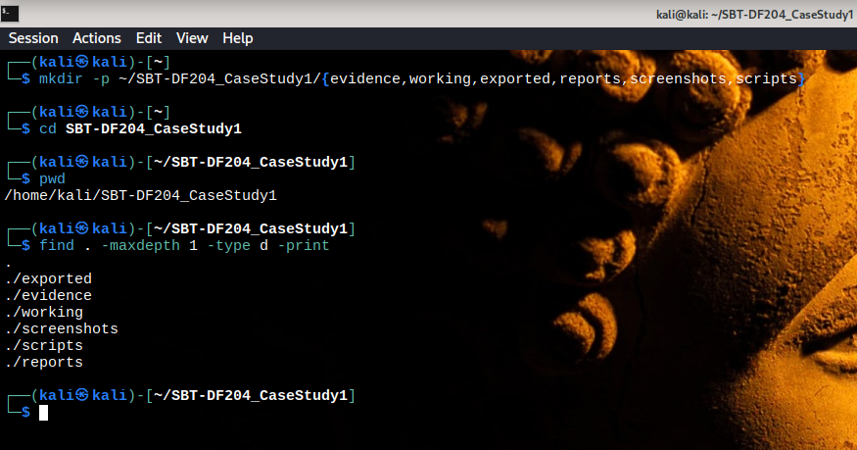

Next, I updated the system package list using sudo apt update to refresh the repositories. I then ran sudo apt upgrade -y to update the installed packages.
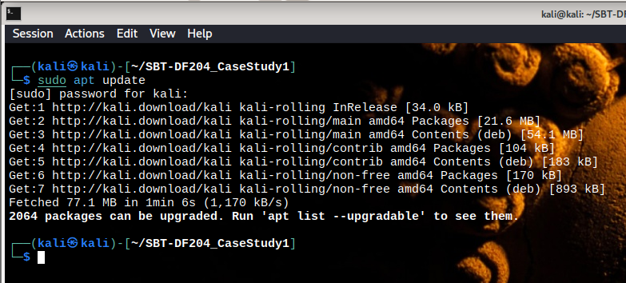
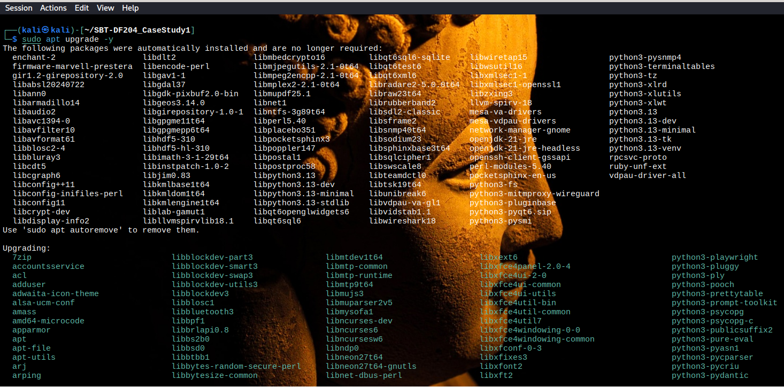

I then ran sudo apt install -y python3 wireshark tshark to confirm that Python 3, Wireshark, and TShark were fully installed and updated, ensuring all tools were ready for analyzing the packet capture.
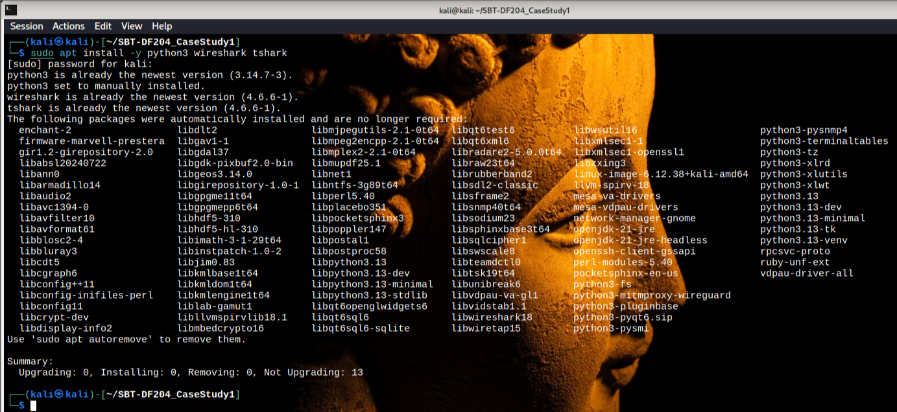

I verified their installation and versions by running python3 --version, wireshark --version, and tshark --version, which returned Python version 3.14.7, Wireshark version 4.6.6, and TShark version 4.6.
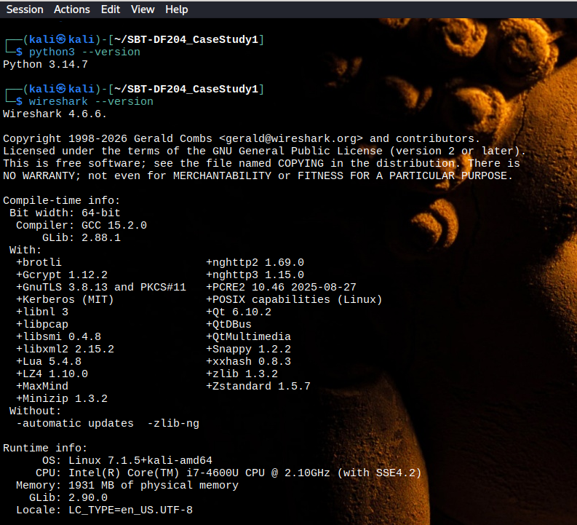

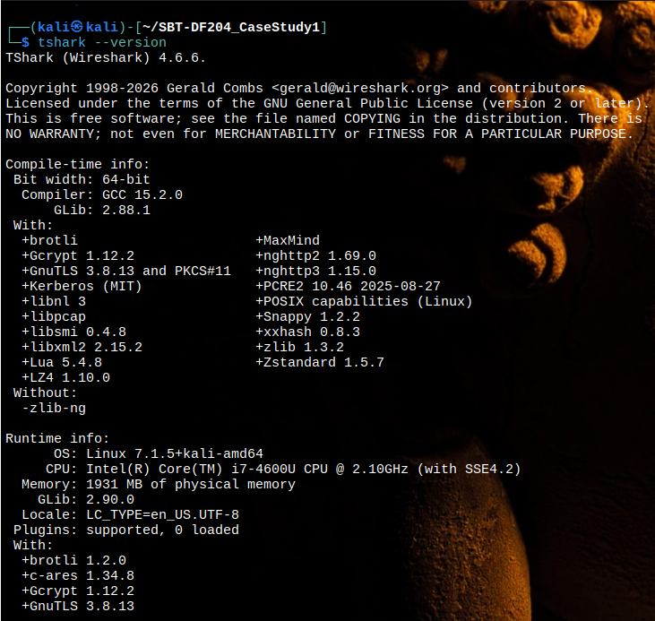

With the environment ready, I acquired the packet capture file nitroba.pcap from Digital Corpora.
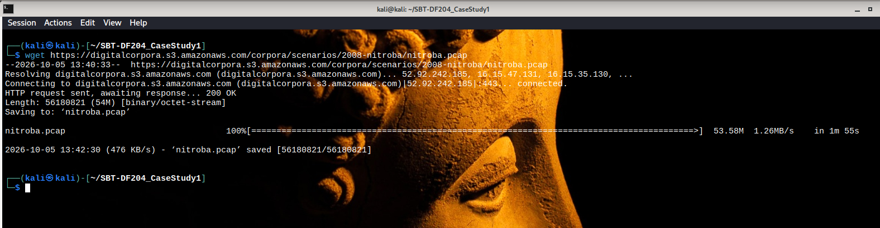

To preserve original evidence integrity, I moved the downloaded file into the evidence directory using mv nitroba.pcap ~/SBT-DF204_CaseStudy1/evidence/. Then, I created a forensic working copy in the working directory, so that all analysis would be performed strictly on the copy.
I ran ls -lh to verify the main folder contents and directory permissions.
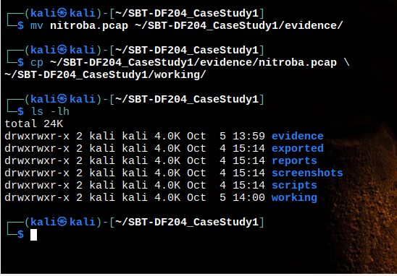

Finally, I calculated the cryptographic hash for both files to confirm integrity before beginning analysis. Running sha256sum ~/SBT-DF204_CaseStudy1/evidence/nitroba.pcap and sha256sum ~/SBT-DF204_CaseStudy1/working/nitroba.pcap yielded the identical hash value 2b77a9eaefc1d6af163d1ba793c96dbccacb04e6befdf1a0b01f8c67553ec2fb for both the original file and the working copy. Checking the file details with ls -lh ~/SBT-DF204_CaseStudy1/evidence/nitroba.pcap confirmed a file size of 54M. This verified that the working copy is an exact match to the acquired evidence and ready for Wireshark inspection.
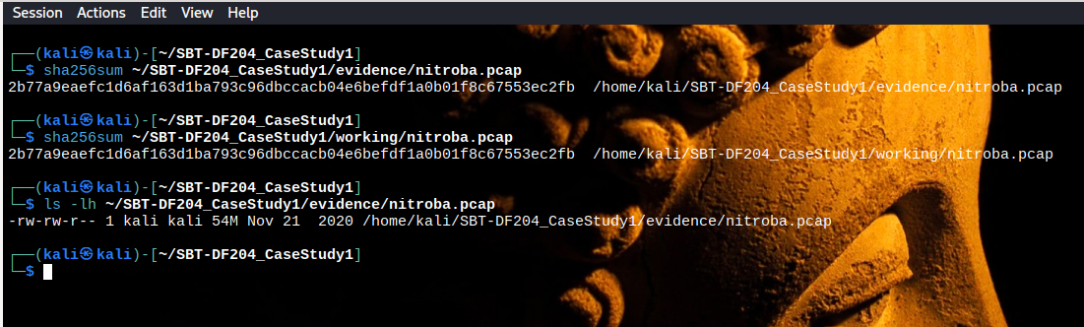

Mini Evidence and Chain of Custody Worksheet

Field | Student Entry
Case/lab identifier | SBTDF204_CaseStudy1_11420
Trainee name | Emmanuel Oluwasegun
Date and time started | 2026-10-05 13:40:33 UTC
Evidence file name(s) | nitroba.pcap
Source or generation method | Downloaded via wget from Digital Corpora
Original SHA-256 | 2b77a9eaefc1d6af163d1ba793c96dbccacb04e6befdf1a0b01f8c67553ec2fb
Working-copy SHA-256 | 2b77a9eaefc1d6af163d1ba793c96dbccacb04e6befdf1a0b01f8c67553ec2fb
Analysis workstation/VM | Kali Linux 7.1.5+kali-amd64 (kali@kali)

THE CLIENT SYSTEM INFO
To find out who visited the web service, we searched the network recording for any traffic connected to the website willselfdestruct.com.
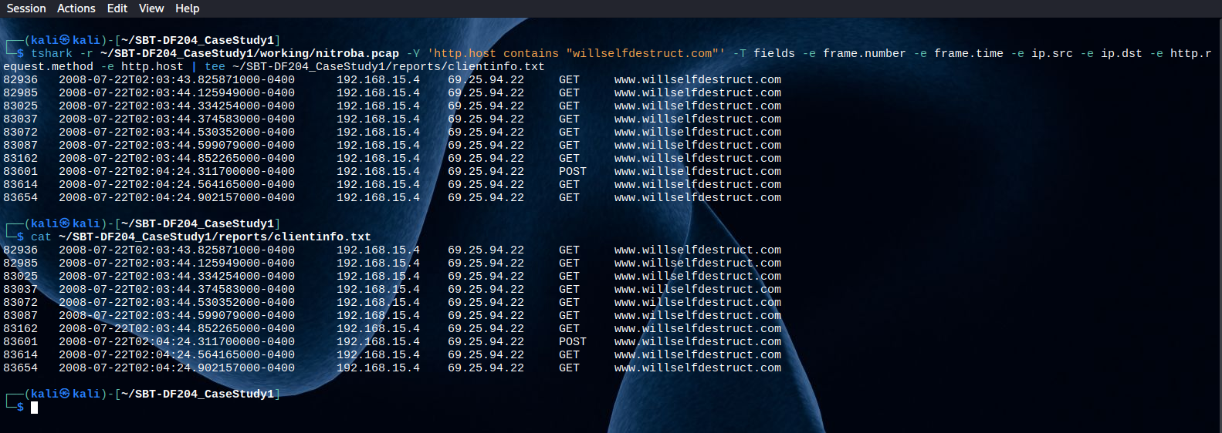
check shows that a computer on the local network visited the site to load the page and then submitted a message. The network recording shows the exact IP address of the user's computer (the client) and the IP address of the website server (the service).
FINDINGS:
- Client ip: 192.168.15.4
- Service ip: 69.25.94.22
- Filter used: http.host contains "willselfdestruct.com"
- First connection: Packet 82936
- Time: 2008-07-22 02:03:43.825871000 -0400
- Action: HTTP GET request to open [www.willselfdestruct.com]
- Form submission: Packet 83601
- Time: 2008-07-22 02:04:24.311700000 -0400
- Action: HTTP POST request sent to [www.willselfdestruct.com]
- Saved report file: ~/SBT-DF204_CaseStudy1/reports/clientinfo.txt.

EVIDENCE LINKING THE CLIENT TO THE HARRASMENT MESSAGE
To find out what message was sent, we looked inside the data sent by the user's computer (192.168.15.4) when it submitted the form on willselfdestruct.com
By inspecting packet 83601, we extracted the exact form entries. The data shows that the user filled out the form specifically to send a threat to Lily Tuckrige's email address.
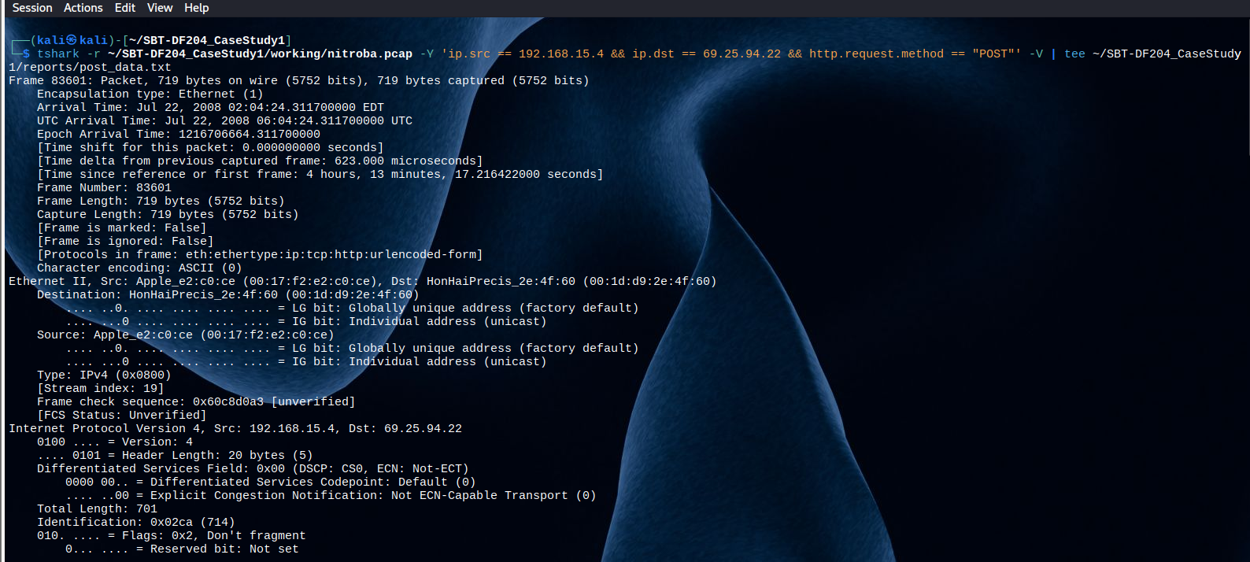
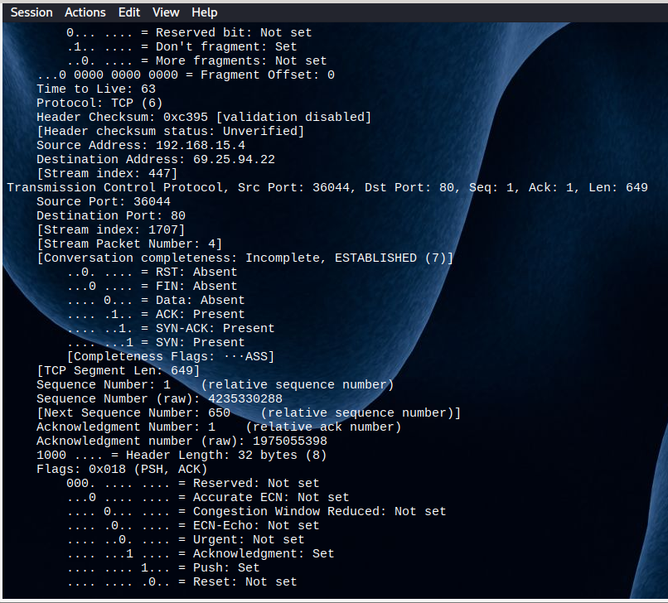
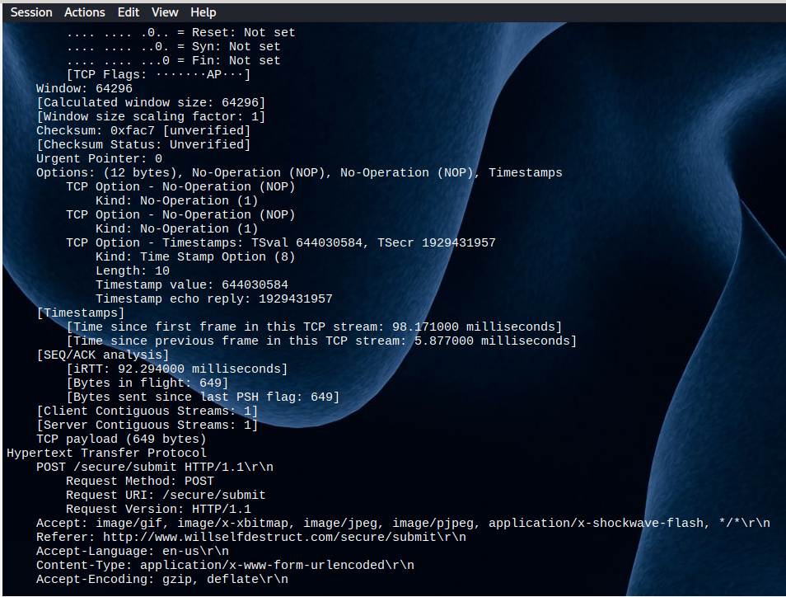
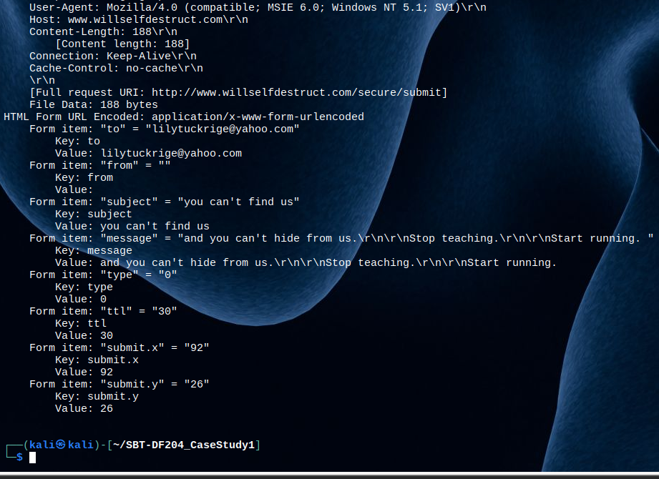
FINDINGS
- Packet Number: 83601
- TCP stream index: 1707
- Time: 2008-07-22 02:04:24.311700000 EDT (06:04:24 UTC)
- Display filter used: ip.src == 192.168.15.4 && ip.dst == 69.25.94.22 && http.request.method == "POST"
- Target website: [http://www.willselfdestruct.com/secure/submit]
- Recipient field: lilytuckrige@yahoo.com
- Subject field: "you can't find us"
- Message body: "and you can't hide from us. Stop teaching. Start running."
- Saved artifact path: ~/SBT-DF204_CaseStudy1/reports/post_data.txt.

HTTP REQUEST AND SERVER RESPONSE
The TCP stream output for Stream 1707 displays the exact raw HTTP request and server response:
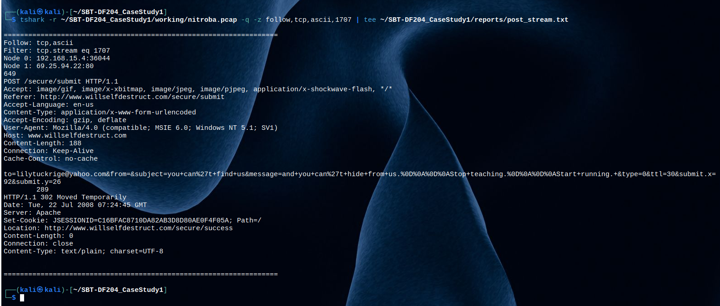
- Full request line: POST /secure/submit HTTP/1.1
- Host header: [www.willselfdestruct.com]
- Raw payload stream: to=lilytuckrige@yahoo.com&from=&subject=you+can%27t+find+us&message=and+you+can%27t+hide+from+us.%0D%0A%0D%0AStop+teaching.%0D%0A%0D%0AStart+running.&type=0&ttl=30&submit.x=92&submit.y=26
- Server response: HTTP/1.1 302 Moved Temporarily redirecting to http://www.willselfdestruct.com/secure/success.

THE CLIENT SYSTEM DEVICE INFORMATION
Every network card built into a computer has a permanent physical ID number called a MAC address. While an IP address can change whenever a computer reconnects to Wi-Fi, the MAC address identifies the actual physical network card inside the physical laptop.
By looking at packet 83601, we extracted the source MAC address connected to IP 192.168.15.4. This gives us the specific physical device used to post the message.
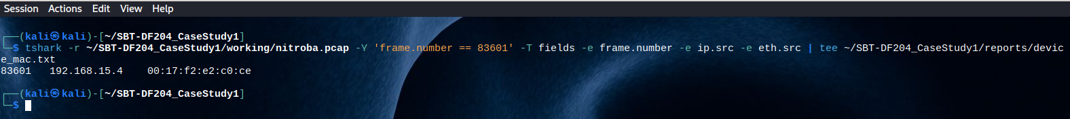
Findings:
- Client ip addr: 192.168.15.4
- Client hardware mac addr: 00:17:f2:e2:c0:ce
- Packet number: 83601
- Display filter used: frame.number == 83601
- Saved artifact path: ~/SBT-DF204_CaseStudy1/reports/device_mac.txt.
Finding MAC address 00:17:f2:e2:c0:ce ties the web traffic to a specific hardware device rather than just a temporary IP address.
This allows us to track all other network traffic sent by this exact same physical laptop throughout the entire capture file, even if its IP address changes.
However, relying only on an IP address or MAC address in an open Wi-Fi network cannot prove who sent the message. In a shared student house with open wireless internet, anyone nearby can join the network, get an IP address assigned automatically, or spoof (fake) a MAC address.
Therefore, a physical device ID shows which laptop sent the data, but it does not prove which person was sitting at the keyboard.

WHO IS ASSOCIATED WITH THE DEVICE?
To discover who owns or uses the device with MAC address 00:17:f2:e2:c0:ce, we searched for web browser cookies that contain an email address (@).
When a user logs into personal web services (like Google Calendar or Gmail), the website saves temporary session files called cookies on their computer. These cookies often store the user's logged-in username or email address.
The packet inspection revealed multiple Google cookies sent from this exact device (00:17:f2:e2:c0:ce) that explicitly contain the user's account name: jcoachj@gmail.com.
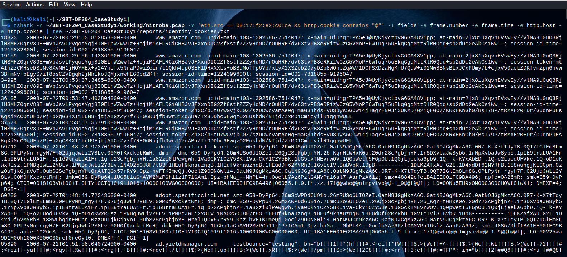
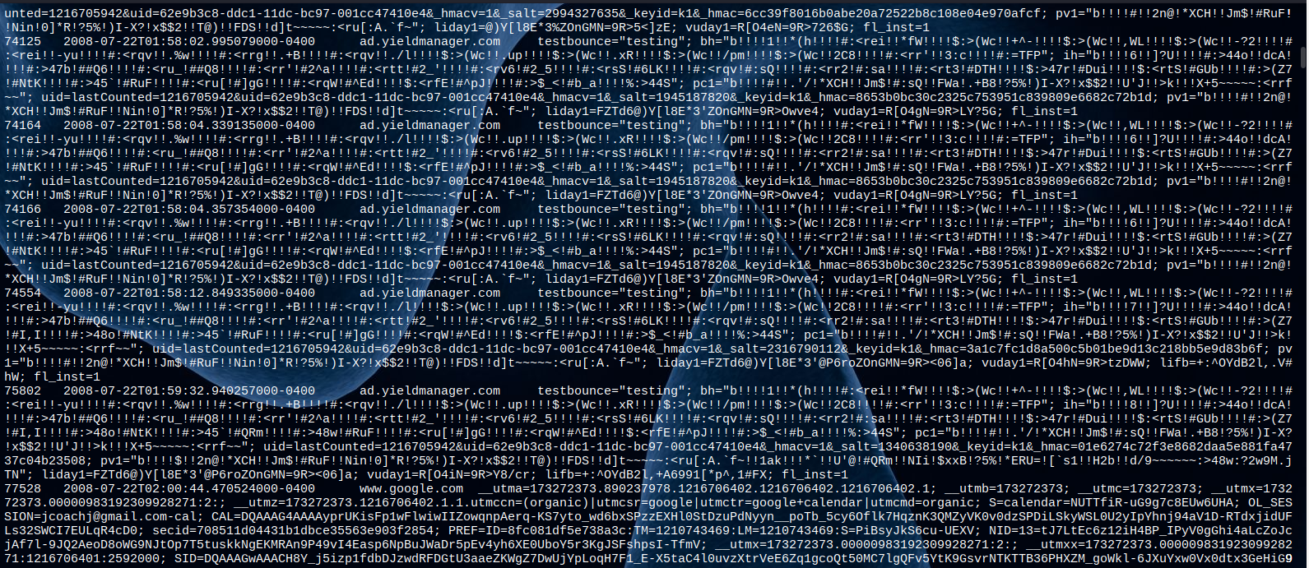
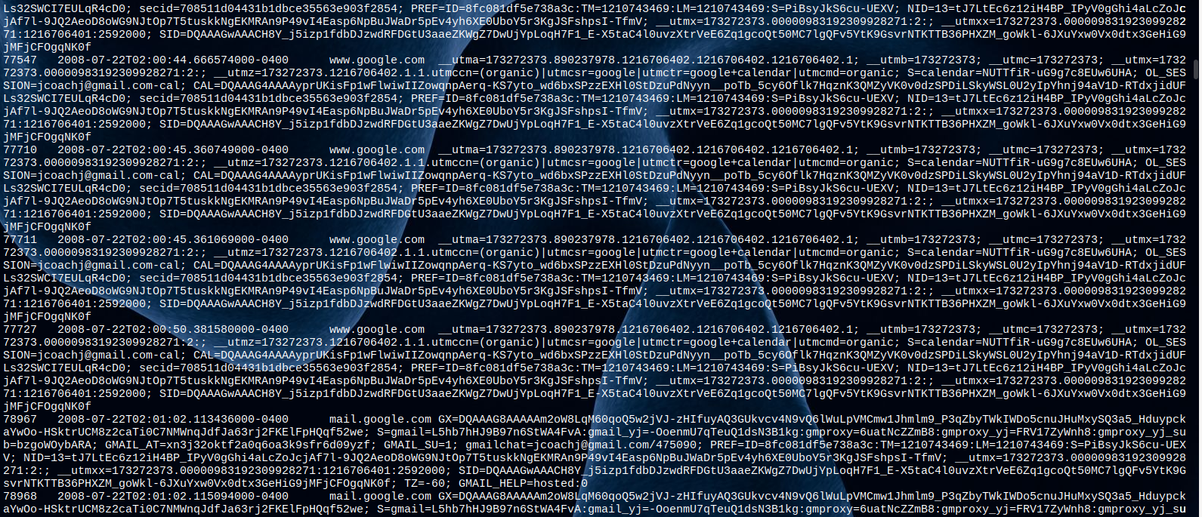
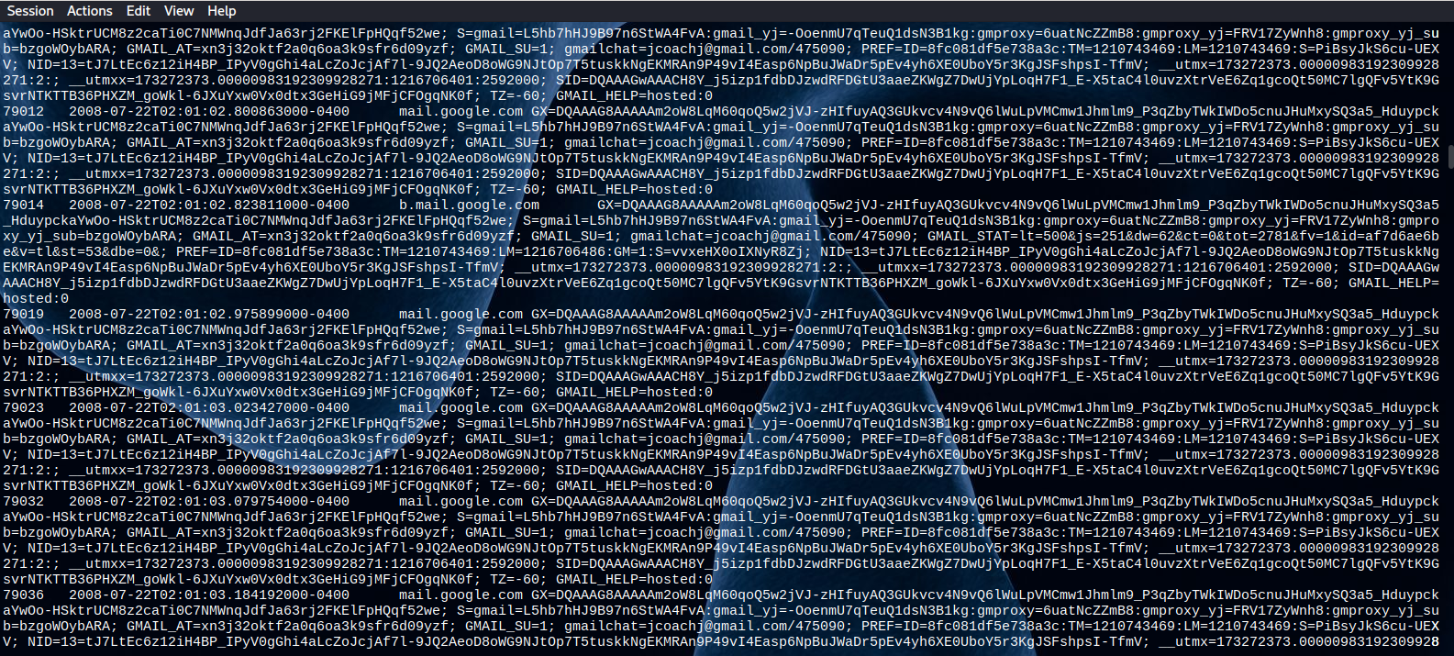
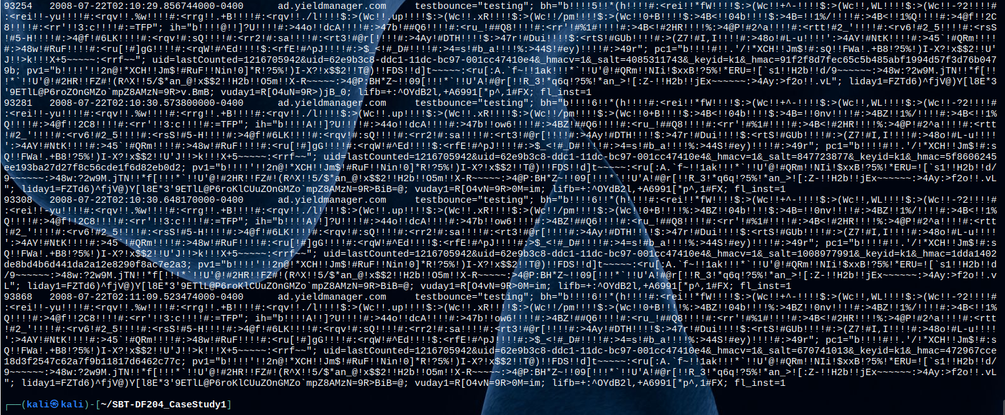

Findings:
- Associated identity: jcoachj@gmail.com
- Client hardware mac addr: 00:17:f2:e2:c0:ce
- Display filter used: eth.src == 00:17:f2:e2:c0:ce && http.cookie contains "@"
- Key evidence packets:
- Packet 77528 (www.google.com): Contains cookie data gmailchat=jcoachj@gmail.com
- Packet 78967 (mail.google.com): Contains cookie data gmailchat=jcoachj@gmail.com
- Packet 79012 (mail.google.com): Contains cookie data gmailchat=jcoachj@gmail.com
- Saved Artifact Path: ~/SBT DF204_CaseStudy1/reports/identity_cookies.txt

To check that our identity findings are perfectly stored, we confirm:
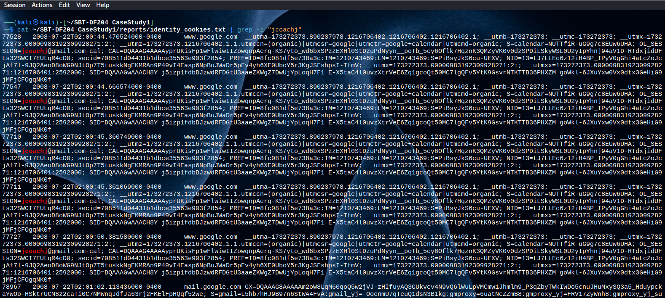

CROSS CHECKING WITH THE ROASTER
Before we can confirm if the person was on the CHM109 roaster we need to follow some steps:
Firstly, we check and download the html format of the site: (digitalcorpora.org/corpora/scenarios/nitroba-university-harassment-scenario)
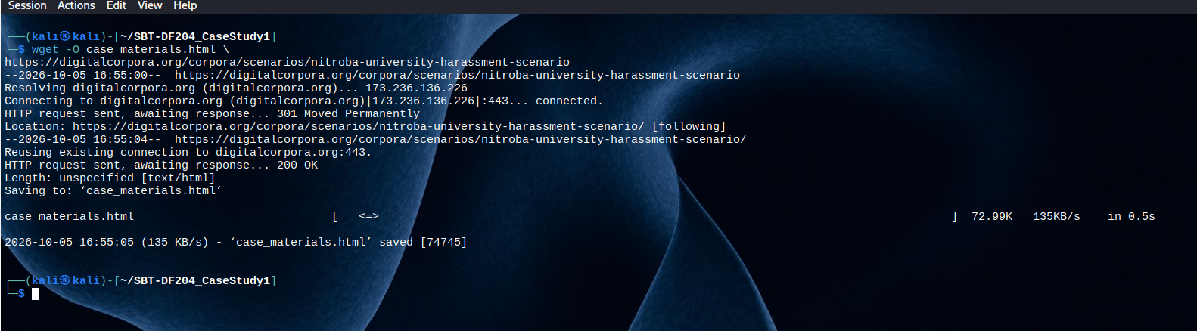
Then we go ahead to look for anything that contains ‘pdf’ and they were dumped as shown in the image below:
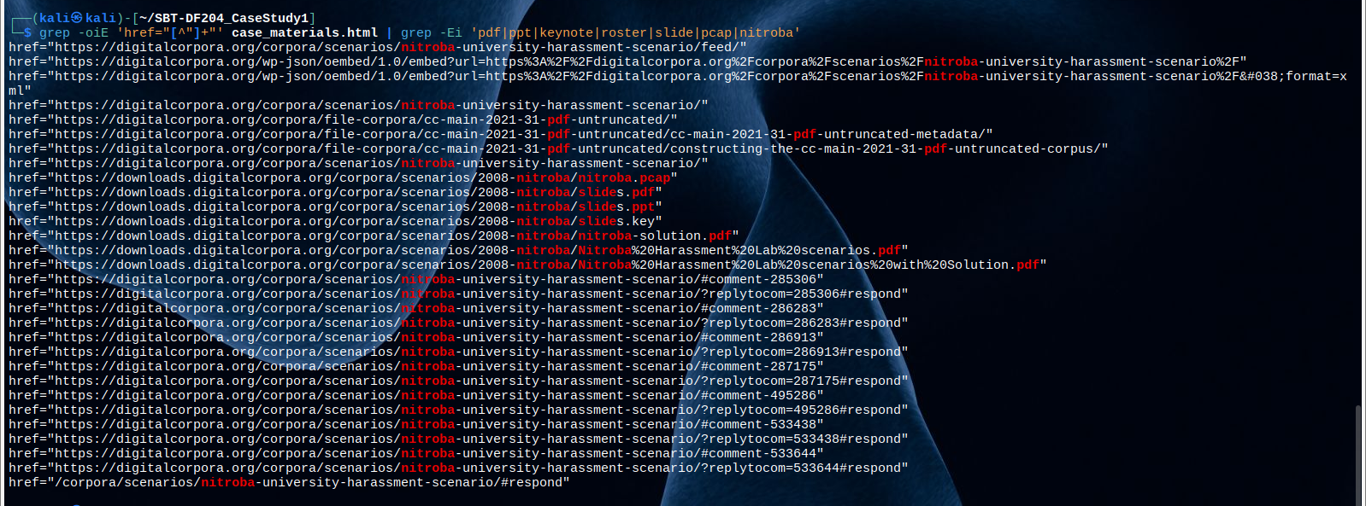
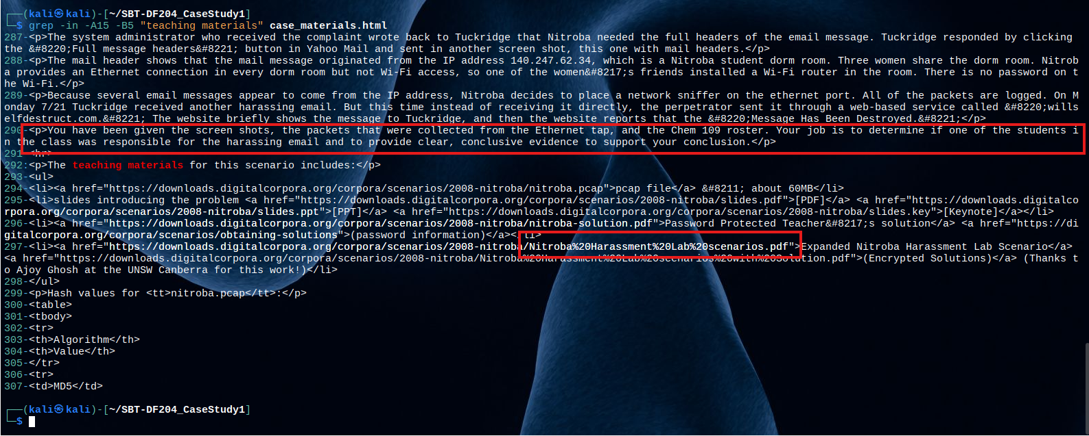
Then I went on to download the slides.pdf:
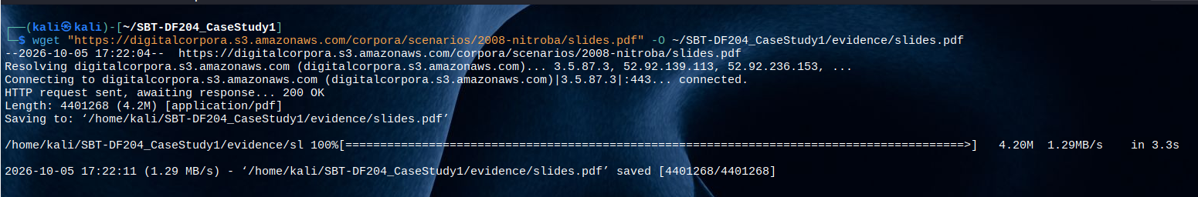
And finally, after running:
pdftotext ~/SBTDF204_CaseStudy1/working/slides.pdf - | cat
we have the list of the students present in the class for Chm 109.
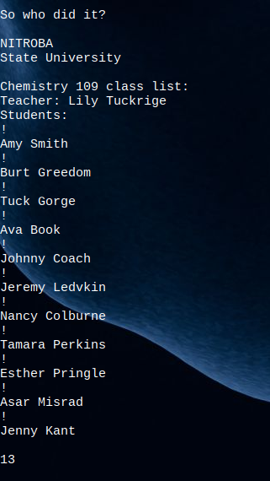

Findings:
- Enrolled Student Name: Johnny Coach
- Course: Chemistry 109 (Instructor: Lily Tuckrige)
- Associated email: jcoachj@gmail.com
- Matched mac address: 00:17:f2:e2:c0:ce
- Source slide reference: Slide 13 (slides.pdf)
Correlating the Google account jcoachj@gmail.com with Johnny Coach on the official Chem 109 roster completes the chain of custody and identity attribution. It directly ties the physical laptop, network traffic, and harassment message back to a specific individual enrolled in Ms. Tuckrige's class.

TIMELINE OF OCCURRENCE
After running: tshark -r ~/SBT-DF204_CaseStudy1/working/nitroba.pcap -Y 'frame.number == 83601' -T fields -e frame.number -e frame.time -e frame.time_utc -e frame.time_epoch | tee ~/SBT-DF204_CaseStudy1/reports/post_time.txt, the following results were gotten:
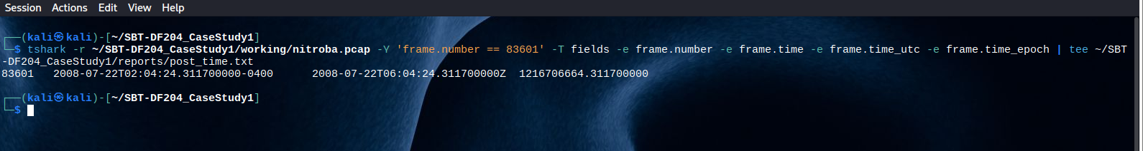
- Packet number: 83601
- Epoch timestamp: 1216706664.311700000
- Display timezone: -0400 (EDT)
- Utc timestamp: 2008-07-22T06:04:24.311700000Z.

EVIDENCE LOG

Evidence ID | Packet or item | Finding | Why it matters
E01 | nitroba.pcap / Packet 83601 | Source IP 192.168.15.4  sent an HTTP POST  request to [www.willselfdestruct  .com/secure/submit] | Identifies the client network address used to transmit the harassment submission.
E02 | TCP Stream 1707 (Packet 83601) | Raw HTTP POST payload containing message to lilytuckrige@yahoo.com: "you can't find us... Stop teaching. Start running." | Captures the raw harassment content and target recipient, confirming the exact incident payload.
E03 | Packet 83601 | Source MAC Address 00:17:f2:e2:c0:ce | Binds the network traffic to a specific physical network interface card/laptop rather than a temporary IP address.
E04 | Packets 77528, 78967, 79012 | Google HTTP session cookies containing gmailchat=jcoachj@gmail.com sent from MAC 00:17:f2:e2:c0:ce | Correlates the physical device to an explicit personal account identity (jcoachj@gmail.com).
E05 | slides.pdf (Slide 13) | Chemistry 109 class list containing student Johnny Coach | Matches the Google account (jcoachj) to an enrolled student in Lily Tuckrige's course.
E06 | Packet 83601 | Timestamp: 2008-07-22 02:04:24 -0400 (EDT) / 2008-07-22 06:04:24 UTC | Establishes the exact time of the offense and accounts for time zone conversion for timeline accuracy.

SUMMARY OF FINDINGS AND CASE CONCLUSION
The digital forensics analysis of the network capture nitroba.pcap establishes that student Johnny Coach submitted a harassing message directed at Chemistry 109 instructor Lily Tuckrige.
The forensic investigation established an unbroken chain of evidence linking the online payload to the perpetrator's physical hardware, online identity, and course enrollment:
- Incident transmission: On July 22, 2008, at 02:04:24 EDT (06:04:24 UTC), an HTTP POST request (Packet 83601) was transmitted from IP address 192.168.15.4 to willselfdestruct.com. TCP Stream 1707 confirms the raw payload targeted lilytuckrige@yahoo.com with threatening text.
- Device identification: Source frame analysis bound IP address 192.168.15.4 to the physical network card MAC address 00:17:f2:e2:c0:ce.
- Identity correlation: Traffic analysis of packets transmitted by MAC address 00:17:f2:e2:c0:ce revealed active Google session cookies (Packets 77528, 78967, and 79012) containing the personal account identity jcoachj@gmail.com.
- Subject attribution: Cross-referencing the account jcoachj@gmail.com against the Chemistry 109 student roster (extracted from Slide 13 of slides.pdf) confirmed a direct match to enrolled student Johnny Coach.

Case Conclusion
Based on the network artifacts, cookie data, hardware identifiers, and course records, Johnny Coach is identified as the individual responsible for transmitting the harassing communication.

