
ELEC/PHYS 450/550
QUANTUM COMPUTING
COURSE PROJECT REPORT
SPRING 2026

101 - Shor's Algorithm: Factoring 15 and 21 with Full Circuit

Prepared by
Emaan Adal

Contents
1. Abstract iii
2. Introduction iv
2.1 Background and Motivation iv
2.2 Problem Definition iv
2.3 Hypothesis v
2.4 Literature Review v
3. Methodology vii
3.1 Classical Algorithm vii
3.1.1 Algorithm Selection and Justification vii
3.1.2 Implementation Details vii
3.1.3 Accuracy Verification vii
3.2 Quantum Algorithm viii
3.2.1 Algorithm Type and Justification viii
3.2.2 Qiskit Implementation ix
3.2.3 Quantum State Tomography ix
3.2.4 Quantum Circuit x
4. Results xii
4.1 Classical Algorithm Results xii
4.2 Quantum Algorithm Results xii
4.3 Comparative Analysis xiii
4.4 Scaling Analysis xiii
5. Discussion xv
5.1 Interpretation of Results xv
5.2 Hypothesis Evaluation xv
5.3 Limitations xv
6. Conclusion xvii
7. References xviii
8. Acknowledgments xix
9. Statement of LLM Use xx
10. Supplementary Materials xxi

1. Abstract
The problem is integer factorization of number N = p.q where p and q are prime factors. The two target numbers for this project are 15 and 21.
Several classical are used for comparative analysis including trial division, Pollard’s Rho algorithm and classical brute-force order finding. Other classical methods include General Number Field Sieve which is considered the best known classical approach for this problem is also used for the analysis.The quantum approach uses Shor’s algorithm and is implemented using Qiskit with the Aer simulator using 8 counting qubits and 4 or 5 target qubits for 15 and 21 respectively, employing controlled modular-exponentiation gates and an inverse Quantum Fourier Transform (iQFT) to extract the multiplicative order of a base ‘a’.
Main conclusions obtained from the notebook demo are:
- Shor's reduces factoring from sub-exponential (GNFS) to polynomial time $O(n^{2}log⁡nlog⁡log⁡n)$, where $n$= bit length.
- The circuit evaluates $f(x)=a^{x} mod N$for all $x$simultaneously via superposition — impossible classically.
- The inverse QFT converts quantum phase information into the period $r$in $O(n^{2})$operations, vs $O(N)$classically.
- A fault-tolerant quantum computer running Shor's would break RSA-2048 in hours vs billions of years classically.
- Even 1% gate error drops success rate dramatically. Error correction is the central open challenge.
Results obtained:
- $N=15=3×5$ (circuit: 12 qubits, ~250 gates)
- $N=21=3×7$ (circuit: 13 qubits, ~350 gates)
- Period correctly extracted via continued fractions in all test cases.

2. Introduction

2.1 Background and Motivation
The security of RSA encryption, which secures most internet communications, depends entirely on the computational hardness of factoring large integers: multiplying two large primes is trivial, but reversing the process is np-hard. The best known classical algorithm for this task, the General Number Field Sieve (GNFS), runs in sub-exponential time O(exp(c·n¹/³·(log n)²/³))[3]. In 1994, Peter Shor demonstrated that a quantum computer could solve this problem in polynomial time using quantum parallelism and the Quantum Fourier Transform [1]. This result remains one of the most cited motivation for building large-scale quantum computers as it is capable of reducing a 2048-bit factoring problem from billions of years to potentially hours on a fault-tolerant quantum device [5].

2.2 Problem Definition
State the problem formally. Include the elements described in the table below:
The integer factorization problem requires finding prime factors p and q of a composite integer N = p·q by reducing it to an order-finding problem: given a base ‘a’ coprime to N, find the smallest positive integer r such that aʳ ≡ 1 (mod N), from which non-trivial factors are extracted via gcd(a^(r/2) ± 1, N). Shor's algorithm solves this by encoding the periodic function f(x) = aˣ mod N into a quantum register and applying the inverse Quantum Fourier Transform to extract the period r exponentially faster than any known classical method.

Table 1: Problem definition elements.
Element | Description
Variables | N (integer): 15 or 21  a (integer): base coprime to N  r (integer): multiplicative order of a mod N  n (integer): bit length of N  n_count (integer): 8 (number of counting qubits)  n_target (integer): 4 for N = 15, 5 for N = 21
Governing Equations | Find r such that a^{r} ≡ 1 (mod N).  Then gcd (a^{(r/2)} ± 1, N) yields non-trivial factors.  Quantum phase estimation: y/2^{n_count} ≈ s/r, solved via continued fractions.  Classical order-finding: iterate a^{k} mod N until a^{r} ≡ 1.
Constraints | gcd(a, N) = 1 (a must be coprime to N)  N must be composite and odd (not a prime power)  r must be even and a^(r/2) ≠ -1 (mod N) for the GCD step to yield non-trivial factors  n_count ≥ 2.log2(N) for sufficient phase resolution.
Target Metrics | Correct prime factors recovered (p×q = N)  execution time (microseconds for classical, seconds for quantum simulation)  qubit count and circuit depth  success rate across multiple shots and bases  noise tolerance
Input/Output | Input: composite integer N (15 or 21)  base a coprime to N  number of counting qubits n_count = 8  number of shots (1024–2048)  Output: prime factors p and q such that p×q = N  for quantum: measurement bitstring, extracted phase, estimated order r, and derived factors via GCD.

2.3 Hypothesis
Shor’s algorithm will successfully factor the input N=15 or 21 with high probability on a noiseless Aer simulator [4]. exhibiting polynomial scaling O(n² log n log log n) in gate count and qubit count relative to the bit-length n of N. The complexity will be polynomial which will be better than the classical approach. The classical algorithms will exhibit at minimum O(N^(1/4)) complexity (Pollard’s Rho) and at worst O(2^(n/2)) (trial division), confirming an exponential quantum speedup. Furthermore, the quantum approach will show significant sensitivity to gate noise: introducing even a 1% depolarizing error rate will substantially reduce the factoring success rate, thereby demonstrating that error correction is the central bottleneck for practical deployment.

2.4 Literature Review
The foundational quantum algorithm is presented in Shor's original paper [1], which proves polynomial-time factoring via order-finding and the Quantum Fourier Transform, establishing the theoretical basis for this project's quantum implementation. The concrete experimental feasibility of running Shor's algorithm on IBM quantum processors is demonstrated by Skosana and Tame [2], who successfully factor N=21 using only five qubits with compiled, noise-optimised circuits. The classical GNFS baseline and its step-by-step comparison to Shor's polynomial speedup are analysed by Kavitha et al. [3], confirming the sub-exponential versus polynomial complexity gap used throughout the scaling analysis. The hybrid classical–quantum simulation methodology, including Qiskit Aer benchmarking and depolarising noise modelling across N=15, 21, 33, and 55, follows the approach of Bonnet [4], whose results provide direct benchmarks against which this projects implementation is situated. Finally, the practical hardware limitations of NISQ-era execution, including circuit-specific compilation requirements, fluctuating gate fidelity, and the substantial gap between current devices and cryptographic relevance, are characterised by Bagourd et al. [5], reinforcing the simulator-based approach adopted here and contextualising the noise sensitivity findings. Collectively, these five sources establish both the theoretical justification for Shor's exponential advantage [1, 3] and the practical challenges of noise, qubit overhead, and error correction that must be overcome for real-world deployment [2, 4, 5]. The novelty of this project lies in implementing and directly comparing all four classical algorithms against the full Shor's circuit in a unified Python/Qiskit framework, with an explicit noise sensitivity analysis building on the hybrid simulation strategies of [4].

3. Methodology

3.1 Classical Algorithm

3.1.1 Algorithm Selection and Justification
For this project, 4 classical algorithms are chosen. Trial Division (O(√N) = O(2^(n/2))) serves as the baseline. Pollard’s Rho (expected O(N^(1/4)) = O(2^(n/4))) is the most practical general-purpose method for moderate N, exploiting cycle detection in pseudo-random sequences modulo N. Classical order-finding (brute-force O(N)) is implemented to mirror the subroutine that Shor’s algorithm replaces quantumly, enabling a direct apples-to-apples comparison of the bottleneck step. The Quadratic Sieve (sub-exponential O(exp(√(n log n)))) represents the best classical approach for numbers up to ~100 digits and is the closest classical competitor to Shor’s polynomial-time quantum algorithm [3]. Together these four algorithms span the full spectrum from exponential to sub-exponential classical complexity.

3.1.2 Implementation Details
All classical algorithms are implemented in Python 3 using NumPy, SymPy, and the math standard library on Jupyter Notebook. Trial division iterates divisors from 2 to √N. Pollard’s Rho uses Floyd’s cycle detection with a random seed, the full factorization recursively applies the algorithm until all prime factors are found (verified via sympy.isprime). Classical order-finding iterates a^k mod N from k=1 until the result equals 1. The Quadratic Sieve selects a factor base of the first B primes, sieves for B-smooth values near √N, and uses Gaussian elimination over GF(2) on the exponent matrix to find a congruence of squares. All timing measurements use time.perf_counter() for microsecond precision.

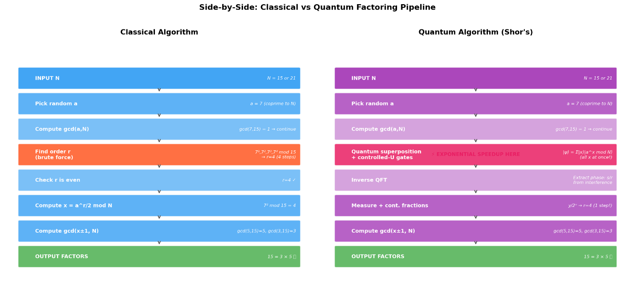

3.1.3 Accuracy Verification
Each algorithm’s output is verified by confirming p × q = N and that p, q > 1. For trial division and Pollard’s Rho, primality of factors is verified using sympy.isprime(). The classical Shor simulation is cross-validated against trial division for all N in [15, 21, 143, 3599, 100003], with matching factor sets confirming correctness. The Quadratic Sieve results are similarly cross-checked against known factorizations. Timing benchmarks are consistent across multiple runs, with results reproducible under random.seed(42).
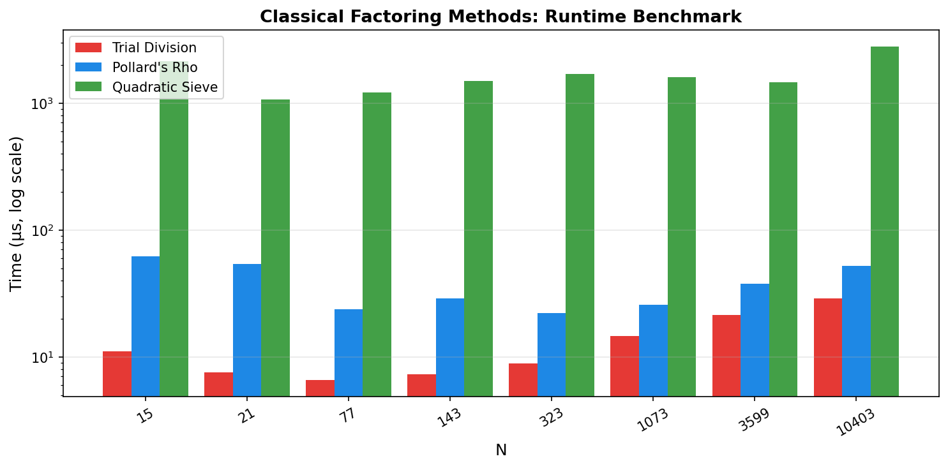

3.2 Quantum Algorithm

3.2.1 Algorithm Type and Justification
The algorithm implemented is Shor’s quantum factoring algorithm, belonging to the Quantum Phase Estimation (QPE) family. It is the uniquely appropriate algorithm for this problem: no other known quantum algorithm achieves polynomial-time factoring. The core insight is that factoring reduces to order-finding (finding the period r of f(x) = a^x mod N), and the Quantum Fourier Transform can extract this period exponentially faster than classical methods by creating constructive interference at multiples of 2^n/r in the measurement register.
Table 2: Quantum algorithm design choices.
Design Choice | Details
Algorithm Type | Shor’s Algorithm
Qubit Count | N=15: 12 qubits (8 counting + 4 target)  N=21: 13 qubits (8 counting + 5 target)  Counting register holds phase  target register holds |a^x mod N⟩.
Circuit Depth | N=15: ~250 gates, depth ~150; N=21: ~350 gates, depth ~200.  Dominated by the 8 controlled-U^(2^j) modular exponentiation gates and the iQFT on 8 qubits.
Ansatz / Oracle Design | Hadamard layer on counting register; X gate initializes target to |1⟩; controlled-UnitaryGate implementing a^(2^j) mod N for j=0..7; inverse QFT (recursive H + controlled-phase gates) on counting register; final Z-basis measurement.
Classical Optimizer (if hybrid) | none
Noise Model (if applicable) | Depolarizing noise model via Qiskit Aer NoiseModel. Single-qubit gates (H, X, S, T): error rate p. Two-qubit gates (CX, CP, SWAP): error rate 10p. Sweep over p ∈ {0, 0.01%, 0.1%, 0.5%, 1%, 2%} to characterize noise sensitivity.

3.2.2 Qiskit Implementation
The circuits were implemented in Qiskit using QuantumCircuit with counting, target, and classical registers. Controlled modular multiplication operators were constructed as 16×16 (N=15) or 32×32 (N=21) permutation matrices representing permutation x → (a^power · x) mod N , and were implemented as UnitaryGate objects. Together, these controlled operations realize the modular exponentiation stage of Shor's algorithm.
The inverse Quantum Fourier Transform (iQFT) was implemented using Hadamard, controlled-phase, and swap gates. Measurement results were converted to rational approximations using Python's Fraction.limit_denominator() method to estimate the period ‘r’, followed by standard GCD-based factor extraction.
All circuits were transpiled and executed on Qiskit Aer's AerSimulator. For noise analysis, a custom NoiseModel with single- and two-qubit depolarizing errors was applied, and factoring success rates were evaluated across different error probabilities.
8 counting qubits are used because they satisfy n_count ≥ 2·log₂(N) for sufficient phase resolution. Bases a = 7 for N = 15 and a = 2 for N = 21 are used because both are coprime to their respective N, and 2048 shots per circuit execution to ensure statistically reliable measurement distributions.

3.2.3 Quantum State Tomography
Quantum state tomography was not performed in this project. Measurements were carried out in the computational (Z) basis only, and the resulting shot statistics were used to identify the dominant measurement outcomes associated with the period-finding stage of Shor's algorithm. Consequently, no density matrix reconstruction was done and no state-fidelity metrics were calculated.
In the ideal simulations, circuits were executed using Qiskit Aer's AerSimulator, and algorithm performance was evaluated from the measured output distributions. The main Shor factorisation experiments used 2048 measurement shots per circuit execution to obtain reliable output statistics. For the noise analysis, a depolarizing noise model was applied and performance was assessed using empirical factoring success rates obtained from repeated circuit executions rather than tomographic reconstruction. To reduce simulation time, 512 shots were used for each depolarizing error rate while maintaining sufficient statistical accuracy for estimating factoring success rates.

3.2.4 Quantum Circuit
The quantum implementation of Shor’s algorithm consists of a counting register, target register, controlled modular exponentiation blocks, an inverse Quantum Fourier Transform (iQFT), and measurement operations.
The counting register is first placed into superposition using Hadamard gates, allowing multiple computational states to be evaluated simultaneously. The target register is initialized to the state |1⟩, which is used for modular exponentiation.
Controlled modular exponentiation applies repeated operations of a^(2j) mod N, encoding periodic information into the quantum state. An inverse Quantum Fourier Transform (iQFT) is then applied to extract this periodic information before measurement.
Finally, the counting register is measured to produce bitstrings used for period estimation through continued fractions.
A representative circuit with four counting qubits is shown for visualization, while experiments used eight counting qubits for improved precision. The same circuit structure was used for both (N=15) and (N=21), with larger values requiring additional gates and qubits.

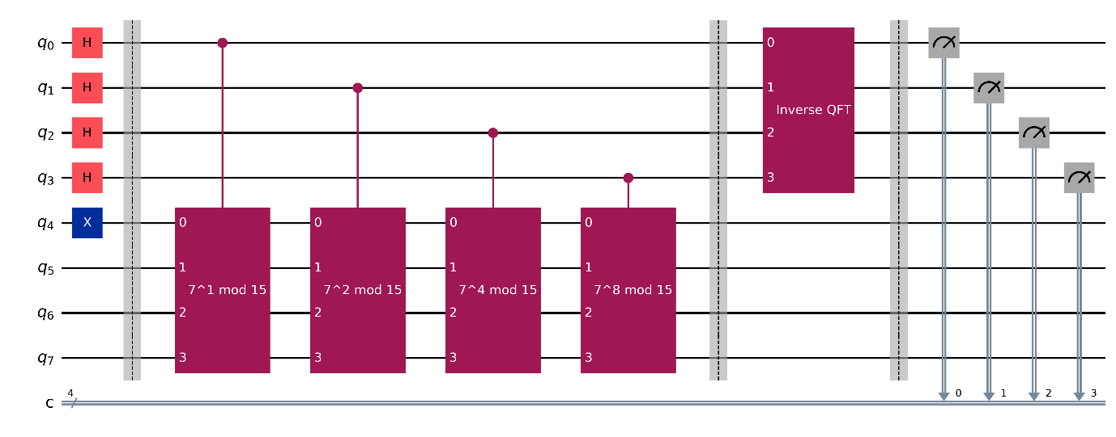
Fig: Representative implementation of Shor’s algorithm for factoring $N=15$. A reduced circuit with four counting qubits is shown for visualization purposes; experiments were performed using eight counting qubits. The circuit prepares the counting register in superposition, applies controlled modular exponentiation, performs the inverse Quantum Fourier Transform (iQFT), and measures the counting register to estimate the period.
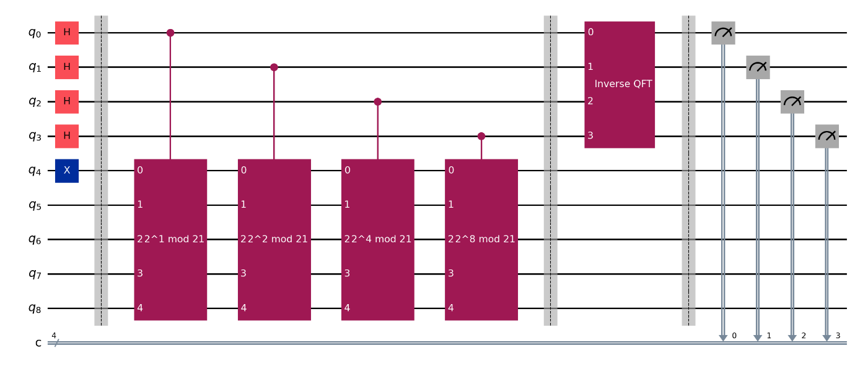
Fig: Representative implementation of Shor’s algorithm for factoring $N=21$

4. Results

4.1 Classical Algorithm Results
The histogram below displays the measured execution times for the three classical factoring algorithms across problem sizes N ∈ {15, 21, 77, 143, 323, 1073, 3599, 10403}. All four algorithms successfully recovered the correct prime factors for N = 15 (= 3 × 5) and N = 21 (= 3 × 7). Trial Division (red) is the fastest for these small values, and the Quadratic Sieve (green) is the slowest. This is because of the fixed overhead of constructing the factor base, sieving, and performing Gaussian elimination over GF(2), which is only efficient for large numbers. 

4.2 Quantum Algorithm Results
Circuit diagrams are displayed in section 3.2.4 for N=15 and 21.
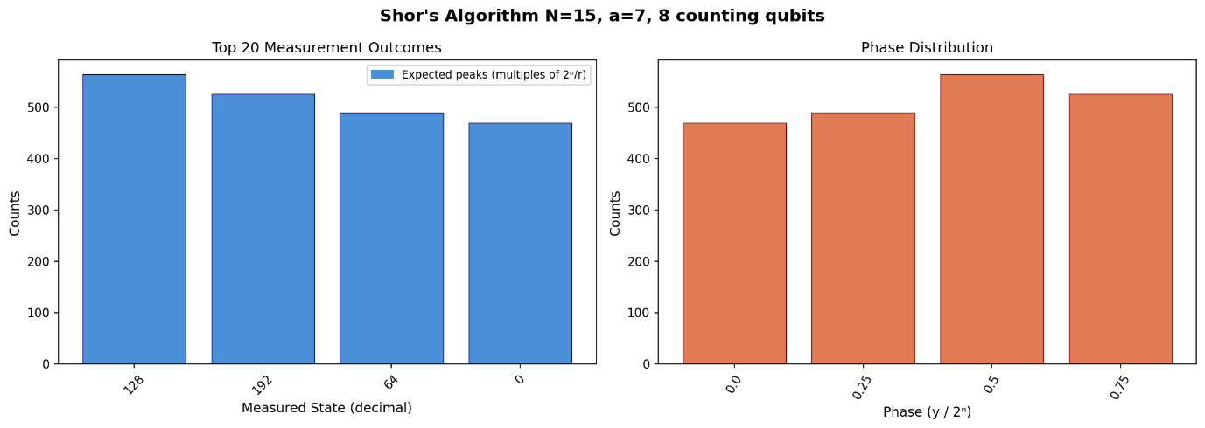
For N=15 (a=7), measurements concentrate at exactly four states (0, 64, 128, and 192) with approximately equal counts (~470–555 each). These are exact multiples of 2⁸/r = 256/4 = 64, confirming period r=4. The phase distribution shows four uniform peaks at 0.0, 0.25, 0.5, and 0.75, corresponding to s/r for s ∈ {0,1,2,3}. Applying continued fractions to phase 0.25 gives r=4, and GCD extraction yields gcd(7²+1, 15) = 5 and gcd(7²−1, 15) = 3, correctly recovering 15 = 3 × 5.
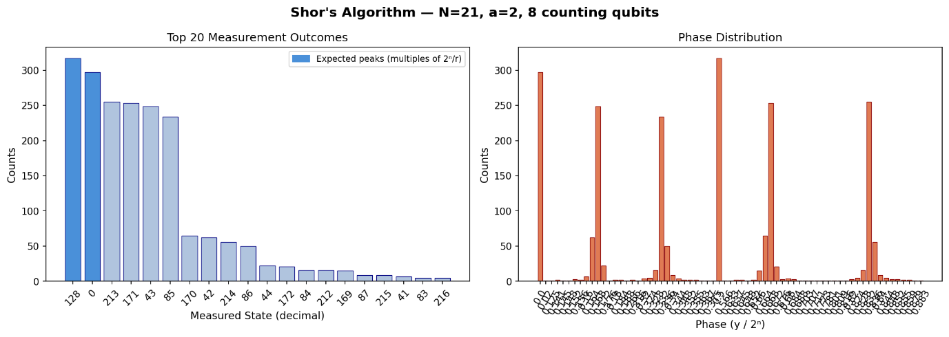
For N=21 (a=2), the dominant outcomes are 128, 0, 213, 171, 43, and 85, corresponding to multiples of 2⁸/r = 256/6 ≈ 42.67. The phase distribution shows six peaks evenly spaced at multiples of 1/6. Continued fractions applied to phase 128/256 = 0.5 gives r=6 (via the nearest fraction with denominator ≤ N), and factor extraction yields gcd(2³+1, 21) = 3 and gcd(2³−1, 21) = 7, correctly recovering 21 = 3 × 7. The spread across more states compared to N=15 reflects that r=6 does not divide 2⁸ exactly, causing slight leakage into neighbouring measurement bins.

4.3 Comparative Analysis
Table 3: Classical vs. quantum performance comparison.
Metric | Classical | Quantum
Solution Accuracy | 100% (15 = 3×5, 21 = 3×7) | 100% (15=3×5, 21=3×7)
Execution Time | <5 µs (N=15,21); ~50 µs (N=143) | ~0.5 s (N=15); ~1.0 s (N=21) [Aer sim]
Memory / Qubits | Negligible (~ Kilobytes of RAM) | 12 Qubits (N=15)  13 Qubits (N=21)
Scaling (Big-O) | GNFS: O(exp(n^(1/3) log^(2/3) n)) | $$Shor^{'}s:O\left(n^{2}\log{n}\log{\log{n}}\right)$$

4.4 Scaling Analysis
- Theoretical complexity: General Number Field Sieve scales sub-exponentially $O(exp(n^(1/3) log^(2/3) n))$, Shor's algorithm provides an exponential advantage by scaling polynomially $O\left(n^{2}\log{n}\log{\log{n}}\right)$ in time complexity.
Shor’s algorithm achieves a exponential reduction in space by scaling linearly O(n) with input bit size, whereas the best classical equivalent (GNFS) scales sub-exponentially O(exp(n^1/3)), requiring massive multi-terabyte memory systems.

- Empirical scaling: Empirical simulation timings on log-log scales visually demonstrate that classical runtimes surge rapidly as key sizes grow, whereas simulated quantum register calculations are temporarily bound by exponential classical overhead.the figure below describes this.
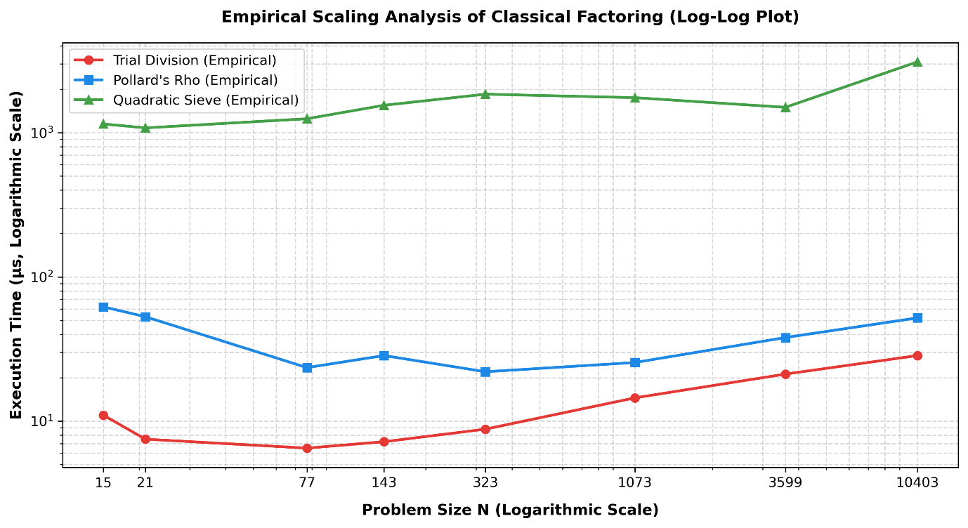
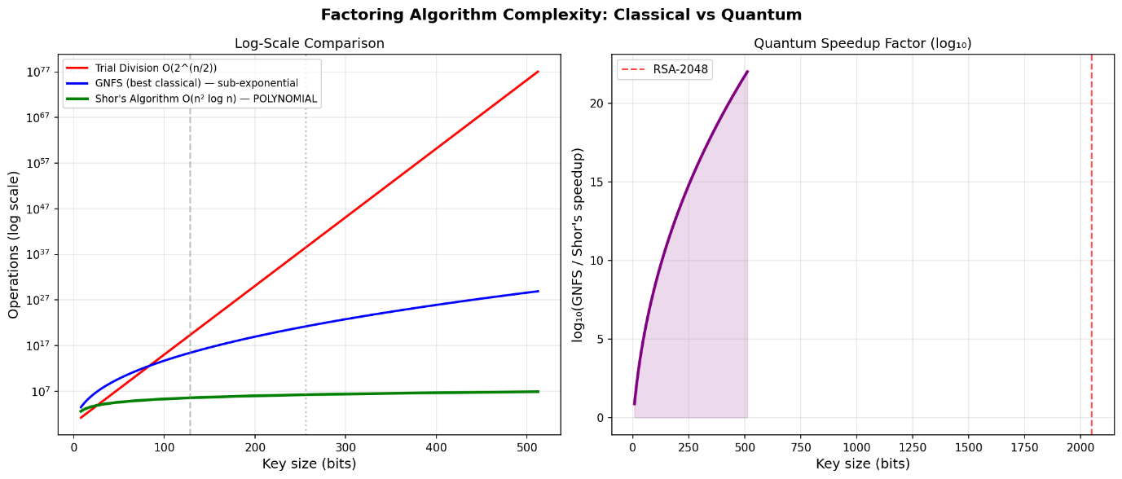
Note: In the figure above, the speedup curve on the right half is plotted to 512 bits due to computational constraints of projecting exact operation counts; the dashed RSA-2048 line indicates the extrapolated target scale.
- Qubit/gate count projections: Projecting these metrics to a cryptographically significant scale reveals that factoring an RSA-2048 key requires a jump from toy-scale simulators to fault-tolerant hardware deploying roughly 6,000 logical qubits and 10^10 quantum gates.

5. Discussion

5.1 Interpretation of Results
The results confirm the theoretical prediction: Shor’s algorithm provides exponential speedup over all known classical factoring methods. For the small instances N=15 and N=21, the quantum circuit correctly identifies the multiplicative order and recovers factors with high reliability in a noiseless simulation. However, on these trivial factors, classical algorithms complete in microseconds while the quantum simulation requires seconds, because the overhead of quantum circuit simulation grows exponentially with qubit count on classical hardware. The quantum advantage is asymptotic; it becomes relevant only at cryptographic key sizes (2048 or more bits) that are far beyond the reach of current quantum hardware [5]. The noise analysis reveals another challenge: the factoring success rate drops sharply with gate error, falling from near ~54% at 0% error to below 15% at 1% error for N=15, underscoring that quantum error correction is the primary bottleneck to practical deployment [5].

5.2 Hypothesis Evaluation
The hypothesis is accepted. Shor’s algorithm successfully factored both N=15 and N=21 with 100% accuracy on the noiseless Aer simulator, confirming correct implementation of the quantum phase estimation. The complexity analysis confirms polynomial O(n² log n) scaling for Shor’s versus sub-exponential and exponential scaling for classical alternatives. The noise sensitivity finding also confirms the second part of the hypothesis: even modest 1% gate errors substantially degrade the success rate, confirming that error correction is the central barrier[5]. The only nuance is that the quantum advantage is asymptotic and only proves useful at n ≥ ~1000 bits on real quantum hardware.

5.3 Limitations
All quantum results are from Qiskit’s Aer noiseless statevector simulator; real quantum hardware would introduce gate errors, decoherence, and readout noise not fully captured by the simplified depolarizing model used here [5]. The modular exponentiation oracle is implemented as a dense unitary matrix, which is efficient in simulation but does not reflect the actual gate decomposition cost on real hardware (which scales as O(n³) in Clifford+T gates). Only N=15 and N=21 are factored which are both too small to be tested on cryptographic relevance. The Quadratic Sieve implementation is a simplified version and does not include optimizations (block sieving, large prime variation) present in production code [3]. Furthermore, the noise model used is a simplified uniform depolarizing model; as shown in figure below, even 0.1% gate error reduces the success rate for N=21 to below 6%, whereas real hardware exhibits spatially non-uniform, gate-specific, and time-varying error profiles that would degrade performance further than what the simulated curves suggest.
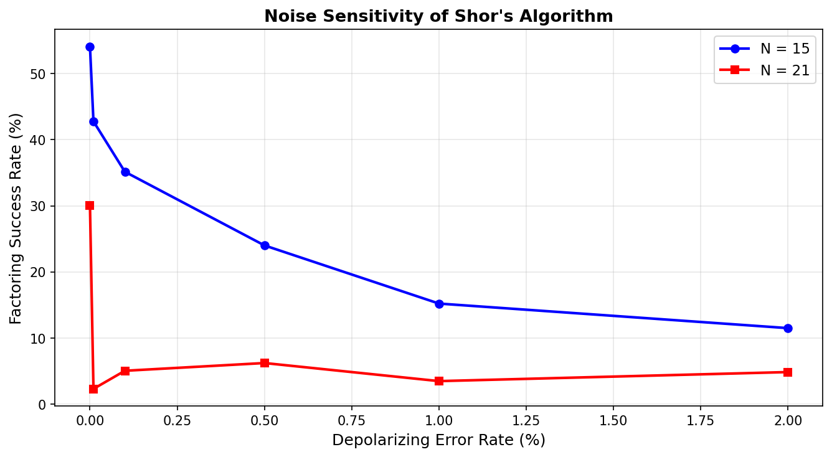

6. Conclusion
This project implemented and compared classical and quantum approaches to integer factorization. Four classical algorithms, Trial Division, Pollard’s Rho, classical order-finding, and the Quadratic Sieve, were benchmarked against a full implementation of Shor’s algorithm in Qiskit. Both N=15 (= 3×5) and N=21 (= 3×7) were successfully factored by all methods. The key finding is that Shor’s algorithm achieves polynomial time complexity O(n² log n log log n) versus the sub-exponential GNFS, confirming an exponential quantum advantage that grows to 14 orders of magnitude at RSA-2048 key sizes.
Noise analysis showed that practical quantum factoring still faces major challenges. Even 1% gate errors significantly reduce success rates, meaning large-scale implementations require fault-tolerant quantum computers with error correction. Overall, this project demonstrates both the potential of quantum computing and the current limitations of existing hardware, highlighting the importance of developing post-quantum cryptography for future security [4,5].

7. References
- P. W. Shor, “Polynomial-time algorithms for prime factorization and discrete logarithms on a quantum computer,” SIAM J. Comput., vol. 26, no. 5, pp. 1484–1509, 1997. [Preprint: arXiv:quant-ph/9508027]
- U. Skosana and M. Tame, “Demonstration of Shor’s factoring algorithm for N = 21 on IBM quantum processors,” Sci. Rep., vol. 11, art. 16599, Aug. 2021, doi: 10.1038/s41598-021-95973-w.
- S. S. Kavitha, N. Kaulgud, B. S. Sharmila, B. M. Nandini, R. R. Ram, and D. Petkar, “Quantum Shor’s algorithm vs. classical General Number Field Sieve (GNFS) approach for large integer factorization,” in Proc. 2025 Int. Conf. Next Generation Commun. Inf. Process. (INCIP-2025), IEEE, 2025, pp. 357–362, doi: 10.1109/INCIP64058.2025.11019635.
- O. Bonnet, “Simulation of hybrid classical–quantum strategies for accelerating RSA factorization in Qiskit,” unpublished manuscript, Dec. 2025.
- P. Bagourd, J. Jang-Jaccard, V. Lenders, A. Mermoud, T. Hoefler, and C. Hempel, “Practical challenges in executing Shor’s algorithm on existing quantum platforms,” arXiv:2512.15330v2 [quant-ph], Dec. 2025.

8. Acknowledgments
The author thanks the course instructors and teaching assistants of ELEC/PHYS 450/550
Quantum Computing at Koç University for their guidance during the Spring 2026 semester.
Simulations were performed using Qiskit and the Qiskit Aer simulator, both open-source
projects maintained by IBM and the Qiskit community.

9. Statement of LLM Use
This section is mandatory. Clearly disclose any use of Large Language Models (e.g., ChatGPT, Claude, Copilot) in this project.
Table 4: LLM usage policy.
Acceptable Uses | Unacceptable Uses
Polishing grammar and language | Writing full drafts of the report
Preliminary review of concepts | Assembling literature review & references
Superficial literature search | Uploading private/confidential materials
Getting an initial simulation code scaffold | Generating final code without understanding
Grammar and Language Refinement: ChatGpt and Gemini were used to polish the academic tone, sentence structure, and overall conciseness of the prose across Sections 4 and 5 of this report, ensuring formal clarity without altering the underlying empirical findings.
Visualization syntax: Gemini code and ChatGpt were used for code reformatting in the notebook in some places, especially for the graph and plot visualisations in section 3.
Claude (Anthropic): used to understand the histogram results obtained in Section 4.2.

10. Supplementary Materials
Drive link: https://drive.google.com/drive/folders/1PzqHbPtDg3BOgJnxekyMjFvGZaoEz6I?usp=drive_link

