# Report on Patient Diagnoses and Age Group Distribution in the Clinic

## 1. Diagnosis Resolution in the Clinic

Most diagnoses are resolved within the clinic. Among the reported cases:  
- Flu has the highest occurrence, with a rate of 27 cases.  
- Hypertension has the lowest occurrence, with a rate of 12 cases.

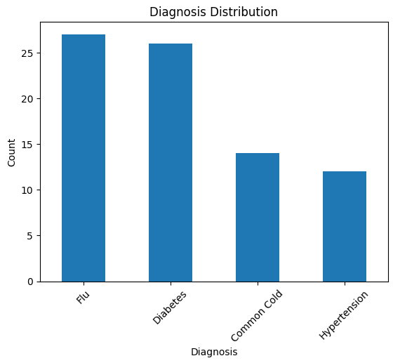

## 2. Age Distribution of Patients

The majority of patients visiting the clinic fall within the Middle Age category with 51.9%, defined as ages 36-60.

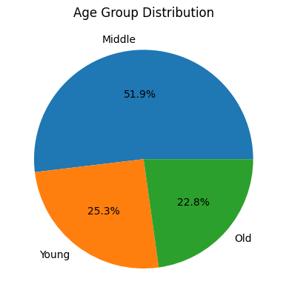

## 3. Diagnosis Trends by Age Group

A comparison of common diagnoses among different age groups shows:  
- Middle Age (36-60 years): Flu and Diabetes are the most common diagnoses.  
- Old Age (60+ years): Diabetes and Common Cold are prevalent.  
- Young Age (Below 36 years): Flu and Diabetes are frequently diagnosed.

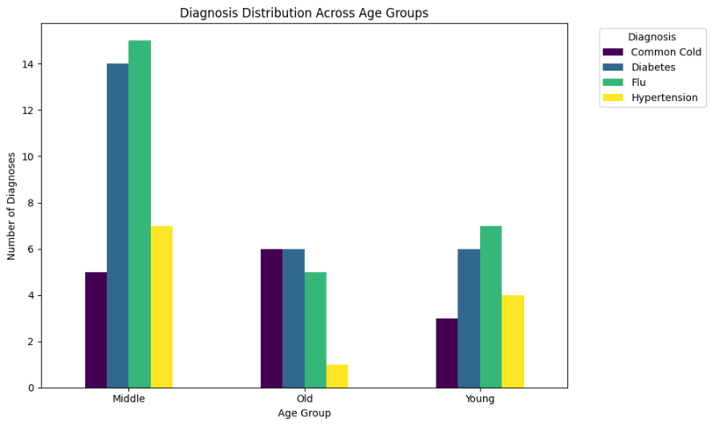

## Conclusion

Flu and Diabetes are widespread among both young and middle-aged individuals, while the elderly primarily deal with Diabetes and Common Cold. Hypertension appears to be less frequent in comparison to other conditions.

Prepared by: Muhammad Emad Hassan