# Sales and Profit Analysis Report

## 1. Monthly Sales Analysis

Highest Sales Month: November with sales of $353.46K (approx. 0.353M, or 353,461 dollars)

Lowest Sales Month: February with sales of $59.75K (approx. 0.060M, or 59,751 dollars)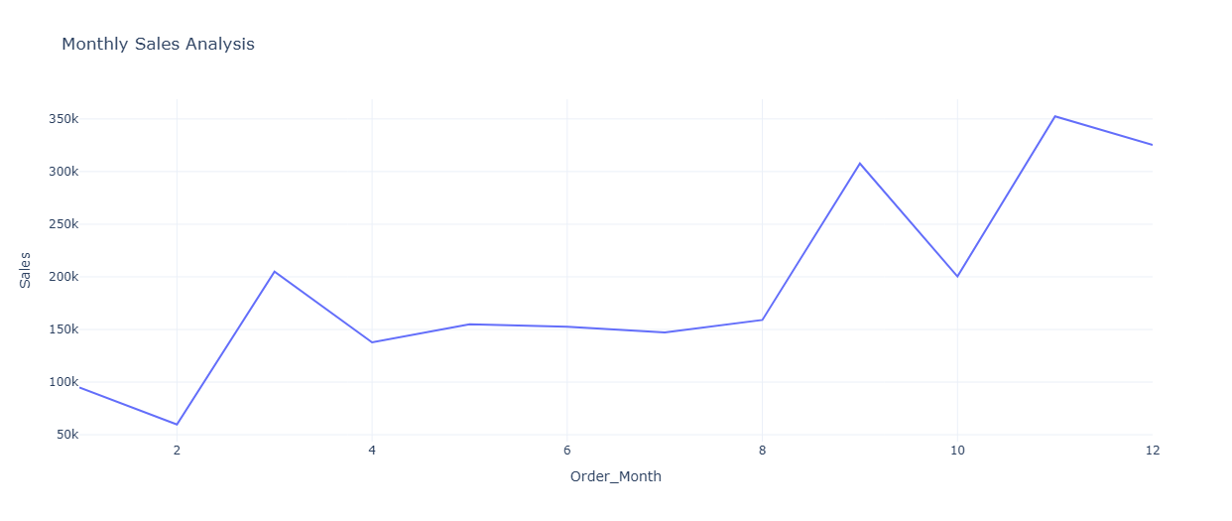

## 2. Sales by Product Categories

Furniture: $742K (approx. 0.742M, or 741,999 dollars)

Office Supplies: $719K (approx. 0.719M, or 719,047 dollars)

Technology: $836K (approx. 0.836M, or 836,154 dollars)

Conclusion: Technology category had the highest sales over the time.

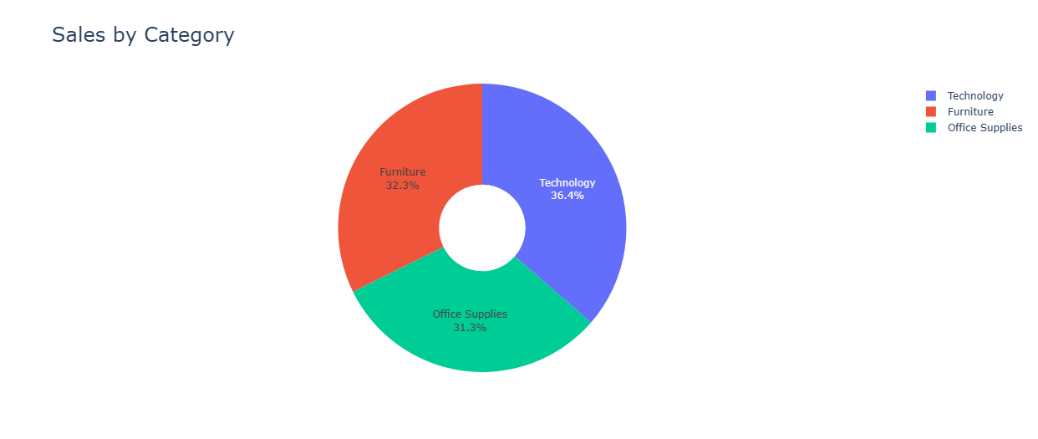

## 3. Sales by Sub-Categories

Phones sub-category recorded the highest sales at $330.01K (approx. 0.330M, or 330,007 dollars)

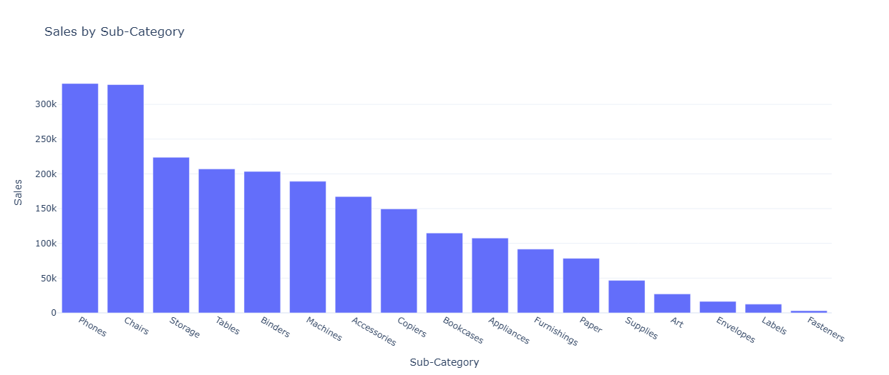

## 4. Monthly Profit Analysis

Highest Profit Month: December with profit of $43.37K (approx. 0.043M, or 43,369 dollars)

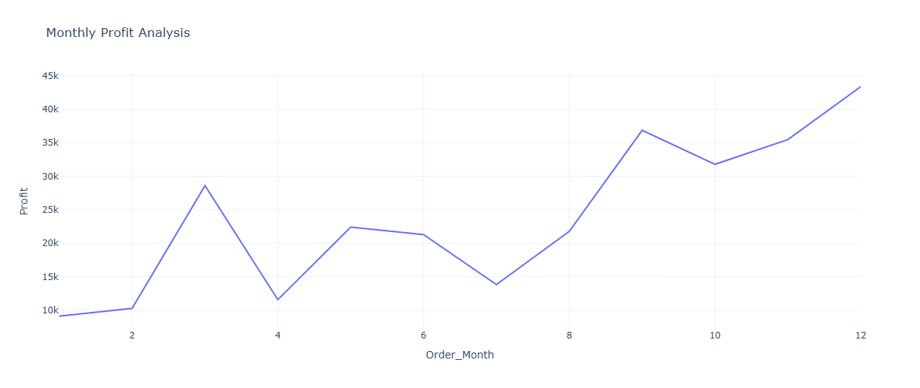

## 5. Profit by Category and Sub-Category

Over 50% of profit came from the Technology category.

The Copier sub-category had the highest sales within all sub-categories.

The 'Tables' sub-category recorded a loss of $17.73K (approx. 0.018M, or 17,725 dollars).

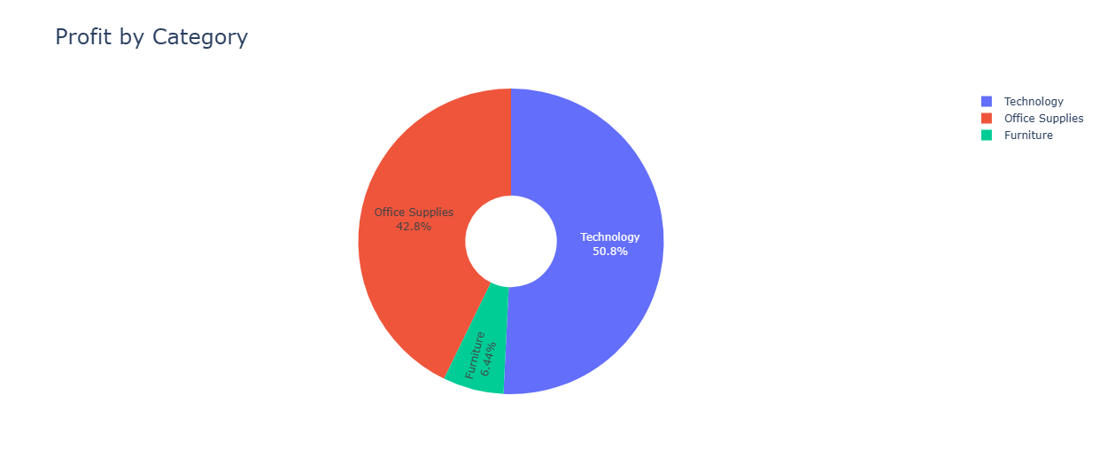

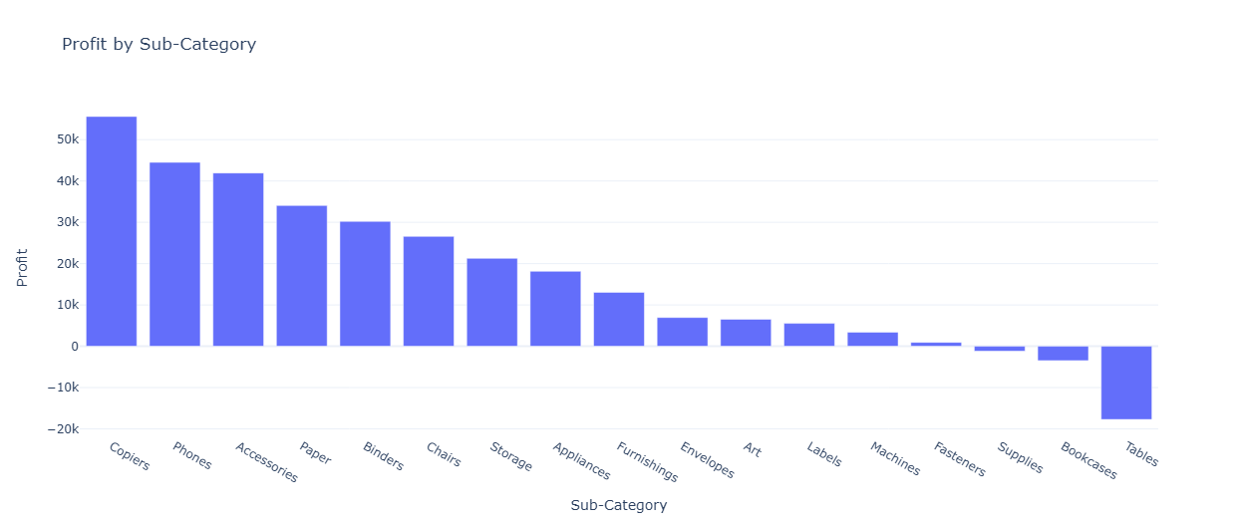

## 6. Sales and Profit by Customer Segment

|  |  |  |  |  |
| --- | --- | --- | --- | --- |
| Customer Segment | Profit (in M) | Sales (in M) | Profit (in $) | Sales (in $) |
| Consumer | 0.134M | 1.161M | 134,119 | 1,161,401 |
| Corporate | 0.092M | 0.706M | 91,979 | 706,146 |
| Home Office | 0.060M | 0.430M | 60,298 | 429,653 |

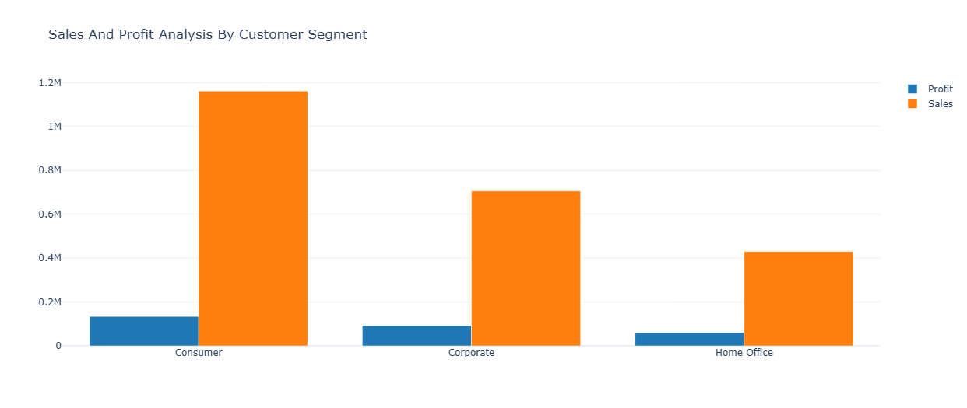

## 7. Sales to Profit Ratio by Segment

Consumer: 8.66

Corporate: 7.68

Home Office: 7.13

Prepared by: Muhammad Emad Hassan