# Netflix Analysis Summary

## Objectives

1. What is the most frequent genre of movies released on Netflix?
2. Which genre has received the highest number of votes?
3. What movie has the highest popularity, and what is its genre?
4. What movie has the lowest popularity, and what is its genre?
5. Which year had the highest number of movies released?

## Results

### Q1: What is the most frequent genre of movies released on Netflix?

The Drama genre appears most frequently in the dataset, accounting for over 14% of all movie entries among 19 genres.

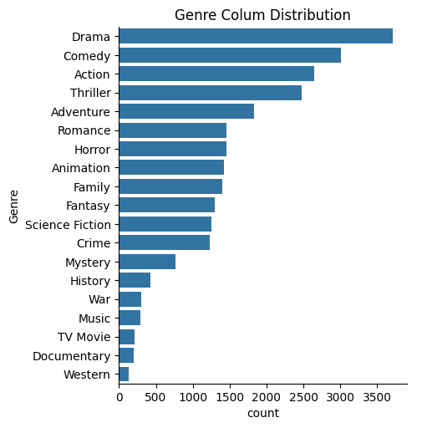

### Q2: Which genre has received the highest number of votes?

We have 25.5% of our dataset with popular vote(6520 rows).Drama again get highest popularity amnong the fans.

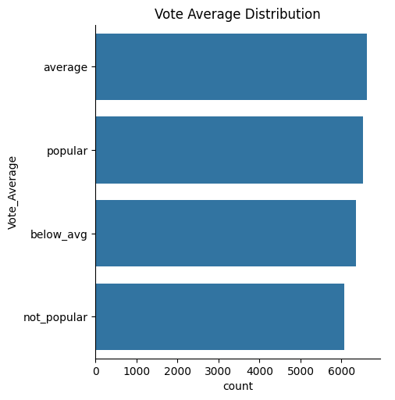

### Q3: What movie has the highest popularity, and what is its genre?

The movie "Spider-Man: No Way Home" holds the highest popularity score in the dataset. Its genres include:

* Action
* Adventure
* Science Fiction

### Q4: What movie has the lowest popularity, and what is its genre?

The movie "United State: Threads" registers the lowest popularity score. Its associated genres are:

* Music
* Drama
* War
* Science Fiction
* History

### Q5: Which year had the most movies released?

The year 2020 recorded the highest number of film releases in the dataset.

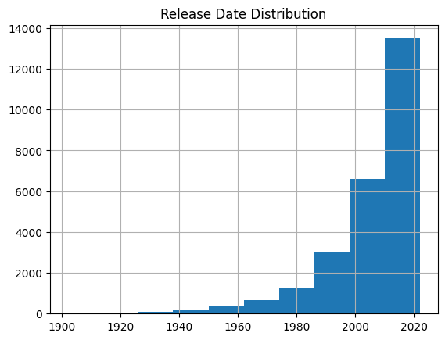

Date: 15-April-2025

Prepared By: Muhammad Emad Hassan