# Day 1 Progress

## Prepared by:

Muahammad Emad Hassan

## Q-Commerce

Why:  
Quick commerce, or Q-commerce, has significant potential as it solves many problems efficiently, delivering goods and services within minutes or hours. This is particularly beneficial in the food industry where convenience is highly valued.

## Specific Niche

Food (Restaurants):  
Targeting the restaurant sector ensures a focused approach to providing diverse food options. It includes both local and international cuisines.

## Business Goal

Offer diverse cuisines to satisfy a variety of preferences and needs. Ensure quick response times for orders, leveraging the fast-paced nature of Q-commerce.

## Who is the Target Audience?

- Corporate Offices: Catering to employees with quick and varied food options during lunch breaks.  
- Birthday Parties: Ensuring timely delivery of meals and desserts for celebrations.  
- Middle-Class Families: Providing easy access to delicious, affordable food for family meals.

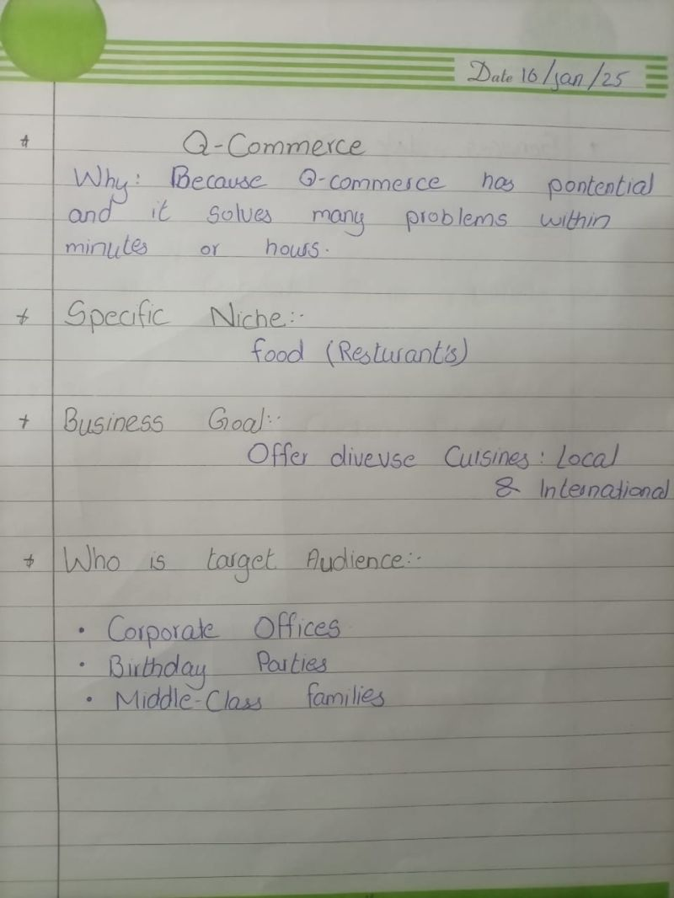

## Creating Schema Data

### Product

- Product ID: Unique identifier for each product  
- Name: Product name  
- Price: Cost of the item  
- Quantity: Amount available in stock

### Customer

- Customer ID: Unique identifier for each customer  
- Name: Customer's name  
- Contact Info: Details for communication

### Order

- Order ID: Unique identifier for the order  
- Product ID: Links the ordered product  
- Quantity: Specifies how much of the product is ordered  
  
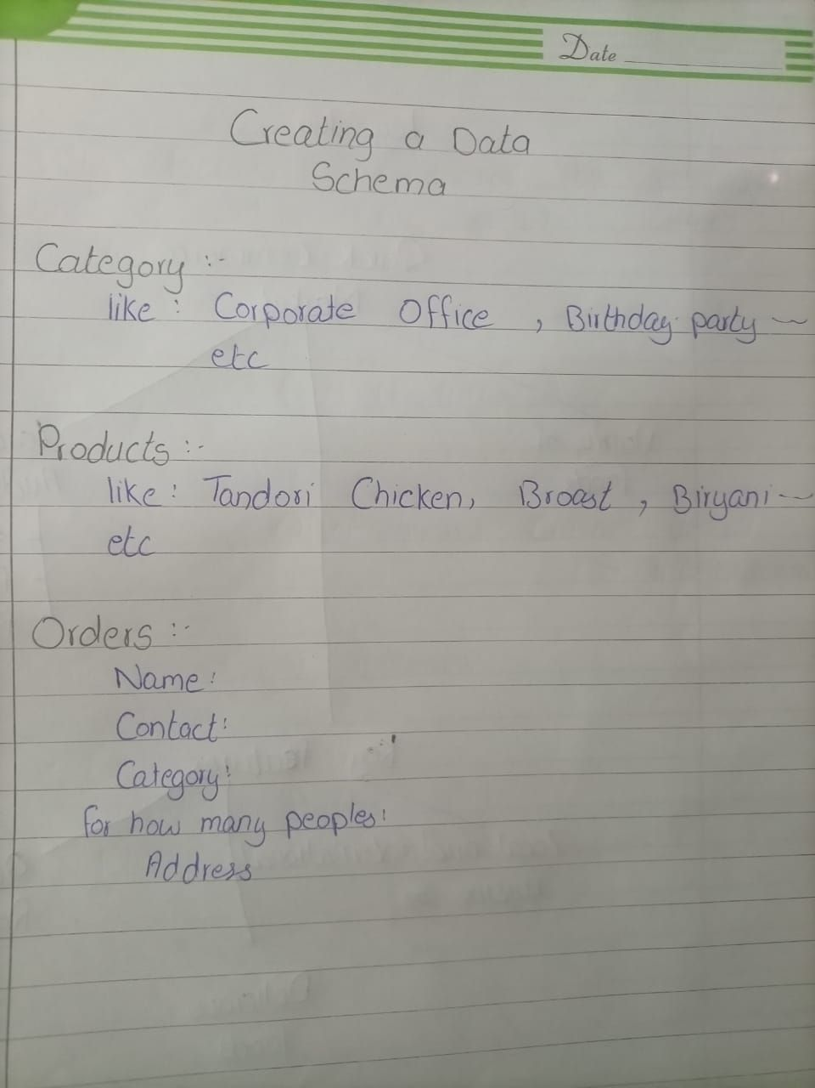

## Diagram

Product Schema:  
 - Product ID  
 - Name  
 - Price  
 - Quantity  
  
Customer Schema:  
 - Customer ID  
 - Name  
 - Contact Info  
  
Order Schema:  
 - Order ID  
 - Product ID  
 - Quantity  
  
Q-Commerce Features:  
 - Variety of Foods  
 - Local & International Cuisine  
 - Targeted Audience:  
 - Corporate Offices  
 - Family Gathering  
 - Parties  
  
 - Key Features:  
 - Delicious Foods  
 - Quick Response  
  
