# Marketplace Hackathon Documentation

Prepared by Muhammad Emad Hassan  
Roll no:00286056

# Contents

1. Introduction

2. API Integration Process Overview

2.1 Provided API Migration

2.2 Schema Adjustments

3. API Call Details

4. Frontend Implementation

5. Dynamic Functionality

6. Conclusion

# 1. Introduction

This document provides an overview of the processes and steps followed during the API integration phase of the Marketplace Hackathon. It includes schema adjustments, API queries, and frontend implementation to achieve dynamic functionality.

# 2. API Integration Process Overview

# 2.1 Provided API Migration

Using the API for Template 6, the migration process was implemented in Sanity CMS. This was facilitated by utilizing the .mjs migration extension.

# 2.2 Schema Adjustments

Adjustments made to the Sanity schema included:  
- Modifications for oldPrice and newPrice fields.  
- Addition of a category schema.  
- Inclusion of a slug field in the product schema.

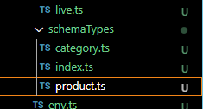

# 3. API Call Details

Data retrieval was conducted using the GROQ query to fetch data from Sanity for all products. Additionally:  
- API queries included fetching data by tags, specifically for highlighting products featured on the frontend.  
  
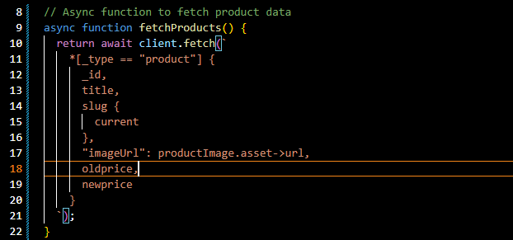

# 4. Frontend Implementation

Upon successful data fetching, the frontend was updated to dynamically display the retrieved information. This ensured accurate and responsive presentation of product data.  
  


# 5. Dynamic Functionality

Dynamic functionality was developed to allow each product to be interactively managed and displayed. This added an interactive dimension to the product features, ensuring a more engaging user experience.  
  
IMG_256

# 6. Conclusion

The integration process successfully showcased the ability to:  
- Migrate and adjust the API.  
- Retrieve data dynamically.  
- Display this information on the frontend while implementing additional interactivity.

Prepared by Muhammad Emad Hassan