Software Requirements and Design Document
for
SmartKnock
Authors:
Emaan Fatima 22i-0869
Aden Sial 22i-1313
Abdul Rehman 22i-0785
TechForge.
27/11/2024
Table of Contents
Table of Contents ii
1. Introduction 1
1.1 Purpose 1
1.2 Product Scope 1
1.3 Title 1
1.4 Objectives 1
1.5 Problem Statement 1
2. Overall Description 1
2.1 Product Perspective 1
2.2 Product Functions 2
2.3 List of Use Cases 2
2.4 Extended Use Cases 2
2.5 Use Case Diagram 2
3. Other Nonfunctional Requirements 2
3.1 Performance Requirements 2
3.2 Safety Requirements 2
3.3 Security Requirements 2
3.4 Software Quality Attributes 2
3.5 Business Rules 3
3.6 Operating Environment 3
3.7 User Interfaces 3
4. Domain Model 3
5. System Sequence Diagram 3
6. Sequence Diagram 3
7. Class Diagram 4
8. Package Diagram 4
9. Deployment Diagram 4

Introduction

Purpose

The main purpose of our device “SmartKnock” is to ensure that users can get notified of the visitors even if they are away from home. There are existing products in the market, such as Ring and Nest Hello, but Smart Knock focuses on offering enhanced features like image capturing. Smart Knock is an affordable solution, designed to provide advanced home security features without the high cost typically associated with similar smart home products.

Product Scope
Smart Knock is a mobile application developed by Tech Forge to enhance home security and convenience. Designed for Android platforms, the app allows homeowners to monitor visitors through real-time notifications and image capturing. When the smart doorbell is pressed, users are notified instantly and receive an image of the visitor on their device. This feature improves home security, ensures constant connectivity, and offers peace of mind. The app aligns with Tech Forge's mission to provide innovative, user-friendly solutions that enhance daily life while prioritizing security and convenience.

Title
Smart Knock: Enhancing Home Security with Real-Time Visitor Monitoring

Objectives
The primary objective of the Smart Knock project is to create an intuitive, user-friendly application that:
• Notifies users in real time when the smart bell is pressed.
• Captures and sends images of the visitor to the user.

Problem Statement
The major reason for choosing the Smart Knock project is the growing need for advanced home security solutions that provide users with remote access and real-time notifications. Traditional doorbells are limited in functionality, unable to inform homeowners when they are away or provide any visual information about visitors. This results in missed deliveries, potential security threats, or the inability to connect with guests in a timely manner. Smart Knock addresses this issue by offering a smart, internet-enabled doorbell that sends real-time notifications and captures images of visitors, ensuring homeowners stay connected to their property regardless of their location.

The feasibility of this project is supported by the increasing adoption of smartphones, the internet, and IoT-enabled devices. With these technologies becoming more accessible, Smart Knock presents a solution that is both practical and scalable. The app’s focus on ease of use, customization, and security makes it a unique product that meets the demand for more efficient home monitoring systems. This project not only addresses a growing security concern but also aligns with the trend of smart home innovation, making it a valuable addition to the market.

Overall Description

Product Perspective
Smart Knock is a new, self-contained product developed by Tech Forge to address the increasing need for home security and convenience. Unlike traditional doorbells, which only alert homeowners when pressed, Smart Knock integrates modern technologies such as real-time notifications and image capturing, offering a comprehensive and smart solution to monitor visitors from anywhere. This product is not a follow-on member of a product family, nor does it replace any existing systems, but rather serves as a novel addition to the growing market of IoT-enabled smart home devices.
Smart Knock functions independently, allowing homeowners to enhance their security without the need for additional hardware or complex integrations. It connects with users' smartphones via an Android app, making it easy to monitor and interact with visitors. The app interfaces with the smart doorbell device through a cloud-based system, ensuring real-time data transmission and efficient image capture. No prior smart home system or devices are required for functionality, making it an accessible solution for a broad audience.

Product Functions
Smart Knock must perform several key functions to ensure it meets the needs of homeowners for effective visitor monitoring and enhanced security. These functions include:
- Real-Time Notifications: The system must send instant alerts to users when the doorbell is pressed, notifying them of a visitor's presence.
- Image Capturing: Upon doorbell activation, the system must capture and send a photo of the visitor to the user's mobile device for identification.
- Mobile Application Interface: The app must allow users to view captured images and manage device settings remotely.
- Visitor Management: Users must be able to view and manage a history of visitors.
- Customizable Settings: Users must have the option to mute notification, sound settings, and other app features to suit their needs.
- User Authentication: The system must ensure secure access to the app, requiring authentication before allowing users to view images or change settings.
These functions are critical to ensuring that Smart Knock delivers its intended benefits of convenience, security, and user-friendliness.

List of Use Cases

Visitor Notification

Help Centre

Multi-user access control

DND mode scheduling

View visitors' history log

Give Feedback

Manage user’s accounts

Set Device Security Pin

Naming known visitors

Analyze Feedback

Extended Use Cases

Do Not Disturb (DND) Mode Scheduling

Scope: Smart Knock smart doorbell system
Level: User goal
Primary Actor: User (Homeowner)
Stakeholders and Interests:
  - User (Homeowner): Wants to avoid disturbances during specific hours.
  - Storage System: Ensures that the DND feature functions correctly, logging events without notifying the user.

Preconditions:
  - The Smart Knock app is installed and functioning correctly.
  - The user has enabled notifications in the app settings.
  - The user is logged in to the app and has access to settings.
  - The DND mode feature is available and operational.

Postcondition:
  - Notifications are suppressed during the chosen time range.
  - Visitors during DND hours are logged but not alerted to the user in real-time.
  - The user can see the log in application events afterward.
Main Success Scenario:
Actor's Actions | System's Responses
1. The user opens the Smart Knock app and navigates to settings. | 2. The system displays DND settings page.
3. The user selects the time range during which notifications should be suppressed. | 4. The system validates the selected time range for correctness.
5. The user saves the settings. | 6. The system saves the DND schedule and confirms successful configuration.
 | 7. The system suppresses notifications during the specified hours.
 | 8. The system continues to log events such as doorbell presses.
9. The user accesses the visitor log to review missed alerts. | 10. The system displays a log of all visitors during the DND time range.
 | 11. Notifications automatically resume outside the DND time range.

Extensions:
3a. User Selects Invalid Time Range:
Actor's Actions | System's Responses
1. The user selects an invalid time range (e.g., start time after end time). | 2. The system displays an error message indicating the time range is invalid.
3. The user enters a valid time range. | 4. The system validates and accepts the updated time range.

6a. System Fails to Save Settings:
Actor's Actions | System's Responses
1. The user attempts to save the DND settings. | 2. The system encounters an error while saving the settings.
 | 3. The system displays an error message prompting the user to try again.
4. The user retries saving the settings. | 5. The system saves the settings successfully after retrying.

5a. User Changes DND Schedule Midway:
Actor's Actions | System's Responses
1. The user accesses the DND settings again during an active DND period. | 2. The system displays the current DND schedule settings.
3. The user adjusts the time range. | 4. The system validates the new time range for correctness.
5. The user saves the updated schedule. | 6. The system applies the updated schedule immediately.

Special Requirements:
  - The system must ensure that notifications resume immediately once the DND time range ends.
  - The event log must remain accessible to the user at all times, regardless of the DND settings.
Technology and Data Variations List:
  - The user may receive notifications depending on app settings, but these will be suppressed during DND hours.
  - Events may be logged with timestamps, and the user should be able to filter or sort the log by date and time.

- Help Center
Scope: Smart Knock smart doorbell system
Level: User goal
Primary Actor: User (Homeowner)
Stakeholders and Interests:
  - User (Homeowner): Wants clear guidance on how to navigate the app and use the Smart Knock system effectively.
  - Storage and Database System: Ensures the help center and tutorial provide accurate and up-to-date information.
Preconditions:
  - The app is installed on the user’s device, and the user is logged in.
  - The app includes help section accessible to the user.
  - The user is connected to the internet to access the FAQs.
Postconditions:
  - The user understands how to navigate the app and set up the Smart Knock system.
  - The user can troubleshoot common issues using the help center without external assistance.
Main Success Scenario:
Actor's Actions | System's Responses
1. The user accesses the Help Center. | 2. The app displays all the FAQs to support the user.
3. The user finds the solution to his problem provided in the FAQ and resolves their issue.

Extensions:

3a. User Cannot Find the Desired Information in the Help Center
Actor's Actions | System's Responses
1. The user searches for specific guidance in the Help Center but cannot find relevant information. | 2. The app provides email to contact customer support.
3. The user sends a mail to that email address addressing the issue faced.

Special Requirements:
  - The tutorial and Help Center must be intuitive and easy to follow.

- Manage User Accounts

Scope: Smart Knock smart doorbell system
Level: Admin goal
Primary Actor: Admin

Stakeholders and Interests:
  - Admin: Wants to effectively manage user accounts or delete any account.
  - Users: Expect their accounts to be created or deleted accurately and securely.
  - Storage and Database System: Ensures that the system functions smoothly, preventing unauthorized access by checking username and password from the database.
Preconditions:
  - The admin is logged into the user management panel with the necessary permissions.
  - Users are already registered in the system.
  - The system is connected to the database and user account management services.
Postconditions:
  - User accounts are successfully created or deleted as requested.
  - Any changes are updated in the system, and users are notified.
Main Success Scenario:
Actor's Actions | System's Responses
1. The admin logs into the Smart Knock. | 2. The system authenticates the admin and grants access to the panel.
3. The admin goes to the User Management section. | 4. The system displays a list of users with their details.
5. The admin adds a new user by entering the required details. | 6. The system validates the details and updates the user list.
7. The admin removes an inactive or unauthorized user from the system. | 8. The system validates the removal and updates the user list.
9. The admin confirms all changes. | 10. The system reflects the updates in real-time.

Extensions:

6a. Invalid User Details Entered
Actor's Actions | System's Responses
1. The admin enters invalid details. | 2. The system displays an error message indicating the issue.
 | 3. The system prompts the admin to correct the data.

6b. User Already Exists
Actor's Actions | System's Responses
1. The admin attempts to add  a user with an email or username that already exists. | 2. The system prevents duplication and notifies the admin that the user already exists.

8a. User Account In Use
Actor's Actions | System's Responses
1. The admin attempts to delete a user currently active in the system. | 2. The system blocks the deletion and notifies the admin that the user is active.

Special Requirements:
  - The system must handle a large number of user accounts efficiently.
  - Proper validation of user data, especially for critical fields like email and password.
Technology and Data Variations List:
- The admin may access the user management panel via a web interface or mobile app, depending on their system setup.
- User details may include variations based on system requirements (e.g., additional fields like role).

- Visitor Notification
Scope: Smart Knock smart doorbell system
Level: User goal
Primary Actor: User (Homeowner)
Stakeholders and Interests:
- User (Homeowner): Wants to be notified promptly when a visitor arrives, with relevant details such as the visitor’s image.
- Cloud and Storage System: Ensures visitor images securely stored and efficiently processed for notification purposes.
- Doorbell: Detects the visitor press, captures the visitor’s image, and triggers the notification system.
Preconditions:
- The Smart Knock doorbell is installed, connected to the user’s network, and integrated with the mobile app.
Postconditions:
- The user receives a real-time notification on their mobile device with the visitor’s image and timestamp.
Main Success Scenario:
Actor's Actions | System's Responses
1. A visitor presses the Smart Knock doorbell. | 2. The system detects the press and triggers the visitor notification system.
 | 3. The system captures an image of the visitor.
 | 4. A notification is sent to the user’s mobile device, including the visitor’s image and timestamp.
5. The user views the notification and decides if he wants to name the visitor in the log for easy accessibility in future. | 6. The system records the user's interaction and updates the database.

Extensions:

6a. Notification Fails to Send
Actor's Actions | System's Responses
1. The system encounters an error while sending the notification due to network issues. | 2. The system stores the event data and retries sending the notification once connectivity is restored.
 | 3. The user is notified of the event soon.

Special Requirements:
- The system must ensure that the visitor's image is captured and sent within seconds of the doorbell press.
- The system must comply with privacy regulations, ensuring that visitor data is stored securely and not misused.
Technology and Data Variations List:
- The app may send notifications based on user preferences.

- Review and Analyze Feedback

Scope: Smart Knock smart doorbell system
Level: Admin goal
Primary Actor: Admin
Stakeholders and Interests:
- Admin: Wants to monitor, analyze, and act on user feedback to improve the product and enhance customer satisfaction.

Preconditions:
- The admin has access to the feedback dashboard through the system.
- Users have submitted feedback through the app, including ratings, comments, and suggestions.

Postconditions:
- The admin gains actionable insights from the feedback, identifies common issues.
Main Success Scenario:
Actor's Actions | System's Responses
1. The admin logs into the system and opens the feedback dashboard. | 2. The system displays user feedback.
3. The admin filters feedback based on rating. | 4. The system updates the feedback view based on the required data.
5. The admin reviews feedback and identifies patterns, such as recurring issues or common positive aspects.
6. The admin uses this analysis to determine key areas for improvement. | 8. The system does not provide a direct response, as this is part of the admin's decision-making.

Technology and Data Variations List:
- Feedback data may include text comments, and ratings.

- Set Security PIN for Device:
Scope: Smart Knock smart doorbell system
Level: User goal
Primary Actor: User (Homeowner)
Stakeholders and Interests:
- Homeowner: Wants to secure their device with a PIN to prevent unauthorized access.
- Database and Storage System: Ensures secure storage of the PIN without affecting user experience.
Preconditions:
- The app supports setting a security PIN for the device.
- The user is logged into the app and has access to the device's settings.
Postconditions:
- The device is secured with a 4 digit PIN.
- Unauthorized users cannot access the device without the correct PIN.

Main Success Scenario:
Actor's Actions | System's Responses
1. The user logs in. | 2. The user has the option to either set PIN (primary user) or enter a PIN (secondary user).
3. The user selects an option. | 4. The system prompts the user to enter a 4 digit PIN.
5. The user enters a 4 digit PIN. | 6. The system validates the PIN format (e.g., length, numeric only).
7. The user confirms the entered PIN. | 8. The system verifies the PIN matches or sets the initial entry and saves it securely.
 | 9. The device is now secured, and the user is required to enter the PIN for future access.

Extensions:
3a. Invalid PIN Format
Actor's Actions | System's Responses
1. The user enters a PIN with invalid format (e.g., too  short, non-numeric characters). | 2. The system displays an error message prompting the user to enter a valid 4 digit numeric PIN.
3. The user re-enters a valid PIN. | 4. The system validates and accepts the PIN.

- Multi-User Access Control:
Scope: Smart doorbell system
Level: User goal
Primary Actor: Primary User (Homeowner)
Stakeholders and Interests:
- Primary User (Homeowner): Wants to manage access for other users while retaining full control over the system.
- Secondary Users (Family Members): Want to have access to the same device.
- Database and Storage System: Ensures multiple users can securely access the system without conflicts.
Preconditions:
- The system supports multiple user accounts.
- The primary user is logged into the app and has full control over system settings.
Postconditions:
- Multiple users can access the same device with their individual notification preferences.
- The primary user maintains control over all access permissions for secondary users.

Main Success Scenario:
Actor's Actions | System's Responses
1. The primary user invites secondary users by sending them device PIN via text.
2. The secondary users receive the text and enter the same PIN on logging in. | 3. The system allows access to the device to secondary user.
4. Each secondary user sets their own notification preferences. | 5. The system saves the notification preferences for each secondary user.
6. The secondary users begin receiving notifications independently based on their preferences. | 7. The system ensures the primary user can modify or revoke permissions at any time.

Extensions:

6a. Removing a secondary user
Actor's Actions | System's Responses
1. The primary user wants to remove a secondary user. | 2. The system displays the list of secondary users.
3. The primary user chooses who to remove | 4. The system applies the changes.

- Visitor History Log:
Scope: Smart doorbell system
Level: User goal
Primary Actor: User (Homeowner)
Stakeholders and Interests:
- User (Homeowner): Wants to review and monitor past visitors for security and awareness.
- Database and Storage System: Ensures accurate logging of visitor data and easy retrieval of information.
Preconditions:
- The system logs all visitor interactions, including images, timestamps.
- The user is logged into the app and has access to the visitor history section.
Postconditions:
- The user can review detailed information about past visitors, including images and timestamps.
- The user can filter and search the visitor history for specific data.
Main Success Scenario:
Actor's Actions | System's Responses
1. The user opens the app and navigates to the visitors section. | 2. The system displays a list of all visitors, including images, timestamps.
3. The user scrolls through the list to review visitor details.
4. The user uses filtering options to sort or search the visitor history by date, time, or visitor identity. | 5. The system updates the display to reflect the user’s chosen filter.
6. The user selects a specific visitor entry to view detailed information. | 7. The system displays detailed visitor information.

- User Feedback:
Scope: Smart Knock smart doorbell system
Level: User goal
Primary Actor: Homeowner
Stakeholders and Interests:
  - User (Homeowner): Wants to provide feedback on the device to improve future performance or report issues.
  - Database and Storage System: Wants to gather user feedback for analysis and system improvements.
Preconditions:
  - The feedback feature is enabled and accessible through the app.
  - The user is logged into the app and has access to the feedback section.
Postconditions:
  - The user’s feedback, including ratings and comments, is stored and linked to the specific Smart Knock device.
  - The feedback is available for future analysis and product improvements.

Main Success Scenario:
Actor's Actions | System's Responses
1. The user navigates to the “Feedback” section within the app. | 2. The system shows “Feedback” section in the app.
3. The user is prompted to provide a rating (e.g., 1-5 stars) and optional comments.
4. The user submits their rating and comment. | 5. The system validates the input (rating and comment).
6. The user successfully submits their feedback. | 7. The system stores the feedback.
Extensions:
3a. Incomplete Feedback
Actor's Actions | System's Responses
1. The user submits feedback without providing a rating. | 2. The system prompts the user to complete the rating before submission.
3. The user completes the rating and resubmits the feedback. | 4. The system validates and saves the completed feedback.
4a. Feedback Submission Error
Actor's Actions | System's Responses
1. The user submits feedback, but the system encounters an error (e.g., no internet connection). | 2. The system displays an error message and asks the user to try again later.
3. The user retries submitting the feedback. | 4. The system saves the feedback and updates the feedback database.
Technology and Data Variations List:
- Feedback may be submitted via different formats (e.g., star ratings, text comments, or audio feedback).
- Feedback can be linked to specific device versions, allowing for targeted analysis based on device model.
- Set name for Visitor:
Scope: Smart Knock smart doorbell system
Level: User goal
Primary Actor: User (Homeowner)
Stakeholders and Interests:
- User (Homeowner): Wants to improve the readability of the visitor log by naming a visitor, making it easier to identify and track visits.
- System: Ensures the name is properly saved and associated with the visitor's record for easy identification in the log.
Preconditions:
- The user is logged into the Smart Knock app.
- A visitor has pressed the doorbell, and their visit is recorded in the system.
- The visitor’s image is available in the visitor log.
- The visitor log feature is functioning correctly.
Postconditions:
- The visitor’s log entry now includes a name, improving readability and making the log easier to review.

Main Success Scenario:
Actor's Actions | System's Responses
1. The user opens the visitor log in the Smart Knock app. | 2. The system displays the list of recorded visits, including details like visitor image and timestamp.
3. The user selects a visitor entry from the log. | 4. The system displays the visitor’s details, including their image and timestamp.
5. The user chooses to set name for the visitor.
6. The user sets the desired name for the visitor. | 7. The system saves the name and associates it with the visitor’s log entry.
11. The user sees the updated visitor log with the named entry. | 12. The system updates the log and displays the visitor’s name alongside their visit details.

Extensions:

7a. Invalid Name Input
Actor's Actions | System's Responses
1. The user enters an invalid name (e.g., special characters, empty field). | 2. The system displays an error message asking the user to enter a valid name.
3. The user corrects the name and submits it again. | 4. The system validates and saves the corrected name.

10a. System Fails to Save Name
Actor's Actions | System's Responses
1. The user confirms the name entry, but the system encounters an error while saving. | 2. The system displays an error message and asks the user to try again.
3. The user retries the action. | 4. The system saves the name and updates the visitor log.

Special Requirements:
- The system should ensure that names are displayed in a readable format in the visitor log.
- The system must allow the user to edit a visitor’s name if necessary.
- The naming feature should be available for all the visitors in the log.

Technology and Data Variations List:
- The visitor log should be synced across all user devices, so any name updates are reflected in real time.

Use Case Diagram
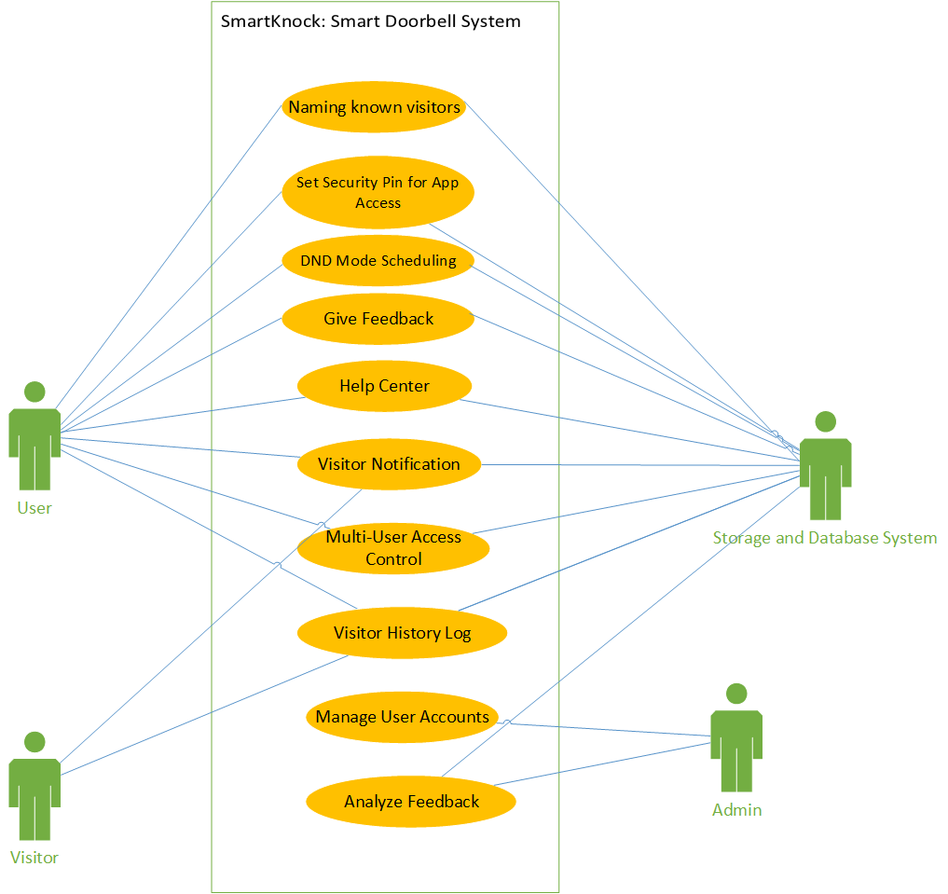

Functional Requirements:
- User Management: Users can create and manage accounts, set up secondary users, and customize notification preferences with secure login options.
- Visitor Management: The system logs visitor events with images and timestamps.
- Notifications: Notifications are sent for doorbell presses.
- Feedback System: Users can submit feedback through the app, which is stored for analysis and future product improvements.

Other Nonfunctional Requirements

Performance Requirements
- Notification Latency: Notifications must be sent within 5 seconds of the doorbell press to alert users promptly.
- Image Capture and Transmission: An image must be captured and sent within 10 seconds to provide timely visitor identification.
- App Response Time: The app must display images within 3 seconds of user interaction for quick access.
- Scalability: The system must support multiple concurrent users without performance issues to accommodate growth.
These requirements ensure real-time responsiveness and reliability for an effective security solution.

Safety Requirements
All images and notifications captured by the system must be backed up on a secure server. In case of system failure or accidental data loss, these images and notifications must be recoverable. The smart doorbell must adhere to safety certifications to ensure the device meets strict safety standards for electrical products. This ensures reducing the risk of electrical hazards such as fires, shocks, or malfunctions.

Security Requirements
• User Authentication:
Secure login with password to ensure authorized access.
• Access Control:
Role-based access to restrict connection to device only to authorized users (family members).

Software Quality Attributes
• Usability:
The app is easy to use, with new users able to navigate and complete basic tasks.
• Reliability:
The system is reliable, it works smoothly with minimal interruptions.
• Maintainability:
The app is easy to update and maintain, with any bug fixes or updates being implementable within 2-3 days.
• Scalability:
The app can handle increasing users without performance issues or slowing down.
• Security:
The app follows basic security practices to protect user data, such as secure login methods.
• Portability:
The app should work on 97% Android devices, ensuring broad compatibility with most modern smartphones.

Business Rules
- User Roles:
  - Admin: Can manage all users and view all feedbacks and control device preferences.
  - Homeowner/User: Can view images and receive notifications but cannot modify system-wide settings.
  - Visitor: Can interact with the doorbell (press it), but cannot access app features or data.
- Data Access:
  - Only authorized users (with the correct device PIN) can access sensitive data like visitor images or view security logs.
  - Guest access is limited to pressing the doorbell, and they cannot view notifications or images.
- Notification Preferences:
  - Users must have the ability to mute notification preferences.
  - Notifications must be sent immediately when the doorbell is pressed.
These business rules ensure that the product operates securely and provides appropriate access based on user roles, while maintaining privacy and control over user data.

Operating Environment
- Hardware Platform:
The Smart Knock app will run on Android smartphones with a minimum of 2GB RAM and 1.5GHz processor.
- Operating System:
The app will support Android versions 8.0 (Oreo) and above, ensuring compatibility with a wide range of devices. It will be optimized for devices with screen sizes ranging from 5.0 to 7.0 inches.
- Smart Doorbell Hardware:
The Smart Knock system will interface with the physical smart doorbell hardware, which includes a camera and button, all connected to a Wi-Fi network for communication.
- Other Software Components:
  - Cloud Storage: For storing visitor images and notification logs (e.g., Firestore and Real-Time Database).
  - Push Notification Service: The app will use Firebase Cloud Messaging (FCM) for sending real-time notifications.
This operating environment ensures compatibility with both hardware and software components, allowing the app to function efficiently in a typical smart home setup.

User Interfaces

Logical Characteristics of User Interface (UI) for the Smart Knock App
The Smart Knock app is a security-focused smart doorbell system, and the user interface (UI) is essential for providing a seamless, intuitive, and accessible experience for different types of users. Below is a description of the logical characteristics of each interface, including standards, guidelines, screen layout, and user interface components.

User Interface Components

A. Login Screen
- Purpose: Allows users to authenticate using email and password.
- Components:
  - Email input field
  - Password input field
  - Login button
  - Checkbox for user or admin
  - Sign-up link (for new users)
- Functionalities:
  - Input validation (check if email is in correct format, password meets alphanumeric criteria)
  - Display errors when login fails
  - Smooth transition to main dashboard or sign-up screen

B. Sign-Up Screen
- Purpose: Allows new users to create an account.
- Components:
  - Name, Email, Password
  - Sign-up button
  - Login link (for existing users)
- Functionalities:
  - Input validation
  - Create user

C. Home/Dashboard Screen
- Purpose: Displays key features like help center, visitor management, settings and feedback.
- Components:
  - Navigation menu
  - Action buttons for:
    - Adding users
    - Changing settings
    - Managing users
  - User profile display (name, device status, etc.)
- Functionalities:
  - Simple, intuitive navigation with clear access to all key features
  - Access to visitor management
  - Send Feedback

D. Visitor Management Screen
- Purpose: Allows users to manage and view information about visitors.
- Components:
  - List of past visitors (names, date/time of visit)
  - Button to view visitor details
- Functionalities:
  - Search/filter visitors by name or date
  - Display recent visitor activity
  - Notifications if a visitor arrives

E. Settings Screen
- Purpose: Allows users to mute notifications, manage secondary user, DND mode .
- Components:
  - Do Not Disturb (DND) scheduling
  - Privacy and security settings (e.g., PIN)
  - Notifications settings
- Functionalities:
  - Set up DND mode for specific times
  - Configure PIN for extra security

F. Add User Screen
- Purpose: Allows the main user to add new users to the system (family members, household staff, etc.).
- Components:
  - Name, email, role (admin/user), and device access permissions fields
  - Add button
  - Cancel button
  - Error message area
- Functionalities:
  - Validating the user details
  - Giving different access rights (admin vs. user)
  - Notification to the added user for confirmation
G. Feedback Screen
- Components:
  - Message Text Area: A large text box where users can describe their feedback in detail.
  - Rating Selector: A 5-star rating system to quickly rate the app overall.
- Buttons:
  - Submit Feedback: Sends the feedback to the app's backend.

H. Help Centre
- Purpose: Provides users with assistance and answers to frequently asked questions (FAQs).
- Components:
  - List of FAQs
  - Contact support email
I. Error Messages & Alerts
- Purpose: Displays critical error messages, warnings, or system alerts.
- Components:
  - Toast messages for minor alerts (e.g., "Settings updated")
  - Clear description of the error
- Functionalities:
  - Non-intrusive alerts (Toast) auto-dismiss after a few seconds

GUI Standards and Product Family Style Guides

Color Scheme
- The app consistently uses a blue and white color palette, creating a calming and user-friendly environment.
- Primary Buttons: Use shades of blue to make them stand out.
- Secondary Buttons: Utilize blue gray backgrounds with white buttons or text for a neutral tone.

Typography
- The Montserrat font family is used across all headings and body text, ensuring a clean and modern look.
- Font sizes are consistent across the app for easy readability:
  - Headings: Larger font size for clear hierarchy.
  - Body Text: Standardized smaller size for detailed information.

Button Design
- Buttons feature rounded corners, giving a modern and approachable feel.
- Primary Buttons: Prominent blue background with white text for actions like “Submit” or “Connect.”
- Secondary Buttons: White or light gray background with blue text or borders for less critical actions.

Icons and Images
- High-quality, consistent icons are used for navigation and actions, designed to complement the blue and white color scheme.
- Icons follow a minimalistic style, ensuring the interface remains uncluttered.
- Images, if used, align with the app’s clean and modern aesthetic.

Screen Layout Constraints
- All screens maintain a consistent layout, with clear divisions between functional areas like forms, buttons, and information displays.
- The design is responsive, ensuring a seamless user experience across different screen sizes.
- Consistent padding and margins are applied across all screens, creating a balanced and visually appealing layout.

4. Standard Buttons and Functions
  - Save: Save the visitor name.
  - Add: Add a new user or visitor.
  - Delete: Remove users or visitors.
  - Help Icon: Opens the FAQ screen or customer support.
  - Log Out: Logs the user out of the app.
  - Feedback Icon: Opens the feedback screen.
  - Submit: Submits the feedback
  - Search Icon: filters visitor log.
  - Home Icon: Takes to the homepage

4. Keyboard Shortcuts
- Provide users with standard shortcuts to navigate the app faster:.(back button,enter button)

5. Error Message Display Standards
- Toast Alerts: Display as small toast messages for system notifications (e.g., "Settings saved, login successful, invalid password etc").

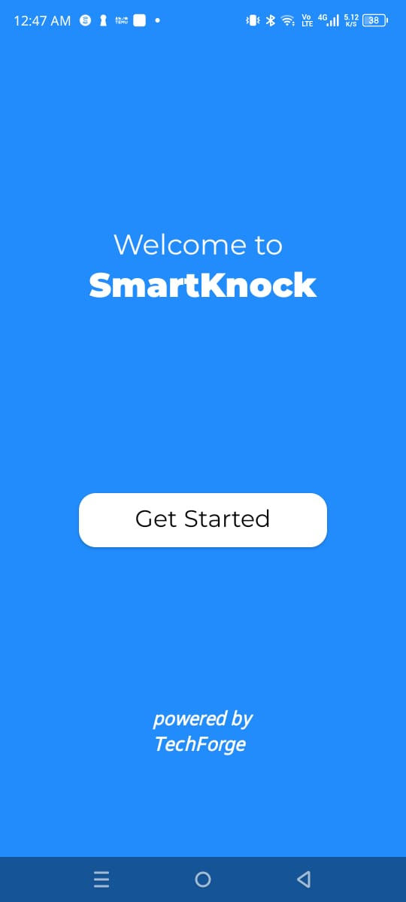
Screen Samples
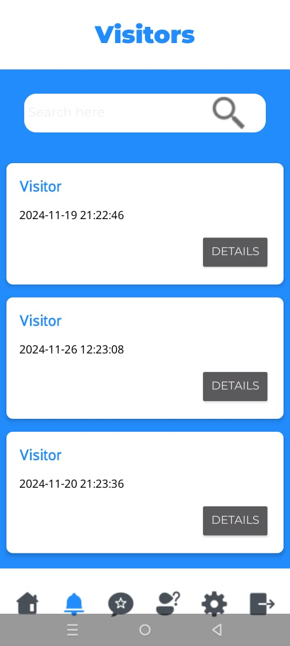

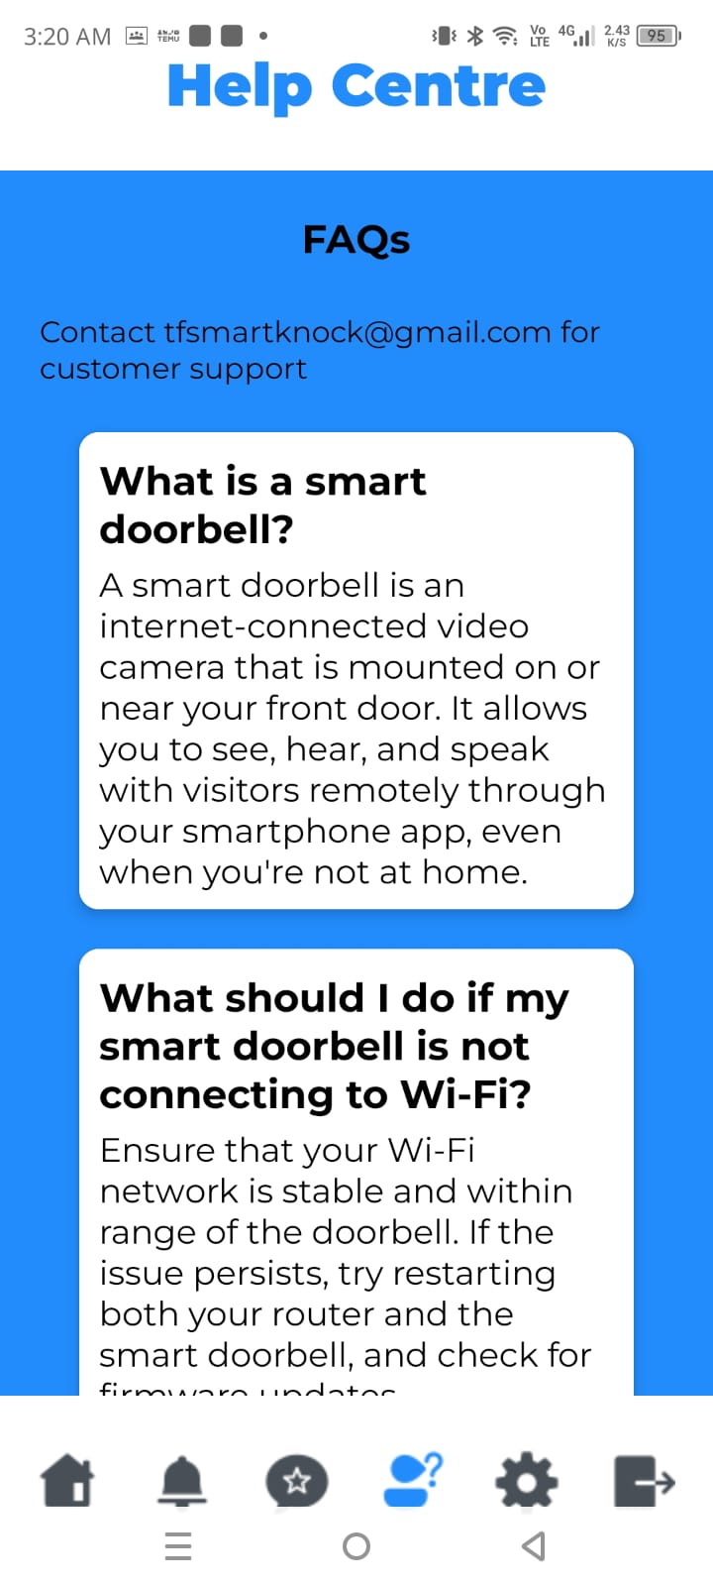
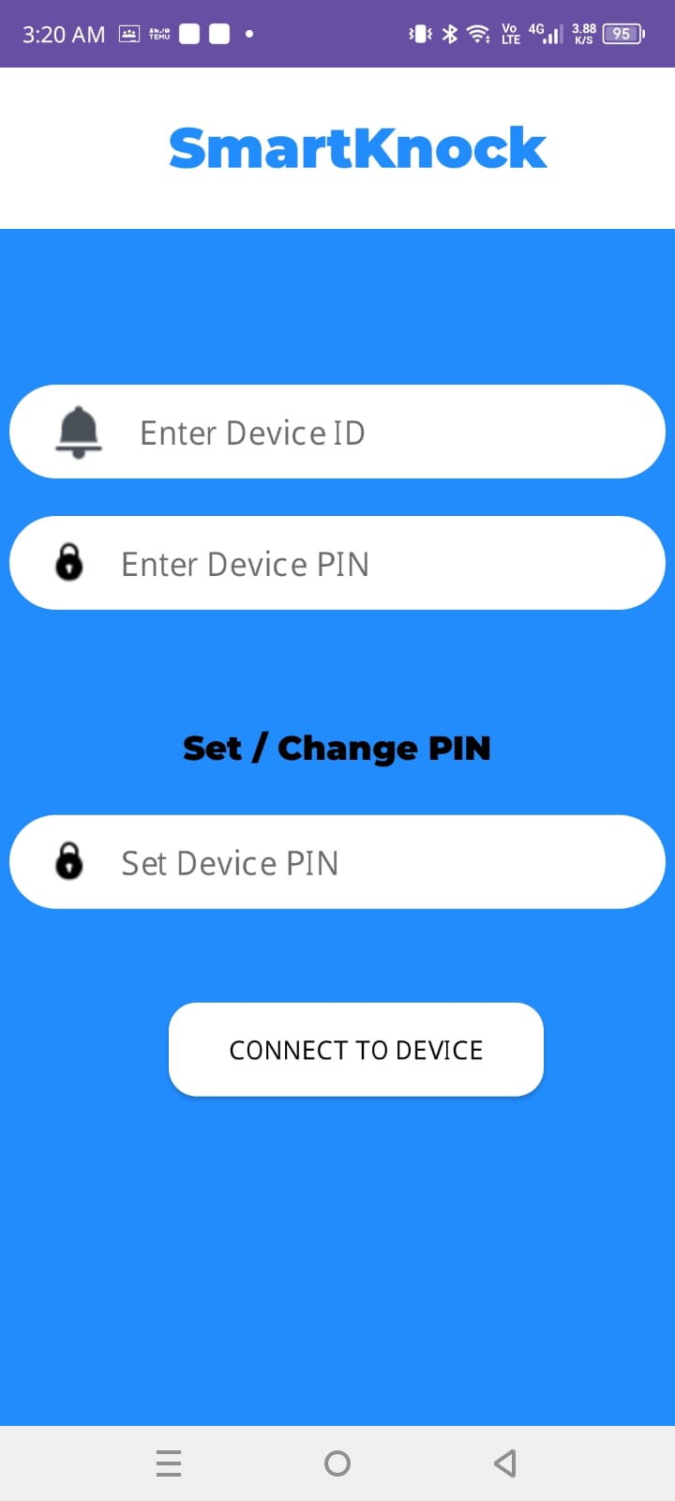

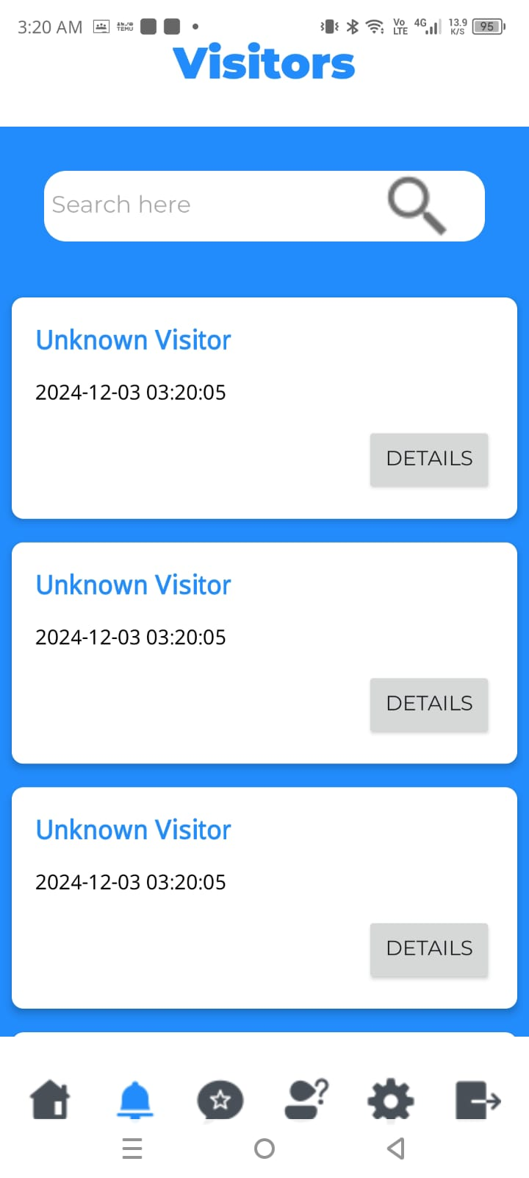
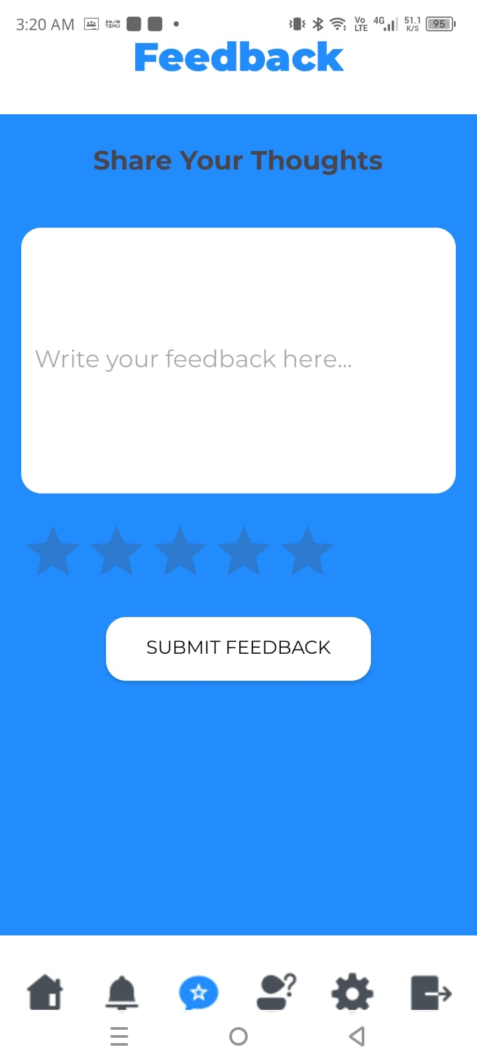

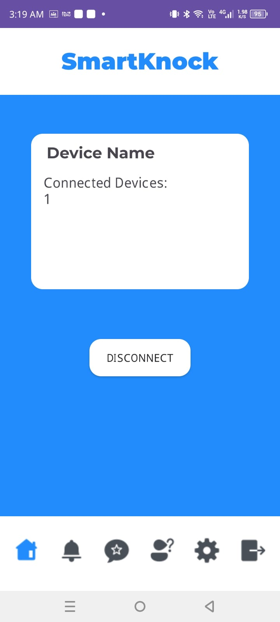

7. User Interface Design Documentation

UI Flow
The app clearly defines the flow between screens, ensuring seamless navigation for the user. Each interaction leads logically to the next step:
- Users log in to access their personalized dashboard.
- From the dashboard, users can manage devices, view visitor logs, and customize settings.
- Navigational elements like a bottom navigation bar users through key features, such as notifications, and the help center.
- The flow prioritizes ease of access, with minimal clicks required to complete actions.

Prototypes
High-fidelity designs illustrate the final user interface, incorporating:
- A blue and white color scheme with Montserrat fonts.
- Consistent button styles (rounded corners, white buttons).
- Interactive elements like toggles, dropdowns, and expandable sections.
- These prototypes serve as a reference for implementing the UI and maintaining alignment with the app’s visual identity.

Interaction Guidelines
Detailed specifications explain how elements behave, including:
- Buttons: Provide visual feedback with color transitions on click and animations during loading actions.
- Navigation: Smooth screen transitions (e.g., slide-in effects for moving between screens).
- Alerts: Notifications appear as pop-ups or banners with dismiss options.
- Forms: Error messages are displayed on toasts for invalid inputs, with clear text.

Responsiveness
The user interface adapts to different screen sizes and orientations:
- Mobile: Ensures optimal layouts for portrait and landscape modes, with appropriately scaled elements and touch-friendly buttons.
- Tablet: Displays additional content or side-by-side views for better utilization of larger screens.
- Dynamic Scaling: All components, including fonts, buttons, and images, resize proportionally to maintain a clean and balanced appearance.
- Consistent padding and spacing enhance readability and usability across devices.

- Three Tier Architecture:
1. UI Layer (Presentation Layer)
- User Management: User activities manage user interactions, such as login, registration, and profile updates.
- Admin Management: Admin pages displays the admin panel, with options to manage users, and feedback.
- Visitor Management: Visitors Activity displays the list of visitors, while VisitorDetails Activity shows detailed information about each visitor.
- Feedback Management: Feedback Activity allows admins to view and manage feedback submitted by users.
2. Business Logic Layer (Application Layer)
- User Management: UserController handles the logic for authenticating and updating user data.
- Admin Management: AdminController manages the business logic related to admin actions such as adding or removing users, and viewing feedback.
- Visitor Management: VisitorController is responsible for managing visitor-related data, including fetching visitor information from Firebase and updating visitor details.
- Notification Management: NotificationController coordinates with NotificationManager to monitor Firebase for new events (e.g., new visitor entries) and send notifications to the UI layer.
3. Data Access Layer (Database Layer)
- User Management: UserManager manages all interactions with Firebase for user data, including authentication and profile updates.
- Admin Management: AdminManager interacts with Firebase to store and manage admin data.
- Visitor Management: VisitorManager interacts with Firebase to fetch, add, update, and delete visitor data.
- Feedback Management: FeedbackManager manages operations for feedback data, interacting with Firebase for real-time data updates.
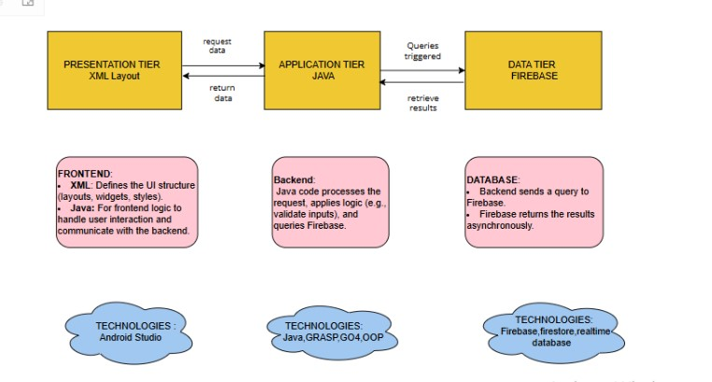
- GRASP :
1. Information Expert
- User Management: The User class holds user-specific data such as name, email, and password, making it the information expert in this domain.
- Admin Management: The Admin class manages admin-related operations and holds admin-specific data, acting as an expert in this context.
- Visitor Management: The VisitorView class stores details of a visitor (name, date, etc.), making it the information expert for handling visitor-related data.
- Feedback Management: The Feedback class encapsulates user feedback, including comments and ratings, ensuring it holds all relevant data for feedback functionality.
2. Creator
- User Management: The UserManager class is responsible for creating and managing User instances, ensuring all user data is handled correctly.
- Admin Management: The AdminController is responsible for creating and managing admin accounts and delegating tasks to relevant components.
- Visitor Management: The VisitorManager creates VisitorView objects when fetching and updating visitor data.
- Feedback Management: The FeedbackController creates instances of feedback based on user input.
3. Low Coupling
- The layers of the application are loosely coupled. For example, the UI does not interact directly with Firebase; instead, it communicates with the VisitorController, UserController, and AdminController, ensuring that changes in one class do not require changes in others.
4. High Cohesion
- User Management: The UserManager class focuses only on managing user data, including authentication and updates.
- Admin Management: The AdminController handles only admin-related logic, ensuring that each class is highly cohesive with a single responsibility.
- Visitor Management: The VisitorAdapter binds visitor data to the RecyclerView, and VisitorController manages the visitor-related logic.
- Notification Management: The NotificationManager handles all notification logic, ensuring that the class is highly cohesive.
5. Controller and Facade
- User Management: The UserController handles the flow of data between the UI and the business logic for user-related operations like login and registration.
- Admin Management: The AdminController is responsible for the admin dashboard's logic, managing tasks such as adding, removing, and viewing admin data.
- Visitor Management: The VisitorController acts as the controller between the UI and Firebase for fetching, updating, and displaying visitor data.
- Notification Management: The NotificationController handles the logic of monitoring Firebase for new visitors and triggering notifications via the NotificationManager.

- Design Patterns:
1. Singleton Pattern
- UserManager, AdminManager, NotificationManager: These classes are designed as singletons to ensure only one instance of each exists throughout the app, managing user, admin, and notification data in a consistent manner.
2. MVC (Model-View-Controller) Pattern
- User Management:
  - Model: User class represents user data.
  - View: UserActivity displays the UI for user interactions.
  - Controller: UserController manages business logic for handling user operations.
- Visitor Management:
  - Model: VisitorView represents visitor data.
  - View: Visitors and VisitorDetailsActivity display visitor data.
  - Controller: VisitorController manages the business logic for fetching and updating visitor data.
- Admin Management:
  - Model: Admin class holds admin-related data.
  - View: AdminDashboard displays the admin UI.
  - Controller: AdminController handles admin-specific logic.
- Notification Management:
  - Model: Notification contains notification-related data.
  - View: NotificationActivity displays notifications.
  - Controller: NotificationController handles business logic for notification operations.
3. Adapter Pattern
- Visitor Management: The VisitorAdapter adapts the visitor data (VisitorView objects) to the format suitable for display in a RecyclerView.
- Feedback Management: The FeedbackAdapter adapts feedback data to display it in a list format in the UI.
- User Management: User Adapter adapts User data into a displayable format for the admin UI.
4. Observer Pattern
- Firebase: Firebase itself acts as the observer, notifying the app of changes in the database (e.g., adding a new visitor or updating feedback) using ChildEventListener or ValueEventListener.
- Notification Management: The NotificationManager listens to Firebase changes and updates the notification UI.
5. Callback Pattern
- Visitor Management: The VisitorCallback interface allows asynchronous operations such as fetching visitors or updating a visitor's data, and informs the caller (UI) once the operation completes.
- Feedback Management: A similar FeedbackCallback interface allows the feedback system to inform the UI when new feedback is available or when feedback submission is successful.
Summary
Concept | Used In | Purpose
Singleton Pattern | UserManager, AdminManager, NotificationManager | Ensures single instances of these managers to maintain consistency.
MVC Pattern | User, Admin, Visitor, Feedback components | Separates concerns between data, UI, and business logic.
Observer Pattern | Firebase Realtime Database, NotificationManager | Notifies the app of real-time changes in data.
Callback Pattern | VisitorCallback, FeedbackCallback | Handles asynchronous operations and notifies UI once tasks are completed.
Adapter Pattern | VisitorAdapter, FeedbackAdapter | Adapts data for display in UI components like RecyclerView.

Domain Model

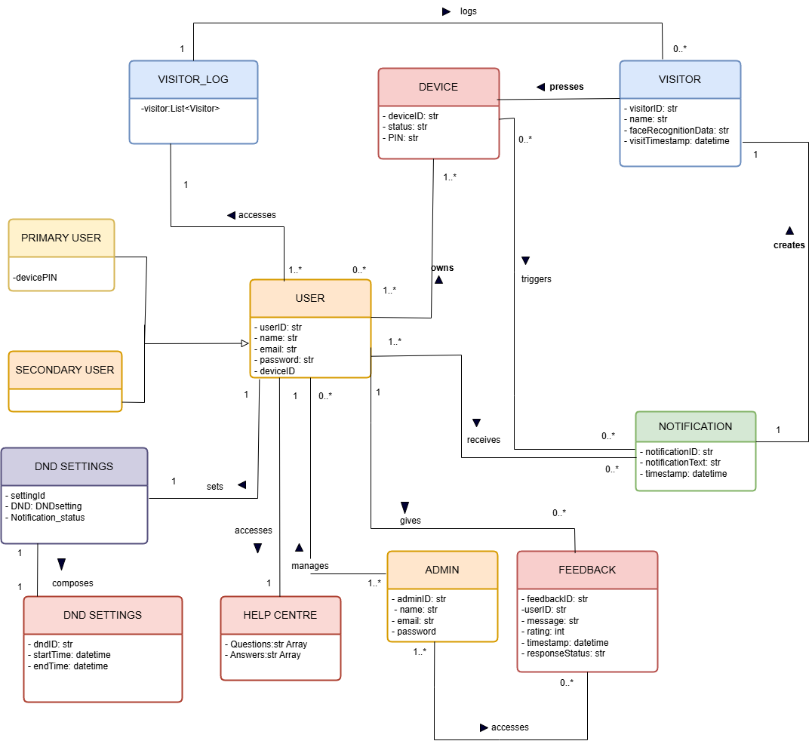

System Sequence Diagram
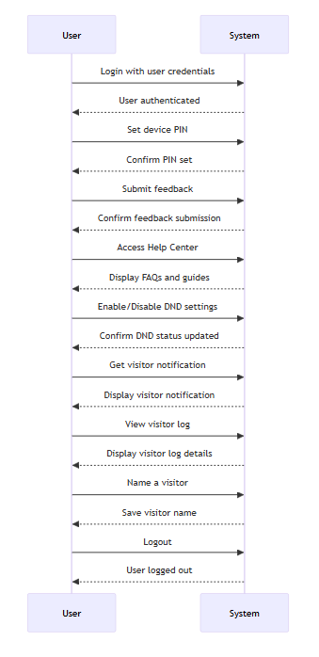

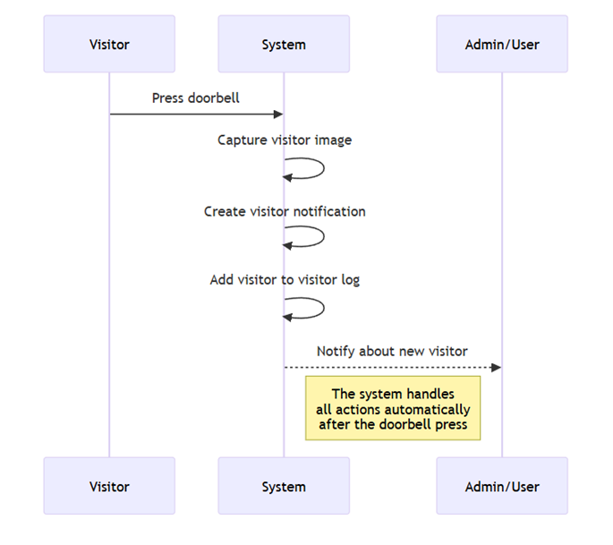

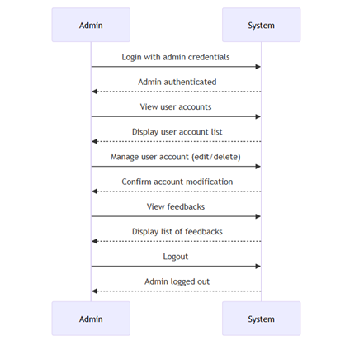

Sequence Diagram
- Visitor History Log:

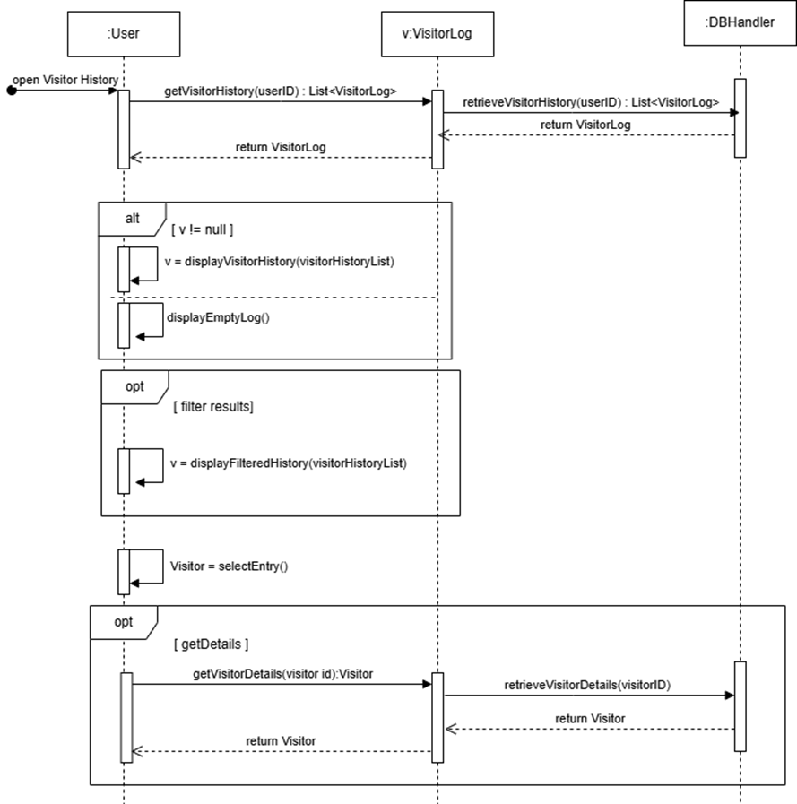

- User Feedback:
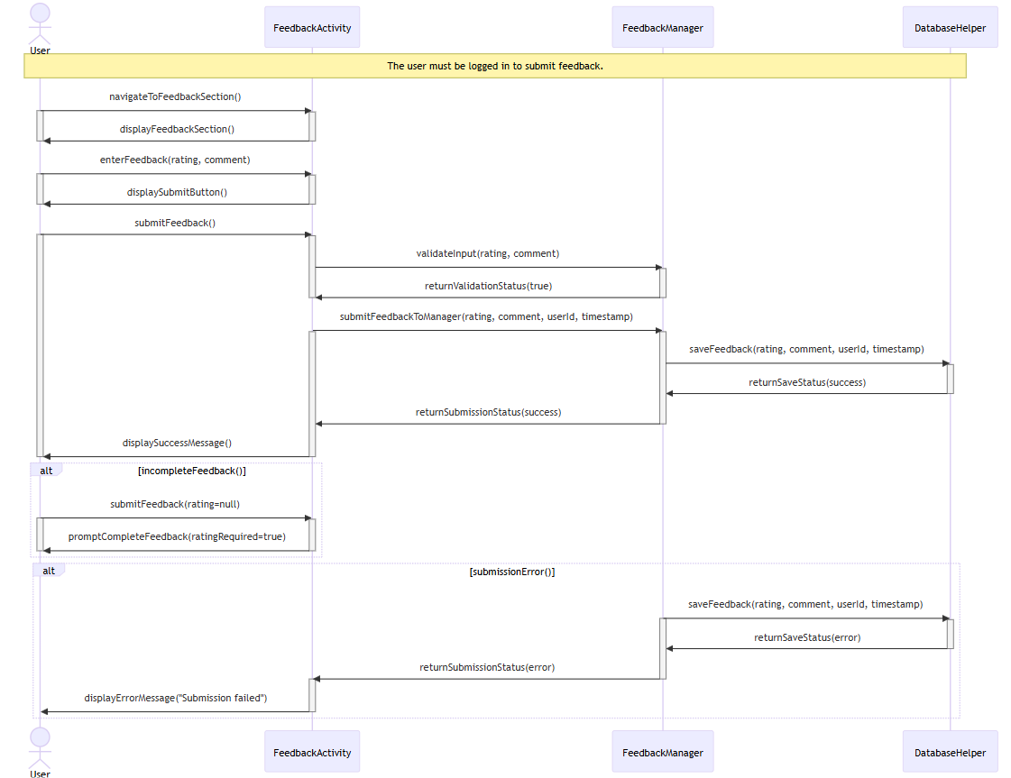

- Manage User Accounts
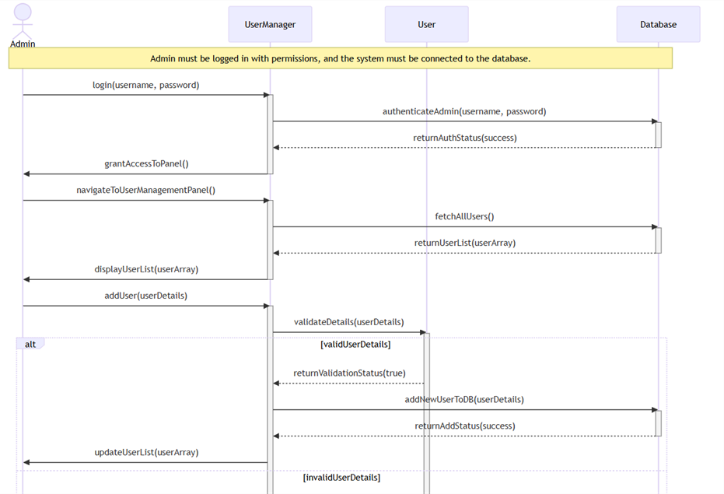

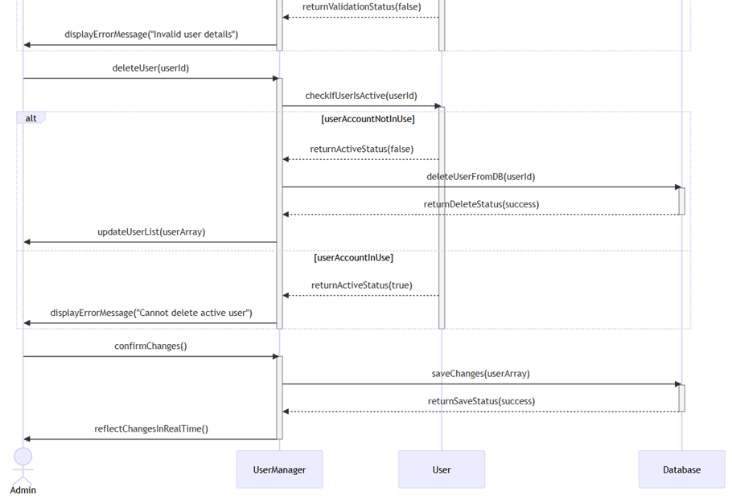

- Visitor Notification
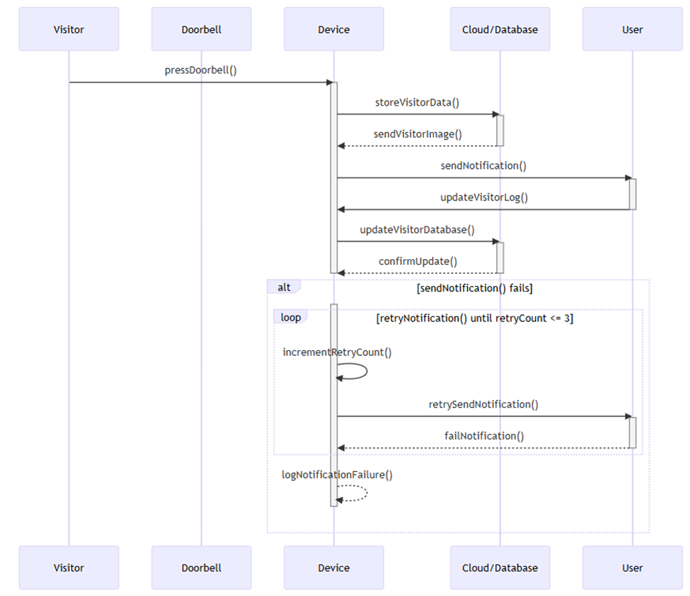

- Set name for Visitor:
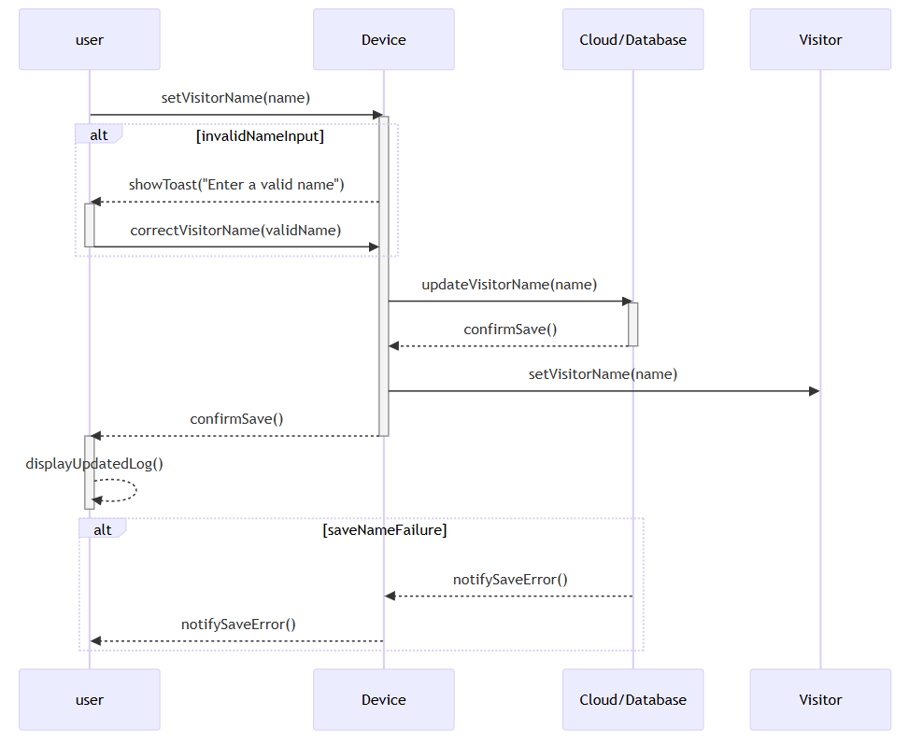

Class Diagram
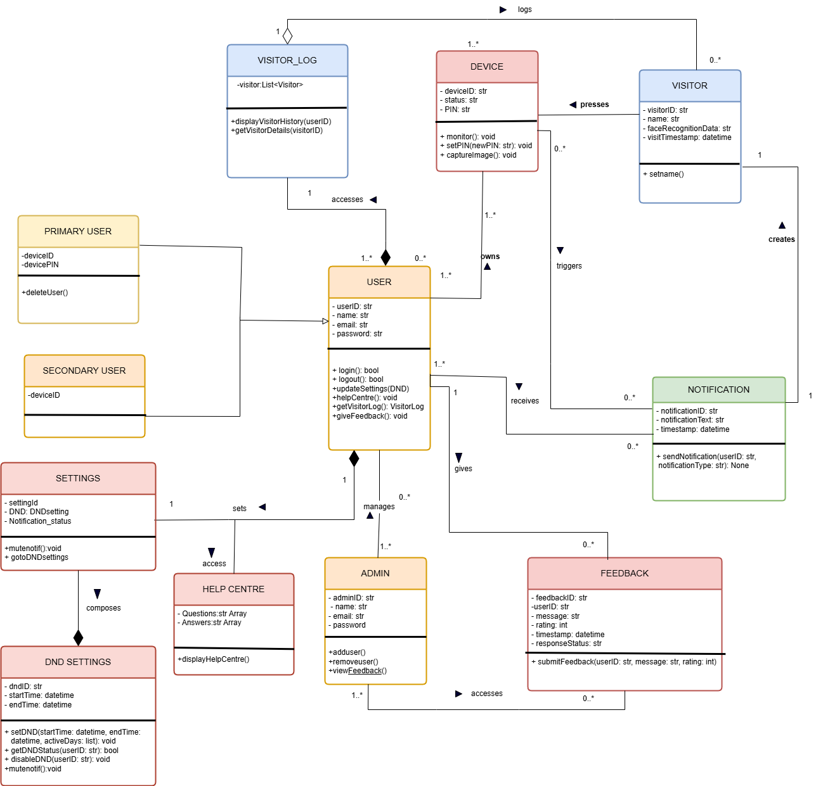

Grasp:
1. Information Expert
- User Management: The User class holds user-specific data such as name, email, and password, making it the information expert in this domain.
- Admin Management: The Admin class manages admin-related operations and holds admin-specific data, acting as an expert in this context.
- Visitor Management: The VisitorView class stores details of a visitor (name, date, etc.), making it the information expert for handling visitor-related data.
- Feedback Management: The Feedback class encapsulates user feedback, including comments and ratings, ensuring it holds all relevant data for feedback functionality.
2. Creator
- User Management: The UserManager class is responsible for creating and managing User instances, ensuring all user data is handled correctly.
- Admin Management: The AdminController is responsible for creating and managing admin accounts and delegating tasks to relevant components.
- Visitor Management: The VisitorManager creates VisitorView objects when fetching and updating visitor data.
- Feedback Management: The FeedbackController creates instances of feedback based on user input.
3. Low Coupling
- The layers of the application are loosely coupled. For example, the UI does not interact directly with Firebase; instead, it communicates with the VisitorController, UserController, and AdminController, ensuring that changes in one class do not require changes in others.
4. High Cohesion
- User Management: The UserManager class focuses only on managing user data, including authentication and updates.
- Admin Management: The AdminController handles only admin-related logic, ensuring that each class is highly cohesive with a single responsibility.
- Visitor Management: The VisitorAdapter binds visitor data to the RecyclerView, and VisitorController manages the visitor-related logic.
- Notification Management: The NotificationManager handles all notification logic, ensuring that the class is highly cohesive.
5. Controller and Facade
- User Management: The UserController handles the flow of data between the UI and the business logic for user-related operations like login and registration.
- Admin Management: The AdminController is responsible for the admin dashboard's logic, managing tasks such as adding, removing, and viewing admin data.
- Visitor Management: The VisitorController acts as the controller between the UI and Firebase for fetching, updating, and displaying visitor data.
- Notification Management: The NotificationController handles the logic of monitoring Firebase for new visitors and triggering notifications via the NotificationManager.
- Design Patterns:
1. Singleton Pattern
- UserManager, AdminManager, NotificationManager: These classes are designed as singletons to ensure only one instance of each exists throughout the app, managing user, admin, and notification data in a consistent manner.
2. MVC (Model-View-Controller) Pattern
- User Management:
  - Model: User class represents user data.
  - View: UserActivity displays the UI for user interactions.
  - Controller: UserController manages business logic for handling user operations.
- Visitor Management:
  - Model: VisitorView represents visitor data.
  - View: Visitors and VisitorDetailsActivity display visitor data.
  - Controller: VisitorController manages the business logic for fetching and updating visitor data.
- Admin Management:
  - Model: Admin class holds admin-related data.
  - View: AdminDashboard displays the admin UI.
  - Controller: AdminController handles admin-specific logic.
- Notification Management:
  - Model: Notification contains notification-related data.
  - View: NotificationActivity displays notifications.
  - Controller: NotificationController handles business logic for notification operations.
3. Adapter Pattern
- Visitor Management: The VisitorAdapter adapts the visitor data (VisitorView objects) to the format suitable for display in a RecyclerView.
- Feedback Management: The FeedbackAdapter adapts feedback data to display it in a list format in the UI.
- User Management: User Adapter adapts User data into a displayable format for the admin UI.
4. Observer Pattern
- Firebase: Firebase itself acts as the observer, notifying the app of changes in the database (e.g., adding a new visitor or updating feedback) using ChildEventListener or ValueEventListener.
- Notification Management: The NotificationManager listens to Firebase changes and updates the notification UI.
5. Callback Pattern
- Visitor Management: The VisitorCallback interface allows asynchronous operations such as fetching visitors or updating a visitor's data, and informs the caller (UI) once the operation completes.
Feedback Management: A similar FeedbackCallback interface allows the feedback system to inform the UI when new feedback is available or when feedback submission is successful
14. Three Tier Architecture
1. UI Layer (Presentation Layer)
- User Management: User activities manage user interactions, such as login, registration, and profile updates.
- Admin Management: Admin pages displays the admin panel, with options to manage users, and feedback.
- Visitor Management: Visitors Activity displays the list of visitors, while VisitorDetails Activity shows detailed information about each visitor.
- Feedback Management: Feedback Activity allows admins to view and manage feedback submitted by users.
2. Business Logic Layer (Application Layer)
- User Management: UserController handles the logic for authenticating and updating user data.
- Admin Management: AdminController manages the business logic related to admin actions such as adding or removing users, and viewing feedback.
- Visitor Management: VisitorController is responsible for managing visitor-related data, including fetching visitor information from Firebase and updating visitor details.
- Notification Management: NotificationController coordinates with NotificationManager to monitor Firebase for new events (e.g., new visitor entries) and send notifications to the UI layer.
3. Data Access Layer (Database Layer)
- User Management: UserManager manages all interactions with Firebase for user data, including authentication and profile updates.
- Admin Management: AdminManager interacts with Firebase to store and manage admin data.
- Visitor Management: VisitorManager interacts with Firebase to fetch, add, update, and delete visitor data.
- Feedback Management: FeedbackManager manages operations for feedback data, interacting with Firebase for real-time data updates.

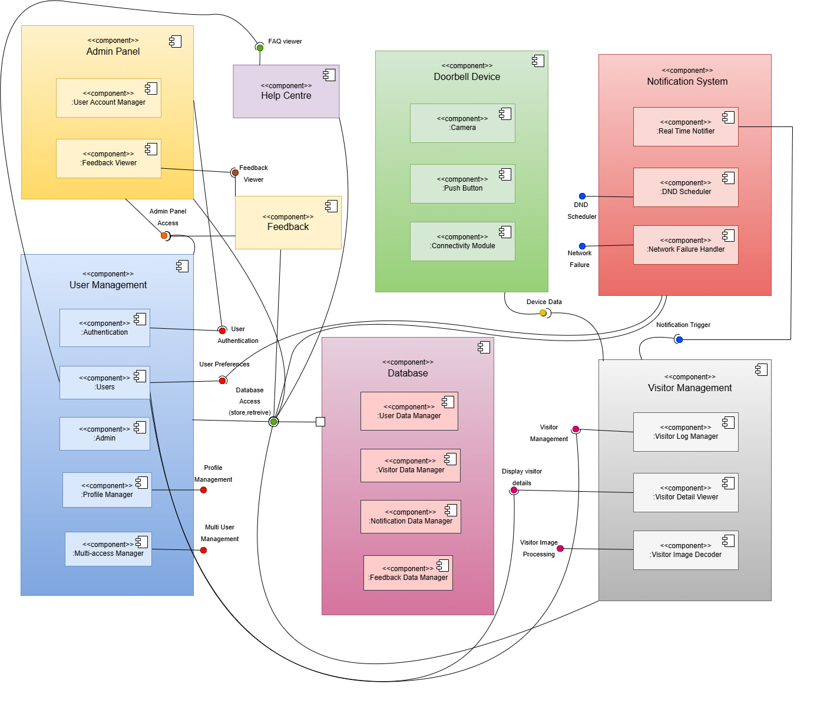
Component Diagram

Package Diagram

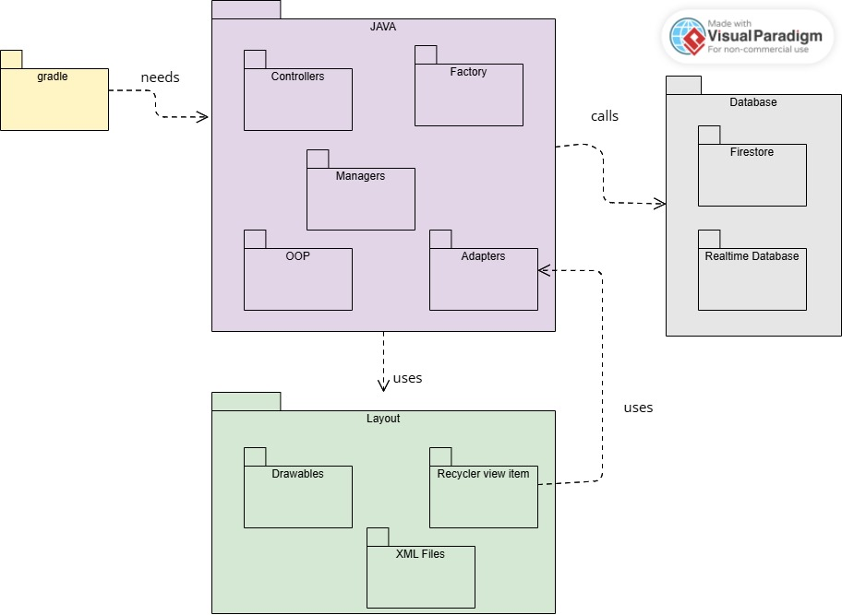

Deployment Diagram

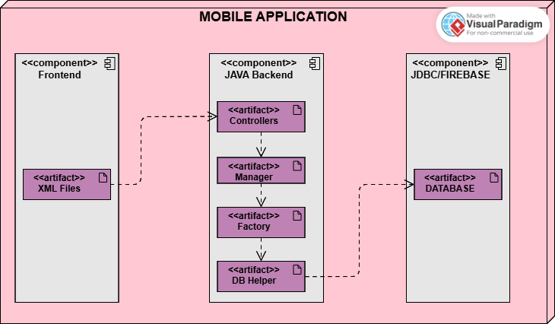

  - Conclusion:
These procedures provides a structured approach for the Smart Knock app, ensuring a seamless user experience through personalized security features. By organizing core functionalities around users, devices, and notifications, the model facilitates efficient home security management tailored to user preferences, ultimately enhancing convenience and safety.

