Emaan Fatima
22i-0869
Info Sec
Assignment#02
Github: https://github.com/emaanfatima118/securechat-skeleton.git

TESTING REPORT

TEST 1: WIRESHARK - ENCRYPTED PAYLOADS
Prove that all communication is encrypted and no plaintext passwords or messages are visible on the wire.
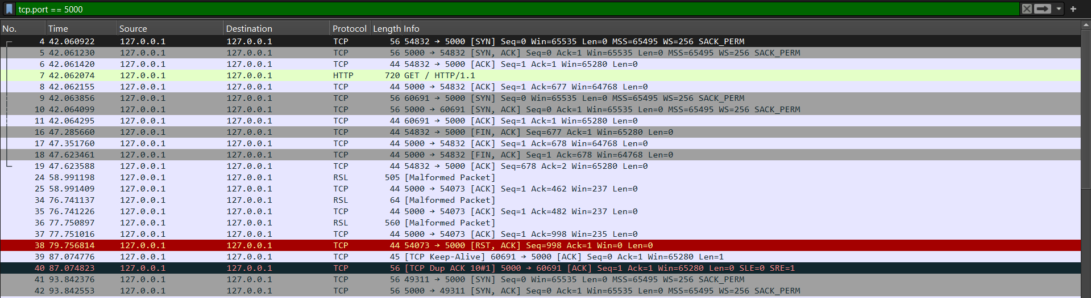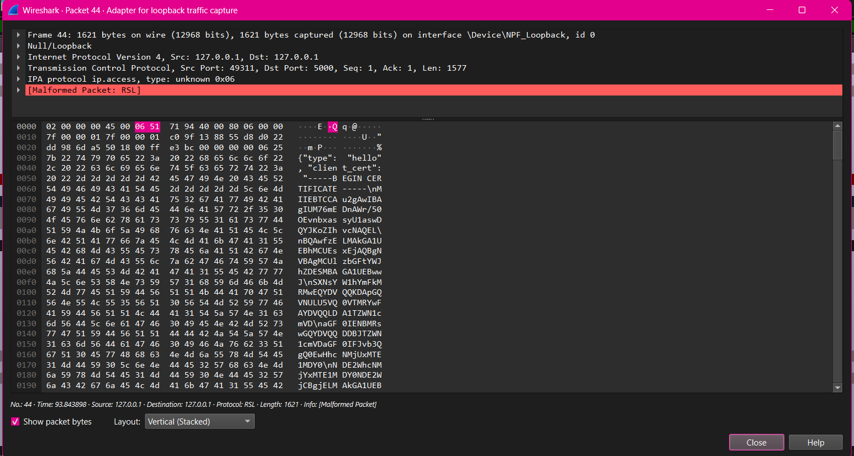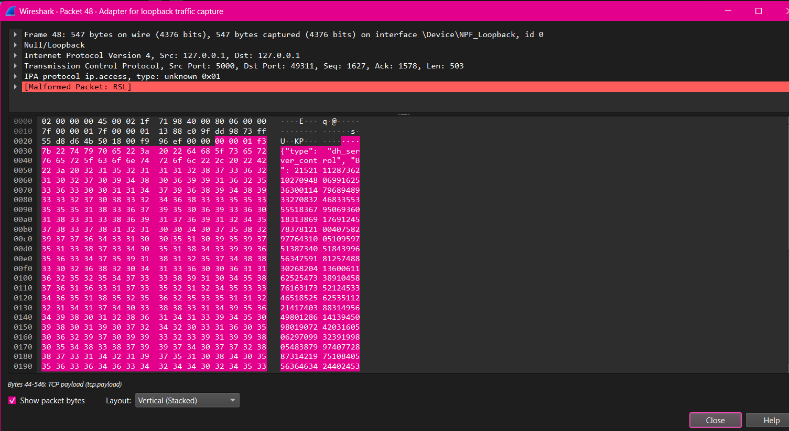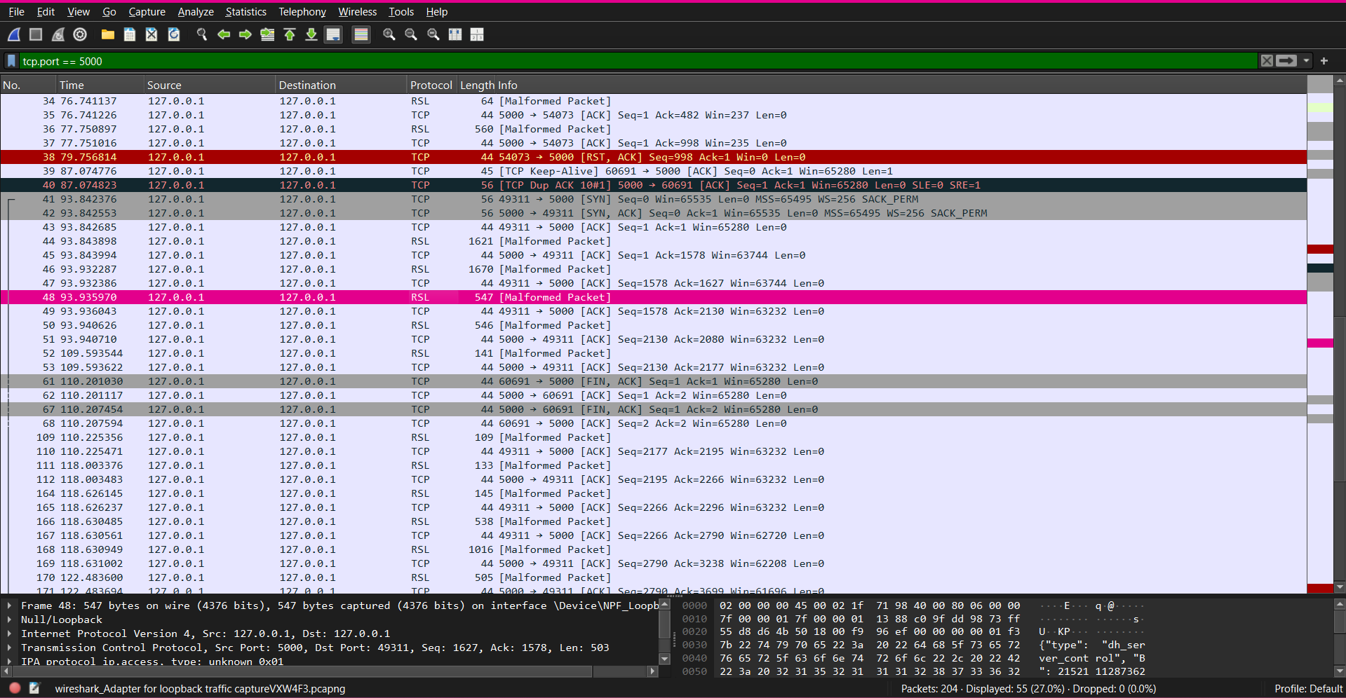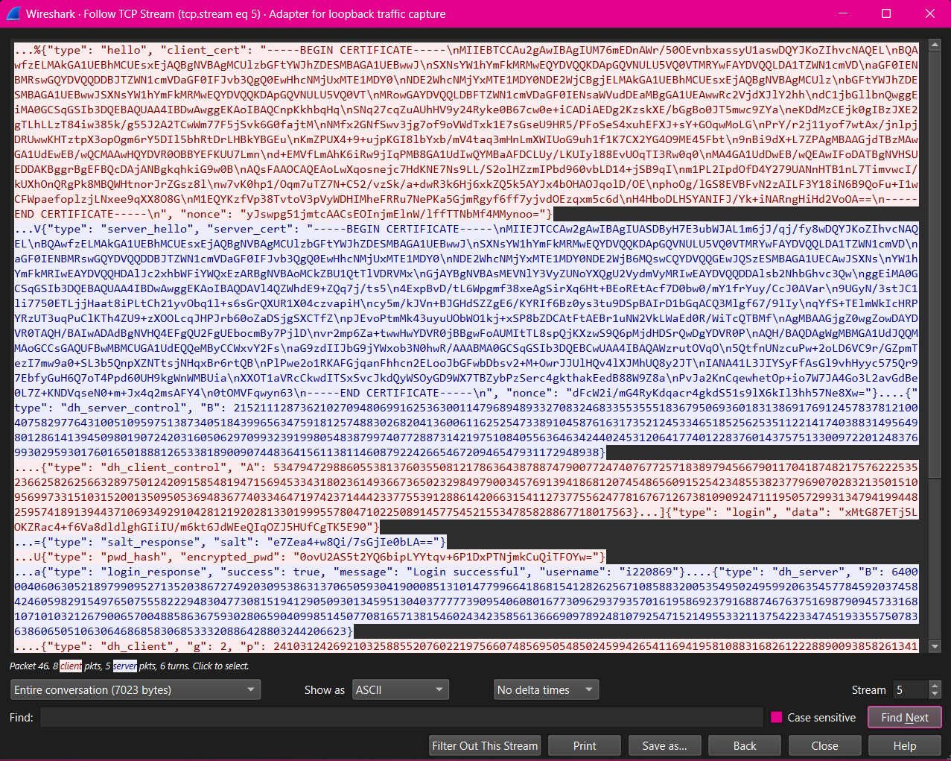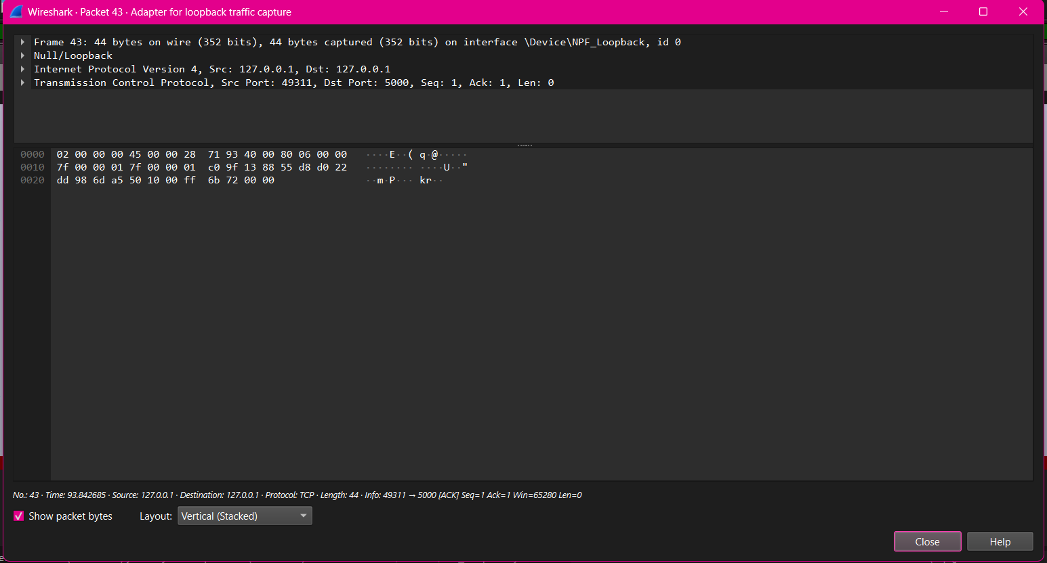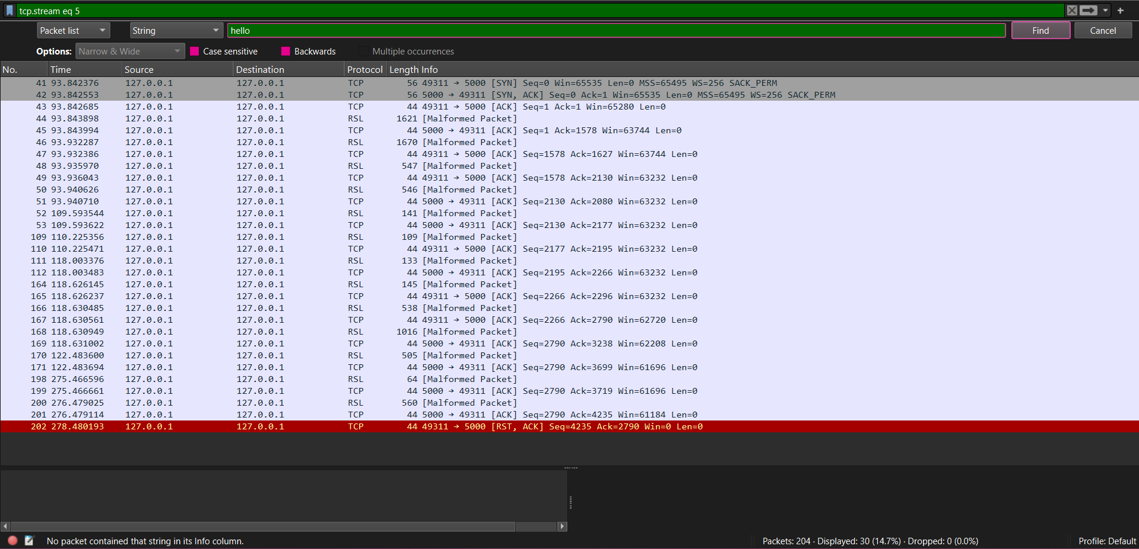

The above screenshot shows that no packet contained the searched plaintext “hello” in the content.

TEST 2: INVALID CERTIFICATE TESTS

Part a: Self-signed Certificate

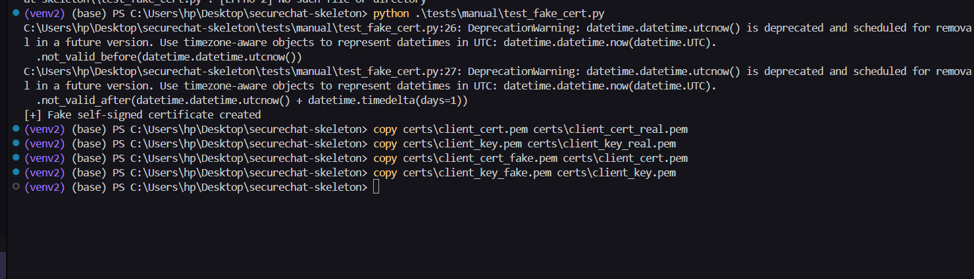
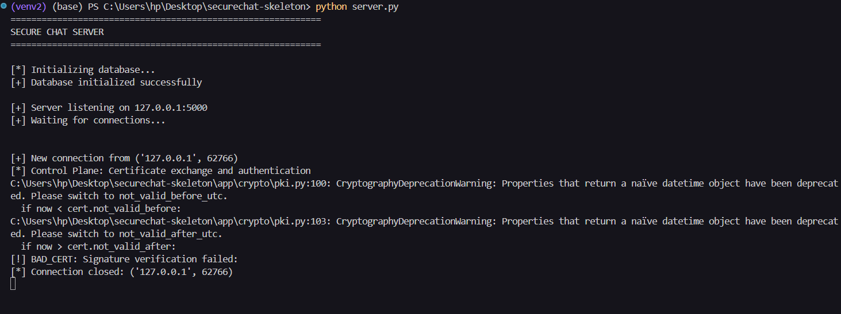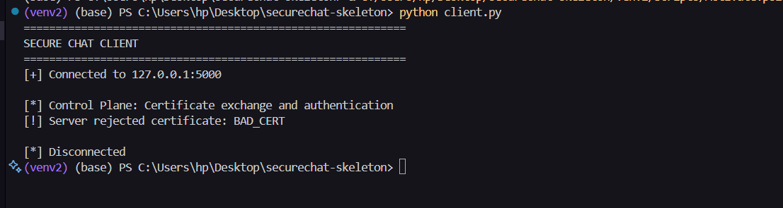
Part b: Expired Certificate
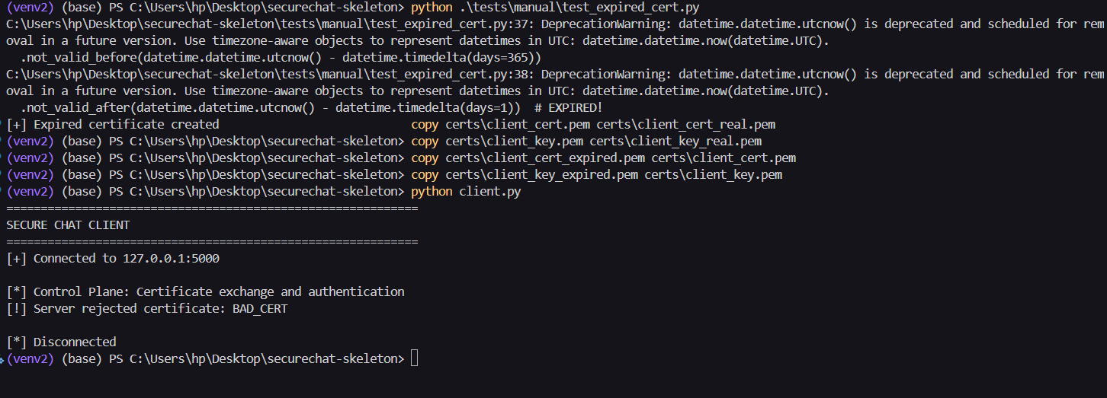
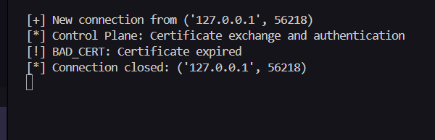

TEST 3: MESSAGE TAMPERING DETECTION
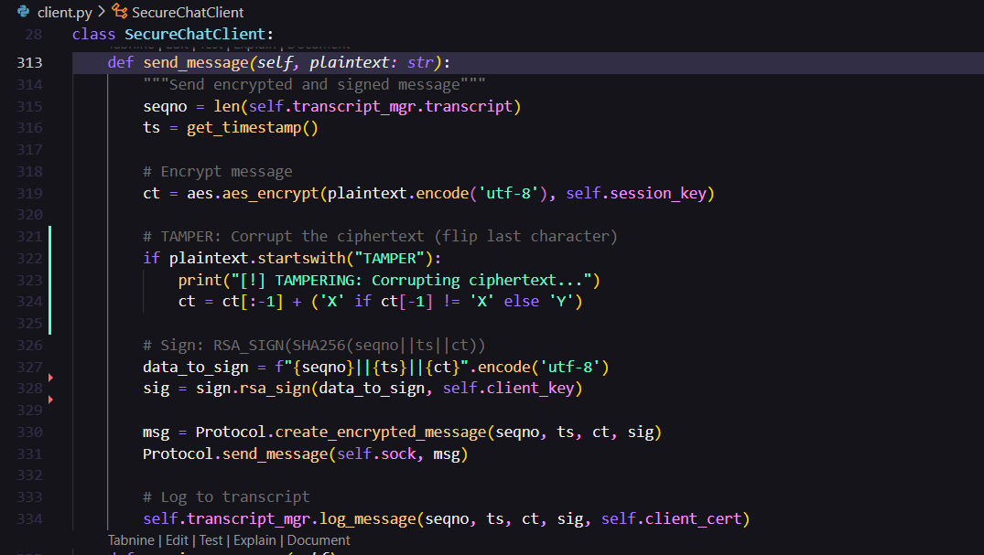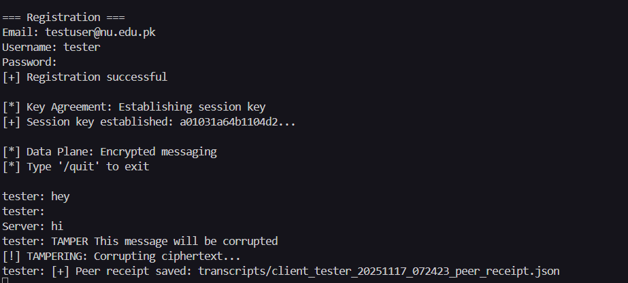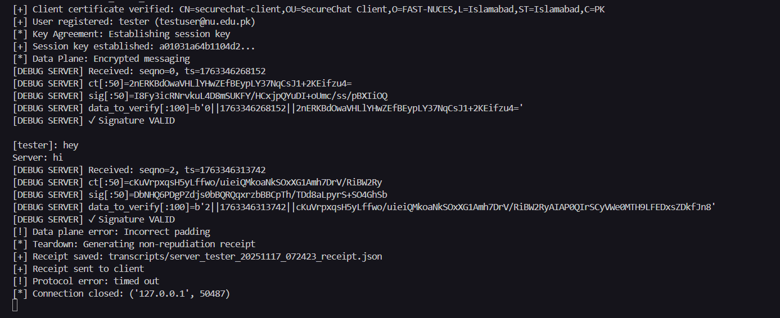

TEST 4: REPLAY ATTACK PREVENTION
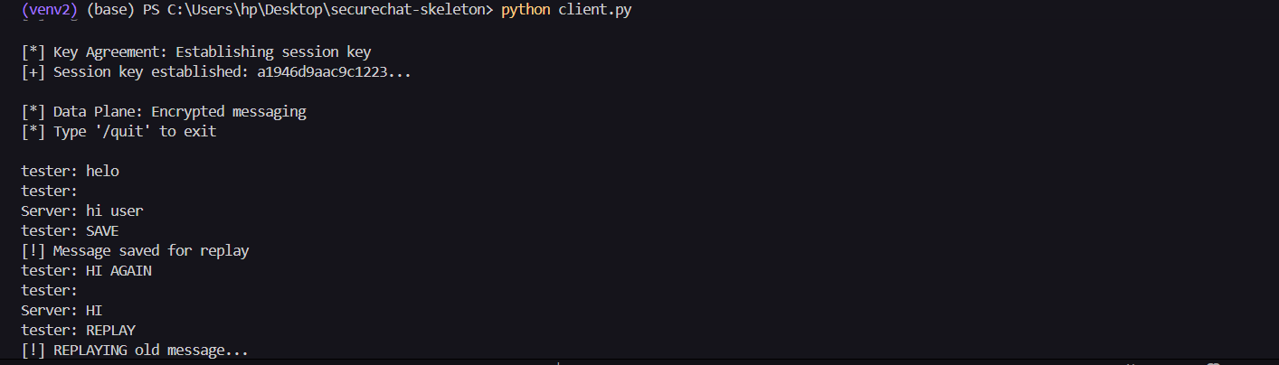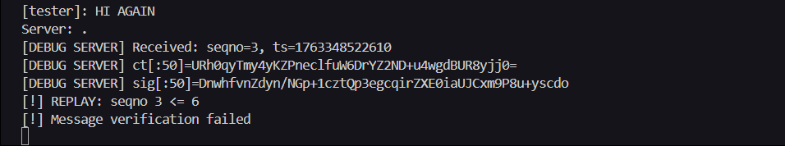

TEST 5: NON-REPUDIATION VERIFICATION

Part a: Correct

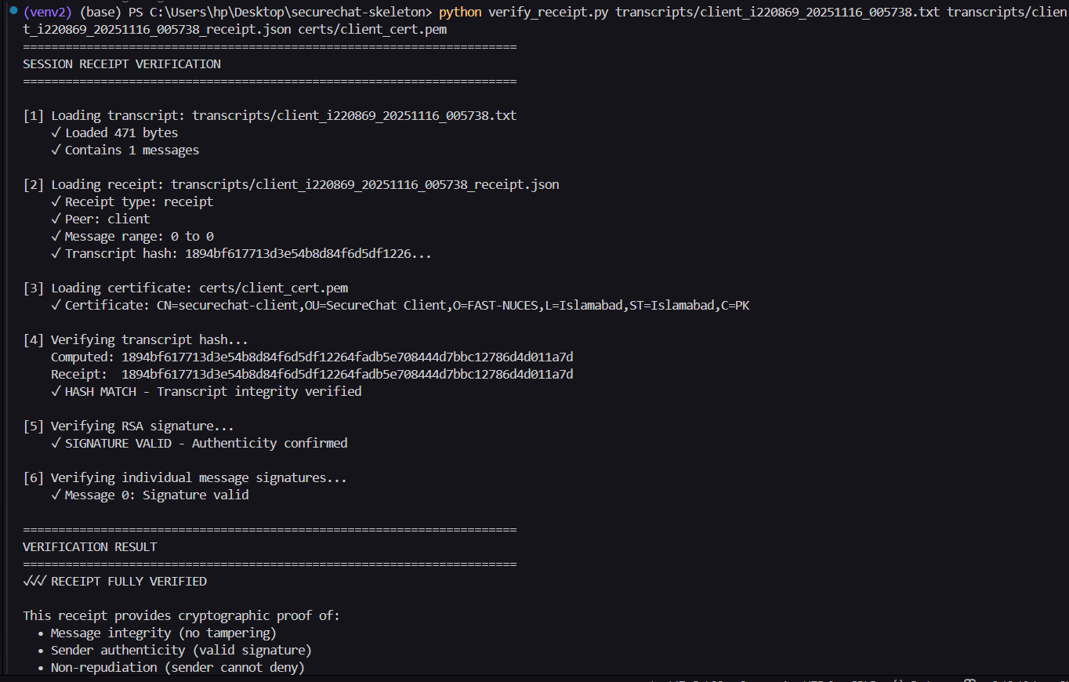

Part b: tampered txt
