DevOps Project
Exploring Current and Future Testing & Observability Needs

22F-3640 Emaan Fatima
22F-3629 Malaika Naveed

1. Introduction to OpenTelemetry
OpenTelemetry (OTel) is a Cloud Native Computing Foundation (CNCF) project that provides a vendor-neutral, open-source framework for collecting telemetry data such as metrics, traces, and logs from applications and infrastructure. It has rapidly become the industry standard for observability in modern software systems.

2. Why OpenTelemetry? The Problem It Solves

2.1 The Observability Gap
Before OpenTelemetry, a typical production issue looked like this:
- User reports the app is slow
- Developer checks Tomcat access logs — sees 500ms response times
- Developer cannot tell if it is a JVM memory issue, a slow database, or high CPU
- Developer must manually correlate logs from 3 different tools
- Root cause takes hours to find

With OpenTelemetry:
- Every HTTP request is automatically timed and counted
- JVM heap memory, GC pauses, thread counts are auto-collected
- All data flows into a single observability backend (Prometheus + Grafana)
- Root cause is visible on a dashboard in real time

3. The Three Pillars of Observability

METRICS | TRACES | LOGS
Numeric measurements over time | Request flow across services | Timestamped event records
CPU, memory, request count | Which service took how long | Errors, warnings, info
Used in this project via Prometheus | Available via Jaeger/Zipkin | Available via stdout/file
Visualized in Grafana | Shows distributed call path | Searchable via ELK Stack

In this project we focus on Metrics — the most critical pillar for a DevOps CI/CD pipeline where performance monitoring and alerting are the primary goals.

4. Project Architecture & Workflow Diagram

4.1 Full Pipeline Architecture

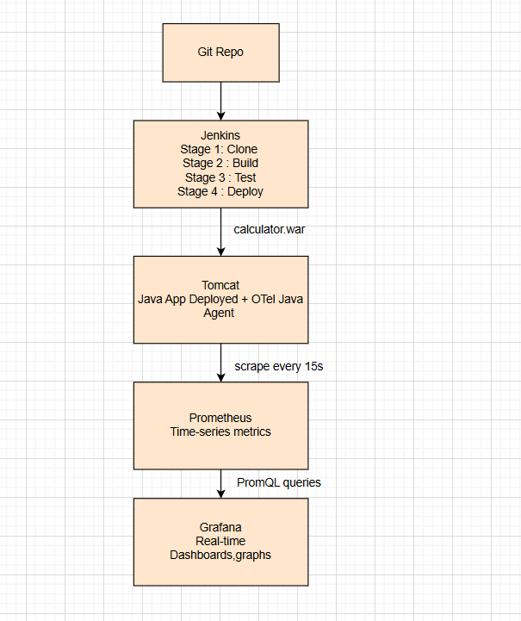

4.2 How OpenTelemetry Fits In
WITHOUT OpenTelemetry:
Tomcat ──► access_log.txt (text file, manual reading)

WITH OpenTelemetry Java Agent:
Tomcat ──► OTel Agent ──► :9464/metrics ──► Prometheus ──► Grafana

5. OpenTelemetry vs Traditional Monitoring

Feature | Without OTel (Tomcat Logs) | With OpenTelemetry
Data Format | Plain text (.txt log files) | Structured numeric metrics
Real-time? | No — logs written after the fact | Yes — scraped every 15 seconds
Queryable? | No — manual grep/search only | Yes — full PromQL query language
Visualizable? | No — raw text only | Yes — Grafana dashboards & graphs
Alerting? | No | Yes — Grafana alert rules
JVM Internals? | No — Tomcat does not expose JVM | Yes — memory, GC, threads, CPU
Vendor Neutral? | No — Tomcat specific | Yes — works on AWS, Azure, GCP
Code Changes? | N/A | Zero — purely agent-based

6. Current & Future Testing Needs — Why OTel Is the Answer

6.1 Current Industry Trend
According to the CNCF Annual Survey 2024, OpenTelemetry is the second most active CNCF project after Kubernetes. Over 70% of organizations using microservices have adopted or are evaluating OpenTelemetry as their observability standard.

6.2 Current Testing Needs OTel Addresses
- Performance Testing — measure real response times under load, not synthetic tests
- Continuous Monitoring — integrate with CI/CD so every deployment is automatically monitored
- SLA Verification — prove that response time is under 200ms using real metrics
- Regression Detection — compare metrics before and after a deployment
- Capacity Planning — use JVM memory trends to predict when to scale

6.3 Future Trends
- AI-Powered Observability — OTel data fed into ML models to predict failures before they happen
- eBPF Integration — kernel-level instrumentation without any agent overhead
- OpenTelemetry Logs — completing the three-pillar vision (metrics + traces + logs unified)
- Continuous Profiling — line-level CPU profiling integrated directly into OTel
- Auto-Remediation — Grafana alerts trigger Jenkins pipelines to auto-rollback bad deployments

7. Complete Tool Stack Summary

Tool | Port | Role | Integration
GitHub | N/A | Source code repository | Jenkins pulls from here
Jenkins | 8080 | CI/CD pipeline engine | Builds WAR, deploys to Tomcat
Maven | N/A | Java build tool | Compiles code, runs tests
Tomcat 9 | 8081 | Java app server | Hosts calculator WAR
OTel Agent | 9464 | Auto-instrumentation | Attaches to Tomcat JVM
Prometheus | 9090 | Metrics database | Scrapes OTel endpoint
Grafana | 3000 | Visualization | Dashboards from Prometheus

8. Conclusion
OpenTelemetry represents the future of software observability. In this project, we demonstrated that a Java web application deployed through a complete DevOps pipeline (GitHub → Jenkins → Tomcat) can be fully instrumented for production-grade monitoring with zero lines of application code changed.

The key takeaway is that OpenTelemetry bridges the gap between DevOps and observability. While Jenkins handles the deployment pipeline, OpenTelemetry ensures that every deployment is monitored, every API call is counted, and every performance degradation is visible in real time through Grafana dashboards.

