Assignment 3: Data Exploration

Emily McNamara

## OVERVIEW

This exercise accompanies the lessons in Environmental Data Analytics on Data Exploration.

## Directions

1. Change “Student Name” on line 3 (above) with your name.
2. Work through the steps, **creating code and output** that fulfill each instruction.
3. Be sure to **answer the questions** in this assignment document.
4. When you have completed the assignment, **Knit** the text and code into a single PDF file.
5. After Knitting, submit the completed exercise (PDF file) to the dropbox in Sakai. Add your last name into the file name (e.g., “Salk_A03_DataExploration.Rmd”) prior to submission.

The completed exercise is due on Tuesday, January 28 at 1:00 pm.

## Set up your R session

1. Check your working directory, load necessary packages (tidyverse), and upload two datasets: the ECOTOX neonicotinoid dataset (ECOTOX_Neonicotinoids_Insects_raw.csv) and the Niwot Ridge NEON dataset for litter and woody debris (NEON_NIWO_Litter_massdata_2018-08_raw.csv). Name these datasets “Neonics” and “Litter”, respectively.

getwd()

## [1] "/Users/emilymcnamara/Desktop/Env Data Analytics/Environmental_Data_Analytics_2020"

# Load Packages  
suppressMessages(library(tidyverse))  
  
# Datasets  
  
Neonics <- read.csv("./Data/Raw/ECOTOX_Neonicotinoids_Insects_raw.csv")  
  
  
Litter <- read.csv("./Data/Raw/NEON_NIWO_Litter_massdata_2018-08_raw.csv")

## Learn about your system

1. The neonicotinoid dataset was collected from the Environmental Protection Agency’s ECOTOX Knowledgebase, a database for ecotoxicology research. Neonicotinoids are a class of insecticides used widely in agriculture. The dataset that has been pulled includes all studies published on insects. Why might we be interested in the ecotoxicologoy of neonicotinoids on insects? Feel free to do a brief internet search if you feel you need more background information.

Answer: Neonicotinoids can accumulate in soils when used repeatedly and can remain in woody plants well after a year. Understanding the longevity of neonics and how they are absorbed in plants is important because of the affects these pesticides have on honey bees and native bees. Because the synthetic chemical is absorbed into the plant, it can be found in pollen and nectar, which has a toxic effect on pollinators that feed on them.

1. The Niwot Ridge litter and woody debris dataset was collected from the National Ecological Observatory Network, which collectively includes 81 aquatic and terrestrial sites across 20 ecoclimatic domains. 32 of these sites sample forest litter and woody debris, and we will focus on the Niwot Ridge long-term ecological research (LTER) station in Colorado. Why might we be interested in studying litter and woody debris that falls to the ground in forests? Feel free to do a brief internet search if you feel you need more background information.

Answer: Studying litter and woody debris that falls to the ground in forests can provide information on fire risk as well as the micro- and macroorganisms that feed on the accumulated biomass. This research can also inform scientists of the carbon sequestration occuring in the forest.

1. How is litter and woody debris sampled as part of the NEON network? Read the NEON_Litterfall_UserGuide.pdf document to learn more. List three pieces of salient information about the sampling methods here:

Answer: * Litter and fine woody debris are collected from elevated and ground traps, respectively. * Litt􏰀er and fine woody debris sampling is executed at terrestrial NEON sites that contain woody vegeta􏰁on >2m tall. Along with most of NEON’s plant produc􏰁vity measurements, sampling for this product occurs only in tower plots. * In sites with forested tower airsheds, the litter sampling is targeted to take place in 20 40m x 40m plots. In sites with low-saturated vegitation, litter sampling is targeted to take place in 26 20m x 20m plots. * Ground traps are sampled once per year.

## Obtain basic summaries of your data (Neonics)

1. What are the dimensions of the dataset?

dim(Neonics)

## [1] 4623 30

# The dimensions of the Neonics dataset are 4623 by 30

1. Using the summary function, determine the most common effects that are studied. Why might these effects specifically be of interest?

summary(Neonics)

## CAS.Number   
## Min. : 58842209   
## 1st Qu.:138261413   
## Median :138261413   
## Mean :147651982   
## 3rd Qu.:153719234   
## Max. :210880925   
##   
## Chemical.Name   
## (2E)-1-[(6-Chloro-3-pyridinyl)methyl]-N-nitro-2-imidazolidinimine :2658   
## 3-[(2-Chloro-5-thiazolyl)methyl]tetrahydro-5-methyl-N-nitro-4H-1,3,5-oxadiazin-4-imine: 686   
## [C(E)]-N-[(2-Chloro-5-thiazolyl)methyl]-N'-methyl-N''-nitroguanidine : 452   
## (1E)-N-[(6-Chloro-3-pyridinyl)methyl]-N'-cyano-N-methylethanimidamide : 420   
## N''-Methyl-N-nitro-N'-[(tetrahydro-3-furanyl)methyl]guanidine : 218   
## [N(Z)]-N-[3-[(6-Chloro-3-pyridinyl)methyl]-2-thiazolidinylidene]cyanamide : 128   
## (Other) : 61   
## Chemical.Grade  
## Not reported :3989   
## Technical grade, technical product, technical formulation: 422   
## Pestanal grade : 93   
## Not coded : 53   
## Commercial grade : 27   
## Analytical grade : 15   
## (Other) : 24   
## Chemical.Analysis.Method  
## Measured : 230   
## Not coded : 51   
## Not reported : 5   
## Unmeasured :4321   
## Unmeasured values (some measured values reported in article): 16   
##   
##   
## Chemical.Purity Species.Scientific.Name  
## NR :2502 Apis mellifera : 667   
## 25 : 244 Bombus terrestris : 183   
## 50 : 200 Apis mellifera ssp. carnica : 152   
## 20 : 189 Bombus impatiens : 140   
## 70 : 112 Apis mellifera ssp. ligustica: 113   
## 75 : 89 Popillia japonica : 94   
## (Other):1287 (Other) :3274   
## Species.Common.Name  
## Honey Bee : 667   
## Parasitic Wasp : 285   
## Buff Tailed Bumblebee: 183   
## Carniolan Honey Bee : 152   
## Bumble Bee : 140   
## Italian Honeybee : 113   
## (Other) :3083   
## Species.Group   
## Insects/Spiders :3569   
## Insects/Spiders; Standard Test Species : 27   
## Insects/Spiders; Standard Test Species; U.S. Invasive Species: 667   
## Insects/Spiders; U.S. Invasive Species : 360   
##   
##   
##   
## Organism.Lifestage Organism.Age Organism.Age.Units  
## Not reported:2271 NR :3851 Not reported :3515   
## Adult :1222 2 : 111 Day(s) : 327   
## Larva : 437 3 : 105 Instar : 255   
## Multiple : 285 <24 : 81 Hour(s) : 241   
## Egg : 128 4 : 81 Hours post-emergence: 99   
## Pupa : 69 1 : 59 Year(s) : 64   
## (Other) : 211 (Other): 335 (Other) : 122   
## Exposure.Type Media.Type   
## Environmental, unspecified:1599 No substrate:2934   
## Food :1124 Not reported: 663   
## Spray : 393 Natural soil: 393   
## Topical, general : 254 Litter : 264   
## Ground granular : 249 Filter paper: 230   
## Hand spray : 210 Not coded : 51   
## (Other) : 794 (Other) : 88   
## Test.Location Number.of.Doses Conc.1.Type..Author.  
## Field artificial : 96 2 :2441 Active ingredient:3161   
## Field natural :1663 3 : 499 Formulation :1420   
## Field undeterminable: 4 5 : 314 Not coded : 42   
## Lab :2860 6 : 230   
## 4 : 221   
## NR : 217   
## (Other): 701   
## Conc.1..Author. Conc.1.Units..Author. Effect   
## 0.37/ : 208 AI kg/ha : 575 Population :1803   
## 10/ : 127 AI mg/L : 298 Mortality :1493   
## NR/ : 108 AI lb/acre: 277 Behavior : 360   
## NR : 94 AI g/ha : 241 Feeding behavior: 255   
## 1 : 82 ng/org : 231 Reproduction : 197   
## 1023 : 80 ppm : 180 Development : 136   
## (Other):3924 (Other) :2821 (Other) : 379   
## Effect.Measurement Endpoint Response.Site   
## Abundance :1699 NOEL :1816 Not reported :4349   
## Mortality :1294 LOEL :1664 Midgut or midgut gland: 63   
## Survival : 133 LC50 : 327 Not coded : 51   
## Progeny counts/numbers: 120 LD50 : 274 Whole organism : 41   
## Food consumption : 103 NR : 167 Hypopharyngeal gland : 27   
## Emergence : 98 NR-LETH: 86 Head : 23   
## (Other) :1176 (Other): 289 (Other) : 69   
## Observed.Duration..Days. Observed.Duration.Units..Days.  
## 1 : 713 Day(s) :4394   
## 2 : 383 Emergence : 70   
## NR : 355 Growing season : 48   
## 7 : 207 Day(s) post-hatch : 20   
## 3 : 183 Day(s) post-emergence: 17   
## 0.0417 : 133 Tiller stage : 15   
## (Other):2649 (Other) : 59   
## Author   
## Peck,D.C. : 208   
## Frank,S.D. : 100   
## El Hassani,A.K., M. Dacher, V. Gary, M. Lambin, M. Gauthier, and C. Armengaud: 96   
## Williamson,S.M., S.J. Willis, and G.A. Wright : 93   
## Laurino,D., A. Manino, A. Patetta, and M. Porporato : 88   
## Scholer,J., and V. Krischik : 82   
## (Other) :3956   
## Reference.Number  
## Min. : 344   
## 1st Qu.:108459   
## Median :165559   
## Mean :142189   
## 3rd Qu.:168998   
## Max. :180410   
##   
## Title   
## Long-Term Effects of Imidacloprid on the Abundance of Surface- and Soil-Active Nontarget Fauna in Turf : 200   
## Reduced Risk Insecticides to Control Scale Insects and Protect Natural Enemies in the Production and Maintenance of Urban Landscape Plants: 100   
## Effects of Sublethal Doses of Acetamiprid and Thiamethoxam on the Behavior of the Honeybee (Apis mellifera) : 96   
## Exposure to Neonicotinoids Influences the Motor Function of Adult Worker Honeybees : 93   
## Toxicity of Neonicotinoid Insecticides on Different Honey Bee Genotypes : 88   
## Chronic Exposure of Imidacloprid and Clothianidin Reduce Queen Survival, Foraging, and Nectar Storing in Colonies of Bombus impatiens : 82   
## (Other) :3964   
## Source Publication.Year  
## Agric. For. Entomol.11(4): 405-419 : 200 Min. :1982   
## Environ. Entomol.41(2): 377-386 : 100 1st Qu.:2005   
## Arch. Environ. Contam. Toxicol.54(4): 653-661: 96 Median :2010   
## Ecotoxicology23:1409-1418 : 93 Mean :2008   
## Bull. Insectol.66(1): 119-126 : 88 3rd Qu.:2013   
## PLoS One9(3): 14 p. : 82 Max. :2019   
## (Other) :3964   
## Summary.of.Additional.Parameters   
## Purity: \xca NR - NR | Organism Age: \xca NR - NR Not reported | Conc 1 (Author): \xca Active ingredient NR/ - NR/ AI kg/ha | Duration (Days): \xca NR - NR NR | Conc 2 (Author): \xca NR (NR - NR) NR | Conc 3 (Author): \xca NR (NR - NR) NR : 389   
## Purity: \xca NR - NR | Organism Age: \xca NR - NR Not reported | Conc 1 (Author): \xca Active ingredient NR - NR AI lb/acre | Duration (Days): \xca NR - NR NR | Conc 2 (Author): \xca NR (NR - NR) NR | Conc 3 (Author): \xca NR (NR - NR) NR : 138   
## Purity: \xca NR - NR | Organism Age: \xca NR - NR Not reported | Conc 1 (Author): \xca Active ingredient NR - NR AI kg/ha | Duration (Days): \xca NR - NR NR | Conc 2 (Author): \xca NR (NR - NR) NR | Conc 3 (Author): \xca NR (NR - NR) NR : 136   
## Purity: \xca NR - NR | Organism Age: \xca NR - NR Not reported | Conc 1 (Author): \xca Active ingredient NR/ - NR/ AI lb/acre | Duration (Days): \xca NR - NR NR | Conc 2 (Author): \xca NR (NR - NR) NR | Conc 3 (Author): \xca NR (NR - NR) NR: 124   
## Purity: \xca NR - NR | Organism Age: \xca NR - NR Not reported | Conc 1 (Author): \xca Active ingredient NR - NR AI ng/org | Duration (Days): \xca NR - NR NR | Conc 2 (Author): \xca NR (NR - NR) NR | Conc 3 (Author): \xca NR (NR - NR) NR : 94   
## Purity: \xca NR - NR | Organism Age: \xca NR - NR Not reported | Conc 1 (Author): \xca Formulation NR - NR ml/ha | Duration (Days): \xca NR - NR NR | Conc 2 (Author): \xca NR (NR - NR) NR | Conc 3 (Author): \xca NR (NR - NR) NR : 80   
## (Other) :3662

Answer: The most common effects studied are abundance and mortality. These effects might be of specific interest because the researcher may be trying to analyze how neonics affect the survival and death rates of different insects and pollinators populations during various stages of development.

1. Using the summary function, determine the six most commonly studied species in the dataset (common name). What do these species have in common, and why might they be of interest over other insects? Feel free to do a brief internet search for more information if needed.

summary(Neonics)

## CAS.Number   
## Min. : 58842209   
## 1st Qu.:138261413   
## Median :138261413   
## Mean :147651982   
## 3rd Qu.:153719234   
## Max. :210880925   
##   
## Chemical.Name   
## (2E)-1-[(6-Chloro-3-pyridinyl)methyl]-N-nitro-2-imidazolidinimine :2658   
## 3-[(2-Chloro-5-thiazolyl)methyl]tetrahydro-5-methyl-N-nitro-4H-1,3,5-oxadiazin-4-imine: 686   
## [C(E)]-N-[(2-Chloro-5-thiazolyl)methyl]-N'-methyl-N''-nitroguanidine : 452   
## (1E)-N-[(6-Chloro-3-pyridinyl)methyl]-N'-cyano-N-methylethanimidamide : 420   
## N''-Methyl-N-nitro-N'-[(tetrahydro-3-furanyl)methyl]guanidine : 218   
## [N(Z)]-N-[3-[(6-Chloro-3-pyridinyl)methyl]-2-thiazolidinylidene]cyanamide : 128   
## (Other) : 61   
## Chemical.Grade  
## Not reported :3989   
## Technical grade, technical product, technical formulation: 422   
## Pestanal grade : 93   
## Not coded : 53   
## Commercial grade : 27   
## Analytical grade : 15   
## (Other) : 24   
## Chemical.Analysis.Method  
## Measured : 230   
## Not coded : 51   
## Not reported : 5   
## Unmeasured :4321   
## Unmeasured values (some measured values reported in article): 16   
##   
##   
## Chemical.Purity Species.Scientific.Name  
## NR :2502 Apis mellifera : 667   
## 25 : 244 Bombus terrestris : 183   
## 50 : 200 Apis mellifera ssp. carnica : 152   
## 20 : 189 Bombus impatiens : 140   
## 70 : 112 Apis mellifera ssp. ligustica: 113   
## 75 : 89 Popillia japonica : 94   
## (Other):1287 (Other) :3274   
## Species.Common.Name  
## Honey Bee : 667   
## Parasitic Wasp : 285   
## Buff Tailed Bumblebee: 183   
## Carniolan Honey Bee : 152   
## Bumble Bee : 140   
## Italian Honeybee : 113   
## (Other) :3083   
## Species.Group   
## Insects/Spiders :3569   
## Insects/Spiders; Standard Test Species : 27   
## Insects/Spiders; Standard Test Species; U.S. Invasive Species: 667   
## Insects/Spiders; U.S. Invasive Species : 360   
##   
##   
##   
## Organism.Lifestage Organism.Age Organism.Age.Units  
## Not reported:2271 NR :3851 Not reported :3515   
## Adult :1222 2 : 111 Day(s) : 327   
## Larva : 437 3 : 105 Instar : 255   
## Multiple : 285 <24 : 81 Hour(s) : 241   
## Egg : 128 4 : 81 Hours post-emergence: 99   
## Pupa : 69 1 : 59 Year(s) : 64   
## (Other) : 211 (Other): 335 (Other) : 122   
## Exposure.Type Media.Type   
## Environmental, unspecified:1599 No substrate:2934   
## Food :1124 Not reported: 663   
## Spray : 393 Natural soil: 393   
## Topical, general : 254 Litter : 264   
## Ground granular : 249 Filter paper: 230   
## Hand spray : 210 Not coded : 51   
## (Other) : 794 (Other) : 88   
## Test.Location Number.of.Doses Conc.1.Type..Author.  
## Field artificial : 96 2 :2441 Active ingredient:3161   
## Field natural :1663 3 : 499 Formulation :1420   
## Field undeterminable: 4 5 : 314 Not coded : 42   
## Lab :2860 6 : 230   
## 4 : 221   
## NR : 217   
## (Other): 701   
## Conc.1..Author. Conc.1.Units..Author. Effect   
## 0.37/ : 208 AI kg/ha : 575 Population :1803   
## 10/ : 127 AI mg/L : 298 Mortality :1493   
## NR/ : 108 AI lb/acre: 277 Behavior : 360   
## NR : 94 AI g/ha : 241 Feeding behavior: 255   
## 1 : 82 ng/org : 231 Reproduction : 197   
## 1023 : 80 ppm : 180 Development : 136   
## (Other):3924 (Other) :2821 (Other) : 379   
## Effect.Measurement Endpoint Response.Site   
## Abundance :1699 NOEL :1816 Not reported :4349   
## Mortality :1294 LOEL :1664 Midgut or midgut gland: 63   
## Survival : 133 LC50 : 327 Not coded : 51   
## Progeny counts/numbers: 120 LD50 : 274 Whole organism : 41   
## Food consumption : 103 NR : 167 Hypopharyngeal gland : 27   
## Emergence : 98 NR-LETH: 86 Head : 23   
## (Other) :1176 (Other): 289 (Other) : 69   
## Observed.Duration..Days. Observed.Duration.Units..Days.  
## 1 : 713 Day(s) :4394   
## 2 : 383 Emergence : 70   
## NR : 355 Growing season : 48   
## 7 : 207 Day(s) post-hatch : 20   
## 3 : 183 Day(s) post-emergence: 17   
## 0.0417 : 133 Tiller stage : 15   
## (Other):2649 (Other) : 59   
## Author   
## Peck,D.C. : 208   
## Frank,S.D. : 100   
## El Hassani,A.K., M. Dacher, V. Gary, M. Lambin, M. Gauthier, and C. Armengaud: 96   
## Williamson,S.M., S.J. Willis, and G.A. Wright : 93   
## Laurino,D., A. Manino, A. Patetta, and M. Porporato : 88   
## Scholer,J., and V. Krischik : 82   
## (Other) :3956   
## Reference.Number  
## Min. : 344   
## 1st Qu.:108459   
## Median :165559   
## Mean :142189   
## 3rd Qu.:168998   
## Max. :180410   
##   
## Title   
## Long-Term Effects of Imidacloprid on the Abundance of Surface- and Soil-Active Nontarget Fauna in Turf : 200   
## Reduced Risk Insecticides to Control Scale Insects and Protect Natural Enemies in the Production and Maintenance of Urban Landscape Plants: 100   
## Effects of Sublethal Doses of Acetamiprid and Thiamethoxam on the Behavior of the Honeybee (Apis mellifera) : 96   
## Exposure to Neonicotinoids Influences the Motor Function of Adult Worker Honeybees : 93   
## Toxicity of Neonicotinoid Insecticides on Different Honey Bee Genotypes : 88   
## Chronic Exposure of Imidacloprid and Clothianidin Reduce Queen Survival, Foraging, and Nectar Storing in Colonies of Bombus impatiens : 82   
## (Other) :3964   
## Source Publication.Year  
## Agric. For. Entomol.11(4): 405-419 : 200 Min. :1982   
## Environ. Entomol.41(2): 377-386 : 100 1st Qu.:2005   
## Arch. Environ. Contam. Toxicol.54(4): 653-661: 96 Median :2010   
## Ecotoxicology23:1409-1418 : 93 Mean :2008   
## Bull. Insectol.66(1): 119-126 : 88 3rd Qu.:2013   
## PLoS One9(3): 14 p. : 82 Max. :2019   
## (Other) :3964   
## Summary.of.Additional.Parameters   
## Purity: \xca NR - NR | Organism Age: \xca NR - NR Not reported | Conc 1 (Author): \xca Active ingredient NR/ - NR/ AI kg/ha | Duration (Days): \xca NR - NR NR | Conc 2 (Author): \xca NR (NR - NR) NR | Conc 3 (Author): \xca NR (NR - NR) NR : 389   
## Purity: \xca NR - NR | Organism Age: \xca NR - NR Not reported | Conc 1 (Author): \xca Active ingredient NR - NR AI lb/acre | Duration (Days): \xca NR - NR NR | Conc 2 (Author): \xca NR (NR - NR) NR | Conc 3 (Author): \xca NR (NR - NR) NR : 138   
## Purity: \xca NR - NR | Organism Age: \xca NR - NR Not reported | Conc 1 (Author): \xca Active ingredient NR - NR AI kg/ha | Duration (Days): \xca NR - NR NR | Conc 2 (Author): \xca NR (NR - NR) NR | Conc 3 (Author): \xca NR (NR - NR) NR : 136   
## Purity: \xca NR - NR | Organism Age: \xca NR - NR Not reported | Conc 1 (Author): \xca Active ingredient NR/ - NR/ AI lb/acre | Duration (Days): \xca NR - NR NR | Conc 2 (Author): \xca NR (NR - NR) NR | Conc 3 (Author): \xca NR (NR - NR) NR: 124   
## Purity: \xca NR - NR | Organism Age: \xca NR - NR Not reported | Conc 1 (Author): \xca Active ingredient NR - NR AI ng/org | Duration (Days): \xca NR - NR NR | Conc 2 (Author): \xca NR (NR - NR) NR | Conc 3 (Author): \xca NR (NR - NR) NR : 94   
## Purity: \xca NR - NR | Organism Age: \xca NR - NR Not reported | Conc 1 (Author): \xca Formulation NR - NR ml/ha | Duration (Days): \xca NR - NR NR | Conc 2 (Author): \xca NR (NR - NR) NR | Conc 3 (Author): \xca NR (NR - NR) NR : 80   
## (Other) :3662

Answer: The six most commonly studied species in the dataset are: Honey Bee, Parasitic Wasp, Buff Tailed Bumblebee, Carniolan Honey Bee, Bumble Bee, and Italian Honeybee. All of these species are pollinator insects and are thus critical for plant reproduction and sustaining ecosystems.

1. Concentrations are always a numeric value. What is the class of Conc.1..Author. in the dataset, and why is it not numeric?

class(Neonics$Conc.1..Author.)

## [1] "factor"

Answer: The class of Conc.1..Author is “factor.” It isn’t numeric because there are characters in the column that aren’t numeric, so R isn’t registaring the entire column to be numeric.

## Explore your data graphically (Neonics)

1. Using geom_freqpoly, generate a plot of the number of studies conducted by publication year.

ggplot(Neonics) +  
 geom_freqpoly(aes(x = Publication.Year), binwidth = 50)

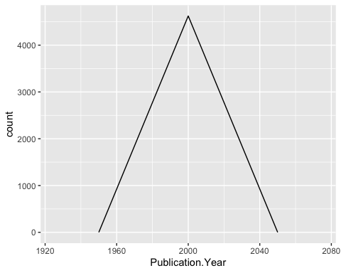

1. Reproduce the same graph but now add a color aesthetic so that different Test.Location are displayed as different colors.

ggplot(Neonics) +  
 geom_freqpoly(aes(x = Publication.Year, bins = 50, color = Test.Location))

## Warning: Ignoring unknown aesthetics: bins

## `stat_bin()` using `bins = 30`. Pick better value with `binwidth`.

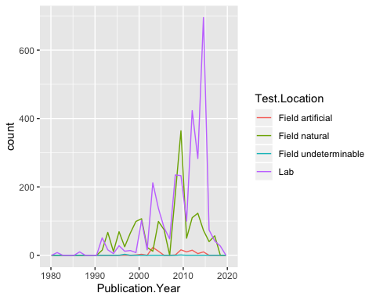

Interpret this graph. What are the most common test locations, and do they differ over time?

Answer: The most common test locations are Lab and Field natural. Both of these test locations differ over time as the count is fewer in the 1990s and early 2000s and grows significantly from ~2008 to 2015. Both counts drop after 2015.

1. Create a bar graph of Endpoint counts. What are the two most common end points, and how are they defined? Consult the ECOTOX_CodeAppendix for more information.

NeonicsBargraph <- ggplot(Neonics, aes(x = Endpoint)) +  
 geom_bar()  
  
NeonicsBargraph

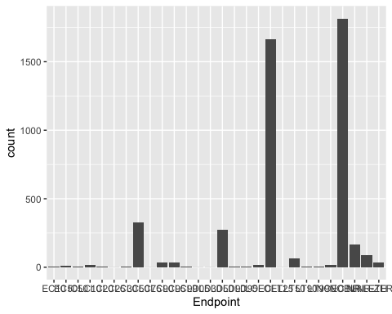

Answer: LOEL and NOEL and the two most common end points. LOEL means Lowest-observable-effect-level and is defined as the lowest dose (concentration) producing effects that were significantly different from responses of controls. NOEL means No-observable-effect-level and is defined as the highest dose (concentration) producing effects not significantly different from responses of controls according to author’s reported statistical test.

## Explore your data (Litter)

1. Determine the class of collectDate. Is it a date? If not, change to a date and confirm the new class of the variable. Using the unique function, determine which dates litter was sampled in August 2018.

view(Litter)  
  
class(Litter$collectDate)

## [1] "factor"

Litter$collectDate <- as.Date(Litter$collectDate)  
  
Litter$collectDate

## [1] "2018-08-02" "2018-08-02" "2018-08-02" "2018-08-02" "2018-08-02"  
## [6] "2018-08-02" "2018-08-02" "2018-08-02" "2018-08-02" "2018-08-02"  
## [11] "2018-08-02" "2018-08-02" "2018-08-02" "2018-08-02" "2018-08-02"  
## [16] "2018-08-02" "2018-08-02" "2018-08-02" "2018-08-02" "2018-08-02"  
## [21] "2018-08-02" "2018-08-02" "2018-08-02" "2018-08-02" "2018-08-02"  
## [26] "2018-08-02" "2018-08-02" "2018-08-02" "2018-08-02" "2018-08-02"  
## [31] "2018-08-02" "2018-08-02" "2018-08-02" "2018-08-02" "2018-08-02"  
## [36] "2018-08-02" "2018-08-02" "2018-08-02" "2018-08-02" "2018-08-02"  
## [41] "2018-08-02" "2018-08-02" "2018-08-02" "2018-08-02" "2018-08-02"  
## [46] "2018-08-02" "2018-08-02" "2018-08-02" "2018-08-02" "2018-08-02"  
## [51] "2018-08-02" "2018-08-02" "2018-08-02" "2018-08-02" "2018-08-02"  
## [56] "2018-08-02" "2018-08-02" "2018-08-02" "2018-08-02" "2018-08-02"  
## [61] "2018-08-02" "2018-08-02" "2018-08-02" "2018-08-02" "2018-08-02"  
## [66] "2018-08-02" "2018-08-02" "2018-08-02" "2018-08-02" "2018-08-02"  
## [71] "2018-08-02" "2018-08-02" "2018-08-02" "2018-08-02" "2018-08-02"  
## [76] "2018-08-02" "2018-08-02" "2018-08-02" "2018-08-02" "2018-08-02"  
## [81] "2018-08-02" "2018-08-02" "2018-08-02" "2018-08-02" "2018-08-02"  
## [86] "2018-08-02" "2018-08-02" "2018-08-02" "2018-08-02" "2018-08-02"  
## [91] "2018-08-02" "2018-08-30" "2018-08-30" "2018-08-30" "2018-08-30"  
## [96] "2018-08-30" "2018-08-30" "2018-08-30" "2018-08-30" "2018-08-30"  
## [101] "2018-08-30" "2018-08-30" "2018-08-30" "2018-08-30" "2018-08-30"  
## [106] "2018-08-30" "2018-08-30" "2018-08-30" "2018-08-30" "2018-08-30"  
## [111] "2018-08-30" "2018-08-30" "2018-08-30" "2018-08-30" "2018-08-30"  
## [116] "2018-08-30" "2018-08-30" "2018-08-30" "2018-08-30" "2018-08-30"  
## [121] "2018-08-30" "2018-08-30" "2018-08-30" "2018-08-30" "2018-08-30"  
## [126] "2018-08-30" "2018-08-30" "2018-08-30" "2018-08-30" "2018-08-30"  
## [131] "2018-08-30" "2018-08-30" "2018-08-30" "2018-08-30" "2018-08-30"  
## [136] "2018-08-30" "2018-08-30" "2018-08-30" "2018-08-30" "2018-08-30"  
## [141] "2018-08-30" "2018-08-30" "2018-08-30" "2018-08-30" "2018-08-30"  
## [146] "2018-08-30" "2018-08-30" "2018-08-30" "2018-08-30" "2018-08-30"  
## [151] "2018-08-30" "2018-08-30" "2018-08-30" "2018-08-30" "2018-08-30"  
## [156] "2018-08-30" "2018-08-30" "2018-08-30" "2018-08-30" "2018-08-30"  
## [161] "2018-08-30" "2018-08-30" "2018-08-30" "2018-08-30" "2018-08-30"  
## [166] "2018-08-30" "2018-08-30" "2018-08-30" "2018-08-30" "2018-08-30"  
## [171] "2018-08-30" "2018-08-30" "2018-08-30" "2018-08-30" "2018-08-30"  
## [176] "2018-08-30" "2018-08-30" "2018-08-30" "2018-08-30" "2018-08-30"  
## [181] "2018-08-30" "2018-08-30" "2018-08-30" "2018-08-30" "2018-08-30"  
## [186] "2018-08-30" "2018-08-30" "2018-08-30"

class(Litter$collectDate)

## [1] "Date"

unique(Litter[,"collectDate"])

## [1] "2018-08-02" "2018-08-30"

1. Using the unique function, determine how many plots were sampled at Niwot Ridge. How is the information obtained from unique different from that obtained from summary?

summary(Litter$plotID)

## NIWO_040 NIWO_041 NIWO_046 NIWO_047 NIWO_051 NIWO_057 NIWO_058 NIWO_061   
## 20 19 18 15 14 8 16 17   
## NIWO_062 NIWO_063 NIWO_064 NIWO_067   
## 14 14 16 17

unique(Litter["plotID"])

## plotID  
## 1 NIWO_061  
## 9 NIWO_064  
## 17 NIWO_067  
## 25 NIWO_040  
## 35 NIWO_041  
## 37 NIWO_063  
## 48 NIWO_047  
## 56 NIWO_051  
## 63 NIWO_058  
## 74 NIWO_046  
## 84 NIWO_062  
## 163 NIWO_057

Answer: The ‘unique’ function eliminates duplicate elements from the column whereas the ‘summary’ function produces result summaries of the number of times each Plot ID is present.

1. Create a bar graph of functionalGroup counts. This shows you what type of litter is collected at the Niwot Ridge sites. Notice that litter types are fairly equally distributed across the Niwot Ridge sites.

LitterBargraph <- ggplot(Litter, aes(x = functionalGroup)) +  
 geom_bar()  
  
LitterBargraph

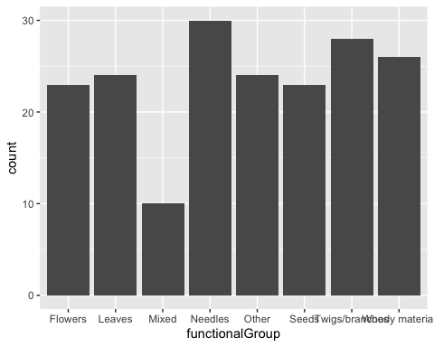

1. Using geom_boxplot and geom_violin, create a boxplot and a violin plot of dryMass by functionalGroup.

# Box Plot  
  
ggplot(Litter) +  
 geom_boxplot(aes(x = functionalGroup, y = dryMass, group = cut_width(functionalGroup, 1)))

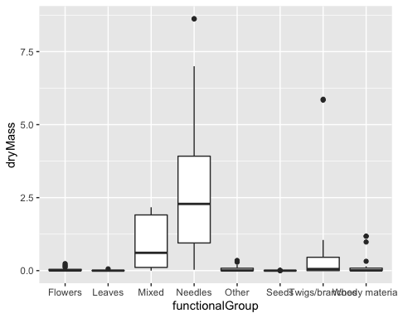

# Violin Plot  
  
ggplot(Litter) +  
 geom_violin(aes(x = functionalGroup, y = dryMass),  
 draw_quantiles = c(0.25, 0.5, 0.75),   
 scale = "count")

## Warning in regularize.values(x, y, ties, missing(ties)): collapsing to unique  
## 'x' values  
  
## Warning in regularize.values(x, y, ties, missing(ties)): collapsing to unique  
## 'x' values  
  
## Warning in regularize.values(x, y, ties, missing(ties)): collapsing to unique  
## 'x' values

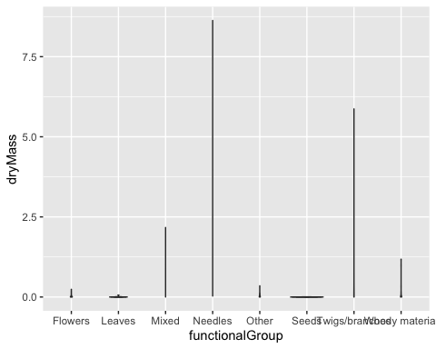

Why is the boxplot a more effective visualization option than the violin plot in this case?

Answer: The boxplot is more effective in this case because it allows you to see the middle 50% of the data distribution and any outliers. The violin plot doesn’t tell you much because there there are many more counts of dryMass than functionalGroup so you can’t really tell what the plot is signifying.

What type(s) of litter tend to have the highest biomass at these sites?

Answer: Needles tend to have the highest biomass at these sites.