Survey Results Tables

Emily McNamara

3/14/2020

## R Markdown

This is an R Markdown document. Markdown is a simple formatting syntax for authoring HTML, PDF, and MS Word documents. For more details on using R Markdown see <http://rmarkdown.rstudio.com>.

When you click the **Knit** button a document will be generated that includes both content as well as the output of any embedded R code chunks within the document. You can embed an R code chunk like this:

GrownCC <- glm(Q6 ~ as.factor(Regions) + as.factor(Q1) + as.factor(Q31)  
 + Q3_1, almonds, family = binomial )  
  
summary(GrownCC)

##   
## Call:  
## glm(formula = Q6 ~ as.factor(Regions) + as.factor(Q1) + as.factor(Q31) +   
## Q3_1, family = binomial, data = almonds)  
##   
## Deviance Residuals:   
## Min 1Q Median 3Q Max   
## -1.8763 -0.8849 -0.7060 1.1407 1.9435   
##   
## Coefficients:  
## Estimate  
## (Intercept) -1.245e+00  
## as.factor(Regions)Delta 1.682e+00  
## as.factor(Regions)North 1.311e+00  
## as.factor(Regions)South -4.018e-01  
## as.factor(Q1)Owner, not responsible for day-to-day management -5.471e-01  
## as.factor(Q1)Owner/operator of almond orchard(s) -5.772e-01  
## as.factor(Q31)25-34 years old 4.006e-01  
## as.factor(Q31)35-44 years old 1.186e+00  
## as.factor(Q31)45-54 years old 1.087e+00  
## as.factor(Q31)55-64 years old 1.135e+00  
## as.factor(Q31)65-74 years old 5.991e-01  
## as.factor(Q31)75 years or older 6.835e-02  
## as.factor(Q31)Prefer not to answer -1.283e+01  
## Q3_1 -1.063e-05  
## Std. Error  
## (Intercept) 9.394e-01  
## as.factor(Regions)Delta 5.441e-01  
## as.factor(Regions)North 5.087e-01  
## as.factor(Regions)South 3.195e-01  
## as.factor(Q1)Owner, not responsible for day-to-day management 4.337e-01  
## as.factor(Q1)Owner/operator of almond orchard(s) 3.155e-01  
## as.factor(Q31)25-34 years old 9.517e-01  
## as.factor(Q31)35-44 years old 9.576e-01  
## as.factor(Q31)45-54 years old 9.594e-01  
## as.factor(Q31)55-64 years old 9.646e-01  
## as.factor(Q31)65-74 years old 1.006e+00  
## as.factor(Q31)75 years or older 1.426e+00  
## as.factor(Q31)Prefer not to answer 6.233e+02  
## Q3_1 4.062e-05  
## z value Pr(>|z|)  
## (Intercept) -1.326 0.18497  
## as.factor(Regions)Delta 3.092 0.00199  
## as.factor(Regions)North 2.577 0.00998  
## as.factor(Regions)South -1.258 0.20849  
## as.factor(Q1)Owner, not responsible for day-to-day management -1.261 0.20716  
## as.factor(Q1)Owner/operator of almond orchard(s) -1.829 0.06736  
## as.factor(Q31)25-34 years old 0.421 0.67376  
## as.factor(Q31)35-44 years old 1.239 0.21549  
## as.factor(Q31)45-54 years old 1.133 0.25728  
## as.factor(Q31)55-64 years old 1.177 0.23938  
## as.factor(Q31)65-74 years old 0.595 0.55165  
## as.factor(Q31)75 years or older 0.048 0.96177  
## as.factor(Q31)Prefer not to answer -0.021 0.98357  
## Q3_1 -0.262 0.79350  
##   
## (Intercept)   
## as.factor(Regions)Delta **  
## as.factor(Regions)North **  
## as.factor(Regions)South   
## as.factor(Q1)Owner, not responsible for day-to-day management   
## as.factor(Q1)Owner/operator of almond orchard(s) .   
## as.factor(Q31)25-34 years old   
## as.factor(Q31)35-44 years old   
## as.factor(Q31)45-54 years old   
## as.factor(Q31)55-64 years old   
## as.factor(Q31)65-74 years old   
## as.factor(Q31)75 years or older   
## as.factor(Q31)Prefer not to answer   
## Q3_1   
## ---  
## Signif. codes: 0 '***' 0.001 '**' 0.01 '*' 0.05 '.' 0.1 ' ' 1  
##   
## (Dispersion parameter for binomial family taken to be 1)  
##   
## Null deviance: 379.46 on 296 degrees of freedom  
## Residual deviance: 344.95 on 283 degrees of freedom  
## (4 observations deleted due to missingness)  
## AIC: 372.95  
##   
## Number of Fisher Scoring iterations: 13

summary_table_GrownCC <- coef(summary(GrownCC))

## Including Plots

You can also embed plots, for example:

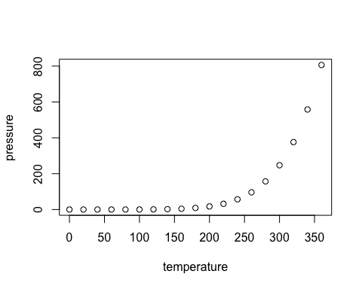

Note that the echo = FALSE parameter was added to the code chunk to prevent printing of the R code that generated the plot.