Structured Exception Handling
for
INTEL Win32

This document describes the structured exception handling architecture used by the INTEL implementation of Win32. This document is targetted at language implementors. This exception handling architecture is language and vendor independent. The Win32 exception handling implementation will support mixed language and mixed vendor development. A proposed extension to the C language is included in this document. This proposed extension has been implemented by the Microsoft Languages Group and by the MIPS Compiler Group. It is presented and used in this document as a convenient form of notation. Constraints of the syntax should not be construed as limitations of the exception handling architecture of Win32.

Definitions

Resumptive Exception Handling
A model for exception handling that allows the exception filter to either abort the procedure that caused the exception, and then invoke the exception handler, or correct the exceptional condition and continue the procedure from the point the exception occurred.

Terminative Exception Handling
A model for exception handling that requires the exception filter to abort the procedure that raised the exception, and then invoke the exception handler.

C++ Structured Exception Handling
The extensions to C++ described in the Annotated Reference Manual for C++ and adopted by the ANSI C++ committee. This structured exception handling is based on the terminative model.

Microsoft C++ Structured Exception Handling
The extensions to C++ described in the Annotated Reference Manual for C++ and adopted by the ANSI C++ committee, only based on the resumptive model of exception handling rather than the terminative model.

Guarded Body
The code body that is enclosed by the _try body of a _try_except or a _try_finally statement. Exceptions occuring in this code will invoke the system exception filter.

Lanuage Specific Exception Filter
The routine installed by the compiler in the exception handling chain. This routine is notified during the search for an exception handler, and also during the search for a termination handler. This routine is not written by the user of the language.

Exception Filter
The code body that composes the expression component of the _try_except statement. The exception filter is written by the user of the language to determine whether or not the exception that occurred can be handled by the exception handler specificied in the body of the _except statement. The exception filter is also responsible for fixing the exceptional condition and resuming execution if the resumptive model of exception handling is supported by the language implementor.

Exception Handler
The code body that is enclosed by the _except body of a _try_except statement. This code will only be executed if an exception occurs within the guarded body and the exception filter indicates that this exception handler can deal with the exception that occurred.

Termination Handler
The code body that is enclosed by the _finally body of a _try_finally statement. This code is guaranteed to get executed. It is executed after the guarded body completes or during the unwind process that occurs if an exception handler was invoked.

C Syntax Extensions

For exception handling, The syntax is

_try-_except-statement ::=

_try compound-statement
_except (expression) compound-statement

The compound-statement after _try is know as the guarded statement.
The expression after _except is know as the exception filter.
The compound-statement after _except is know as the exception handler.

For termination handling it is

_try-_finally-statement ::=

_try compound-statement
_finally compound-statement

The compound-statement after _try is know as the guarded statement.
The compound-statement after _finally is know as the termination handler.

Examples:

_try
{
// guarded body
}
_except( // exception filter
GetExceptionCode() == EXCEPTION_ACCESS_VIOLATION // EXAMPLE
? EXCEPTION_EXECUTE_HANDLER
: EXCEPTION_CONTINUE_SEARCH)
{
// exception handler
}

_try
{
// guarded body
}
_finally
{
// termination handler
}

Jumps (via goto) are not allowed into the guarded body, the exception handler, or the termination handler.

The leave statement is only valid within a guarded body. It is used to exit the guarded body and continue execution after the _try_except or _try_finally statement.

Intrinsic Functions

Microsoft's structured exception handling is supported by three intrinsic functions. These functions are GetExceptionCode, GetExceptionInformation, and AbnormalTermination.

GetExceptionCode is used to retrieve the type of exception that has occurred.

GetExceptionInformation is used to retrieve detailed information about the exception. GetExceptionInformation can only be called from within the exception filter of the _try-_except statement. The information provided is destroyed when RtlUnwind is called, therefore it can not be used within the exception handler, unless it has been copied to safe storage by the exception filter or language specific exception filter.

Prototype:

RtlUnwind(Target Frame Pointer to Unwind to,Address of execution return point,Program control flag == 0 means continue execution when done unwinding)

AbnormalTermination is used by the _try-_finally termination handler to determine if the handler was reached through an exception or through normal execution. This intrinsic function can only be called from within a termination handler.

Exception Handling Control Flow - Overview
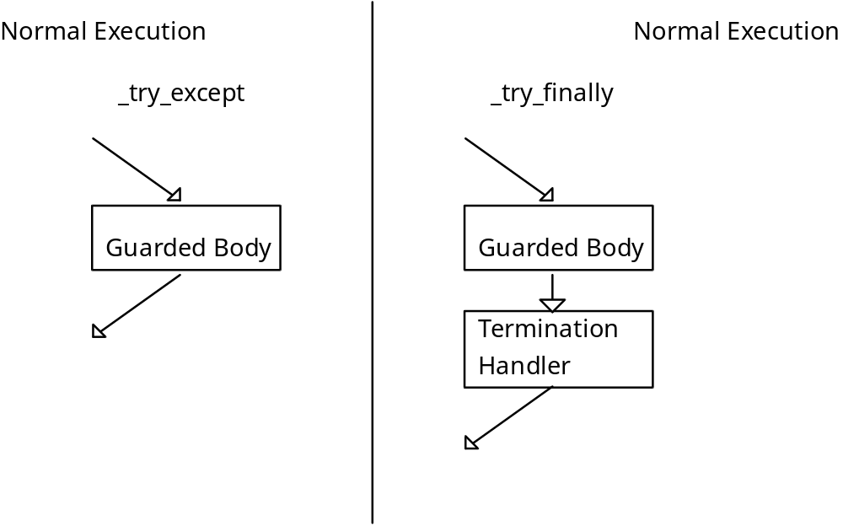

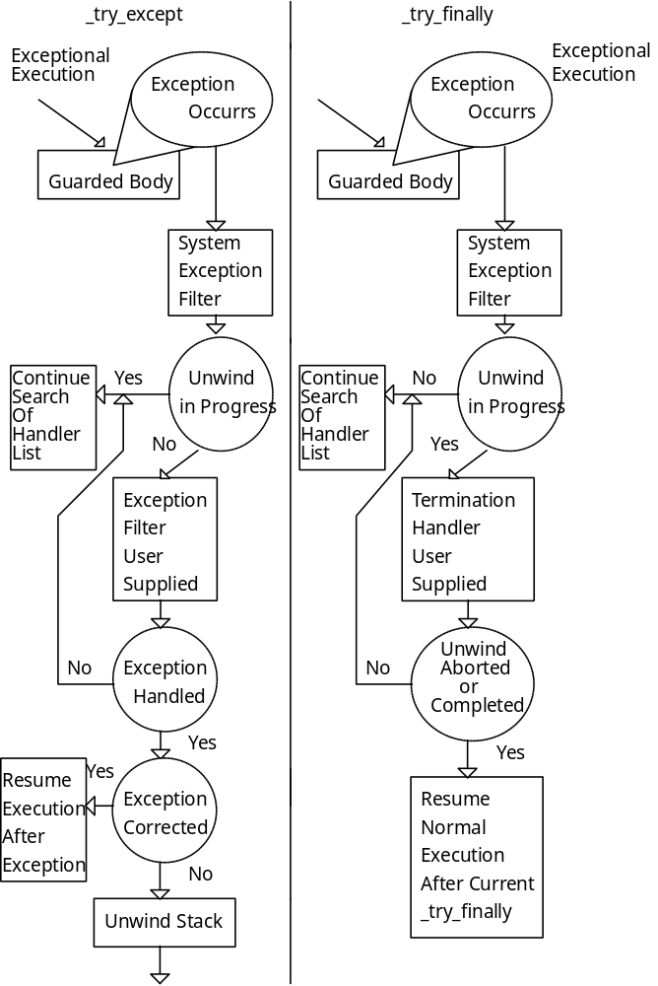
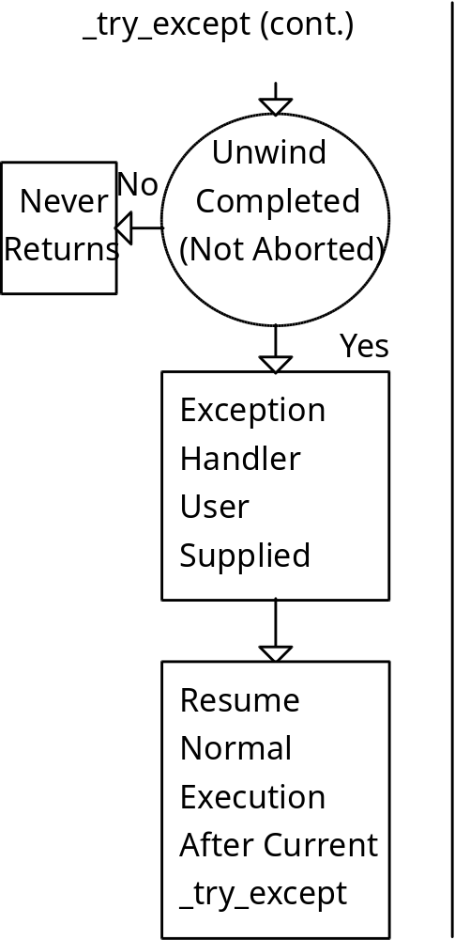

Exception handling flow control

The guarded body is executed. If an exception occurrs the operating system starts looking for an exception handler to deal with the exception. The language specific exception filter is called with pertinent information about the exception. The language specific exception filter calls the exception filter provided by the user. If the exception filter indicates that it can not deal with the exception that has occurred, then the operating system continues searching for an appropriate exception handler. If the exception filter indicates that it has corrected the exceptional event the operating system returns program control to the point exception occurred. The final option is for the exception filter to unwind the stack to the _try_except statement that installed it. After this has been accomplished the exception handler is executed and following that, normal execution resumes immediately after the _try_except statement.

Termination handling flow control

The guarded body is executed. If an exception is not generated during the execution of the guarded body, the termination handler will execute immediately after completion of the guarded body. If the guarded body generates an exception, the termination handler will be executed during the stack unwinding process that occurs after an exception filter capable of handling the exception has been found and has terminated the execution path that lead to the exception by unwinding the stack. If the exceptional condition is corrected by the exception filter, the guarded body execution path is resumed, and the termination handler will get executed as if no exception had occurred.

Execution Handling Flow Control - Code Examples

The following eight execution examples should provide a clear illustration of how the Win32 exception handling model works. The discussion in the following paragraphs will refer constantly to the attached addendums A and B, which comprise the sample program EXCEPT which should be considered part of this document.

EXCEPTION HANDLER EXAMPLES

EXCEPT 1 0

Exception handling demonstration program
Exception Handler Example (0)
[30] ExampleTryExcept:: Guarded body enter
[30] SEH Pointer == 12ff78
[31] ExampleTryExcept:: Guarded body leave
[32] ExampleTryExcept:: Normal execution resumed

EXCEPT 1 1

Exception handling demonstration program
Exception Handler Example (1)
[30] ExampleTryExcept:: Guarded body enter
[30] SEH Pointer == 12ff78
[33] ExampleTryExcept:: Language specific exception filter
[35] ExampleTryExcept:: User supplied exception filter
[37] ExampleTryExcept:: Start stack unwind
[37] SEH Pointer == 12ff78
[37] SEH Pointer == 12ffd4
[38] ExampleTryExcept:: Unwind complete,
prepare to call exception handler
[38] Stack Pointer == 12ff74
[38] Frame Pointer == 12ff90
[39] ExampleTryExcept:: Exception handler executing
[32] ExampleTryExcept:: Normal execution resumed

EXCEPT 1 2

Exception handling demonstration program
Exception Handler Example (2)
[30] ExampleTryExcept:: Guarded body enter
[30] SEH Pointer == 12ff78
[10] SEH Pointer == 12ff5c
[10] UnwindTerm:: Guarded body enter
[14] UnwindTerm:: Language specific exception filter
[17] UnwindTerm:: Exception Handler search in progress
[17] Stack Pointer == 12fde4
[33] ExampleTryExcept:: Language specific exception filter
[35] ExampleTryExcept:: User supplied exception filter
[37] ExampleTryExcept:: Start stack unwind
[37] SEH Pointer == 12ff78
[37] SEH Pointer == 12ffd4
[14] UnwindTerm:: Language specific exception filter
[15] UnwindTerm:: Unwind in progress
[16] SEH Pointer == 12ff78
[16] Stack Pointer == 12fc60
[16] Frame Pointer == 12ff6c
[18] UnwindTerm:: Termination Handler
[19] UnwindTerm:: Abnormal Termination
[38] ExampleTryExcept:: Unwind complete,
prepare to call exception handler
[38] Stack Pointer == 12ff74
[38] Frame Pointer == 12ff90
[39] ExampleTryExcept:: Exception handler executing
[32] ExampleTryExcept:: Normal execution resumed

EXCEPT 1 3

Exception handling demonstration program
Exception Handler Example (3)
[30] ExampleTryExcept:: Guarded body enter
[30] SEH Pointer == 12ff78
[10] SEH Pointer == 12ff5c
[10] UnwindTerm:: Guarded body enter
[14] UnwindTerm:: Language specific exception filter
[17] UnwindTerm:: Exception Handler search in progress
[17] Stack Pointer == 12fde4
[33] ExampleTryExcept:: Language specific exception filter
[35] ExampleTryExcept:: User supplied exception filter
[37] ExampleTryExcept:: Start stack unwind
[37] SEH Pointer == 12ff78
[37] SEH Pointer == 12ffd4
[14] UnwindTerm:: Language specific exception filter
[15] UnwindTerm:: Unwind in progress
[16] SEH Pointer == 12ff78
[16] Stack Pointer == 12fc60
[16] Frame Pointer == 12ff6c
[18] UnwindTerm:: Termination Handler
[19] UnwindTerm:: Abnormal Termination
[20] UnwindTerm:: Aborting unwind
[13] UnwindTerm:: Normal execution resumed
after unwind was terminated
[31] ExampleTryExcept:: Guarded body leave
[32] ExampleTryExcept:: Normal execution resumed

TERMINATION HANDLER EXAMPLES

EXCEPT 2 0

Exception handling demonstration program
Termination Handler Example (0)
[ 1] SEH Pointer == 12ff78
[ 2] ExampleTryFinally:: Guarded body enter
[ 3] ExampleTryFinally:: Guarded body leave
[ 9] Stack Pointer == 12ff88
[ 9] ExampleTryFinally:: Termination handler executing
[ 4] ExampleTryFinally:: Normal excution resumed

EXCEPT 2 1

Exception handling demonstration program
Termination Handler Example (1)
[ 1] SEH Pointer == 12ff78
[ 2] ExampleTryFinally:: Guarded body enter
[ 5] ExampleTryFinally:: Language specific exception filter
[ 8] ExampleTryFinally:: Exception handler search in progress
[ 8] Stack Pointer == 12fe00
------> OPERATING SYSTEM DIALOG
FOR EXCEPTIONS APPEARS HERE
[ 5] ExampleTryFinally:: Language specific exception filter
[ 6] ExampleTryFinally:: Unwind in progress
[ 6] Stack Pointer == 47037c
[ 6] Frame Pointer == 12ff90
[ 9] Stack Pointer == 12fc58
[ 9] ExampleTryFinally:: Termination handler executing

EXCEPT 2 2

Exception handling demonstration program
Termination Handler Example (2)
[ 1] SEH Pointer == 12ff78
[ 2] ExampleTryFinally:: Guarded body enter
[10] SEH Pointer == 12ff5c
[10] UnwindTerm:: Guarded body enter
[14] UnwindTerm:: Language specific exception filter
[17] UnwindTerm:: Exception Handler search in progress
[17] Stack Pointer == 12fde4
[ 5] ExampleTryFinally:: Language specific exception filter
[ 8] ExampleTryFinally:: Exception handler search in progress
[ 8] Stack Pointer == 12fde4
------> OPERATING SYSTEM DIALOG
FOR EXCEPTIONS APPEARS HERE
[14] UnwindTerm:: Language specific exception filter
[15] UnwindTerm:: Unwind in progress
[16] SEH Pointer == 12ff78
[16] Stack Pointer == 12fc3c
[16] Frame Pointer == 12ff6c
[18] UnwindTerm:: Termination Handler
[19] UnwindTerm:: Abnormal Termination
[ 5] ExampleTryFinally:: Language specific exception filter
[ 6] ExampleTryFinally:: Unwind in progress
[ 6] Stack Pointer == 47035a
[ 6] Frame Pointer == 12ff90
[ 9] Stack Pointer == 12fc3c
[ 9] ExampleTryFinally:: Termination handler executing

EXCEPT 2 3

Exception handling demonstration program
Termination Handler Example (3)
[ 1] SEH Pointer == 12ff78
[ 2] ExampleTryFinally:: Guarded body enter
[10] SEH Pointer == 12ff5c
[10] UnwindTerm:: Guarded body enter
[14] UnwindTerm:: Language specific exception filter
[17] UnwindTerm:: Exception Handler search in progress
[17] Stack Pointer == 12fde4
[ 5] ExampleTryFinally:: Language specific exception filter
[ 8] ExampleTryFinally:: Exception handler search in progress
[ 8] Stack Pointer == 12fde4
------> OPERATING SYSTEM DIALOG
FOR EXCEPTIONS APPEARS HERE
[14] UnwindTerm:: Language specific exception filter
[15] UnwindTerm:: Unwind in progress
[16] SEH Pointer == 12ff78
[16] Stack Pointer == 12fc3c
[16] Frame Pointer == 12ff6c
[18] UnwindTerm:: Termination Handler
[19] UnwindTerm:: Abnormal Termination
[20] UnwindTerm:: Aborting unwind
[13] UnwindTerm:: Normal execution resumed
after unwind was terminated
[ 3] ExampleTryFinally:: Guarded body leave
[ 9] Stack Pointer == 12ff88
[ 9] ExampleTryFinally:: Termination handler executing
[ 4] ExampleTryFinally:: Normal excution resumed

Appendix A
EH.ASM

.386p

_DATA segment para public 'DATA'
_DATA ends

FLAT group _DATA

; OS Support Functions

extrn _RtlUnwind:near
extrn _printf:near

P EQU 8 ; offset to stack parameters, from EBP

_UNWINDING EQU 2
_UNWINDING_FOR_EXIT EQU 4
_UNWIND_IN_PROGRESS EQU _UNWINDING + _UNWINDING_FOR_EXIT

_CONTINUE_SEARCH EQU 1
_CONTINUE_EXECUTION EQU 0

; Operating System Dependent
_REGISTRATION_RECORD struc
_RegistrationRecordPrev dd ?
_RegistrationRecordFilter dd ?
_REGISTRATION_RECORD ends

; Registration Record used by this example, language vendor specific
; Contains Operating System Dependent fields and two implementation
; specific fields
_LV_REG_RECORD struc
_LVRegRecordPrev dd ? ; REQUIRED BY OS
_LVRegRecordFilter dd ? ; REQUIRED BY OS
_LVRegRecordFramePtr dd ? ; saves EBP
_LVRegRecordStackPtr dd ? ; saves ESP
_LV_REG_RECORD ends

; Operating System Dependent
_EXCEPTION_REPORT_RECORD struc
_ExceptNumber dd ?
_ExceptFlags dd ?
_ExceptRecord dd ?
_ExceptAddress dd ?
_ExceptParameters dd ?
_ExceptInfo dd ?
_EXCEPTION_REPORT_RECORD ends

ReportRecord EQU 0
RegRecord EQU 4
ContextRecord EQU 8
DispatchRecord EQU 12

;ExceptionFilter(&ReportRecord,&RegistrationRecord,&ContextRecord,&DispatcherRecord);
;
; ReportRecord
; RegistrationRecord is a pointer to the SEH structure being processed
; ContextRecord
; DispatcherRecord is reserved for use by the host OS
;

_ACCESS_VIOLATION equ 0C0000005h

GENERATE_EXCEPTION macro
xor EAX,EAX
mov [EAX],EAX
endm

GET_EXCEPTION_CODE_INTRINSIC macro
mov EAX,[EBP].P+ReportRecord
mov EAX,[EAX]._ExceptNumber
endm

ABNORMAL_TERMINATION_INTRINSIC_FALSE macro
xor EAX,EAX
endm

ABNORMAL_TERMINATION_INTRINSIC_TRUE macro
mov EAX,1
endm

ABNORMAL_TERMINATION_INTRINSIC macro
or EAX,EAX
endm

PRINT_SEH macro ID,VALUE
push VALUE
push ID
push offset __Seh
call _printf
add ESP,12
endm

PRINT_STACK macro ID,VALUE
push ECX
mov ECX,VALUE
push VALUE
push ID
push offset __Stack
call _printf
add ESP,12
pop ECX
endm

PRINT_FRAME macro ID,VALUE
push VALUE
push ID
push offset __Frame
call _printf
add ESP,12
endm

PRINT_STR macro ID,STRING
push ID
push STRING
call _printf
add ESP,8
endm

_TEXT segment para public 'CODE'
assume CS:_TEXT

extrn __Seh : near
extrn __Frame : near
extrn __Stack : near

extrn _DT1 : near
extrn _DT2 : near
extrn _DT3 : near
extrn _DT4 : near
extrn _DT5 : near
extrn _DT6 : near
extrn _DT7 : near
extrn _DT8 : near
extrn _DT9 : near
extrn _DT10 : near
extrn _DT11 : near
extrn _DT12 : near
extrn _DT13 : near
extrn _DT14 : near
extrn _DT15 : near
extrn _DT16 : near
extrn _DT17 : near

extrn _DT30 : near
extrn _DT31 : near
extrn _DT32 : near
extrn _DT33 : near
extrn _DT34 : near
extrn _DT35 : near
extrn _DT36 : near
extrn _DT37 : near
extrn _DT38 : near

SUCCESS equ 1
ERROR equ 0

public _ExampleTryFinally
public _ExampleTryExcept

; void ExampleTryFinally(int pFlag)
; {
; _try
; {
; if (pFlag == 0)
; {
; // normal execution
; }
; else if (pFlag == 1)
; {
; uint *A = NULL;
;
; *A = 0; // generate exception
; }
; else
; {
; UnwindTerm(pFlag); // demonstrate unwind
; // 2 normal unwind
; // 3 aborts unwind, and resumes execution
; }
; }
; _finally
; {
; }
; }
;
; void UnwindTerm(int pFlag)
; {
; _try
; {
; void *B = NULL;
;
; *B = 0;
; }
; _finally
; {
; if (pFlag == 3
; && AbnormalTermination())
; {
; return ERROR; // executed if (pFlag == 3
; } // and exception occurred, normal execution
; } // resumes at the return ERROR statement
; return SUCCESS;
; }

public _ExampleTryFinally

_ExampleTryFinally proc near
push EBP
mov EBP,ESP

; exception handler install beg

; implementation specific
; perserve register variables here
; EDI and ESI are my examples

push EDI
push ESI

; implementation specific portion of seh
; is stored first

; reserve space for stack pointer
push EBP
; save frame pointer
push EBP

; operating system specific portion of seh
; is stored last

; pointer to filter function
push offset FilterTerm
; prev registration record
push FS:0

; implementation specific
; save stack pointer in reserved space

mov [ESP]+12,ESP

; install filter in eh chain

mov FS:0,ESP

; exception handler install end

PRINT_SEH 1,FS:0

; { guarded body of _try_finally statement

PRINT_STR 2,<offset _DT1>

; [EBP]+P == 0 means normal execution path

cmp dword ptr [EBP]+P,0
je _tm1

; [EBP]+P == 1 means simple exception in guarded body

cmp dword ptr [EBP]+P,1
je _tm0

; [EBP]+P > 1 means exception in called function
; exception handler search and termination handler
; unwind example

push [EBP]+P
call UnwindTerm
add ESP,4
jmp short _tm1

_tm0: GENERATE_EXCEPTION

_tm1:

PRINT_STR 3,<offset _DT2>

; } guarded body

; re-entry point for normal execution from exception handler
_tm2:
; exception handler remove beg
; remove seh from eh chain by
; restoring the previous seh pointer
; to the operating system eh hook

pop FS:0

; implementation specific
; advance stack pointer to where register
; variables are perserved, removing seh from stack

add ESP,12

; implementation specific
; restore register variables here
; EDI and ESI are my examples

pop ESI
pop EDI

; exception handler remove end

; implementation specific
; set up flag to HandlerTerm that can
; be used by compiler intrinsic AbnormalTermination
; which is used to determine whether or not
; an exceptional event has cause the execution
; of the finally clause

ABNORMAL_TERMINATION_INTRINSIC_FALSE

; execute finally clause for
; cases of normal program execution

call HandlerTerm

PRINT_STR 4,<offset _DT3>

; return to caller
pop EBP
ret
_ExampleTryFinally endp

; implementation specific
; routine that gets called as the exception
; list is being walked. this routine is given
; sufficient information to determine what
; action, if any, it should take

; in the case of FilterTerm, it tells the
; operating system to CONTINUE SEARCH ing for
; all events, and it calls HandlerTerm only
; when it is called during an unwind process
; it does nothing but return CONTINUE SEARCH ing
; when called upon to handle an exception

FilterTerm proc near
push EBP
mov EBP,ESP

PRINT_STR 5,<offset _DT4>

mov EAX,[EBP].P+ReportRecord
test dword ptr [EAX]._ExceptFlags,_UNWIND_IN_PROGRESS
jz _H0

push EBP
PRINT_STR 6,<offset _DT5>
pop EBP
; execute only during
; unwind, not during
; search for exception
; handler

; restore EBP so local variables
; from ExampleTryFinally can be
; accessed by HandlerTerm, since it
; exists in the context of ExampleTryFinally

; note that the value of ESP has
; no relation to the value of ESP during
; normal execution

mov EAX,[EBP].P+RegRecord
mov EBP,[EAX]._LVRegRecordFramePtr

PRINT_STACK 6,ESP
PRINT_FRAME 6,EBP

; implementation specific
; set up flag to HandlerTerm that can
; be used by compiler intrinsic AbnormalTermination
; which is used to determine whether or not
; an exceptional event has cause the execution
; of the finally clause

ABNORMAL_TERMINATION_INTRINSIC_TRUE

; execute finally clause for
; cases of exceptional program execution

call HandlerTerm

mov EAX,_CONTINUE_SEARCH
pop EBP
ret

_H0:
PRINT_STR 8,<offset _DT6>
PRINT_STACK 8,ESP

mov EAX,_CONTINUE_SEARCH
pop EBP
ret
FilterTerm endp

HandlerTerm proc near
PRINT_STACK 9,ESP
PRINT_STR 9,<offset _DT7>

ret
HandlerTerm endp

UnwindTerm proc near
push EBP
mov EBP,ESP

; termination handler install beg

; implementation specific portion of seh
; is stored first

; reserve space for stack pointer

push EBP

; save frame pointer

push EBP

; operating system specific portion of seh
; is stored last

; pointer to filter function

push offset FilterTermUnwind

; prev registration record

push FS:0

; implementation specific
; save stack pointer in reserved space

mov [ESP]+12,ESP

mov FS:0,ESP

PRINT_SEH 10,ESP
PRINT_STR 10,<offset _DT8>

; termination handler install end

GENERATE_EXCEPTION

; WILL NEVER EXECUTE THE CODE FROM HERE
; TO _TU2 THE WAY THIS CODE IS WRITTEN

; termination handler remove beg

; remove seh from eh chain by
; restoring the previous seh pointer
; to the operating system eh hook

pop FS:0

; implementation specific
; remove seh from stack

mov ESP,EBP

; termination handler remove end

; implementation specific
; set up flag to HandlerTerm that can
; be used by compiler intrinsic AbnormalTermination
; which is used to determine whether or not
; an exceptional event has cause the execution

; of the finally clause

PRINT_STR 11,<offset _DT9>

ABNORMAL_TERMINATION_INTRINSIC_FALSE

; execute finally clause for
; cases of normal program execution

call HandlerTermUnwind

_TU1:
; clean up stack

mov ESP,EBP

PRINT_STR 12,<offset _DT10>
; return to caller

mov EAX,SUCCESS
pop EBP
ret

_TU2:

; RETURN ERROR entry point from _finally statement

; exception handler remove beg

; remove seh from eh chain by
; restoring the previous seh pointer
; to the operating system eh hook

pop FS:0

; implementation specific
; remove seh from stack

mov ESP,EBP

PRINT_STR 13,<offset _DT11>
; exception handler remove end

mov EAX,ERROR
pop EBP
ret
UnwindTerm endp

FilterTermUnwind proc near
push EBP
mov EBP,ESP

PRINT_STR 14,<offset _DT12>

mov EAX,[EBP].P+ReportRecord
test dword ptr [EAX]._ExceptFlags,_UNWIND_IN_PROGRESS
jz _H2

push EBP
PRINT_STR 15,<offset _DT13>
pop EBP

; execute only during
; unwind, not during
; search for exception
; handler

; restore EBP so local variables
; from UnwindTerm can be
; accessed by HandlerTermUnwind, since it
; exists in the context of UnwindTerm

; note that the value of ESP has
; no relation to the value of ESP during
; normal execution

mov EAX,[EBP].P+RegRecord
mov EBP,[EAX]._LVRegRecordFramePtr

mov EBX,[EAX]._LVRegRecordPrev
push EBX

PRINT_SEH 16,EBX
PRINT_STACK 16,ESP
PRINT_FRAME 16,EBP

pop EBX

; implementation specific
; set up flag to HandlerTerm that can
; be used by compiler intrinsic AbnormalTermination
; which is used to determine whether or not
; an exceptional event has cause the execution
; of the finally clause

ABNORMAL_TERMINATION_INTRINSIC_TRUE

; execute finally clause for
; cases of exceptional program execution

call HandlerTermUnwind

jmp short _H3

_H2:
PRINT_STR 17,<offset _DT14>
PRINT_STACK 17,ESP
_H3:
mov EAX,_CONTINUE_SEARCH
pop EBP
ret
FilterTermUnwind endp

HandlerTermUnwind proc near
; save abnormal termination flag

push EAX

; save unwind frame target

push EBX

PRINT_STR 18,<offset _DT15>

; restore unwind frame target

pop EBX

; restore abnormal termination flag

pop EAX

ABNORMAL_TERMINATION_INTRINSIC

jz _H3

PRINT_STR 19,<offset _DT16>

cmp dword ptr [EBP].P,3
jne _H3

PRINT_STR 20,<offset _DT17>

; ignore this parameter

push 0
; resume execution immediately after the
; unwind
push offset _H4
; target seh for RtlUnwind to unwind the
; stack too
push EBX
call _RtlUnwind
_H4: ; execution should resume here after unwind

; jump back to UnwindTerm and expect
; it to remove exception handler

push offset _TU2
_H3:
ret
HandlerTermUnwind endp

; void ExampleTryExcept(int pFlag)
; {
; _try
; {
; printf("[%2d] \n",1);
; if (pFlag == 0)
; {
; }
; else if (pFlag == 1)
; {
; int *C = NULL;;
;
; *C = 0;
; }
; else
; {
; UnwindTerm(pFlag);
; }
; }
; _except(GetExceptionCode() == ACCESS_VIOLATION)
; {
; }
; }

public _ExampleTryExcept

_ExampleTryExcept proc near
push EBP
mov EBP,ESP

; exception handler install beg

; implementation specific
; perserve register variables here
; EDI and ESI are my examples

push EDI
push ESI

; implementation specific portion of seh
; is stored first

; reserve space for stack pointer

push EBP

; save frame pointer

push EBP

; operating system specific portion of seh
; is stored last

; pointer to filter function

push offset FilterExcept

; prev registration record

push FS:0

; implementation specific
; save stack pointer in reserved space

mov [ESP]+12,ESP

; install filter in eh chain

mov FS:0,ESP

PRINT_STR 30,<offset _DT30>
PRINT_SEH 30,ESP

; exception handler install end

; { guarded body of _try_except statement

; [EBP]+P == 0 means normal execution path

cmp dword ptr [EBP]+P,0
je _ex1

; [EBP]+P == 1 means simple exception in guarded body

cmp dword ptr [EBP]+P,1
je _ex0

; [EBP]+P > 1 means exception in called function
; exception handler search and termination handler
; unwind example

push [EBP]+P
call UnwindTerm
add ESP,4
jmp short _ex1

_ex0:
GENERATE_EXCEPTION

_ex1:

PRINT_STR 31,<offset _DT31>

; } guarded body

_ex2:

; exception handler remove beg

; remove seh from eh chain by
; restoring the previous seh pointer
;

pop FS:0

; implementation specific
; advance stack pointer to where register
; variables are perserved, removing seh from stack

add ESP,12

; implementation specific
; restore register variables here
; EDI and ESI are my examples

pop ESI
pop EDI

; exception handler remove end

; NOTE: handler is not executed unless an exception occurs

PRINT_STR 32,<offset _DT32>

; return to caller
pop EBP
ret
_ExampleTryExcept endp

; implementation specific
; routine that gets called as the exception
; list is being walked. this routine is given
; sufficient information to determine what
; action, if any, it should take

; in the case of FilterExcept, it tells the
; operating system to CONTINUE SEARCH ing for
; all exceptions other than ACCESS VIOLATIONS.
; it also tells the operating system to CONTINUE
; SEARCH ing during unwinds, because it does not
; contain a termination handler

FilterExcept proc near
push EBP
mov EBP,ESP
PRINT_STR 33,<offset _DT33>
mov EAX,[EBP].P+ReportRecord
test dword ptr [EAX]._ExceptFlags,_UNWIND_IN_PROGRESS
jz _F0

PRINT_STR 34,<offset _DT34>

; unwind in progress
; no work for exception handler
; so inform operating system to
; continue search

mov EAX,_CONTINUE_SEARCH
pop EBP
ret

_F0:
PRINT_STR 35,<offset _DT35>
GET_EXCEPTION_CODE_INTRINSIC
cmp EAX,_ACCESS_VIOLATION
je _F1

PRINT_STR 36,<offset _DT36>
mov EAX,_CONTINUE_SEARCH
pop EBP
ret

_F1:
; unwind stack frame, which causes all
; termination handlers installed after
; the exception handler to be invoked
; note that RtlUnwind does not change
; the stack pointer, but termination handlers
; may alter ESP

PRINT_STR 37,<offset _DT37>

; ignore this parameter

push 0

; resume execution immediately after the
; unwind

push offset _F2

mov EAX,[EBP].P+RegRecord
push EAX

; print out start of this registration record

PRINT_SEH 37,EAX
pop EAX
; target seh for RtlUnwind to unwind the stack
; too
push EAX

mov EAX,[EAX]
; print out start of previous registration record
PRINT_SEH 37,EAX

call _RtlUnwind
_F2: ; execution should resume here after unwind

; reset EBP for Handler, so it has access to
; the local variables of the function it was
; declared in, likewise reset ESP

mov EAX,[EBP].P+RegRecord
mov EBP,[EAX]._LVRegRecordFramePtr
mov ESP,[EAX]._LVRegRecordStackPtr

PRINT_STR 38,<offset _DT38>
PRINT_STACK 38,ESP
PRINT_FRAME 38,EBP

call HandlerExcept

; resume execution after handler
; completes execution

push offset _ex2

ret
FilterExcept endp

; EXCEPTION HANDLER OF _TRY_EXCEPT STATEMENT

HandlerExcept proc near
PRINT_STR 39,<offset _DT39>

ret
HandlerExcept endp

_TEXT ends
end
end

Appendix B
EXCEPT.C

#include <stdio.h>
#include <stdlib.h>

char _Seh[] = "[%2d] SEH Pointer == %x\n";
char _Stack[] = "[%2d] Stack Pointer == %x\n";
char _Frame[] = "[%2d] Frame Pointer == %x\n";

char DT1[] = "[%2d] ExampleTryFinally:: Guarded body enter\n";
char DT2[] = "[%2d] ExampleTryFinally:: Guarded body leave\n";
char DT3[] = "[%2d] ExampleTryFinally:: Normal excution resumed\n";
char DT4[] = "[%2d] ExampleTryFinally:: Language specific exception filter\n";
char DT5[] = "[%2d] ExampleTryFinally:: Unwind in progress\n";
char DT6[] = "[%2d] ExampleTryFinally:: Exception handler search in progress\n";
char DT7[] = "[%2d] ExampleTryFinally:: Termination handler executing\n";
char DT8[] = "[%2d] UnwindTerm:: Guarded body enter\n";
char DT9[] = "[%2d] UnwindTerm:: Guarded body leave\n";
char DT10[] = "[%2d] UnwindTerm:: Normal execution resumed\n";
char DT11[] = "[%2d] UnwindTerm:: Normal execution resumed after unwind was terminated\n";
char DT12[] = "[%2d] UnwindTerm:: Language specific exception filter\n";
char DT13[] = "[%2d] UnwindTerm:: Unwind in progress\n";
char DT14[] = "[%2d] UnwindTerm:: Exception Handler search in progress\n";
char DT15[] = "[%2d] UnwindTerm:: Termination Handler\n";
char DT16[] = "[%2d] UnwindTerm:: Abnormal Termination\n";
char DT17[] = "[%2d] UnwindTerm:: Aborting unwind\n";

char DT30[] = "[%2d] ExampleTryExcept:: Guarded body enter\n";
char DT31[] = "[%2d] ExampleTryExcept:: Guarded body leave\n";
char DT32[] = "[%2d] ExampleTryExcept:: Normal execution resumed\n";
char DT33[] = "[%2d] ExampleTryExcept:: Language specific exception filter\n";
char DT34[] = "[%2d] ExampleTryExcept:: Unwind in progress\n";
char DT35[] = "[%2d] ExampleTryExcept:: User supplied exception filter\n";
char DT36[] = "[%2d] ExampleTryExcept:: Exception is not handled by this exception handler, continue search\n";
char DT37[] = "[%2d] ExampleTryExcept:: Start stack unwind\n";
char DT38[] = "[%2d] ExampleTryExcept:: Unwind complete, prepare to call exception handler\n";
char DT39[] = "[%2d] ExampleTryExcept:: Exception handler executing\n";

void ExampleTryExcept(int a);
void ExampleTryFinally(int a);

void main(int argc,char **argv)
{
int i;

printf("Exception handling demonstration program\n");
if (argc <= 1)
{
printf("Usage...\n\
test statement condition statement condition ...\n\
\n\
statement can be:\n\
1 for _try_except\n\
2 for _try_finally\n\
\n\
condition can be:\n\
0 for normal execution\n\
1 for exception in the guarded body, no unwinding\n\
2 for exception in function called by guarded body, unwinding\n\
3 to stop unwinding from exception in function called by guarded body\n\
\n\
example:\n\
test 1 0 2 0 1 1 2 3 1 2\n\n");
}
else
{
for (i = 1;
i < argc;
++i)
{
int x;
int y;

x = atoi(argv[i]);
if (i + 1 < argc)
{
y = atoi(argv[++i]);
}
else
{
y = 0;
}
switch (x)
{
case 1:
{
printf("Exception Handler Example (%d)\n",y);
ExampleTryExcept(y);
break;
}
case 2:
{
printf("Termination Handler Example (%d)\n",y);
ExampleTryFinally(y);
break;
}
default:
{
printf("\nUnrecognized Example (%d)\n\n",y);
}
}
}
}
}

Appendix C
MAKEFILE

except.exe : eh.obj except.obj
link eh.obj except.obj -subsystem:console -entry:mainCRTStartup -out:except.exe
c:\nt\mstools\lib\console.lib c:\nt\mstools\lib\ntdll.lib c:\nt\mstools\lib\base.lib
c:\nt\mstools\lib\libc.lib

eh.obj : eh.asm
masm386 -D__NT__ -DM_I386=1 -Mx -z -DI8086N eh.asm;
vtomf eh.obj

except.obj : except.c
cl386 -c -DI386 except.c
cvtomf except.obj

