1.Game

(1).Read the configuration from "main.ini" file. The sample main.ini is illustrated below:
[KeyBoard]
#KeyBoard for Game
#you can only choose from a-zA-Z up,down,left,right.If you choose other charactors the game will not work.
up=up
down=down
left=left
right=right
pause=p
quit=q

XML could be apply for this configuration as well

(2).Main Algorithm
The core algorithm of the program is to test the collisions of the pads, the ball and the block. In this game, we make nine grids which like a table with three columns and three rows. Like Figure 1.

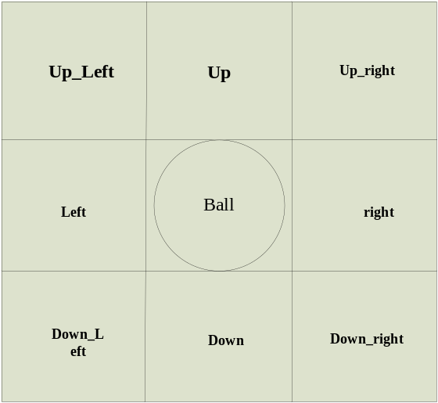
Figure 1 Detecting Ball Collision with other 8 blocks
In figure 1, we can see that the centre of the grids is the ball and the rest eight grids are the directions of the ball used to test its collision with the block or the pad and change the new direction of the ball after it has collided.

If bounding box of ball intersects with left blocks and right blocks. pongSpeed.X will be -pongSpeed.X. If bounding box of ball intersects with up and down, pongSpeed.Y will be -pongSpeed.Y.
If bounding box of ball intersects with up_left blocks or down_right block, the speed of X and Y will exchange. The code snippet is:
float temp = speed.X;
speed.X = -speed.Y;
speed.Y = -temp;

If bounding box of ball intersects with up_right or down_left block, the speed of X and Y will exchange. The code snippet is:
float temp = speed.X;
speed.X = speed.Y;
speed.Y = temp;
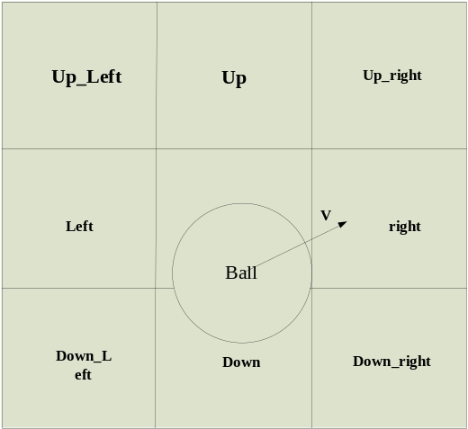
Figure 2 Ball Collision with “down_right" Blocks

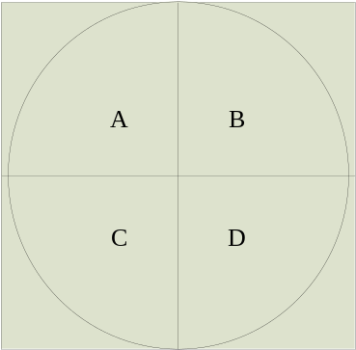
Figure 3 Dividing Ball into 4 parts
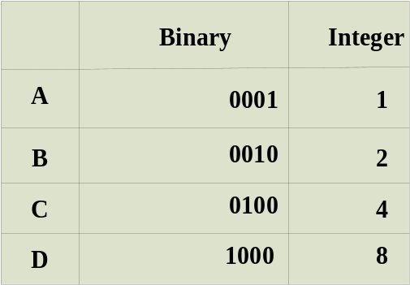
Figure 4 Binary Table
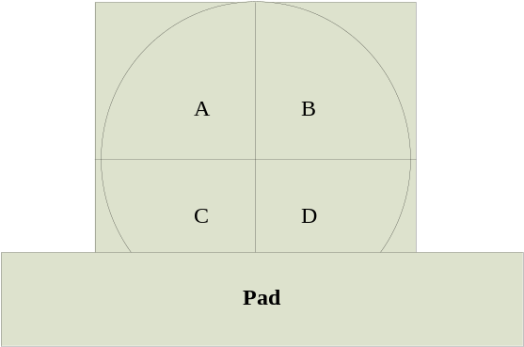
Figure 5 Ball collision with Pad

