Note: 3D,22,32,2H,0X are in the same team for SDC-II
Software Requirements Specification (SRS)
Explainable AI-Generated Code Detection System
1. Abstract
The Explainable AI-Generated Code Detection System is designed to identify whether a submitted piece of source code was written by a human, generated by an AI model, produced through human-AI collaboration (hybrid), or deliberately disguised to appear human-written (adversarial). With AI coding assistants becoming widely available, existing plagiarism and evaluation tools can no longer reliably confirm code authorship, creating challenges in academic assessment and technical hiring.
The system uses a pretrained code-understanding transformer model (CodeBERT / UniXcoder) combined with structural and stylometric features (naming conventions, comment style, indentation patterns, and token-level probability signals) to classify code samples. Unlike existing black-box detectors, the system also provides an explainability layer that highlights which specific features contributed to a given classification, making the result interpretable for non-technical evaluators such as professors and recruiters.
The platform is designed to be deployed as a lightweight API that can operate independently through a web interface, or be integrated into an existing coding platform (such as the college's Toofaan/Tesselator IDE) to automatically scan code at the point of submission, without noticeably delaying the student's workflow.
The primary objective of the system is to provide a fast, explainable, and generalizable AI-code detection capability that supports academic integrity, technical hiring verification, and secure software review practices.
2. Functional Requirements
2.1 User Authentication
- User registration and login.
- Role-based authentication for Student, Faculty/Evaluator, and Administrator.
- Secure password management.
2.2 Code Submission Module
- Users can paste code directly or upload a code file.
- Support for multiple programming languages (Python, Java, C++, and others).
- Option to trigger detection automatically at the point of submission (e.g., IDE 'Submit' action).
2.3 Feature Extraction Module
- Tokenize submitted code and pass it through a pretrained encoder (CodeBERT/UniXcoder).
- Extract token-level probability signals.
- Compute structural features: naming style, comment density, whitespace/indentation patterns, AST-based metrics.
2.4 AI Code Detection Module
- Classify code as Human-written, Fully AI-generated, Hybrid, or Adversarial.
- Return a confidence score for the predicted class.
- Support evaluation on unseen languages, domains, and AI generators.
2.5 Explainability Module
- Identify which extracted features most influenced the classification decision.
- Generate a visual breakdown (e.g., bar chart) showing feature contributions.
- Present explanations in plain language understandable to non-technical users.
2.6 Student Dashboard
- View own past code submissions.
- View detection results and explanations (where permitted).
- Track submission history over time.
2.7 Faculty / Evaluator Dashboard
- View flagged submissions across students or candidates.
- Review confidence scores and explanations for each submission.
- Generate class-wide or batch-level detection reports.
2.8 Administrator Dashboard
- Manage users and role-based access.
- Configure or update the underlying detection model.
- Monitor overall platform usage and system health.
2.9 Report Generation
- Generate detection reports for individual submissions.
- Generate aggregate reports for a class, batch, or hiring pipeline.
- Export reports in PDF/CSV format.
2.10 API Integration Module
- Expose a REST API endpoint (e.g., POST /detect) for external integration.
- Enable integration with the college's coding platform (Toofaan/Tesselator) to scan code at submission time.
- Return structured JSON output containing verdict, confidence score, and explanation data.
3. Non-Functional Requirements
Performance
- Detection should complete within a few seconds so as not to delay code submission.
- Dashboard analytics should load within 3 seconds.
- Support multiple concurrent submissions without performance degradation (e.g., during lab exams).
Security
- Secure authentication and authorization.
- Encrypt sensitive user and code data.
- Role-based access control.
- Secure API communication using HTTPS.
Reliability
- System availability of at least 99%.
- Detection failures must not block or delay a student's code submission.
- Automatic logging and recovery from failures without data loss.
Scalability
- Support an increasing number of users, submissions, and courses.
- Easily integrate additional AI generator families as new detection targets.
Usability
- Simple and intuitive user interface.
- Explanations must be understandable to non-technical evaluators.
- Responsive design for desktop and mobile devices.
Maintainability
- Modular pipeline: feature extraction, classification, and explainability are independently replaceable.
- Well-documented API and codebase.
- Easy integration of future detection models or feature sets.
Compatibility
- Compatible with modern web browsers.
- Support for multiple programming languages beyond the initial training set.
- Designed to integrate with existing platforms (e.g., Toofaan/Tesselator).
4. Users
Student
The student writes and submits code through the platform (directly or via an integrated IDE), and may view their own submission history and, where permitted, their detection results.
Faculty / Evaluator
Faculty members, professors, or technical recruiters review flagged submissions, examine confidence scores and explanations, and use this information to assess academic integrity or genuine coding skill.
Administrator
The administrator manages users, oversees the detection model configuration, monitors platform usage, and maintains overall system health.
5. Modules in the Application
1. User Authentication Module
Description: Handles secure user registration, login, logout, and role-based access for different users.
Functions:
- User Registration
- User Login/Logout
- Password Management
- Role-Based Authentication (Student, Faculty, Administrator)
2. Code Submission Module
Description: Allows users to submit code for analysis, either by pasting it directly or through an integrated coding platform.
Functions:
- Paste / Upload Code
- Multi-Language Support
- Trigger Detection on Submit
3. Feature Extraction Module
Description: Encodes submitted code using a pretrained transformer and extracts structural/stylometric features.
Functions:
- Tokenization
- CodeBERT / UniXcoder Encoding
- Token Probability Extraction
- Structural Feature Computation (naming, comments, indentation, AST)
4. AI Detection Module
Description: Classifies code as human-written, AI-generated, hybrid, or adversarial using the extracted features.
Functions:
- Binary / Multi-Class Classification
- Confidence Scoring
- Cross-Language and Cross-Domain Evaluation
5. Explainability Module
Description: Identifies and visualizes which features contributed most to a given classification decision.
Functions:
- Feature Contribution Scoring
- Visual Breakdown Generation
- Plain-Language Explanation Output
6. Student Dashboard Module
Description: Provides students with a view of their own submission history and results.
Functions:
- View Submission History
- View Own Detection Result (if permitted)
- View Explanations
7. Faculty / Evaluator Dashboard Module
Description: Allows faculty or recruiters to review flagged submissions and analyze detection outcomes.
Functions:
- View Flagged Submissions
- Review Confidence Scores and Explanations
- Generate Class/Batch Reports
8. Administrator Module
Description: Provides complete system management and monitoring capabilities.
Functions:
- Manage Users
- Manage Detection Model / Thresholds
- Monitor Platform Usage
- Generate Institutional Reports
9. Reporting & Analytics Module
Description: Generates reports and visual summaries for different users.
Functions:
- Individual Submission Reports
- Class/Batch Analytics
- Export Reports (PDF/CSV)
- Graphs and Charts
10. API Integration Module
Description: Exposes the detection pipeline as a REST API so it can be called by external platforms.
Functions:
- POST /detect Endpoint
- Structured JSON Response (verdict, confidence, explanation)
- Integration with Toofaan / Tesselator

6. Workflow
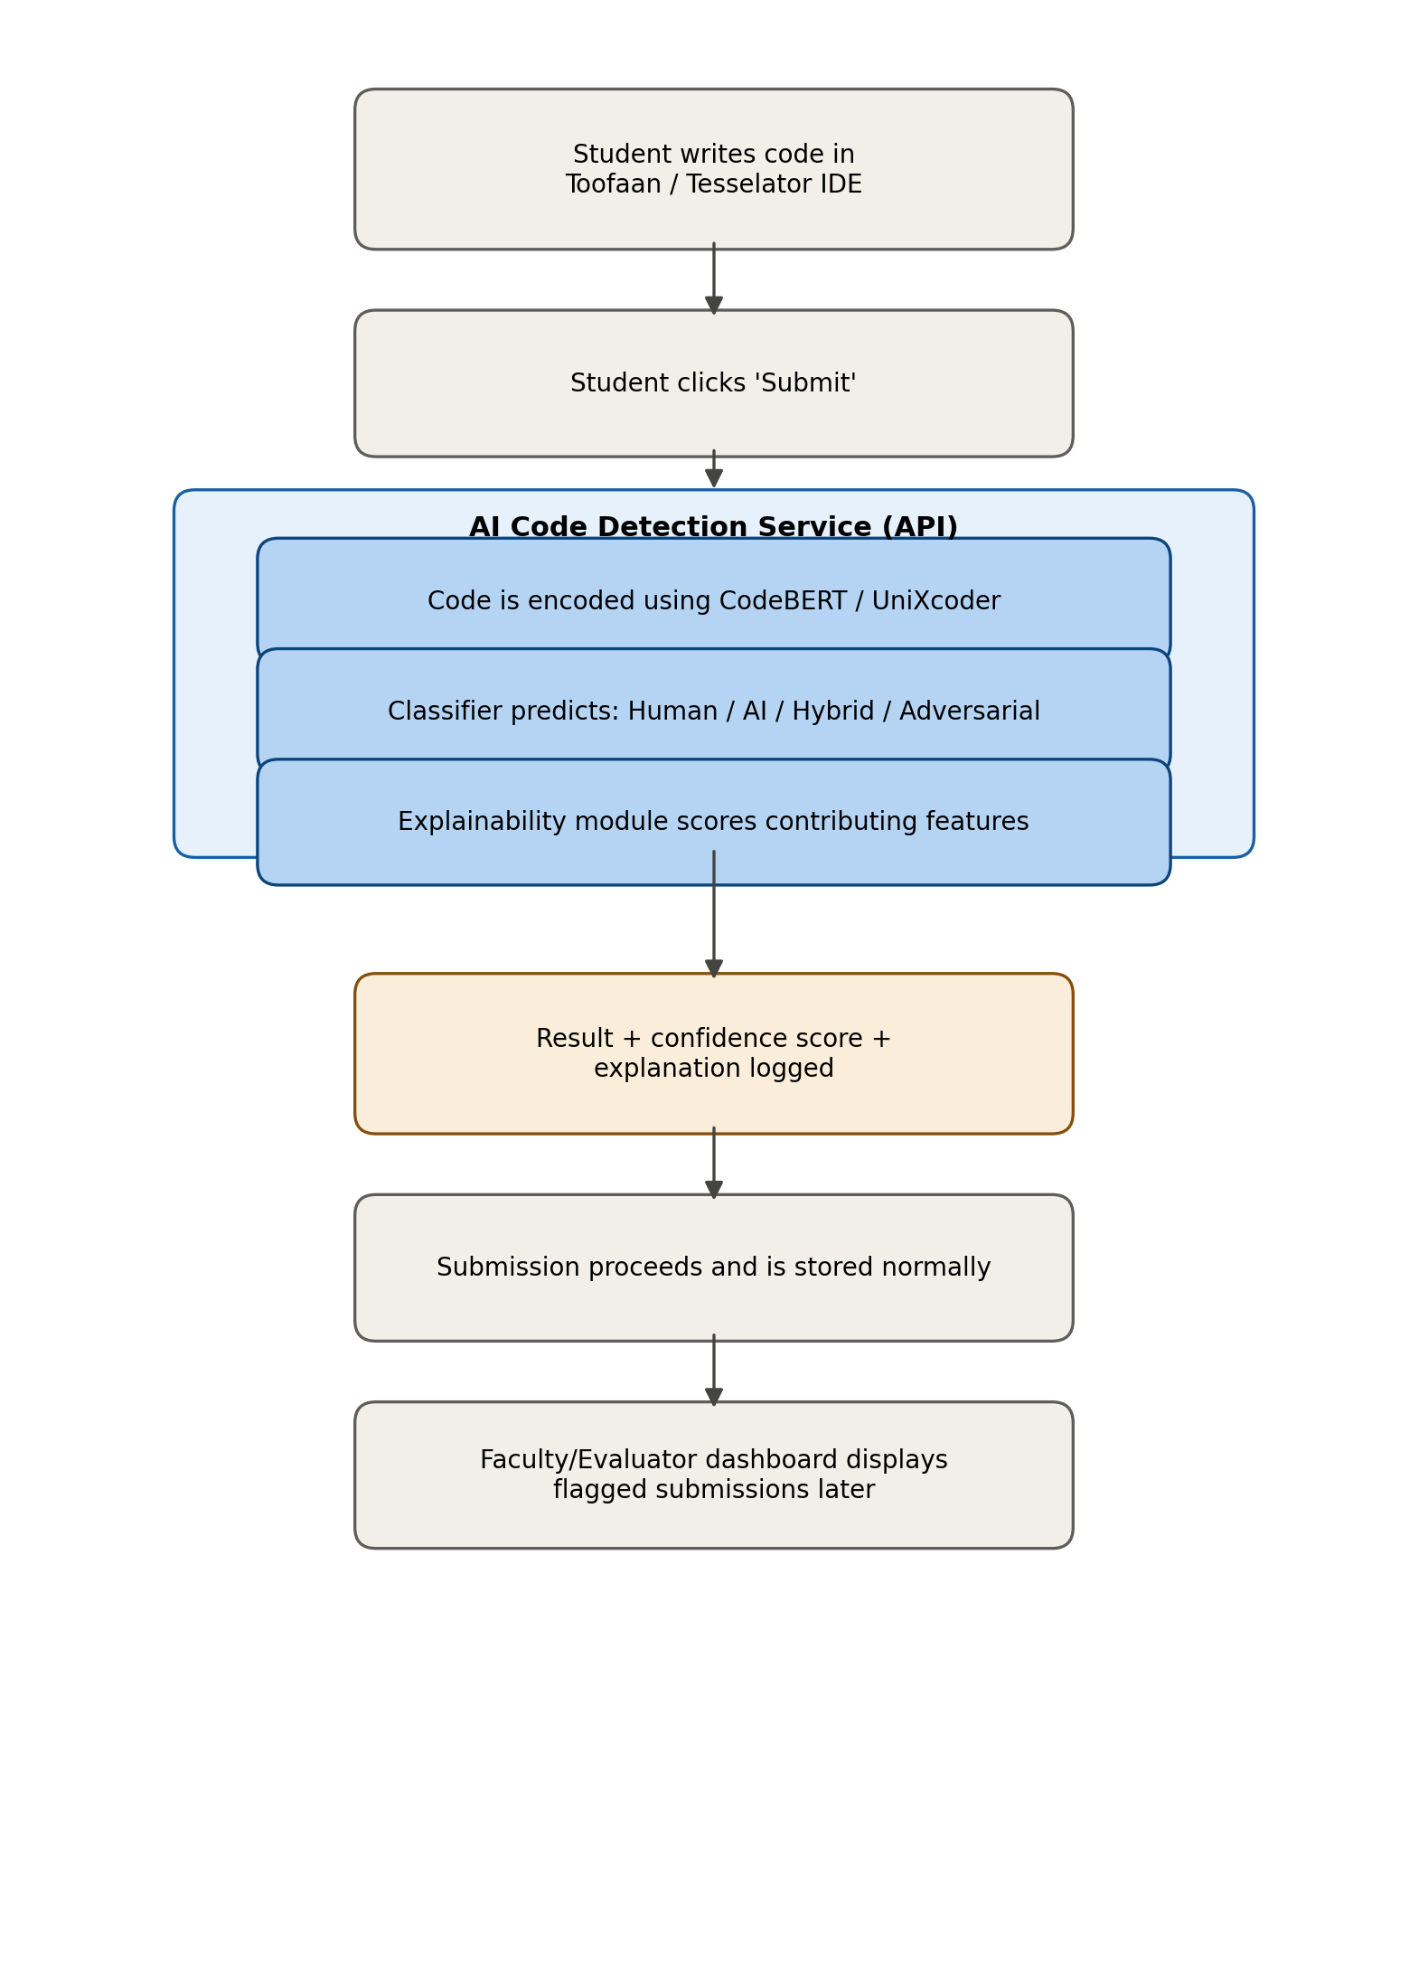

7. Use Case Diagram
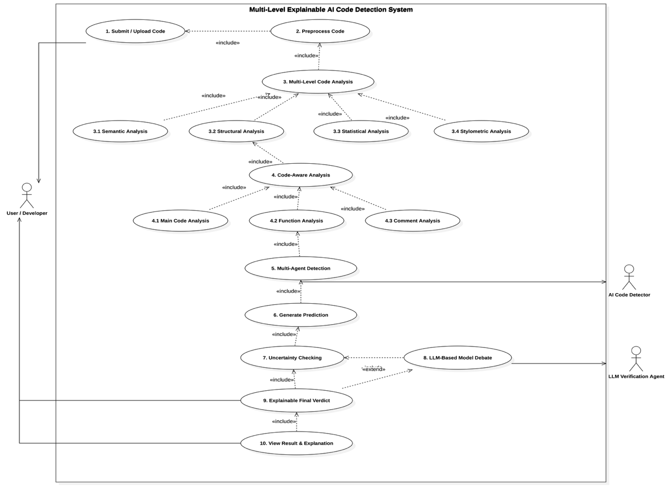
8. Class Diagram
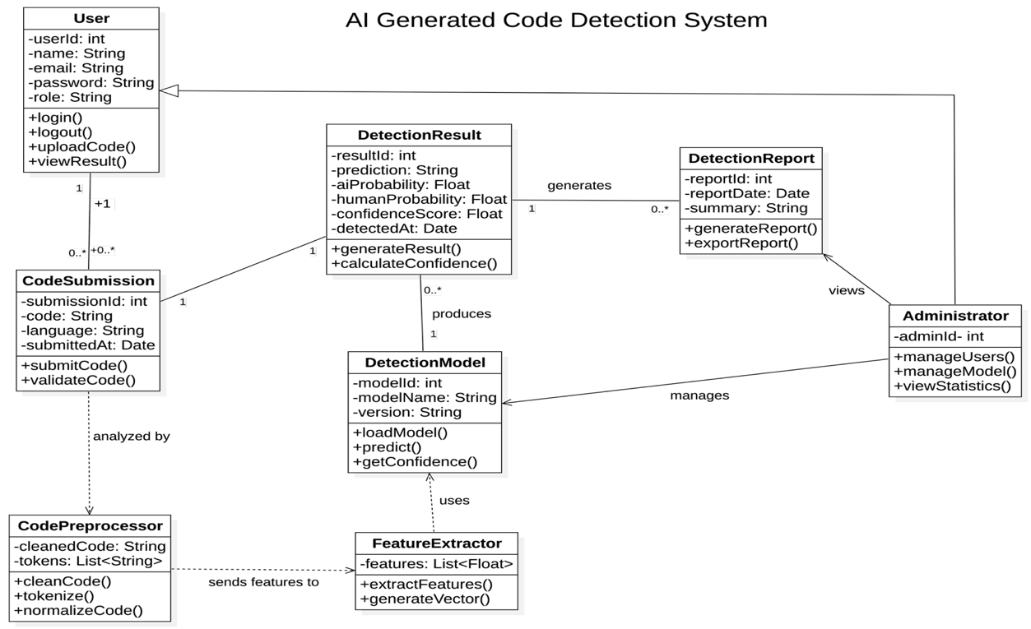
9. Sequence Diagram
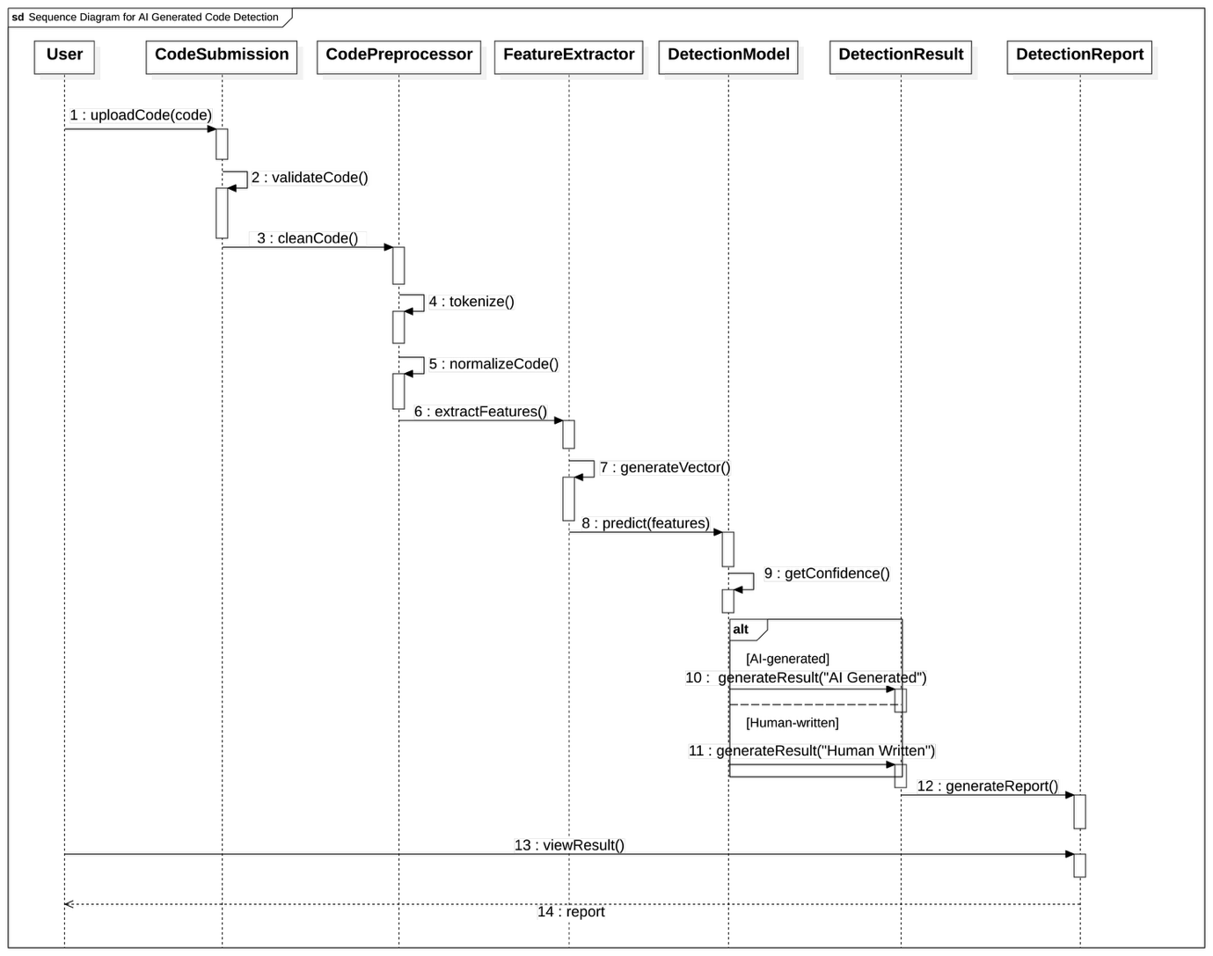
10. Component Diagram
