LAB ACTION PLAN FOR WEEK 4

Objective:
To enable students to:
- Understand the structure and lifecycle of a Maven project.
- Build and package Java and Web applications using Maven.
- Add dependencies using pom.xml, compile and test using plugins.
- Resolve errors and conflicts arising from dependency mismatches.
- Work with parent and multi-module Maven projects.
- Generate executable JARs and deployable WARs using Maven.
Students must document observations, include screenshots of executions, and answer scenario-based questions after completing the tasks.

Understanding Maven Project Structure
Maven standardizes the project structure for both Java and web-based applications.
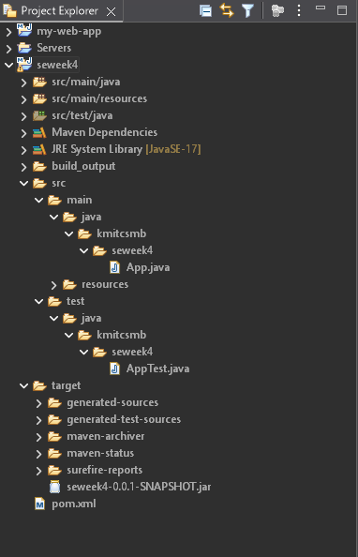
src/
├── main/
│ ├── java/ → Application source code
│ └── resources/ → Configuration files like config.properties
└── test/
├── java/ → Unit test source code
└── resources/ → Test resources
The compiled files and reports are generated in the target/ directory after a successful build.

Steps to Perform Maven Build and Testing
----mvn clean install
- clean: Deletes the previous build (target/ folder)
- install: Builds, tests, and installs the package to local .m2 repository
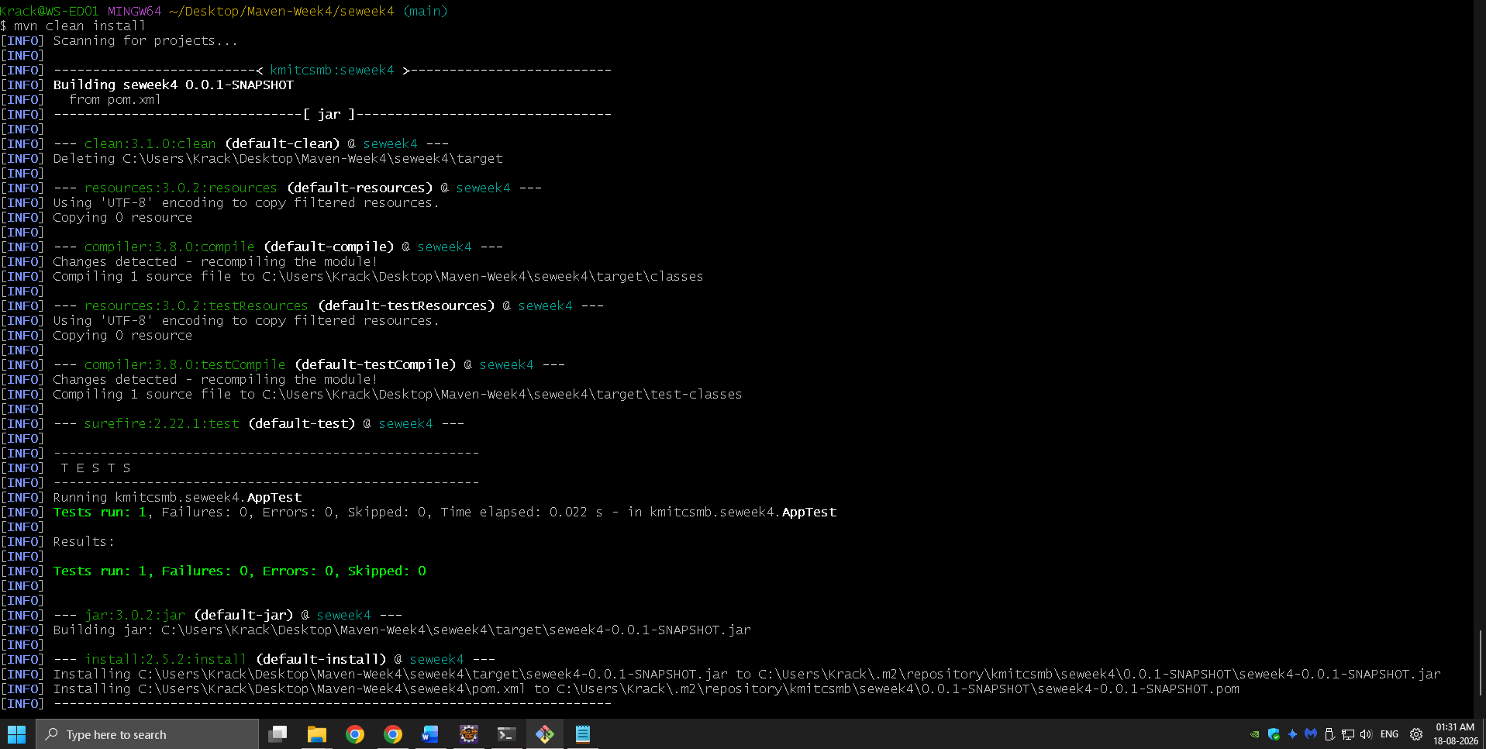
After execution:
- target/ folder contains compiled .class files and the final .jar or .war
- Artifact is stored in:
~/.m2/repository/groupId/artifactId/version/
Add a Dependency (e.g., Gson):
In pom.xml:
<dependency>
<groupId>com.google.code.gson</groupId>
<artifactId>gson</artifactId>
<version>2.10</version>
</dependency>
After running:
mvn clean install
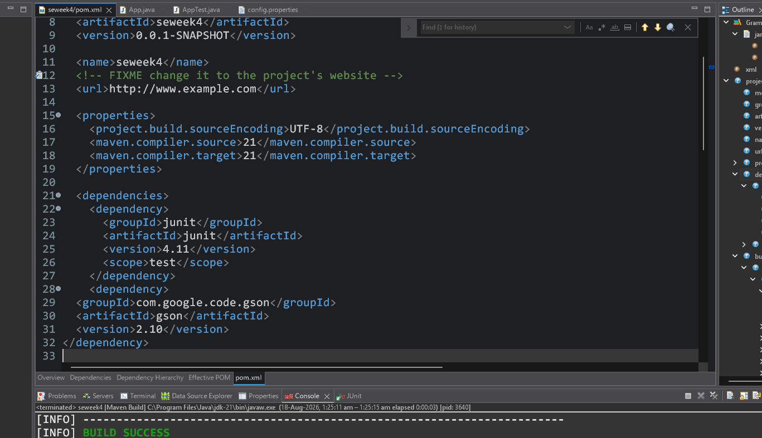
Check:
- Gson JAR is downloaded to .m2/repository/com/google/code/gson/gson/
- If version is wrong or not found → BUILD FAILURE with dependency resolution error.
Creation of Maven Java Project
Step 1. Open Eclipse IDE
└── 1.1. Launch Eclipse workspace
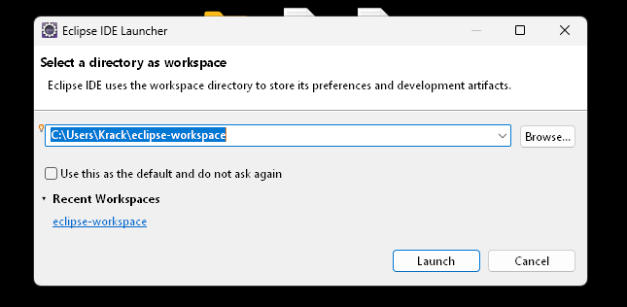
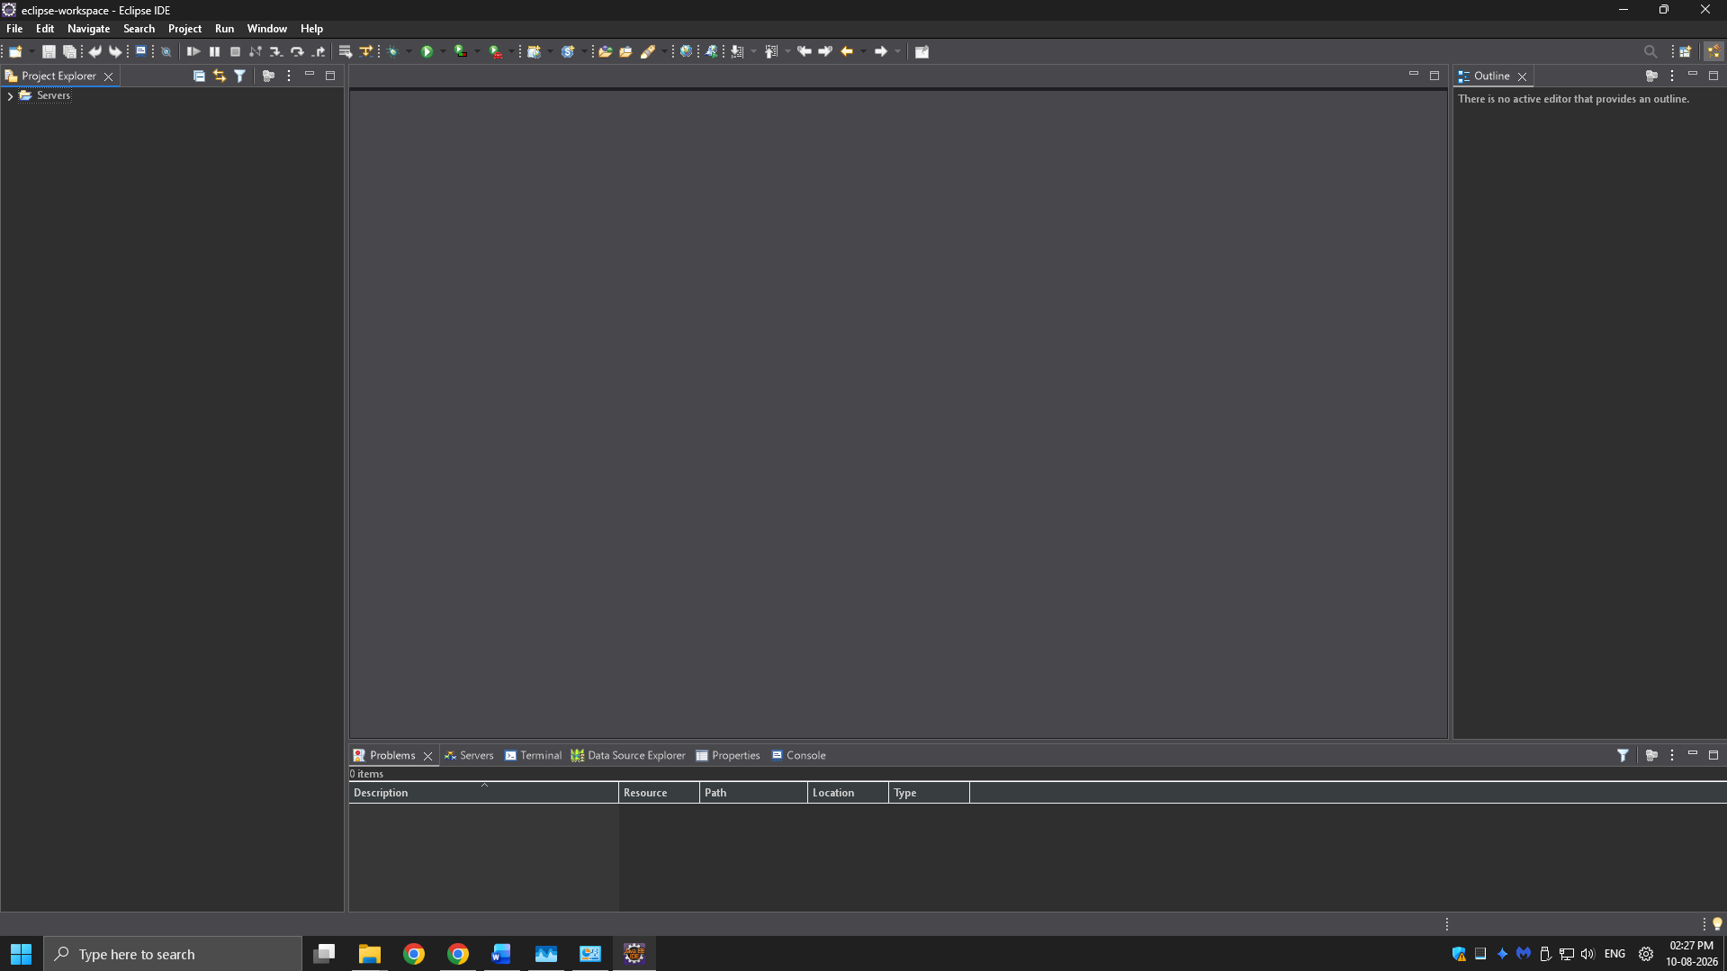
Step 2. Install Maven Plugin (if not installed)
└── 2.1. Go to "Help" in the top menu
└── 2.1.1. Click "Eclipse Marketplace"
└── 2.1.2. Search for "Maven Integration for Eclipse"
└── 2.1.3. Install the plugin if not already installed
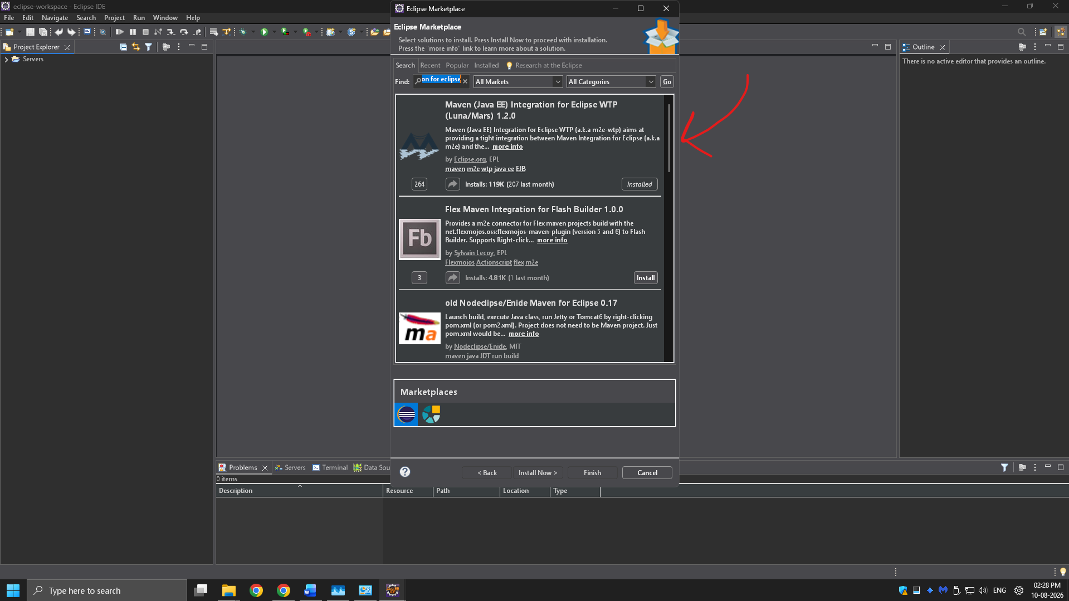

Step 3. Create a New Maven Project
└── 3.1. File -> New -> Project...
└── 3.1.1. Expand "Maven"
└── 3.1.2. Select "Maven Project" and click "Next"
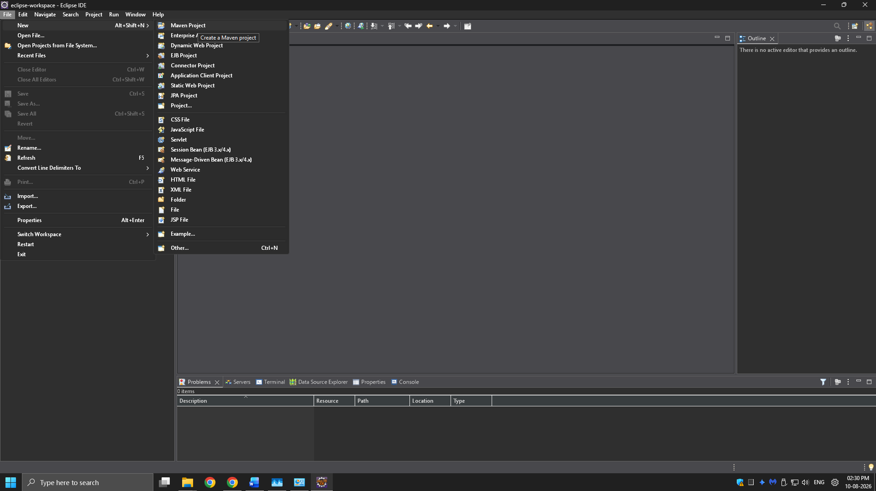

Step 4. Set Project Configuration
└── 4.1. Select workspace location (default or custom)
└── 4.2. Click "Next"

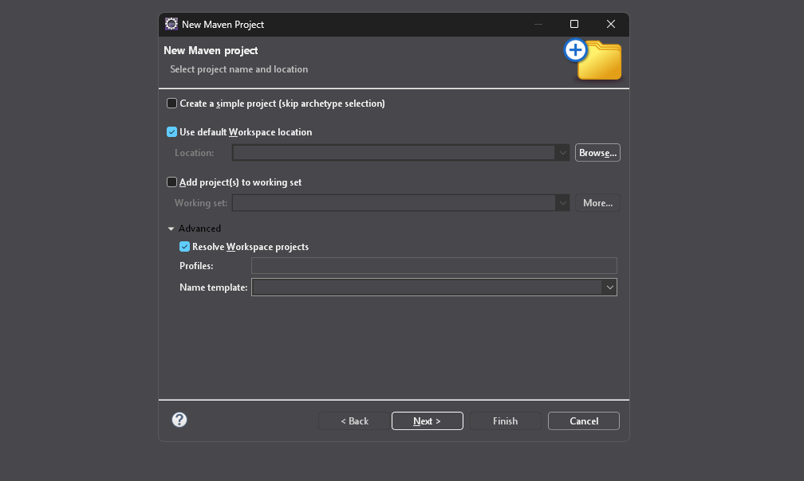

Step 5. Choose Maven Archetype
└── 5.1. Select an archetype(e.g "org.apache.maven.archetypes -> maven-archetype-quickstart 1.4 ")
└── 5.2. Click "Next"
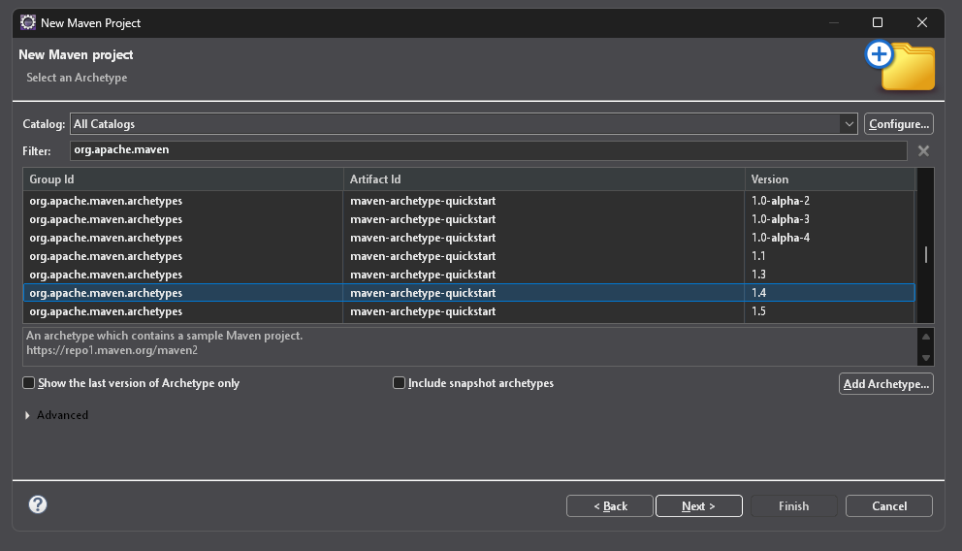
Step 6. Define Project Metadata
└── 6.1. Group ID: (e.g., com.example)
└── 6.2. Artifact ID: (e.g., my-maven-project)
└── 6.3. Version: (default is usually fine)
└── 6.4. Click "Finish"
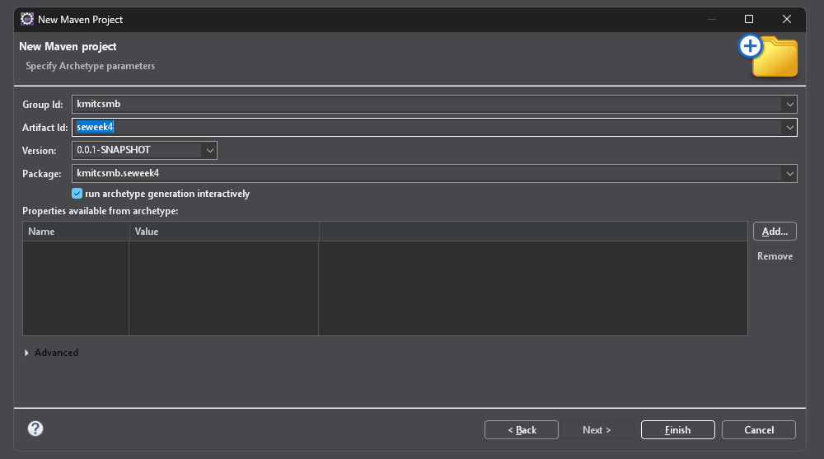

In Console, artifacts are grouped. When prompted with Y/N, type 'Y'.
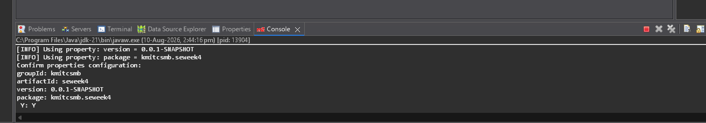
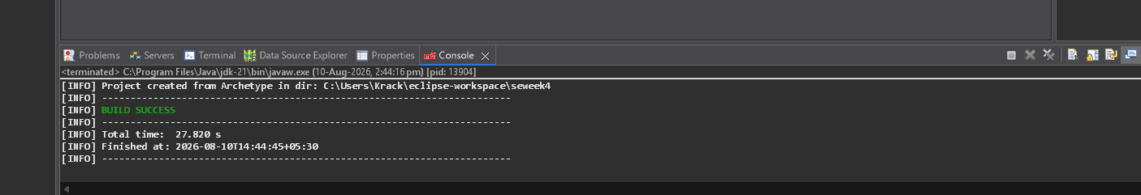
Step 7. Maven Project Created
└── 7.1. Project structure is generated with a standard Maven layout
└── 7.2. Includes:
└── src/main/java (for Java source code)
└── src/test/java (for test code)
└── pom.xml (Maven configuration file)
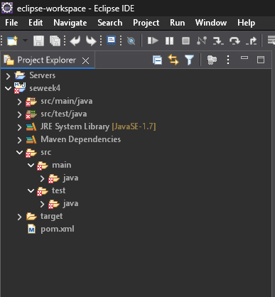
Step 8. Update Project Settings (if needed)
└── 8.1. Right-click on the project -> Maven -> Update Project...
└── 8.2. Ensure dependencies are up to date
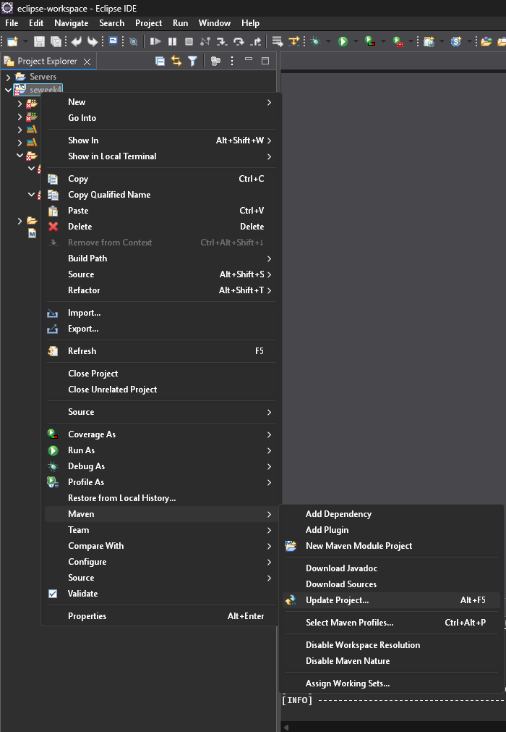
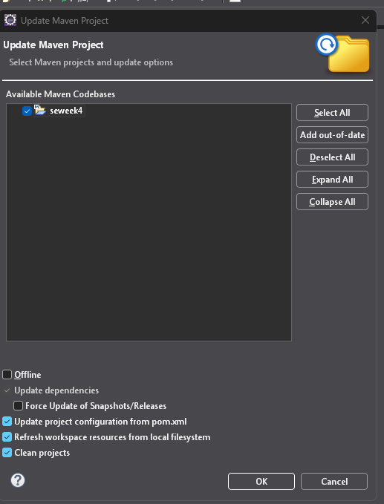
Step 9. Build and Run Maven Project
└── 9.1. Right-click on App.java -> Run As -> Maven Clean
└── 9.1.1. Right-click on App.java -> Run As -> Maven Install
└── 9.1.2. Right-click on App.java -> Run As -> Maven Test
└── 9.1.3. Right-click on App.java -> Run As -> Maven Build
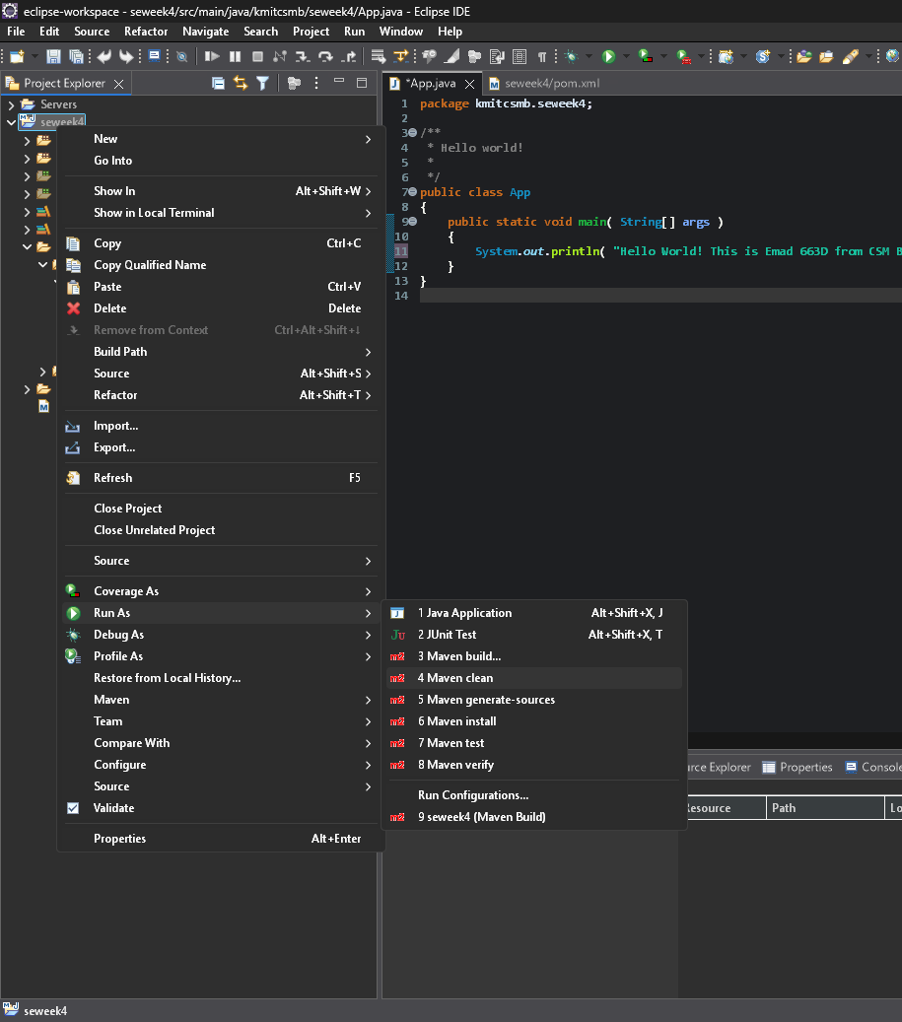
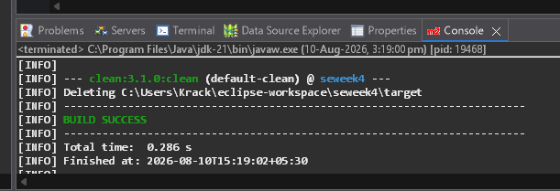
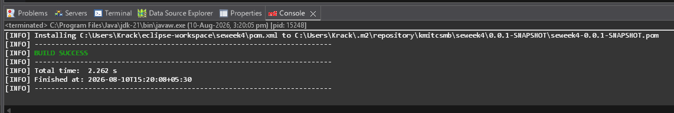
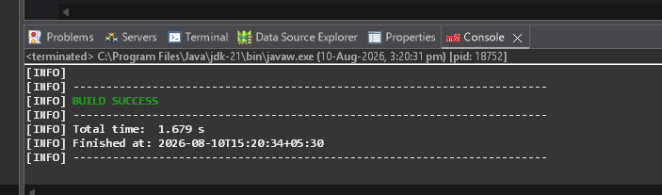

Step 10. In the Maven Build dialog:
└── Enter Goals: clean install test
└── Click on Apply -> Click on Run
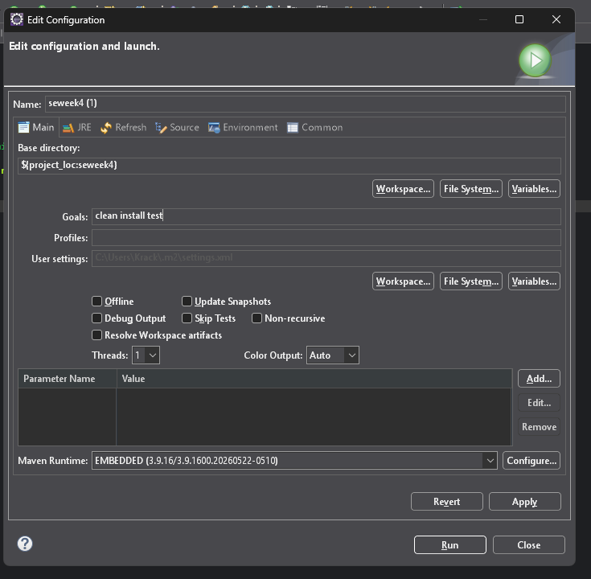
Step 11. Check console for BUILD SUCCESS message.
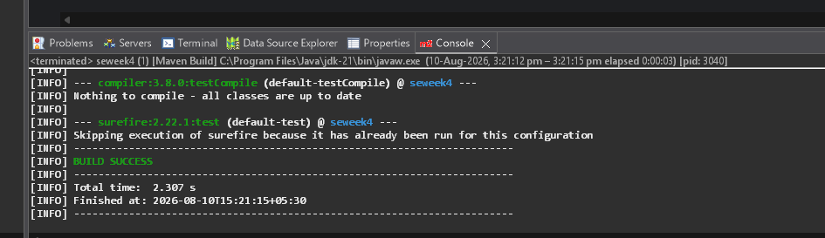
Step 12. Run the application:
└── Right-click on App.java -> Run As -> Java Application
└── Output: "Hello World" displayed.
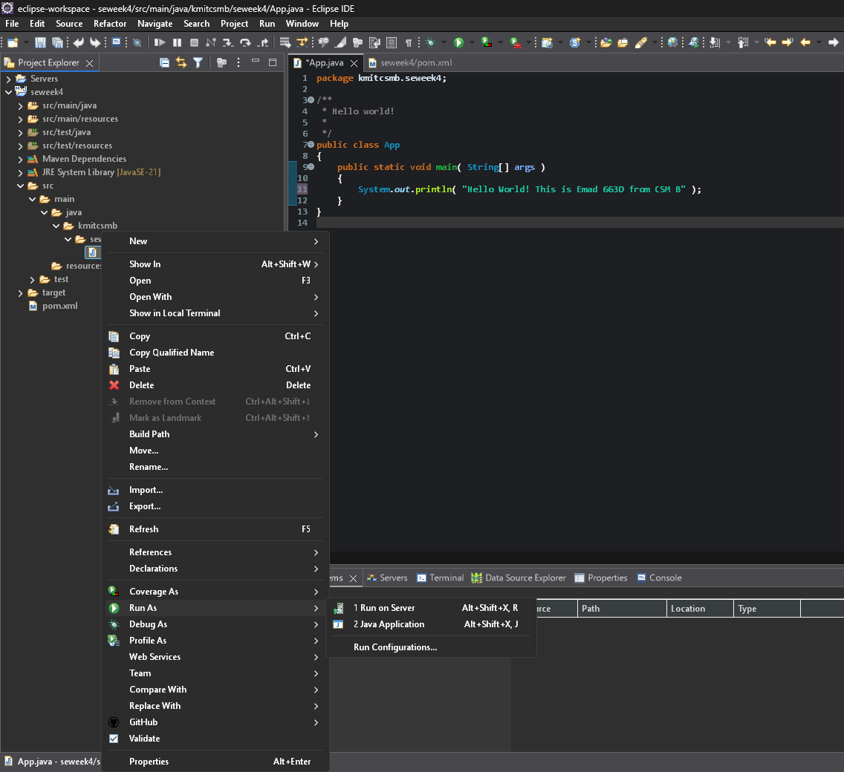
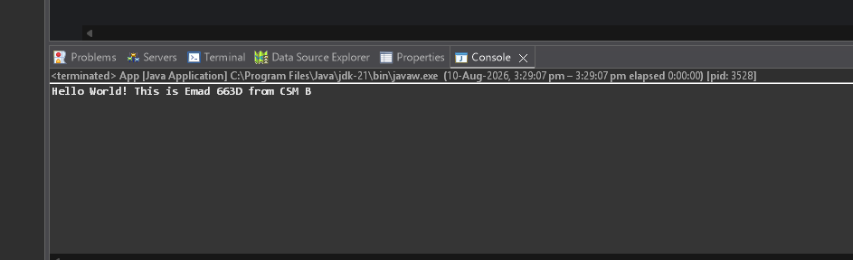

Creation of Maven web Java Project
Step 1: Open Eclipse
└── 1.1 Launch Eclipse IDE.
└── 1.2 Select or create a workspace.

Step 2: Create a New Maven Project
└── 2.1. File -> New -> Project...
└── 2.1.1. Expand "Maven"
└── 2.1.2. Select "Maven Project" and click "Next"
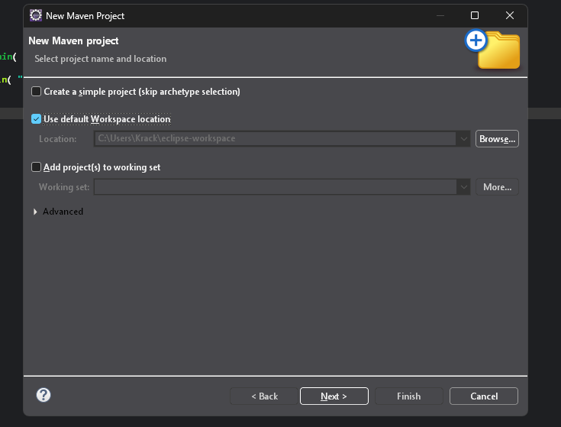
Step 3: Choose Maven Archetype
└── 3.1. Select an archetype(e.g "'org.apache.maven.archetypes' -> 'maven-archetype-webapp' 1.4 ")
└── 3.2. Click "Next"
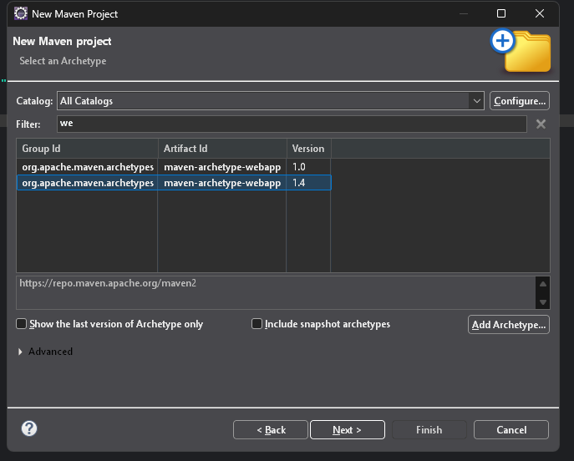
Step 4: Configure the Maven Project
└── 4.1 Group Id: Enter a group ID (e.g., com.example).
└── 4.2 Artifact Id: Enter an artifact ID (e.g., my-web-app).
└── 4.3 Click **Finish** to create the project.
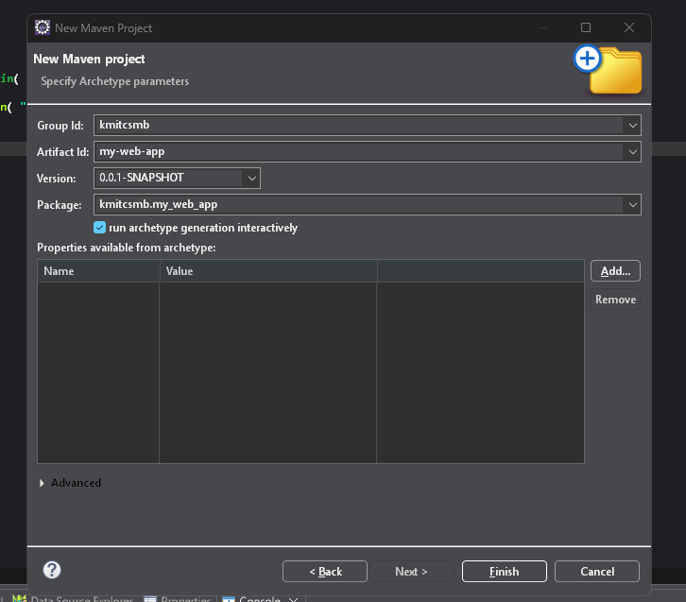
Step 5: Add Maven Dependencies
└── 5.1 Open the **pom.xml** file in the Maven project.
└── 5.2 Add the necessary dependencies for your web project (e.g., Servlet, JSP):
Go to browser -> Open mvnrepository.com
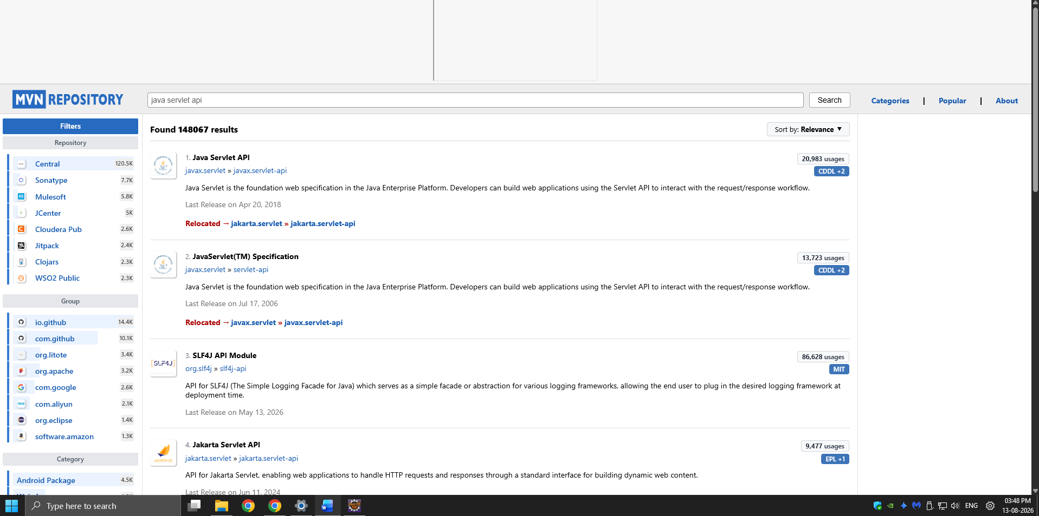
Search for 'Java Servlet API' -> Select the latest version.
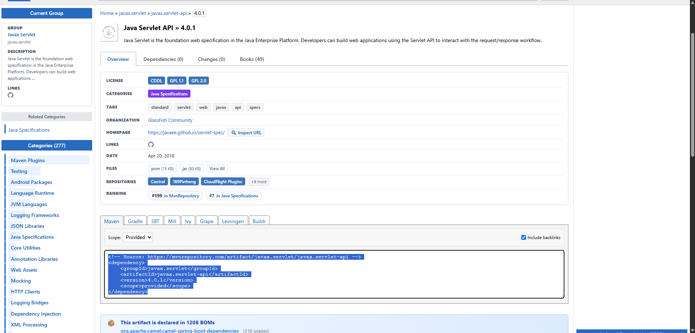
Copy the dependency code -> Paste it in MavenWeb’s pom.xml under the target folder
└── Example:
```xml
<dependency>
<groupId>javax.servlet</groupId>
<artifactId>javax.servlet-api</artifactId>
<version>4.0.1</version>
<scope>provided</scope>
</dependency>
```
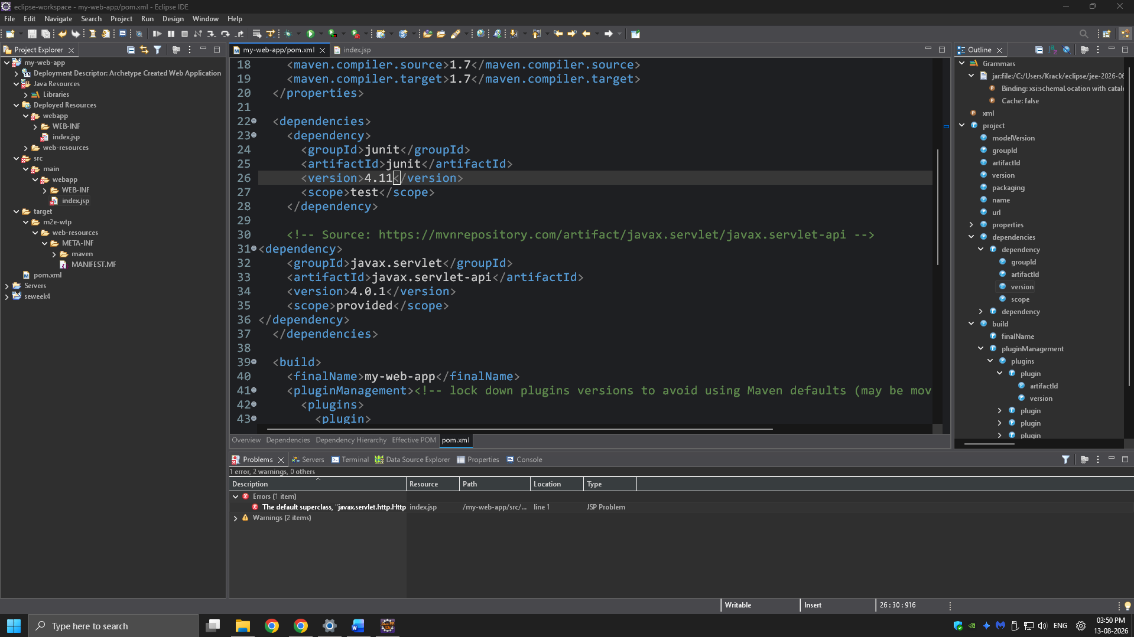

Step 6:-. Configure server:
└── Window -> Show View -> Servers
└── Add server -> Select Tomcat v9.0 server -> Click Next
└── Configure server options (e.g., ports, server location).
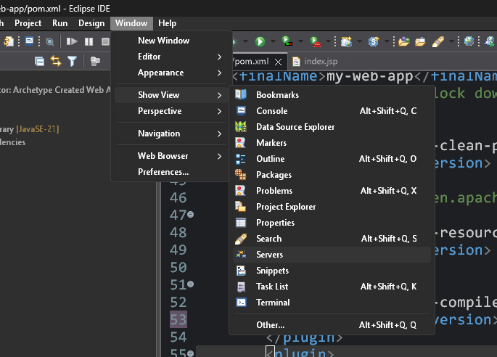
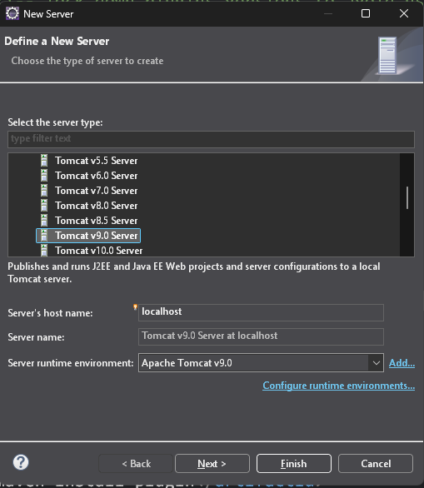
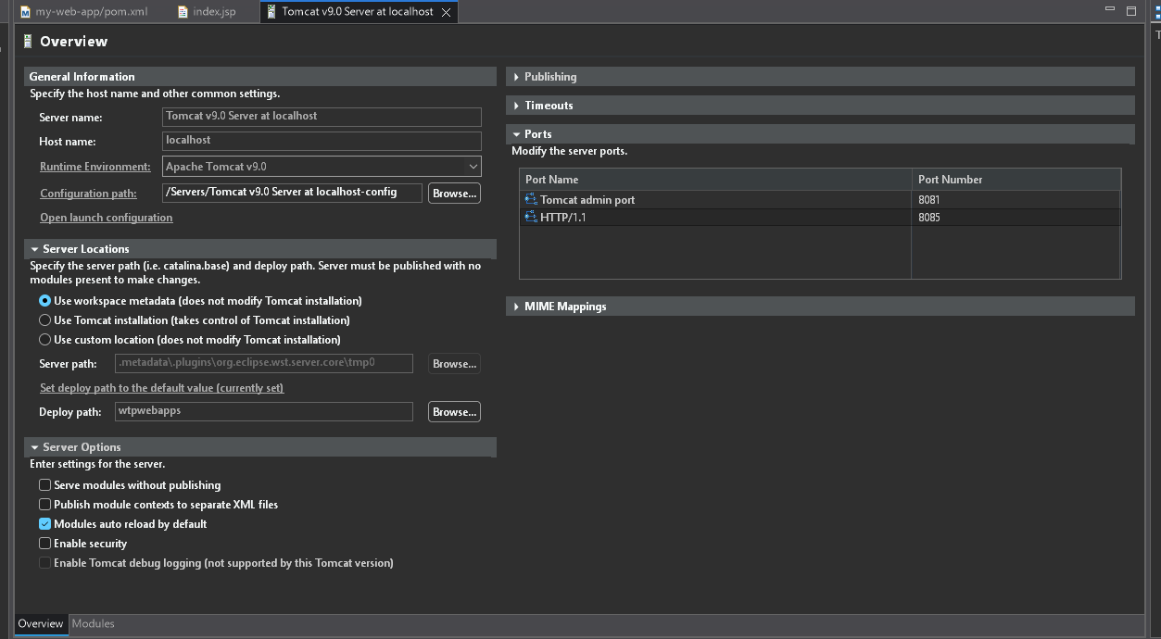
Step 7:-. Modify 'tomcat-users.xml':
└── Add role and user details under <tomcat-users> tag.
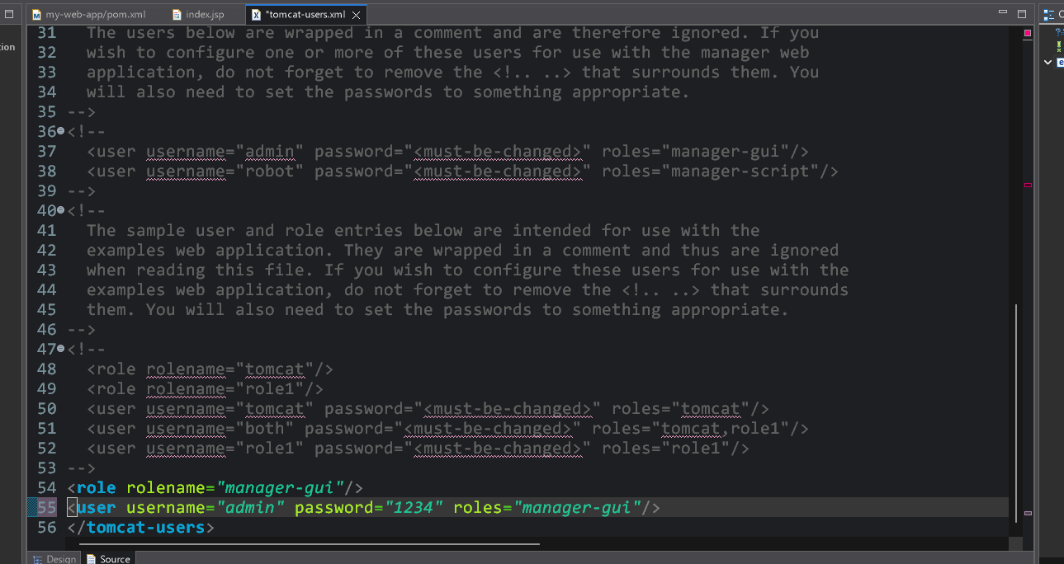
Step 8:. Build the project:
└── Right-click on index.jsp -> Run As -> Maven Clean
└── Right-click on index.jsp -> Run As -> Maven Install
└── Right-click on index.jsp -> Run As -> Maven Test
└── Right-click on index.jsp -> Run As -> Maven Build
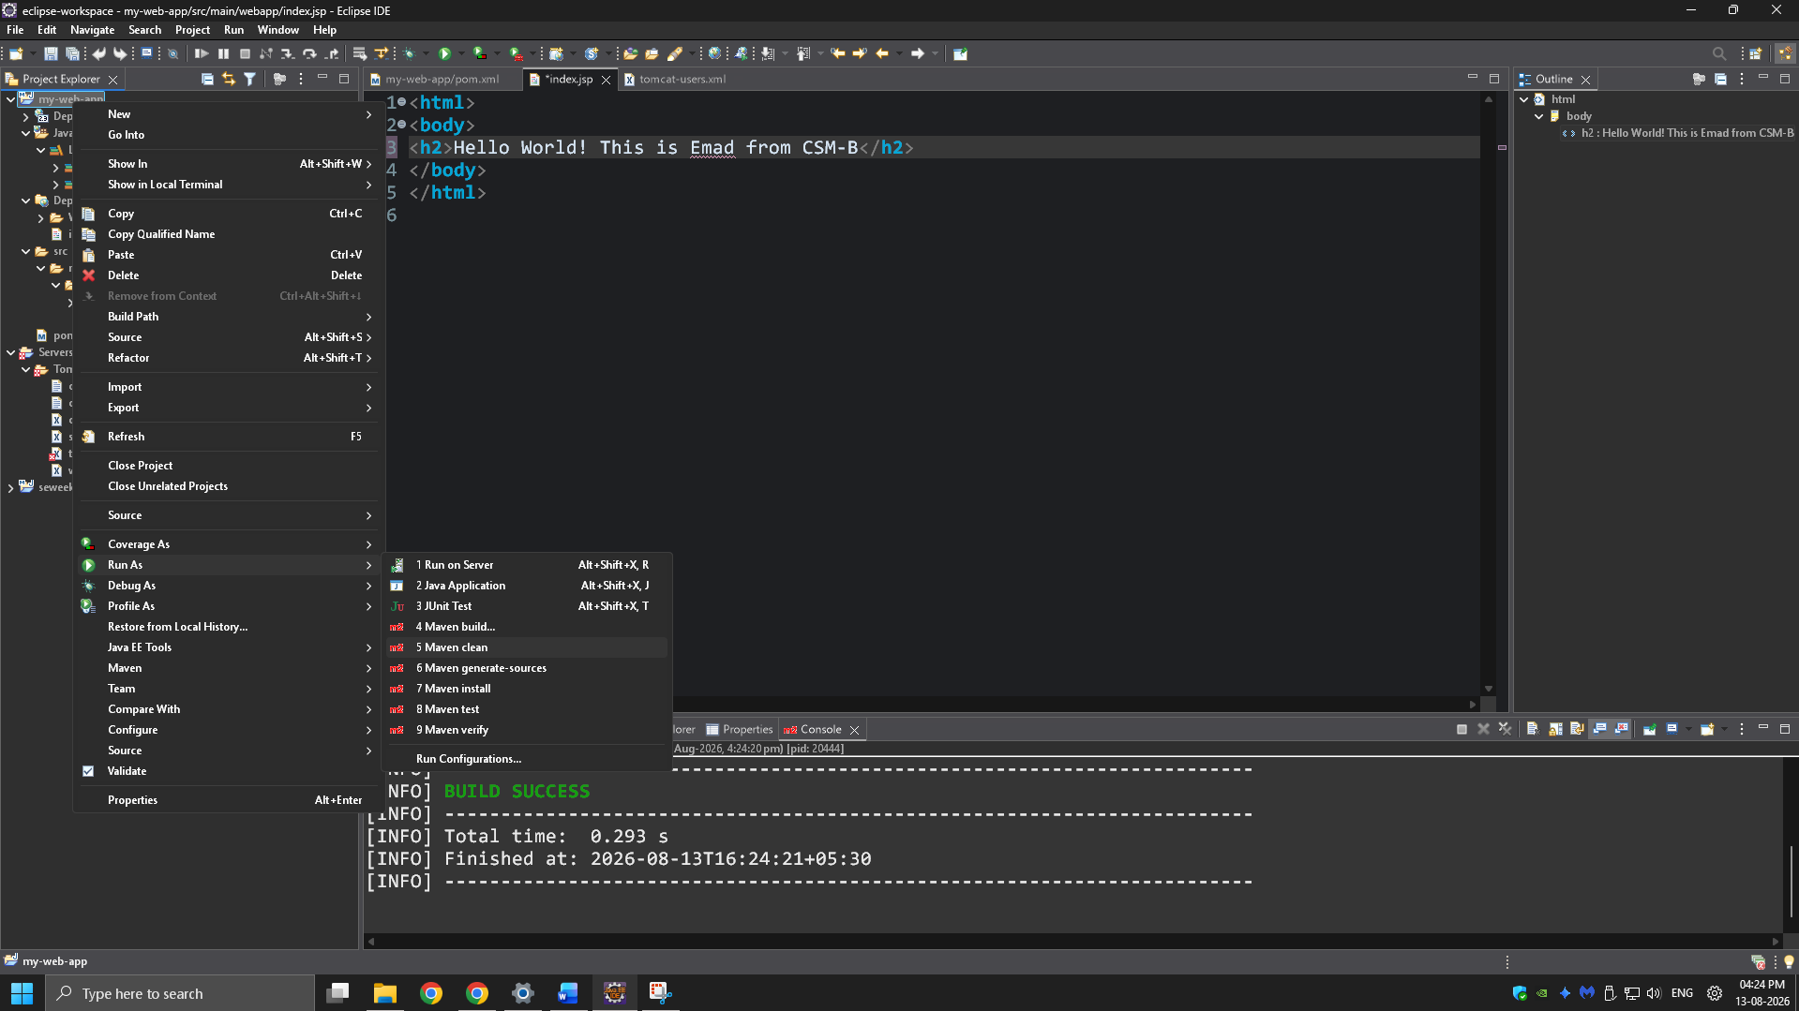
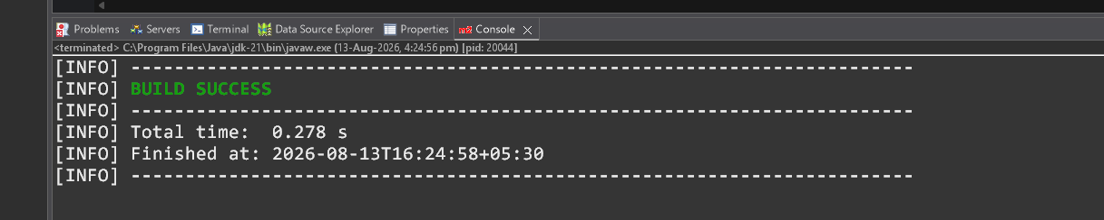
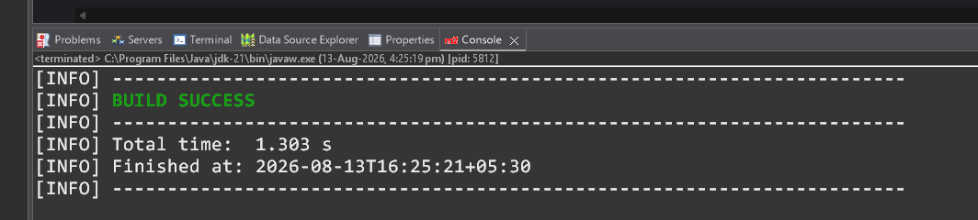
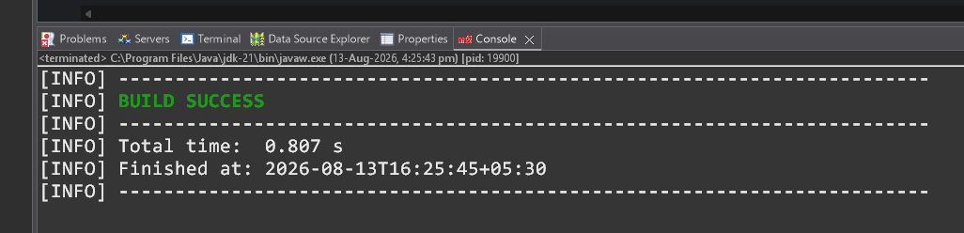
Step 9. In the Maven Build dialog:
└── Enter Goals: clean install test
└── Click on Apply -> Click on Run
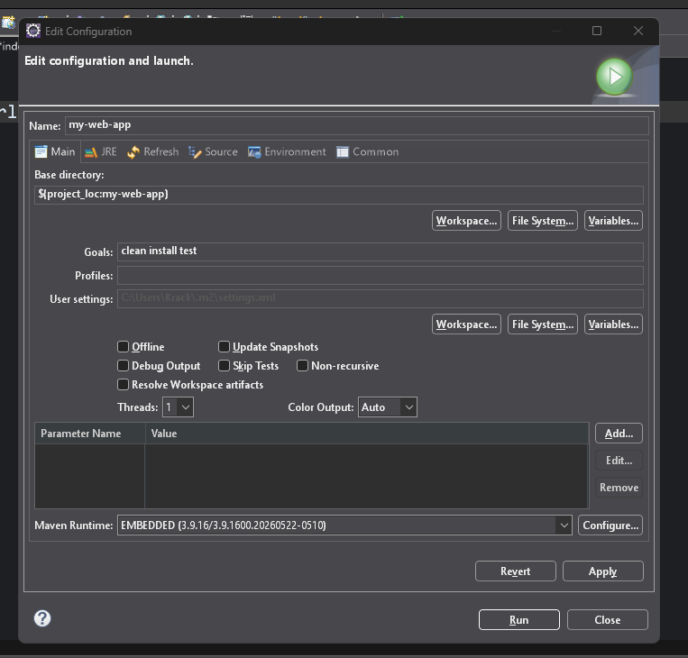
Step 10. Check console for BUILD SUCCESS message.
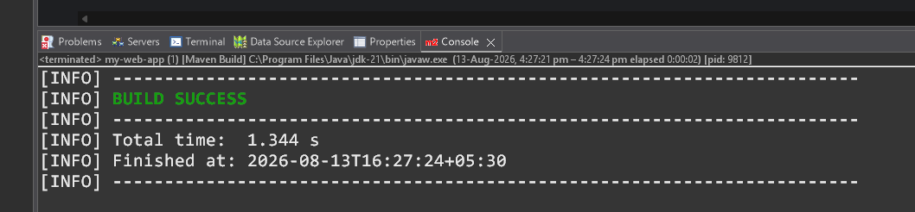
Step 11. Run the application:
└── Right-click on index.jsp -> Run As -> Run on Server
└── Select the Tomcat server -> Click on Finish
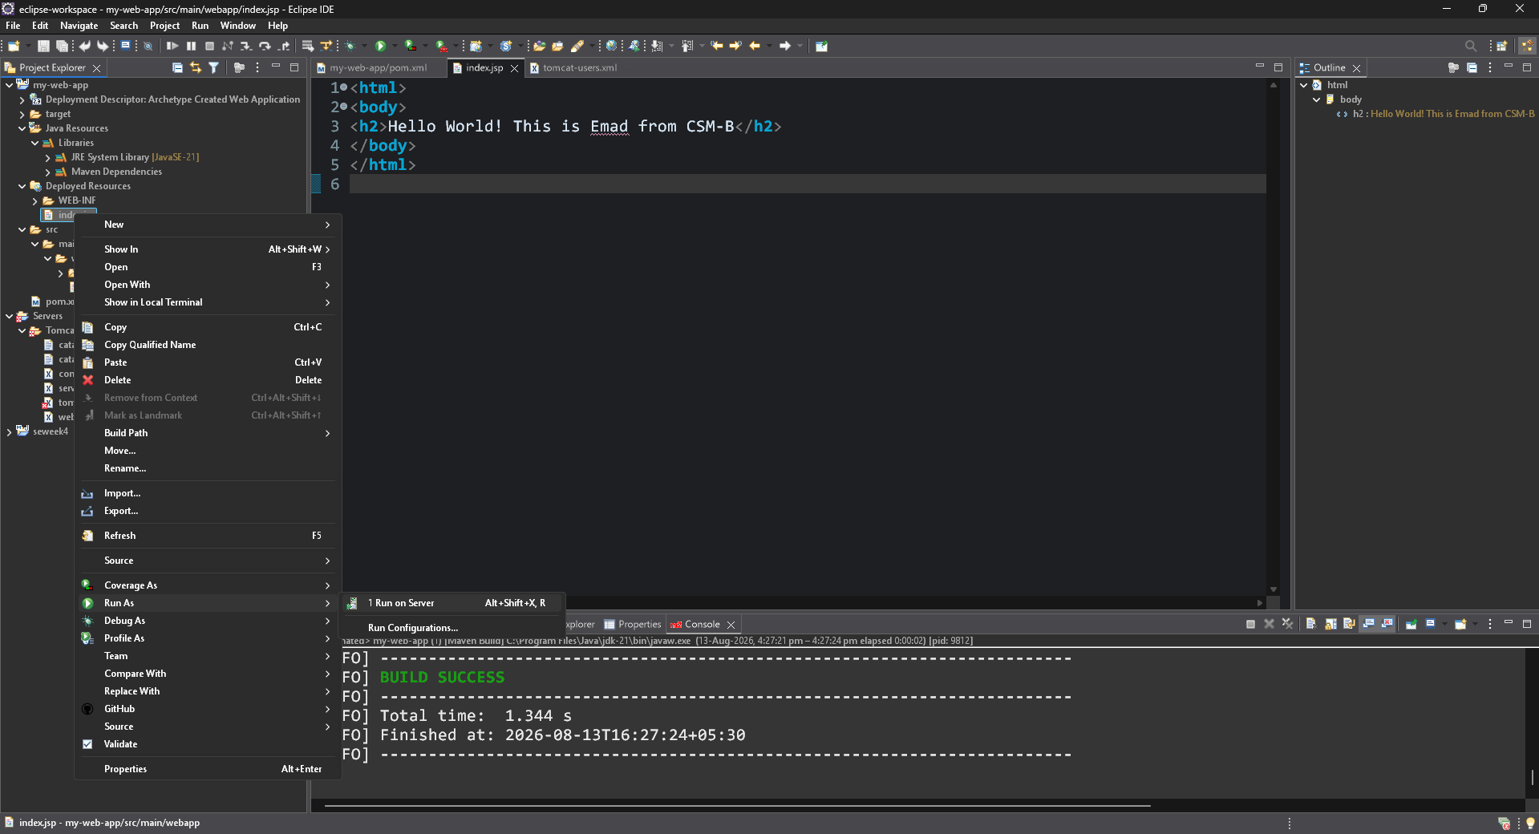
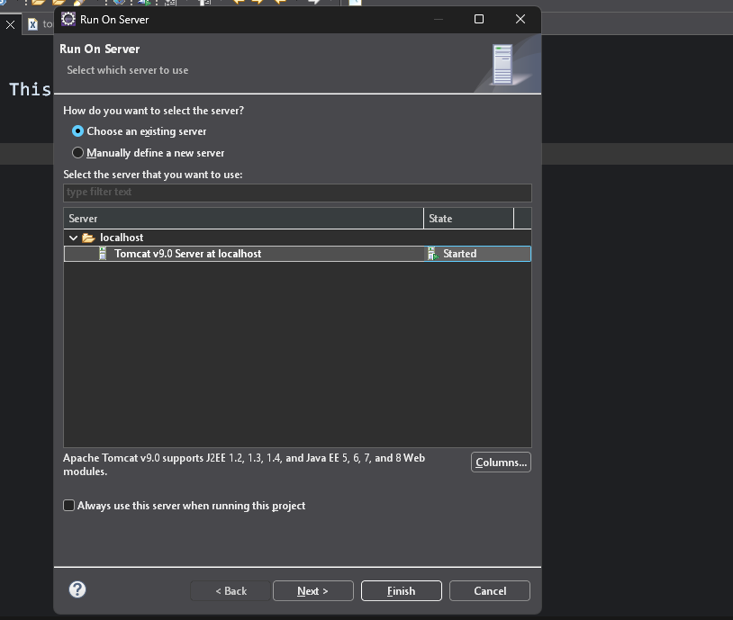
Step 12. Output: "Hello World" webpage displayed.
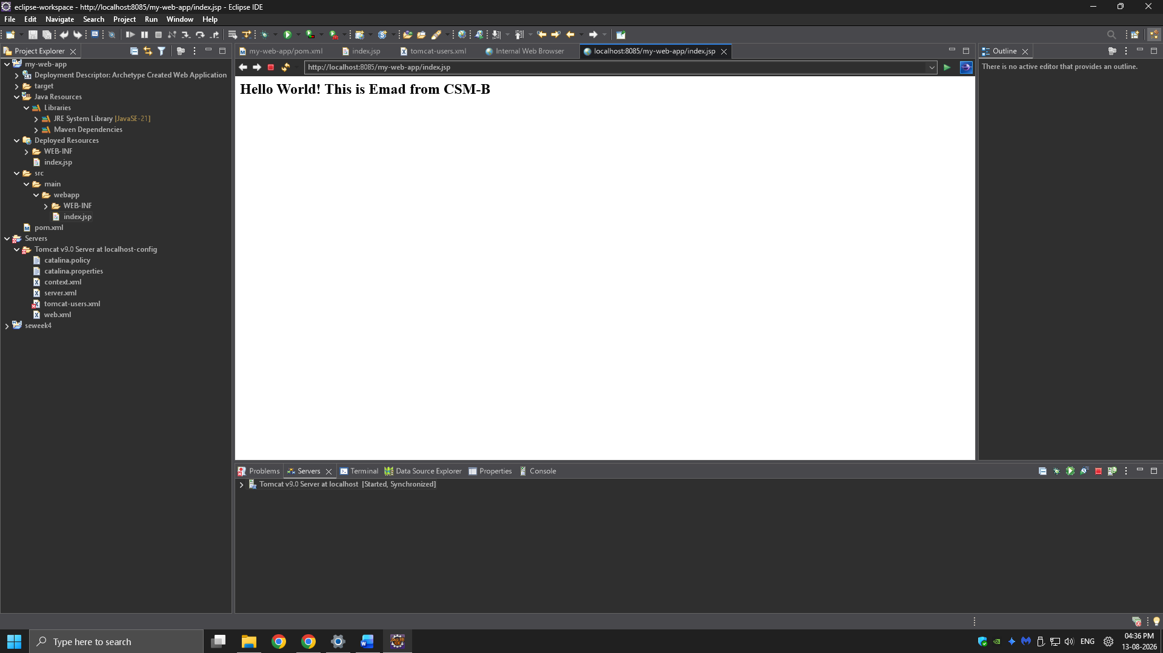
Note:-Now push yours Maven java project and Maven Web Project into your github
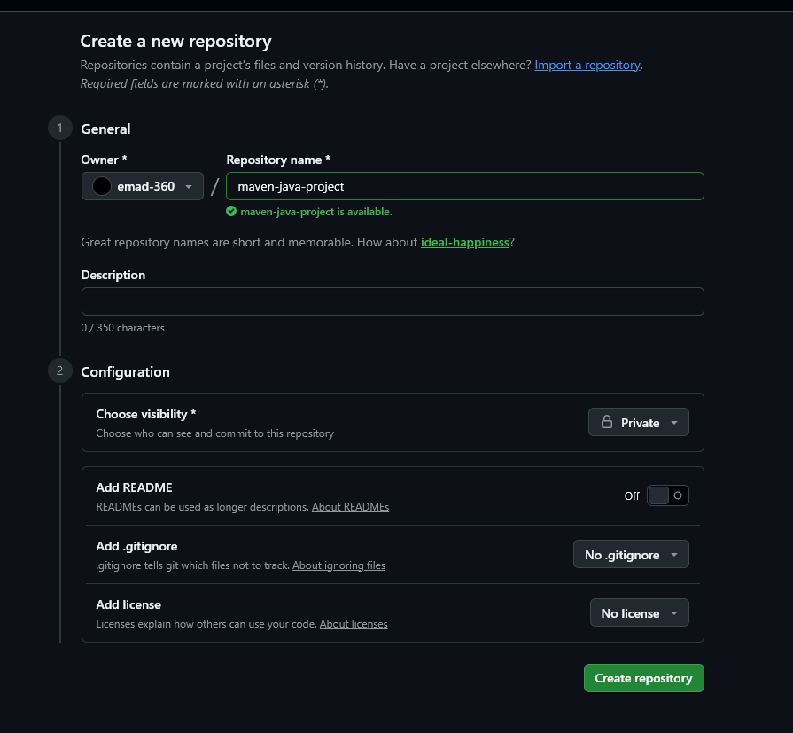
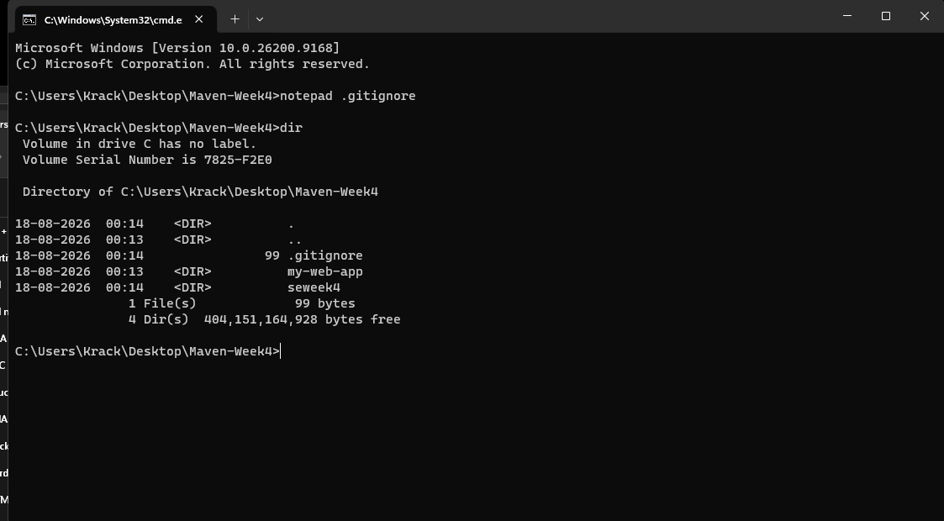

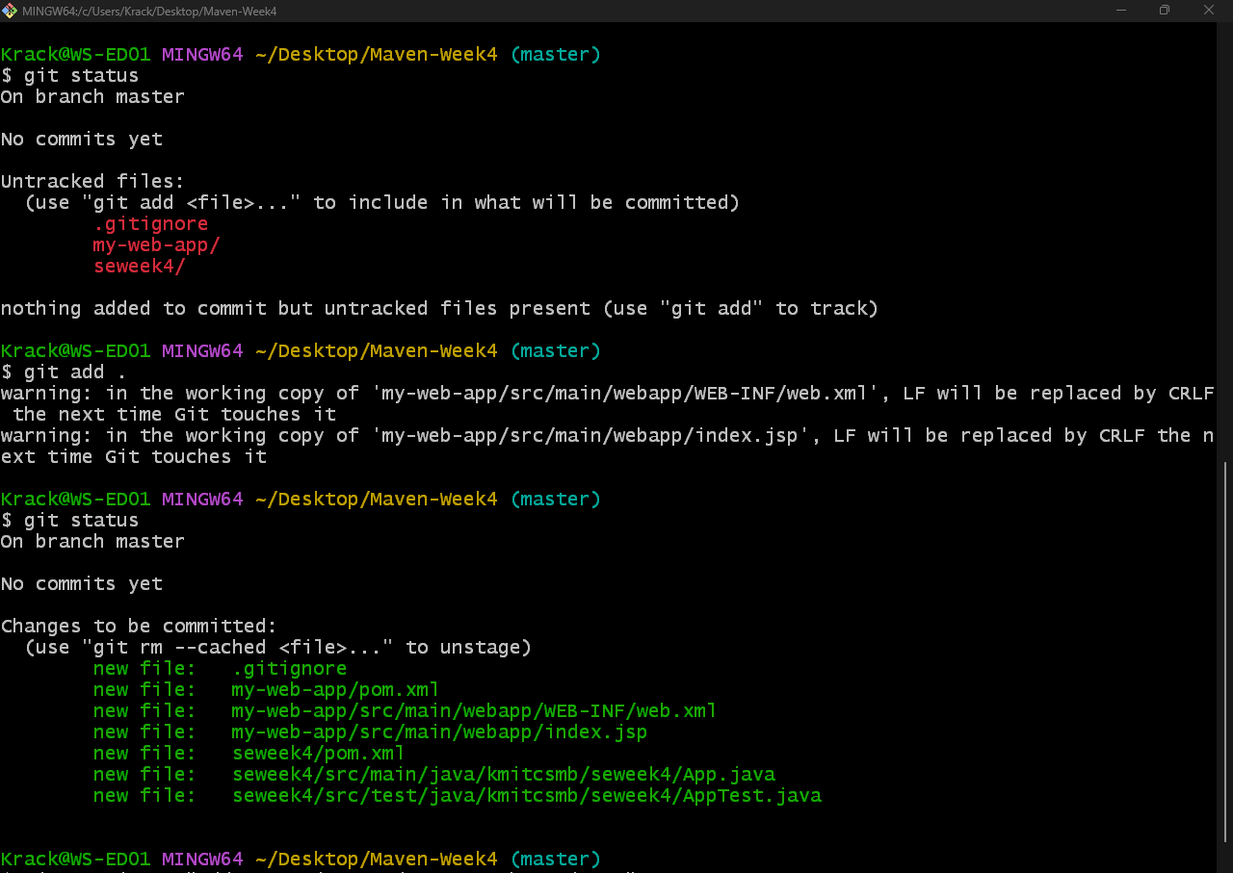
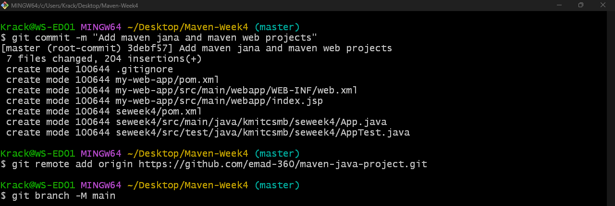
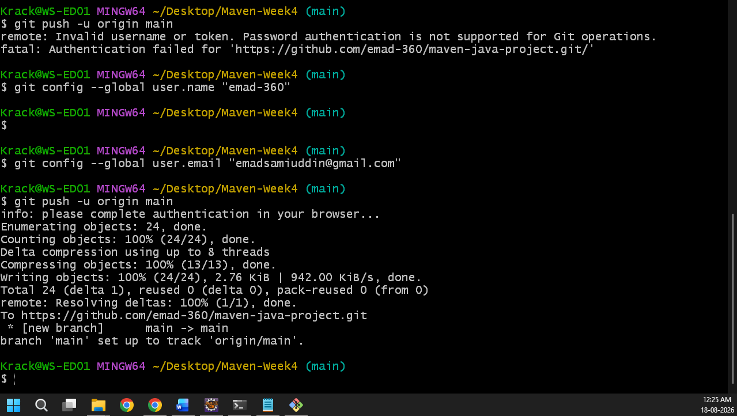
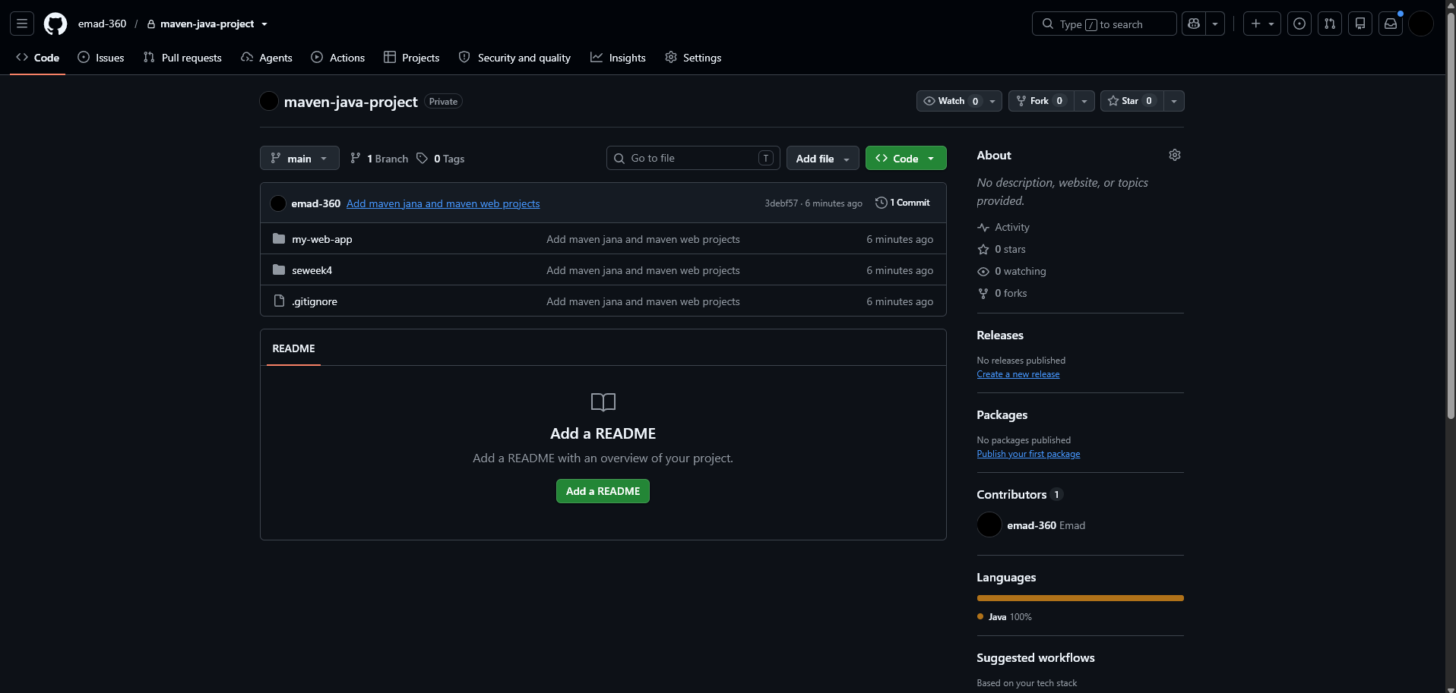
- Configure Java Version via Compiler Plugin
In pom.xml:
<plugin>
<groupId>org.apache.maven.plugins</groupId>
<artifactId>maven-compiler-plugin</artifactId>
<version>3.11.0</version>
<configuration>
<source>17</source>
<target>17</target>
</configuration> </plugin>
Check:
- Run mvn package
- Inspect generated JAR: jar tf target/myapp.jar
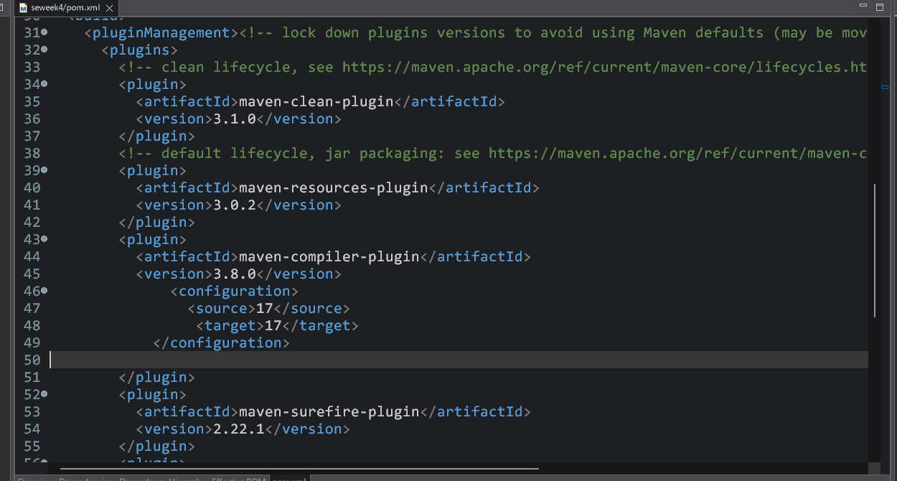
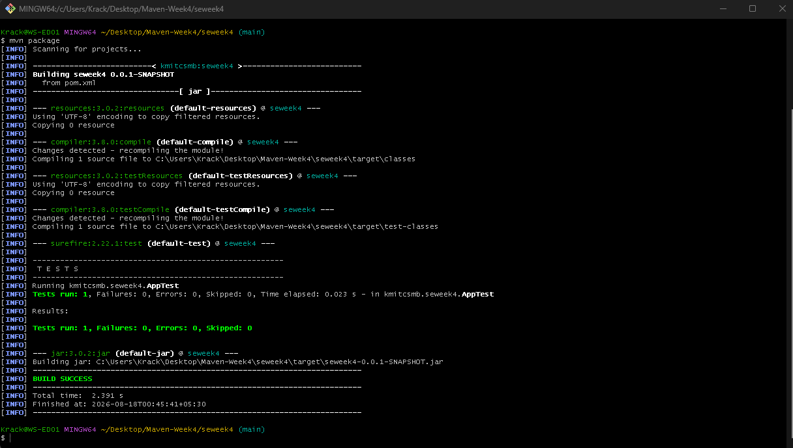
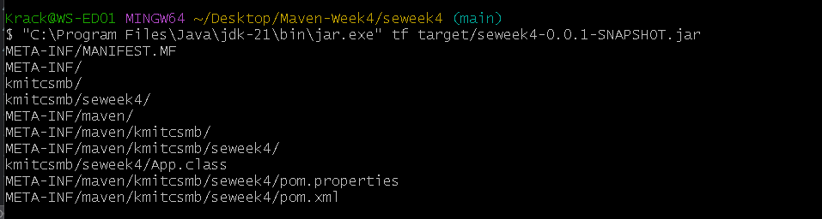
- JUnit Testing and Reports
Place test files in src/test/java. Example:
public class AppTest {
@Test
public void testSum() {
assertEquals(5, 2 + 3);
}
}
Run:
mvn test
Check:
- target/test-classes/ → compiled test .class files
- target/surefire-reports/ → .txt or .xml test results
If test fails → corresponding log and failure trace shown
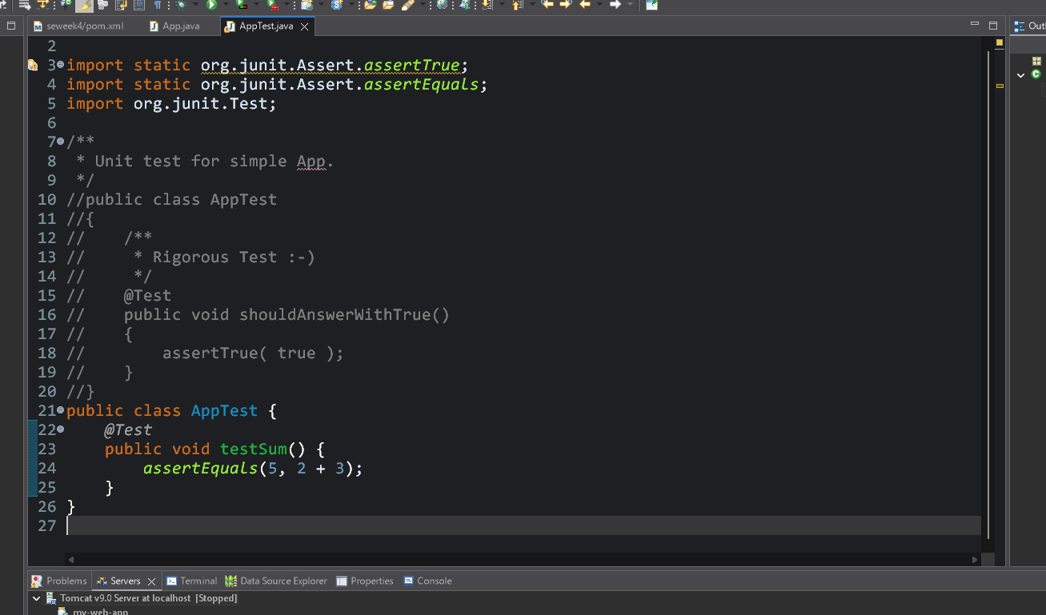
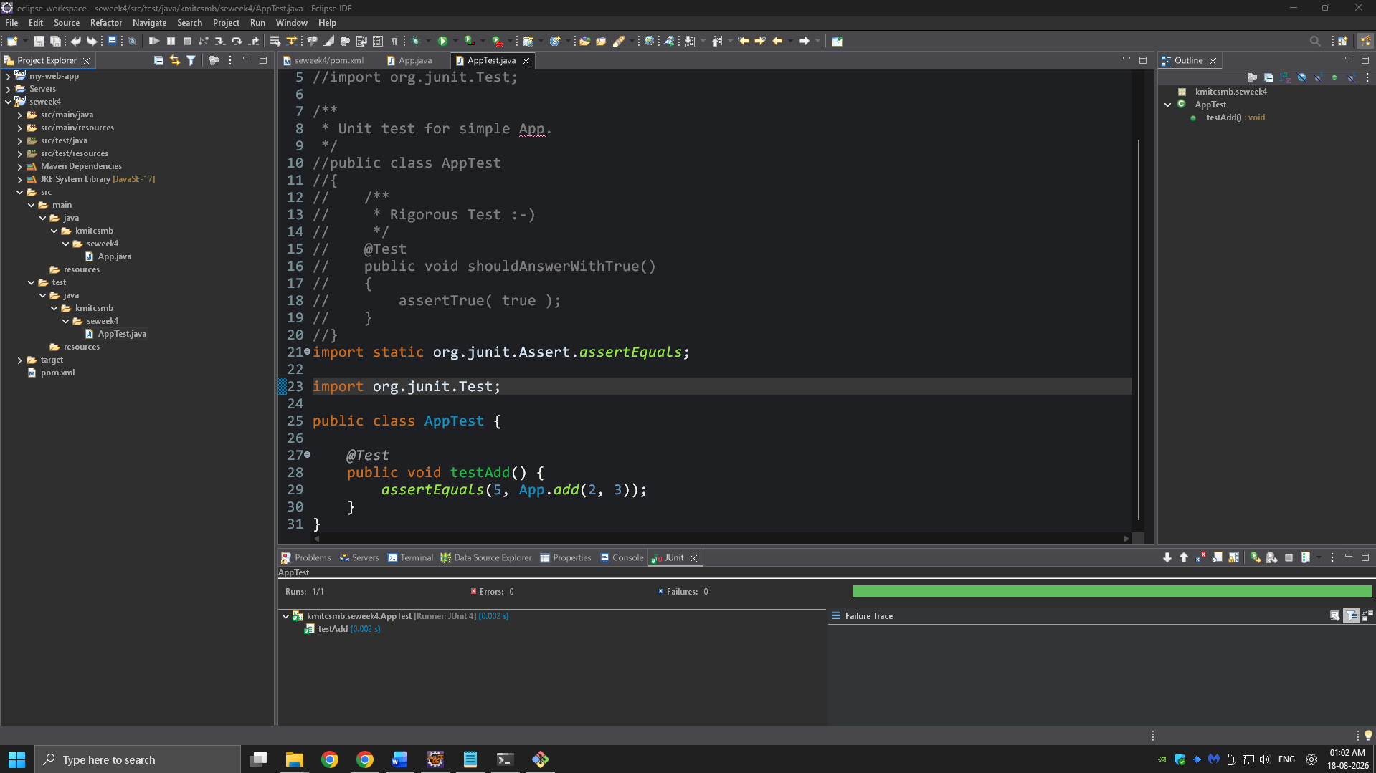
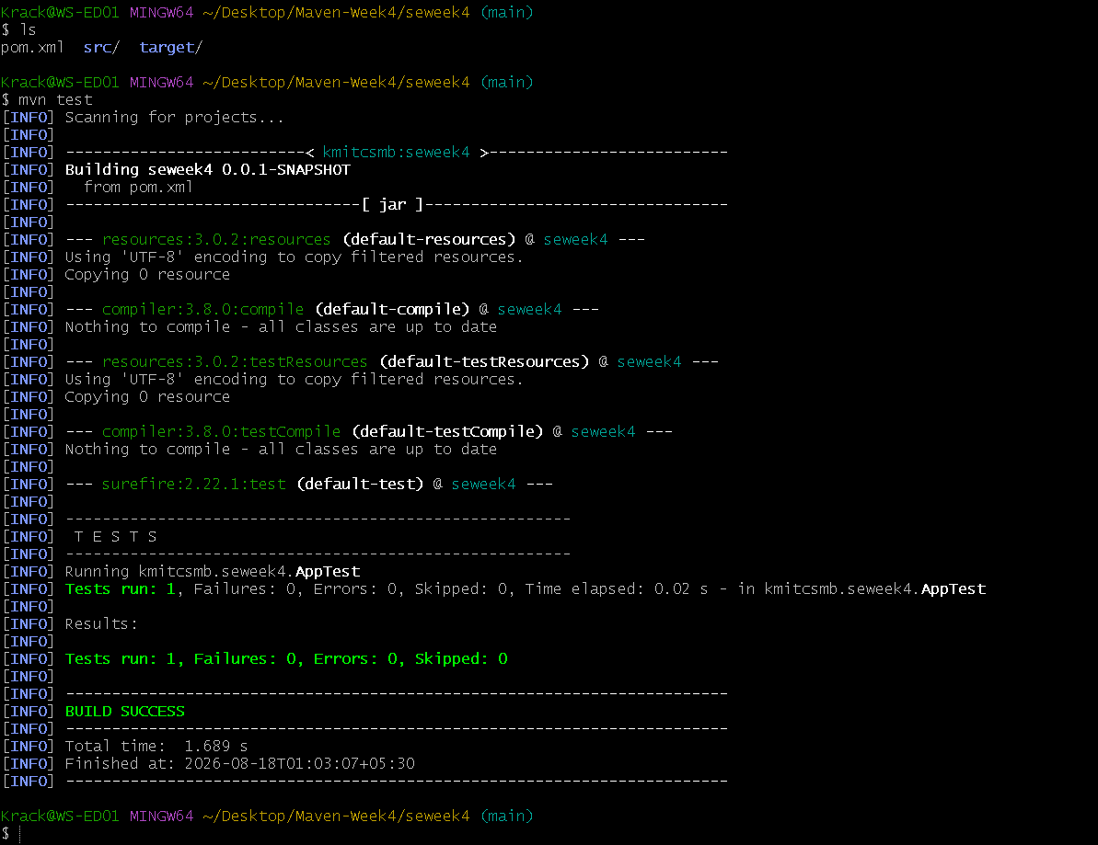
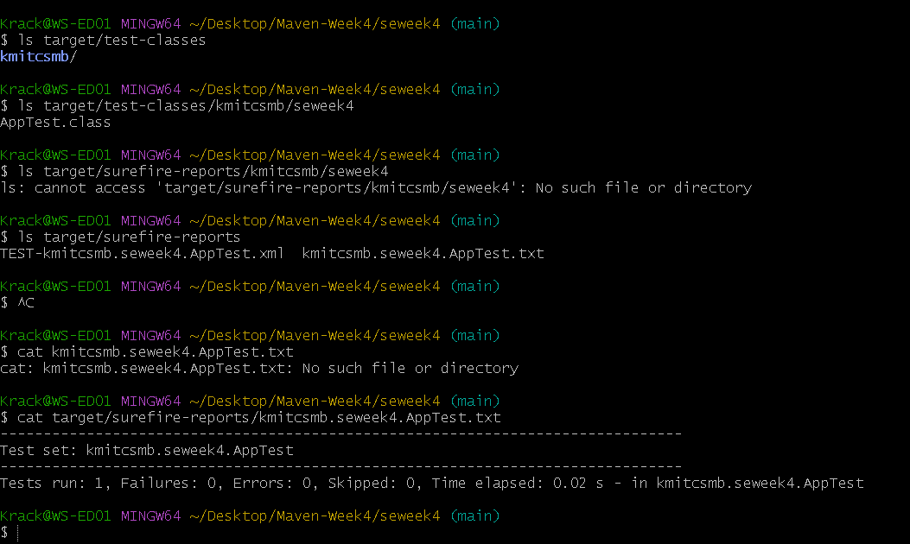
- Handling Errors in pom.xml
- Typos in version numbers or missing repositories cause BUILD FAILURE
- Maven shows precise error in console
- Fix the dependency tag → re-run mvn clean install
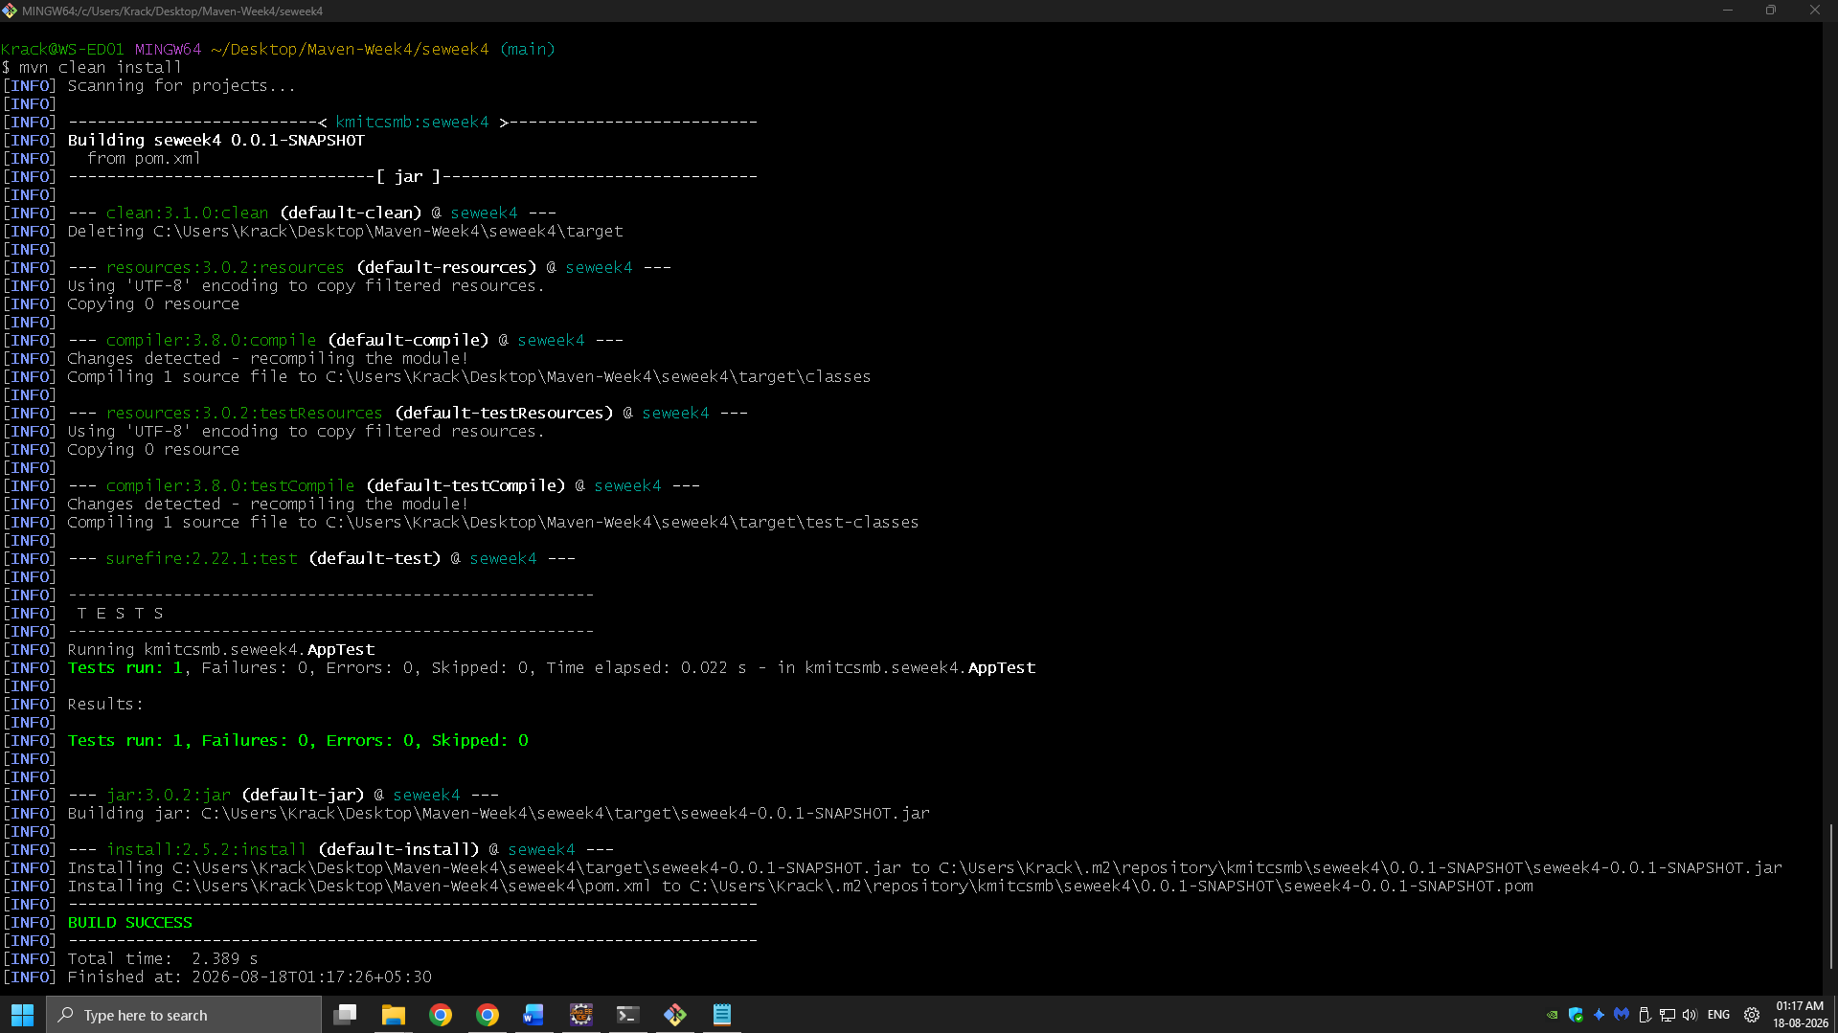

- Adding Resource Files
Put config.properties inside:
src/main/resources/config.properties
To read:
InputStream input = getClass().getClassLoader().getResourceAsStream("config.properties");
After build, check target/classes/ → file should exist there.
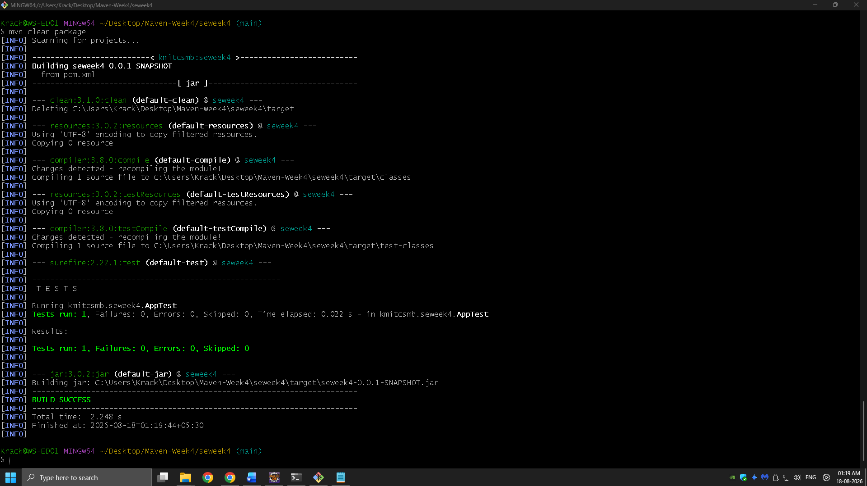
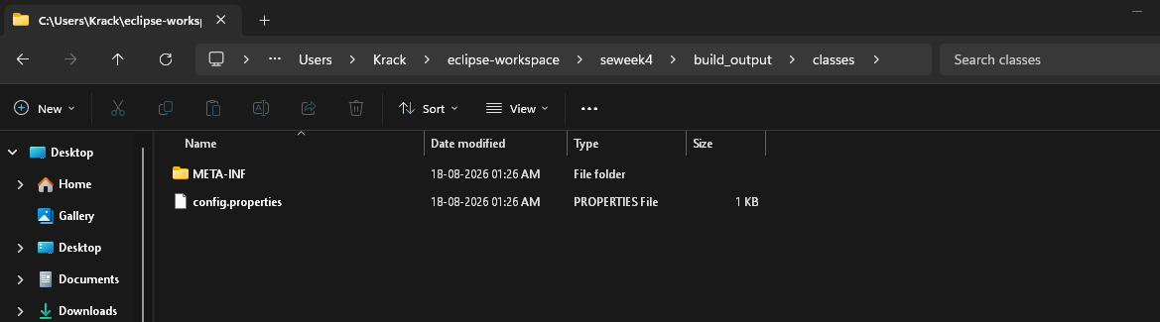

- Multi-Module and Parent Projects
Structure:
parent/
├── pom.xml (packaging: pom)
├── core/
| └── pom.xml
└── web/
└── pom.xml
- Parent pom.xml defines <modules> and common dependencies
- Each submodule builds independently into its target/ directory

- Executable JARs

Add to pom.xml:

<build>
<plugins>
<plugin>
<groupId>org.apache.maven.plugins</groupId>
<artifactId>maven-jar-plugin</artifactId>
<configuration>
<archive>
<manifest>
<mainClass>com.example.Main</mainClass>
</manifest>
</archive>
</configuration>
</plugin>
</plugins>
</build>
Run:
mvn package
java -jar target/myapp.jar

- Building a WAR File
Create a Maven web project with structure:
src/main/webapp/
└── WEB-INF/web.xml

Add:
<packaging>war</packaging>
Command:
mvn package
Generates target/mywebapp.war → deploy on Tomcat server.
- Scenario-Based Questions:

- If my error is about:
Failed to execute goal org.apache.maven.plugins:maven-compiler-plugin:3.8.1:compile
[ERROR] -> [Help 1]
[ERROR] To see the full stack trace of the errors, re-run Maven with the -X switch.
How can I resolve it using maven terminal?
- A dependency you added is not recognized by the compiler. What steps would you take to confirm it is available in .m2 and listed in dependency tree?
- A teammate sends a .patch file for a bug fix. How would you apply it and include it in your Maven build?
- You have multiple JUnit test failures and want to rerun only failed tests. How would you approach this?
- Your Maven build fails due to “Unsupported class version error.” What plugin and configuration would you review?
- You need to change your Java application from a WAR to a standalone JAR. What pom.xml changes are needed?
- You are required to change the default build output directory from target/ to build_output/. How would you configure it?
- You want to skip tests during the Maven build. What command would you use?
- How would you generate a site report (with test coverage, dependency analysis) for a Maven project?
- How do you build a Java project using Maven, and what files are generated in the target/ folder after running mvn clean install?
- How does Maven resolve dependency conflicts when two libraries use different versions of the same dependency, and how can you view and manage the dependency tree?
- How do you write and run a JUnit test in a Maven project, and where are the compiled test classes and reports stored after running mvn test?
- How can you create an executable JAR with a main method using Maven, and which plugin helps configure this behavior?
- How do you install and use a custom third-party JAR file in your Maven project, and how can you confirm it’s included in the build and classpath?
- How do you create a Maven web project that packages into a WAR file, and what is the standard folder structure for such a project?
- What command do you use to build a WAR file in Maven, where is it generated, and how can you deploy it to a server like Apache Tomcat?
- How do you add JSTL and servlet-api dependencies in a Maven web project, and why should the servlet API use provided scope instead of compile?
- How do you set up a multi-module Maven web project with separate modules for core logic and web interface, and how are these modules built and connected?
- How do you configure a Maven web project, and how does its packaging and execution differ from a traditional WAR-based application?
Answers to the above questions:
1. Run mvn clean compile -X to clean the project and get the full compiler error/stack trace, then fix the reported Java/compiler configuration or source error.
2. Check the dependency under ~/.m2/repository , then run mvn dependency:tree (or mvn dependency:tree -Dincludes=groupId:artifactId ) to confirm its version and resolution.
3. Apply the patch with git apply fix.patch , then run mvn clean install so the patched source is compiled and included in the build.
4. Run mvn surefire:test -Dtest=TestClassName#testMethodName for specific failures, or rerun the failed tests using Maven Surefire’s generated failure information.
5. Review the maven-compiler-plugin configuration in pom.xml , especially and (or ), and ensure they match the installed JDK version.
6. Change war to jar and remove WAR-specific configuration/dependencies such as maven-war-plugin and web-app 2/3 setup if no longer needed.
7. Configure Maven with build_output in pom.xml to replace the default target/ directory.
8. Run mvn clean install -DskipTests to build the project without executing tests.
9. Run mvn site (often after configuring JaCoCo and dependency-report plugins) to generate the Maven site reports under target/site/ .
10. Run mvn clean install ; Maven compiles, tests, packages, and installs the artifact, generating files such as .class files, test classes/reports, the JAR/WAR, and Maven metadata under target/ .
11. Maven normally uses the nearest dependency in the dependency tree (and then declaration order for ties); use mvn dependency:tree to inspect conflicts and or explicit dependencies to control versions.
12. Put tests under src/test/java , annotate methods with @Test , run mvn test , and find compiled test classes in target/test-classes/ and Surefire reports in target/surefire-reports/ .
13. Configure the maven-jar-plugin with the Main-Class manifest entry (or use the Maven Shade Plugin) and run mvn package to create an executable JAR.
14. Install the JAR with mvn install:install-file -Dfile=library.jar -DgroupId=... - DartifactId=... -Dversion=... -Dpackaging=jar , declare it as a dependency, and verify it with mvn dependency:tree and the generated JAR/classpath.
15. Set war , use src/main/java , src/main/resources , and src/main/webapp/WEB-INF (with web.xml if required), and run mvn package to create the WAR.
16. Run mvn package , find the WAR in target/ , and copy/deploy it to Tomcat’s webapps/ directory or deploy it through Tomcat Manager. 3/3
17. Add JSTL and jakarta.servlet-api / javax.servlet-api dependencies, using provided scope for the Servlet API because the web container such as Tomcat supplies it at runtime.
18. Create a parent POM with separate core and web modules, make web depend on core , and run mvn clean install from the parent so Maven builds the modules in dependency order.
19. Configure the project’s packaging and plugins in pom.xml ; unlike a traditional WAR application deployed to a servlet container, a standalone Maven web application is typically packaged as an executable JAR and run directly with java -jar .

Conclusion
Mastering Maven empowers students to structure projects efficiently, manage complex dependencies, and automate testing and packaging. By practicing real-world scenarios—such as resolving build errors, handling resource files, applying patches, and deploying to servers—students gain valuable hands-on experience aligned with professional software development workflows. Maven not only streamlines builds but also enforces standardization and reusability across projects. Through Maven, students learn efficient project management, dependency control, multi-module integration, and reproducible builds. Understanding Maven’s lifecycle, plugin system, and error handling prepares students for professional DevOps and CI/CD workflows. This lab equips students with hands-on experience in packaging, testing, resolving conflicts, and deploying real-world Java and Web applications.

