Now this has a knock-on effect on our testing, because we will have to learn HTML better, CSS better. We'll have to learn how to use the Dev Tools. We'll have to learn a little bit more JavaScript. But none of that is hard. Everything that you're going to learn in here is very small chunks, and it's just practice. And just knowing the patterns to use in order to put it into action.

* We're going to learn how to automate from the console.
* We're going to learn how to use bookmarklets so that we have code in the bookmark, and we can just click it and set up test data.
* We're going to learn how to use the built-in JavaScript IDE for the snippets in Chrome itself.

In this course, we're going to show you how to automate the Todos App, because it's a very little app, and it's nice and easy to work with.

I'm going to quickly show you something that we can aspire to.

So, here's a [game](https://phoboslab.org/xtype/).

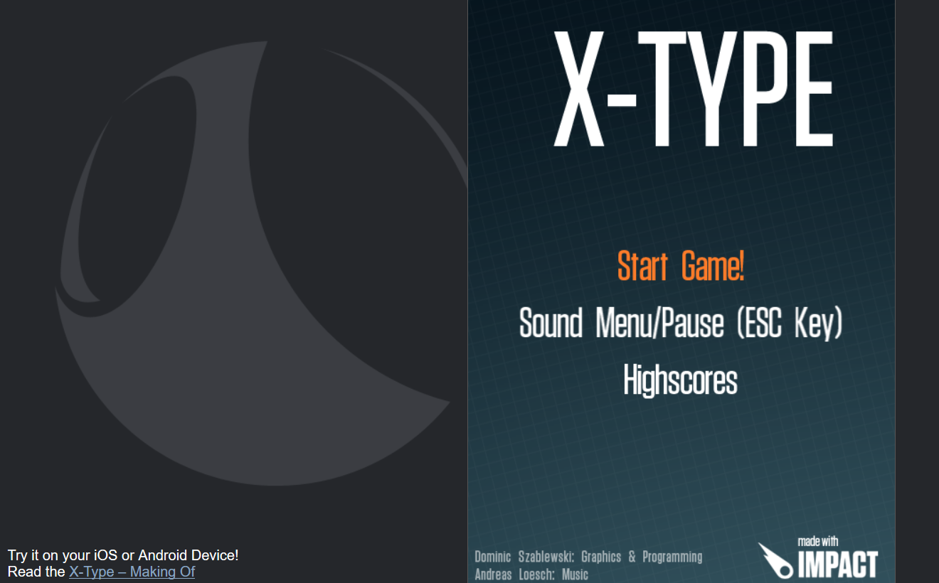

The game is running in the browser. I've automated this. And I'm not using any external tools. All the automated execution is done from code that I've written in the console. And it's not a lot of code. It's not using artificial intelligence. It's not using any complicated techniques. It's just I've analyzed the game, I've understood roughly the data structures in that game, and then I've written some code to manipulate them.

But you can imagine how useful this would be to have a little bot that can play the game better than a human. To reach levels that a human can't normally access, so that we can test the game and see how far the game lets a person go, without having to write any cheat code in the game or anything like that.

And this is something I do to practice my JavaScript skills, and this has a knock-on effect.

I'm not going to show you how I do this in this course, but I'm going to show you all the techniques that I use in order to be able to do this. And if you keep practicing, eventually you will be able to end up doing things like this as well and automate pretty much any application you want from within the browser.

So, let's start at the very basics in the next lecture.

**Resources**

* [Alan Richardson's Blog](https://blog.eviltester.com/)
* [Additional information, apps and support for the course](https://eviltester.com/jsauto)
* [Alan's Company Site](https://compendiumdev.co.uk/)
* [Alan's Testing Site](https://eviltester.com/)

**Quiz: +100 credits**

**1. Is it possible to automate web applications from the browser itself?**

No, you must install a GUI Automation Tool

No, we should only ever use the API

No, Test Automation is bad

Yes, we can write JavaScript in the browser to automate web applications

**2. What is a Browser Based Test Automation Bot?**

A robot that we have to buy that costs millions of dollars

A hypnotized human that will repeat tasks as required

A chrome plugin that automates the web application

A model based execution script that can run in the browser

**3. Which of the following do we need to learn to fully automate applications from within the browser?**

HTML

CSS

JavaScript

All of the above

**4. What is a bookmarklet?**

something you use so you don't lose your place when reading a book

code that runs from a bookmark in your browser

a market for buying Chrome plugins

a small device for writing the expiry date on tinned food