TECHNICAL PROPOSAL
RestroGrid
Admin Dashboard
A technical review of the RestroGrid Kitchen Operations System (KOS) admin console: information architecture, module capabilities, data model, and go-live recommendations.
Prepared for: Eddy
Subject system: restrogrid.com/admin
Date: July 21, 2026
Prepared by: Claude, on behalf of Eddy
RestroGrid — Full-stack restaurant & cafe management: POS, KDS, CDS and Kiosk Ordering, unified.

Contents
1. Executive Summary
2. System Architecture
3. Dashboard Information Architecture
4. Module-by-Module Review
4.1 Multi-Location Dashboard
4.2 Stations Management
4.3 KDS Station Configuration
4.4 Inventory Management
4.5 Products Catalog
4.6 Product Types
4.7 POS Dashboard
4.8 Orders Management
4.9 Tables Management
4.10 Payment Methods
4.11 Cash Drawers & Shift Management
4.12 Receipt Settings & Jofotara E-Invoicing
4.13 User Management & Access Control
4.14 Station Types Configuration
4.15 Reports & Analytics Dashboard
5. Core Data Model
6. Roles, Access Control & Multi-Location Security
7. Real-Time & Operational Logic
8. Current Environment Assessment
9. Recommendations & Next Steps
Appendix A — Access Details

1. Executive Summary
RestroGrid is a full-stack restaurant and cafe management platform built around a single admin console. The dashboard reviewed here (restrogrid.com/admin) is the operational control center behind RestroGrid's four customer-facing surfaces — Point of Sale (POS), Kitchen Display System (KDS), Customer Display / order-status monitor (CDS), and self-service Kiosk Ordering — and it is where every location, station, product, staff assignment and financial record in the system is configured and monitored.
This document reviews the dashboard as currently deployed: its information architecture, the sixteen functional modules captured across the attached screenshots, the data model those modules sit on top of, and the operational logic (real-time sync, multi-location isolation, business-day accounting) that ties them together. It closes with an assessment of the environment's current state and a set of concrete recommendations for taking the system from its present demo/staging condition to production readiness.
The system underneath the dashboard is the same Kitchen Operations System (KOS) codebase that powers RestroGrid's POS, KDS and mobile applications — the admin console is not a separate product bolted on afterward, but the configuration and reporting layer of the same Laravel application, sharing one database, one real-time event bus, and one set of location/station primitives with every other surface.

2. System Architecture
The admin dashboard is a server-rendered Laravel application. It is not a separate SPA calling a public API — it shares models, migrations and business logic directly with the POS, KDS and mobile surfaces, which keeps station, product and order data consistent across every screen in the system.
Layer | Technology | Role in the Dashboard
Backend framework | Laravel 12 (PHP 8.2+) | Routing, auth, validation, and the Eloquent models backing every admin screen (Location, Station, Product, PosOrder, etc.)
Database | MySQL (SQLite for testing) | System of record for locations, stations, catalog, orders, payments, users and station assignments
Real-time layer | Redis + Pusher WebSockets | Pushes order, batch and station-status changes to KDS, CDS and the mobile app the instant they occur
Admin front end | Blade + Alpine.js + Tailwind CSS 4 (Vite) | Renders every screen documented in Section 4; Alpine.js drives in-page interactivity (filters, tabs, modals) without a full SPA rebuild
Session auth | Laravel session guard | Email/password login for admin.restrogrid.com, backing the “admin@example.com” demo account
API / mobile auth | Laravel Sanctum | Token auth for the Flutter station app and any headless API consumers
Mobile app | Flutter | Station logins (grill, cabinet, cashier, KDS) and the no-login customer order monitor, sharing the same backend
Charting | Chart.js | Sales trend, location performance and station-efficiency charts on the dashboard and reporting screens
Because the dashboard, POS, KDS and mobile app all read and write the same tables through the same real-time bus, a change made in the admin console — adding a station, editing a product, closing a cash drawer — is visible on every connected screen without a manual sync step.

3. Dashboard Information Architecture
The left-hand navigation is organized into five functional groups. This structure was read directly from the live sidebar and reflects how RestroGrid separates day-to-day kitchen operations from back-office administration and reporting.
Group | Contains
Operations | Stations, KDS Stations, Cooking Batches, Hot Cabinet
Inventory | Ingredients, Recipes, Prep Items, Products, Product Types
POS Management | POS Dashboard, Operations, Configuration, Financial, Reports & Analytics, Settings
Administration | Multi-Location Dashboard, Location Management, User Management, Station Management, Batch Management, Station Types, Loyalty Management, Local Users, Drivers, Order Dispatch, User Analytics
Reports | Dashboard, Production Analytics, Wastage Analytics, Inventory Analytics, User Performance
A Dark Mode toggle sits at the base of the sidebar and applies across every module. Section 4 below walks through the modules an administrator interacts with most — covering both day-to-day operations (stations, KDS routing, inventory) and back-office configuration (payments, receipts, users, reporting).

4. Module-by-Module Review
Each subsection below documents one screen captured from the live admin console, its purpose, and the key capabilities visible on it.

4.1 Multi-Location Dashboard
The landing screen after login. It rolls every location up into one operational snapshot: total locations, active users, active cooking batches and daily revenue, followed by a top-performing-locations table, a per-location health indicator, live station monitoring cards, a 7-day performance chart and active-user counts by branch.
- Top-line KPIs: total locations, active users, active batches (today vs. all-time), daily revenue vs. yesterday
- “Top Performing Locations” table with revenue, order count and a direct View link per branch
- “Location Health Status” cards — excellent / warning states driven by station uptime
- “Real-time Station Monitoring” — live utilization and batch count per station, sourced from the WebSocket feed
- 7-day location performance chart and active-user breakdown by branch
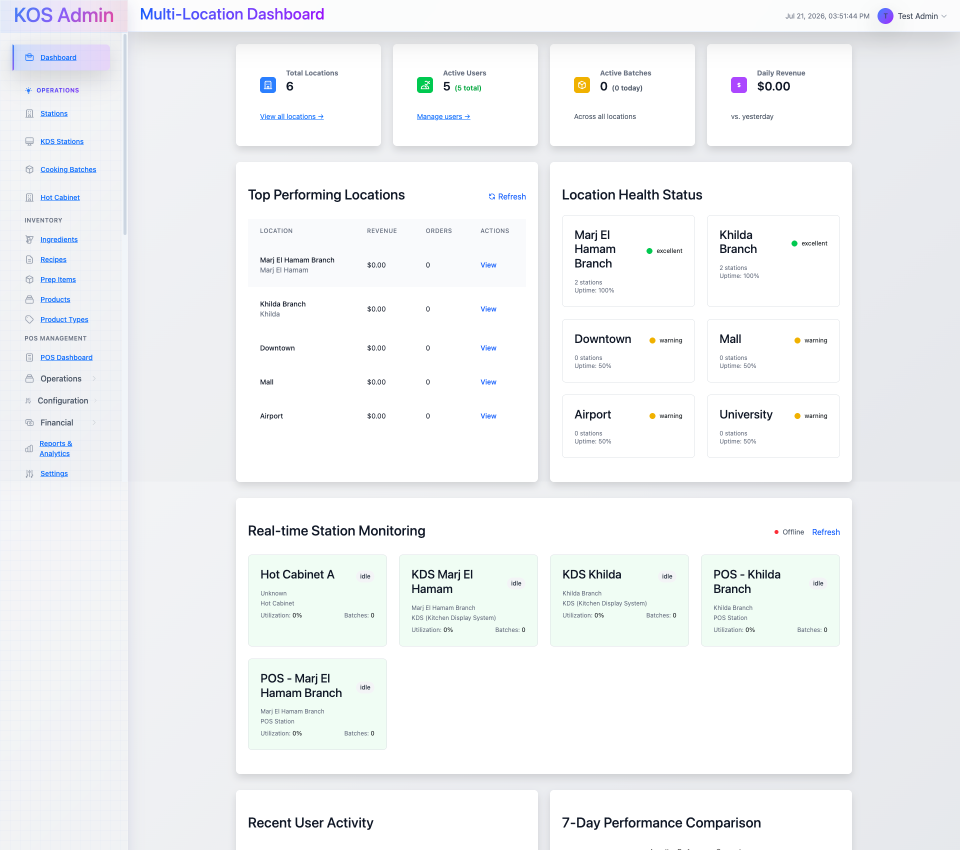
Fig. 4.1 — Multi-Location Dashboard: KPI cards, top locations, health status and real-time station monitoring.

4.2 Stations Management
Lists every kitchen and POS station across all locations with type, assigned location, capacity, assigned-user count and active status, plus search and filtering by station type, status and assignment. The “Add Station” form configures a station's basic information, operational status and — where applicable — its cooking parameters.
- Filterable station list: search, station type, status, assignment status
- Per-station detail: type, location, capacity, assigned users (with a View shortcut), active/inactive state
- Add Station form — Basic Information (name, type, location, capacity), Configuration (status, description)
- Cooking Configuration — a togglable panel exposing cooking phases (1 or 2-phase), phase-1 duration, cooking capacity, and the specific product types the station is allowed to cook
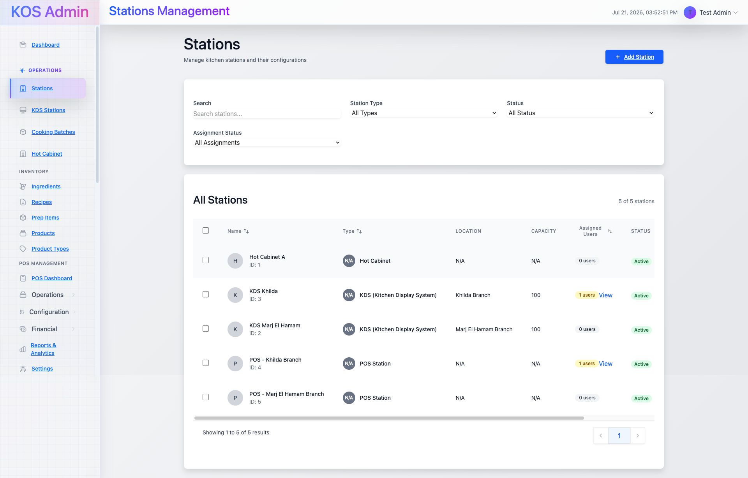
Fig. 4.2a — Stations list: 5 active stations across Hot Cabinet, KDS and POS types.
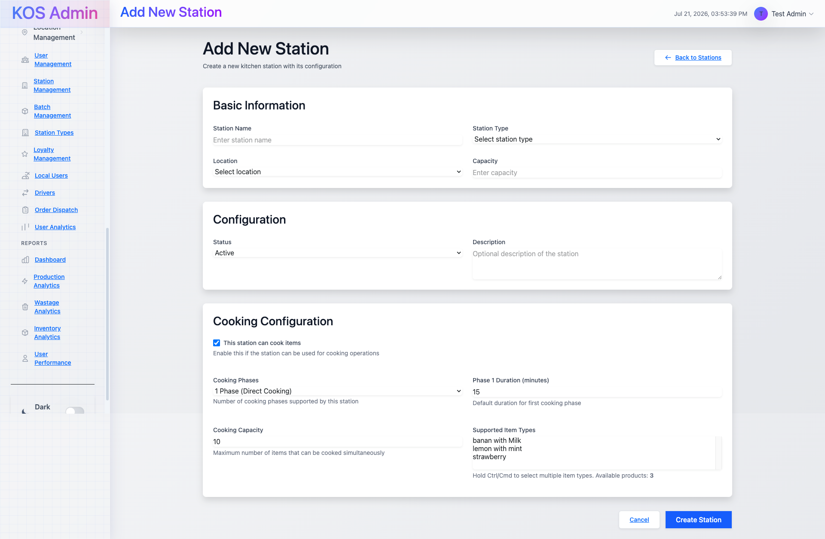
Fig. 4.2b — Add Station form with Cooking Configuration expanded: phases, capacity and supported item types.

4.3 KDS Station Configuration
Configures which physical KDS screens exist and which station types each one monitors — separate from the kitchen stations themselves. This is how one location can run a single expedite screen showing every order alongside dedicated screens for the bar or shisha section.
- Per-screen configuration: auto-accept, sound alerts, active/inactive, and an “Expedite Screen” flag that shows orders from all stations
- Each screen is scoped to one or more monitored station types (e.g. the Bar screen watches only the Drinks Bar Station)
- Category–Station Mappings — routes product categories to a station type for items that aren't explicitly linked to a product
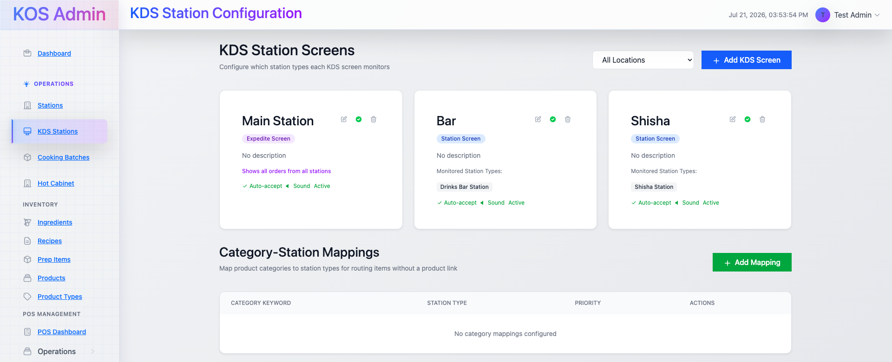
Fig. 4.3 — KDS Station Configuration: Main (expedite), Bar and Shisha screens with their monitored station types.

4.4 Inventory Management
A single hub for ingredients, recipes and prep items, with stock levels, category, unit cost and low-stock status. Tabs switch between the three record types without leaving the page.
- Ingredient list with category, current stock (with unit), cost, and stock-status badge
- Total Ingredients / Low Stock Items / Total Recipes / Prep Items summary cards
- Add Ingredient and Add Recipe actions available directly from the header
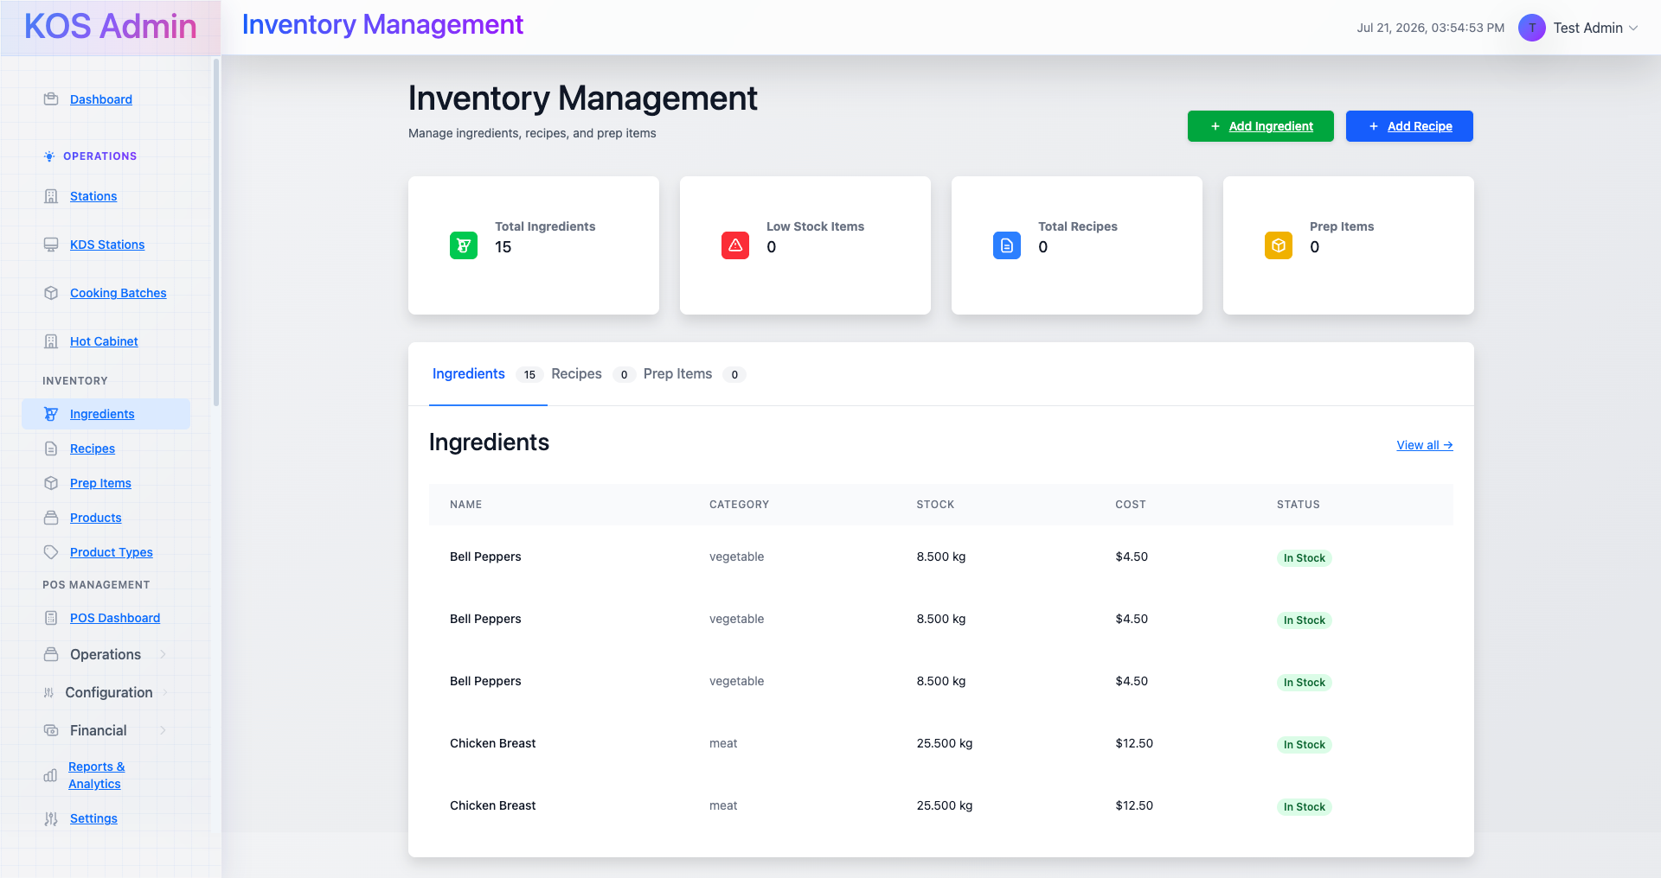
Fig. 4.4 — Inventory Management: 15 ingredients tracked with live stock and cost data.

4.5 Products Catalog
The sellable menu catalog shared by POS, KDS and (per the product roadmap) Kiosk Ordering. Each product card shows price, cooking time, its product type and the station type it routes to, with quick View / Edit / Delete actions.
- Filters: free-text search, product type, station type, status
- Card view with image, price (JOD), cooking time and station-type tag
- Create Product entry point for new catalog items
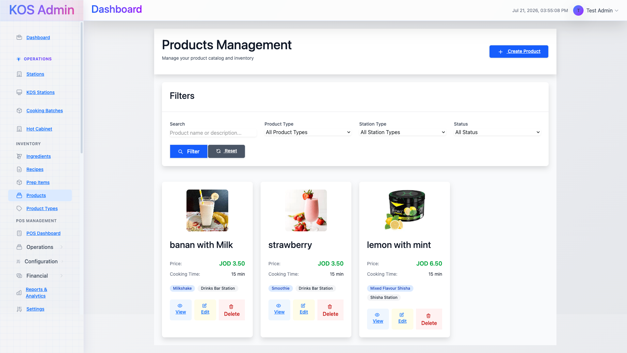
Fig. 4.5 — Products catalog: milkshake, smoothie and shisha items, each priced and routed to a station.

4.6 Product Types
Product types are the categories menu items roll up into (Soft Drink, Fresh Juice, Smoothie, Shisha variants, etc.), each declaring which station types are compatible with it. This mapping is what lets a station's Cooking Configuration restrict itself to a defined list of item types.
- Each type card shows its category tag, description, compatible stations, and live product/station counts
- Create Product Type entry point, with the same search/category/status filters as the product catalog
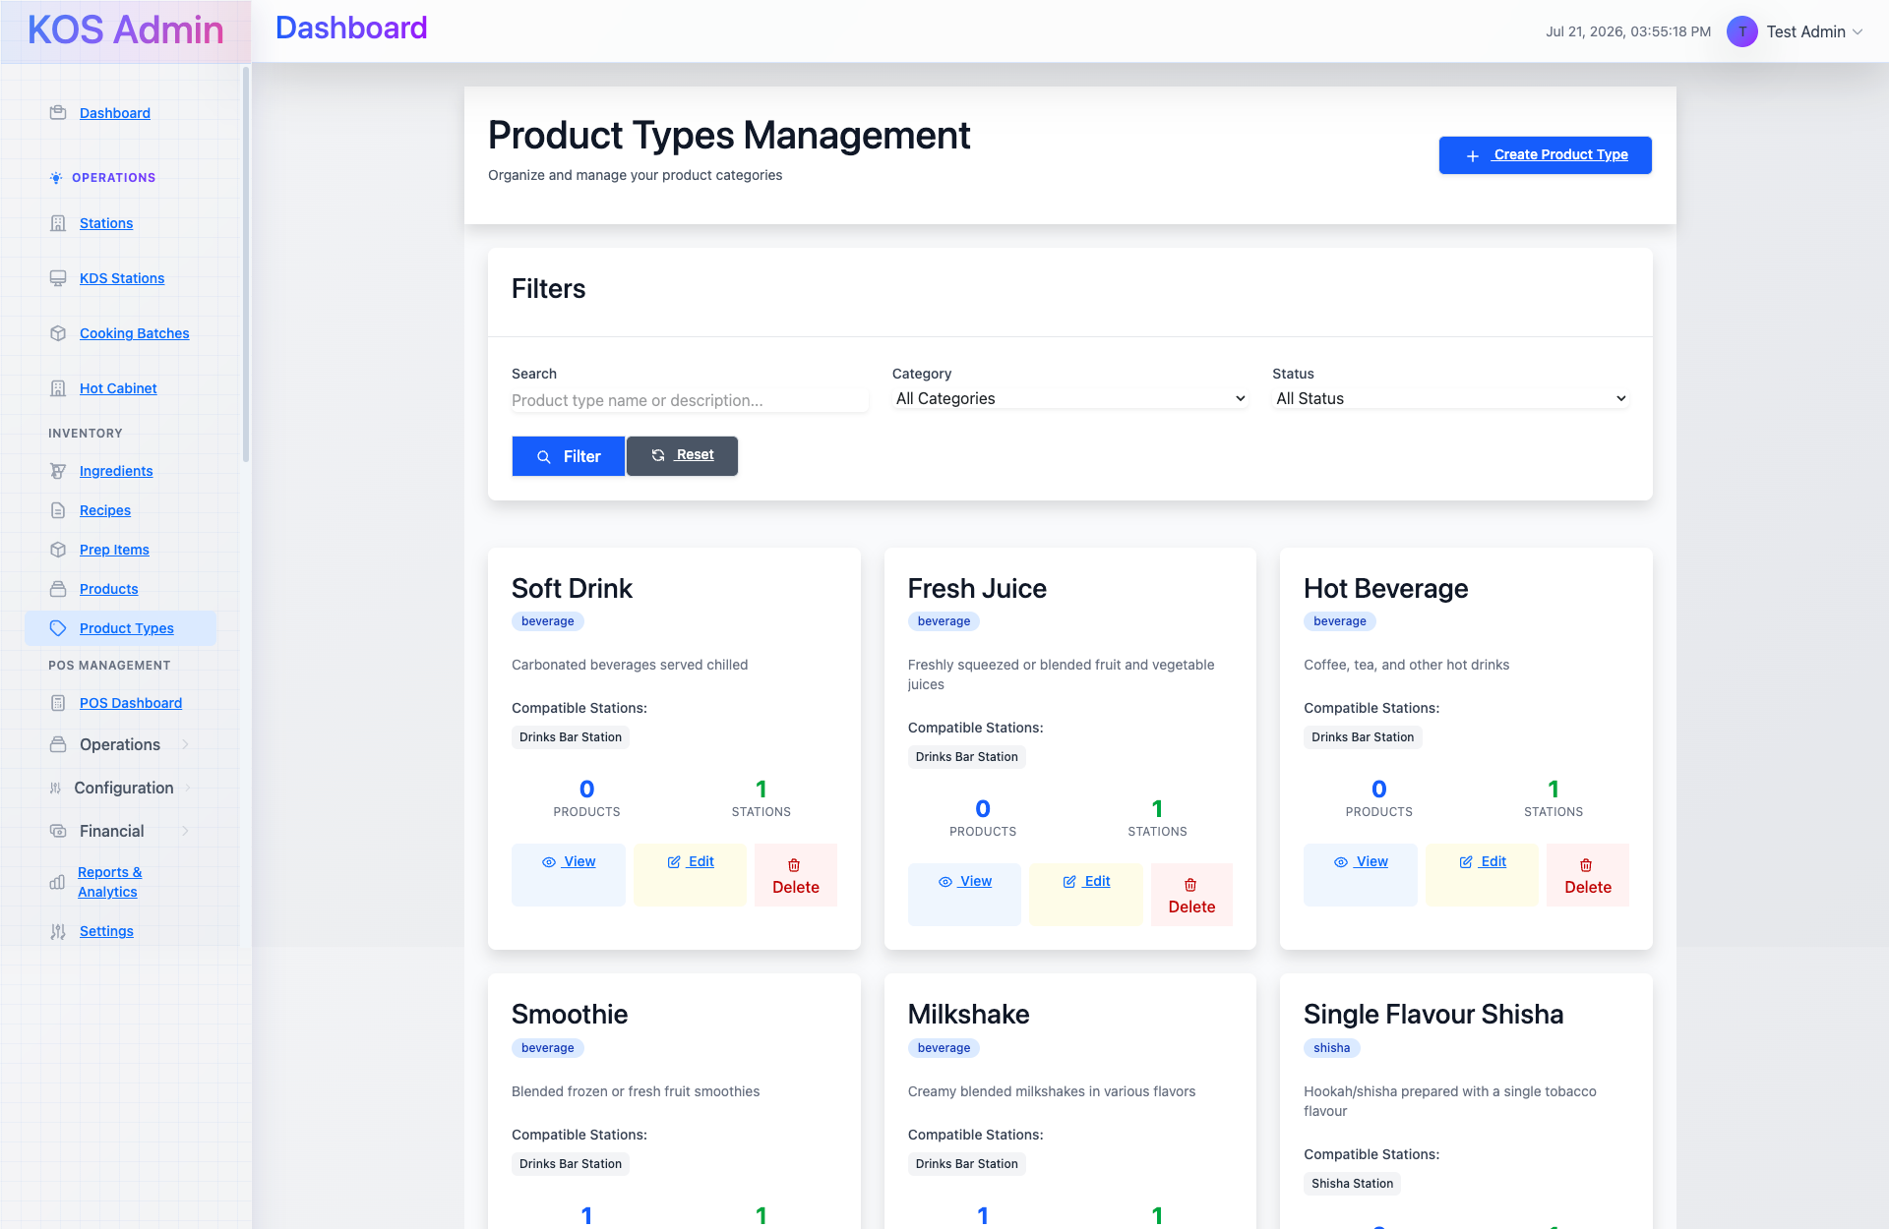
Fig. 4.6 — Product Types: beverage and shisha categories mapped to their compatible stations.

4.7 POS Dashboard
The front-of-house operational summary: today's sales, order count, average order value and active orders, a 7-day sales trend, payment-method mix, table-status overview and a live active-orders queue.
- Today's Sales / Orders Today / Avg Order Value / Active Orders KPI row
- Sales Trend (Last 7 Days) chart and Payment Methods (Today) breakdown
- Table Status Overview — available / occupied / cleaning / reserved counts at a glance
- Active Orders queue with order #, table, cashier, status, amount, time and a direct action
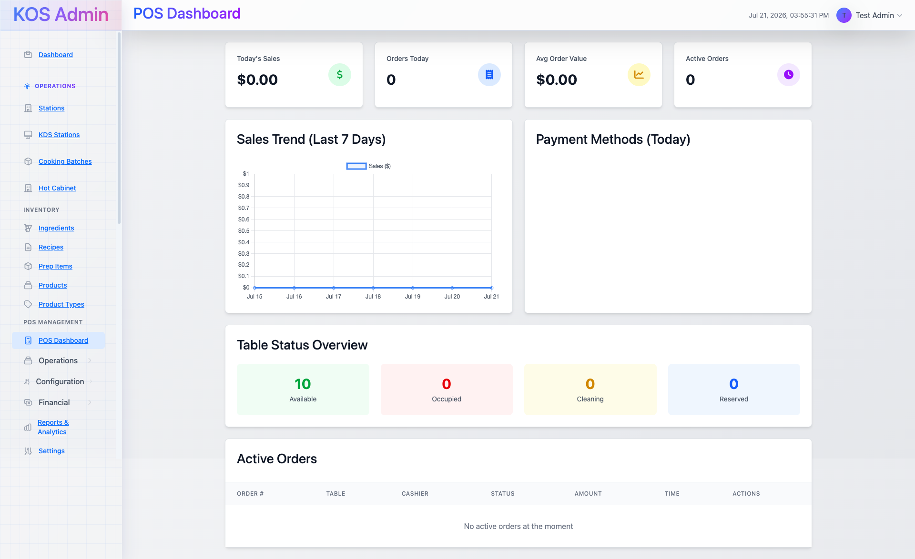
Fig. 4.7 — POS Dashboard: sales trend, payment mix, table status and the live order queue.

4.8 Orders Management
A full order ledger across dine-in, delivery and takeaway, filterable by status and payment, with order #, customer, table, type, item count, amount, fulfillment status and timestamp.
- Search by order number or customer name; filter by status and payment
- Dual status badges per order — fulfillment (Completed) and payment (Paid)
- Per-order detail view via the action column
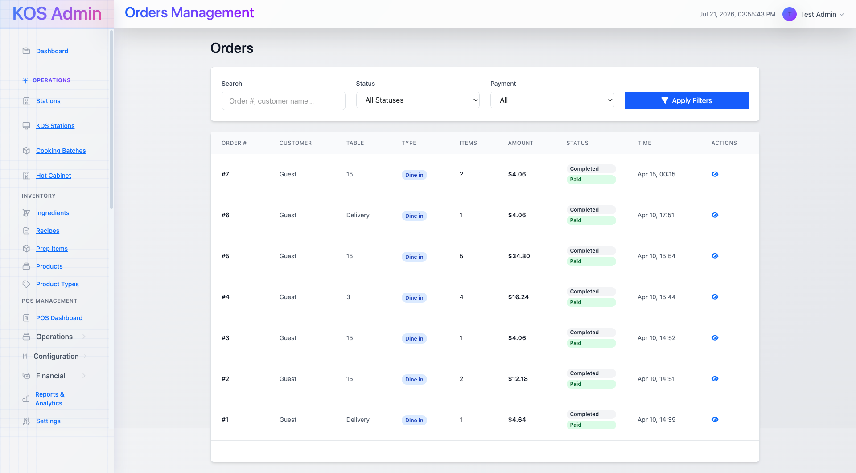
Fig. 4.8 — Orders Management: completed, paid orders across dine-in and delivery types.

4.9 Tables Management
Manages the physical floor plan by section — Indoor, Outdoor, Patio, VIP — with per-table seat count, location and live availability status, filterable by location for multi-branch operators.
- Section-grouped table grid (Indoor / Outdoor / Patio / VIP) with seat capacity per table
- Live status per table (Available shown here; Occupied / Cleaning / Reserved also modeled)
- Add Table action and per-table Edit/Delete controls
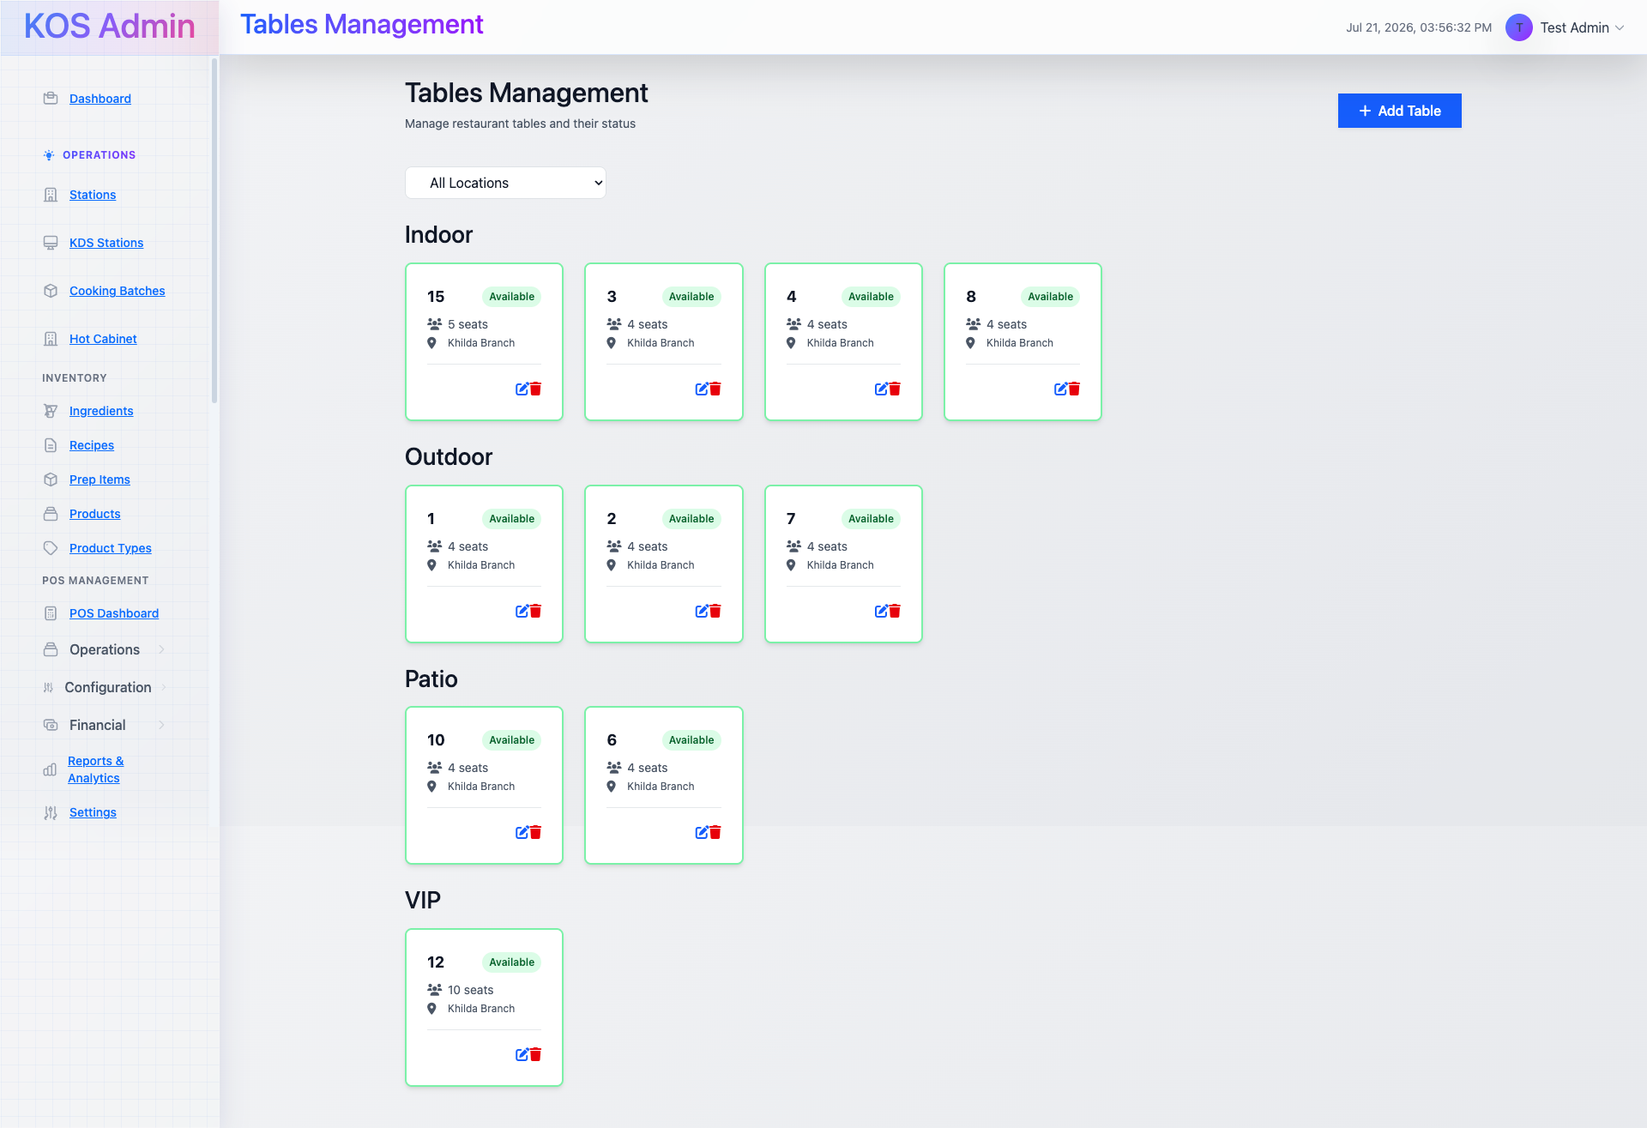
Fig. 4.9 — Tables Management: 10 tables across four seating sections at the Khilda branch.

4.10 Payment Methods
Configures every tender type accepted at checkout, each with a bilingual (English/Arabic) label, display order, and whether a reference number is required at the point of payment.
- Six methods configured out of the box: Cash, Credit Card, Debit Card, Mobile Wallet, Gift Card, Online Payment
- Per-method Active/Inactive toggle, display order, and “Requires Reference” flag
- Add Payment Method for extending the list (e.g. a new mobile wallet provider)
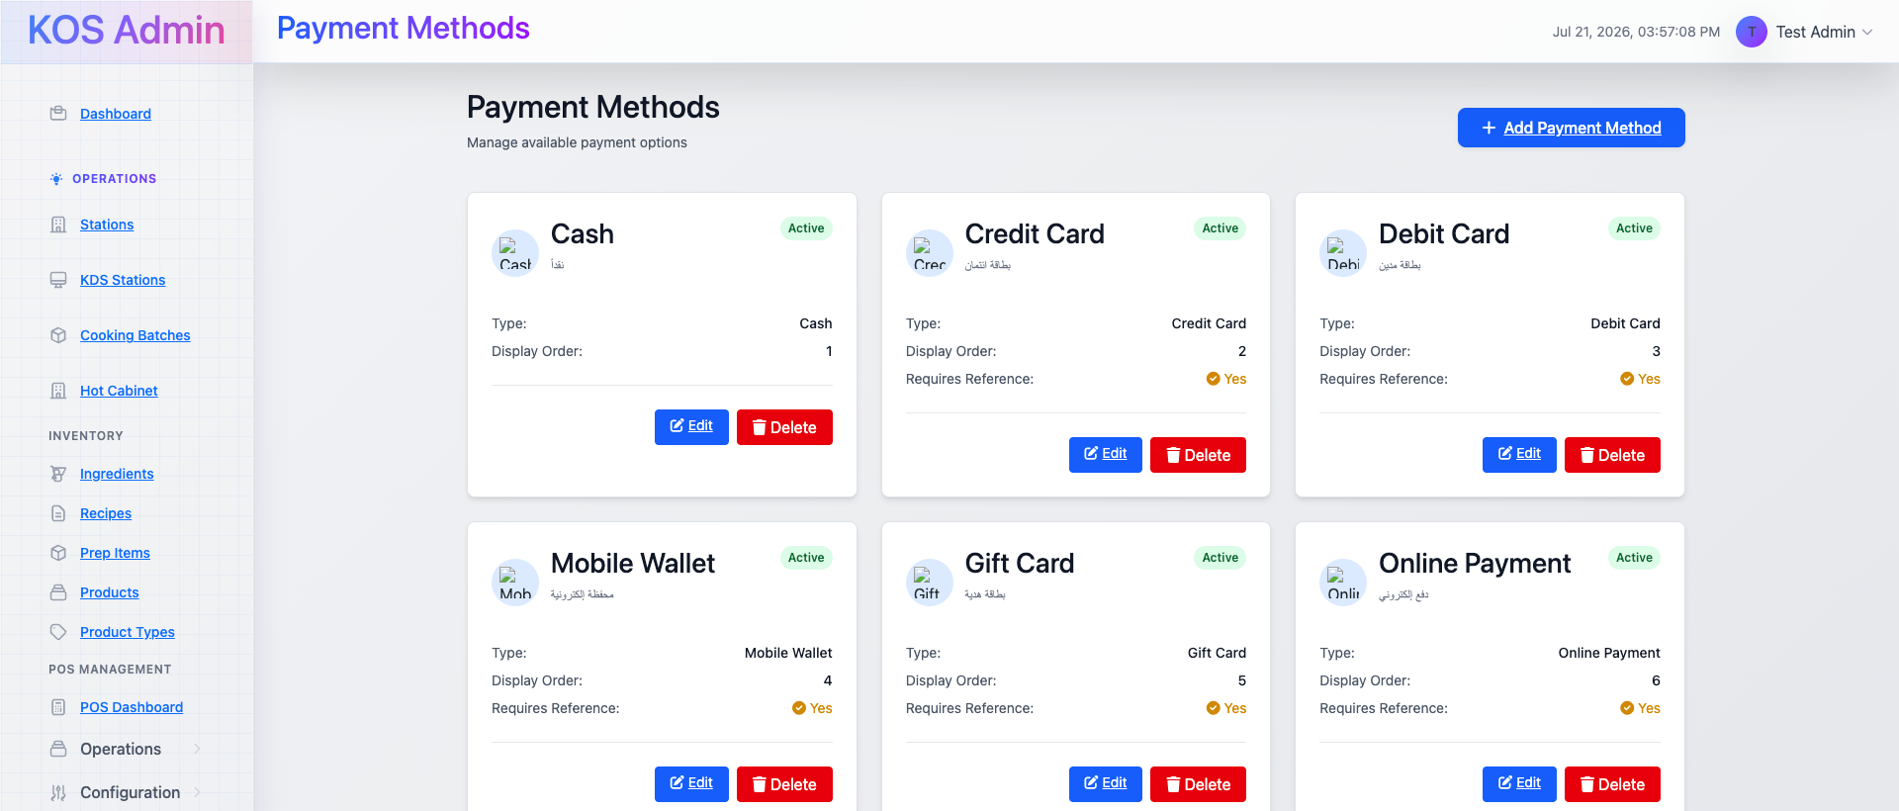
Fig. 4.10 — Payment Methods: all six tender types active, with bilingual labels and reference rules.

4.11 Cash Drawers & Shift Management
Tracks cash-handling by shift: starting cash, running sales, cash drops and expected-vs-actual cash at close, per station and cashier, with a history of recently closed shifts and their variance.
- Active Shifts panel — starting cash, current sales, cash drops and expected cash, live per station
- Cash Drop, Close Shift and Report actions directly on the active-shift card
- Recent Closed Shifts table — cashier, location, duration, total sales, cash variance and status
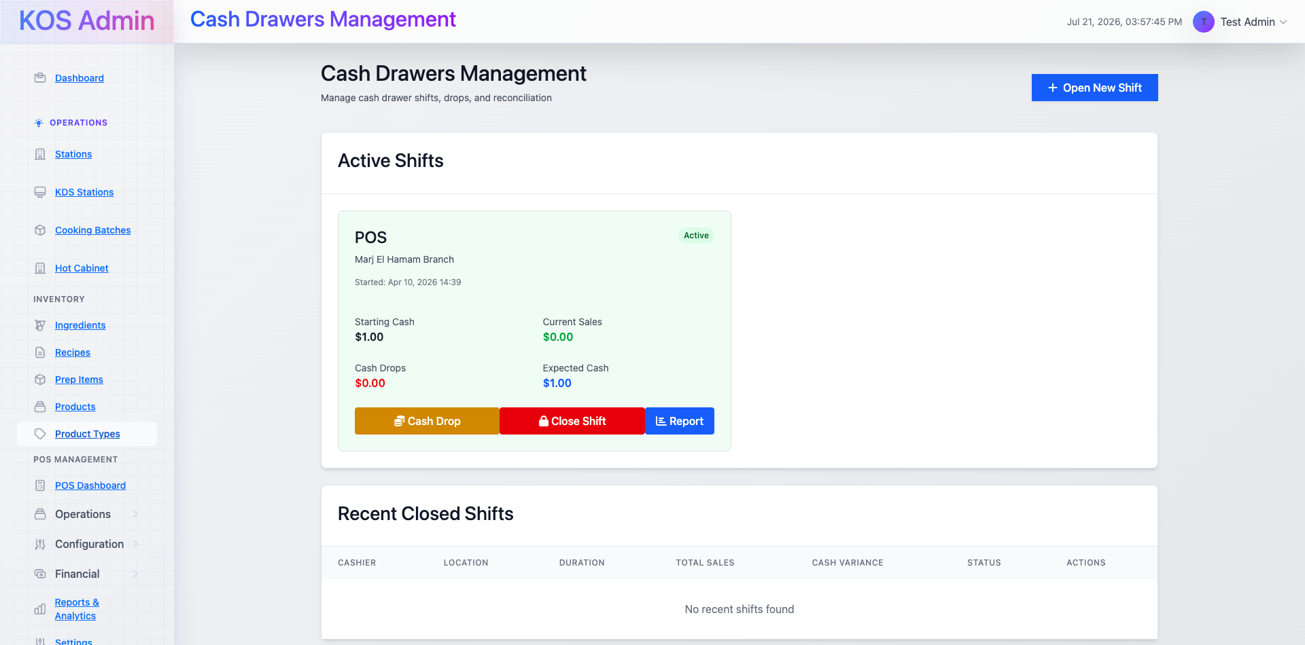
Fig. 4.11 — Cash Drawers Management: an active POS shift at the Marj El Hamam branch.

4.12 Receipt Settings & Jofotara E-Invoicing
Controls receipt content and formatting across four tabs — General, Appearance, Jofotara E-Invoicing and Email & SMS. The General tab alone covers bilingual restaurant identity, tax registration number, contact details, and line-item toggles for order number, cashier name, table number and a kitchen copy.
- Bilingual fields throughout: Restaurant Name / Name (Arabic), Footer Text / Footer Text (Arabic)
- Tax Registration Number field feeding Jordan's Jofotara e-invoicing integration (its own configuration tab)
- Show order number / cashier name / table number and Print kitchen copy toggles
- Test Receipt action to validate formatting before saving
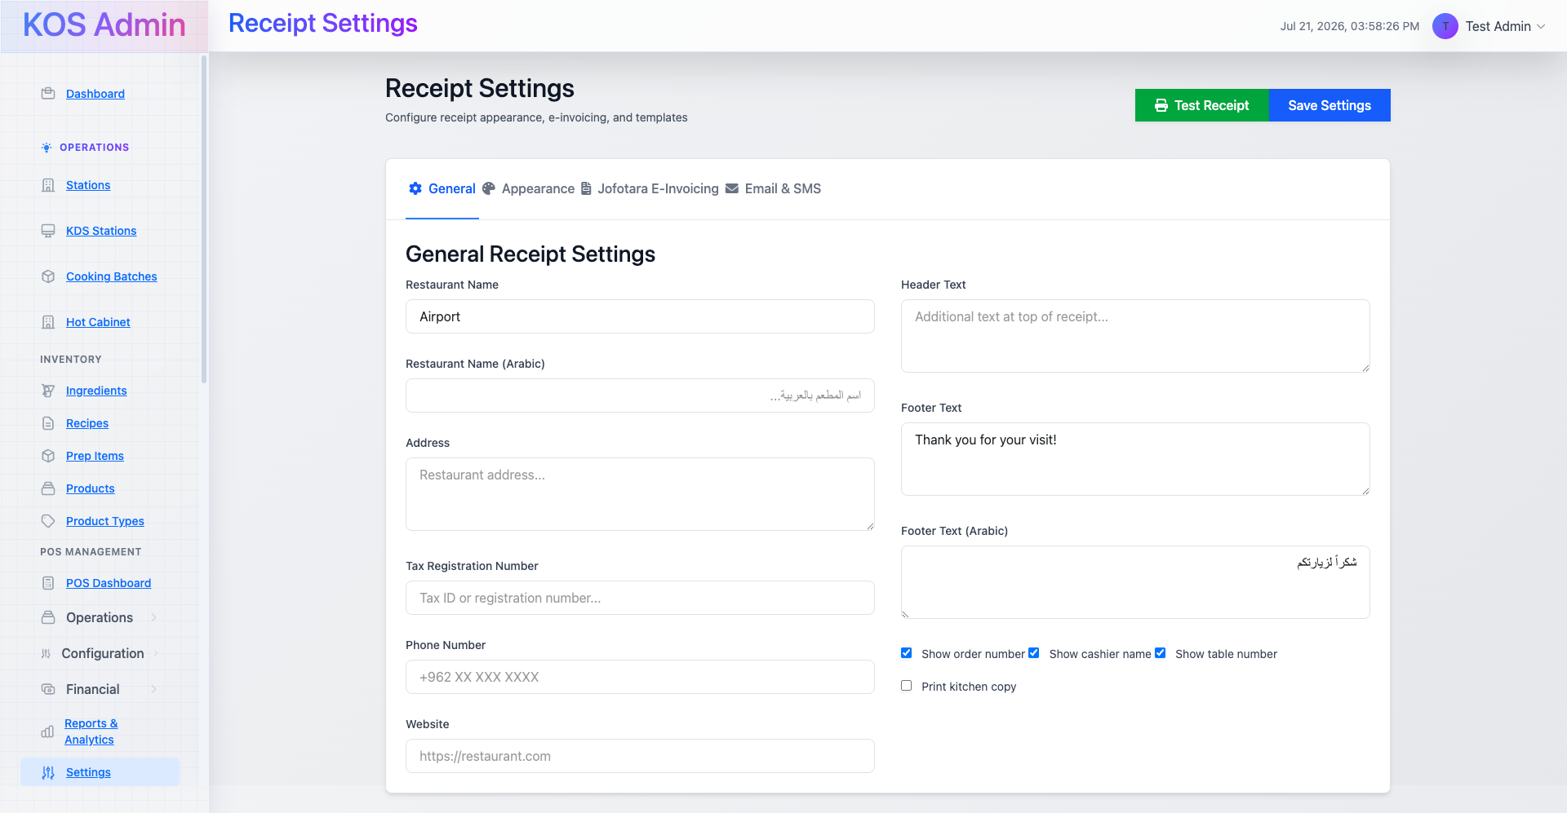
Fig. 4.12 — Receipt Settings (General tab): bilingual identity, tax ID, and line-item display toggles.

4.13 User Management & Access Control
Manages every staff account and its location access from one screen: role, number of assigned locations, active status and last-active date, with an Access Matrix view and CSV export for audit purposes.
- Role tags per user — Multi-Location Manager, grill, hot_cabinet, pos_station, kds_(kitchen_display_system)
- Filters by location, role and manager type; Export and Access Matrix actions in the header
- Per-user Edit, location-assignment and deactivate controls in the Actions column
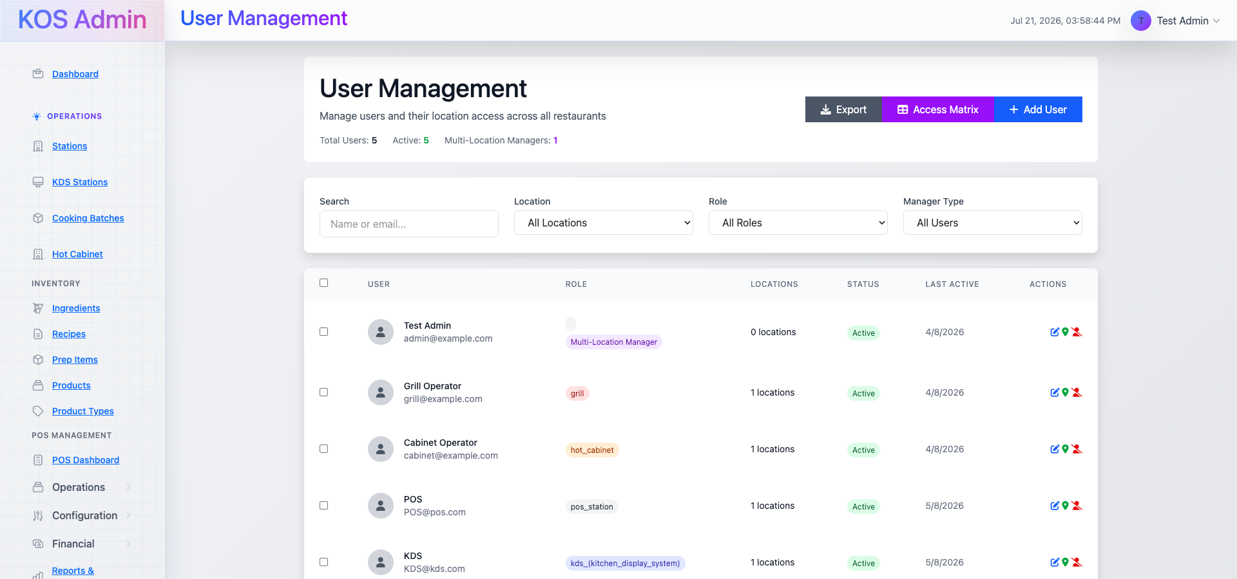
Fig. 4.13 — User Management: 5 staff accounts, one multi-location manager and four single-station roles.

4.14 Station Types Configuration
The master catalog of station types available system-wide — the templates that individual Stations (Section 4.2) are instantiated from. Each type carries a category and a description that appears throughout the product and station-assignment UI.
- Eleven station types configured: Hot Cabinet, KDS, Grill, Prep, Fryer, Salad, Rice, Dispatch, POS, Drinks Bar, Shisha
- Each grouped by category — Storage, Display, Cooking, Preparation, Management, pos, Beverages, Shisha
- Add Station Type action for extending the catalog as new station kinds are introduced
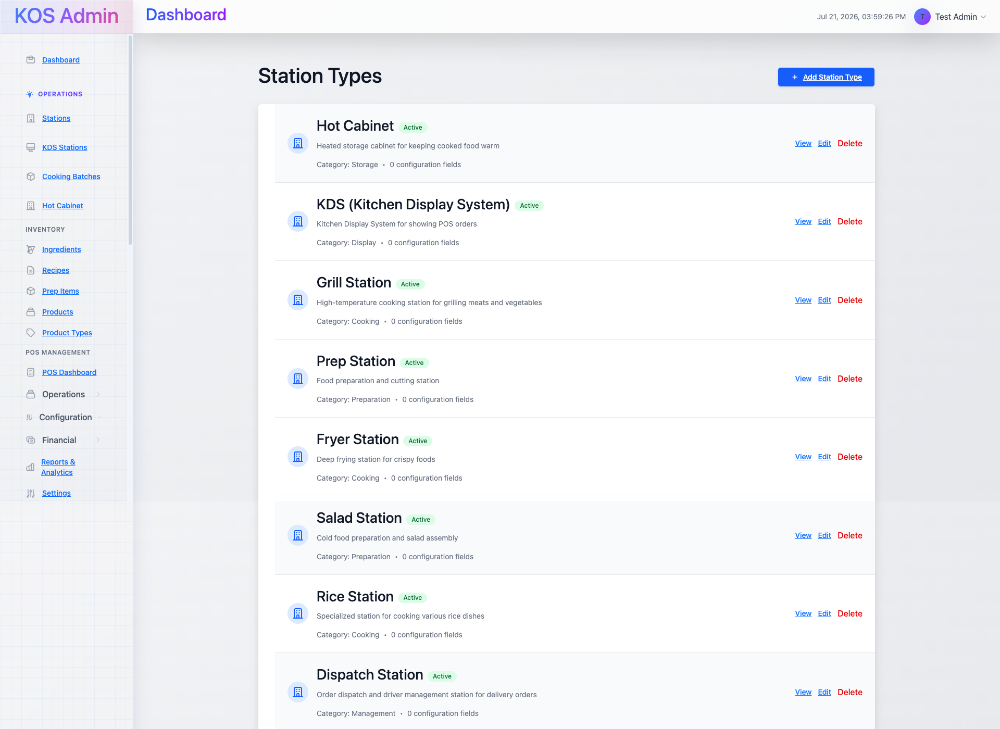
Fig. 4.14 — Station Types: the full catalog of cooking, service and display station templates.

4.15 Reports & Analytics Dashboard
The reporting home page, summarizing batches created/completed, active batches, quantity produced and wastage cost for the day, with entry points into four deeper report types and a live station-performance table.
- Today's Overview: batches created, completed, active, quantity produced, wastage incidents and cost
- Four report modules: Production Analytics, Wastage Analytics, Inventory Analytics, User Performance
- Station Performance table — total batches, completed count and efficiency percentage per station
- All figures reported in the location's local timezone (UTC+3 / Asia/Amman)
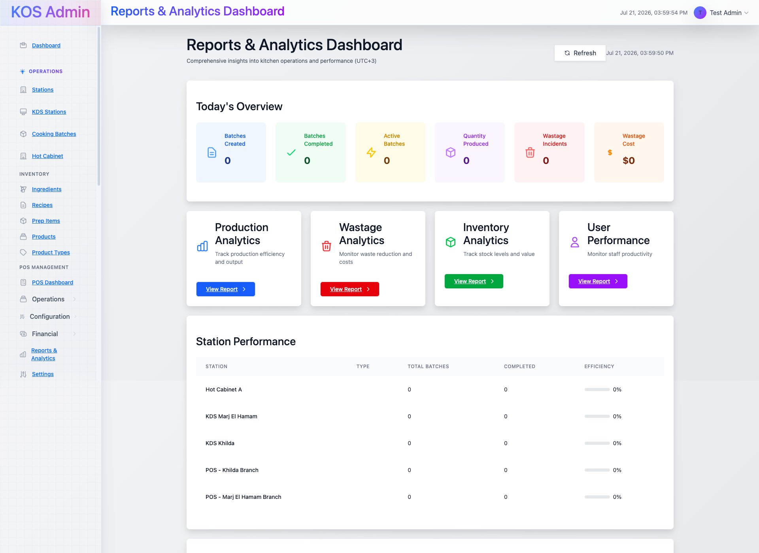
Fig. 4.15 — Reports & Analytics Dashboard: daily overview and per-station efficiency.

5. Core Data Model
Every screen in Section 4 is a view over a compact set of Eloquent models. The table below groups them by the domain they serve; this is the same model layer shared by the POS, KDS and mobile app, not a separate reporting schema.

Operations & Catalog
Model | Purpose
Location | A physical restaurant or cafe branch; the root scope for stations, products, orders and staff
Station / StationType | A configured kitchen or POS station, instantiated from a system-wide station type template
Product / ProductType | Sellable menu items and the categories they belong to, each mapped to compatible station types
Recipe / Ingredient / PrepItem | Inventory-side records driving stock tracking and cost calculation
CookingBatch / GrillLocation / CabinetShelf / BatchTransfer | The two-phase batch-cooking workflow and its physical placement (grill slot, cabinet shelf) and transfer history
ReadyItem | Finished items awaiting sale or pickup

POS Domain
Model | Purpose
PosOrder / PosOrderItem | Orders and line items, covering dine-in, takeaway and delivery, with split-order support
PosTable | Floor-plan tables with section, capacity and live status
PosCustomer | Guest profiles with order history, spend and loyalty points
PosModifier / PosOrderItemModifier | Product modifiers and the modifiers actually applied to an order line
PosPaymentMethod / PosPayment | Configured tender types and the payments recorded against an order
PosTaxRate | Location-scoped tax configuration applied at checkout
PosReceipt | Generated receipts, including Jofotara e-invoice status and QR payload
PosGiftCard / PosGiftCardTransaction | Stored-value gift cards and their transaction history
PosCashDrawer / PosCashDropLog | Per-shift cash reconciliation and mid-shift cash drops

Identity & Access
Model | Purpose
User | A staff account, authenticated via session (admin) or Sanctum token (API/mobile)
UserStation | Pivot linking a user to a station with assignment type (permanent / temporary / shift-based) and priority
UserLocation | Pivot controlling which locations a user can access, underpinning the Access Matrix in Section 4.13

6. Roles, Access Control & Multi-Location Security
Access in RestroGrid is scoped on two axes at once: which location a user can see, and which station role they hold within it. The User Management screen (Section 4.13) shows both — a “Multi-Location Manager” tag grants cross-branch visibility, while roles like grill, hot_cabinet, pos_station and kds_(kitchen_display_system) scope a user to a single station function.
- Assignment types: permanent, temporary and shift-based, each with a priority value used to resolve a user's default station on login
- A dedicated Station Assignment Validator checks cross-location assignments so staff can't be scheduled onto a station outside their granted locations
- The Access Matrix view (linked from User Management) gives administrators a single grid of every user against every location, for audit and onboarding
- CSV export of the user list supports external audit and payroll/HR reconciliation

7. Real-Time & Operational Logic
Three pieces of operational logic run underneath the dashboard and are worth calling out separately because they affect how every number on these screens should be read.

Real-time sync
Order, batch and station-status changes are pushed over Redis-backed Pusher WebSockets. The “Real-time Station Monitoring” cards on the Multi-Location Dashboard and the live queue on the POS Dashboard reflect this — they update without a page refresh, and the same event stream drives the KDS, CDS and mobile app.

Two-phase batch cooking
Cooking Batches move through a defined lifecycle: created at a Grill station, timed through Phase 1 at a specific grill location (A1–B2), transferred in full or in part to a Hot Cabinet shelf for Phase 2, and finally marked ready for sale. Grill locations are released automatically on transfer, preventing double-booked slots — this is enforced at the model layer, not just in the UI.

Business-day accounting (3 AM cutoff)
Because service commonly runs past midnight, RestroGrid treats the business day as ending at 3:00 AM rather than 00:00. Every statistic on the Reports & Analytics Dashboard and POS Dashboard — orders today, sales today, active batches — is computed against this cutoff, so late-night sales are not incorrectly split across two calendar days.

Timezone handling
Orders synced from external POS integrations (Revel, Loyverse) arrive in UTC and are converted server-side to the location's local timezone (Asia/Amman, UTC+3) before storage — the Reports & Analytics Dashboard explicitly labels its figures “(UTC+3)” for this reason.

8. Current Environment Assessment
The screenshots reviewed here were captured from a live but lightly-seeded environment, not a production deployment with real trading history. That's a useful baseline to record explicitly before treating any figure on these screens as representative:
- 6 locations configured, 5 active staff accounts, and only the Khilda branch carries meaningful seed data (5 tables, a mix of completed orders, an open POS cash-drawer shift)
- Most locations show $0.00 revenue and 0 orders — expected for branches with no seeded transactions, not a defect
- 15 ingredients and 3 published products are configured; recipes and prep items are both at 0, so cost roll-ups and low-stock alerts have nothing to calculate against yet
- Four location health cards report “warning” status purely because those branches have 0 stations attached — the health indicator is working correctly, the branches are simply unconfigured
- The catalog and station-type data reflects a shisha lounge / cafe concept (Drinks Bar Station, Shisha Station, milkshake/smoothie products) rather than a full-service restaurant menu — worth confirming this is the intended pilot concept before broader rollout
None of this indicates a functional problem with the dashboard — every module renders correctly and the underlying logic (health scoring, KPI aggregation, low-stock thresholds) is operating as designed. It does mean the reporting and analytics screens will only become meaningful once real locations are configured with full staffing, menus and transaction volume.

9. Recommendations & Next Steps
To move from this staging snapshot to a production-ready rollout, we'd prioritize the following:
- Complete station coverage — attach at least one active station to the four locations currently showing a health “warning”, or archive them if they are not yet operating
- Build out the full menu catalog and recipes for each location going live, so that cost tracking, low-stock alerts and production analytics have real data to work from
- Confirm the Jofotara e-invoicing configuration end-to-end (tax registration number, sandbox vs. production credentials) before the first real receipt is issued
- Run a full order lifecycle test per location — POS order → KDS routing → two-phase batch cook → cashier pickup → CDS status update — to validate the real-time chain before staff training
- Finalize the role/assignment matrix for each location (permanent vs. shift-based staff) and review it in the Access Matrix before granting production logins
- Decide and document a cash-drawer reconciliation policy — the variance reporting is in place, but a written procedure for handling non-zero variance is not something the system can enforce on its own
- Once transaction volume exists, revisit the Reports & Analytics thresholds (low-stock levels, wastage-cost alerts) to make sure default values suit real operating patterns

Appendix A — Access Details
Item | Value
Landing page | restrogrid.com
Admin dashboard | restrogrid.com/admin
Demo email | admin@example.com
Demo password | password
Credentials above are demo/staging access only and should be rotated before any production launch.

