University of Central Punjab – Faculty of Information Technology | DevOps Fundamentals – Spring, 2026
DevOps Fundamentals [Spring, 2026]
TERM PROJECT – Multi-Environment CI/CD Pipeline with Static Web Application
Total Marks: 100 | Weeks Covered: 1 – 16 | CLO: CLO1, CLO2, CLO3

OBJECTIVES
Teams will design and implement a complete, production-grade CI/CD pipeline for a containerized static web application across three isolated software environments: Development, Staging, and Production. Each environment has its own dedicated CI workflow (triggered on a Pull Request) and its own dedicated CD workflow (triggered on a merge/push), giving six GitHub Actions workflow files in total. Each team member authors exactly one workflow file and exactly one web page.

By the end of this Term Project, students will be able to:
- Create and manage a structured GitHub repository with a three-tier branching strategy (feature → develop → staging → main).
- Design and implement six GitHub Actions workflow files: ci-dev.yml, cd-dev.yml, ci-staging.yml, cd-staging.yml, ci-prod.yml, and cd-prod.yml.
- Configure three GitHub Environments (development, staging, production) each with its own environment-level secrets.
- Build and push environment-tagged Docker images to Docker Hub from each CI pipeline.
- Trigger automated deployments on Render.com from each CD pipeline using environment-specific deploy hook URLs.
- Author a complete, valid HTML page and its linked CSS file following a shared design system.
- Demonstrate end-to-end automated delivery from a code push on a feature branch to a live deployment on the appropriate Render service.

IMPORTANT INSTRUCTIONS
- Group Size: Five (5) students per group. A group of six is permitted; in that case the Team Lead must add an extra row to Table 1 and assign one additional page (contact.html).
- Team Lead (TL): One student acts as the Team Lead; all others are Team Members.
- New Repository: Students MUST create a brand-new GitHub repository for this Term Project. Do NOT reuse or fork any repository from any previous assignment.
- Assignment Document in Repo: This Term Project document (.docx) must be committed to the root of the repository. Each student must fill in their own row in Table 1 (Group Details) directly inside the versioned document.
- Secrets Ownership: All GitHub secrets and environment configurations must be created by the Team Lead using the TL's own Docker Hub and Render credentials. No team member other than the TL should create or modify secrets.
- All deployments MUST be triggered via the GitHub Actions CD pipelines. Manual deployment on Render is NOT permitted after the initial service setup.
- Only the Team Lead submits the final document to the LMS.
- Plagiarism will result in ZERO marks for all members involved.
- Each team member must work on their own feature branch and open a Pull Request (PR) targeting the develop branch.
- No JavaScript of any kind is permitted. All pages must be built exclusively using HTML5 and CSS3. Forms must use HTML-only attributes (no JS event listeners, no fetch, no XMLHttpRequest).

GROUP DETAILS
Table 1: Group Details – Each student must fill their own row (including Assigned Workflow File and Assigned Page) in the versioned copy inside the repository.

Sr # | Student Name | GitHub Username | Role (Lead/Member) | Assigned Workflow File | Assigned Page | Branch Worked On | Screenshots Added (Y/N)
1 | Emad Mustafeez | emadgitgit | Team lead | all | all | all | all

Group Repository URL: https://github.com/emadgitgit/pakvista-cicd

Deployed Application URLs:
Development: https://pakvista-cicd-dev-latest-nug7.onrender.com
Staging: https://pakvista-cicd-staging-latest-rgae.onrender.com/
Production: https://pakvista-cicd-prod-latest-gpin.onrender.com

SCENARIO
Your team is the engineering crew for PakVista – a static informational website about Pakistan's top five tourist destinations. The site consists of five HTML pages, each dedicated to one destination, plus a shared stylesheet that enforces a consistent visual identity. The website must be built using HTML5 and CSS3 only – no JavaScript is required or permitted.

The project lifecycle mirrors a real-world professional workflow across three isolated environments:

Environment | Purpose | Docker Image Tag | Render Service
Development | Active development; CI triggered on every PR to develop | :dev-latest / :dev-<sha> | pakvista-dev (on Render)
Staging | Pre-release validation; CI triggered on every PR to staging | :staging-latest / :staging-<sha> | pakvista-staging (on Render)
Production | Live public site; CI triggered on every PR to main | :prod-latest / :prod-<sha> | pakvista-prod (on Render)

The Team Lead sets up the repository, Dockerfile, shared stylesheet (style.css), and all six CI/CD workflow files. Each team member is individually responsible for building one destination page (HTML + CSS) and authoring one workflow file – either a CI or a CD workflow for any one environment.

Table 2: PakVista Page Assignment
Sr # | Page File | Page Name | Page Responsibility
1 | index.html | Home / Welcome | A welcoming landing page introducing PakVista, with a hero section, a brief paragraph about Pakistan's tourism, and navigation links to all five destination pages.
2 | lahore.html | Lahore – City of Gardens | Dedicated page for Lahore covering the Badshahi Mosque, Lahore Fort, and Shalimar Gardens, with descriptive paragraphs and an HTML-only image placeholder section.
3 | hunza.html | Hunza Valley | Dedicated page for Hunza Valley covering Rakaposhi viewpoint, Attabad Lake, and Baltit Fort, with descriptive paragraphs and an HTML-only image placeholder section.
4 | karachi.html | Karachi – City of Lights | Dedicated page for Karachi covering Clifton Beach, Mohatta Palace, and the Pakistan Maritime Museum, with descriptive paragraphs and an HTML-only image placeholder section.
5 | swat.html | Swat – Switzerland of Pakistan | Dedicated page for Swat Valley covering Malam Jabba, Mingora Bazaar, and the Swat Museum, with descriptive paragraphs and an HTML-only image placeholder section.

Table 3: Workflow File Assignment
Each team member must author exactly one workflow file. The Team Lead authors the remaining workflow files as part of the repository setup.

Sr # | Workflow File | Environment | Trigger | Responsibility
1 | .github/workflows/ci-dev.yml | development | pull_request → develop | Assigned to Member 1 (Team Lead): Checkout, HTML & CSS Linting, Building with Parcel, Docker Login, Build, Tag (:dev-latest, :dev-<sha>), Push to Docker Hub.
2 | .github/workflows/cd-dev.yml | development | push → develop | Assigned to Member 2: Checkout, declare environment: development, curl POST to RENDER_DEPLOY_HOOK_DEV_URL, output confirmation.
3 | .github/workflows/ci-staging.yml | staging | pull_request → staging | Assigned to Member 3: Checkout, HTML & CSS Linting, Building with Parcel, Docker Login, Build, Tag (:staging-latest, :staging-<sha>), Push to Docker Hub.
4 | .github/workflows/cd-staging.yml | staging | push → staging | Assigned to Member 4: Checkout, declare environment: staging, curl POST to RENDER_DEPLOY_HOOK_STAGING_URL, output confirmation.
5 | .github/workflows/ci-prod.yml | production | pull_request → main | Assigned to Member 5: Checkout, HTML & CSS Linting, Building with Parcel, Docker Login, Build, Tag (:prod-latest, :prod-<sha>), Push to Docker Hub.
6 | .github/workflows/cd-prod.yml | production | push → main | Authored by Team Lead as part of setup: Checkout, declare environment: production, curl POST to RENDER_DEPLOY_HOOK_PROD_URL, output confirmation.

Individual Member Workflow
Each team member independently follows the complete GitFlow for their assigned page and workflow file:
- Create a personal feature branch from develop using the naming convention:
feature/<github-username>/<page-name> (e.g., feature/sara-malik/lahore)
- Build the assigned HTML page with appropriate content. Link the page to the shared style.css. No JavaScript permitted.
- Author the assigned workflow file (Table 3) in .github/workflows/. The workflow must be syntactically correct YAML.
- Commit both the page file and the workflow file to the feature branch, then push to GitHub.
- Open a Pull Request (PR) targeting the develop branch. The CI workflow for the development environment (ci-dev.yml) fires automatically. Verify all steps pass.
- Request a review from the Team Lead. Once CI passes and the PR is approved, the Team Lead merges it. The merge triggers the CD pipeline (cd-dev.yml) and deploys the updated site to the Render development service.

Complete automated flow:
Feature Branch → PR to develop → ci-dev.yml builds & pushes :dev-latest → PR merged → push on develop → cd-dev.yml deploys to pakvista-dev on Render → Live PakVista Development updated.

REPOSITORY SETUP (NEW REPO FROM SCRATCH)
The Team Lead must complete ALL of the following setup steps before any team member begins working.

5.1 Create the GitHub Repository
- Create a new public GitHub repository named pakvista-cicd (or a name agreed by the team). Do NOT clone or fork any existing repository.
- Create the develop, staging, and main branches. Set develop as the default working branch. The promotion flow is: develop → staging → main.
- Apply Branch Protection Rules on develop, staging, and main:
  - Require at least 4 Pull Request reviews before merging.
  - Require the corresponding CI status check to pass before merging (ci-dev for develop; ci-staging for staging; ci-prod for main).
- Commit the Term Project document (.docx) to the root of the repository.

5.2 Create Render Services
The Team Lead must sign up on Render (render.com) and create three separate Web Services, one per environment, each connected to the Team Lead's Docker Hub image repository. The deploy hook URL for each service is obtained from: Render Dashboard → Service → Settings → Deploy Hook.

Render Service Name | Docker Image Tag Used | Secret Name for Hook URL | Notes
pakvista-dev | :dev-latest | RENDER_DEPLOY_HOOK_DEV_URL | Store in GitHub 'development' environment
pakvista-staging | :staging-latest | RENDER_DEPLOY_HOOK_STAGING_URL | Store in GitHub 'staging' environment
pakvista-prod | :prod-latest | RENDER_DEPLOY_HOOK_PROD_URL | Store in GitHub 'production' environment

5.3 Required Repository Structure
Table 4: Expected Repository Structure

File / Folder | Purpose
index.html | PakVista Home / Welcome page – created by Member 1 (Team Lead)
lahore.html | Lahore destination page – created by Member 2
hunza.html | Hunza Valley destination page – created by Member 3
karachi.html | Karachi destination page – created by Member 4
swat.html | Swat destination page – created by Member 5
style.css | Shared stylesheet enforcing consistent visual identity across all pages
Dockerfile | Multi-stage Dockerfile to containerise the application (nginx:alpine-based)
.github/workflows/ci-dev.yml | CI workflow for Development – triggered on pull_request targeting develop
.github/workflows/cd-dev.yml | CD workflow for Development – triggered on push to develop
.github/workflows/ci-staging.yml | CI workflow for Staging – triggered on pull_request targeting staging
.github/workflows/cd-staging.yml | CD workflow for Staging – triggered on push to staging
.github/workflows/ci-prod.yml | CI workflow for Production – triggered on pull_request targeting main
.github/workflows/cd-prod.yml | CD workflow for Production – triggered on push to main
TermProject_Spring2026.docx | This Term Project question paper (versioned in repo root)

GITHUB ENVIRONMENTS & SECRETS (MANDATORY)
The Team Lead is responsible for creating all three GitHub Environments and all secrets listed below. The TL is the repository admin and the credentials belong exclusively to the TL's Docker Hub and Render accounts. No other team member should create or modify secrets.

6.1 Create GitHub Environments
Navigate to: Repository → Settings → Environments → New Environment. Create the following three environments:

- development
- staging
- production

6.2 Required Secrets
Table 5: Secrets Configuration Reference

Scope | Secret Name | Value / Description
Repository | DOCKERHUB_USERNAME | Team Lead's Docker Hub account username. Added at: Settings → Secrets and variables → Actions → Repository secrets.
Repository | DOCKERHUB_TOKEN | Team Lead's Docker Hub Personal Access Token (PAT) generated from Docker Hub → Account Settings → Security. Reference: https://docs.docker.com/security/for-developers/access-tokens/
Environment: development | RENDER_DEPLOY_HOOK_DEV_URL | Deploy-hook webhook URL from the pakvista-dev Render service. Added inside the 'development' environment secrets.
Environment: staging | RENDER_DEPLOY_HOOK_STAGING_URL | Deploy-hook webhook URL from the pakvista-staging Render service. Added inside the 'staging' environment secrets.
Environment: production | RENDER_DEPLOY_HOOK_PROD_URL | Deploy-hook webhook URL from the pakvista-prod Render service. Added inside the 'production' environment secrets.

Reference: GitHub Encrypted Secrets – https://docs.github.com/en/actions/security-guides/encrypted-secrets | GitHub Environments – https://docs.github.com/en/actions/deployment/targeting-different-environments/using-environments-for-deployment

CI PIPELINE REQUIREMENTS
There are three CI workflow files, one per environment. All three follow the same structure; the only differences are the trigger branch, the image tags, and the file name.

7.1 Trigger Configuration
Workflow File | Trigger Event | Target Branch | Image Tags Applied
ci-dev.yml | pull_request | develop | :dev-latest and :dev-<sha>
ci-staging.yml | pull_request | staging | :staging-latest and :staging-<sha>
ci-prod.yml | pull_request | main | :prod-latest and :prod-<sha>

7.2 Mandatory Steps (all CI workflows)
Each CI workflow must include the following steps in the stated order:

Step 1 – Checkout
Check out the repository code using actions/checkout@v4.
Reference: https://github.com/actions/checkout

Step 2 – Checkout
Lint HTML with HTMLHint, CSS with Stylelint and Build with Parcel.

Step 3 – Docker Login
Authenticate with Docker Hub using docker/login-action@v3 and the DOCKERHUB_USERNAME and DOCKERHUB_TOKEN repository-level secrets.
Reference: https://github.com/docker/login-action | https://docs.docker.com/security/for-developers/access-tokens/

Step 4 – Build Image
Build the Docker image from the Dockerfile in the project root using docker/build-push-action@v5 with push: false.
Reference: https://github.com/docker/build-push-action

Step 5 – Tag Image
Apply environment-specific tags

Step 6 – Push Image
Re-run docker/build-push-action@v5 with push: true to push the tagged image to Docker Hub.
Reference: https://docs.docker.com/docker-hub/ | https://github.com/docker/build-push-action

7.3 Additional CI Requirements
- The workflow must exit with a non-zero code if any step fails, preventing a broken image from being available for deployment. This is the default behaviour of GitHub Actions (fail-fast).
- The CI status check must be registered as a required check in the Branch Protection Rules on the target branch.
- The workflow file must specify runs-on: ubuntu-latest.

CD PIPELINE REQUIREMENTS
There are three CD workflow files, one per environment. All three follow the same structure; the only differences are the trigger branch, the GitHub Environment declared, and the deploy hook secret name.

8.1 Trigger Configuration
Workflow File | Trigger Event | Target Branch | Deploy Hook Secret Used
cd-dev.yml | push | develop | RENDER_DEPLOY_HOOK_DEV_URL (in 'development' env)
cd-staging.yml | push | staging | RENDER_DEPLOY_HOOK_STAGING_URL (in 'staging' env)
cd-prod.yml | push | main | RENDER_DEPLOY_HOOK_PROD_URL (in 'production' env)

8.2 Mandatory Steps (all CD workflows)
Each CD workflow must include the following steps in the stated order:

Step 1 – Checkout
Check out the repository code using actions/checkout@v4.
Reference: https://github.com/actions/checkout

Step 2 – Declare Environment
The job must declare the appropriate GitHub Environment (environment: development | staging | production) so that the environment-level deploy hook secret is injected into the job.
Reference: https://docs.github.com/en/actions/deployment/targeting-different-environments/using-environments-for-deployment

Step 3 – Deploy
Send an HTTP POST request to the Render deploy hook URL using curl:
curl -X POST ${{ secrets.RENDER_DEPLOY_HOOK_DEV_URL }} # cd-dev.yml
curl -X POST ${{ secrets.RENDER_DEPLOY_HOOK_STAGING_URL }} # cd-staging.yml
curl -X POST ${{ secrets.RENDER_DEPLOY_HOOK_PROD_URL }} # cd-prod.yml
Reference: https://docs.render.com/deploy-hooks | https://docs.github.com/en/actions/writing-workflows/choosing-what-your-workflow-does/workflow-commands-for-github-actions

Step 4 – Confirm
Output a timestamped deployment confirmation message as the final step using echo, e.g.: echo "Deployment to <environment> triggered at $(date)"
Reference: https://docs.render.com/deploy-hooks

8.3 Additional CD Requirements
- The CD workflow file must declare runs-on: ubuntu-latest.
- The job must NOT contain any Docker build or push steps – those responsibilities belong exclusively to the CI workflows.
- The workflow must be triggered only on push events to the specified branch (no workflow_dispatch or schedule triggers are required, though they may be added as extras).

DOCKERFILE REQUIREMENTS
The Team Lead must create the Dockerfile in the repository root. The following requirements must be met:

- Base image: nginx:alpine (official Nginx image on Alpine Linux). Reference: https://hub.docker.com/_/nginx
- The COPY instruction must copy all HTML pages and style.css from the project root into /usr/share/nginx/html/.
- EXPOSE 80 must be declared.
- No build tools, Node.js, or package managers are required as the site is purely static HTML and CSS.
- The Dockerfile must be placed in the repository root (not in a subdirectory).

Example minimal Dockerfile:
FROM nginx:alpine
COPY *.html /usr/share/nginx/html/
COPY style.css /usr/share/nginx/html/
EXPOSE 80

Reference – Docker Official nginx Image: https://hub.docker.com/_/nginx | Dockerfile Reference: https://docs.docker.com/reference/dockerfile/

HTML PAGE REQUIREMENTS
All pages must comply with the following standards. Pages not meeting these requirements will not receive full marks for the page development task.

- All pages must be valid HTML5 documents, starting with <!DOCTYPE html>.
- Each page must include a <meta charset="UTF-8"> and a descriptive <title> tag.
- All pages must link to the shared style.css using: <link rel="stylesheet" href="style.css">
- Every page must contain a consistent navigation bar (<nav>) with anchor links to all five destination pages and the home page.
- Content must be relevant and complete – placeholder text (e.g., 'Lorem Ipsum') is NOT acceptable.
- No JavaScript: <script> tags, inline event handlers (onclick, onsubmit, etc.), and external .js file links are strictly prohibited.
- All images must use HTML <figure> and <figcaption> elements with descriptive alt attributes. Actual image files are optional; a styled empty <div class="img-placeholder"> with a descriptive label inside is acceptable.
- Pages must be semantically correct: use <header>, <main>, <section>, <article>, <footer> where appropriate.

Reference – HTML5 Specification: https://html.spec.whatwg.org/ | MDN HTML Reference: https://developer.mozilla.org/en-US/docs/Web/HTML

CSS (style.css) REQUIREMENTS
The Team Lead must create a shared style.css in the repository root. All team members must link their page to this file and must NOT create separate CSS files. Additional inline <style> blocks within individual pages are permitted for minor page-specific overrides only.

- Define a consistent colour palette using CSS custom properties (CSS variables) at :root level.
- Provide base styles for: body, h1–h3, p, a, nav, ul/li, table, th, td, footer.
- Provide a .nav-bar class or equivalent that renders a horizontal navigation bar visible on all pages.
- Provide a .img-placeholder class that renders an empty box (e.g., 200px × 150px, with a border and background colour) as a stand-in for actual images.
- The stylesheet must produce a consistent, professional appearance across all five pages when viewed in a modern browser.
- Media queries for basic mobile responsiveness are recommended but not mandatory.

Reference – CSS Reference: https://developer.mozilla.org/en-US/docs/Web/CSS | CSS Custom Properties: https://developer.mozilla.org/en-US/docs/Web/CSS/Using_CSS_custom_properties

WORKFLOW OVERVIEW SUMMARY
Table 6: All Six Workflow Files – Design Reference

Workflow File | Trigger | Environment | Key Steps
ci-dev.yml | pull_request → develop | CI – Development | Checkout → Docker Login → Build Image → Tag (:dev-latest, :dev-<sha>) → Push to Docker Hub
cd-dev.yml | push → develop | CD – Development | Checkout → env: development → curl POST RENDER_DEPLOY_HOOK_DEV_URL → echo confirmation
ci-staging.yml | pull_request → staging | CI – Staging | Checkout → Docker Login → Build Image → Tag (:staging-latest, :staging-<sha>) → Push to Docker Hub
cd-staging.yml | push → staging | CD – Staging | Checkout → env: staging → curl POST RENDER_DEPLOY_HOOK_STAGING_URL → echo confirmation
ci-prod.yml | pull_request → main | CI – Production | Checkout → Docker Login → Build Image → Tag (:prod-latest, :prod-<sha>) → Push to Docker Hub
cd-prod.yml | push → main | CD – Production | Checkout → env: production → curl POST RENDER_DEPLOY_HOOK_PROD_URL → echo confirmation

MANDATORY TASKS
The following tasks must ALL be completed for full marks:

13.1 Team Lead Tasks
- Create a new GitHub repository from scratch (pakvista-cicd or team-agreed name). Do NOT reuse any previous repository.
- Establish the branching strategy: create develop, staging, and main branches. Set develop as default.
- Apply Branch Protection Rules on develop, staging, and main – require CI to pass and require at least one review before merging.
- Create three GitHub Environments (development, staging, production) and configure all five secrets (Table 5).
- Create three Render Web Services (pakvista-dev, pakvista-staging, pakvista-prod) each connected to the TL's Docker Hub image. Copy each deploy hook URL and store it in the correct GitHub Environment secret.
- Commit the Term Project document (.docx) to the repository root.
- Set up the initial repository structure: commit style.css, the Dockerfile, and a skeleton index.html (Home / Welcome page).
- Author all six workflow files OR author the workflow files not assigned to team members (per Table 3). Verify each is syntactically valid YAML before committing.
- Review and approve each team member's Pull Request after CI passes.
- After all five PRs are merged into develop, promote the changes: open a PR from develop → staging, merge it; then from staging → main, merge it. Verify the CI and CD pipelines fire correctly for each promotion.

13.2 Each Team Member's Individual Tasks
- Create a personal feature branch from develop using the convention: feature/<github-username>/<page-name>.
- Build the assigned HTML page (Table 2) with meaningful, complete content. Link it to the shared style.css. No JavaScript.
- Author the assigned workflow file (Table 3) in .github/workflows/. The workflow must be syntactically correct, well-commented YAML.
- Commit both files (HTML page and workflow file) to the feature branch and push to GitHub.
- Open a Pull Request targeting the develop branch with a meaningful PR description. Verify the CI workflow (ci-dev.yml) fires and all steps pass.
- After the Team Lead reviews and approves the PR, confirm the PR is merged and the CD workflow (cd-dev.yml) fires automatically.
- Verify the live PakVista Development site on Render reflects the newly added page.
- Capture all mandatory screenshots (Section 16) and fill in your row in Table 1 in the versioned document.
- Write a 4–5 line individual reflection (Section 17).

TASKS & MARKING SCHEME
Table 7: Marks Breakdown

Sr # | Task Description | Max Marks
Repository Setup & Assignment Versioning |  | 10 Marks
1 | Create a new GitHub repository from scratch (pakvista-cicd or team-agreed name). Do NOT reuse any previous assignment repository. | 5
2 | Version the Term Project document (TermProject_Spring2026.docx) inside the repo root; each member fills their row in Table 1 including Assigned Workflow File and Assigned Page. | 5
Three-Environment GitHub Setup (Environments, Secrets & Branch Protection) |  | 15 Marks
3 | Create three GitHub Environments: development, staging, production. | 3
4 | Configure repository-level secrets: DOCKERHUB_USERNAME and DOCKERHUB_TOKEN (Team Lead's credentials). | 3
5 | Configure three environment-level secrets: RENDER_DEPLOY_HOOK_DEV_URL, RENDER_DEPLOY_HOOK_STAGING_URL, RENDER_DEPLOY_HOOK_PROD_URL inside their respective GitHub Environments. | 6
6 | Apply Branch Protection Rules on develop, staging, and main requiring the corresponding CI check to pass before merging. | 3
HTML Page Development (Full Git & GitHub Flow) |  | 20 Marks
7 | Each member creates their feature branch using the correct naming convention (feature/<username>/<page-name>). | 4
8 | Each member builds their assigned HTML page with complete, relevant content (no Lorem Ipsum), linked to shared style.css, no JavaScript. | 10
9 | Each member opens a PR targeting develop with a meaningful description; CI passes before merge. | 6
CI Pipelines – Build & Push Docker Images (ci-dev, ci-staging, ci-prod) |  | 25 Marks
10 | ci-dev.yml: correct pull_request trigger targeting develop, all five mandatory steps present and correctly configured. | 8
11 | ci-staging.yml: correct pull_request trigger targeting staging, environment-specific image tags (:staging-latest, :staging-<sha>), push to Docker Hub succeeds. | 8
12 | ci-prod.yml: correct pull_request trigger targeting main, environment-specific image tags (:prod-latest, :prod-<sha>), push to Docker Hub succeeds. | 9
CD Pipelines – Automated Deployment to Render (cd-dev, cd-staging, cd-prod) |  | 20 Marks
13 | cd-dev.yml: correct push trigger on develop, declares environment: development, curl POST to RENDER_DEPLOY_HOOK_DEV_URL, echo confirmation. | 6
14 | cd-staging.yml: correct push trigger on staging, declares environment: staging, curl POST to RENDER_DEPLOY_HOOK_STAGING_URL, echo confirmation. | 7
15 | cd-prod.yml: correct push trigger on main, declares environment: production, curl POST to RENDER_DEPLOY_HOOK_PROD_URL, echo confirmation. Live production PakVista on Render displays all five pages. | 7
End-to-End Verification, Screenshots & Reflection |  | 10 Marks
16 | Screenshots: all six workflow runs (CI + CD per environment), Docker Hub image tags, three live Render service URLs with all pages accessible. | 5
17 | Individual reflection (4–5 lines per member) on multi-environment CI/CD and their experience authoring a workflow file and an HTML page. | 5
TOTAL |  | 100 Marks

SUBMISSION REQUIREMENTS
The Team Lead must submit the following on LMS:

- Completed Term Project document with all group details filled in (Table 1), including each member's Assigned Workflow File and Assigned Page.
- GitHub repository URL (must be public or shared with the instructor).
- All three Render live application URLs (Development, Staging, Production).
- Screenshot 1: GitHub repository showing all three GitHub Environments (development, staging, production) with their respective secrets configured.
- Screenshot 2: Each member's CI workflow run (ci-dev.yml) triggered by their individual PR – all steps green. One screenshot per member or a combined view showing all members' runs.
- Screenshot 3: Docker Hub repository page showing pushed images with all correct environment-specific tags (dev-latest, staging-latest, prod-latest, along with SHA-tagged variants).
- Screenshot 4: All three CD workflow runs (cd-dev.yml, cd-staging.yml, cd-prod.yml) – deploy step completed and confirmation echo visible.
- Screenshot 5: Live PakVista site on each of the three Render services showing all five pages are accessible (three screenshots total, one per environment).
- Screenshot 6: The Term Project .docx file visible in the GitHub repository file listing.
- Individual Reflection: Each team member must write 4–5 lines on what they learnt and any challenges they faced, especially regarding authoring a GitHub Actions workflow file and building their HTML page.

VERIFICATION SCREENSHOTS
Paste your verification screenshots in the table below. Label each one clearly.

Screenshot Label | Screenshot (Paste Here)
GitHub Environments (development, staging, production) & All Secrets | 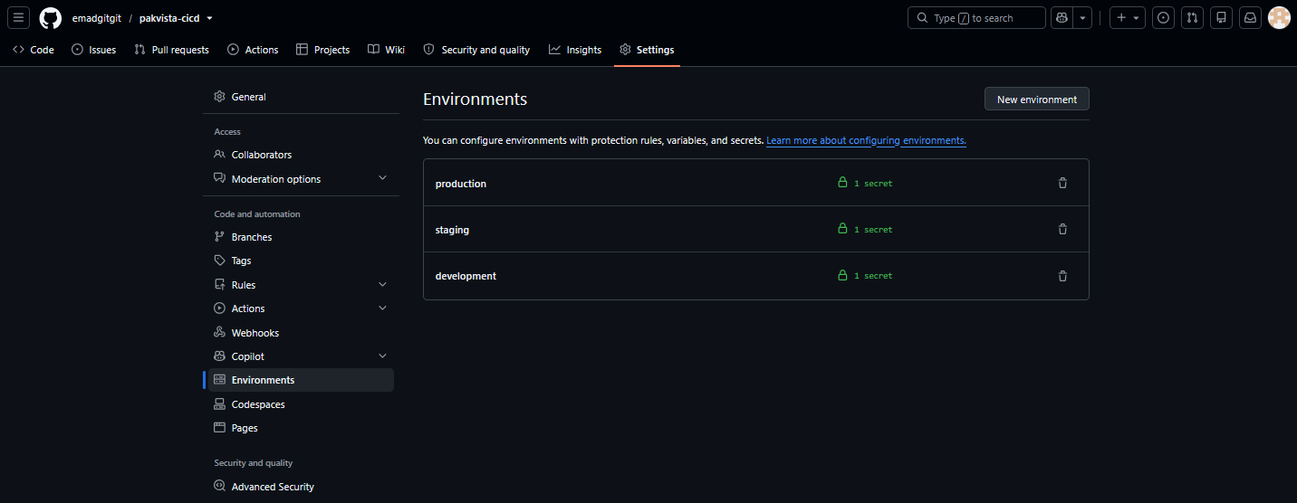
CI Workflow Runs – Triggered by each member's PR on develop (all steps green) | 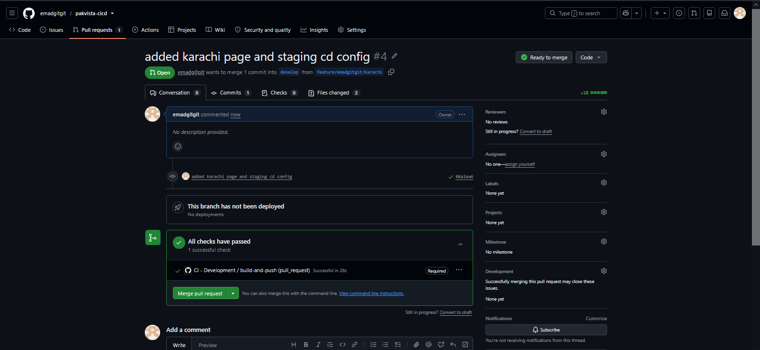  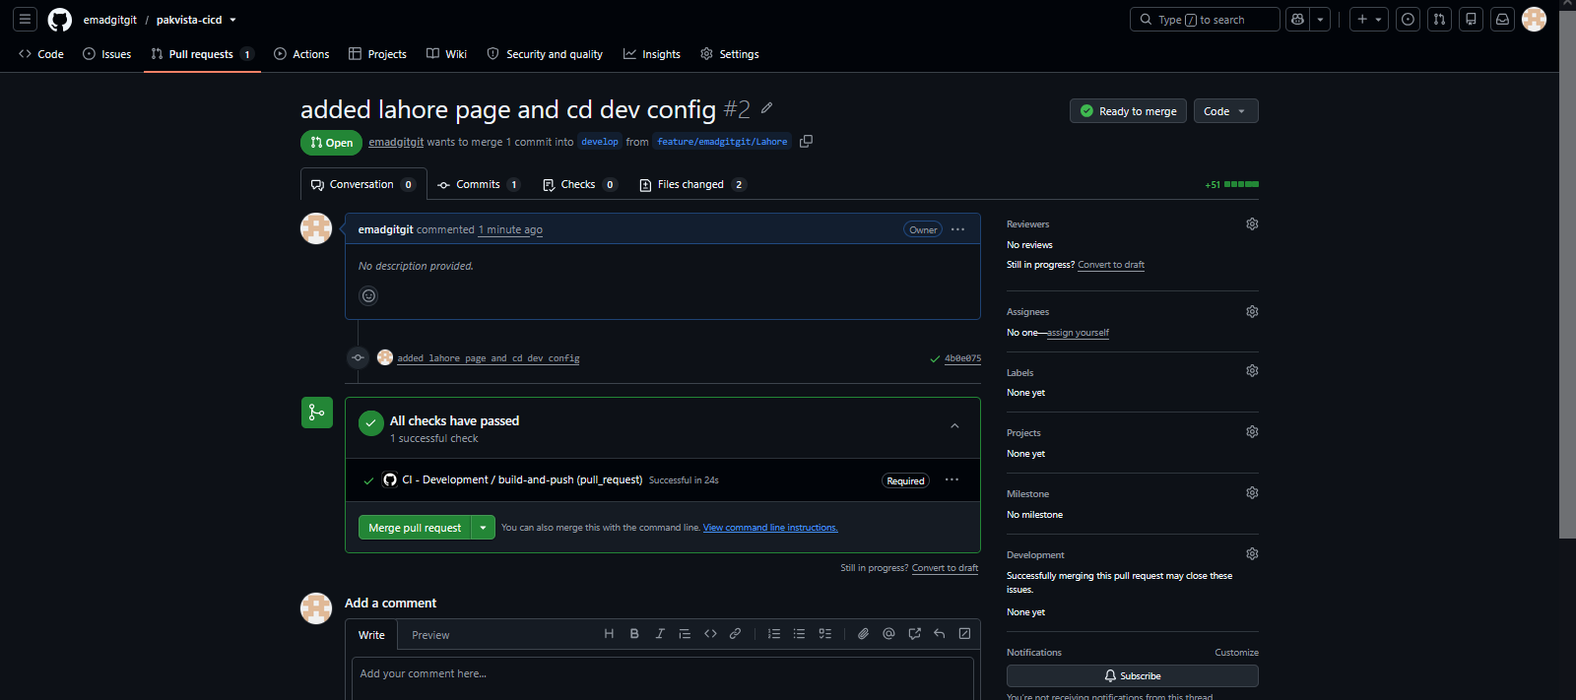  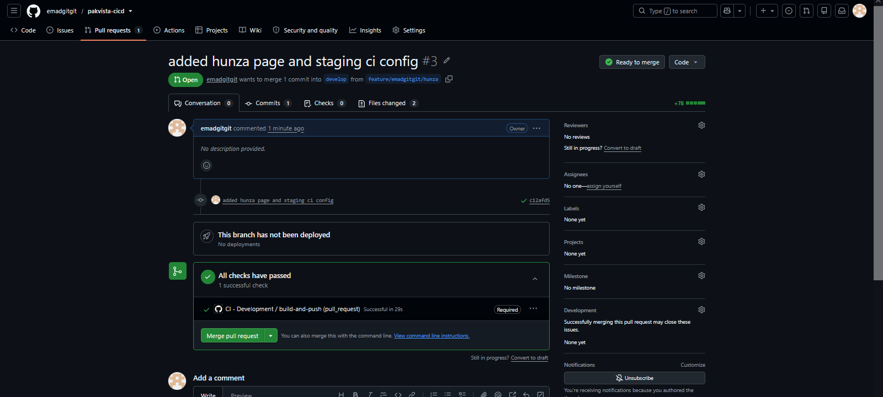  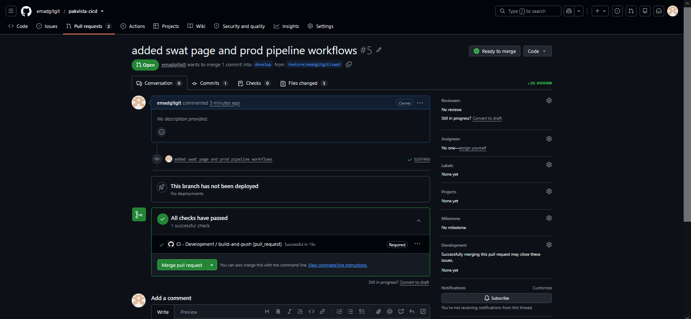
Docker Hub – Pushed Images with All Environment Tags (dev, staging, prod) | 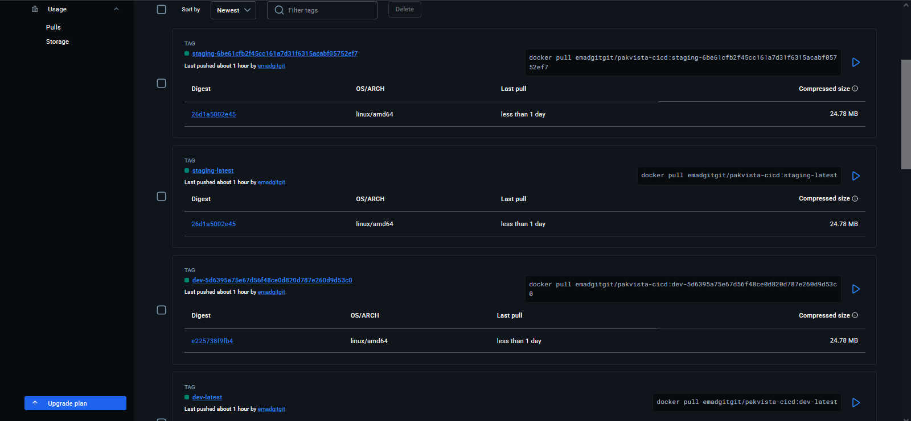  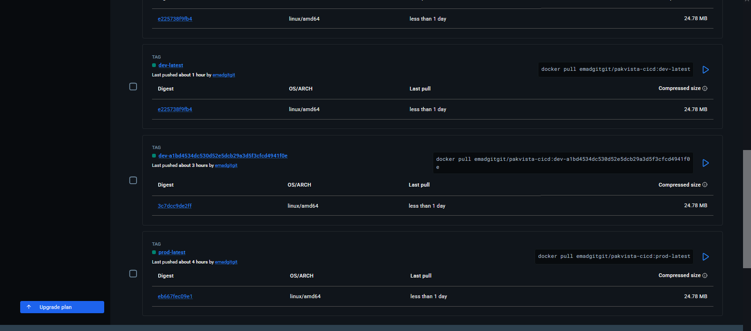
CD Workflow Runs – All three environments triggered by push events | 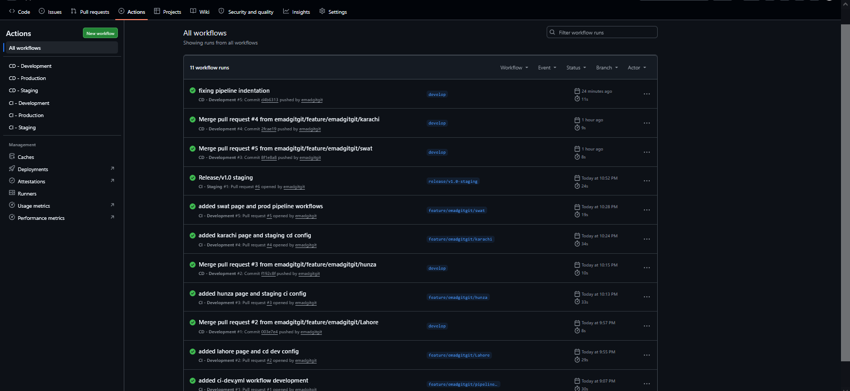
Live PakVista – Development Render Service (all 5 pages accessible) | 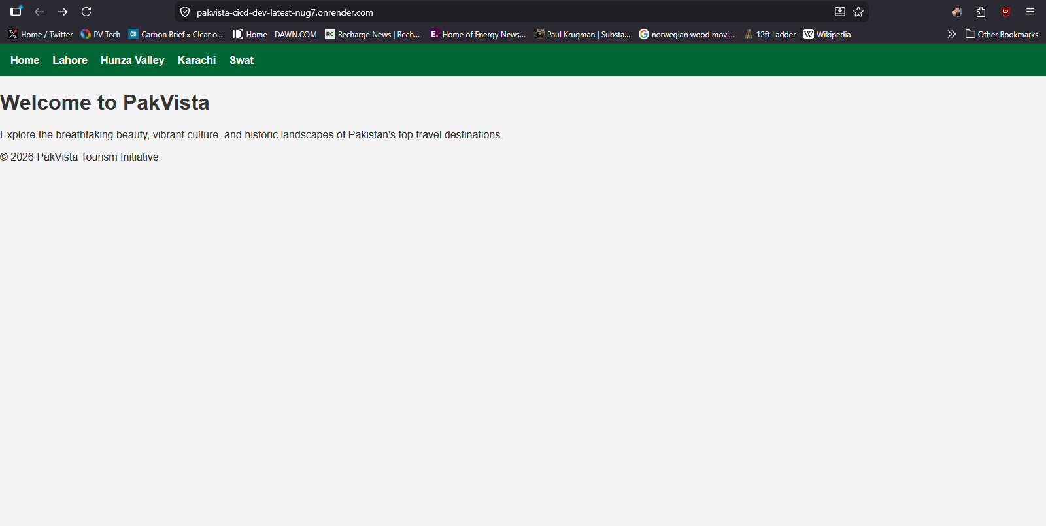  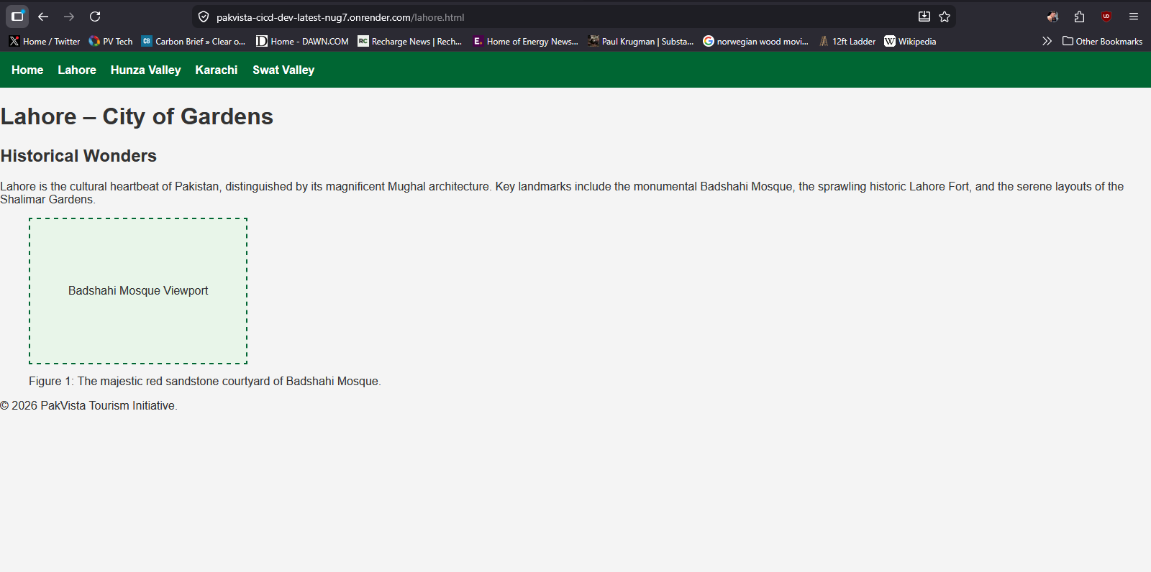  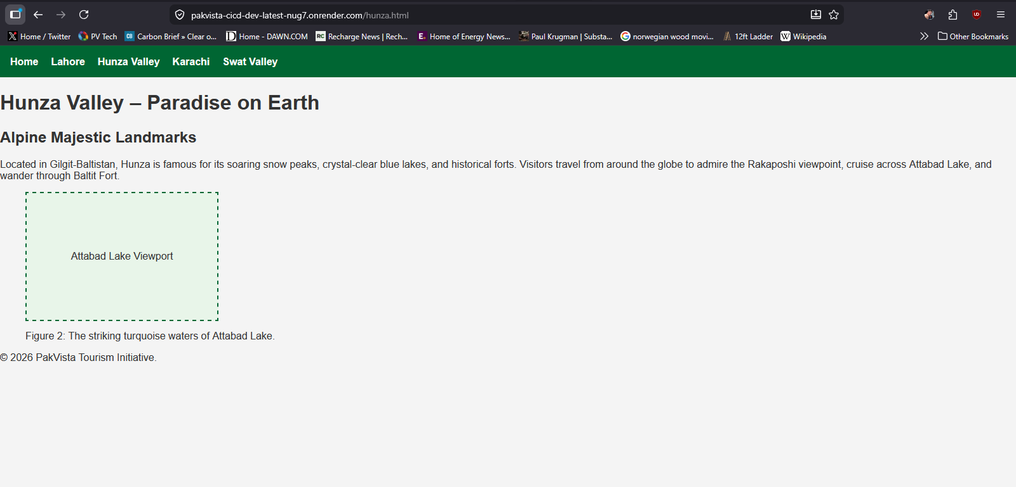  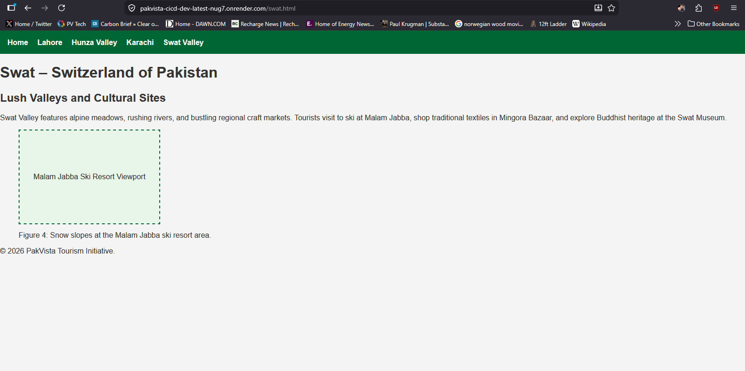
Live PakVista – Staging Render Service (all 5 pages accessible) | 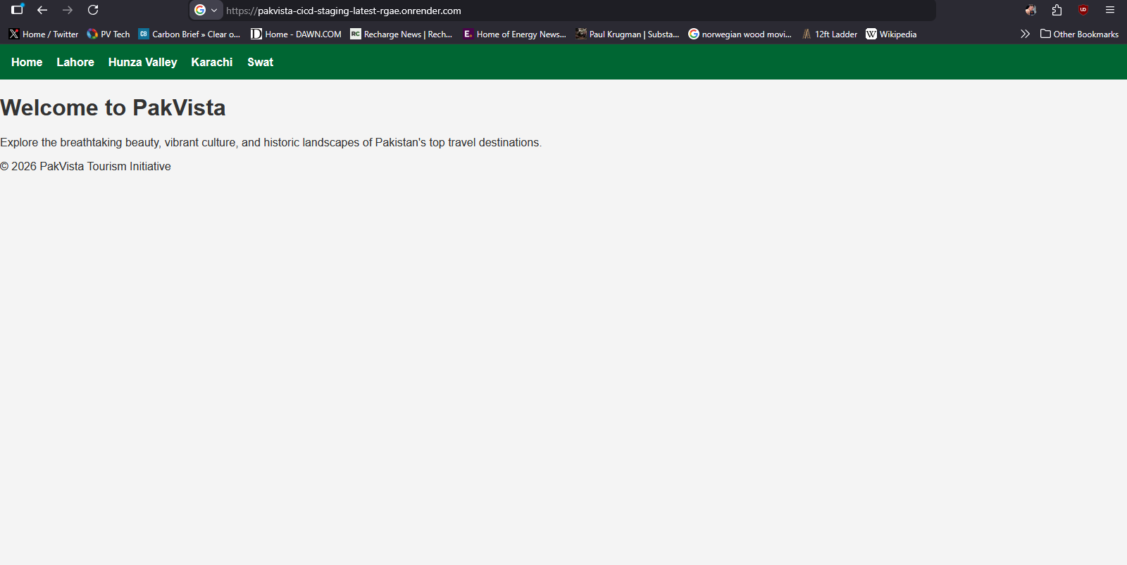  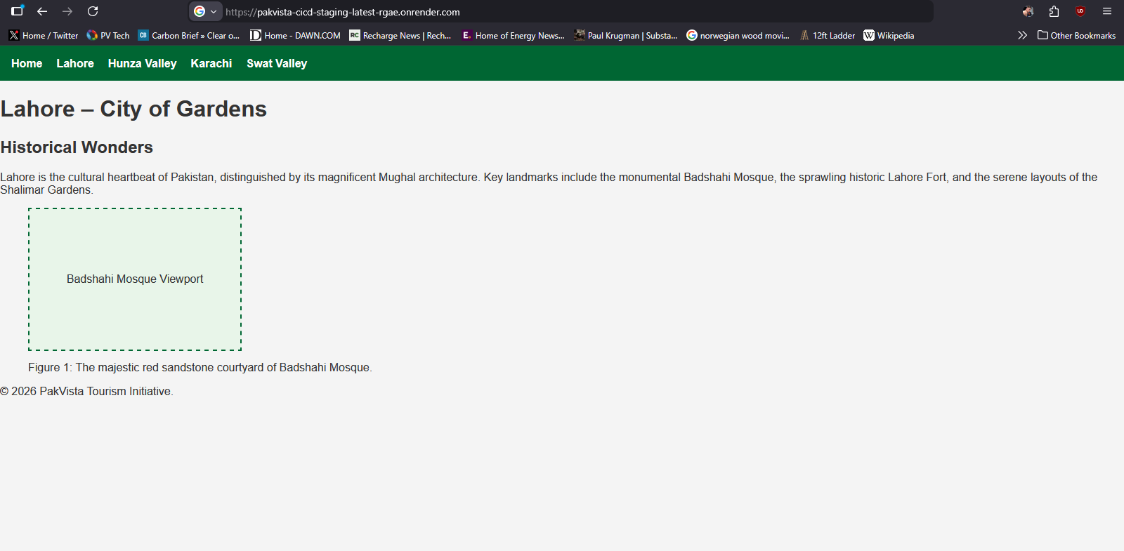  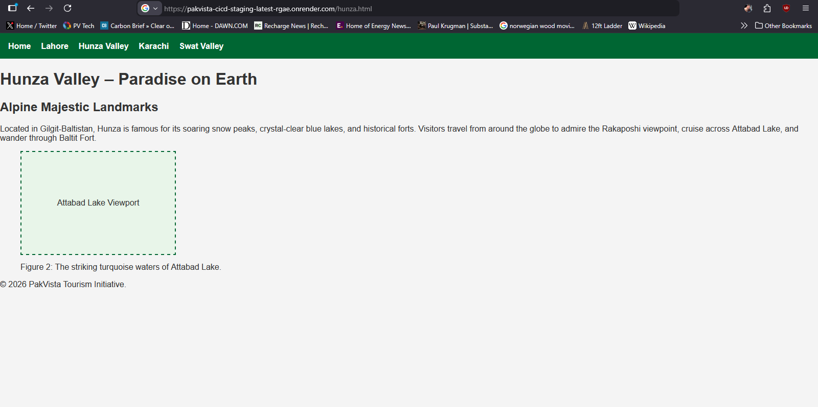  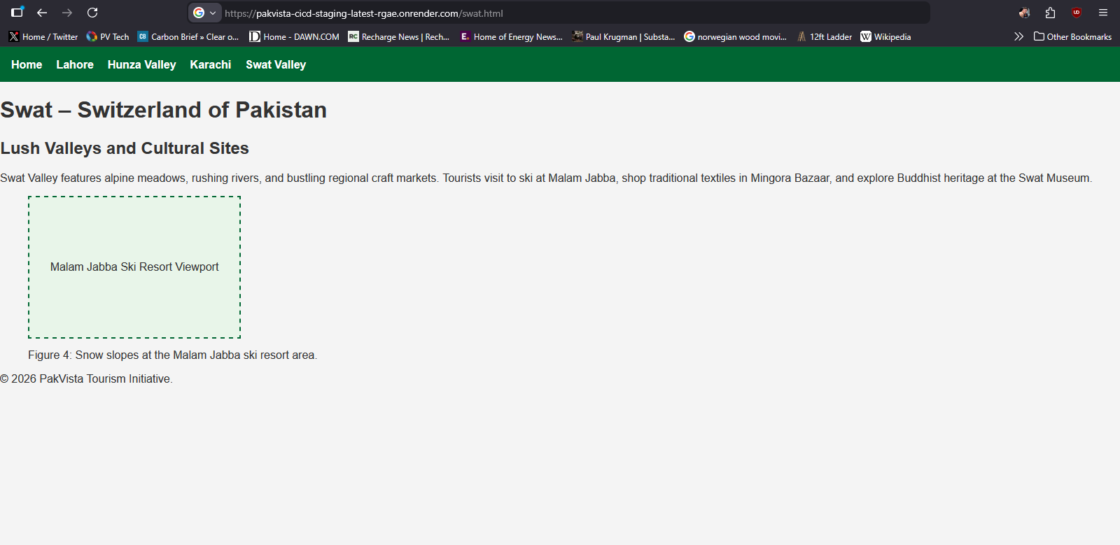
Live PakVista – Production Render Service (all 5 pages accessible) | 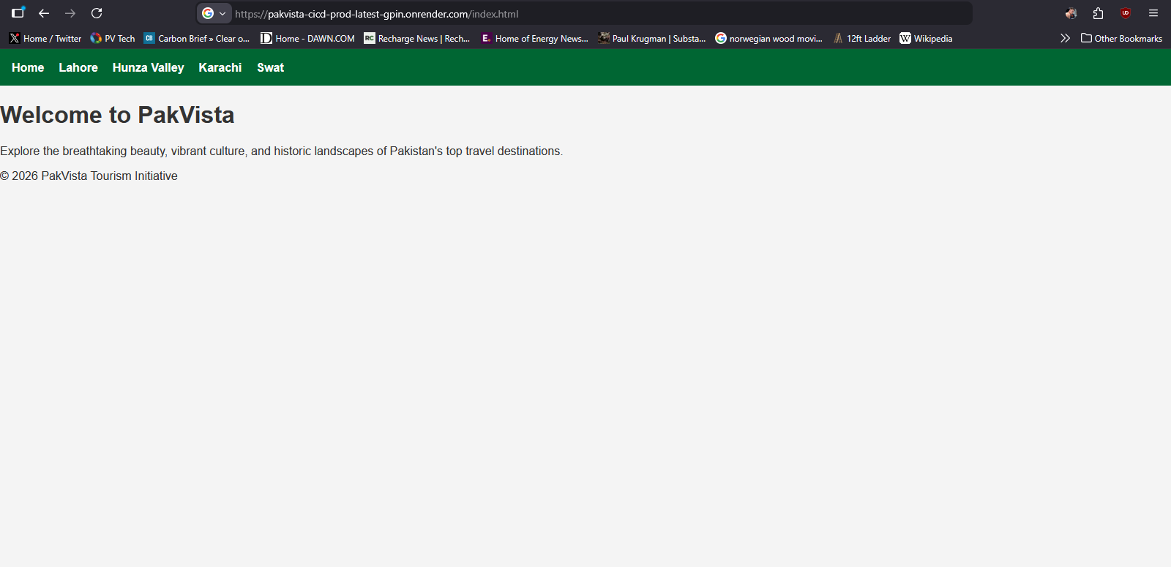  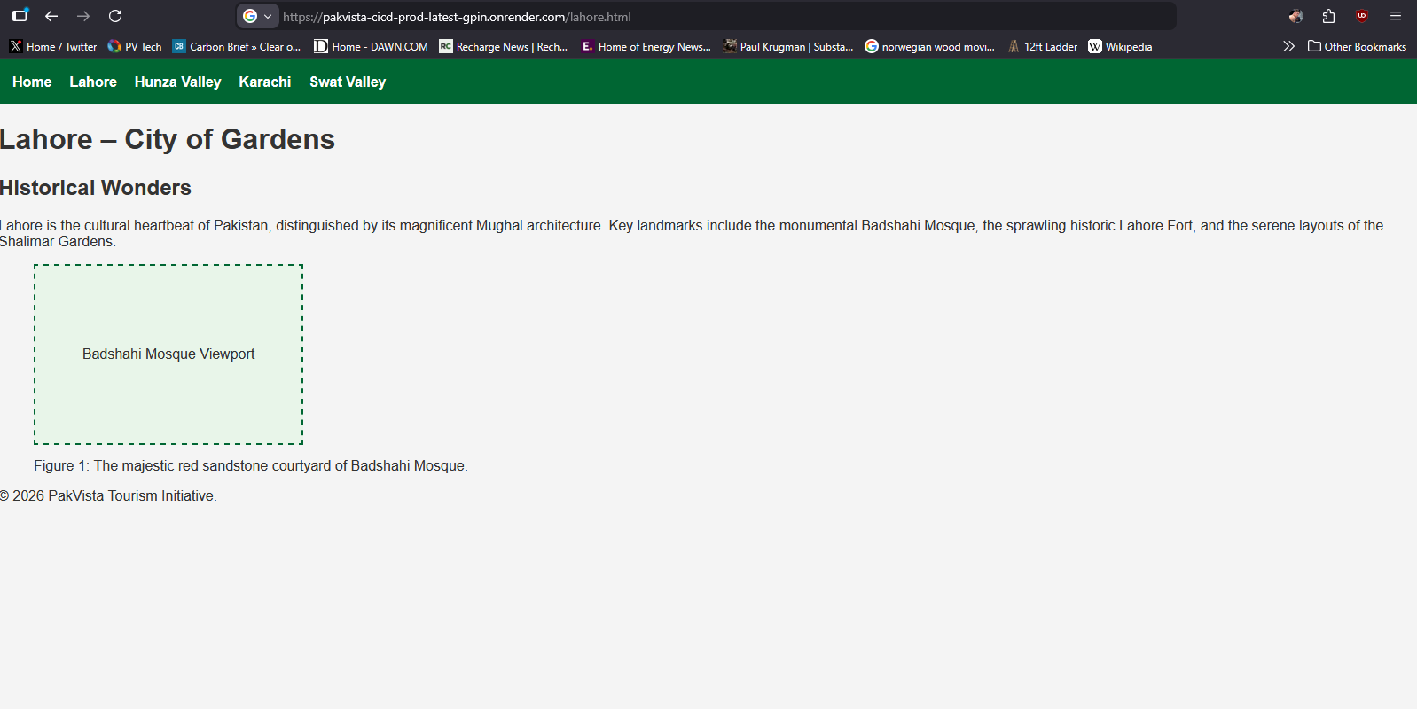  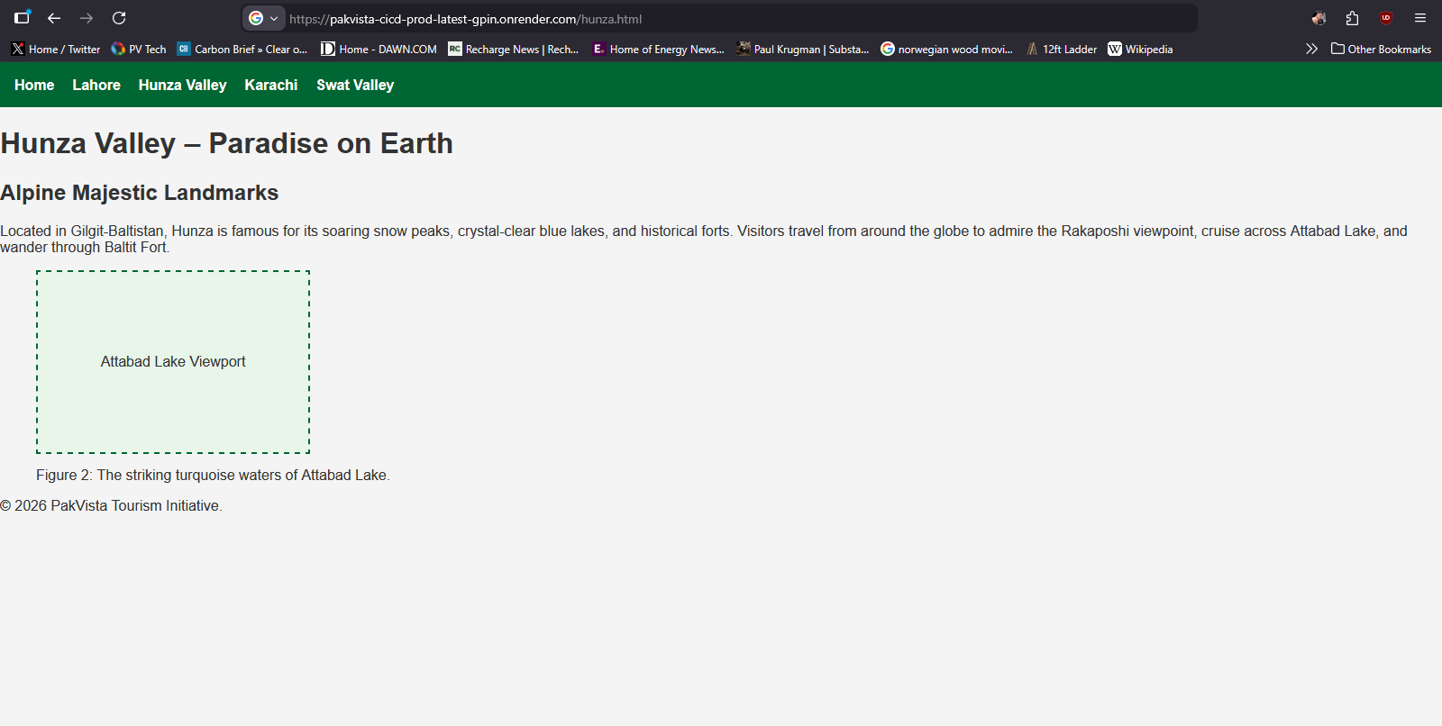  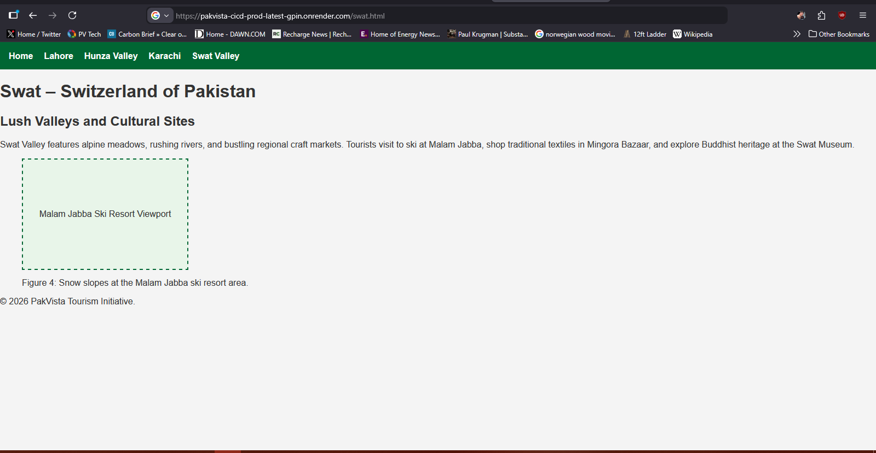
Term Project .docx visible in GitHub Repository file listing | 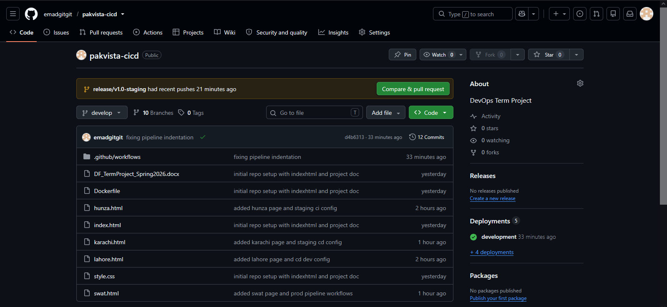

INDIVIDUAL REFLECTIONS
Each team member must write 4–5 lines below describing what they learnt during this Term Project, any challenges they encountered while authoring their workflow file and building their HTML page, and how they resolved those challenges.

Member 1: [Emad Mustafeez] – Reflection
Implementing this CI/CD pipeline showed me how automation links development straight to live deployment. Handling team branches and protection rules made me realize how easily code drifts without solid branch governance.

OFFICIAL REFERENCE DOCUMENTATION
All technical work must align with the official documentation listed below. Students are expected to consult these resources while building their workflow files, Dockerfile, and HTML pages.

Resource | Official URL
GitHub Actions – Workflow Syntax | https://docs.github.com/en/actions/writing-workflows/workflow-syntax-for-github-actions
GitHub Actions – Events that Trigger Workflows | https://docs.github.com/en/actions/writing-workflows/choosing-when-your-workflow-runs/events-that-trigger-workflows
GitHub Actions – Contexts (github.sha, secrets, etc.) | https://docs.github.com/en/actions/writing-workflows/choosing-what-your-workflow-does/accessing-contextual-information-about-workflow-runs
GitHub Actions – Encrypted Secrets | https://docs.github.com/en/actions/security-guides/encrypted-secrets
GitHub Actions – Environments for Deployment | https://docs.github.com/en/actions/deployment/targeting-different-environments/using-environments-for-deployment
GitHub Actions – Branch Protection Rules | https://docs.github.com/en/repositories/configuring-branches-and-merges-in-your-repository/managing-protected-branches/about-protected-branches
actions/checkout@v4 (Official Action) | https://github.com/actions/checkout
docker/login-action@v3 (Official Docker Action) | https://github.com/docker/login-action
docker/build-push-action@v5 (Official Docker Action) | https://github.com/docker/build-push-action
docker/metadata-action@v5 (Official Docker Action) | https://github.com/docker/metadata-action
Docker Hub – Repositories & Access Tokens | https://docs.docker.com/docker-hub/ | https://docs.docker.com/security/for-developers/access-tokens/
Docker Official nginx Image | https://hub.docker.com/_/nginx
Dockerfile Reference | https://docs.docker.com/reference/dockerfile/
Render.com – Deploy Hooks | https://docs.render.com/deploy-hooks
Render.com – Docker Deploys | https://docs.render.com/docker
HTML5 Specification (WHATWG) | https://html.spec.whatwg.org/
MDN Web Docs – HTML Reference | https://developer.mozilla.org/en-US/docs/Web/HTML
MDN Web Docs – CSS Reference | https://developer.mozilla.org/en-US/docs/Web/CSS
CSS Custom Properties (Variables) | https://developer.mozilla.org/en-US/docs/Web/CSS/Using_CSS_custom_properties

