Instruction on how to use DQA tool

Download the Microsoft Excel File tool with file “xxxxx” from the SHEILD Portal after login in to the platform

Open the downloaded file using Microsoft Excel 2008 or Higher. Excel would usually show a message with the prompt displayed below, click on “OK”

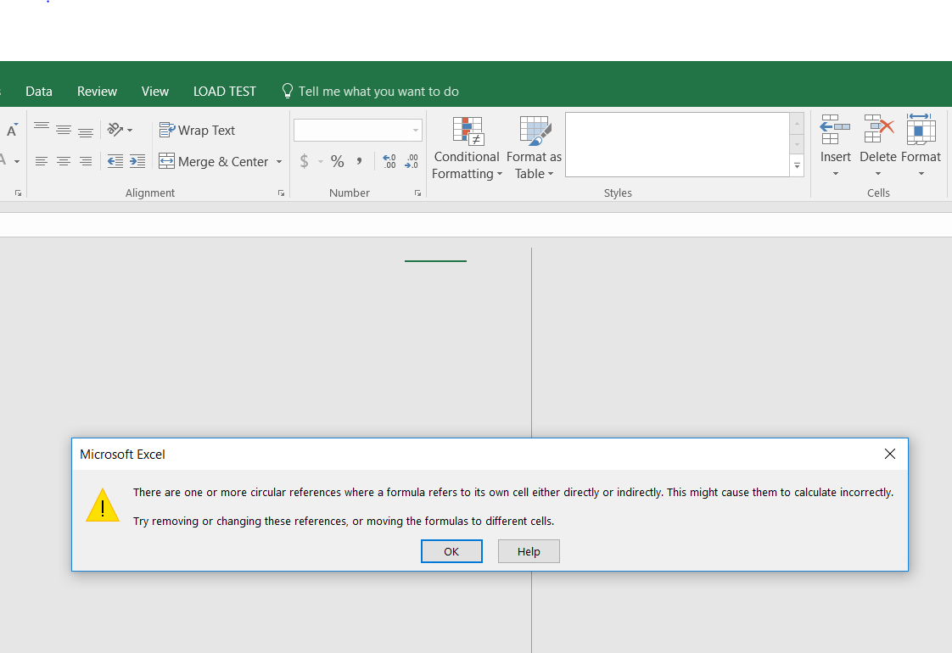

On the orange bar a security warning would appear asking you to click to “Enable Content”, please click to enable the formulas on the workbook

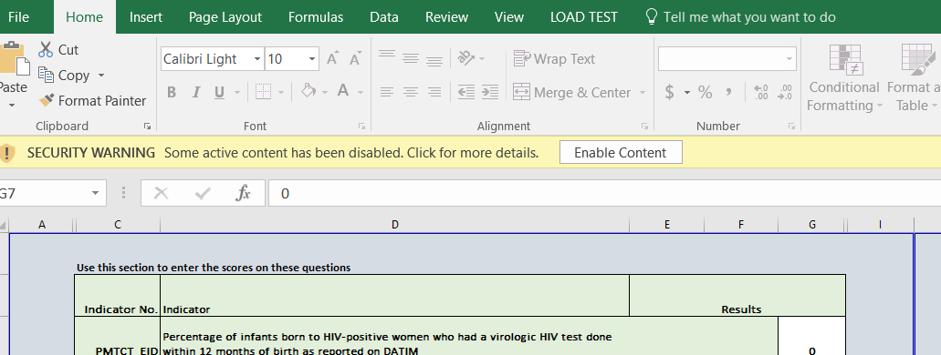

Excel would usually show a second (2nd) message with the prompt displayed below, click on “Continue”

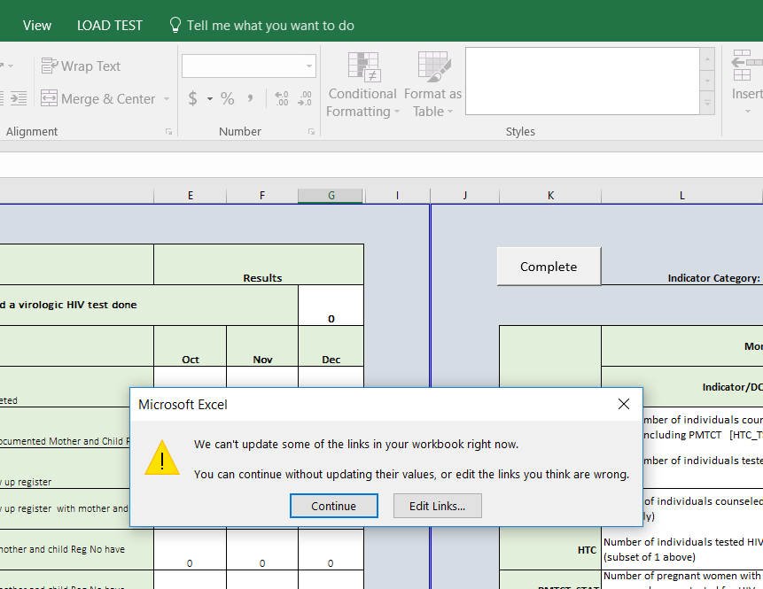

First select the Implementing Partner from the drop down in cell “P2”

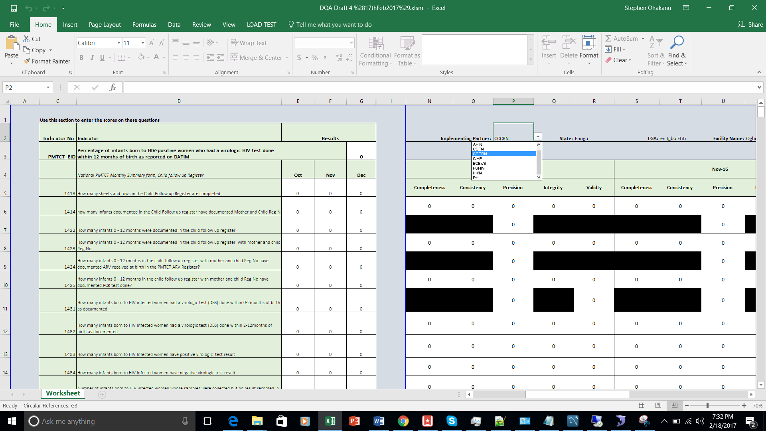

Select the state form the drop down that matches the state of the facility for the intended DQA in cell “R2”

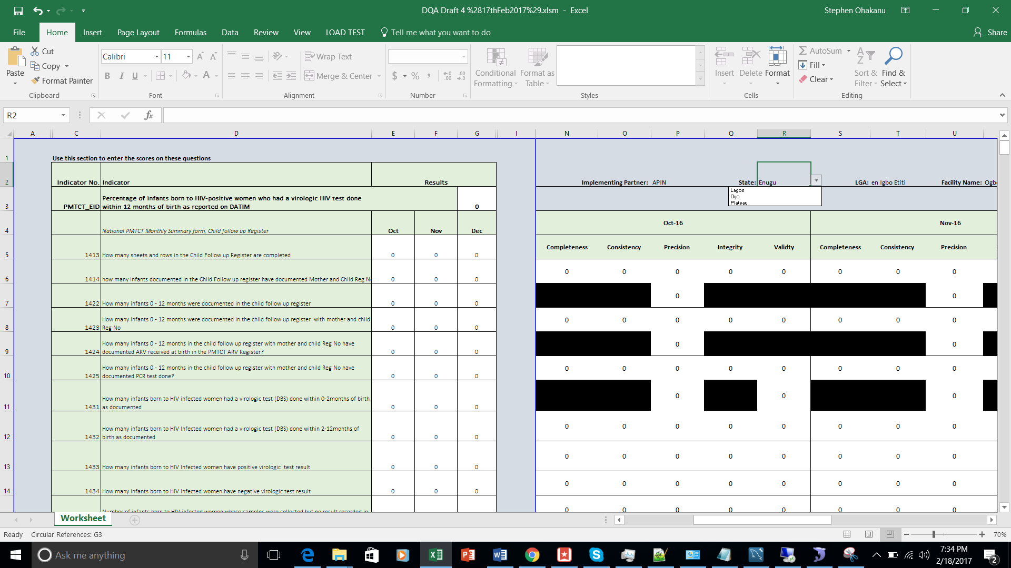

Seelct the LGA for facility of the inteded DQA report from cell “T2”

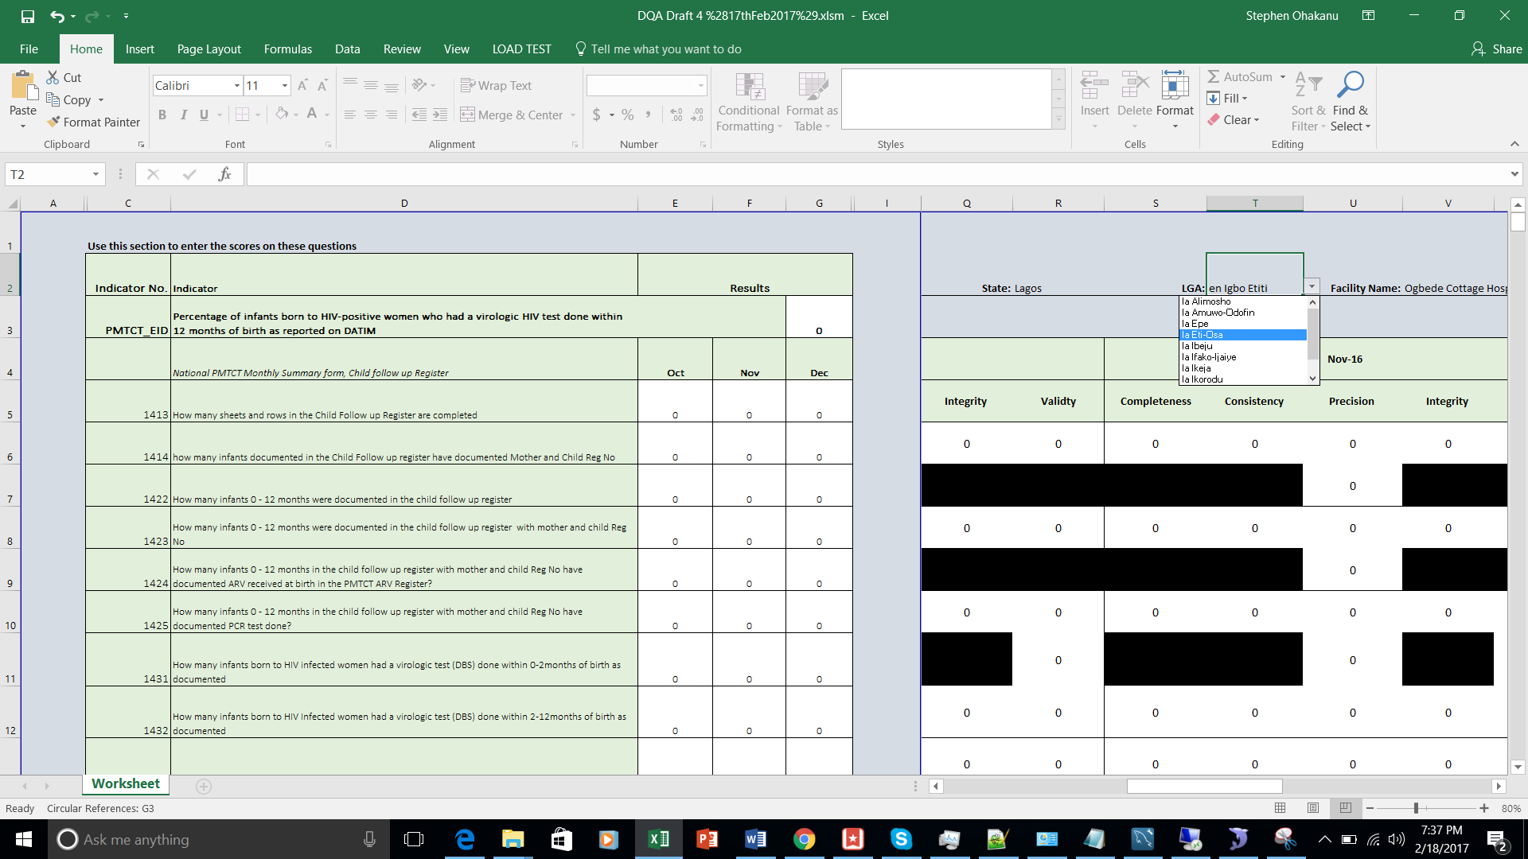

Select the Facility form the drop down in cell “V2”

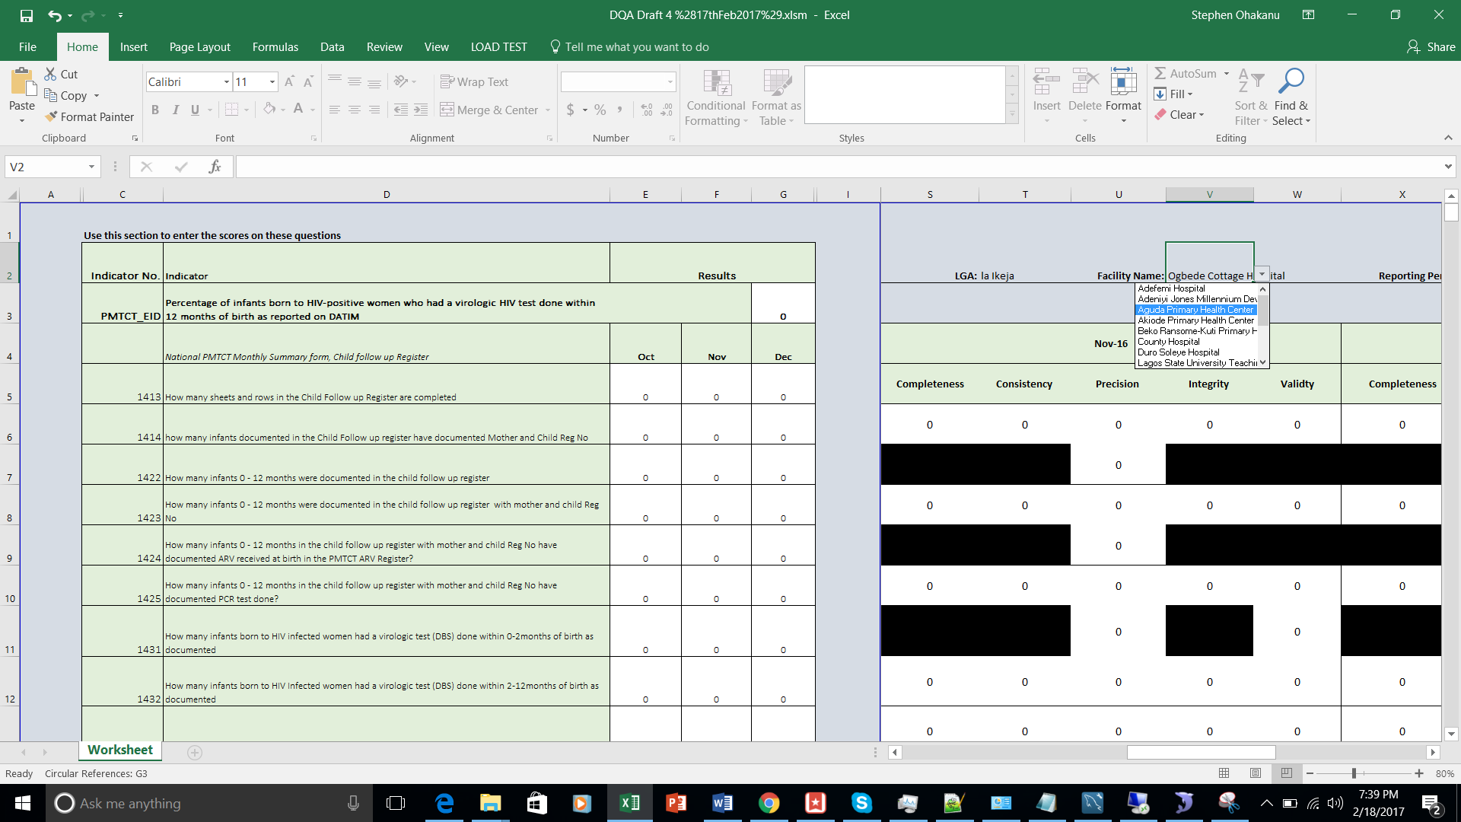

Select the Reporting Period from the cell “Y2”

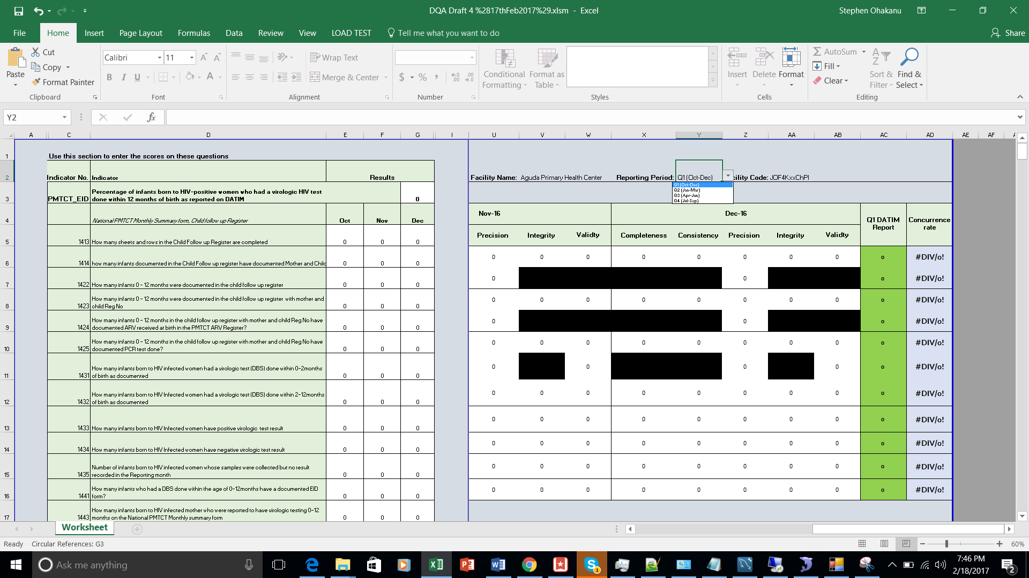

Select the thematic area from the drop down in cell “M2”

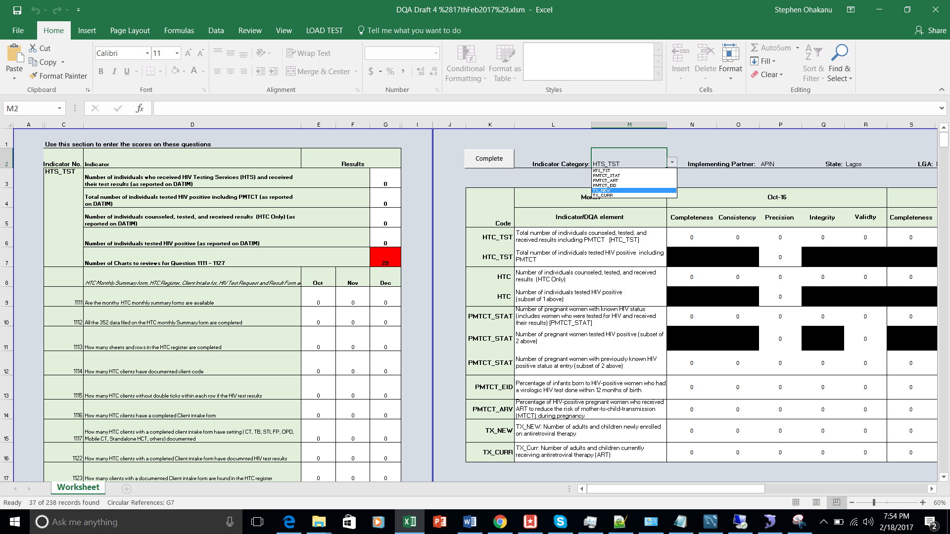

Changing thematic area would load the the data entry questions displyed in the column C to G.

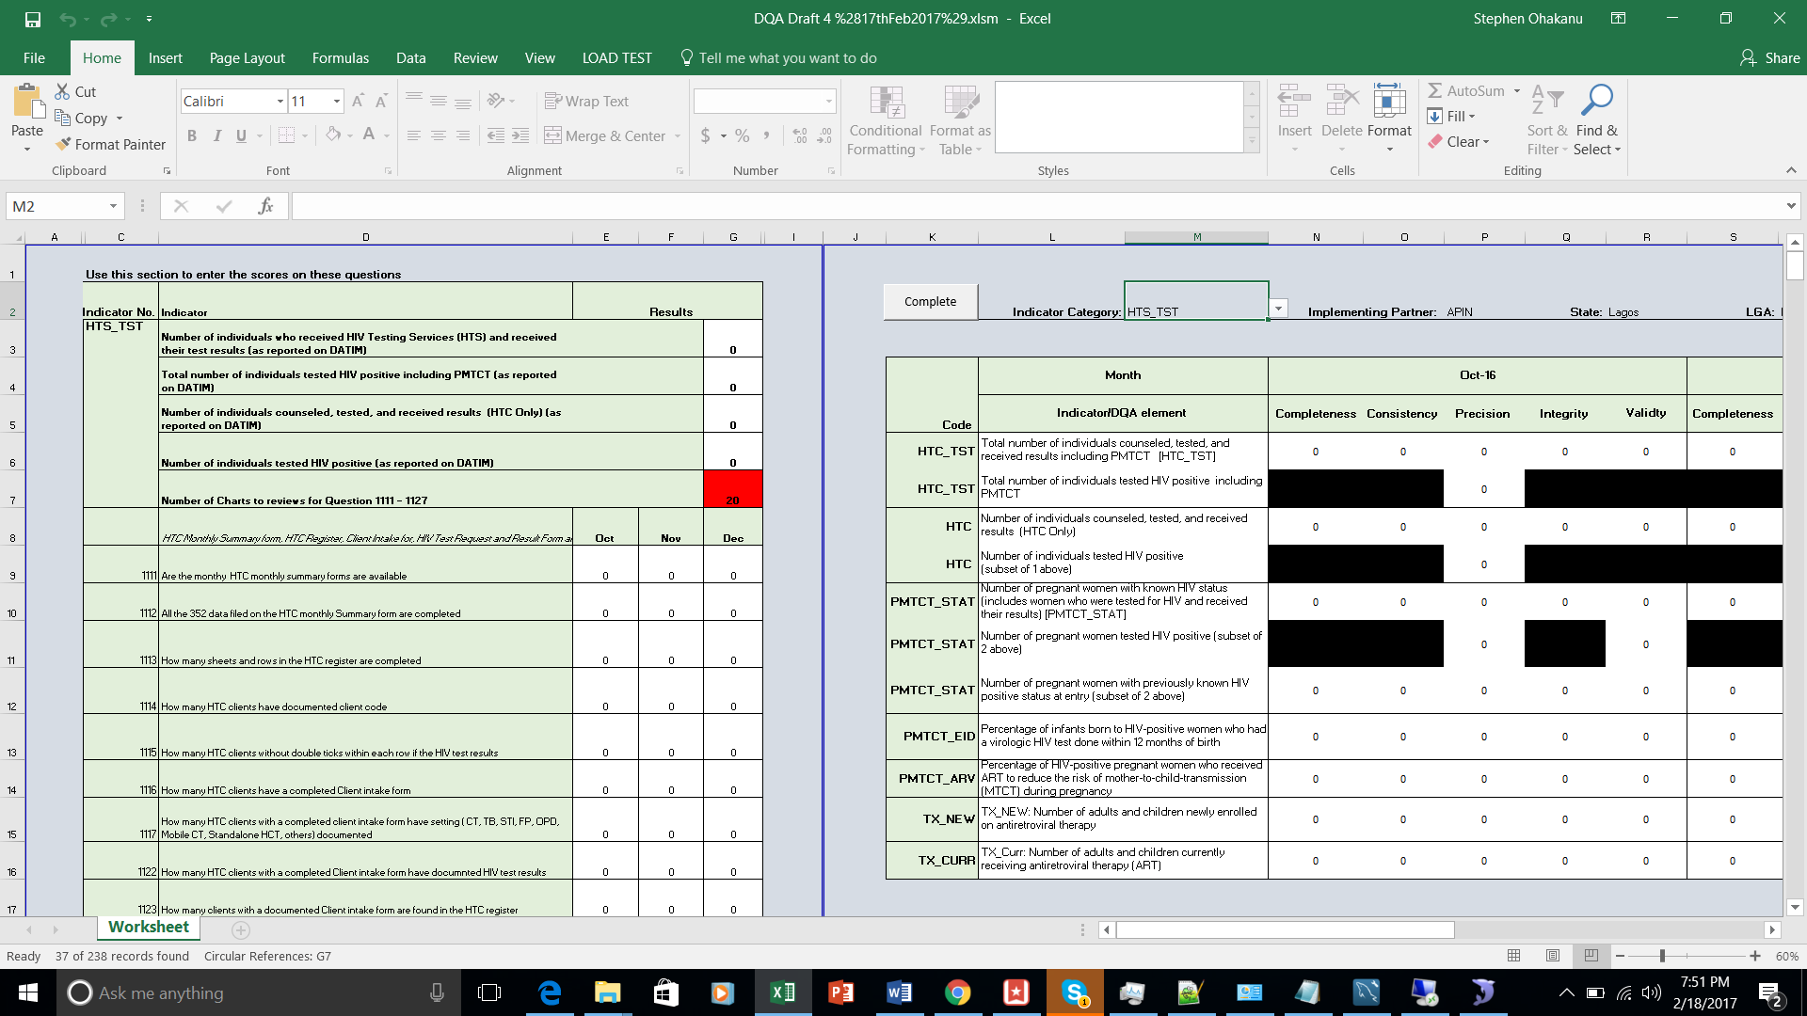

After completing the all the thematic area click on the “Complete” button to lock the form and display the ressult in the excel form

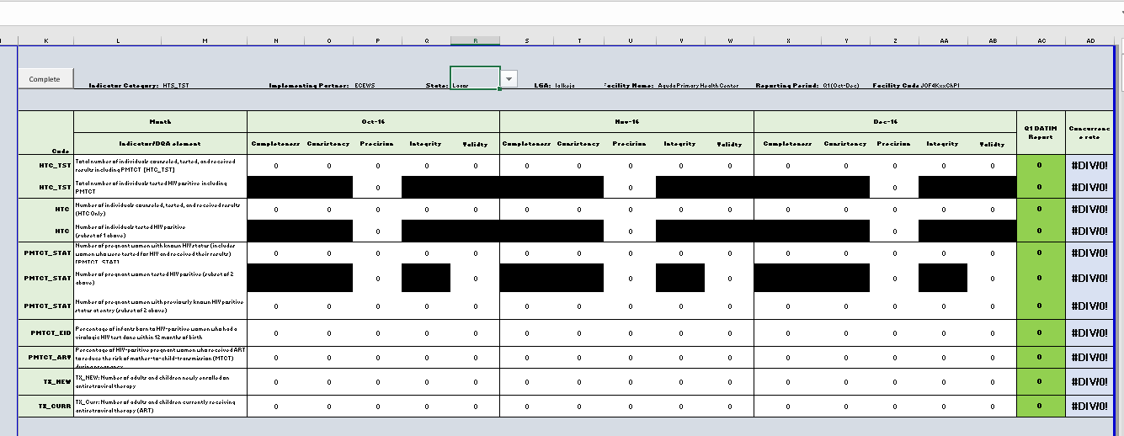

Save the report using the name of the facility

