***gatesnfences.com issues:***

Environment:

* OS: Windows 11
* Browser: Google Chrome - Version 126.0.6478.185 (Official Build) (64-bit)
* Precondition: Navigate to: <https://www.gatesnfences.com/index.html>

1. **Not possible to search anything through ‘search’ field:**

Severity: **HIGH**

Test steps:

1. In the field ‘Search’ at right side near top, input any reasonable entry like: “fence”, “top”….
2. Click search, or tap Enter

Expected result:

1. Input is shown in ‘search’ field
2. Expected to show ‘not found item’ or something similar, any result

Actual result:

2) Empty page appears with text in center of page: “404 not found”

Tester’s observation comment:

Developers should check database

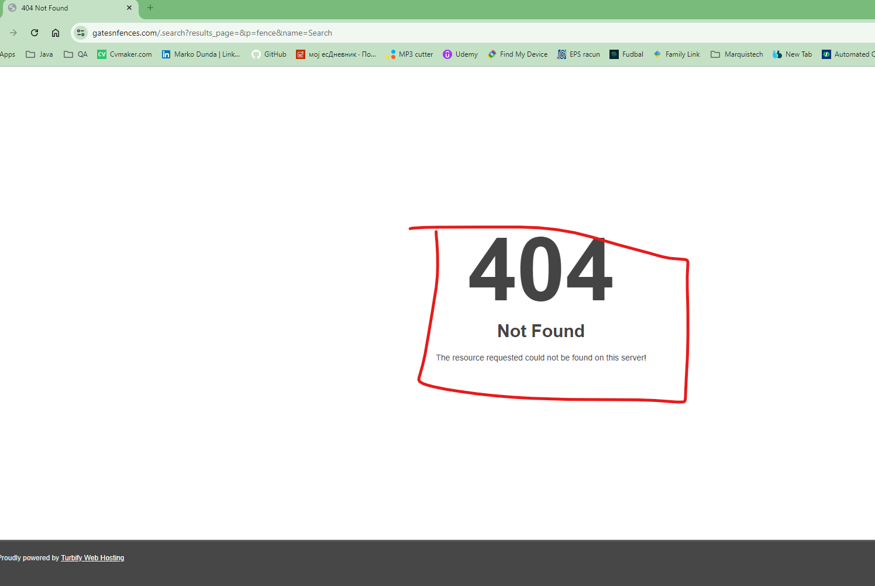 

1. **Showing secure threat due to search try:**

Severity: **HIGH**

Test steps:

1. Scroll down to the footer section
2. Click on ‘Contact us’ hyperlink
3. In the right section, type in ‘yahoo’ field any normal text. Click on submit

Expected result:

1. Footer section is shown
2. ‘Contact us’ form is shown
3. It should show yahoo search results

Actual result:

3) It shows unsecure submission threat

Tester’s observation comment:

Site should be secured against leaking information to potential interceptors! This can drag out customers away

