Partisan Deadlocks and Agenda-Setting in American State Legislatures

Henry A. Kim
Department of Political Science
University of California, San Diego
La Jolla, CA 92093-0521
h27kim@ucsd.edu

Abstract

The debate over “party influence,” or the appearance thereof, in American politics has been waged between those who see it primarily as the product of legislator preferences (Rohde 1991; Aldrich 1994; Krehbiel; 1998) and those who see it as the consequence of partisan control over legislative institutions, particularly those affecting the legislative agenda (Cox and McCubbins 1993, 2004). Unfortunately, as most of the research has been limited to the single case of the U.S. Congress with relatively limited variation, it has not been possible to decisively demonstrate the effect of either preferences or institutions separate from each other.

State legislatures provide an alternative to Congress in examining the role of parties and agenda-setting institutions in obtaining legislative outcomes. I focus on partisan deadlocks, where equal numbers of legislators from each party are present in a legislature, particularly on how voting patterns in these legislatures change relative to a “normal” session with a partisan majority. These provide a natural experiment because they temporarily eliminate a “majority party” with an institutionally privileged position with regards to the legislative agenda and because they have generally led to “power-sharing” agreements between parties that rearrange agenda-setting power of various players in the legislative process. I find that the control over the agenda-setting institutions have a great deal of effect in biasing legislative outcome in favor of the majority, during “normal” sessions, consistent with the view of party influence as predominantly institution-, rather than preference-, based.
1. Introduction: The Continuing Search for Party Influence in Legislatures

There is a long history of debate concerning the roles played by legislative parties in American politics, particularly in Congress. Recently, the debate has involved those who argue that party influence arises from 1) the majority party’s monopoly over the critical bottlenecks in the legislative process (Cox and McCubbins 1993, 2005), 2) the product of majority party’s ideological homogeneity (Rohde 1991; Aldrich 1994), or 3) it is merely a chimera generated by high correlation between legislator ideologies and party affiliations (Krehbiel 1993, 1998). While most of these debates have been constrained to Congress, there have been a number of recent studies seeking to expand the debate to state legislatures, such as Aldrich and Battista (2002) and Wright and Schaffner (2002).
In practice, the Conditional Party Government thesis, as the Aldrich-Rohde argument has come to be known, has proven very difficult to distinguish from Krehbiel’s claim that there exists no appreciable effect solely attributable to the presence of “party.” Both are preference-based arguments, contending that a given set of outcomes is primarily the consequence of the legislators’ preferences and little else. While the Conditional Party Government thesis does posit some additional influence attributable to the party organizations, this “influence” manifests itself only when there is sufficient preference homogeneity within the majority party behind a particular action. Put differently, it is only a transient feature itself dependent on the distribution of member preferences, not a permanent effect based on the roles of the parties and their leaderships as institutional fixtures in the legislative process separate from the legislators’ wants at a given time. Since party effect manifests itself only if preferences are properly aligned, it is impossible to separate the influences of party and properly aligned preferences. Since the properly aligned preferences among legislators is a sufficient explanation for why a given outcome took place, the addendum of the party in the Conditional Party Government thesis, especially if its effect is merely “conditional” on the distribution of member preferences, explains little else.
The impossibility of separating the effects of a particular configuration of legislative preferences and an additional party effect that itself allegedly arises only when such configurations are in place necessarily implies that the party influence, if any exists, must be “institutional” in nature, based on the permanent features of legislative parties independent of what the legislators want at any given time. The explanation for party influence offered by Cox and McCubbins (1993, 2005) fits such a bill. They posit that the majority party’s influence comes mainly from its privileged position in the legislative process, particularly the monopoly it enjoys over key bottlenecks in the legislative process. At each step of the legislative process, agents of the majority party “screen” pieces of legislation that come before them, or block undesirable bills from reaching the next stage. Party unity and other assorted evidence of party influence in the legislative voting arise from the bias thus introduced in the selection of the bills permitted to be voted on, as bills opposed by any large fraction of the majority party are killed off much earlier in the legislative process. Specifically, they attach great significance to the control over the legislative calendar enjoyed by the Speaker in the U.S. House at the penultimate stage, for, unlike various committees playing the screening role earlier, he is alone in being delegated to act at the behest of the entire majority party caucus for all legislation. He is furthermore incentivized to act for the common good of his co-partisans as he owes continuation in his position to maintenance of widespread support among the rank and file. On the other hand, members of committees, especially if they share common policy interests, can sometimes conspire to advance their own parochial interests even at the expense of their party colleagues elsewhere.
In principle, the Procedural Cartel Theory, as the Cox-McCubbins thesis has come to be known, is much easier to evaluate than its competitors. It posits a particular mechanism through which party influence is primarily exercised—specific institutional features of certain legislatures, including U.S. Congress, that confer a privileged procedural position upon the majority party. By identifying a single specific institution as the fount of party influence, it also offers a means of falsification, a desirable trait of a scientific theory, through the implication that, in absence of such an institution, party influence may be greatly diminished or even eliminated altogether.
In practice, however, the continued focus on the modern U.S. Congress as the primary topic of research in American legislative politics has made its evaluation difficult, for the procedural privileges enjoyed by the majority party therein has remained much the same through most of the 20th Century. In absence of the necessary variation, the extent to which the majority party is advantaged through its procedural privileges cannot be adequately gauged.
In comparison, state legislatures offer the variation necessary for evaluating the import of agenda-setting institutions for the manifestation of party influence. There is much variation among state legislatures in the degree to which the majority party leadership controls the flow of legislation from the introduction to the floor voting. Covariation between the extent of party influence observed in legislative outcomes in various state legislatures and the procedural opportunities afforded to the majority party should, in theory, indicate the extent to which the former arises from the majority’s control over the legislative agenda. Nevertheless, a naive comparison between state legislatures, even where they offer different institutional features, may not suffice. As noted by Erikson, McIver, and Wright (1993), there is much variation in ideological makeup among various states, including between Democrats and Republicans. Whether the differences observed when comparing roll call behavior across states owes more to preferences or institutional differences would be difficult, if at all possible, to determine. An “experiment,” in the form of an exogenously induced event that a) changes the distribution of agenda power within given legislatures while b) leaving preferences reasonably unaffected is desirable.
Happily, recent decades have provided such “natural experiments” in multiple states in the form of partisan ties—where the legislatures were evenly split between Democrats and Republicans. Ties are useful as they deny both parties any exclusive claim to the majority status and whatever privileged status that goes with it. In addition, examining them offers the additional benefit of keeping the preference distribution within the legislature reasonably constant, for partisan deadlocks generally take place in legislature where both parties are highly competitive. If the primary source of party influence consisted of institutional factors, the changes would depend on the specifics of institutional changes adopted and in general should be significant. If party influence, instead, owes mainly to preference distribution, the institutional adaptations would be largely irrelevant and the overall changes would be minimal.
The aim of this chapter is to explore the institutional basis of party influence using the partisan deadlocks that took place in two specific legislatures, the House of Representatives in the State of Washington and the House of Delegates in the State of Virginia, as the experiments. These legislatures offer the opportunity for a twofold evaluation of how party influence arises. When a partisan majority exists, the Washington House bestows a great deal of procedural privileges on its Speaker, especially in determining the floor agenda. The Virginia House, on the other hand, does not provide for the Speaker, or any other single partisan body, to decide what ultimately should be brought up for the floor vote. Notwithstanding the imperfections of a state-to-state comparison, “normal” sessions in these bodies allow one to explore how a legislature with a centralized, majority-controlled agenda-setting mechanism—in the form of the Speaker or something else—would differ from a more decentralized legislature lacking such a mechanism in terms of the legislative outcomes. More importantly, the partisan deadlocks allow for intertemporal comparisons within the respective legislatures between the periods of partisan majorities and the tied periods. This allows for an evaluation of how these two very different assemblies responded to the
”shock” of partisan deadlock. I combine an analysis of roll call voting in these legislatures before, during, and after the ties with information obtained from interviews with elected officials and legislative staffers in these and other state legislatures, to assess how centralized agenda setting powers in the hands of the majority party leadership affect the manifestation of party influence.

2. The Consequences of the party influence
Traditionally, various measures of party cohesion, such as the Rice Index, were deemed to be sufficient indicators of the degree of party influence. Kingdon (1979) noted that such indices reveal little about party influence rather than legislator preferences—they may simply agree with each other all the time and vote accordingly, not that there is any constraint imposed by parties beyond what legislators would otherwise have done. The Krehbiel critique (1993, 1998, 2000), re-emphasizing Kingdon’s argument, has put the validity of made such metrics in serious doubt. More recent attempts at measuring party influence, such as Snyder and Groseclose (2000), presume a specific form of party influence—that it consists of pressure brought upon legislators to change their votes under certain circumstances. Yet, this is not the only channel for the majority party to exert an influence in legislative outcome—control over legislative agenda gives the majority leadership the means to affect the outcomes without forcing the backbenchers to take actions that they otherwise would not have. What observable consequences, then, are expected to follow from the majority party monopoly over the legislative agenda?
2.1 Party Influence and Dimensionality
One consequence of the partisan monopoly over legislative agenda is a reduction in the dimensionality of the voting space. The ability to control the legislative agenda implies an ability to determine, in advance of actual votes, the types of coalition that would be actually observed on the floor. If the majority party leadership were to monopolize the legislative agenda on behalf of their caucus, we would expect most of the bills reaching the floor voting stage to be largely supported by members of the majority party and opposed mainly by members of the minority party. The discipline of either party need not be perfect—merely that the opposing voting coalitions be stable and that “defections” from each be more or less ordered. Such orderedness corresponds to what the scaling literature, such as Poole and Rosenthal (1991, 1997), characterize as unidimensional policy conflict. That roll calls in U.S. Congress throughout history have been largely characterized by unidimensionality, that the dimension of policy conflict corresponds neatly to the party divisions, and that the only periods of significantly multidimensional roll calls coincided with the nearly partyless periods of 1820s and 1850s, have led to the argument that the unidimensionality of policy conflict is itself a product of party influence. Jenkins (1999) and Wright and Schaffner (2002) have used the findings concerning dimensionality in the Confederate Congress and the Nebraska Unicameral, respectively, to draw conclusions about party influence or the lack thereof in these legislatures.
How exactly this unidimensionality in roll calls arises, however, is somewhat controversial. Notwithstanding a handful of exceptions, the vast majority of legislatures so far studied exhibit fairly low dimensionality. Even if a lack of “significant party influence” is allowed for such multidimensional legislatures that might be found, it is not clear whether party influence would vary linearly with the dimensionality of the legislature, especially since determining the dimensionality of roll calls remains more of an art than a science, something that cannot be readily reduced to any one agreed statistic that can be tested. It is even conceivable that a strong, rather than a weak party might sometimes give rise to the appearance of multidimensionality. Furthermore, it is commonly assumed that the various statistical methods for scaling legislative votes, such as DW-Nominate developed by Poole and Rosenthal, necessarily measure the preferences of the legislators. Indeed, DW-Nominate scores for the members of the U.S. Congress are routinely used by scholars as a measure of their ideology. If so, unidimensionality of roll call voting can simply imply a particular distribution of legislator preferences—specifically, that they somehow all lie along a straight line— rather than the presence of any party influence as such. Converse (1964) claims that preferences of political sophisticates—amongst whom, presumably, elected politicians belong—tend to lie in a single readily definable left-right dimension. Krehbiel (1991, 1998) also argues that legislators’ preferences may well be “naturally” low dimensional without any external force inducing it. Such arguments find an echo among some psychometricians, who note that it may be simply beyond the cognitive capacity of a human brain to process and categorize patterns beyond two dimensions (see Borg and Groenen 1997, for a discussion). If so, low vs. high dimensionality of roll call voting may not, by itself, provide much information about the strength of party influence.
2.2. Roll Rates and Support Rates
Partisan control over the legislative agenda, however, predicts patterns of roll call voting beyond mere low dimensionality of the voting space. The majority party leadership is hypothesized to use the agenda power to protect the interests of its members, or to prevent the bills opposed by a sufficiently large fraction its members from being brought to a floor voting, especially if it poses a danger of actually passing over their objection. If we assume that the majority party caucus operates under majority rule and the caucus or its agents control the legislative agenda, then no bill opposed by more than half of the majority party may successfully pass the floor voting stage. Indeed, such bills probably would not even reach that stage at all. In practice, the threshold may actually be higher, as elected officials and legislative staffers in certain state legislatures indicate that the majority party leadership, where it controls the agenda, tends to eschew alienating even relatively small fractions of their own co-partisans (Personal interviews). The consequence of such practices by the majority party would lead to the appearance of relative unity on part of the majority party: on any given vote, almost all members of the majority party will be voting on the same side. There will be often little or no need for members of the majority to defect: if they oppose the bill in sufficient numbers, the bill simply would be screened away. The only exception may arise when a small number of extremists oppose a bill supported by all others in the majority, but even then, only when the opponents are sufficiently few in number.
What of the minority party? The majority leadership would not care how the members of the minority vote, excepts as that affects whether the bill has enough votes to successfully pass. If the minority party legislator were to find the bills put to final passage preferable to the status quo, they may find themselves in a bind, having to choose between voting sincerely and voting with their co-partisans against their own interests. But the minority has little substantive reward to mollify such would-be defectors: lacking control over legislative agenda, it cannot affect policy changes, leading to relatively frequent defections from the minority, especially among those with more “centrist” policy preferences. One consequence of the power to screen bills being limited only to the majority, then, will be that, in most votes, a largely unified majority party will oppose a frequently divided minority party. This is different from the traditional manner in which intraparty cohesiveness has been used as a measure of party influence, in which greater cohesiveness within both the majority and minority parties was thought to indicate a greater party effect.
The majority party leadership would bring up bills for floor consideration not only because most of their members agree on a common position, but because they are united in support of the bill and the associated policy change—bringing up a bill just to vote it down represents a waste in time and effort, if the aim is solely to make the point. The minority, on the other hand, is more likely to be divided between supporters and opponents. In addition to the disparity in party unity between the majority and the minority, party influence implies a disparity in support for the bills reaching the floor voting stage: the likelihood of support for the bills in floor voting among the members of the majority party will be higher than that for the minority party. This takes further the asymmetry between the majority and minority roll-rates in Congress noted by Cox and McCubbins (2002, 2005): the majority party is rarely forced to suffer a bill passing in spite of majority of its members voting against it, while the minority often suffers the fate. Majority party monopoly over the legislative agenda implies that, even when the minority is not technically rolled, the support for the bills on floor from the members of the majority party is likely to be higher than that from the minority. This would appear both in the aggregate level of support given by members of each party in floor voting and in frequency of “partisan” bills in favor of the majority party. .
3. Centralized vs. Decentralized Screening Mechanisms
Why should a single, centralized screening mechanism, such as the Speaker of the U.S. house, function differently from a multitude of committees fulfilling a similar function? They should differ because the single, centralized agenda-setter would be responsible to the whole party, acting on its behest at all times, while the same cannot be said for committees.
Consider two archetypical legislatures. One is characterized by completely autonomous committees controlling the agenda in their respective jurisdictions, both negatively (each committee can block bills it dislikes and not fear discharge) and positively (any bill that a committee chooses to report will automatically be considered on the floor). The other archetype is characterized by both a set of policy committees and a centralized screening mechanism, which we label for present purposes the Rules Committee, where the consent of the latter is required for a bill to be considered on the floor. Furthermore, assume that the Rules Committee is firmly under the control of the majority party, acting in their collective interest but individual policy committees are not.
A committee is assumed to choose from a set of policies for which there is a high probability of success. If the committee proposal were sent directly to the floor without an intermediary, the committee needs to only assure that a floor majority that support the bill exists. If there is an additional “filter” along the legislative process, in the form of a centralized screener, on the other hand, the committee is restricted to choosing among the set of policies that are preferred by both a floor majority and the screener. Consequently, every policy sought by both the relevant committee and a floor majority would be proposed and all the floor coalitions associated with them would be observed in a committee-dominated legislature, while, in a legislature with centralized screening, only a subset of policies, those sought by the committee, a floor majority, and the centralized screener would be proposed and the floor coalitions associated with those policies unwanted by the centralized screener would not be observed. The first consequence of adding additional screeners along the legislative process, regardless of the partisan context, is that the diversity of observed voting coalitions will be reduced. The centralized screener, however, is explicitly assumed to be an agent of the majority party, tasked with preventing the bills opposed by his co-partisans from reaching the floor, thus preventing the majority party rolls. I provide below a spatial illustration of the consequences of centralized screening.
Figure 1 illustrates the differences in legislative outcomes with and without centralized screening. In Figure 1a), committees are assumed to be autonomous, without having to satisfy an additional centralized agenda-setter, which I label, for convenience, the Rules Committee. Let C be the median of a committee, F be the floor median, SQ the status quo, and SQ’ the reflection point. Assume that the majority party is to the left. Without having to satisfy the Rules Committee, every bill proposing moving policy to the right of SQ up to SQ’ can successfully reach the floor and become enacted, with everyone to the right of the floor median voting in favor of it. The lack of centralized screening mechanism permits greater number of bills to the floor, with their more diverse supporting coalitions. Some of these bills would have led to the majority party being rolled in this particular example.
Figure 1b) adds P, the ideal point of the Rules Committee median, assumed to lie well within the majority party, to the Figure 1a). In this particular example, no bill would be simultaneously preferred by the medians of the policy committee, the Rules Committee, and the floor, so no such bill would reach the floor and a voting coalition consisting mainly of the minority party members would not be observed. This, among others, would prevent the majority party from being rolled.
Suppose the status quo were more extreme so that the Rules Committee is willing to agree to a policy change, i.e. as shown in Figure 1c). The committee, along with a majority on the floor, is willing to change policy up to SQ’—but such an extreme policy change would lead to the majority party being rolled. The centralized screener, however, is willing to accept policy change only up to SQ_{p}’, which will not subject the majority party to a roll.
All these results depend on the caveat that the committee is not always fully representative of the party. If the committee preferences mirrored perfectly that of the majority party, a lack of centralized screening would be inconsequential. Even if they did not, majority party leadership may have some coercive means on hand to bring them into line. It is true that state legislatures often provide for greater freedom to the leadership in committee assignments. Some also allow for greater leeway in bill referrals (Personal interviews). But, as in Congress, there are limits to which the leadership can control committees through coercive means. Committee assignments take into consideration member interests, policy expertise, and other facets of internal party politics, each of which may sometimes override members’ loyalty to the party. While the leadership may punish disloyalty via removal from committees and or take other disciplinary actions, relatively small acts of disloyalty cannot be punished in the same manner as major acts of betrayal. Too harsh a punishment, furthermore, can lead to defections, which may be problematic, especially if the margin of majority is small—assuming parties are at all relevant. In addition, even disloyal members need to be assigned to some committee somewhere. Finally, even if the Speaker were to enjoy the total freedom to disregard nominal jurisdictions of all committees, not all bills can be assigned exclusively to a handful of “loyal” committees, while leaving the “disloyal” ones’ dockets empty; considerations of policy relevance and workload management require that even “disloyal” committees handle at least some share of the legislative business. All these possibilities combine to form the inescapable conclusion that, no matter how well disciplined the majority party in a given legislature might be, reliance solely on the committees is not likely to lead to a foolproof control over the legislative agenda on behalf of the majority party. A completely successful delegation to committees can be possible only if the entire majority party consisted of clones with identical preferences. A legislature dominated by “disloyal” committees would resemble the nonpartisan, median-dominated legislature described by Krehbiel (1998) in that committees would report whichever bills they prefer over the status quo that are viable—that is, it is supported by a majority on the floor, and if applicable, other pivotal voters, but not necessarily by a majority of the majority party. While real life legislative committees may not be quite so “disloyal” in most legislatures, they may still find sufficient opportunities for frustrating the majority party unless subject to a further check in form of the centralized screener later in the legislative process.
Unlike the various policy committees, however, a single centralized screening mechanism, whether in form of the majority party leadership (Cox and McCubbins 1993) or the Rules Committee of the U.S. House (Dion and Huber, 1996), is specifically delegated with the task of setting the legislative agenda at the behest of the entire majority party, not with any other potentially distracting tasks, such as specializing in their given policy jurisdiction. Furthermore, if that mechanism consists of a single identifiable individual, such as the Speaker of the legislature, he owes continuation in his job to how effectively he protects the collective interests of those who gave him the position in the first place, namely his co-partisans. The clarity in the role combined with the job-specific incentives combine to reduce the likelihood of their defection and the chance that a defection will be long tolerated, unlike policy committees where countervailing forces are potentially more significant.
4. Hypotheses for a Static Comparison
Given the limitations of the majority party in strictly enforcing discipline over committees, a legislature without a single, centralized screening mechanism following the committees in the legislative process would exhibit a lower degree of party influence than one that does feature such an institution, such as that represented by the Speaker of the U.S. House. In light of the foregoing discussion about various manifestations of “party effects,” I anticipate the following to be true.
First, coalition patterns in a committee-dominated legislature (as the legislatures without a single, centralized screening mechanism will be henceforth referred to) will be more diverse than that in a centralized legislature (as the legislatures with a single, centralized screening mechanism will be henceforth referred to), often oriented along a dimension other than that of the Democratic-Republican divide. This would manifest itself as greater dimensionality in roll call voting. This can be measured in practice by the amount of variance explained by the dimensions other than the first using widely used scaling software such as Optimal Classification developed by Poole and Rosenthal.
H1: Ceteris paribus, a committee-dominated legislature should exhibit greater
dimensionality, as measured by the percentage of variance explained by non-primary dimensions, than a centralized legislature.

Second, we expect the majority party in a centralized legislature to show greater unity from vote to vote than the minority party, for the partisan central screener would seek to preserve the unity of his own partisans, but not that of the minority. Specifically, if the appearance of party cohesion is driven solely by interparty preference heterogeneity and intraparty homogeneity as is argued by the preference-based theories, there is no particular reason to expect greater unity for the majority than the minority.
H2: Ceteris paribus, a centralized legislature should feature greater party unity
for the majority party than the minority than in a committee-dominated legislature.

Finally, we anticipate greater asymmetry between the majority and the minority parties for a centralized legislature than a committee-dominated variety, both in terms of roll rates and support for the items brought to floor vote. As noted above, maintaining discipline over diverse committees in a committee-dominated legislature is difficult: bills undermining the majority party’s interests can slip through committees much more easily than they can the single centralized screener working at the behest of the majority party caucus.
H3: Ceteris paribus, the number of majority party rolls will be larger in a
committee-dominated legislature than in a centralized legislature

H4: Ceteris paribus, the difference between the majority and the minority party
in the average support for bills brought to final passage vote will be smaller in a committee-dominated legislature than in a centralized-legislature.

5. Consequences of a Partisan Deadlock
Partisan deadlock, with equal numbers of Democrats and Republicans in a chamber, is significant because it eliminates the majority party and its monopoly over procedural privileges. If a legislature is normally characterized by the majority party leadership’s monopoly on legislative agenda, the two new, “co-majority” parties will be forced to find means of sharing this power. A single theoretical prediction for what would then take place is difficult because the patterns of sharing vary from state to state: the Washington House, for example, opted for total veto over the agenda by each party’s leadership; the Michigan House chose alternation in both the Speakership and the committee chairmanships from month to month; the New Jersey Senate decided on a quota system in which each party’s leaders were allowed to unilaterally bring up a set number of bills for floor consideration for each voting session. Because this paper focuses on the case of the Washington House as the case of a centralized legislature, I assume its power-sharing agreement as the baseline for tied centralized legislatures in general. Specifically, the partisan deadlock in Washington led to election of the Democratic and Republican leaders as co-Speakers, each of whom enjoyed only the power of a “half-Speaker.” The rules required that the powers of a full Speaker could only be exercised by mutual agreement between both. The usual powers of the Speakership, including the power to determine the legislative agenda, could not be exercised unilaterally by either, essentially giving each a complete veto power over the other.
Where a partisan majority exists, only the members of the majority party enjoy any protection from having to vote on bills that they oppose. The tie extends the protection to both parties: all bills brought to a floor vote must now enjoy widespread support within both. At minimum, it suggests that neither party should find themselves being rolled, for such large opposition to a bill within either party would lead to one of the co-Speakers preventing the bill from being voted on in the first place.
H5: If a centralized legislature undergoes a partisan deadlock, the disparity in unity
in roll call voting between both parties will disappear.

H6: If a centralized legislature undergoes partisan deadlock, neither party will be
rolled in floor voting.

H7: If a centralized legislature undergoes partisan deadlock, the difference in the
average support given to the bills brought to floor vote between the parties will
disappear.

Partisan deadlock in a committee-dominated legislature, on the other hand, cannot produce such dramatic changes: all the incentives for at least occasional shows of disloyalty by committees remain. If anything, the means of disciplining wayward members and committees are further reduced for a single defection can now change the majority status of either party. While both the value of the majority status and onus of the minority status may be rather diminished in policy terms in a committee-dominated legislature, the minority party’s leader usually does suffer some reduction in various perquisites of the office, if nothing else. This provides at least some incentive for the party leaders to refrain from leaning too hard on their co-partisans for the fear that they may be reduced to being in the minority. If the committees change little in their composition, they can only be expected to largely continue as they did before the legislature became tied, reproducing much the same pattern of roll call voting as with a partisan majority, save for a possibility of some limited changes owing to the anticipated reaction from the new floor median. Thus, we expect the following:

H8: Partisan deadlock in a committee-dominated legislature does

not necessarily reduce the former minority party’s roll rate.

H9: Partisan deadlock in a committee-dominated legislature does
not reduce the frequency of partisan bills reaching the floor.
6. Washington and Virginia: A Comparison
When a partisan majority exists, the Speaker of the House of Representatives in Washington enjoys almost total control over what matters are brought to the floor—virtually no motion can be voted on the floor except by his ruling. The Speaker’s hands are strengthened by a quasi-parliamentary rule that equates raising a point of order to a motion for removing the Speaker, with the proviso that should the motion succeed, various decisions he has so far made, including committee assignments, would be undone (Personal interviews with legislative staffers in Olympia, Washington). The fear of such disruptions strengthens the hand of the Speaker in much the same fashion as a dissolution of government that would take place in a parliamentary government following a confidence vote (e.g. Diermeier and Fedderson, 1997).
The Speaker of the Virginia House of Delegates is not necessarily powerless—he assigns all members of committees, including those of the minority party, and can remove them at will. He also has wide discretion in choosing the committee to which a bill should be referred. He does not, however, determine the agenda for floor consideration of bills reported from committees: the bills are placed on the calendar automatically. The rules of the chamber, as customarily interpreted, dictate that all bills reported from committees be placed on the calendar (44, The Rules of the Virginia House of Delegates; personal interviews). The placement on the calendar is not necessarily final: some bills may be expedited by suspending the rules, which requires a two-thirds vote. A majority may vote to either re-refer a bill to another committee or to postpone the floor consideration for a day. These actions, however, require only that a motion be made by any member of the legislature, not that a special privilege limited to any one person or a body be invoked. Finally, within individual committees, the chairs are free to set the committee agenda as they see fit.
The reaction to the partisan deadlock in these chambers differed in a manner reflecting their institutional differences. Prior to the 1998 elections, the Washington House was controlled by a Republican majority, 56 to 42, while in 1996, Democrats held a small majority in the Virginia House—52 to 47, with one independent who usually voted with the Republicans . When the Washington legislature was tied during the 1999-2001 period, as noted above, the legislature opted to place in the hands of each party’s leader complete veto power over the legislative agenda—only the bills approved by both party’s leaders were allowed to be brought up for floor consideration. The story in Virginia, on the other hand, is a little more complicated. Technically, the Virginia House in 1998 consisted of 50 Democrats, 49 Republicans, and one independent, but the tie was sealed when the lone independent, already a frequent ally of the Republicans, chose to formally join the Republican caucus. The initial reaction by the Democrats to the election returns was to refuse to seat two of the Republican legislators at the beginning of the session on a technicality and to elect one of their own as the Speaker, but the following Republican outrage forced them to relent. The following “power-sharing” plan gave the Republicans a co-chair in every committee (except the Rules: but this is not a particularly powerful committee.) as well as equal representation. The Democratic Speaker did, in principle, retain the monopoly over both committee assignment and bill referrals and several of the Republicans assigned to key committees were Democratic allies. Still, consultation did take place and the final assignments reflected some Republican input. Once appointed, the co-chairs were free to organize the internal procedures of the committees as they could agree between themselves, as no rule provided for uniform committee procedures (Personal interviews).
The end of the deadlock in the Washington House was relatively uneventful: the elections of both 1998 and 2000 returned tied chambers, but the special elections held in 2001 did not, as a Republican appointed to fill a vacant seat earlier in the session was defeated by a Democrat and gave the Democrats a two-seat advantage. This, in turn, allowed them to completely reorganize the legislature in their favor. The following election, in 2002, gave the Democrats a 51 to 47 advantage. The situation in Virginia, as was at the beginning of the tie, was a little more complicated. While the elections of 1999 (The Virginia House has off-year elections) returned a Republican majority of 52, plus the lone independent—who, incidentally, did not join the Republican caucus this time—against 47 Democrats, the co-chair arrangement remained, as the power-sharing requirement called for their retention until one party or the other obtained a majority of 53. Republicans, however, now enjoyed a majority on all committees and the new Speaker was able to remove some liberal Democratic co-chairs. It is worth noting, however, that no Republican was removed from the committee they were serving in except at their own request (Personal interviews) at this time, despite having been Democratic appointees.
Notwithstanding the varied institutional reasons for comparing Washington and Virginia, there are a number of important potential objections that need to be addressed. The most significant of these is that I cannot control for the differences in preferences between the states. A related objection is that, the partisan differences in Virginia, a Southern state with a long tradition of a conservative Democratic Party, may not be comparable to those in Washington. The first objection is met by the design of the research: the heart of this research is not a straightforward comparison between the legislatures in Virginia and Washington, but a comparison of the reactions within each to an exogenous common shock, the partisan deadlock. To the second, I respond by noting that Virginia differs from other Southern states by exhibiting high degrees of partisan polarization. Erikson, McIver, and Wright (1993) show that the electorates in both Virginia and Washington rank among the top quintile among the states in the degree of their partisan polarization. While there is no firm evidence concerning legislators, it is not unreasonable to expect them to be similarly polarized.
7. Data
I have collected and analyzed final passage votes on contested, or non-unanimous, House bills from the periods before, during, and after the partisan deadlocks in the Washington House and the Virginia House. I have limited the sample only to the bills originating from the chamber in question to limit the influence exerted from the other, untied chamber. In order to focus on actual changes in the policy, rather than various symbolic votes without consequences, and to avoid multiple observations on the same policy change, only final passage votes are examined. That the votes on the final passage are more likely to be sincere than on procedural motions also helps isolate the effect of agenda-control rather than partisan pressure, should any exist.
Finally, only “contested votes,” meaning the votes where at least one “no” vote was cast, are included. This is necessary because unanimous votes convey no information about the nature of coalition formation in the legislatures in question.
8. Findings
Figure 2 shows the percentages of the variance explained by each dimension in the 1997 Washington House and the 1996 Virginia House, when both legislatures featured partisan majorities, as estimated using the Optimal Classification software developed by Poole and Rosenthal. Both are fairly “unidimensional” in that the first dimension explains by far the most variance in both cases. However, while the first dimension explains 67.3% of the variance in the Washington legislature, it only explains 30.9% in its Virginia counterpart. For all additional dimensions up to ten, however, the amount of variance explained by each additional dimension is higher in the Virginia House than the Washington House. Put differently, roll call voting in Virginia is significantly less unidimensional than its counterpart in Washington, as expected from the hypothesis H1.
The relative cohesiveness of the majority and minority parties can be compared in two ways. First, we can use the more traditional measure, the Rice index. Second, in light of the fact that both legislatures, at least when a partisan majority is in place, are broadly unidimensional, we can use the Optimal Classification software to estimate the locations of cutpoints along the primary axis on which the legislator’s putative ideal points lie.
Table 2 shows the Rice indices in the 1996 Virginia House and the 1997 Washington House. As expected, there is a large disparity in the cohesiveness of the majority and the minority parties in Washington, while that in Virginia is small, as expected from H2. In fact, it is worth noting that the majority is more cohesive and the minority less so in Washington than their counterparts in Virginia. Greater disparity in intraparty cohesiveness is expected if the outcome is driven not by intraparty homogeneity in preferences—which would lead to high cohesiveness in both the majority and the minority parties—but by systematic screening of bills with a bias in favor of the majority.
Figure 3 shows histograms of cutpoint distributions in the 1996 Virginia and 1997 Washington Houses, estimated using the Optimal Classification software. The x-axis shows deciles of legislators in order of estimated ideal points from left to right and the y-axis shows the percentage of cutpoints estimated to be within that decile. If run using only one dimension, the software generates a rank order of legislators’ estimated ideal points from left to right. Based on these ideal points, the software also estimates the locations of cutpoints for every scalable vote. Figure 4 illustrates the concept of cutpoints. A cutpoint is the midpoint between the status quo and the new location where a bill proposes to change the policy to. If the policy space is strictly unidimensional and voting is perfect, everyone to on one side of the cutpoint closer to the newly proposed policy location would vote “yes” and everyone on the other side would vote “no.” The estimated location of a cutpoint, then, is where a given vote divides the legislature. If H2 is true, there should be very few cutpoints in the interior of the majority party, except, possibly, on the extremist fringes, while they should be concentrated in the interior of the minority party.
The rank order of estimated ideal points in the 1996 Virginia House shows that body to be rather highly polarized, although not quite to the extent of the 1997 Washington House. In the former, there are only five Republicans estimated to be more “liberal” than the most “conservative” Democrats and eight Democrats to the right of the most “liberal” Republican, all concentrated in the middle of the spectrum—between 45th and 57th out of 100. In Washington, on the other hand, there is no overlap between the Democrats and Republicans.
In the resulting histogram, then, 2nd, 3rd, and 4th deciles correspond to the interior of the Democratic Party in both legislatures, while the 7th, 8th, and 9th deciles correspond to the interior of the Republican Party. There is some disparity in the distributions of cutpoints within the majority (the Democrats) and the minority (the Republicans) in Virginia, but this is dwarfed by that in Washington. Given the powers of the Speaker, the majority party in the Virginia House may well obtain some advantage, but this is not as clearly manifested as that in the Washington House.
Table 2 illustrates the asymmetry between the majority and the minority parties in the Virginia House and the Washington House, during the same period. Since I assume that the votes cast for final passage of bills are reasonably sincere, the probability of “yes” votes can be interpreted as the measure of support for the bill. As expected from hypotheses H3 and H4, the asymmetry is much greater in the Washington House with a centralized screening mechanism in person of the Speaker. While there is some disparity in the Virginia House, it is not so great as that in Washington.
While these findings are suggestive of greater party influence in the Washington House than in the Virginia House, a firm conclusion is not yet warranted: particular distributions of preferences or status quo points that differ across state lines can account for these outcomes as well as a more institutionally-based explanation. What preference-based explanations cannot explain, however, are the changes that take place with the onset of the tie, as illustrated in Tables 3 and 4.
As Table 3 indicates, there is hardly any change in legislative outcome between the 1996 session with a small Democratic majority and the deadlocked 1998 session, as expected from hypotheses H8 and H9. There are more noticeable differences between the 2000 session with a small Republican majority and the 1998 session, but they remain minor. These may be due to “partisan” reasons, such as the retention of the Speakership by the Democrats during the deadlock, the difficulty of replacing the Democrat-appointed Republican members of various committees, and so forth. These changes, however, are also consistent with the fact that the floor median in the Virginia House has been steadily moving in the more conservative (i.e. Republican) direction in small increments, leaving the committees, who, after all, cannot be so effectively controlled by the party leaders at all times, to change their coalition formation strategies accordingly. “Significant party effects” as such in the Virginia House, then, if any exists, are not clearly and reliably present.
Changes in the Washington House, on the other hand, are unmistakable. A far larger fraction of legislative business is done through unanimous votes—there are 260 unanimous final passage votes in 2001, or 81.5% of the total, compared to 361, which make up 64.2% of the total in 1997. When the votes are “contested,” not only do the bills receive more widespread support in general, the asymmetry between the parties that characterize the sessions with partisan majorities almost completely disappears, as expected from hypotheses H5, H6, and H7. When the deadlock ends and the Democrats gain a majority, the pattern reverses itself, showing nearly the degree of asymmetry shown earlier, but in favor of the Democrats this time.
The two instances of where the Republicans are rolled are, admittedly, somewhat inconsistent with the hypothesis H6. Upon queried on the topic, legislative staffers in the Washington legislature noted that they involved bills where a minority of the Republicans were extremely vocal in their support, while others, despite not being in favor, were not so ardent in their opposition enough to block their introduction to the floor altogether (Personal interviews). The configuration of other branches of state government, where the Democrats controlled both the Senate and the governorship, furthermore allowed the Democrats to prevail on both occasions while preventing the Republicans from scoring comparable successes of their own. If so, such occasions represent a limit on understanding legislative politics purely based on numbers. Incorporating the intensity of preferences into the model (as in case of Bawn and Koger 2003, for example) might be helpful, but that remains, at present, beyond the scope of this paper. If these two exceptions are to be ignored, the outcome is completely consistent with the consequences predicted by the theory of party-based centralized screening mechanisms: the joint control of the centralized screening mechanism allows both parties’ leaders to block bills opposed by large fractions of their co-partisans. Neither party suffers significant internal divisions in floor voting. Party rolls disappear almost completely. Overall frequency of partisan bills is reduced and, when they do take place, they do not exhibit the lopsided asymmetry that characterizes the periods with a partisan majority. All these are as predicted by the theory of party influence rooted in institutions. While a preference-based model of legislative process may account for this by claiming odd changes in distributions of preferences or status quo points over time, it cannot predict the outcome that actually takes place, but only an ex post justification.
9. Conclusion
On one hand, the findings described in this paper seem obvious, in light of the disparity in institutional arrangements adopted in the respective legislatures with the onset of the partisan deadlock examined here: the legislative institutions adopted in Olympia, Washington with the onset of the partisan deadlock were designed precisely to achieve the outcome described here. But that is precisely the point of this article: the outcome is obvious only when one considers the impact of institutions. When solely viewed through the prism of preferences as an explanation of legislative outcomes, it makes little sense that coalitional patterns observed in the Washington legislature should suddenly transform itself, and then revert to the old pattern, except for the change in the direction of partisan asymmetry. The type of roll call votes observed during the partisan deadlock, in particular, defy an explanation free of institutions.
This paper also highlights the import of particular types of institutions for manifestation of “party influence.” The search for party influence tends to focus on pressure as the primary form of party influence: whether a legislator, in a close vote, is forced to change his or her vote. Agenda control, on the other hand, offers a mechanism for party influence on legislative outcomes that does not require arm-twisting: legislators may vote sincerely on the floor, only that what bills they are allowed to vote on have been biased in favor of the majority. Note that the majority party leadership in Virginia does not, in principle, lack for means of disciplining their co-partisans when necessary. Yet, coalitional patterns seen in the Virginia House during the periods examined here show little that requires an invocation of “significant party influence” for an explanation. In contrast, the patterns seen in the Washington House during periods of partisan majority, coupled with the high degree of partisan polarization among the electorate, seem at first glance to imply that the “party effects” seen in that state may be primarily preference-based in nature. The outcomes that obtained during partisan deadlock suggest that it rests on an institutional basis in reality.
Democrats and Republicans in the Washington House, during the tie, effectively merged into a single procedural coalition. In a sense, they together constituted one majority party, albeit one riven with deep ideological divisions between its two main “factions,” namely Democrats and Republicans. The overriding goal of this new majority party was not to “win” on policy grounds, for there was rather little that its main constituent parts could agree, but rather to manage the differences between them. This was achieved admirably, thanks to the centralized control over the legislative agenda jointly held by the leaders of both factions. This suggests a new approach to conceptualizing the roles of parties and their leaders—as a means of mediation and accommodation between groups with divergent views, rather than as vehicle for pursuit of some shared policy aims.
References

Aldrich, John, 1994, “A Model of a Legislature with Two Parties and a Committee
System,” Legislative Studies Quarterly, 19, 313-339

Aldrich, John, 1995, Why Parties? Chicago, University of Chicago Press.

Aldrich, John and David Rohde, 1997, “Balance of Power: Republican Party Leadership
and the Committee System in the 104th House,” Presented at the annual meeting of the Midwest Political Science Association, Chicago.

Aldrich, John, and John S. Coleman Battista, 2002, “Conditional Party Government in
the States,” American Journal of Political Science, 46, 164-172.

Bawn, Kathleen, and Greg Koger, 2003, “Effort and Intensity in Legislative Politics:
Reconsidering Obstruction in the Pre-Cloture Senate,” Presented at the annual meeting of the Midwest Political Science Association, Chicago.

Borg, Ingwer, and Patrick Groenen, Modern Multidimensional Scaling: Theory and
Applications, New York, Springer.

Brady, David, 1973, Congressional Voting in a Partisan Era, Lawrence, University of
Kansas Press.

Converse, Philip, 1964, “The Nature of Belief Systems in Mass Publics,” in David Apter,
ed., Ideology and Discontent, New York, The Free Press of Glencoe.

Cooper, Joseph, 1975, “Strengthening the Congress: An Organizational Perspective,”
Harvard Journal of Legislation 12, 307-68.

Cooper, Joseph and David Brady, “Institutional Context and Leadership Style: The
House from Cannon to Rayburn,” American Political Science Review, 75, 411-25.

Cox, Gary W. and Mathew D. McCubbins, 1993, Legislative Leviathan, Berkley,
University of California Press.

Cox, Gary W. and Mathew D. McCubbins, 2001, “Agenda Power in the U.S. House of
Representatives,” New Directions in Studying the History of the U.S. Congress ,David Brady and Mathew McCubbins (eds), Stanford University Press.

Cox, Gary W. and Mathew D. McCubbins, 2005, Setting the Agenda, Cambridge
University Press.

Dion, Douglas and John Huber, 1996, “Procedural Choice and the House Committee on
Rules,” The Journal of Politics, 58, 25-53.
Diemeier, Daniel, and Timothy Fedderson, 1998. “Cohesion in Legislatures and the Vote
of Confidence Procedure.” American Political Science Review 92: 611-621

Erikson, Robert S., John P. McIver, Gerald C. Wright, 1993, Statehouse Democracy:
Public Opinion and the American States, New York, Cambridge University Press.

Jenkins, Jeffery, 1999, “Examining the Bonding Effects of the Party: A Comparative
Analysis of Roll Call Voting in the U.S. and Confederate Houses,” American Journal of Political Science, 43, 1144-1165.

Kiewiet, D. Roderick and Mathew D. McCubbins, 1991, The Logic of Delegation:
Congressional Parties and the Appropriations Process, Chicago, University of Chicago Press.

Krehbiel, Keith, 1991, Information and Legislative Organization, Ann Arbor, University
of Michigan Press.

Krehbiel, Keith, 1993, “Where is the Party?” British Journal of Political Science, 23,
235-266

Krehbiel, Keith, 1998, Pivotal Politics: A Theory of U.S. Lawmaking, Chicago,
University of Chicago Press.

Krehbiel, Keith, 2000, “Party Discipline and Measures of Partisanship,” American
Journal of Political Science, 44, 212-227.

Londregan, John, and James Snyder, 1994, “Comparing Committee and Floor
Preferences,” Legislative Studies Quarterly, 19, 233-266.

Poole, Keith, and Howard Rosenthal, 1991, “Patterns of Congressional Voting,”
American Journal of Political Science, 35, p. 228-278.

Poole, Keith, and Howard Rosenthal, 1997, Congress: A Political-Economic History of
Roll Call Voting, New York, Oxford University Press.

Poole, Keith, 2002, “Nonparametric Unfolding of Binary Choice Data,” Political
Analysis, 8, 211-237.

Rohde, David, 1991, Parties and Leaders in the Postreform House, Chicago, University
of Chicago Press.

Rohde, David, and Kenneth Shepsle, 1973, “Democratic Committee Assignments in the
House of Representatives: Strategic Aspects of a Social Choice Process,” American Political Science Review, 67, 889-905

Shepsle, Kenneth, 1978, The Giant Jigsaw Puzzle: Democratic Committee Assignments
in the Modern House, Chicago, University of Chicago Press.

Smith, Steven S., 2000, “Positive Theories of Congressional Parties,” Legislative Studies
Quarterly, 25, 193-215.

Snyder, James, and Timothy Groseclose, 2000, “Evaluating Party Influence in
Congressional Roll-Call Voting,” American Journal of Political Science, 44, 193-211.

Weingast, Barry, and William Marshall, 1988, “The Industrial Organization of
Congress,” Journal of Political Economy, 96, 132-163.

Wright, Gerald C. and Brian Schaffner, 2002, “The Influence of the Party: Evidence
from the State Legislatures,” American Political Science Review, 96, 367-380.
Figure 1: Consequences of Centralized Screening

a) Policy Change with Autonomous Committee

SQ F C SQ’
b) No Policy Change with Centralized Screening

P SQ F C
c) Limited Policy Change with Centralized Screening

SQ P SQ’_{P} F C SQ’

Figure 2: Percentages of Variance explained by each Dimension in the Virginia House and the Washington House under Partisan Majorities

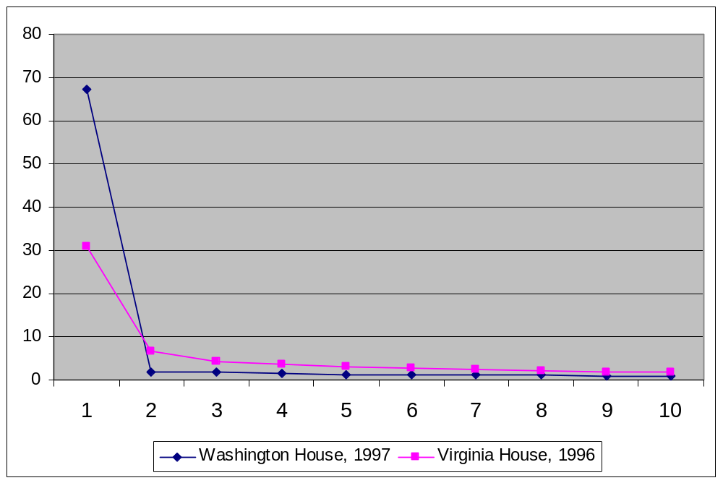
Table 1: Average Rice Indices for the Majority and Minority Parties in Virginia and Washington

 | Washington, 1997 | Virginia, 1996
Average Rice Index for the Majority Party  Average Rice Index for the Minority Party  Average Difference | 90.1 (16.4)  69.8 (30.0)  20.3 (34.5) | 83.1 (20.4)  75.6 (29.2)  7.5 (33.0)
*Standard Deviation in parentheses
Figure 3: Distributions of Cutpoints in Virginia and Washington Houses under Partisan Majorities

The Virginia House, 1996
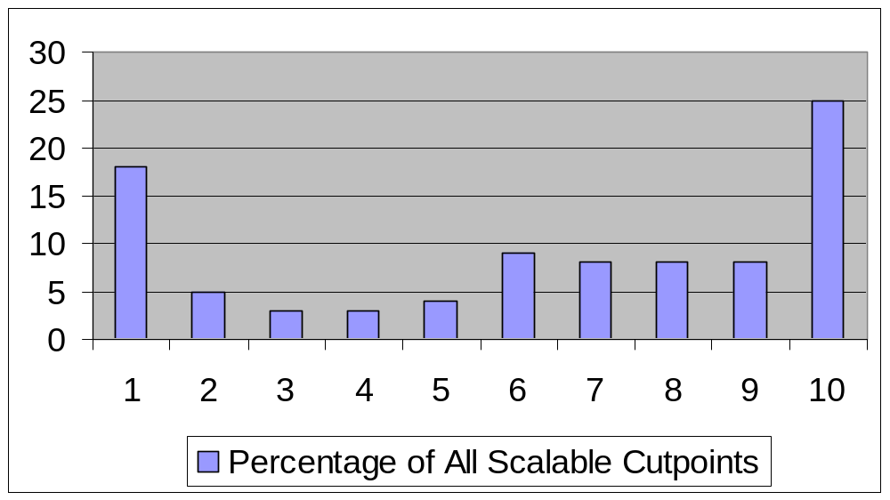

The Washington House, 1997
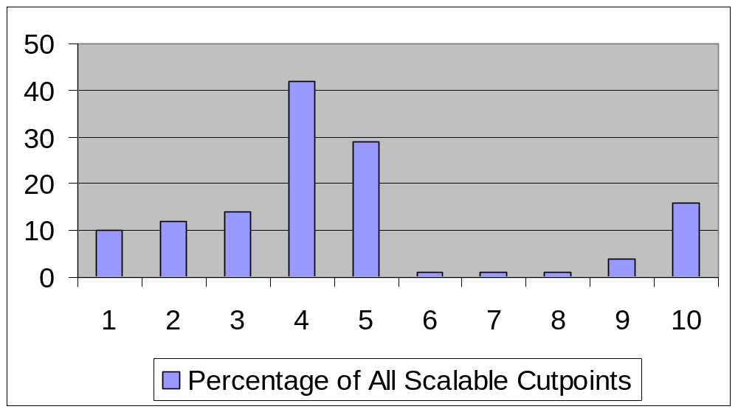
Figure 4: Cutpoints along a Unidimensional Policy Space

No Yes

SQ Cutpoint B

SQ: Status Quo
B: New Proposal
Table 2: Partisan Asymmetries in Virginia and Washington under Partisan Majorities
 | 1997 Washington House | 1996 Virginia House
Avg. Probability of Yes Vote  Avg. Probability of Yes Vote by a member of Minority Party  Avg. Probability of Yes Vote by a member of Majority Party  Number of Contested Votes  Number of Majority Rolls  Number of Minority Rolls  Number of Pro-Majority Bills  Number of Pro-Minority Bills | .803 (.186)  .947 (.034)  .611 (.118)  201  0  83  114  19 | .868 (.147)  .906 (.135)  .828 (.241)  201  7  19  59  26
*Standard Deviation in parentheses

Table 3: Partisan Bias in the Virginia House, with Partisan Majorities and Deadlocks
 | 1996 (Dem Majority) | 1998 (Tied) | 2000 (Rep Majority )
Overall Probability of Yes Vote  Probability of Yes Vote by a Democrat  Probability of Yes Vote by a Republican  Average Democratic Rice Index  Average Republican Rice Index  Number of Contested Votes  Number of Democratic Rolls  Number of Republican Rolls  Number of Pro-Democratic  Bills Reaching the Floor  Number of Pro-Republican Bills Reaching the Floor | .868 (.147)  .  .906 (.135)  .828 (.241)  83.1 (20.4)  75.6 (29.2)  201  7  19  59  26 | .875 (.134)  .910 (.323)  .839 (.378)  83.7 (21.3)  73.6 (30.5)  209  5  16  57  18 | .855(.145)  .858(.213)  .870(.185)  79.4 (25.5)  77.9 (27.8)  269  16  18  54  68
*Standard Deviation in parentheses

Table 4: Partisan Bias in the Washington House, with Partisan Majority and Tie
 | 1997 (Rep Majority) | 2001 (Tie) | 2003 (Dem. Majority)
Avg. Probability of Yes Vote  Avg. Probability of Yes Vote by a Democrat  Avg. Probability of Yes Vote by a Republican  Average Democratic Rice Index  Average Republican Rice Index  Number of Contested Votes  Number of Democratic Rolls  Number of Republican Rolls  Number of Pro-Democratic Bills Reaching the Floor  Number of Pro-Republican Bills Reaching the Floor | .803 (.186)  .611 (.118)  .947 (.034)  69.8 (30.0)  90.1 (16.4)  201  83  0  19  114 | .900(.115)  .908(.150)  .  892(.166)  82.6 (26.8)  80.5 (27.5)  59  0  2  13  13 | .835 (.152)  .959 (.074)  .694 (.333)  91.7 (14.6)  70.8 (29.4)  151  0  43  81  13
*Standard Deviation in parentheses.

I use the pronoun “he” to refer to any generic person, regardless of gender. I recognize that while there has been no female Speaker in the U.S. House, there have been several female leaders in state legislatures.
Consider a legislature with a very large majority party divided into 4 factions. Suppose further that only three factions are necessary to comprise a floor majority. Finally suppose that the minority always votes against the majority party. Since passing every legislation with all four factions agreeing with one another requires many more votes than is necessary, the majority leadership might use the rule that, whenever three of the four factions agree, even if the fourth opposes, a bill would be brought to the floor. The leadership, however, arranges the agenda such that no one faction would be rolled more than others. Standard scaling software would yield four dimensions of equal importance, yet this result would in fact be the result of a robust party influence, not an indication of its absence.
This assumption is made by Cox and McCubbins (1993).
Interview with Jamie Daniels, Chief of Staff to the Republican co-Speaker in the Washington House in 2001.
I assume specifically final passage votes rather than amendments or procedural votes. This is because a) final passage votes are expected to be sincere, as the vote constitutes the final word on the bill while procedural votes are more likely to be strategic; b) the majority party may not be able to impose such a tight control over the amendment procedure.
I define a bill as “partisan” if the members of one party are statistically more likely to vote it for than those of the other.
This can be encapsulated in the problem of choosing 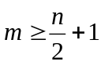 legislators in a chamber of n members, where m is an integer. Without any screener, the problem is simply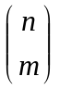. With k screeners, the problem becomes 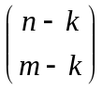 and < k > 0.
Legislators and staffers interviewed in Michigan, Oregon, Virginia, and Washington have all noted that committee jurisdictions in state legislatures are quite flexible.
The wording in the Rules does not specifically that bills reported by committees shall be heard the next day, only that such bills should be placed on Calendar upon being reported from the committee and be read three times on three separate days. Legislative staffers, however, note that the Rules are interpreted as requiring “automatic scheduling” of the bills.
The Rules Committee in the Virginia House, although chaired by the Speaker, does not seem to have a particular function. It is certainly not central to the legislative process in the manner of the U.S. House Rules Committee. The rules of the chamber assign to the Rules Committee various “housekeeping” chores, such as the authority over the facilities, but in practice, it has been used for a variety of bills in different policy areas, thanks, in part, to the leeway granted to the Speaker concerning committee jurisdictions. Even so, during the period in question (the 1996, 1998, and 2000 sessions), very few bills not supported by a unanimity on the floor were handled by the committee—5 out of 679—and only two were relatively controversial: one was supported by 52% of Democrats and the other 44%; both received 84% support from the Republicans. The former, in particular, took place during the period of unquestioned Democratic majority—the 1996 session. These seem to warrant that the lack of co-chair in the Rules Committee was not particularly critical in the operations of the legislature during the tie.
Technically, the graph is same as that of a Skree plot of eigenvalues from double-centered agreement score matrix. This is because the percentage of variance explained by adding dimension is, in fact, same as normalized values of the eigenvalues.
See Poole and Rosenthal (2001) for the details on this package. The choice of the algorithm is not central to the findings—comparable figures were obtained using W-Nominate as well.

