The influence of parties and Courts on Mexico’s
Instituto Federal Electoral, 1996-2003

by

Guillermo Rosas
(Washington University, St, Louis)

Federico Estévez
(Instituto Tecnológico Autónomo de México), and

Eric Magar
(Instituto Tecnológico Autónomo de México)

16 March, 2005

Presented at the annual meeting of the Midwest Political Science Association, Chicago, Illinois, 7 April 2005.

Abstract
We employ Markov Chain Monte Carlo simulation techniques (Martin & Quinn 2002) to infer the ideal positions of Councilors in Mexico's Instituto Federal Electoral. The analysis is based on votes cast by 11 members of IFE's Council General, from 1996 to 2003. We detect some partisan influences on Councilor’s votes. Measuring party influences is difficult because of the This task is the task is made difficult by agenda-masked by a high degree of consensusresults suggest that the effect that parties had

(1) party quotas in cg; (2) trife can turn down. We expect by (1) partisan behavior in CG; by (2) a large degree of consensus. Detecting (1) hard when (2) is also there. MCMC to infer positions. (2) is there, (1) somewhat

Intro
*In 1997 and 2000 Mexicans ousted the party that retained power for nearly seven decades, uninterrupted. They did so peacefully, in the voting precincts. Much of the credit for the success of the Mexican transition to democracy has naturally gone to the authority in charge of planning and executing all aspects of federal elections: IFE, the Federal Electoral Institute. A new Council General – IFE’s board of directors – had been appointed in 1996. Contrary to past councilors, the new… were autonomous. They captained the midterm election of 1997, when the ruling Institutional Revolutionary Party (PRI) lost control of the lower chamber of Congress for the first time, and then the presidential election of 2000, when the right-of-center National Action Party (PAN) defeated the PRI.
We study the voting patterns in the Council General in the crucial period between October 1996 and December 2003 – when Vicente Fox was inaugurated as president.

Lo de abajo es un cut&paste de la intro de Memo.
Mexico's Instituto Federal Electoral (IFE) was established in the early 1990's as a semi-automous agency in charge of overseeing federal elections. Though IFE's charter originally called for a preponderant presence of the Executive power in its board, successive reforms have led to the creation of a vigorous agency independent from Mexico's once omnipotent Presidents. Concurrent with its increasing autonomy, IFE took over the years an ever more important role in organizing all electoral aspects of Mexico's protracted transition to democracy. IFE's Council General decides on all organizational matters relating to elections, including the creation and upkeep of electoral lists, installation of electoral booths, vote counting, monitoring of campaign spending by parties, and overall regulation of political campaigns. Given IFE's political standing and relatively untarnished reputation as a professional, autonomous bureaucracy, scholars have shown extreme interest in studying all aspects of its organization and general conduct, including the voting behavior of individuals in its Council General. Indeed, an important debate concerns the putative independence and objectivity of IFE's Councilors. In its earliest incarnation, IFE's Council General included ten Councilors. Four of these were Legislative Councilors|two representatives of the Senate and two representatives of Congress|that represented, respectively, the majority party and the largest minority party in each Chamber. In effect, these four seats granted the larger political parties (PRI, PAN, and PRD) direct representation in the Institute's main executive body, fostering a situation presumably conducive to checks and balances. In Molina & Hernández's parlance (1999), IFE's original institutional setup could be seen as one of “party watchdogs" rabidly keeping tabs on each other's behavior. Unfortunately, this incipient scheme of checks and balances was incomplete due to the preponderant presence of the Executive's representative at IFE (the Interior Ministry), who acted as Chairman of the Council General, had the capacity to control agenda items, and could cast a vote in the Council (in practice, the Chairman voted only occasionally). IFE's original charter created a second group of six Citizen Councilors to seat in the Council General. Citizen Councilors could in principle reduce political bickering, grant voice and representation to the electorate, and bring into IFE extensive legal and technical knowhow. The six Citizen Councilors voted in all deliberations and were able to introduce new agenda items as long as these were recognized by the Council's Chairman. Yet, because the first Council General (1994-1996) was still presided by the Interior Ministry, and because large parties were granted votes in all decisions through their Senate and Congressional representatives, questions arised early on concerning the “autonomous" capacity of the first set of Citizen Councilors. IFE was reformed in 1996, and this time legislators returned nine Citizen Councilors to fill the Council General with a group of individuals without formal partisan ties. Legislative Councilors were scrapped from IFE's charter; more importantly, the Interior minister lost the faculty to act as Chairman of the Council, which in practice meant that the Executive lost control over electoral matters. The Legislative branch kept its ability to nominate an enlarged Council General, and new Councilors were voted in after extensive bargaining among the major political parties. The 1996 reform turned IFE into an agency autonomous from Executive interference, but the choice of simple majority voting to elect Citizen Councilors in Congress, meant that under certain circumstances one or two large parties could be shut off from the decision process. Therefore, IFE has achieved procedural autonomy, but might be less “representative" of major political forces than it was during the 1994-1996 period.
Whether a country's electoral authority should represent parties and thus generate checks and balances (the \party watchdog" model) or whether it should be controlled by presumably objective non-partisan experts (the “technocratic" model) is a moot point. Other Latin American countries have chosen varied institutional arrangements, and these might have all sorts of different effects on citizens' behaviors and attitudes.
Be this as it may, I submit that an examination of the voting records of IFE Councilors could throw light on ideological and attitudinal differences that might be caused by different institutional configurations of the electoral authority. However, even if the analysis were exclusively focused on the 1996-2003 Council, we would still learn
something about the preferences of individuals that are not officially tied to political parties, and are not elected by popular vote, yet carry out decisions that affect party politics in the country. In any case, I analyze the voting record of twenty-one IFE Councilors in two different Councils (1994-1996, 1996-2003) to estimate the spatial location of their “ideal” or “bliss points".
I use Bayesian MCMC estimation algorithms developed by Quinn & Martin (2002, 2003) to inspect IFE's voting record and describe the ideal points of its Councilors. In this research note, I limit the analysis to a thorough inspection of data, without injecting better information into the estimation process through thoughtful specification of priors.
The paper is organized as follows: Section 2 renders explicit the construction of the statistical model from first principles about the voting calculus of IFE Councilors. Section 3 summarizes the data analysis, and Section 4 concludes by suggesting avenues for further research.

Our intuition of the effects of IFE’s rules
Councilors are appointed by two-thirds vote in the lower house of Congress. It has been agreed informally, in all appointment sessions since 1994, that each party in the enacting coalition is entitled to appoint a share of Councillors roughly proportional to its lower chamber seat share, and that appointee proposals can be vetoed by any other party in the coalition. In the 1996 appointment the PRI, the PAN, the PRD, and the PT were in the enacting coalition, leaving no one behind; in 2003, the PRD and the PT were excluded from the enacting coalition, and the PVEM was brought in. Councilors serve seven-year terms. Tenure in office is somewhat secure, since Councilors can only be impeached by a two-thirds vote in the lower house. Replacements in the Council General are picked from a closed list that is negotiated along with the nine new Citizen Councilors before the start of a term.
These rules lend themselves well to analysis with a standard principal-agent framework. From this perspective, Councilors are the agents of the enacting coalition at IFE. Parties in the enacting coalition delegate authority to interpret the law and run all aspects of federal elections to their appointees. The first problem, from the perspective of those in the enacting coalition, becomes how to reduce agency losses that result from the Council General behaving in ways other than those that best serve their interests. The second problem arises from the fact that the enacting coalition is a collective principal, whose members have conflicting interests (for a general discussion of the logic of delegation, see Kiewiet and McCubbins 1991:22-38).
There are general mechanisms to mitigate agency costs. One consists of designing a contract with appropriate incentives for agent behavior. Even if the object of the 1996 IFE reform was precisely to give Citizen Councilors autonomy from parties, the contract retains one important element to constrain their behavior: the threat of impeachment. Councilors wishing to protect their tenure should therefore make sure not to act in ways that systematically hurt the interests of parties with two-thirds support in the lower chamber. Another mitigating mechanism is process of careful screening of potential agents, so as to reduce the chances of selecting types who will take courses of action hurting the principal’s interests. Parties have actively engaged in this screening process, proposing names of people who, a priori, seem to have preferences in accordance with the party, despite the prohibition to nominate party members.
Agency costs can also be mitigated through institutional checks. Here the collective nature of the principal, and the inherent conflict of interests, are served well by the collective nature of the agent and the formal and informal rules of appointment. A stylized view of nominations has each party in the enacting coalition choosing types sharing the party interests, and proposing them to the other coalition members. Proposals too far from the other parties are vetoed, and only more moderate names survive. As in Cox and McCubbins’ (1993) congressional committees, we see the resulting Council General as a microcosm of the enacting coalition in the lower house, with Councilors checking one another as lower house parties would. Members of the enacting coalitions for the second and third Council Generals, and the shares of Councillors each member appointed, appear in Table 1.

Table 1
Lower House parties and the Councilors they appointed
 | 1994-1997 legislature (enacting coalition in boldface) | 2nd CG (1996-2000) | 2nd CG (2000-2003, after two replacements) | 2000-2003 legislature (enacting coalition in boldface) | 3rd CG (2003-2010)
PAN | 119 | 2 | 2 | 151 | 4
PRI | 300 | 3 | 4 | 224 | 4
PRD | 71 | 3 | 2 | 97
PT | 10 | 1 | 1 | 6
PVEM |  |  |  | 17 | 1
CD |  |  |  | 5
Total | 500 | 9 | 9 | 500 | 9

To the extent that screening went well, we would expect Councilors to behave like their parent party would. Therefore, same-party appointees should behave in patently similar ways. Moreover, since Council General decisions are taken by majority vote (with some *¿cuántas y de qué tipo? by super-majority vote), and no party has had it by itself, we should see coalitions like those observed in the chamber of deputies form in contested Council General votes, pitting some parties against one or more. From the perspective of the rules, contested votes not conforming to these two patterns can be considered agency costs.
There is another actor that most discussions of IFE have tended to omit (*true? If so, interesting framing wrinkle…). All Council General decisions are liable to be sent to the Federal Electoral Court (Trife), created with the 1996 electoral reform. The Court is thus in a position to turn down any one of CG’s decisions. In practice, the rulings of the Justices have been remarkably unpredictable. (*Story or bit of evidence to support last claim.), and anything sent to Court had a good probability of being turned down or amended substantially. A councilor who cared for some resolution therefore had to anticipate all major complaints and make a priori concessions to preempt the affected from calling in the Court. This could be achieved in two ways. First, by amending the proposal if necessary, in order to internalize the Court’s preferences and avoid a negative ruling. The unpredictable nature of the Court’s behavior rendered this difficult, if not impossible: what the Court wants has remained too fuzzy. This leaves the second way of overcoming the Court: by reducing the probability that someone will want to object a decision in Court. This called for bigger voting coalitions in the Council General than needed. (*Who can send stuff to Court?)
If our logic is correct, a preliminary summary of the evidence suggests that Trife indeed exerted influence. Figure 1 shows the very high degree of consensus in the votes that make our dataset. The mass of consensual votes (ie those where all 9 councilors voted identically, without abstentions) appears sandwiched between the pair of lines. The slice is quite thick at certain moments, leaving relatively few contested votes (ie those where at least one different vote or one abstention was recorded) throughout the period.

Figure 1
The votes taken in Council General sessions, 1994-2004
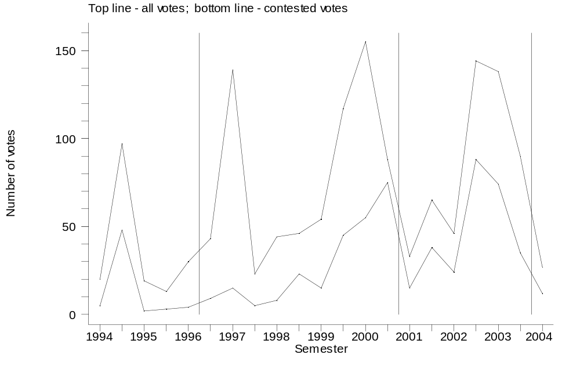

Consensus can be the product of similar preferences among Councilors. Or by anticipation (perhaps even negative agenda power), Councilors never proposing something that will not get enough support in the CG unless the Court can be confidently seen a non-threat for the winning coalition.

Data and methods
*Cut and paste del paper de Memo.

Results
Empirical patterns. If a single dimension, partisan blocs seem detectable, although they overlap to a considerable extent. Yet the big jump in Barragán with the exit of Molinar and Zebadúa – they should all slide to open room for newcomers, but without jumping over each other – is suggestive of a latent second dimension.

Figure 2
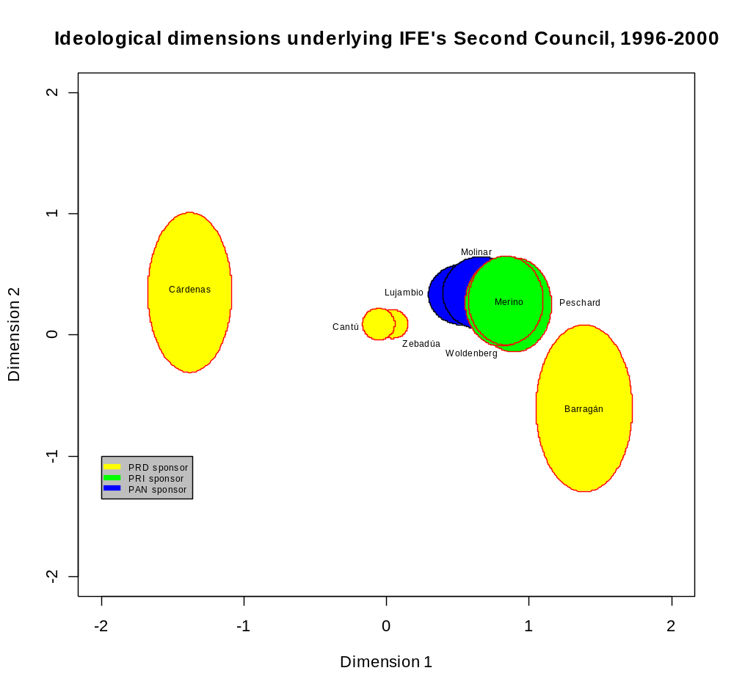

Two dimensional analysis reveals a different story. There is a bloc that voted together. 1996-2000 dim1 mattered most (as seen in the relative positions of 1-dim estimation); in 2000-2003 dim2 mattered most. This explains the change in Barragán from one end of the specturn to the other.
Again, consensus suggests that the Court could have been such an important player that Councilors insured their proposals through consensus, preempting other parties from seeking a Court ruling. If judges are partisan (they are also the product of an appointment impeachment game of similar nature, but their behavior seems pretty much erratic), consensus also helps prevent a negative ruling in case an extra-partisan plaintiff.

Figure 3
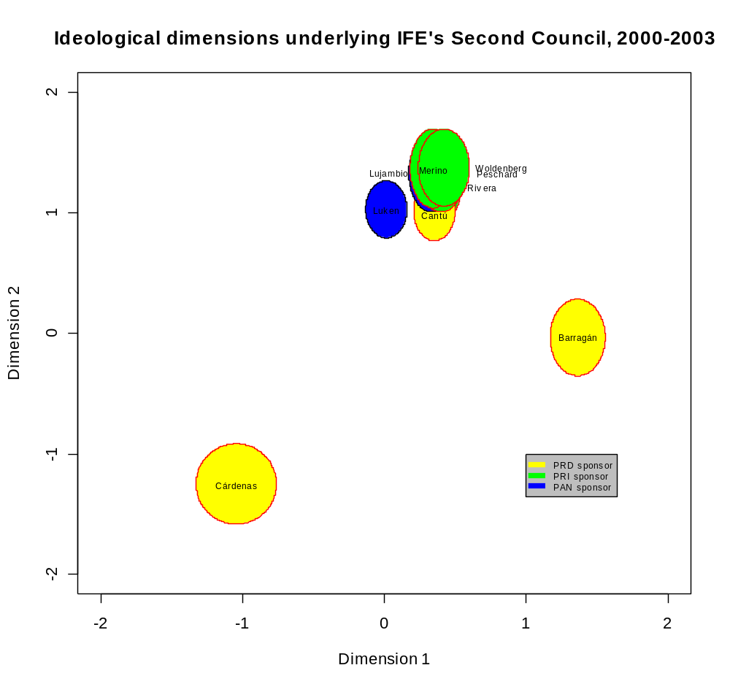

Discussion

Conclusion

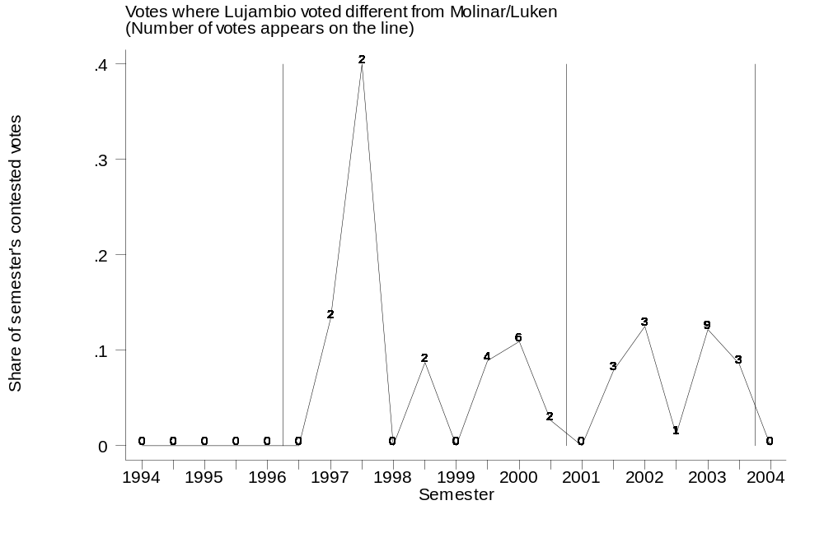

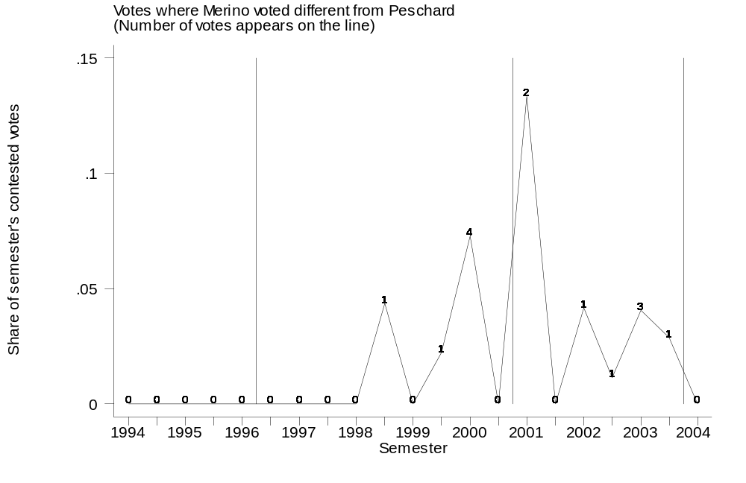

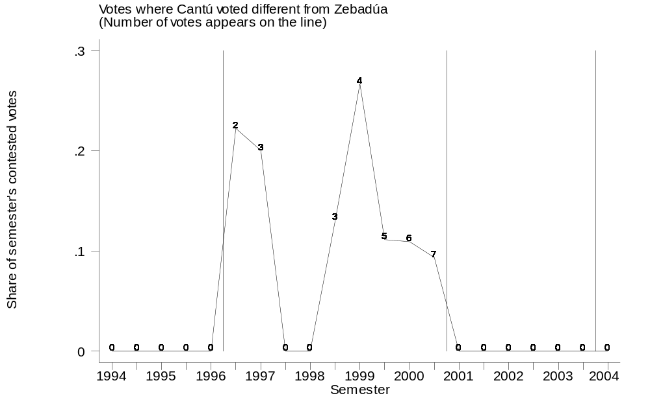

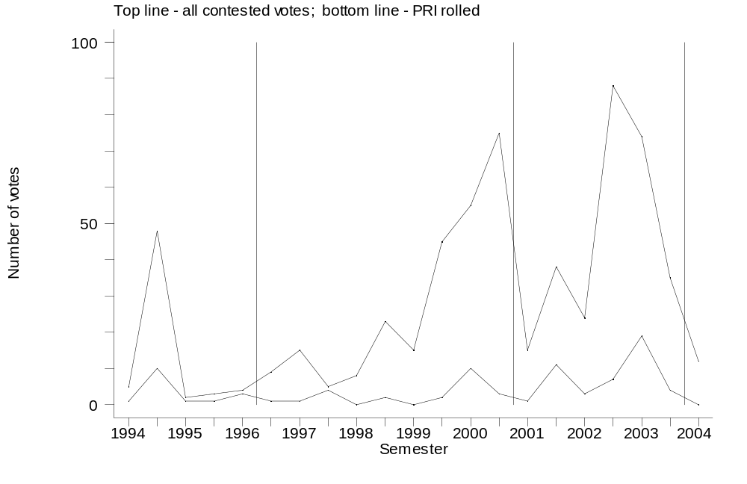

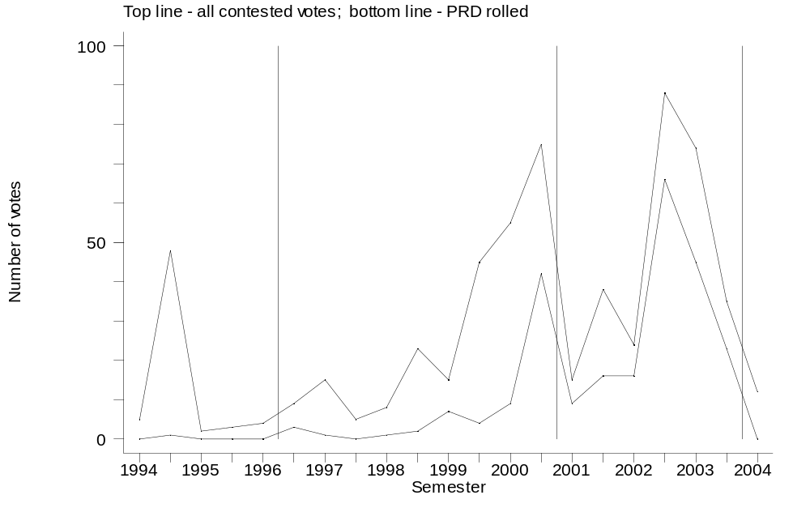

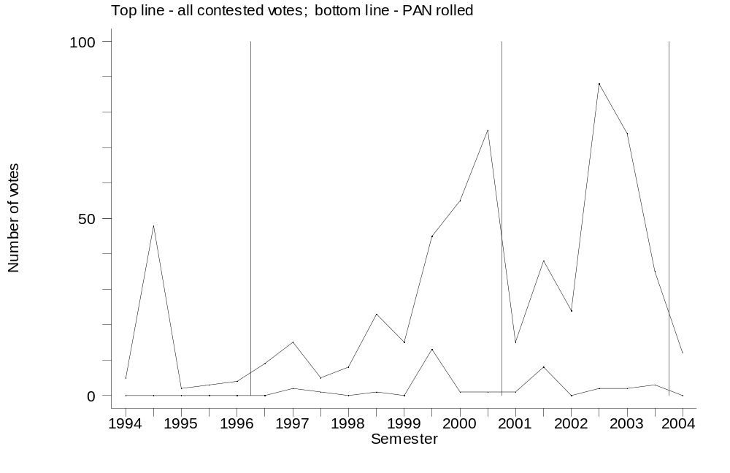

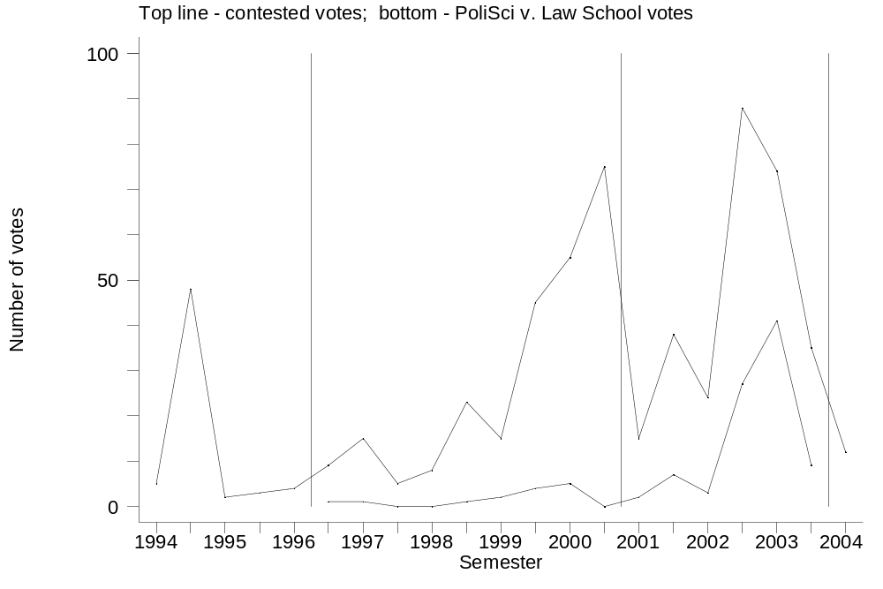

-> term = 2

vfaccpoli | Freq. Percent Cum.
------------+-----------------------------------
0 | 18 7.29 7.29
1 | 2 0.81 8.10
2 | 2 0.81 8.91
3 | 9 3.64 12.55
4 | 13 5.26 17.81
5 | 75 30.36 48.18
6 | 128 51.82 100.00
------------+-----------------------------------
Total | 247 100.00

-> term = 3

vfaccpoli | Freq. Percent Cum.
------------+-----------------------------------
0 | 30 10.99 10.99
1 | 3 1.10 12.09
2 | 6 2.20 14.29
3 | 28 10.26 24.54
4 | 206 75.46 100.00
------------+-----------------------------------
Total | 273 100.00

-> term = 2

vfaccabog | Freq. Percent Cum.
------------+-----------------------------------
0 | 10 4.05 4.05
1 | 208 84.21 88.26
2 | 29 11.74 100.00
------------+-----------------------------------
Total | 247 100.00

-> term = 3

vfaccabog | Freq. Percent Cum.
------------+-----------------------------------
0 | 7 2.56 2.56
1 | 105 38.46 41.03
2 | 137 50.18 91.21
3 | 24 8.79 100.00
------------+-----------------------------------
Total | 273 100.00

We thank Alonso Lujambio and Jeff Weldon for comments and critiques; and our research assistants – Sergio , Gustavo, Mariana, who else.
To my knowledge, Malo & Pastor's (1996) account remains the most authoritative analysis of the voting behavior of Councilors from 1994 to 1995. They code information contained in the minutes of all sessions of the Council General between June 1994 and November 1995 and analyze the voting record of six Citizen Councilors and four Legislative Councilors in search of the determinants of the electoral behavior of these individuals.

