**Parliamentary Debate in the UK House of Commons**

Jack Blumenau

Roberta Damiani

**Abstract**

We describe the institutional setting of parliamentary debate in the UK House of Commons and assess the determinants of participation in Commons’ debates using data on more than two million speeches from 1979 to 2019. We show that the main determinant of participation in parliamentary debate in the UK is whether an MP holds an institutionally powerful position in either the government or opposition parties. In addition, we describe two patterns in the evolution of debate behaviour in the Commons over time. First, although MPs in government and opposition leadership positions give more speeches than backbench MPs in all periods that we study, the speech-making “bonus” these actors enjoy has decreased over time. Second, MPs have increasingly employed constituency-oriented language in their parliamentary speeches over the past 40 years; a finding we link to theoretical accounts of legislative competition in personal-vote-seeking electoral systems.

**Word count:** 7450 (excluding references and abstract)

**Keywords:** UK; House of Commons; Debate; Parliament; Speech

# **Introduction**

Political debate in Westminster typically evokes two contrasting images in the popular imagination. The first is of two party leaders squaring off against one another at Prime Minister’s Question Time. The second is of independent-minded backbenchers delivering barnstorming speeches in opposition to policies espoused by their own party leaders. These views reflect two central forms of political conflict that govern interactions in the House of Commons. The first is rooted in an understanding of debate as an expression of the UK’s two-party, oppositional politics, where competition and confrontation across party lines is the key guiding feature. Even the physical structure of the Commons’ chamber reflects the inter-party impression of British politics, with ranks of governing party MPs separated from and faced adversarially against rows of opposition party legislators. The second view focuses on the fact that, in the UK, parliamentary debate is a key arena in which industrious backbenchers can hold executive actors, even those from their own parties, to account. As Anthony King argued, one of the most important dynamics governing political outcomes in the House is the relationship between party leaders and their own backbenchers (King 1976). In short, parliamentary debate in the Commons is a microcosm of the different modes of political competition that exist in the UK more generally.

Parliamentary debates also clearly form a core focal point in British politics. Debates are widely covered in the UK media, and both voters and MPs view speaking in debate as one of the most important roles that an MP performs (Campbell and Lovenduski 2015). Similarly, MPs spend a great deal of their working week attending and speaking in parliamentary debates both in absolute terms (Proksch and Slapin 2012, 522) and also in relation to the amount of time devoted to debate in other parliamentary bodies. More generally, Commons’ debates lie at the heart of all parliamentary business, and the historical importance of the House of Commons as a debating chamber is well established (Bryant 2014).

Unsurprisingly, then, particularly given the availability of rich data over a long time period, Commons’ debates have been the focus of several existing studies. For example, Proksch and Slapin (2012) and Slapin and Proksch (2015) use data on the UK to test the effects of political institutions on speech-making, and find that British MPs who are ideologically distant from their party leadership speak more often than their German counterparts. There is also a growing literature that uses quantitative text analysis tools to look at different aspects of UK legislative speech, such as the measurement of emotion (Rheault et al. 2016), linguistic complexity (Spirling 2016), and polarization (Peterson and Spirling 2018). Scholars have also used debates in the House of Commons to measure the effects of MPs’ career backgrounds on their voting behaviour (O’Grady 2019); to evaluate the extent of dyadic representation (Blumenau 2019a); and to trace the development of governmental agenda-setting powers (Eggers and Spirling 2014) and informal institutions that govern parliamentary life in the UK (Eggers and Spirling 2018). Additionally, several studies use parliamentary debates from the UK to examine the role of gender in political discussion. For example, Catalano (2009) and Bird (2005) both find that female MPs participate more in “feminine” areas of debate and ask more questions related to gender issues, and Blumenau (2019b) finds that the appointment of a female cabinet minister can lead other women to be more active and influential in the course of relevant political debates.

In this chapter, we describe the degree to which different actors contribute to political debate in the UK. Our primary analysis reveals few surprises. The main determinant of debate participation in the Commons is the position that the MP holds in the government or opposition hierarchy. We find, for example, that cabinet ministers deliver, on average, almost one thousand speeches more per parliamentary term than is typical for backbench MPs. We also show that MPs in junior ministerial positions, and MPs who hold shadow government positions, are more likely to speak, and speak for longer, than are typical backbenchers.

Second, we consider how patterns of participation in UK parliamentary debates have changed in recent years. For example, consistent with claims made by MPs that John Bercow, the Speaker of the House of Commons who took office in 2009, “has liberated backbenchers and multiplied our chances of holding the Executive to account” (Flynn 2012, 182), we provide evidence of substantial increases in opportunities for backbench MPs to use parliamentary debate as a venue for pressuring the government during Bercow’s tenure We also show that while cabinet ministers continue to play a disproportionately large role in parliamentary debate in the UK, the speaking gap between the cabinet and backbench MPs has decreased gradually but markedly over the past 40 years.

Finally, we also describe an interesting evolution in the focus of parliamentary speeches in the UK. Theoretical accounts of parliamentary debate suggest that speech-making is a valuable tool for reelection-seeking legislators, because it provides an opportunity for MPs to deliver personal messages to voters which may, in some instances, differ from the messages communicated by the MPs’ party (Proksch and Slapin 2012; Slapin and Proksch 2015; Blidook and Kerby 2011; Soroka, Penner, and Blidook 2009). As parliamentary debate is widely covered in the media, and as MPs promote their debate contributions through their correspondence with constituents, an MP’s speeches can play a potentially important role in shaping voters’ perceptions. However, we know little about how the incentives to appeal to constituents through speech have evolved over time. We show that such appeals, as measured by the fraction of speeches in which an MP references their “constituents” or “constituency”, have more than doubled over the past 40 years in UK political debate. We see this as evidence that a key incentive that underpins several existing theories of intraparty competition and elite communication may have strengthened in the UK in recent years.

# **Institutional and party system background**

British politics is typically characterised as the canonical example of a two-party system, where only the Labour Party and the Conservative Party have a realistic expectation of getting into government (Garnett and Lynch 2014, 394). The structure of the party system is induced by the first-past-the-post electoral system that is used for general elections, where the candidate who wins the most votes in a constituency is elected and represents that constituency in the House of Commons. It is well-established that single-member district plurality systems encourage two-party politics, as parties with low or moderate support which is evenly dispersed across constituencies are prevented from winning seats, and strategic voters have incentives to abandon unpopular candidates in favour of those who are more competitive (Duverger 1954; Cox 1997). Similarly, a commonly cited advantage of plurality systems is that the same forces that lead to the dominance of two parties also deliver clear parliamentary majorities to one of these parties, hence providing for strong one-party government (Garnett and Lynch 2014, 515–22).

Relatedly, the UK government has traditionally been seen as comparatively powerful both in terms of policy-making and agenda-setting in relation to other advanced democracies (Cox 2005). Although formally the control of time in the House of Commons rests with MPs, the House has delegated most of it to the government (Natzler and Hutton 2019, 18.10). Government business has precedence at every sitting of the House (with exceptions like Opposition Days, Private Members’ days and days controlled by the Backbench Business Committee) (House of Commons 2018, 17–21), and the government has various tools at its disposal (such as programming motions) to prevent MPs from using parliamentary debate to delay the progress of bills through the commons. In combination with traditionally very high levels of party voting unity in the Commons, this has meant that, historically, policy-making in the UK has been overwhelmingly dominated by the governing party.

However, there have been a number of changes in recent years that have made government management of the House of Commons “significantly more complex than it used to be.” (Russell and Cowley 2018, 22) First, in recent decades, the first-past-the-post system has not prevented smaller parties such as the Liberal Democrats, the United Kingdom Independence Party, Plaid Cymru, and the Scottish National Party from gaining a larger share of the vote at general elections (while other parties, such as UKIP and the Brexit Party have failed to breakthrough in Westminster elections). The increasing fractionalization of the party system at the electoral level has also lead to an increasingly fractured distribution of seats in parliament, and both the 2010 and the 2017 general election resulted in coalition governments. This evolution of the party system constitutes a fundamental change in the management of legislative activities in the House of Commons, especially in periods of coalition.

Second, declining levels of party discipline mean that the government’s ability to unilaterally set the agenda has diminished in comparison to previous eras. As in other parliamentary systems, the government’s power is reliant on being able to impose party discipline and cajole its MPs to vote cohesively on government business – something that is typically straightforward (Sieberer 2006). But in recent years the degree of voting cohesion among Westminster parties has declined dramatically. Rebellious votes are increasingly common, and are not been limited to minor issues (Cowley 2015). For example, backbench dissent was a key factor in determining government policy towards the issue of a referendum on membership of the EU during the 2010-2015 coalition government. These increasing trends of dissent and rebellion have led to a reappraisal of the power of party leaders at Westminster. As Russell and Cowley (2018, 22) have argued, “political parties in the House of Commons have become significantly more challenging for leaders to manage and hold together”.

At the same time, reforms implemented in 2010 significantly weakened the government’s control over the agenda by introducing a new category of “backbench business” which would be scheduled via the Backbench Business Committee (M. Russell 2011b). While these reforms were, at least in theory, supported by the government, recent developments in UK politics also suggest instances where the government’s hold over the parliamentary agenda has been eroded by backbench action directly. The most dramatic expression of this point was the Commons’ decision to temporarily suspend the government’s usual control of the agenda on specific days to allow MPs to vote on alternative proposals for the resolution of the Brexit crisis. For the government to lose control of the order paper, against its own expressed will, is unprecedented in recent British political history. The shock-waves that followed from Brexit led to significant disruption of the usual patterns of loyal voting behaviour in the Commons, and caused party management problems for several Conservative governments, and also the for the Labour party in opposition.

Taken together, these changes highlight the fact that the interaction between the parliamentary and electoral systems in the UK provides MPs with mixed incentives which create a trade-off between party loyalty and constituency responsiveness. As Cain, Ferejohn, and Fiorina (1984, 217) suggest, an inherent tension in SMD parliamentary systems such as the UK is that “electoral rules create incentives for a personal vote and legislative rules deny representatives the opportunity to establish it.” On the one hand, political parties play a crucial role in electoral politics: in the UK, almost all candidates become MPs through a party, and most electors tend to cast votes on the basis of party labels rather than from a detailed understanding of the positions taken by individual MPs. Given the large number of “safe” parliamentary seats in the UK, parties are key gate-keepers to parliamentary representation. This creates incentives for MPs to toe the party line, and these incentives are reinforced by the tools of legislative discipline that party leaders wield. Leaders control the distribution of legislative offices, which can be used to induce loyal behaviour from MPs, and the government can also use the threat of a confidence vote to raise the stakes to defection from recalcitrant members.

On the other hand, single-member district systems provide clear dyadic links between MPs and constituents, and offer strong incentives for incumbent MPs to cultivate a personal vote (Cain, Ferejohn, and Fiorina 1987; Carey and Shugart 1995; Kam 2009). The literature on incumbency and personal vote is less developed in the UK than in the US, but empirical work in the UK suggests that a small incumbency bonus does seems to exist for MPs who manage to build a reputation as promoters and defenders of local interests (Cain, Ferejohn, and Fiorina 1984, 1987; Smith 2013), although partisan dynamics interact with incumbency and remain crucial in determining election outcomes (Eggers and Spirling 2017; Cutts and Russell 2015). Furthermore, a recent set of experimental papers suggest that voters in the UK are more likely to support MPs who demonstrate their independence from the party line (Vivyan and Wagner 2015; Campbell et al. 2019a), who make a feature of their local roots to the constituency (Campbell et al. 2019b), and who dedicate more time to constituency service activities rather than national policy-making (Vivyan and Wagner 2016). Parliamentarians are clearly aware of these incentives: British MPs spend a lot of their time on constituency work, including correspondence and surgeries (Gaines 1998; Norton 2013, 222–26; Cain, Ferejohn, and Fiorina 1984, 1987), and there is evidence that the effects of constituent preferences on both MPs’ voting (Hanretty, Lauderdale, and Vivyan 2017) and speech-making (Blumenau 2019a) behaviour are non-zero. Overall, these studies suggest that MPs will often have reasonably strong incentives to differentiate themselves from their party colleagues in order to appeal to their specific constituencies.

# 

# **The institutional setting of legislative debate**

What are the consequences of this system for the rules and practice of parliamentary debate? Slapin and Proksch (2015) argue that the rules that govern parliamentary debate are endogenous institutions which are shaped by parties and their leaders and which can be explained, at least in part, by the incentives created by the broader political system.[1] According to this view, party leaders care about their parties’ electoral prospects, and parliamentary speeches that dissent from the party line can harm the party brand that is core to communicating with voters. The bind that leaders face is that, in some circumstances, adherence to the party brand may in fact damage the electoral prospects of individual MPs, and therefore leaders face a trade-off between imposing message unity and allowing expressions of individual policy-difference. In particular, when the electoral system creates incentives for parties to develop strong and cohesive party brands, then the parliamentary debate rules will be restricted, putting more power over speaking time in the hands of party leaders. By contrast, when the electoral system incentivises the cultivation of a personal vote, debate rules will be more permissive, and backbench legislators will have more freedom to contribute to debate, even if that means contradicting the party line.

The institutional rules governing parliamentary debate in the UK neatly reflect this theoretical argument. As described above, the UK’s first-past-the-post electoral system creates incentives for MPs to seek a personal vote. As a consequence, we should expect UK debate rules to be relatively permissive, and for party leaders to have weak control over the debate contributions made by backbenchers. The procedures and conventions that regulate proceedings in the Commons[2] make clear that all speaking time in the Commons is reserved for individual MPs, as opposed to parties, and the Speaker of the House of Commons, a non-partisan figure, allocates speaking time among MPs. The Speaker maintains order when the House is sitting, and he or she has “absolute discretion” over which members are called to speak (Rogers and Walters 2018, 52–53). Crucially, party leaders have no role in selecting which MPs are allowed to speak in debate.

MPs wishing to make a speech during a debate must “catch the Speaker’s eye” by standing up when the Speaker is about to call the next speaker (Natzler and Hutton 2019, 21.8). Members may also submit a written note in advance to let the Speaker know that they want to be called, but submitting such a request does not guarantee that the member will be called (Rogers and Walters 2018, 281). In practice, convention dictates that the Speaker tries to balance the MPs’ interventions alternating between parties, and to make sure that all views on the topic under consideration are represented (Natzler and Hutton 2019, 21.8). One MP describes the process of selection for MPs in debate as being subject to a “scientific pecking order of precedence in the Speaker’s database”, whose criteria include “seniority, knowledge of subject, frequency of speaking and immaculate behaviour records” (Flynn 2012, 184). However, despite these informal criteria for participation, Flynn (2012, 184) also emphasises the personal nature of Commons’ debate, and suggests that “antagonising a Speaker is a kamikaze ploy” for those who wish to participate in debate.

Unlike the practice in many other parliaments, it is also typical for UK MPs to “intervene” in each other’s speeches. Whether an MP is able to intervene on another MP is outside of the Speaker’s purview, as interventions are granted only if the MP who has the floor chooses to “give way”. The expectation is that MPs will give way in most cases, and frequent interventions lead to a back-and-forth style of debate that is relatively uncommon in most parliamentary settings. MPs in the UK therefore have a great deal of freedom to pick and choose the debates to which they contribute, and they do so largely without requiring the permission or favour of party leaders. Certainly in comparison to many other European parliaments featured in this volume, British MPs have a remarkable degree of latitude in terms of their participation in parliamentary debate.

Despite these relatively backbench-friendly rules, it remains the case that party leaders hold a dominant position in Commons’ debates. An important exception to the Speaker’s discretion is with regard to the contributions of frontbench MPs, such as government ministers and opposition shadow ministers. Most debates on government business start with a long statement by the responsible minister or cabinet minister, and this is followed by the relevant shadow minister’s response. There are also similar patterns – where executive actors and party leadership figures are given precedence in speaking – for the “winding-up” speeches at the end of each debate (Rogers and Walters 2018, 52–53; Norton 2013, 91). Committee chairs, who do not enjoy formal speaking privileges, are also often accorded some priority by Speaker, as well as other Members with relevant positions or experience in a debate on a specific subject (Natzler and Hutton 2019, 21.8).

Similarly, at the beginning of parliamentary business each day, government ministers respond to oral questions raised by other MPs. At these “question time” debates, certain actors – most notably the opposition spokespeople for the relevant departments – have privileges in terms of the number of questions they are allowed to ask. During Question Time, ministers take turns answering questions from members. Members must submit their questions in advance, and the order of the questions is determined at random. The Speaker can limit the number of questions, and if there are too many submissions then only those placed sufficiently highly on the list are selected (Natzler and Hutton 2019, 22.3). In addition, while the Speaker has the power to place time limits on the duration of speeches of backbench MPs, these limits are looser for frontbench MPs. Accordingly, while the rules allow backbench MPs a great deal of freedom to contribute to debate, the structure of parliamentary discussions nevertheless means that those in institutionally powerful positions speak frequently and at length in the Commons.

There are, however, a number of mechanisms through which non-government actors can set the agenda for debates in parliament. For instance, following recommendations of the Modernisation Committee of the House in 1999, some debates also take place in a parallel debating chamber called Westminster Hall. Having a parallel debating chamber has greatly increased the opportunities for backbenchers to raise issues for which there would normally be no time in the House, and backbenchers often use these debates to raise matters relevant for their constituencies (Norton 2013, 116). Debates in Westminster Hall include those that are scheduled by the Petitions Committee, which considers petitions submitted online by members of the public. Recent work suggests that these petitions have non-negligible effects on the behaviour of MPs, encouraging them to attend and speak in debates that are marked by high levels of interest to their constituents (Blumenau 2019a). Similarly, on “Opposition Days”, of which there are 20 in each parliamentary session, business chosen by the opposition parties takes precedence over government business, and on 35 days in each session debates are selected by the Backbench Business Committee. The establishment of this committee was widely seen as a significant reform which created new opportunities for backbenchers to set the agenda in parliament (M. Russell 2011a).

Table 1 summarises the main debate types used in the House of Commons.

**Table 1: Parliamentary debate types in the House of Commons**

|  |  |  |  |
| --- | --- | --- | --- |
| **Type of debate** | **Goal** | **Rules** | **Time limits** |
| Government business | Debates on government legislation and business | Minister gives opening statement, shadow replies, backbenchers catch the Speaker’s eye, wind-up at the end | Speaker can set 20-minute limit for frontbench and stricter limits for backbench |
| Emergency debates and urgent questions | Questioning Ministers on matters of urgent character | Speaker determines whether to grant an urgent question submitted by members | 3 minutes for Minister’s answer and 2 minutes for questioner for a supplementary question |
| Opposition Days and Backbench Business | Business for debate placed on the agenda by opposition or backbenchers, respectively | 20 days in each session dedicated to opposition business and 35 to backbench business | Same as government business |
| Question Time | Routine questioning of Ministers | 4 times a week, Ministers take turns appearing in the House, between 30 and 60 minutes. Order of questions determined at random, Speaker can set quota for number. | 15 minutes for Ministers answering for a full hour, less for shorter sessions. |
| Westminster Hall debates | Provides an additional venue to debate backbench business and petitions | Same rules as House debates | At Chair’s discretion |

Mirroring the changes made in parliament as a whole, the rules and practices of parliamentary debate in the UK have been subject to reform in recent years. In particular, the election of John Bercow to the position of Speaker of the House in 2009 marked a turning point in the relationship between the executive – in the form of government ministers – and backbench MPs in the Commons (Rogers and Walters 2018, 182). One of Bercow’s key manifesto commitments when running for Speaker was to use the position to strengthen the role of backbenchers in relation to the executive. As he argued, “if there is any one measurement by which I would want my time as Speaker to be assessed it is that the backbench MP felt, and emphatically was, more significant in the House than he or she was before.” (Bercow 2009) In particular, Bercow promised to reform the rules of procedure in order to make it easier for MPs to raise urgent questions on topical subjects with ministers, and to instigate debate on pressing issues that were not directly a part of the government’s agenda. One MP describes the Bercow speakership as such a revolution that “in the future parliamentary history may be divided into years BB and AB – Before Bercow and After Bercow” (Flynn 2012, 181).

Overall, the conventions and rules that govern parliamentary debate in the Commons give extensive privileges to agenda-setting actors who have formal positions within the legislative hierarchy. Cabinet ministers, ministers, shadow cabinet ministers, shadow ministers, and chairs of select committees are all given more opportunities to contribute to debate than backbench MPs, and will typically dominate parliamentary discussions as a result. However, the recent reforms of the Commons, both generally and specifically with regard to parliamentary debate, suggest that the gap between frontbench and backbench actors may have narrowed over time. In addition to describing general patterns of variation between MPs, in what follows we also examine how patterns of participation in the commons have changed over time.

# **What is the role of intra- and inter-party politics in legislative debates?**

## ***Descriptive analysis***

We collect all speeches made in either the main chamber of the House of Commons or in Westminster Hall between 3rd May 1979 and 25th July 2019. Our data collection period covers periods of Conservative (1979-1997 and 2015-2017), Labour (1997-2010), coalition (2010-2015), and minority party (2017-2019) government. We include speeches by all MPs in the analysis, except for those delivered by the Speaker or Deputy Speakers of the House, who give far more speeches than any other MP, and whose speeches are necessarily procedural. We also exclude from the analysis any debate contribution by an MP which is shorter than 50 words. In total we analyse 2105 MPs who make 2.2 million debate contributions, which are constituted of 451 million words.[3]

Table 2 shows some basic descriptive statistics for our data. In the table we highlight our two outcome variables, and also the main variables we will use to predict debate participation in the UK. These summary statistics highlight that parliamentary debate is a key activity for UK MPs. For instance, we find that the average MP delivers 334 speeches per Parliament (approximately 69 thousand words) and that almost all MPs speak at least once during a given parliamentary term.

| **Table 2: Descriptive statistics** | | | | |
| --- | --- | --- | --- | --- |
| Variable | Mean | SD | Min | Max |
| # Speeches | 333.5 | 411.9 | 1.0 | 8133.0 |
| # Words | 69410.6 | 66719.2 | 63.0 | 1042403.0 |
| Female | 0.2 | 0.4 | 0.0 | 1.0 |
| Seniority | 10.5 | 7.3 | 0.0 | 40.0 |
| Margin | 21.4 | 13.9 | 0.0 | 77.1 |
| Committee Chair | 0.1 | 0.2 | 0.0 | 1.0 |
| Cabinet Minister | 0.1 | 0.2 | 0.0 | 1.0 |
| Junior Minister | 0.1 | 0.3 | 0.0 | 1.0 |
| Shadow Cabinet Minister | 0.1 | 0.2 | 0.0 | 1.0 |
| Shadow Junior Minister | 0.1 | 0.3 | 0.0 | 1.0 |
| Party Size | 283.9 | 107.2 | 1.0 | 419.0 |
| Age | 53.5 | 9.8 | 22.5 | 87.5 |

In the analyses below, we study a number of individual determinants of legislative speech in the UK, including age, tenure, gender, and institutional status. Here, we present some descriptive evidence relating to the role of gender and seniority in UK debate.

Figure 1 shows the proportion of speeches delivered by male and female MPs from each of the UK’s party families, pooled across the time period we study. Light gray bars indicate the percentage of speeches delivered by female MPs, mid gray bars indicate the percentage of words delivered by female MPs, and dark gray bars indicate the percentage of female MPs in the legislative party across the time period.

**Figure 1: Gender and speechmaking, by party family**

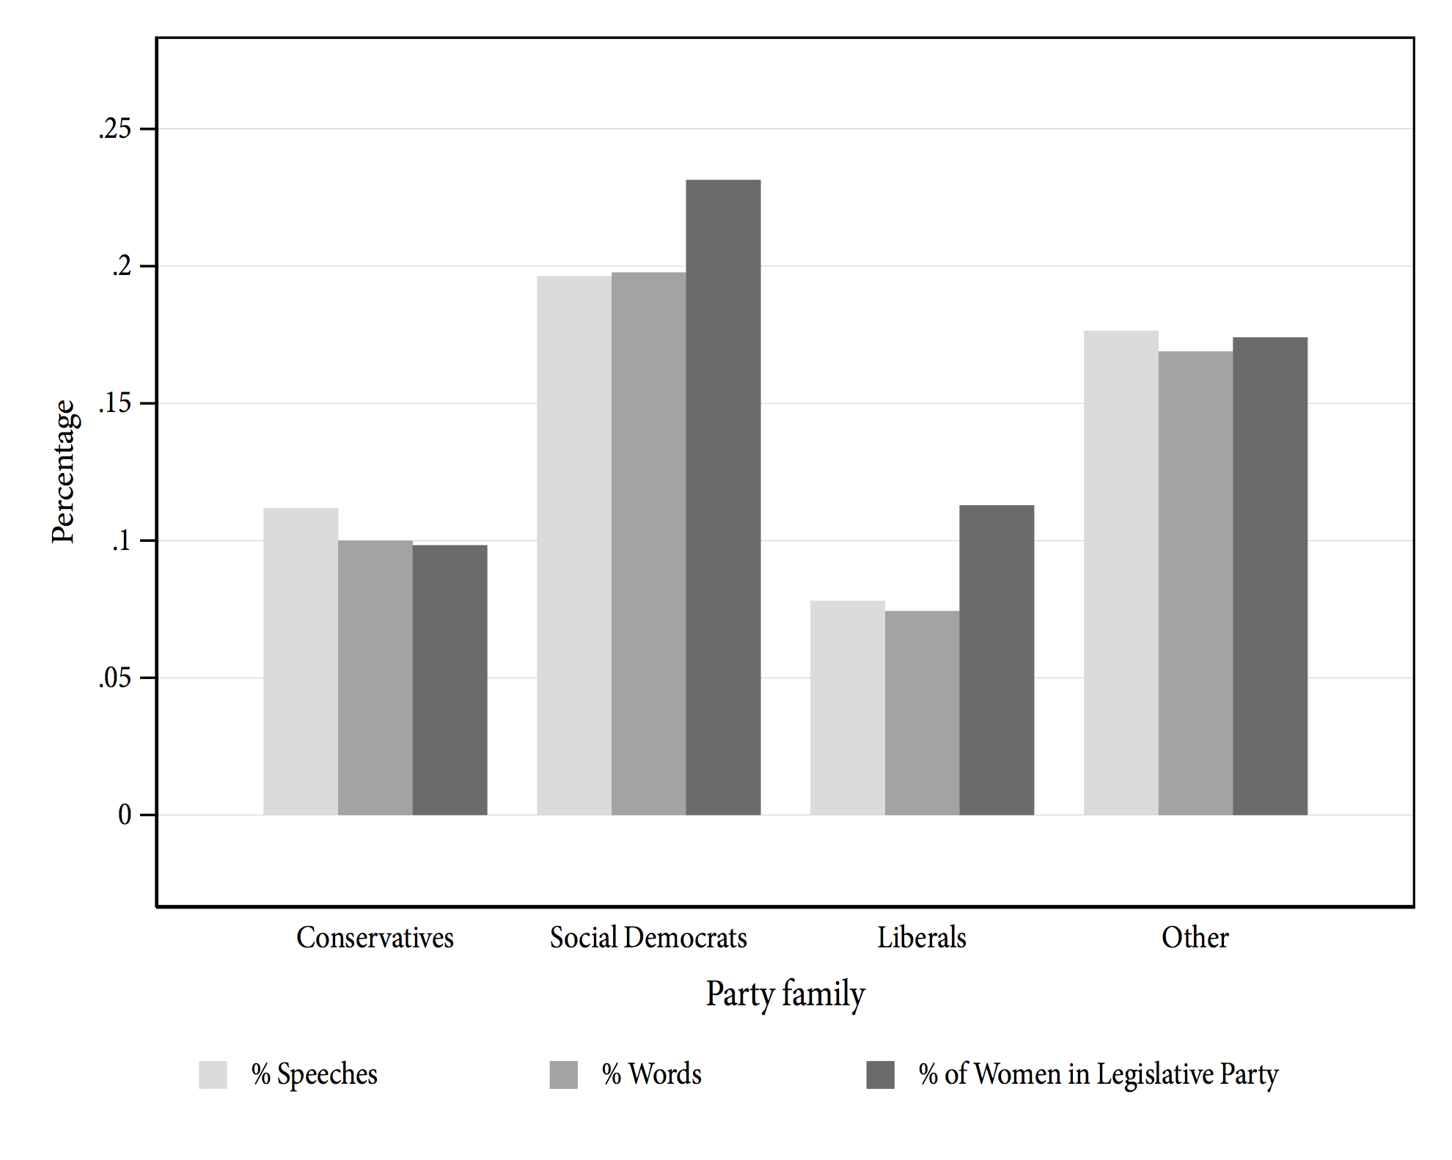

Two key patterns are clear from this plot. First, at this aggregate level, speeches by male MPs vastly outnumber speeches by female MPs. Across all parties, the percentage of words or speeches delivered by women never exceeds 20% and in many cases women make fewer than 10% of the debate contributions in the House of Commons. Second, it is clear that the proportion of speeches delivered by female MPs is tightly related to the proportion of female MPs in a given party. Although there are some small discrepancies for a few parties – Social Democrat (Labour) and Liberal (Liberal Democrat) women contribute slightly fewer speeches than their share of party seats would suggest, and Conservative women contribute slightly more – in general, women’s share of debate time is largely determined by their share of the parliamentary seats. Overall, then, this analysis suggests that women are underrepresented numerically in terms of the number of MPs elected, and this translates into a deliberative deficit in parliamentary debate.

Figure 2 decomposes these patterns by the “seniority” of the MP. The x-axis here refers to the number of years that an MP has served in parliament, and the y-axis measures the mean number of speeches delivered by male (light gray bars) and female (dark gray bars) MPs. As with the previous figure, we see little evidence of a large gendered difference in parliamentary speaking time, even conditional on the seniority of the MP. Although it is clear that more experienced MPs deliver more speeches than less experienced MPs, men and women of equivalent years of experience deliver roughly the same number of speeches in a given parliamentary term.

**Figure 2: Gender and speechmaking, by seniority**

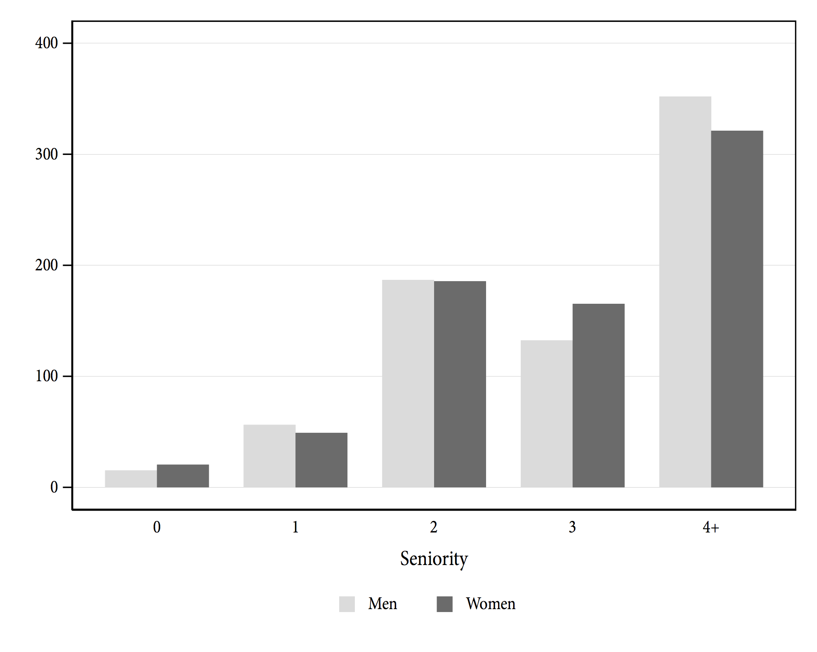

It is worth noting that these aggregate figures also mask significant heterogeneity in debate participation across policy areas. For instance, while women are somewhat *over*represented in debates that focus on certain policy areas – such as transport, education, health, children, and schools – they are significantly *under*represented in debates that focus on international affairs, trade, justice, business, the economy, and agriculture (Blumenau 2019b, S1). Accordingly, while women may on average deliver a similar number of speeches to men from year to year, in the UK they appear to contribute disproportionately to those debates dealing with policy areas that could be characterised as traditionally “feminine”, and less to debates in traditionally “masculine” policy areas. This finding is consistent with research on the gendered dynamics of debate in other parliamentary settings (Bäck and Debus 2019).

## 

## ***Multivariate analysis***

To assess the determinants of participation in legislative debate in a multivariate framework, we estimate a negative binomial regression model in which our outcome variable is the number of speeches made by a given MP in a given Parliament (the period of time between two general elections). We also show results from a linear regression model where our dependent variable captures the number of words spoken by a given MP in a given Parliament.

We describe variation in speaking rates using two sets of variables. First, building on the insights outlined above in our analysis of parliamentary procedures, we include five dummy variables that correspond to important institutional positions that MPs might hold in the House of Commons. As procedural privileges allow frontbenchers to speak more than other members, we include indicators for whether, at any point in the relevant Parliament, an MP was a government junior minister, a cabinet minister, a shadow junior minister, or a shadow cabinet minister. We additionally include a variable which distinguishes those MPs who chair parliamentary committees. The baseline comparison for these variables is any MP who does not hold one of these positions – a “backbench” MP. We also include a binary variable to capture differences between MPs from the governing party (or parties) and MPs from non-governing parties.

Aside from these institutional variables, we include a series of MP-specific characteristics. In particular, we include an indicator for whether the MP is female, the age of the MP (in years), age squared, and the seniority of the MP (in years). To evaluate whether MPs speech-making behaviour is sensitive to electoral security – a hypothesis advanced elsewhere (Kellermann 2016) – we also include the margin of victory of the MP in the most recent general election (in percentage points). We also include a set of dummy variables to capture the effects of party affiliation as well as fixed-effects for each parliamentary term. Finally, we also control for a continuous variable (“Exposure”) that measures the percentage of time in which the MP held her seat during a given Parliament (we include the logged version of this variable in the negative binomial model).

We include the same sets of covariates for both of our outcome variables, and the results of our regressions are presented in table 3, and we illustrate the coefficients associated with the key explanatory variables in figures 3 and 4.

**Figure 3: Number of speeches – Negative binomial coefficients**

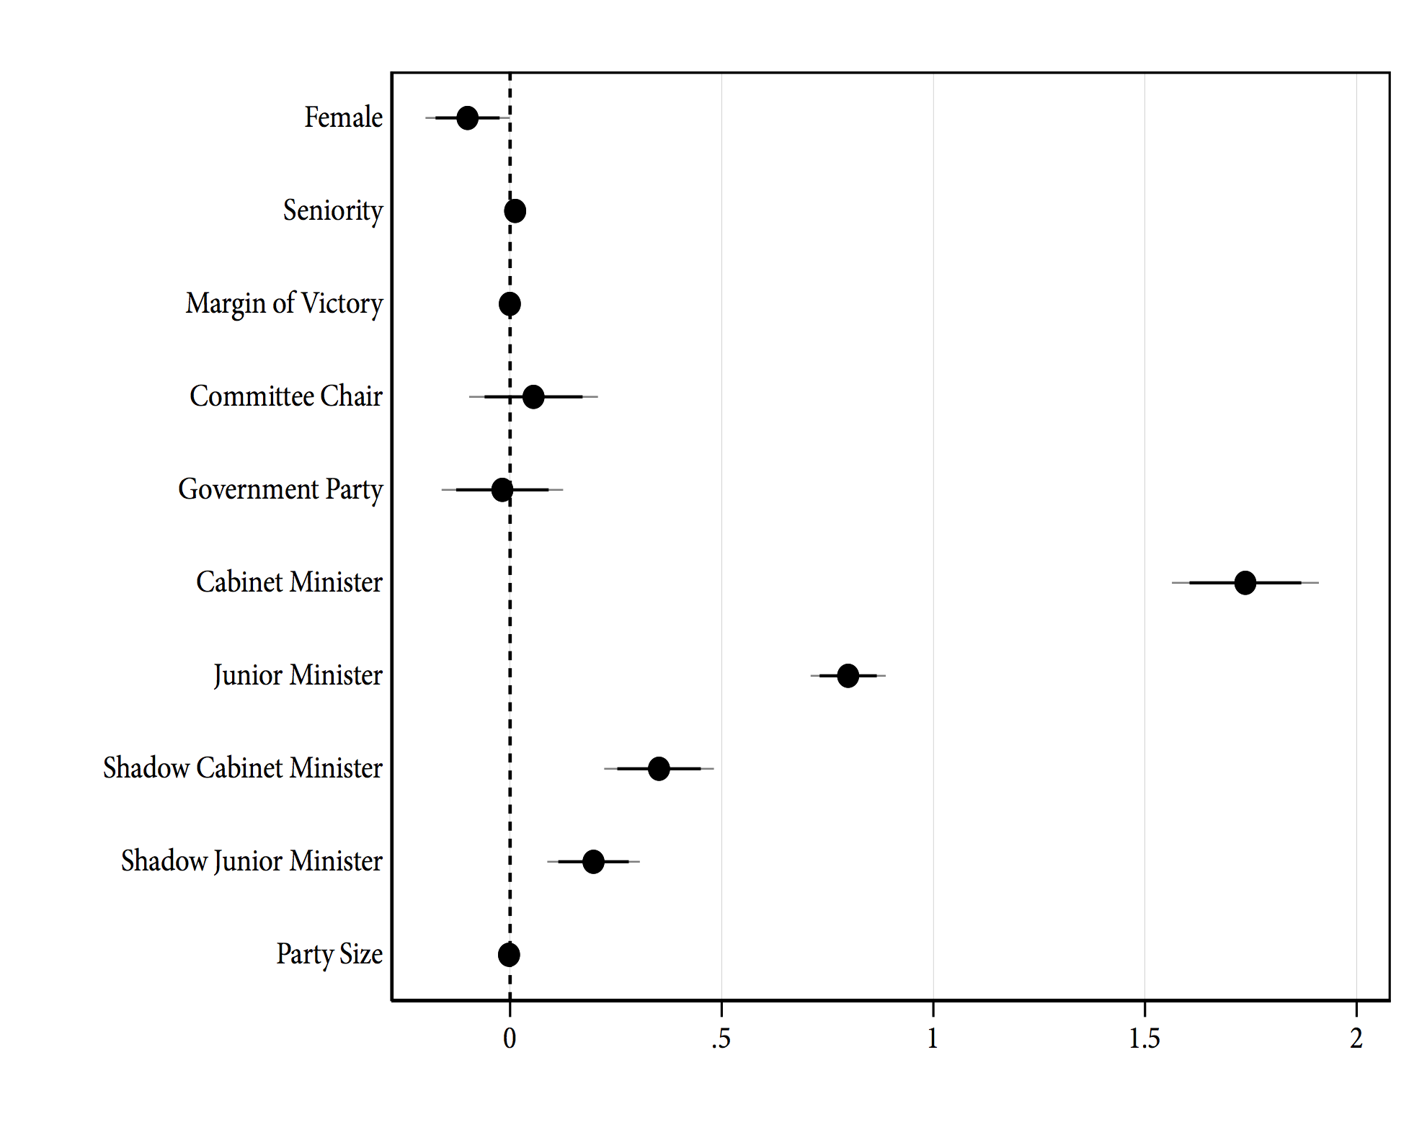

The results in figure 3 demonstrate that institutional prerogatives are clearly important in determining speaking patterns in the House of Commons. We estimate large, positive, and significant coefficients for both the junior minister and cabinet minister variables, and smaller effects for the shadow junior and shadow cabinet ministers. The average marginal effects reveal that cabinet ministers are responsible for approximately one thousand additional contributions to debate (per Parliament) than is typical for backbench MPs. They also clearly speak far more frequently than either shadow cabinet ministers, junior ministers, or shadow junior ministers.

In general, the effects of these institutional characteristics dwarf the effects of other variables. We find no significant effects on speech-making of the gender of the MP, the size of an MP’s party or whether an MP is a member of the governing party. We find small and insignificant effects of being a committee chair on speech-making, though this may well reflect the fact that the speeches of committee chairs are likely to be more specialised: chairs may speak more frequently and at greater length than other backbenchers in debates that relate to their committees, but less in debates that are unrelated to their committee work.

One interesting null finding here is that the strong association between seniority and speech-making demonstrated in figure 2 disappears almost entirely in this analysis. This suggests that it is not that senior MPs speak more *per se*, but rather that senior MPs are more likely to be elected to important government and opposition positions, and that the holders of these positions are more likely to contribute to parliamentary debate than are backbench MPs. Finally, contrary to many findings in the literature which document associations between electoral marginality and MP behaviour of various forms (Killermann and Proksch 2013; Kellermann 2016; Bowler 2010), we find no clear association between the electoral security of an MP – as measured by their margin of victory in the previous election – and speech-making.

We see very similar results in both statistical and substantive terms from the models analysing the number of words, rather than the number of speeches, delivered during a parliamentary term. Cabinet ministers utter, on average, 130 thousand words more per Parliament than do backbenchers, junior ministers deliver approximately 50 thousand words more than backbenchers, and we also see large effects for both shadow junior and shadow cabinet ministers. Again, we see relatively small effects for the other independent variables though in these models the effects of being a committee chair are positive and significant: compared to backbench MPs, committee chairs contribute 11 thousand additional words to parliamentary debate over the course of a parliamentary term.

**Figure 4: Number of Words – OLS coefficients**

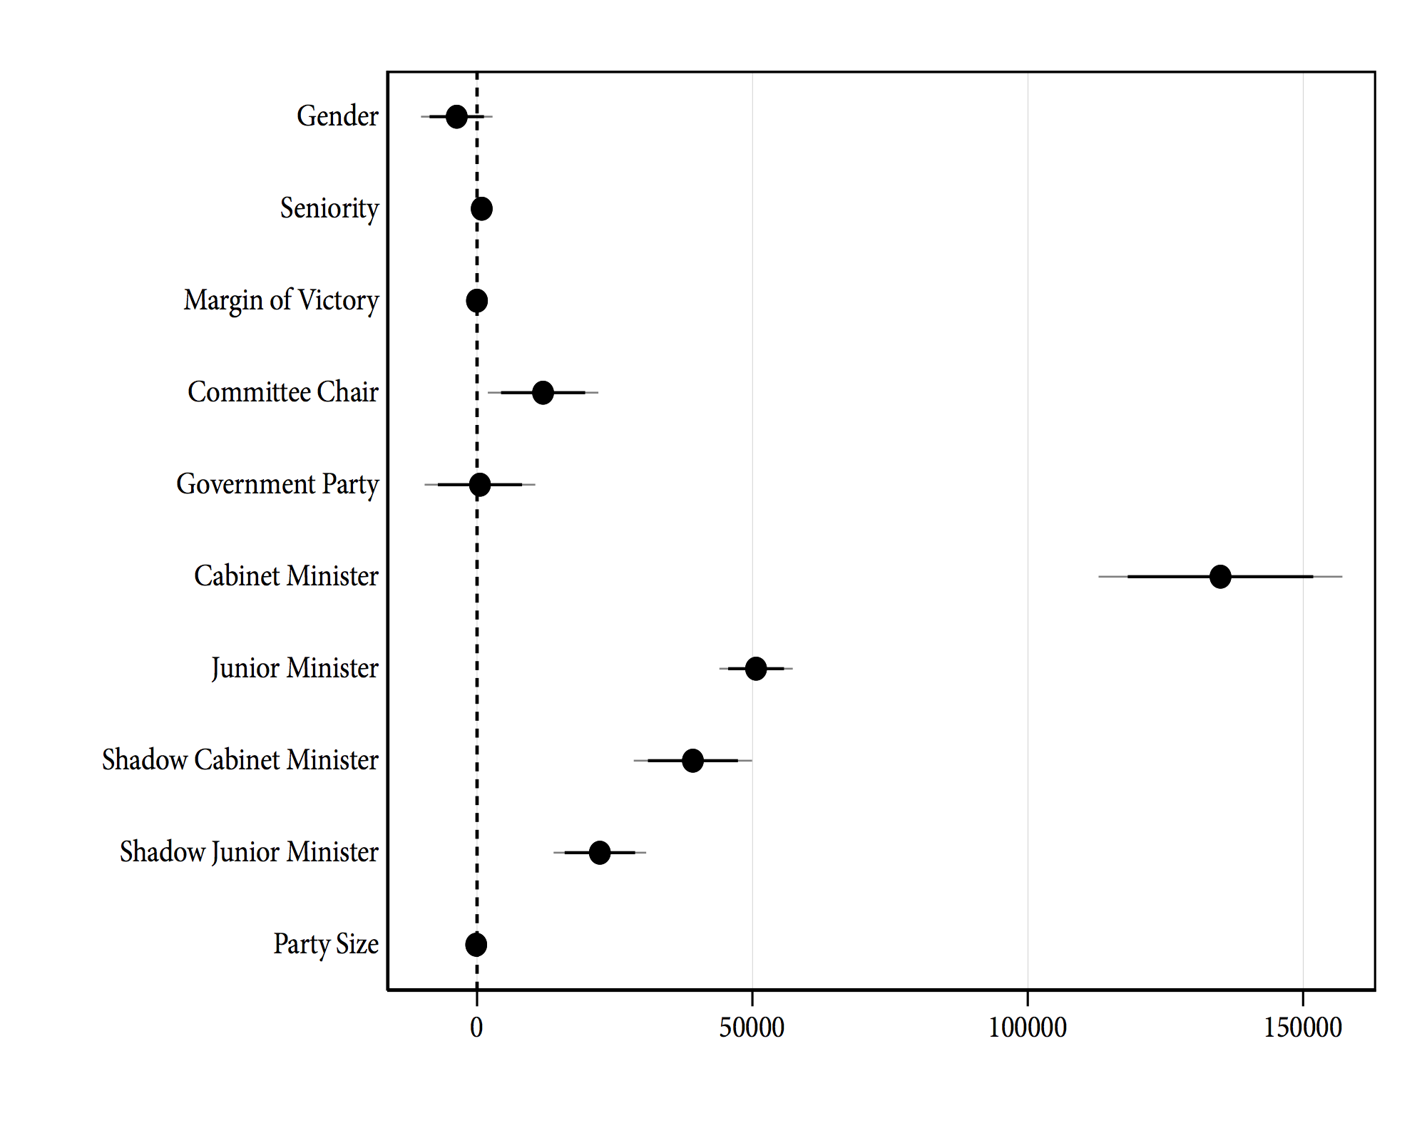

[INCLUDE REGRESSION TABLE from “regression_results.doc” ABOUT HERE]

# 

# **Country-specific analysis**

## ***Patterns of debate participation over time***

How have patterns of participation in debate changed over time? If, as we have argued, the changes to the party system, reforms to parliamentary rules of procedure, and the election of an backbench-promoting Speaker of the House have had an impact on the functioning of parliament, we would expect to see these effects manifest on levels of participation of different classes of MPs over time. We evaluate this expectation empirically in this section by looking at the relative degree of government dominance over plenary speaking time in recent years.

We begin in figure 5 by assessing changes in three quantities that are indicative of the extent of backbench power in the Commons. On Bercow’s election as Speaker, he claimed that it was his aim to “deliberately rescue ‘urgent questions’” (Bercow 2009) and in the left-hand panel of the figure we show the number of urgent questions in the Commons in each parliamentary session since 1997. As is clear from the figure, the use of urgent questions spiked sharply after Bercow’s election as Speaker and has continued to rise in recent years.

Similarly, Bercow’s appointment is also associated with an increase in the number of emergency debates in the Commons. Emergency debates are another mechanism through which backbenchers can pressure and scrutinise the government of the day, and the Speaker plays a key role in determining whether they will take place. The middle panel shows the number of emergency debates held in each parliament since 1979, and again there is a relatively clear increase after Bercow’s election in 2009.

Finally, the right-hand panel shows the average number of MPs speaking in Commons’ debates in each session since 1997. Although this evidence is indirect, the increase in debate attendance over recent years also implies that MPs are more involved in the process of parliamentary debate, and that they have greater opportunities to scrutinise the government than in the past.

Collectively, these patterns suggest that recent years have seen an increase in the opportunities that backbench MPs have to hold the government to account, and the timing of these changes, which are closely associated with the tenure of Bercow, implies that the balance of power between the legislature and the executive in UK parliamentary debates is affected by the occupant of the Speaker’s chair.

**Figure 5: Emergency debates, urgent questions, and number of MPs in debate**

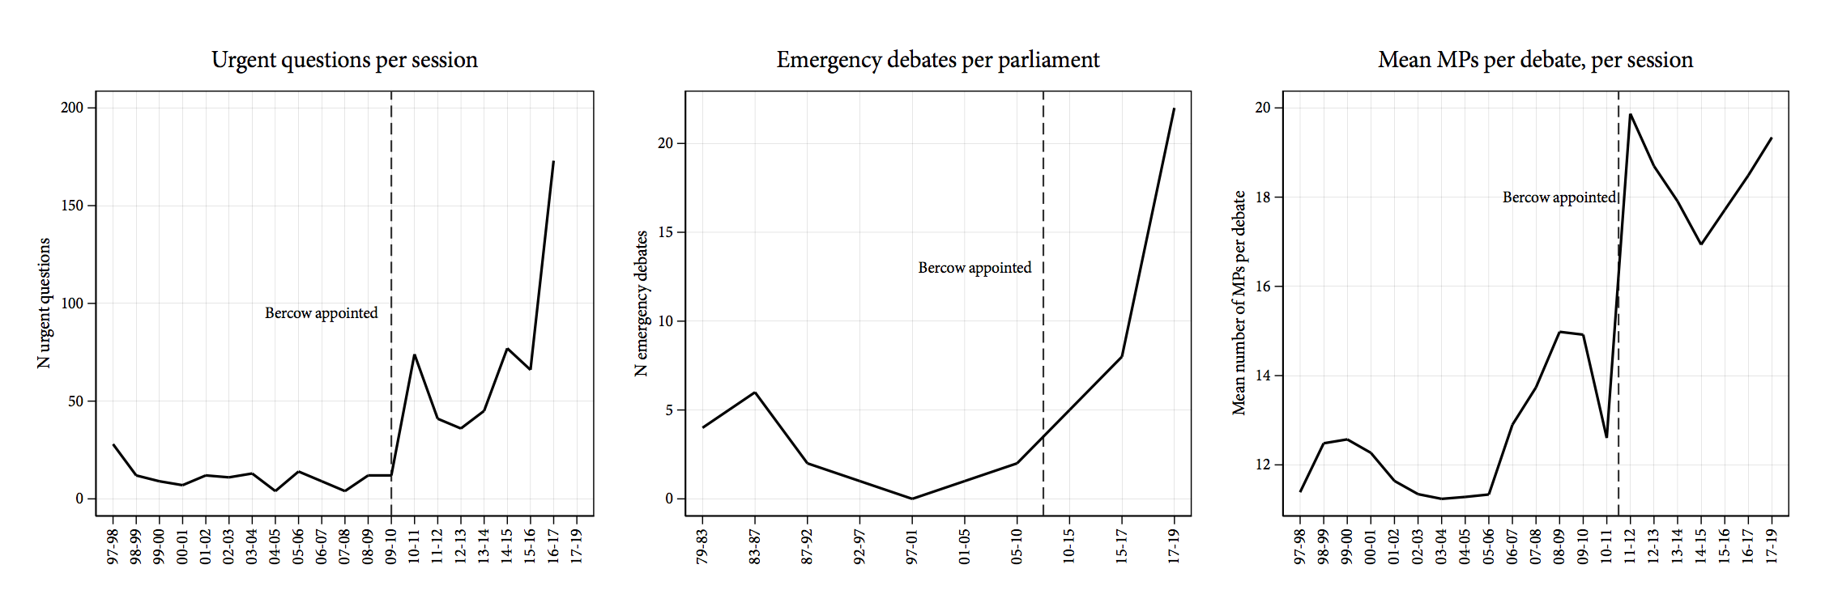

More generally, we can also evaluate how, at the aggregate level, the differences in participation between backbench and frontbench MPs documented in figure 3 have changed over time. For this analysis, we use a similar model to that presented above, but here we interact the main institutional position variables – cabinet minister, shadow cabinet minister, junior minister, shadow junior minister – with a set of dummy variables for each Parliament. This allows us to assess the degree to which the speech-making “bonus” documented in figure 3 for these actors varies over time. We plot the results in figure 6, where the points represent average marginal effects of each type of MP on the number of speeches delivered (relative to backbench MPs), in each Parliament.

**Figure 6: Status effects over time**

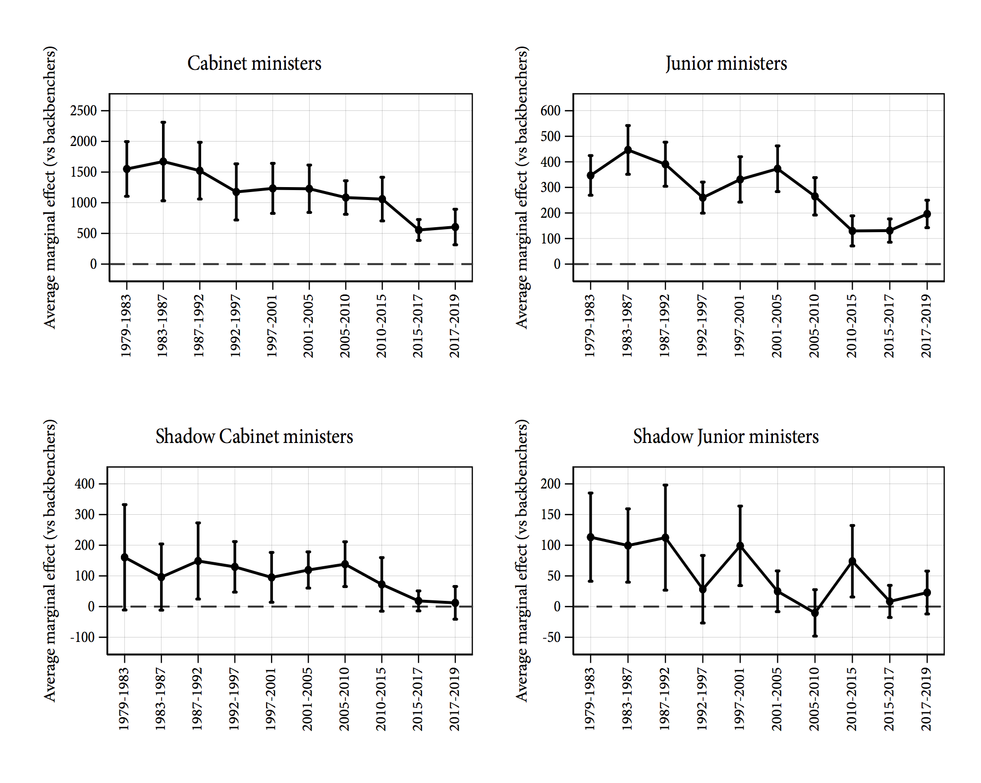

This analysis reveals that while MPs in the four positions highlighted in the figure speak more than backbench MPs throughout this period, there has been a narrowing of the speech-making gap in recent years. Throughout the 1980s and 1990s, for example, shadow cabinet and shadow junior ministers gave approximately 100 speeches more per Parliament than the average backbench MP, but this gap has reduced to approximately 50 speeches in the most recent parliament. Similarly, government junior ministers typically gave about 300 speeches more than backbenchers per Parliament up until 2010, but this difference has decreased to approximately 150 speeches since then. The most pronounced effects are those for cabinet ministers. Between 1979 and 1992, cabinet ministers delivered more than one and a half thousand more speeches than was the case for backbench MPs, but this number has decreased steadily in the years between 1992 and the 2019.

Overall, the analysis in this section suggests that while MPs with positions at the top of the legislative hierarchy continue to dominate parliamentary debate, the difference in participation with backbench MPs has decreased over time. Backbench MPs have more opportunities to scrutinize government activity, a greater ability to put items for debate onto the agenda, and generally participate more now than in the past.

## ***Constituency-oriented language***

In this final empirical analysis, we document one broad change in the focus of parliamentary speech over the time period in our data. Canonical theories of political communication and parliamentary debate suggest that MPs use their parliamentary speeches “to send policy signals as part of party competition” (Proksch and Slapin 2012, 521), and in particular that these speeches give MPs the opportunity to send personal messages to voters. This view of legislative speech as public communication is widely held in work focusing on both the UK (Proksch and Slapin 2012; Slapin and Proksch 2015; Blumenau 2019a) and elsewhere (Maltzman and Sigelman 1996; Quinn et al. 2010; Blidook and Kerby 2011; Soroka, Penner, and Blidook 2009; Martin and Vanberg 2008; Lin and Osnabrügge 2018). However, to our knowledge, no previous work has evaluated whether the incentives to make constituent-oriented appeals in parliamentary speech have varied over time.

Figure 7 shows the proportion of speeches in the Commons each year, for each major party, that contain either the word “constituency” or “constituent”. Although there is some variation by party, the general trend is clear: there has been a substantial increase in the use of these words since 1979, and the rate of constituency-oriented language is now roughly double the level of the beginning of the period. Averaging across parties, in the most recent parliament, MPs have made reference to constituencies in nearly 15% of their speeches, compared to only 6% in the 1979-1983 parliamentary term. These increases are particularly pronounced for the Conservative and Labour parties, and less so for the Liberal Democrats whose rate of constituent-oriented language has remained relatively stable throughout the period.

Figure 7: Use of constituency-oriented language in speeches over time.

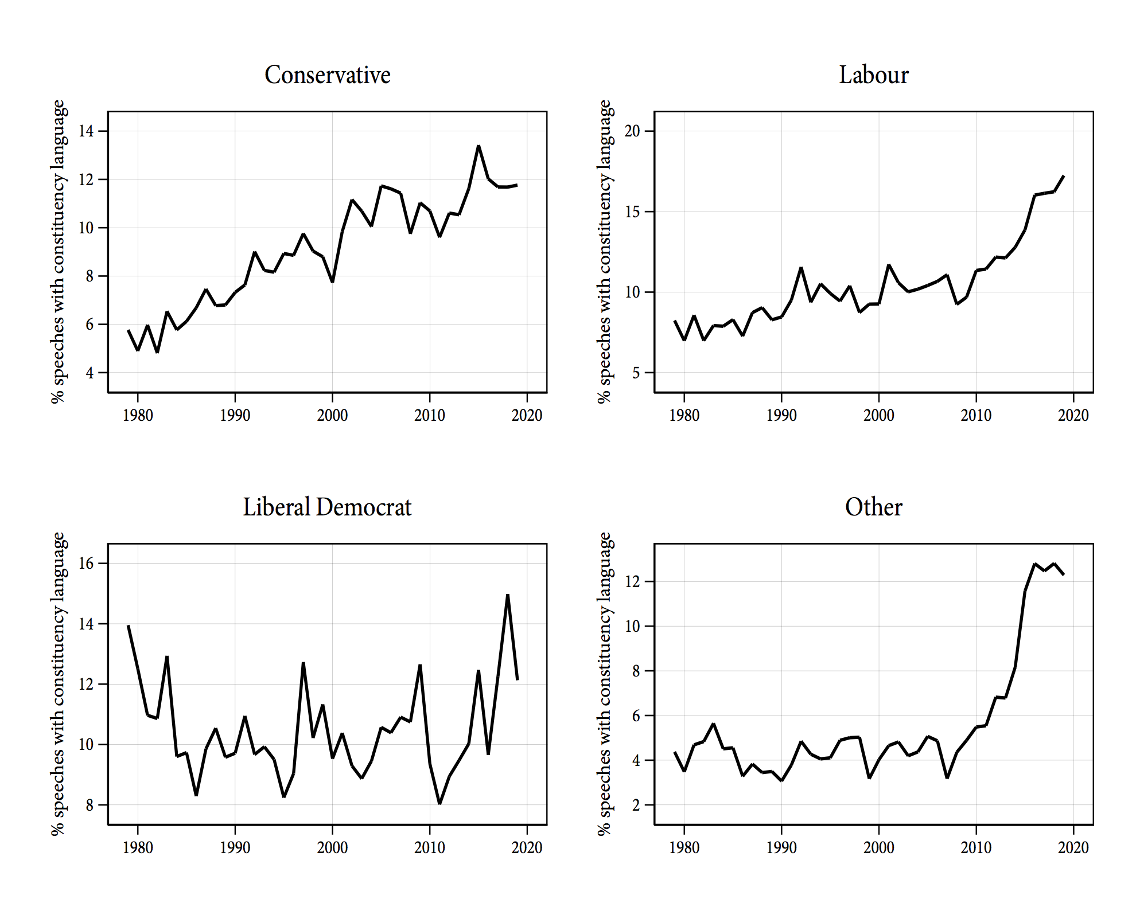

In sum, our evidence suggests that MPs are increasingly eager to show concern for their constituents’ interests by making frequent references to them during their speeches. In the most recent parliament, British MPs refer to their constituents in approximately one in ten speeches, compared to one in twenty speeches in 1979. Given that the incentives created by the electoral system to cultivate a personal vote lie at the heart of existing theories of legislative behaviour, we think it is notable that the evidence here suggests that these incentives – or the mitigating factors that typically override them – appear to be changing in the UK over time. We believe that developing theories to explain this change represent a promising avenue for future work on both legislative debate and UK politics more generally.

# **Conclusions**

Under the model of legislative speech developed by Slapin and Proksch (2015), electoral systems that promote personal vote-seeking and encourage MPs to develop independent name recognition should also encourage the adoption of legislative rules that give backbench MPs high levels of autonomy in parliamentary debate. The UK provides a good fit to this model, as the first-past-the-post, candidate-centred electoral system is paired with parliamentary institutions that put the debate participation decisions of MPs firmly outside of the control of the leaders of political parties. As our discussion made clear, British MPs have very few hurdles to clear if they wish to participate in debate beyond merely showing (and standing) up.

While this characterisation of parliamentary debate in the UK is consistent with that in Slapin and Proksch (2015, 83), our discussion also revealed a somewhat under-appreciated feature of the UK’s legislative organisation: the discretion given to the Speaker to determine speaking precedence means that an activist Speak can play an important role in affecting the balance of time allocated to different types of debate, and to different actors within debate. As we saw with the example of John Bercow, this can have implications for the relative prevalence of intra- versus inter-party modes of politics in the Commons.

However, despite the relatively permissive rules of parliamentary debate in the UK, actors in key institutional positions of power – cabient ministers, junior ministers, shadow cabinet ministers, and shadow junior ministers – nevertheless account for a large proportion of speeches delivered on the floor of the House. Our analysis revealed that MPs holding these positions deliver many thousands of words more than the typical backbencher each Parliament, and that these institutional determinants of speechmaking are far more important than other individual level predictors.

We also provided evidence that both the determinants of speechmaking and the focus of Commons’ speeches have evolved over the past 40 years. First, we showed that although those in ministerial and shadow ministerial positions continue to deliver more speeches on average than their backbench colleagues, this speechmaking bonus has gradually diminished over time. Second, we showed that MPs have increasingly used their parliamentary speeches to make reference to their constituents.

Pushing these findings further and investigating the reasons why parliamentary behaviour in the UK, particularly in legislative debate, has changed over time is an important avenue for future study. While we have shown here that there is evidence of increasing focus on constituency concerns from MPs, the analysis we provide is descriptive, and fairly broad. It would be interesting to know, for example, whether MPs have adapted the speeches they make in the Commons to more generally reflect the issue priorities of their constituents over time. Further, has this increased constituency focus come at the expense of party message unity? If so, why do party elites tolerate these expressions of independence more now than in the past? We leave these questions for future work.

# **References**

Bäck, Hanna, and Marc Debus. 2019. “When Do Women Speak? A Comparative Analysis of the Role of Gender in Legislative Debates.” *Political Studies* *67* (3): pp. 576–96.

Bercow, John. 2009. “Speech to the Hansard Society.” <https://www.johnbercow.co.uk/content/parliamentary-reform-route-here-there>.

Bird, Karen. 2005. “Gendering parliamentary questions.” *The British Journal of Politics and International Relations* *7* (3): pp. 353–70.

Blidook, Kelly, and Matthew Kerby. 2011. “Constituency influence on ‘constituency members’: the adaptability of roles to electoral realities in the canadian case.” *Journal of Legislative Studies* *17* (3): pp. 327–339.

Blumenau, Jack. 2019a. “Online Activism and Dyadic Representation: Evidence from the UK E-Petition System.” *Working Paper*.

Blumenau, Jack. 2019b. “The effects of female leadership on women’s voice in political debate.” *British Journal of Political Science*: pp. 1-22.

Bowler, Shaun. 2010. “Private members’ bills in the UK parliament: Is there an ‘electoral connection’?” *The Journal of Legislative Studies* *16* (4): pp. 476–494.

Bryant, Chris. 2014. *Parliament the Biography: Volume 1 Ancestral Voices*. Vol. 1. London: Doubleday.

Cain, Bruce E., John A. Ferejohn, and Morris P. Fiorina. 1984. “The Constituency Service Basis of the Personal Vote for U.S. Representatives and British Members of Parliament.” *American Political Science Review* *78* (1): 110–25.

Cain, Bruce, John Ferejohn, and Morris Fiorina. 1987. *The personal vote: Constituency service and electoral independence*. Cambridge, MA: Harvard University Press.

Campbell, Rosie, Philip Cowley, Nick Vivyan, and Markus Wagner. 2019a. “Legislator dissent as a valence signal.” *British Journal of Political Science* *49* (1): pp. 105–128.

Campbell, Rosie, Philip Cowley, Nick Vivyan, and Markus Wagner. 2019b. “Why friends and neighbors? Explaining the electoral appeal of local roots.” *Journal of Politics* *81* (3): pp. 937–951.

Campbell, Rosie, and Joni Lovenduski. 2015. “What Should MPs Do? Public and Parliamentarians’ Views Compared.” *Parliamentary Affairs* *68* (4): pp. 690–708.

Carey, John M., and Matthew Soberg Shugart. 1995. “Incentives to cultivate a personal vote: A rank ordering of electoral formulas.” *Electoral Studies* *14* (4): pp. 417–439.

Catalano, Ana. 2009. “Women acting for women? An analysis of gender and debate participation in the British House of Commons 2005–2007.” *Politics & Gender* *5* (1): pp. 45–68.

Cowley, Philip. 2015. “The coalition and Parliament.” In *The Coalition Effect, 2010–2015*, edited by Anthony Seldon, and MikeEditors Finn, pp. 136–56. Cambridge, United Kingdom: Cambridge University Press.

Cox, Gary W. 1997. *Making votes count: strategic coordination in the world’s electoral systems*. Cambridge: Cambridge University Press.

Cox, Gary W. 2005. *The efficient secret: The cabinet and the development of political parties in Victorian England*. Cambridge; New York: Cambridge University Press.

Cutts, David, and Andrew Russell. 2015. “From coalition to catastrophe: the electoral meltdown of the Liberal Democrats.” *Parliamentary Affairs* *68* (suppl_1): pp. 70–87.

Duverger, Maurice. 1954. “Political Parties.” London: Metheun; New York: Wiley.

Eggers, Andrew C, and Arthur Spirling. 2014. “Ministerial responsiveness in westminster systems: Institutional choices and House of Commons debate, 1832–1915.” *American Journal of Political Science* *58* (4): pp. 873–887.

Eggers, Andrew C, and Arthur Spirling. 2017. “Incumbency effects and the strength of party preferences: Evidence from multiparty elections in the United Kingdom.” *The Journal of Politics* *79* (3): pp. 903–920.

Eggers, Andrew C, and Arthur Spirling. 2018. “The shadow cabinet in Westminster systems: modeling opposition agenda setting in the House of Commons, 1832–1915.” *British Journal of Political Science* *48* (2): pp. 343–367.

Flynn, Paul. 2012. *How to be an MP*. London: Biteback Publishing.

Gaines, Brian J. 1998. “The impersonal vote? Constituency service and incumbency advantage in British elections, 1950-92.” *Legislative Studies Quarterly*: pp. 167–195.

Garnett, Mark, and Philip Lynch. 2014. *Exploring British Politics*. Routledge.

Goet, Niels D. 2019. “The Politics of Procedural Choice: Regulating Legislative Debate in the UK House of Commons, 1811–2015.” *British Journal of Political Science*: pp. 1–19.

Hanretty, Chris, Benjamin E Lauderdale, and Nick Vivyan. 2017. “Dyadic representation in a Westminster system.” *Legislative Studies Quarterly* *42* (2): pp. 235–267.

House of Commons. 2018. “Standing Orders: Public Business, HC 1020.” House of Commons. 2018.

Kam, Christopher J. 2009. *Party discipline and parliamentary politics*. Cambridge, UK; New York: Cambridge University Press.

Kellermann, Michael. 2016. “Electoral vulnerability, constituency focus, and parliamentary questions in the House of Commons.” *The British Journal of Politics and International Relations* *18* (1): pp. 90–106.

Killermann, Kira, and Sven-Oliver Proksch. 2013. “Dynamic political rhetoric: Electoral, economic, and partisan determinants of speech-making in the UK Parliament.” In *Annual Meeting of the American Political Science Association, Chicago, Il*.

King, Anthony. 1976. “Modes of Executive-Legislative Relations: Great Britain, France , and West Germany.” *Legislative Studies Quarterly* *1* (1): pp. 11–36.

Lin, Nick, and Moritz Osnabrügge. 2018. “Making comprehensible speeches when your constituents need it.” *Research and Politics:* pp. 1-8.

Maltzman, Forrest, and Lee Sigelman. 1996. “The politics of talk: Unconstrained floor time in the U.S. house of representatives.” *Journal of Politics* *58* (3): pp. 819–830.

Martin, Lanny W, and Georg Vanberg. 2008. “Coalition Government and Political Communication.” *Political Research Quarterly* *61* (3): pp. 502–516.

Natzler, David, and Mark Hutton (eds.). 2019. *Erskine May’s Treatise on the Law, Privileges, Proceedings and Usage of Parliament, 24th ed.* London; Markham, Ont.: Lexis Nexis.

Norton, Philip. 2013. *Parliament in British politics*. Houndmills, Basingstoke, Hampshire: Palgrave Macmillan.

O’Grady, Tom. 2019. “Careerists versus coal-miners: Welfare reforms and the substantive representation of social groups in the british labour party.” *Comparative Political Studies* *52* (4): pp. 544–578.

Peterson, Andrew, and Arthur Spirling. 2018. “Classification Accuracy as a Substantive Quantity of Interest: Measuring Polarization in Westminster Systems.” *Political Analysis* *26* (1): pp. 120–128.

Proksch, Sven-Oliver, and Jonathan B. Slapin. 2012. “Institutional Foundations of Legislative Speech.” *American Journal of Political Science* *56* (3): pp. 520–537.

Quinn, Kevin M., Burt L. Monroe, Michael Colaresi, Michael H. Crespin, and Dragomir R. Radev. 2010. “How to analyze political attention with minimal assumptions and costs.” *American Journal of Political Science* *54* (1): pp. 209–228.

Rheault, Ludovic, Kaspar Beelen, Christopher Cochrane, and Graeme Hirst. 2016. “Measuring emotion in parliamentary debates with automated textual analysis.” *PloS One* *11* (12): e0168843.

Rogers, Robert, and Rhodri Walters. 2018. *How Parliament Works 8th edition*. Routledge.

Russell, Meg. 2011a. “‘Never Allow a Crisis to Go to Waste’: The Wright Committee Reforms to Strengthen the House of Commons.” *Parliamentary Affairs* *64* (4): pp. 612–633.

Russell, Meg. 2011b. “’Never Allow Crisis Go to Waste’: The Wright Committee Reforms to Strengthen the House of Commons.” *Parliamentary Affairs* 64 (4): pp. 612–633.

Russell, Meg, and Philip Cowley. 2018. “Modes of UK executive-legislative relations revisited.” *Political Quarterly* *89* (1): pp. 18–28.

Sieberer, Ulrich. 2006. “Party unity in parliamentary democracies: A comparative analysis.” *Journal of Legislative Studies* *12* (2): pp. 150–178.

Slapin, Jonathan B., and Sven-Oliver Proksch. 2015. *The Politics of Parliamentary Debate: Parties, Rebels and Representation*. Cambridge: Cambridge University Press.

Smith, Timothy Hallam. 2013. “Are you sitting comfortably? Estimating incumbency advantage in the UK: 1983–2010–A research note.” *Electoral Studies* *32* (1): pp. 167–173.

Soroka, Stuart, Erin Penner, and Kelly Blidook. 2009. “Constituency Influence in Parliament.” *Canadian Journal of Political Science* *42* (3): pp. 563-591.

Spirling, Arthur. 2016. “Democratization and linguistic complexity: The effect of franchise extension on parliamentary discourse, 1832–1915.” *The Journal of Politics* *78* (1): pp. 120–136.

Vivyan, Nick, and Markus Wagner. 2015. “What do voters want from their local MP?” *Political Quarterly* *86* (1): pp. 33–40.

Vivyan, Nick, and Markus Wagner. 2016. “House or home? Constituent preferences over legislator effort allocation.” *European Journal of Political Research* *55* (1): pp. 81–99.

1. Note that other perspectives on the determinants of change to institutional rules of debate exist (Goet 2019).
2. While some of these procedures are codified in the Standing Orders of the House (House of Commons 2018), the customs and practices that govern parliamentary business are, however, most clearly articulated in Erskine May, the text written by Clerk of the House of Commons Thomas Erskine May, first published in 1844 and now in its 25th updated edition (Natzler and Hutton 2019).
3. Note that here we collapse all individual utterances made by an MP in a given debate into a single “debate contribution”.